Architecture
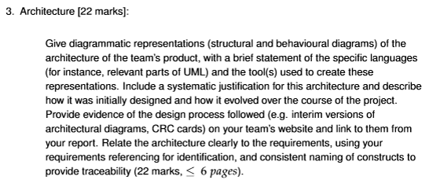
Give class and sequence diagrams (and how they were made (with what languages / tools)). Justification for the architecture based off requirements doc. (evolution comes after development). Save all interim and improved upon versions of the architecture documentation and put them on the website.

