

Project Title: Four Seasons Music Store

Group members

Sylvere Tanauh Ekponon – 300936445

Anupom Roy – 300853516

Contents

Detailed description 3

Version History 4

GITHUB SCREENCAP 4

Typography and Colour 5

Wireframes 5

Capture 5

# Detailed description

Music Store application, a sample online application that will be secure to sells music albums online, and that implements site administration. The Application will also allow new user can register, sign-in. Only register user can add album and modify an album. The site will also data persistence. Authorization will have done by OWIN technology and persistence will have done by Entity framework.

# Version History

V0.1 Site structure and major pages

V0.2 DB & Partial Function

V0.3 Main Tracking Page Created

V0.4 Repeater and Image slider added

V0.6 List view replaced

V0.7 Functionality for add Album

V0.8 NuGet Packages updated

V0.9 Startup and Login album page created

V1.0 Register, Login, Logout logic created to ensure authorization

V1.1 Update NEVBAR

V1.2 Album page and default page update with full functionality and pagination

V2.0 Added CURD functionality with authentication.

V3.0 Will introduce shopping curt functionality

### GITHUB SCREENCAP





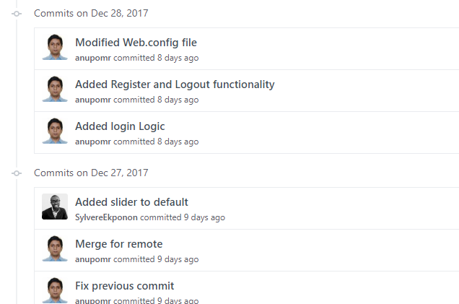



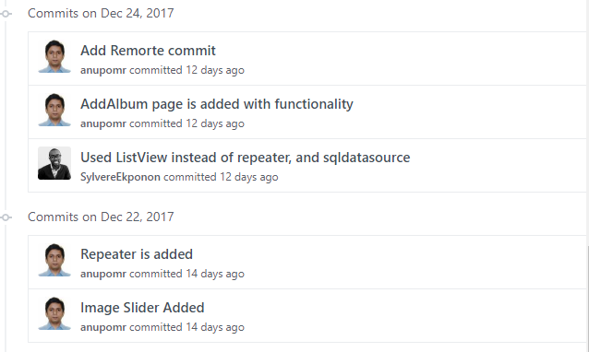

### 

# Typography and Colour

All fonts are client defaults

Color code (HEX OR RGB)

|  |  |
| --- | --- |
| #000000 |  |
| #0a5579 |  |
| #067139 |  |
| #cc482f |  |
| #f8b619 |  |

# Wireframes

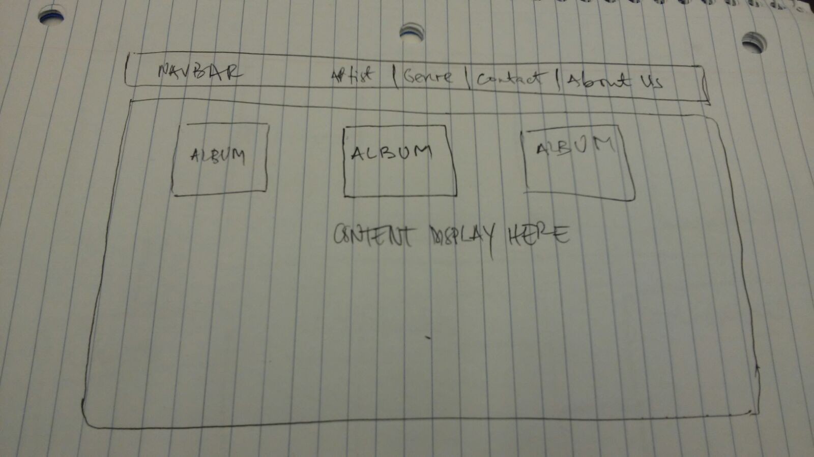

# Capture

