[Skip to content](https://www.overleaf.com/learn/latex/Learn_LaTeX_in_30_minutes" \l "main-content)

Top of Form

Bottom of Form

# **Learn LaTeX in 30 minutes**

In this guide, we hope to give you your first introduction to LATEX. The guide does not require you to have any prior knowledge of LATEX, but by the time you are finished, you will have written your first LaTeX document, and hopefully will have a good knowledge of some of the basic functions provided by LATEX.

## **Contents**

* [1 What is LaTeX?](https://www.overleaf.com/learn/latex/Learn_LaTeX_in_30_minutes#What_is_LaTeX.3F)
* [2 Why learn LaTeX?](https://www.overleaf.com/learn/latex/Learn_LaTeX_in_30_minutes#Why_learn_LaTeX.3F)
* [3 Writing your first piece of LaTeX](https://www.overleaf.com/learn/latex/Learn_LaTeX_in_30_minutes#Writing_your_first_piece_of_LaTeX)
* [4 The preamble of a document](https://www.overleaf.com/learn/latex/Learn_LaTeX_in_30_minutes#The_preamble_of_a_document)
* [5 Adding a title, author and date](https://www.overleaf.com/learn/latex/Learn_LaTeX_in_30_minutes#Adding_a_title.2C_author_and_date)
* [6 Adding comments](https://www.overleaf.com/learn/latex/Learn_LaTeX_in_30_minutes#Adding_comments)
* [7 Bold, italics and underlining](https://www.overleaf.com/learn/latex/Learn_LaTeX_in_30_minutes#Bold.2C_italics_and_underlining)
* [8 Adding images](https://www.overleaf.com/learn/latex/Learn_LaTeX_in_30_minutes#Adding_images)
  + [8.1 Captions, labels and references](https://www.overleaf.com/learn/latex/Learn_LaTeX_in_30_minutes#Captions.2C_labels_and_references)
* [9 Creating lists in LaTeX](https://www.overleaf.com/learn/latex/Learn_LaTeX_in_30_minutes#Creating_lists_in_LaTeX)
  + [9.1 Unordered lists](https://www.overleaf.com/learn/latex/Learn_LaTeX_in_30_minutes#Unordered_lists)
  + [9.2 Ordered lists](https://www.overleaf.com/learn/latex/Learn_LaTeX_in_30_minutes#Ordered_lists)
* [10 Adding math to LaTeX](https://www.overleaf.com/learn/latex/Learn_LaTeX_in_30_minutes#Adding_math_to_LaTeX)
* [11 Basic Formatting](https://www.overleaf.com/learn/latex/Learn_LaTeX_in_30_minutes#Basic_Formatting)
  + [11.1 Abstracts](https://www.overleaf.com/learn/latex/Learn_LaTeX_in_30_minutes#Abstracts)
  + [11.2 Paragraphs and newlines](https://www.overleaf.com/learn/latex/Learn_LaTeX_in_30_minutes#Paragraphs_and_newlines)
  + [11.3 Chapters and Sections](https://www.overleaf.com/learn/latex/Learn_LaTeX_in_30_minutes#Chapters_and_Sections)
* [12 Creating tables](https://www.overleaf.com/learn/latex/Learn_LaTeX_in_30_minutes#Creating_tables)
  + [12.1 Creating a simple table in LaTeX](https://www.overleaf.com/learn/latex/Learn_LaTeX_in_30_minutes#Creating_a_simple_table_in_LaTeX)
  + [12.2 Adding borders](https://www.overleaf.com/learn/latex/Learn_LaTeX_in_30_minutes#Adding_borders)
  + [12.3 Captions, labels and references](https://www.overleaf.com/learn/latex/Learn_LaTeX_in_30_minutes#Captions.2C_labels_and_references_2)
* [13 Adding a Table of Contents](https://www.overleaf.com/learn/latex/Learn_LaTeX_in_30_minutes#Adding_a_Table_of_Contents)
* [14 Downloading your finished document](https://www.overleaf.com/learn/latex/Learn_LaTeX_in_30_minutes#Downloading_your_finished_document)

# **What is LATEX?**

LATEX (pronounced *LAY-tek* or *LAH-tek*) is a tool used to create professional-looking documents. It is based on the WYSIWYM (what you see is what you mean) idea, meaning you only have focus on the contents of your document and the computer will take care of the formatting. Instead of spacing out text on a page to control formatting, as with Microsoft Word or LibreOffice Writer, users can enter plain text and let LATEX take care of the rest.

# **Why learn LATEX?**

LATEX is used all over the world for scientific documents, books, as well as many other forms of publishing. Not only can it create beautifully typeset documents, but it allows users to very quickly tackle the more complicated parts of typesetting, such as inputting mathematics, creating tables of contents, referencing and creating bibliographies, and having a consistent layout across all sections. Due to the huge number of open source *packages* available (more on this later), the possibilities with LATEX are endless. These *packages* allow users to do even more with LATEX, such as add footnotes, draw schematics, create tables etc.

One of the most important reasons people use LATEX is that it separates the content of the document from the style. This means that once you have written the content of your document, we can change its appearance with ease. Similarly, you can create one style of document which can be used to standardise the appearance of many different documents. This allows scientific journals to create templates for submissions. These templates have a pre-made layout meaning that only the content needs to be added. In fact there are hundreds of [templates](https://www.sharelatex.com/templates) available for everything from CVs to slideshows.

# **Writing your first piece of LATEX**

The first step is to create a new LATEX project. You can do this on your own computer by creating a new **.tex** file, or else you can [start a new project in Overleaf](https://www.overleaf.com/learn/latex/Creating_a_document_in_Overleaf). Let's start with the simplest working example:

\documentclass{article}

\begin{document}

First document. This is a simple example, with no

extra parameters or packages included.

\end{document}

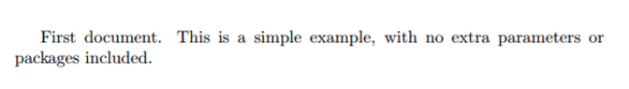

You can see that LATEX has already taken care of the first piece of formatting for you, by indenting the first line of the paragraph. Let's have a close look at what each part of our code does.

[Open an example in Overleaf](https://www.sharelatex.com/project/new/template?zipUrl=/project/582dbc33f220531c2d4bda27/download/zip&templateName=Learn%20LaTeX%20in%2020%20minutes:%20Part%201&compiler=pdflatex)

The first line of code declares the type of document, known as the *class*. The class controls the overall appearance of the document. Different types of documents will require different classes i.e. a CV/resume will require a different class than a scientific paper. In this case, the class is **article**, the simplest and most common LATEX class. Other types of documents you may be working on may require different classes such as **book** or **report**.

After this, you write the content of our document, enclosed inside the **\begin{document}** and **\end{document}** tags. This is known as the *body* of the document. You can start writing here and make changes to the text if you wish. To see the result of these changes in the PDF you have to compile the document. To do this in Overleaf, simply hit ***Recompile***. (You can also set your project to automatically recompile when you edit your files, by clicking on the small arrow next to the '**Recompile***button and set '****Auto Compile*** to '**On***.)*

If you are using a basic text editor such as gedit, emacs, vim, sublime, notepad etc., you will have to compile the document manually. To do this, simply run **pdflatex <your document>** in your computers terminal/command line. See [here](https://en.wikibooks.org/wiki/LaTeX/Basics#Compilation) for more information on how to do this.

If you are using a [dedicated LaTeX editor](https://en.wikibooks.org/wiki/LaTeX/Installation#Editors) such as TeXmaker or TeXworks, simply hit the ***Recompile*** button. Consult the programs documentation if you are unsure of where this is.

Now that you have learnt how to add content to our document, the next step is to give it a title. To do this, we must talk briefly about the **preamble**.

# **The preamble of a document**

In the previous example the text was entered after the **\begin{document}** command. Everything in your **.tex** file *before* this point is called the **preamble**. In the preamble you define the type of document you are writing, the language you are writing in, the *packages* you would like to use (more on this later) and several other elements. For instance, a normal document preamble would look like this:

\documentclass[12pt, letterpaper]{article}

\usepackage[utf8]{inputenc}

Below a detailed description of each line:

**\documentclass[12pt, letterpaper]{article}**

As said before, this defines the type of document. Some additional parameters included in the square brackets can be passed to the command. These parameters must be comma-separated. In the example, the extra parameters set the font size (**12pt**) and the paper size (**letterpaper**). Of course other font sizes (**9pt**, **11pt**, **12pt**) can be used, but if none is specified, the default size is **10pt**. As for the paper size other possible values are **a4paper** and **legalpaper**; see the article about [Page size and margins](https://www.overleaf.com/learn/latex/Page_size_and_margins) for more details about this.

**\usepackage[utf8]{inputenc}**

This is the encoding for the document. It can be omitted or changed to another encoding but utf-8 is recommended. Unless you specifically need another encoding, or if you are unsure about it, add this line to the preamble.

# **Adding a title, author and date**

To add a title, author and date to our document, you must add three lines to the **preamble** (NOT the main body of the document). These lines are

**\title{First document}**

This is the title.

**\author{Hubert Farnsworth}**

Here you put the name of the Author(s) and, as an optional addition, you can add the next command within the curly braces:

**\thanks{funded by the Overleaf team}**

This can be added after the name of the author, inside the braces of the **author** command. It will add a superscript and a footnote with the text inside the braces. Useful if you need to thank an institution in your article.

**\date{February 2014}**

You can enter the date manually or use the command **\today** so the date will be updated automatically at the time you compile your document

With these lines added, your preamble should look something like this

\documentclass[12pt, letterpaper, twoside]{article}

\usepackage[utf8]{inputenc}

\title{First document}

\author{Hubert Farnsworth \thanks{funded by the Overleaf team}}

\date{February 2017}

Now that you have given your document a title, author and date, you can print this information on the document with the **\maketitle** command. This should be included in the **body** of the document at the place you want the title to be printed.

\begin{document}

\maketitle

We have now added a title, author and date to our first \LaTeX{} document!

\end{document}

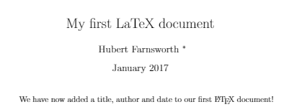

[Open an example in Overleaf](https://www.sharelatex.com/project/new/template?zipUrl=/project/582dbeacf220531c2d4bdaaa/download/zip&templateName=Learn%20LaTeX%20in%2020%20minutes:%20Part%202&compiler=pdflatex)

# **Adding comments**

As with any code you are writing, it can often be useful to include comments. Comments are pieces of text you can include in the document which will not be printed, and will not affect the document in any way. They are useful for organizing your work, taking notes, or commenting out lines/sections when debugging. To make a comment in LATEX, simply write a **%** symbol at the beginning of the line as shown below:

\begin{document}

\maketitle

We have now added a title, author and date to our first \LaTeX{} document!

% This line here is a comment. It will not be printed in the document.

\end{document}



[Open an example in Overleaf](https://www.sharelatex.com/project/new/template?zipUrl=/project/58a308db13712fef4e9deff7/download/zip&templateName=Learn%20LaTeX%20in%2020%20minutes:%20Part%203&compiler=pdflatex)

# **Bold, italics and underlining**

We will now look at some simple text formatting commands.

* **Bold**: Bold text in LaTeX is written with the **\textbf{...}** command.
* *Italics*: Italicised text in LaTeX is written with the **\textit{...}** command.
* Underline: Underlined text in LaTeX is written with the **\underline{...}** command.

An example of each of these in action is shown below:

Some of the \textbf{greatest}

discoveries in \underline{science}

were made by \textbf{\textit{accident}}.

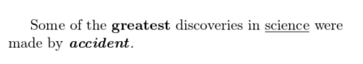

Another very useful command is the **\emph{...}** command. What the **\emph** command actually does with its argument depends on the context - inside normal text the emphasized text is italicized, but this behaviour is reversed if used inside an italicized text- see example below:

Some of the greatest \emph{discoveries}

in science

were made by accident.

\textit{Some of the greatest \emph{discoveries}

in science

were made by accident.}

\textbf{Some of the greatest \emph{discoveries}

in science

were made by accident.}

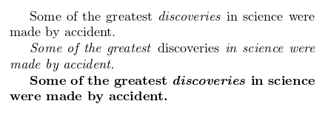

Moreover, some packages, e.g. [Beamer](https://www.overleaf.com/learn/latex/Beamer), change the behaviour of **\emph** command.

[Open an example in Overleaf](https://www.sharelatex.com/project/new/template?zipUrl=/project/58a30a6813712fef4e9df06b/download/zip&templateName=Learn%20LaTeX%20in%2020%20minutes:%20Part%204&compiler=pdflatex)

# **Adding images**

We will now look at how to add images to a LATEX document. On Overleaf, you will first have to [upload the images](https://www.overleaf.com/learn/latex/Including_images_in_ShareLaTeX).

Below is a example on how to include a picture.

\documentclass{article}

\usepackage{graphicx}

\graphicspath{ {images/} }

\begin{document}

The universe is immense and it seems to be homogeneous,

in a large scale, everywhere we look at.

\includegraphics{universe}

There's a picture of a galaxy above

\end{document}

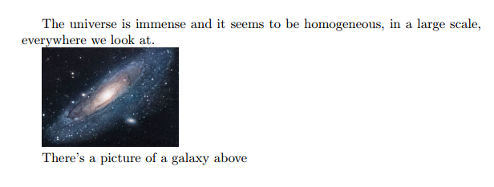

[Open an example in Overleaf](https://www.sharelatex.com/project/new/template?zipUrl=/project/58a30b7413712fef4e9df0a8/download/zip&templateName=Learn%20LaTeX%20in%2020%20minutes:%20Part%205&compiler=pdflatex)

LATEX can not manage images by itself, so you will need to use a *package*. Packages can be used to change the default look of your LATEX document, or to allow more functionalities. In this case, you need to include an image in our document, so you should use the **graphicx** package. This package gives new commands, **\includegraphics{...}** and **\graphicspath{...}**. To use the **graphicx** package, include the following line in you preamble: **\usepackage{graphicx}**

The command **\graphicspath{ {images/} }** tells LATEX that the images are kept in a folder named *images* under the current directory.

The **\includegraphics{universe}** command is the one that actually included the image in the document. Here *universe* is the name of the file containing the image without the extension, then *universe.PNG* becomes *universe*. The file name of the image should not contain white spaces nor multiple dots.

Note: *The file extension is allowed to be included, but it's a good idea to omit it. If the file extension is omitted it will prompt LaTeX to search for all the supported formats. It is also usually recommended to use lowercase letters for the file extension when uploading image files. For more details see the section about*[*generating high resolution and low resolution images*](https://www.overleaf.com/learn/latex/Learn_LaTeX_in_30_minutes#Generating_high-res_and_low-res_images)*.*

## **Captions, labels and references**

Images can be captioned, labelled and referenced by means of the **figure** environment as shown below:

\begin{figure}[h]

\centering

\includegraphics[width=0.25\textwidth]{mesh}

\caption{a nice plot}

\label{fig:mesh1}

\end{figure}

As you can see in the figure \ref{fig:mesh1}, the

function grows near 0. Also, in the page \pageref{fig:mesh1}

is the same example.

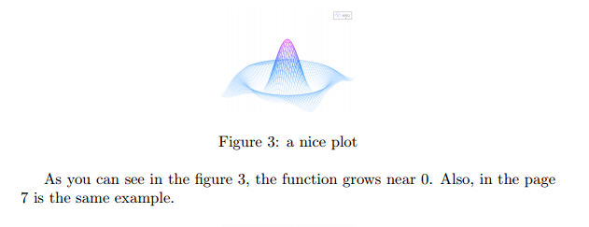

[Open an example in Overleaf](https://www.sharelatex.com/project/new/template?zipUrl=/project/58a30c5613712fef4e9df0e8/download/zip&templateName=Learn%20LaTeX%20in%2020%20minutes:%20Part%206&compiler=pdflatex)

There are three important commands in the example:

* **\caption{a nice plot}**: As you may expect this command sets the caption for the figure. If you create a list of figures this caption will be used there. You can place it above or below the figure.
* **\label{fig:mesh1}**: If you need to refer the image within your document, set a label with this command. The label will number the image, and combined with the next command will allow you to reference it.
* **\ref{fig:mesh1}**: This code will be substituted by the number corresponding to the referenced figure.

When placing images in a LATEX document, we should always put them inside a **figure** environment or similar so that LATEX will position the image in a way that fits in with the rest of your text.

*Note: If you are using captions and references on your own computer, you will have to compile the document twice for the references to work. Overleaf will do this for you automatically.'*

# **Creating lists in LATEX**

Lists are very simple to create in LATEX. You can create lists using different list *environments*. Environments are sections of our document that you want to present in a different way to the rest of the document. They start with a **\begin{...}** command and end with an **\end{...}** command.

There are two main different types of lists, *ordered* lists and *unordered* lists. Each will use a different environment.

## **Unordered lists**

Unordered lists are produced by the **itemize** environment. Each entry must be preceded by the control sequence **\item** as shown below.

\begin{itemize}

\item The individual entries are indicated with a black dot, a so-called bullet.

\item The text in the entries may be of any length.

\end{itemize}

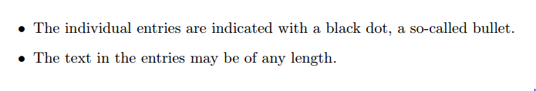

By default the individual entries are indicated with a black dot, so-called bullet. The text in the entries may be of any length.

[Open an example in Overleaf](https://www.sharelatex.com/project/new/template?zipUrl=/project/52fe74766a6237452e000088/download/zip&templateName=Lists%20Examples&compiler=pdflatex)

## **Ordered lists**

Ordered list have the same syntax inside a different environment. We make ordered lists using the **enumerate** environment:

\begin{enumerate}

\item This is the first entry in our list

\item The list numbers increase with each entry we add

\end{enumerate}

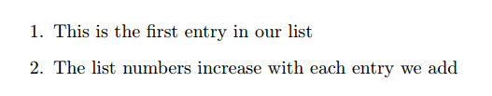

As with unordered lists, each entry must be preceded by the control sequence **\item**, which will automatically generate the number labelling the item. The enumerate labels consists of sequential numbers starting at one.

[Open an example in Overleaf](https://www.sharelatex.com/project/new/template?zipUrl=/project/52fe74766a6237452e000088/download/zip&templateName=Lists%20Examples&compiler=pdflatex)

# **Adding math to LATEX**

One of the main advantages of LATEX is the ease at which mathematical expressions can be written. LATEX allows two writing modes for mathematical expressions: the **inline** mode and the **display** mode. The first one is used to write formulas that are part of a text. The second one is used to write expressions that are not part of a text or paragraph, and are therefore put on separate lines. Let's see an example of the **inline** mode:

In physics, the mass-energy equivalence is stated

by the equation $E=mc^2$, discovered in 1905 by Albert Einstein.

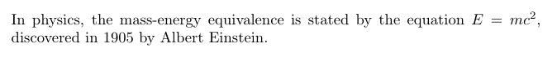

To put your equations in *inline* mode use one of these delimiters: **\( ... \)**, **$ ... $** or **\begin{math} ... \end{math}**. They all work and the choice is a matter of taste.

The *displayed* mode has two versions: numbered and unnumbered.

The mass-energy equivalence is described by the famous equation

\[ E=mc^2 \]

discovered in 1905 by Albert Einstein.

In natural units ($c = 1$), the formula expresses the identity

\begin{equation}

E=m

\end{equation}

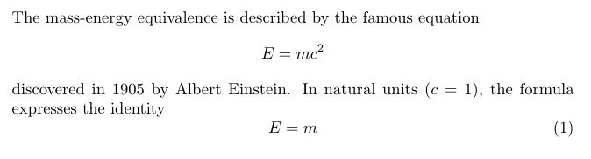

To print your equations in *display* mode use one of these delimiters: **\[ ... \]**, **\begin{displaymath} ... \end{displaymath}** or **\begin{equation} ... \end{equation}**. $$ ... $$ is [**discouraged**](https://texfaq.org/FAQ-dolldoll) as it can give inconsistent spacing, and may not work well with some math packages.

Important Note: *equation* environment is provided by an external package, consult the****[amsmath](https://www.overleaf.com/learn/latex/Aligning_equations" \o "Aligning equations)****[article](https://www.overleaf.com/learn/latex/Aligning_equations" \o "Aligning equations).*

[Open an example in Overleaf](https://www.sharelatex.com/project/new/template?zipUrl=/project/52ec4e44b43917a25a000e96/download/zip&templateName=Math%20Expressions&compiler=pdflatex)

Many math mode commands require the **amsmath** package, so be sure to include it when writing math. An example is shown below of some basic math mode commands.

Subscripts in math mode are written as $a_b$ and superscripts are written as $a^b$. These can be combined an nested to write expressions such as

\[ T^{i_1 i_2 \dots i_p}_{j_1 j_2 \dots j_q} = T(x^{i_1},\dots,x^{i_p},e_{j_1},\dots,e_{j_q}) \]

We write integrals using $\int$ and fractions using $\frac{a}{b}$. Limits are placed on integrals using superscripts and subscripts:

\[ \int_0^1 \frac{dx}{e^x} = \frac{e-1}{e} \]

Lower case Greek letters are written as $\omega$ $\delta$ etc. while upper case Greek letters are written as $\Omega$ $\Delta$.

Mathematical operators are prefixed with a backslash as $\sin(\beta)$, $\cos(\alpha)$, $\log(x)$ etc.

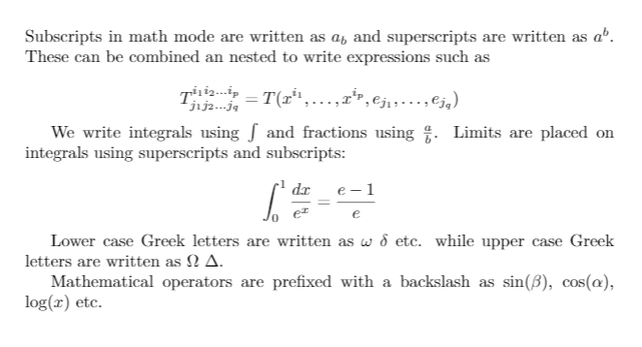

[Open an example in Overleaf](https://www.sharelatex.com/project/new/template?zipUrl=/project/58a30cfd13712fef4e9df123/download/zip&templateName=Learn%20LaTeX%20in%2020%20minutes:%20Part%207&compiler=pdflatex)

The possibilities with math in LATEX are endless and it is impossible to list them all here. Be sure to check out our other articles on

* [Mathematical expressions](https://www.overleaf.com/learn/latex/Mathematical_expressions)
* [Subscripts and superscripts](https://www.overleaf.com/learn/latex/Subscripts_and_superscripts)
* [Brackets and Parentheses](https://www.overleaf.com/learn/latex/Brackets_and_Parentheses)
* [Fractions and Binomials](https://www.overleaf.com/learn/latex/Fractions_and_Binomials)
* [Aligning Equations](https://www.overleaf.com/learn/latex/Aligning_equations_with_amsmath)
* [Operators](https://www.overleaf.com/learn/latex/Operators)
* [Spacing in math mode](https://www.overleaf.com/learn/latex/Spacing_in_math_mode)
* [Integrals, sums and limits](https://www.overleaf.com/learn/latex/Integrals%2C_sums_and_limits)
* [Display style in math mode](https://www.overleaf.com/learn/latex/Display_style_in_math_mode)
* [List of Greek letters and math symbols](https://www.overleaf.com/learn/latex/List_of_Greek_letters_and_math_symbols)
* [Mathematical fonts](https://www.overleaf.com/learn/latex/Mathematical_fonts)

# **Basic Formatting**

We will now look at how to write abstracts, as well as how to format a LATEX document into different chapters, sections and paragraphs.

## **Abstracts**

In scientific documents it's a common practice to include a brief overview of the main subject of the paper. In LATEX there's the **abstract** environment for this. The **abstract** environment will put the text in a special format at the top of your document.

\begin{document}

\begin{abstract}

This is a simple paragraph at the beginning of the

document. A brief introduction about the main subject.

\end{abstract}

\end{document}

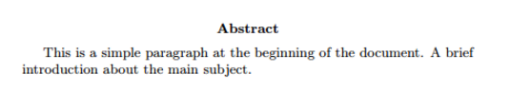

[Open an example in Overleaf](https://www.sharelatex.com/project/new/template?zipUrl=/project/58a30dd713712fef4e9df14e/download/zip&templateName=Learn%20LaTeX%20in%2020%20minutes:%20Part%208&compiler=pdflatex)

## **Paragraphs and newlines**

\begin{document}

\begin{abstract}

This is a simple paragraph at the beginning of the

document. A brief introduction about the main subject.

\end{abstract}

Now that we have written our abstract, we can begin writing our first paragraph.

This line will start a second Paragraph.

\end{document}

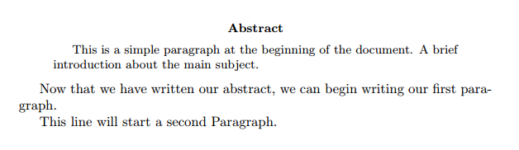

[Open an example in Overleaf](https://www.sharelatex.com/project/new/template?zipUrl=/project/58a30dd713712fef4e9df14e/download/zip&templateName=Learn%20LaTeX%20in%2020%20minutes:%20Part%208&compiler=pdflatex)

When writing the contents of your document, if you need to start a new paragraph you must hit the "Enter" key twice (to insert a double blank line). Notice that LATEX automatically indents paragraphs.

To start a new line without actually starting a new paragraph insert a *break line* point, this can be done by **\\** (a double backslash as in the example) or the **\newline** command.

Care should be taken that multiple \\ or \newlines are not used to "simulate" paragraphs with larger spacing between them, as this can interfere with LATEX's typesetting algorithms. The recommended method to do so is to keep using double blank lines to create new paragraphs without any \\, and then add **\usepackage{parskip}** to the preamble.

You can find more information in the [Paragraphs and new lines](https://www.overleaf.com/learn/latex/Paragraphs_and_new_lines) article.

## **Chapters and Sections**

Commands to organize a document vary depending on the document type, the simplest form of organization is the sectioning, available in all formats.

\chapter{First Chapter}

\section{Introduction}

This is the first section.

Lorem ipsum dolor sit amet, consectetuer adipiscing

elit. Etiam lobortisfacilisis sem. Nullam nec mi et

neque pharetra sollicitudin. Praesent imperdietmi nec ante.

Donec ullamcorper, felis non sodales...

\section{Second Section}

Lorem ipsum dolor sit amet, consectetuer adipiscing elit.

Etiam lobortis facilisissem. Nullam nec mi et neque pharetra

sollicitudin. Praesent imperdiet mi necante...

\subsection{First Subsection}

Praesent imperdietmi nec ante. Donec ullamcorper, felis non sodales...

\section*{Unnumbered Section}

Lorem ipsum dolor sit amet, consectetuer adipiscing elit.

Etiam lobortis facilisissem

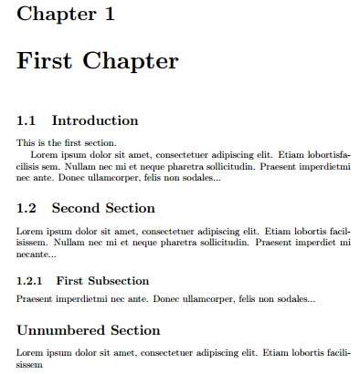

[Open an example in Overleaf](https://www.sharelatex.com/project/new/template?zipUrl=/project/58a30e7b13712fef4e9df182/download/zip&templateName=Learn%20LaTeX%20in%2020%20minutes:%20Part%209&compiler=pdflatex)

The command **\section{}** marks the beginning of a new section, inside the braces is set the title. Section numbering is automatic and can be disabled by including a **\*** in the section command as **\section*{}**. We can also have **\subsection{}**s, and indeed **\subsubsection{}**s. The basic levels of depth are listed below:

|  |  |
| --- | --- |
| -1 | **\part{part}** |
| 0 | **\chapter{chapter}** |
| 1 | **\section{section}** |
| 2 | **\subsection{subsection}** |
| 3 | **\subsubsection{subsubsection}** |
| 4 | **\paragraph{paragraph}** |
| 5 | **\subparagraph{subparagraph}** |

Note that **\part** and **\chapter** are only available in *report* and *book* document classes.

For a more complete discussion about the document structure see the [article about sections and chapters](https://www.overleaf.com/learn/latex/Sections_and_chapters).

# **Creating tables**

## **Creating a simple table in LATEX**

Below you can see the simplest working example of a table

\begin{center}

\begin{tabular}{ c c c }

cell1 & cell2 & cell3 \\

cell4 & cell5 & cell6 \\

cell7 & cell8 & cell9

\end{tabular}

\end{center}

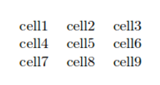

The **tabular** environment is the default LATEX method to create tables. You must specify a parameter to this environment, in this case **{c c c}**. This tells LATEX that there will be three columns and that the text inside each one of them must be centred. You can also use **r** to align the text to the right and **l** for left alignment. The alignment symbol **&** is used to specify the breaks in the table entries. There must always be one less alignment symbol in each line than the number of columns. To go to the next line of your table, we use the *new line* command **\\**. We wrap the entire table inside the **center** environment so that it will appear in the center of the page.

[Open an example in Overleaf](https://www.sharelatex.com/project/new/template?zipUrl=/project/58a3101d13712fef4e9df258/download/zip&templateName=Learn%20LaTeX%20in%2020%20minutes:%20Part%2010&compiler=pdflatex)

## **Adding borders**

The *tabular* environment is more flexible, you can put separator lines in between each column.

\begin{center}

\begin{tabular}{ |c|c|c| }

\hline

cell1 & cell2 & cell3 \\

cell4 & cell5 & cell6 \\

cell7 & cell8 & cell9 \\

\hline

\end{tabular}

\end{center}

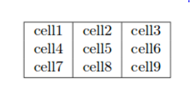

You can add borders using the horizontal line command **\hline** and the vertical line parameter **|**.

* **{ |c|c|c| }**: This declares that three columns, separated by a vertical line, are going to be used in the table. The **|** symbol specifies that these columns should be separated by a vertical line.
* **\hline**: This will insert a horizontal line. We have included horizontal lines at the top and bottom of the table here. There is no restriction on the number of times you can use **\hline**.

Below you can see a second example.

\begin{center}

\begin{tabular}{||c c c c||}

\hline

Col1 & Col2 & Col2 & Col3 \\ [0.5ex]

\hline\hline

1 & 6 & 87837 & 787 \\

\hline

2 & 7 & 78 & 5415 \\

\hline

3 & 545 & 778 & 7507 \\

\hline

4 & 545 & 18744 & 7560 \\

\hline

5 & 88 & 788 & 6344 \\ [1ex]

\hline

\end{tabular}

\end{center}

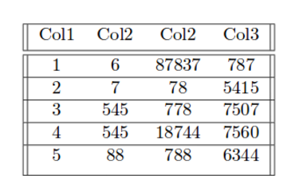

Creating tables in LATEX can be a bit tricky sometimes, so you may want to use the [TablesGenerator.com](https://www.tablesgenerator.com/) online tool to export LATEX code for tabulars. The *File > Paste table data* option lets you copy and paste data from spreadsheet applications.

[Open an example in Overleaf](https://www.sharelatex.com/project/new/template?zipUrl=/project/58a3101d13712fef4e9df258/download/zip&templateName=Learn%20LaTeX%20in%2020%20minutes:%20Part%2010&compiler=pdflatex)

## **Captions, labels and references**

You can caption and reference tables in much the same way as images. The only difference is that instead of the **figure** environment, you use the **table** environment.

Table \ref{table:data} is an example of referenced \LaTeX{} elements.

\begin{table}[h!]

\centering

\begin{tabular}{||c c c c||}

\hline

Col1 & Col2 & Col2 & Col3 \\ [0.5ex]

\hline\hline

1 & 6 & 87837 & 787 \\

2 & 7 & 78 & 5415 \\

3 & 545 & 778 & 7507 \\

4 & 545 & 18744 & 7560 \\

5 & 88 & 788 & 6344 \\ [1ex]

\hline

\end{tabular}

\caption{Table to test captions and labels}

\label{table:data}

\end{table}

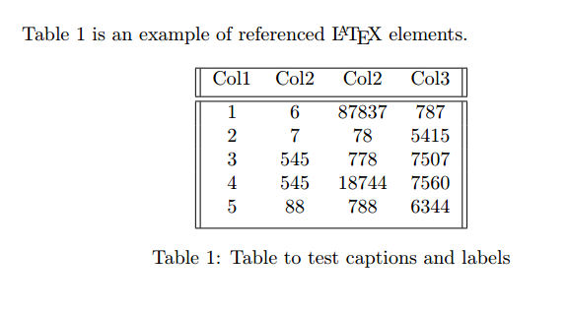

[Open an example in Overleaf](https://www.sharelatex.com/project/new/template?zipUrl=/project/58a3101d13712fef4e9df258/download/zip&templateName=Learn%20LaTeX%20in%2020%20minutes:%20Part%2010&compiler=pdflatex)

*Note: If you are using captions and references on your own computer, you will have to compile the document twice for the references to work. Overleaf will do this for you automatically.'*

# **Adding a Table of Contents**

To create the table of contents is straightforward, the command **\tableofcontents** does all the work for you:

\documentclass{article}

\usepackage[utf8]{inputenc}

\title{Sections and Chapters}

\author{Gubert Farnsworth}

\date{ }

\begin{document}

\maketitle

\tableofcontents

\section{Introduction}

This is the first section.

Lorem ipsum dolor sit amet, consectetuer adipiscing

elit. Etiam lobortisfacilisis sem. Nullam nec mi et

neque pharetra sollicitudin. Praesent imperdietmi nec ante.

Donec ullamcorper, felis non sodales...

\section*{Unnumbered Section}

\addcontentsline{toc}{section}{Unnumbered Section}

Lorem ipsum dolor sit amet, consectetuer adipiscing elit.

Etiam lobortis facilisissem. Nullam nec mi et neque pharetra

sollicitudin. Praesent imperdiet mi necante...

\section{Second Section}

Lorem ipsum dolor sit amet, consectetuer adipiscing elit.

Etiam lobortis facilisissem. Nullam nec mi et neque pharetra

sollicitudin. Praesent imperdiet mi necante...

\end{document}

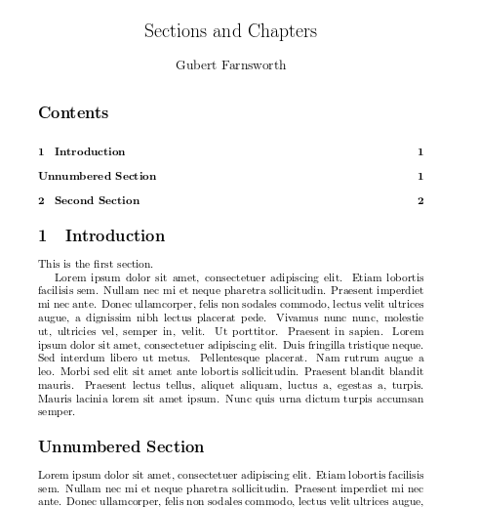

Sections, subsections and chapters are automatically included in the table of contents. To manually add entries, for example when you want an unnumbered section, use the command **\addcontentsline** as shown in the example.

[Open an example in Overleaf](https://www.sharelatex.com/project/new/template?zipUrl=/project/58a3103d13712fef4e9df25b/download/zip&templateName=Learn%20LaTeX%20in%2020%20minutes:%20Part%2011&compiler=pdflatex)

# **Downloading your finished document**

You can download your finished PDF from the left hand menu as above by clicking *PDF*. There is also the quicker option of clicking the *Download PDF* button on your PDF viewer as shown below.



* [Documentation Home](https://www.overleaf.com/learn)
* [Learn LaTeX in 30 minutes](https://www.overleaf.com/learn/latex/Learn_LaTeX_in_30_minutes)

## **Overleaf guides**

* [Creating a document in Overleaf](https://www.overleaf.com/learn/how-to/Creating_a_document_in_Overleaf)
* [Uploading a project](https://www.overleaf.com/learn/how-to/Uploading_a_project)
* [Copying a project](https://www.overleaf.com/learn/how-to/Copying_a_project)
* [Creating a project from a template](https://www.overleaf.com/learn/how-to/Creating_a_project_from_a_template)
* [Using the Overleaf project menu](https://www.overleaf.com/learn/how-to/Using_the_Overleaf_project_menu)
* [Including images in Overleaf](https://www.overleaf.com/learn/how-to/Including_images_on_Overleaf)
* [Exporting your work from Overleaf](https://www.overleaf.com/learn/how-to/Exporting_your_work_from_Overleaf)
* [Working offline in Overleaf](https://www.overleaf.com/learn/how-to/Working_Offline_in_Overleaf)
* [Using Track Changes in Overleaf](https://www.overleaf.com/learn/how-to/Track_Changes_in_Overleaf)
* [Using bibliographies in Overleaf](https://www.overleaf.com/learn/how-to/Using_bibliographies_on_Overleaf)
* [Sharing your work with others](https://www.overleaf.com/learn/how-to/Sharing_a_project)
* [Using the History feature](https://www.overleaf.com/learn/latex/Using_the_History_feature)
* [Debugging Compilation timeout errors](https://www.overleaf.com/learn/how-to/Why_do_I_keep_getting_the_compile_timeout_error_message%3F)
* [How-to guides](https://www.overleaf.com/learn/how-to)
* [Guide to Overleaf’s premium features](https://www.overleaf.com/learn/how-to/Overleaf_premium_features)

## **LaTeX Basics**

* [Creating your first LaTeX document](https://www.overleaf.com/learn/latex/Creating_a_document_in_LaTeX)
* [Choosing a LaTeX Compiler](https://www.overleaf.com/learn/latex/Choosing_a_LaTeX_Compiler)
* [Paragraphs and new lines](https://www.overleaf.com/learn/latex/Paragraphs_and_new_lines)
* [Bold, italics and underlining](https://www.overleaf.com/learn/latex/Bold%2C_italics_and_underlining)
* [Lists](https://www.overleaf.com/learn/latex/Lists)
* [Errors](https://www.overleaf.com/learn/latex/Errors)

## **Mathematics**

* [Mathematical expressions](https://www.overleaf.com/learn/latex/Mathematical_expressions)
* [Subscripts and superscripts](https://www.overleaf.com/learn/latex/Subscripts_and_superscripts)
* [Brackets and Parentheses](https://www.overleaf.com/learn/latex/Brackets_and_Parentheses)
* [Matrices](https://www.overleaf.com/learn/latex/Matrices)
* [Fractions and Binomials](https://www.overleaf.com/learn/latex/Fractions_and_Binomials)
* [Aligning equations](https://www.overleaf.com/learn/latex/Aligning_equations_with_amsmath)
* [Operators](https://www.overleaf.com/learn/latex/Operators)
* [Spacing in math mode](https://www.overleaf.com/learn/latex/Spacing_in_math_mode)
* [Integrals, sums and limits](https://www.overleaf.com/learn/latex/Integrals%2C_sums_and_limits)
* [Display style in math mode](https://www.overleaf.com/learn/latex/Display_style_in_math_mode)
* [List of Greek letters and math symbols](https://www.overleaf.com/learn/latex/List_of_Greek_letters_and_math_symbols)
* [Mathematical fonts](https://www.overleaf.com/learn/latex/Mathematical_fonts)
* [Using the Symbol Palette in Overleaf](https://www.overleaf.com/learn/how-to/Using_the_Symbol_Palette_in_Overleaf)

## **Figures and tables**

* [Inserting Images](https://www.overleaf.com/learn/latex/Inserting_Images)
* [Tables](https://www.overleaf.com/learn/latex/Tables)
* [Positioning Images and Tables](https://www.overleaf.com/learn/latex/Positioning_images_and_tables)
* [Lists of Tables and Figures](https://www.overleaf.com/learn/latex/Lists_of_tables_and_figures)
* [Drawing Diagrams Directly in LaTeX](https://www.overleaf.com/learn/latex/Picture_environment)
* [TikZ package](https://www.overleaf.com/learn/latex/TikZ_package)

## **References and Citations**

* [Bibliography management with bibtex](https://www.overleaf.com/learn/latex/Bibliography_management_with_bibtex)
* [Bibliography management with natbib](https://www.overleaf.com/learn/latex/Bibliography_management_with_natbib)
* [Bibliography management with biblatex](https://www.overleaf.com/learn/latex/Bibliography_management_with_biblatex)
* [Bibtex bibliography styles](https://www.overleaf.com/learn/latex/Bibtex_bibliography_styles)
* [Natbib bibliography styles](https://www.overleaf.com/learn/latex/Natbib_bibliography_styles)
* [Natbib citation styles](https://www.overleaf.com/learn/latex/Natbib_citation_styles)
* [Biblatex bibliography styles](https://www.overleaf.com/learn/latex/Biblatex_bibliography_styles)
* [Biblatex citation styles](https://www.overleaf.com/learn/latex/Biblatex_citation_styles)

## **Languages**

* [Multilingual typesetting on Overleaf using polyglossia and fontspec](https://www.overleaf.com/learn/latex/Multilingual_typesetting_on_Overleaf_using_polyglossia_and_fontspec)
* [Multilingual typesetting on Overleaf using babel and fontspec](https://www.overleaf.com/learn/latex/Multilingual_typesetting_on_Overleaf_using_babel_and_fontspec)
* [International language support](https://www.overleaf.com/learn/latex/International_language_support)
* [Quotations and quotation marks](https://www.overleaf.com/learn/latex/Typesetting_quotations)
* [Arabic](https://www.overleaf.com/learn/latex/Arabic)
* [Chinese](https://www.overleaf.com/learn/latex/Chinese)
* [French](https://www.overleaf.com/learn/latex/French)
* [German](https://www.overleaf.com/learn/latex/German)
* [Greek](https://www.overleaf.com/learn/latex/Greek)
* [Italian](https://www.overleaf.com/learn/latex/Italian)
* [Japanese](https://www.overleaf.com/learn/latex/Japanese)
* [Korean](https://www.overleaf.com/learn/latex/Korean)
* [Portuguese](https://www.overleaf.com/learn/latex/Portuguese)
* [Russian](https://www.overleaf.com/learn/latex/Russian)
* [Spanish](https://www.overleaf.com/learn/latex/Spanish)

## **Document structure**

* [Sections and chapters](https://www.overleaf.com/learn/latex/Sections_and_chapters)
* [Table of contents](https://www.overleaf.com/learn/latex/Table_of_contents)
* [Cross referencing sections, equations and floats](https://www.overleaf.com/learn/latex/Cross_referencing_sections%2C_equations_and_floats)
* [Indices](https://www.overleaf.com/learn/latex/Indices)
* [Glossaries](https://www.overleaf.com/learn/latex/Glossaries)
* [Nomenclatures](https://www.overleaf.com/learn/latex/Nomenclatures)
* [Management in a large project](https://www.overleaf.com/learn/latex/Management_in_a_large_project)
* [Multi-file LaTeX projects](https://www.overleaf.com/learn/latex/Multi-file_LaTeX_projects)
* [Hyperlinks](https://www.overleaf.com/learn/latex/Hyperlinks)

## **Formatting**

* [Lengths in LATEX](https://www.overleaf.com/learn/latex/Lengths_in_LaTeX)
* [Headers and footers](https://www.overleaf.com/learn/latex/Headers_and_footers)
* [Page numbering](https://www.overleaf.com/learn/latex/Page_numbering)
* [Paragraph formatting](https://www.overleaf.com/learn/latex/Paragraph_formatting)
* [Line breaks and blank spaces](https://www.overleaf.com/learn/latex/Line_breaks_and_blank_spaces)
* [Text alignment](https://www.overleaf.com/learn/latex/Text_alignment)
* [Page size and margins](https://www.overleaf.com/learn/latex/Page_size_and_margins)
* [Single sided and double sided documents](https://www.overleaf.com/learn/latex/Single_sided_and_double_sided_documents)
* [Multiple columns](https://www.overleaf.com/learn/latex/Multiple_columns)
* [Counters](https://www.overleaf.com/learn/latex/Counters)
* [Code listing](https://www.overleaf.com/learn/latex/Code_listing)
* [Code Highlighting with minted](https://www.overleaf.com/learn/latex/Code_Highlighting_with_minted)
* [Using colours in LaTeX](https://www.overleaf.com/learn/latex/Using_colours_in_LaTeX)
* [Footnotes](https://www.overleaf.com/learn/latex/Footnotes)
* [Margin notes](https://www.overleaf.com/learn/latex/Margin_notes)

## **Fonts**

* [Font sizes, families, and styles](https://www.overleaf.com/learn/latex/Font_sizes%2C_families%2C_and_styles)
* [Font typefaces](https://www.overleaf.com/learn/latex/Font_typefaces)
* [Supporting modern fonts with XƎLATEX](https://www.overleaf.com/learn/latex/XeLaTeX)

## **Presentations**

* [Beamer](https://www.overleaf.com/learn/latex/Beamer)
* [Powerdot](https://www.overleaf.com/learn/latex/Powerdot)
* [Posters](https://www.overleaf.com/learn/latex/Posters)

## **Commands**

* [Commands](https://www.overleaf.com/learn/latex/Commands)
* [Environments](https://www.overleaf.com/learn/latex/Environments)

## **Field specific**

* [Theorems and proofs](https://www.overleaf.com/learn/latex/Theorems_and_proofs)
* [Chemistry formulae](https://www.overleaf.com/learn/latex/Chemistry_formulae)
* [Feynman diagrams](https://www.overleaf.com/learn/latex/Feynman_diagrams)
* [Molecular orbital diagrams](https://www.overleaf.com/learn/latex/Molecular_orbital_diagrams)
* [Chess notation](https://www.overleaf.com/learn/latex/Chess_notation)
* [Knitting patterns](https://www.overleaf.com/learn/latex/Knitting_patterns)
* [CircuiTikz package](https://www.overleaf.com/learn/latex/CircuiTikz_package)
* [Pgfplots package](https://www.overleaf.com/learn/latex/Pgfplots_package)
* [Typesetting exams in LaTeX](https://www.overleaf.com/learn/latex/Typesetting_exams_in_LaTeX)
* [Knitr](https://www.overleaf.com/learn/latex/Knitr)
* [Attribute Value Matrices](https://www.overleaf.com/learn/latex/Attribute_Value_Matrices)

## **Class files**

* [Understanding packages and class files](https://www.overleaf.com/learn/latex/Understanding_packages_and_class_files)
* [List of packages and class files](https://www.overleaf.com/learn/latex/List_of_packages_and_class_files)
* [Writing your own package](https://www.overleaf.com/learn/latex/Writing_your_own_package)
* [Writing your own class](https://www.overleaf.com/learn/latex/Writing_your_own_class)

## **Advanced TeX/LaTeX**

* [In-depth technical articles on TeX/LaTeX](https://www.overleaf.com/learn/latex/Articles)

About

* [About us](https://www.overleaf.com/about)
* [Our values](https://www.overleaf.com/about/values)
* [Careers](https://apply.workable.com/overleaf/)
* [Press & awards](https://www.overleaf.com/for/press)
* [Blog](https://www.overleaf.com/blog)

Learn

* [LaTeX in 30 minutes](https://www.overleaf.com/learn/latex/Learn_LaTeX_in_30_minutes)
* [Templates](https://www.overleaf.com/latex/templates)
* [Webinars](https://www.overleaf.com/events/webinars)
* [Tutorials](https://www.overleaf.com/learn/latex/Tutorials)
* [How to insert images](https://www.overleaf.com/learn/latex/Inserting_Images)
* [How to create tables](https://www.overleaf.com/learn/latex/Tables)

Plans & pricing

* [Premium features](https://www.overleaf.com/learn/how-to/Overleaf_premium_features)
* [For individuals & groups](https://www.overleaf.com/user/subscription/plans)
* [For enterprise](https://www.overleaf.com/for/enterprises)
* [For universities](https://www.overleaf.com/for/universities)
* [For students](https://www.overleaf.com/user/subscription/plans#view=student)

Get involved

* [Become an Overleaf advisor](https://www.overleaf.com/for/community/advisors)
* [Participate in user research](https://calendly.com/overleaf/user-research)
* [Join beta program](https://www.overleaf.com/beta/participate)
* [Refer a friend](https://www.overleaf.com/user/bonus)

Help

* [Documentation](https://www.overleaf.com/learn)
* [Contact us](https://www.overleaf.com/contact)
* [Website status](https://status.overleaf.com/)

© 2022 Overleaf

[Privacy and Terms](https://www.overleaf.com/legal)

* [English](https://www.overleaf.com/learn/latex/Learn_LaTeX_in_30_minutes)

[Overleaf on Twitter](https://twitter.com/overleaf)

[Overleaf on Facebook](https://www.facebook.com/overleaf.editor)

[Overleaf on LinkedIn](https://www.linkedin.com/company/writelatex-limited)

We only use cookies for essential purposes and to improve your experience on our site. You can find out more in our [cookie policy](https://www.overleaf.com/legal#Cookies).