

**SCHOOL MANAGEMENT SYSTEM (SMS)**

CONTENTS

**INTRODUCTION** 1

**Start** 1

**Body** 1

**End** 2

**STRUCTURE** 3

**Sign-in Page** 3

**Password Recovery Page** 4

**Dashboard** 4

**My Children** 4

**My Account** 6

**My Profile** 6

**LIST OF FIGURES** 7

# 

# **INTRODUCTION**

## **Start**

School Management System (SMS) refers to a comprehensive software platform designed to streamline and enhance various administrative and academic processes within educational institutions. It is a centralized digital solution that helps automate routine tasks, improve communication, and ensure efficient management of school operations.

## **Body**

Here are some short notes on the key features and benefits of a School Management System:

1. School Information Management: SMS allows schools to store and manage student data effectively, including personal information, contact details, enrolment history, and academic records. This information can be easily accessed and updated as needed.
2. Attendance Tracking: The system enables efficient tracking of student attendance, both for individual classes and overall school attendance. It can generate reports, identify patterns of absenteeism, and notify parents and authorities about any irregularities.
3. Grade Management: SMS facilitates the management of student grades and academic progress. Teachers can enter grades, calculate averages, and generate report cards electronically. Parents and students can access these records online, promoting transparency and timely feedback.
4. Timetable Generation: The system assists in creating and managing school timetables, assigning teachers to classes, and scheduling extracurricular activities. It optimizes resource allocation and minimizes conflicts, ensuring a balanced and efficient timetable.
5. Communication and Collaboration: SMS offers a platform for seamless communication among teachers, students, parents, and administrators. It enables sending announcements, notifications, and reminders through email. It can also facilitate discussions, file sharing, and online forums to enhance collaboration.
6. Fee Management: The system simplifies the process of fee collection, tracking, and management. It allows schools to generate fee invoices, track payments, and issue receipts electronically. Parents can access their payment history and receive alerts for pending fees.
7. Library Management (Planned): SMS includes features for managing library resources, such as cataloging books, tracking borrowing and returns, and generating overdue notices. It helps in maintaining an organized and efficient library system.
8. Staff Management: The system enables schools to manage faculty and staff details, including employment records, attendance, and performance evaluations. It can also facilitate communication and collaboration among staff members.
9. Data Security and Privacy: SMS ensures the security and privacy of sensitive information by implementing robust data encryption, access controls, and regular backups. It adheres to relevant data protection regulations and offers role-based access to safeguard confidential data.
10. Reporting and Analytics: The system generates various reports, analytics, and insights to help administrators make informed decisions. It can provide information on attendance trends, academic performance, financials, and other key metrics.

## **End**

Implementing a school management system can bring numerous benefits, including increased efficiency, reduced paperwork, improved communication, enhanced decision-making, and better overall organization and management of the school. It empowers educators and administrators to focus more on delivering quality education and nurturing student development.

# **STRUCTURE**

## **Sign-in Page**

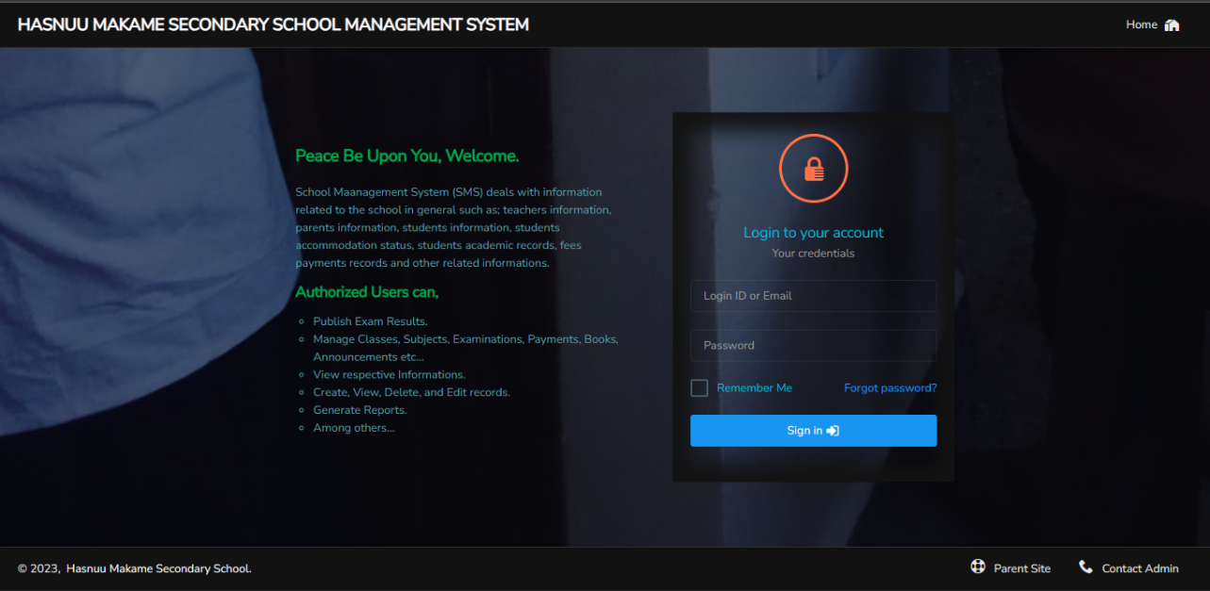A sign in page or login page is a web interface that allows you (a user) to access the system providing your unique credentials, typically a **login ID** or **Email** and **password**.

Here are some key elements and considerations for a login page: User Identification:

Figure : Login Page

Let’s zoom in a little bit,

This is the field where you enter your username (provided login ID or your Email address).

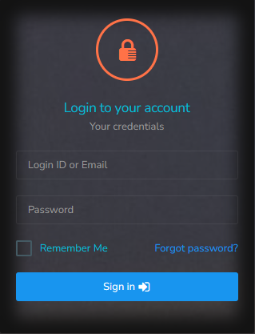

This enables you to initiate the password recovery process and regain access to your account in case you forgot your password (See the Password Recovery Page Section).

When selected this allows you to stay logged in on the device you are using, so you do have to login in again at most for 30 days.

This is the password field where you input your secret password.

Figure : Login Section Looks like

Last but not least, in case you have an issue to be addressed get admin contacts by clicking this link here.

Figure : Footer Section Part

By the way, want to go to our website? Just click this.

## **Password Recovery Page**

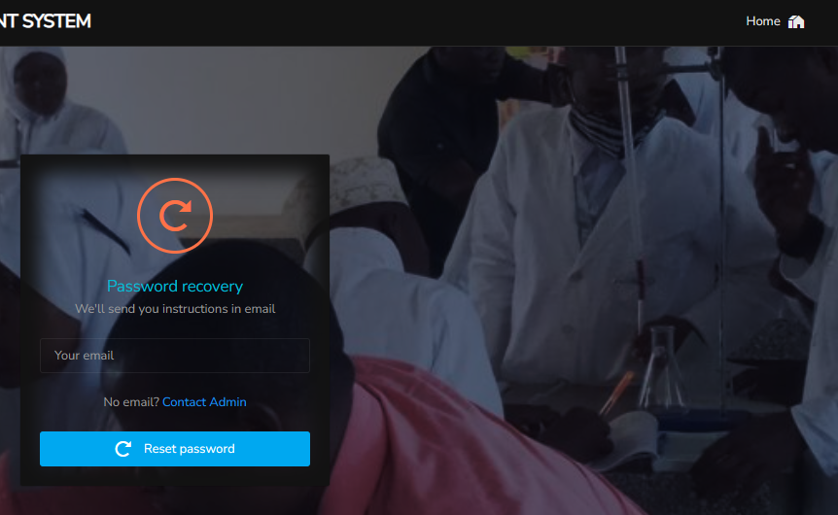In case you forgot your password. If you clicked the Forgot Password? Link you will be redirected to this page. This is where you actually initiate the password recovery process. You will be required to provide your email address, and the system will handle the rest. Be sure to check your mail inboxes. You can return to the login page in any moment by just clicking on “Home” button.

By the way feel free to Contact Admin if you need to.

Figure : Password Recovery Page

## **Dashboard**

This is a visual representation of key performance indicators (KPIs), metrics, and important data related to the system. It offers a high-level overview of the system's links, status, and relevant data. Here you may find any planned events, notifications, and notices when they are available.

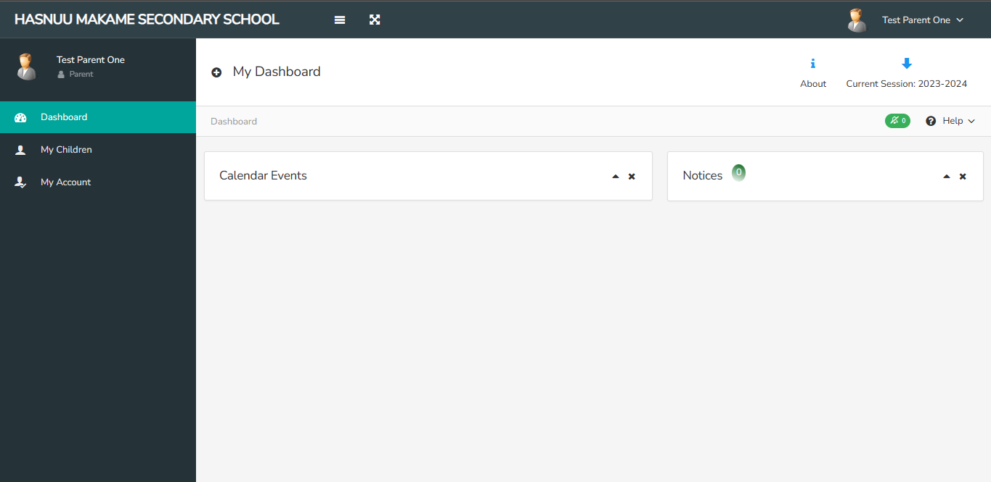

Figure : Dashboard Page

**NOTE:**

If it is your first time accessing the system using the provided login ID or your email address with the default password. You will be redirected to “My Account” page, where you will be required to change your default password. You will not be able to access the Dashboard Page unless you update your password.

## **My Children**

Under this page, you will find all of your children available in the system with related links to access various data.

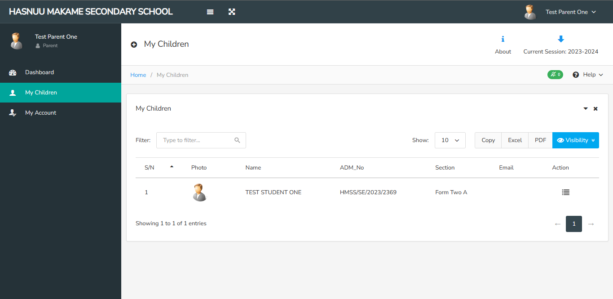

Figure : My Children Page

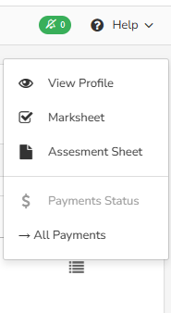Click this icon to access the menu links. The results will look like figure below;

You can access message or notification by just clicking this

Click here to view your children payments status (if available). You will see the option with current year, if any payments were done. Just click it to access the records.

Click here to view your children assessments marks sheet or results. This sheet includes Class Work (CW), Home Work (HW) and Topic Test (TT) marks.

Click here to view your children examination(s) mark sheets or results.

Click here to view your children profile data.

Figure : Menu Links

The “View Profile”, “Marksheet”, and “Assessment Sheet” options are self-explanatory. Just navigate to them, you will enjoy. Enjoy!.

## **My Account**

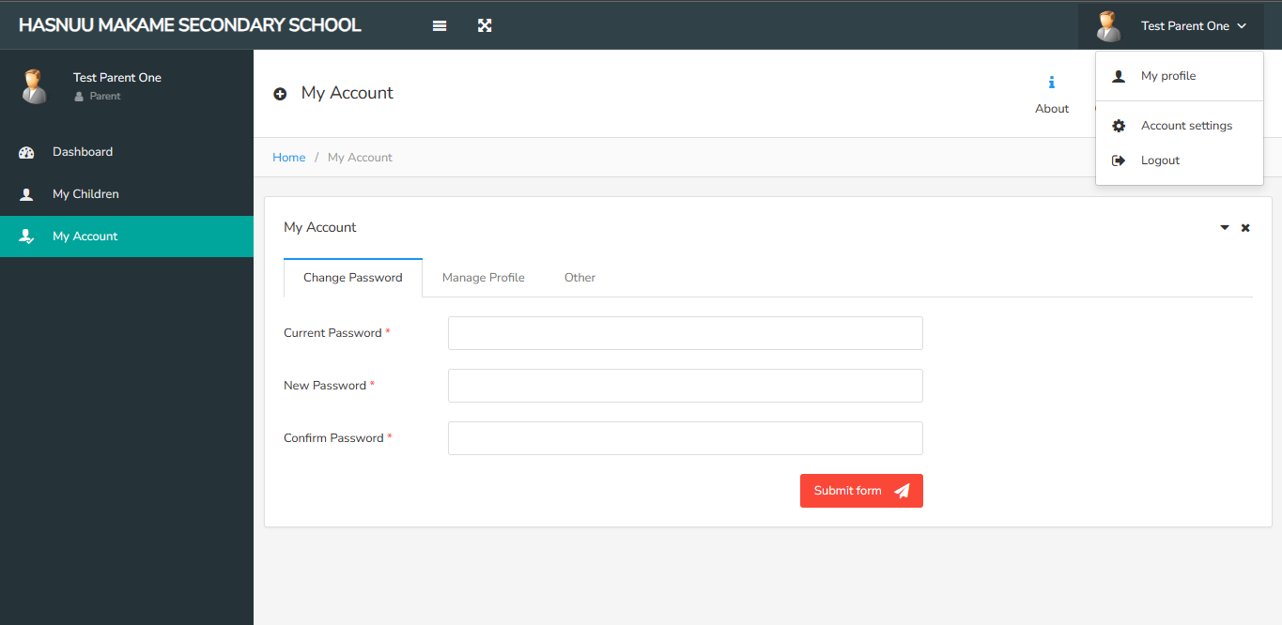

Figure : My Account Page

These two have the same functionality. In this page you can change your password and updating some of your data including changing your profile photo in “Manage Profile tab”. Also, you can decide whether to minimize sidebar (Hiding sidebar texts, with only the icons revealed) or to show charts (you may see charts on your dashboard) found in “Other” tab.

## **My Profile**

In this page you will find your profile information; it is accessed from this button

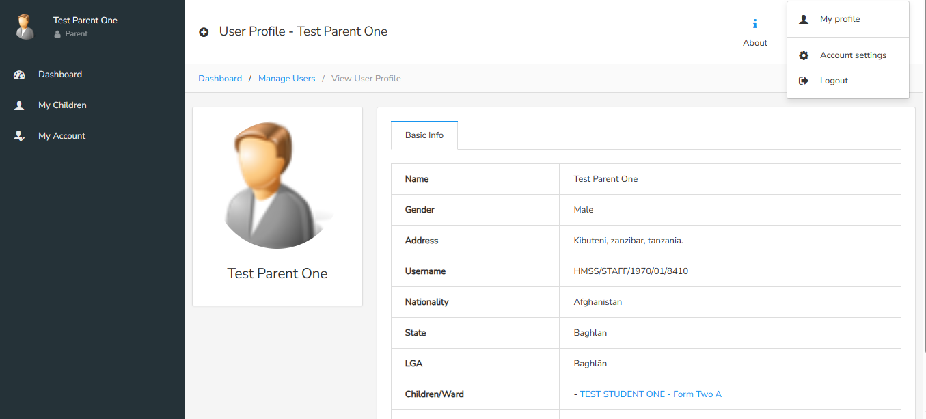

Figure : My Profile Page

# **LIST OF FIGURES**

Figure 1: Login Page 3

Figure 2: Login Section Looks like 3

Figure 3: Footer Section Part 3

Figure 4: Password Recovery Page 4

Figure 5: Dashboard Page 4

Figure 6: My Children Page 5

Figure 7: Menu Links 5

Figure 8: My Account Page 6

Figure 9: My Profile Page 6