

**SCHOOL MANAGEMENT SYSTEM (SMS)**

CONTENTS

**INTRODUCTION** 1

**Start** 1

**Body** 1

**End** 2

**STRUCTURE** 3

**Sign-in Page** 3

**Password Recovery Page** 4

**Dashboard** 4

**My Account** 5

“Manage Profile” tab 5

“Other” tab 6

**My Profile** 7

**Academics** 8

**Students** 8

**Exams** 9

**LIST OF FIGURES** 10

# **INTRODUCTION**

## **Start**

School Management System (SMS) refers to a comprehensive software platform designed to streamline and enhance various administrative and academic processes within educational institutions. It is a centralized digital solution that helps automate routine tasks, improve communication, and ensure efficient management of school operations.

## **Body**

Here are some short notes on the key features and benefits of a School Management System:

1. School Information Management: SMS allows schools to store and manage student data effectively, including personal information, contact details, enrolment history, and academic records. This information can be easily accessed and updated as needed.
2. Attendance Tracking: The system enables efficient tracking of student attendance, both for individual classes and overall school attendance. It can generate reports, identify patterns of absenteeism, and notify parents and authorities about any irregularities.
3. Grade Management: SMS facilitates the management of student grades and academic progress. Teachers can enter grades, calculate averages, and generate report cards electronically. Parents and students can access these records online, promoting transparency and timely feedback.
4. Timetable Generation: The system assists in creating and managing school timetables, assigning teachers to classes, and scheduling extracurricular activities. It optimizes resource allocation and minimizes conflicts, ensuring a balanced and efficient timetable.
5. Communication and Collaboration: SMS offers a platform for seamless communication among teachers, students, parents, and administrators. It enables sending announcements, notifications, and reminders through email. It can also facilitate discussions, file sharing, and online forums to enhance collaboration.
6. Fee Management: The system simplifies the process of fee collection, tracking, and management. It allows schools to generate fee invoices, track payments, and issue receipts electronically. Parents can access their payment history and receive alerts for pending fees.
7. Library Management (Planned): SMS includes features for managing library resources, such as cataloging books, tracking borrowing and returns, and generating overdue notices. It helps in maintaining an organized and efficient library system.
8. Staff Management: The system enables schools to manage faculty and staff details, including employment records, attendance, and performance evaluations. It can also facilitate communication and collaboration among staff members.
9. Data Security and Privacy: SMS ensures the security and privacy of sensitive information by implementing robust data encryption, access controls, and regular backups. It adheres to relevant data protection regulations and offers role-based access to safeguard confidential data.
10. Reporting and Analytics: The system generates various reports, analytics, and insights to help administrators make informed decisions. It can provide information on attendance trends, academic performance, financials, and other key metrics.

## **End**

Implementing a school management system can bring numerous benefits, including increased efficiency, reduced paperwork, improved communication, enhanced decision-making, and better overall organization and management of the school. It empowers educators and administrators to focus more on delivering quality education and nurturing student development.

# **STRUCTURE**

## **Sign-in Page**

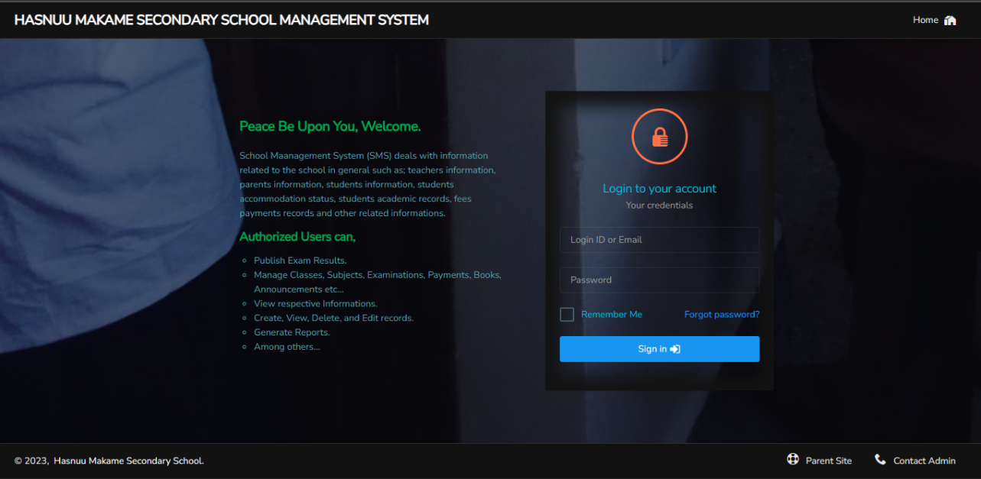A sign in page or login page is a web interface that allows you (a user) to access the system providing your unique credentials, typically a **login ID** or **Email** and **password**.

Here are some key elements and considerations for a login page: User Identification:

Figure : Login Page

Let’s zoom in a little bit,

This is the field where you enter your username (provided login ID or your Email address).

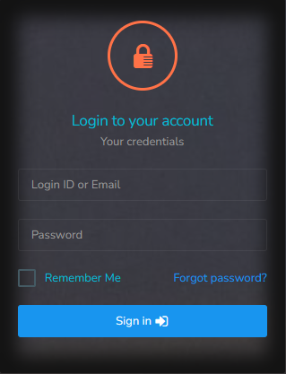

This enables you to initiate the password recovery process and regain access to your account in case you forgot your password (See the Password Recovery Page Section).

When selected this allows you to stay logged in on the device you are using, so you do have to login in again at most for 30 days.

This is the password field where you input your secret password.

Figure : Login Section Looks like

Last but not least, in case you have an issue to be addressed get admin contacts by clicking this link here.

Figure : Footer Section Part

By the way, want to go to our website? Just click this.

## **Password Recovery Page**

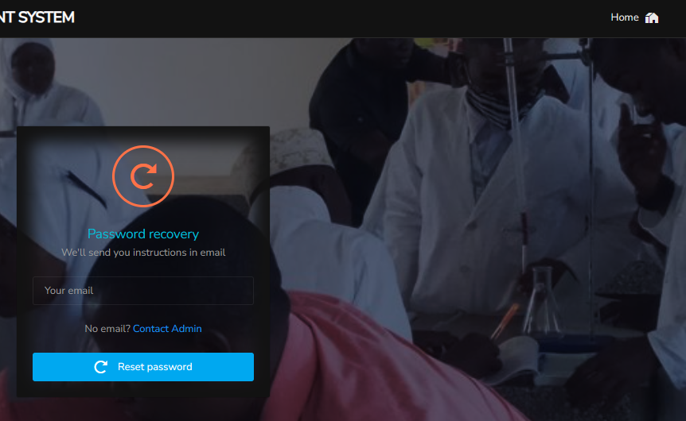In case you forgot your password. If you clicked the Forgot Password? Link you will be redirected to this page. This is where you actually initiate the password recovery process. You will be required to provide your email address, and the system will handle the rest. Be sure to check your mail inboxes. You can return to the login page in any moment by just clicking on “Home” button.

By the way feel free to Contact Admin if you need to.

Figure : Password Recovery Page

## **Dashboard**

This is a visual representation of key performance indicators (KPIs), metrics, and important data related to the system. It offers a high-level overview of the system's links, status, and relevant data. Here you may find any planned events, notifications, charts, and notices whenever available.

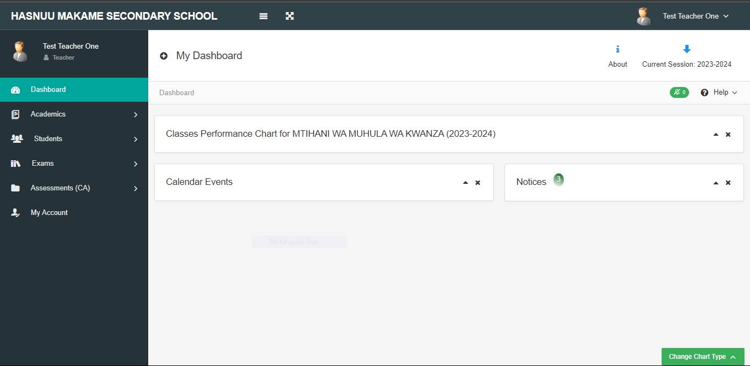

Figure : Dashboard Page

**NOTE**

If it is your first time accessing the system using the provided login ID or your email address with the default password. You will be redirected to “My Account” page, where you will be required to change your default password. You will not be able to access the Dashboard Page unless you update your password.

## **My Account**

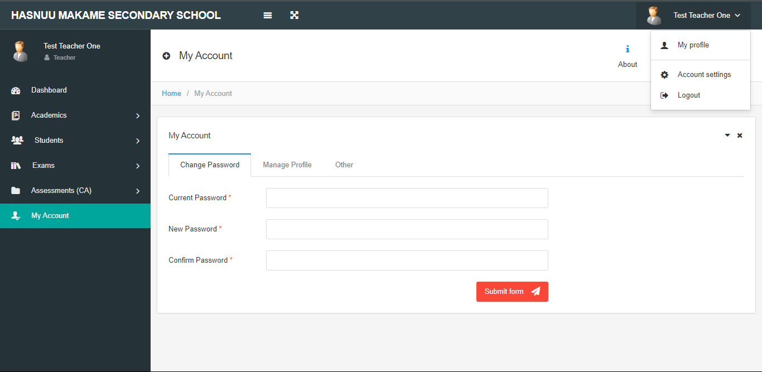

Figure : My Account Page

These two have the same functionality. In this page you can change your password and updating some of your data including changing your profile photo in “Manage Profile” tab. Also, you can decide whether to minimize sidebar (Hiding sidebar texts, with only the icons revealed) or to show charts (you may see charts on your dashboard only for devices with medium screen devices (greater than 768px)) found in “Other” tab.

### “Manage Profile” tab

In this tab you can update your data by submitting form after filling the form inputs. To change your profile photo, click on this button then choose the photo or take the photo of your choice to upload in to the system. The photo must be of type jpeg, gif, png, or jpg and a maximum of 2 megabytes (MB).

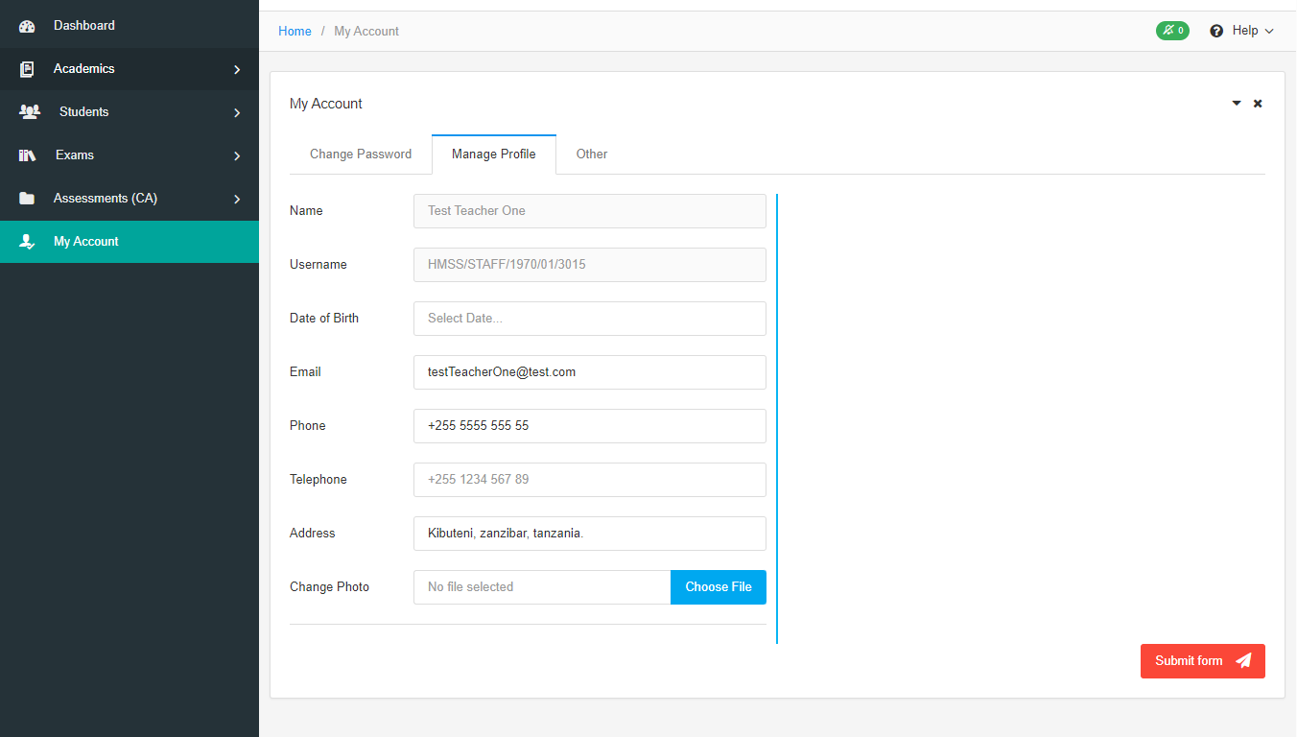

Figure : Manage Profile Tab with Basic Information

In *Figure 7* above is shows only the basic data, the ones that you can update. To update the staff data your administrator must allow that action. Once allowed, you will see staff records added as in the *Figure 8* below. Only then you can update other staff data such as, work related data and education background data.

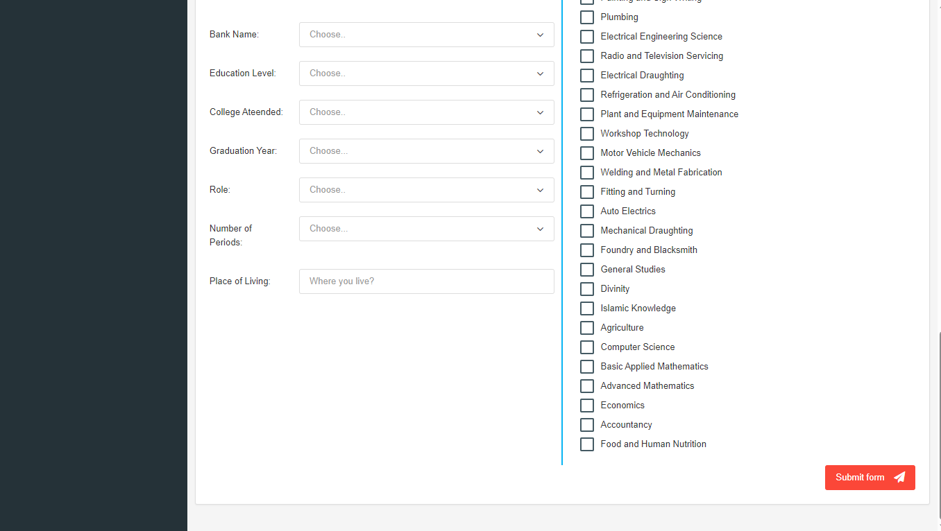

Figure : Manage Profile Tab with All information

### “Other” tab

This tab will only be visible for devices with medium screen sizes. Here you can decide whether to minimize side bar, and whether to show charts.

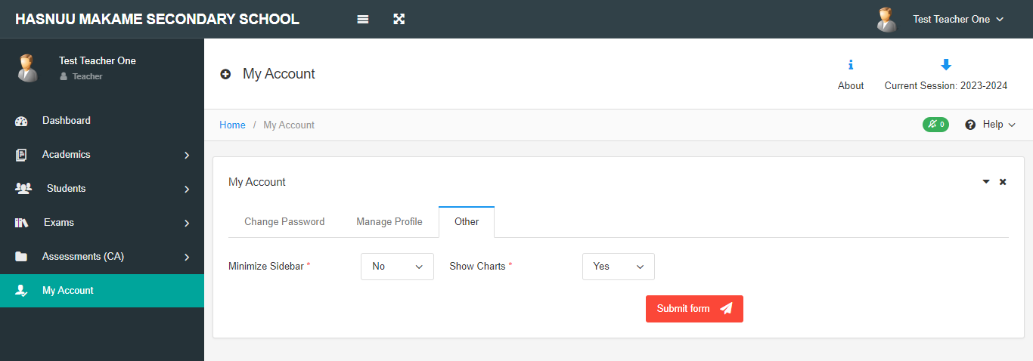

Figure : Other Tab

The minimized sidebar will look like the in figure below:-

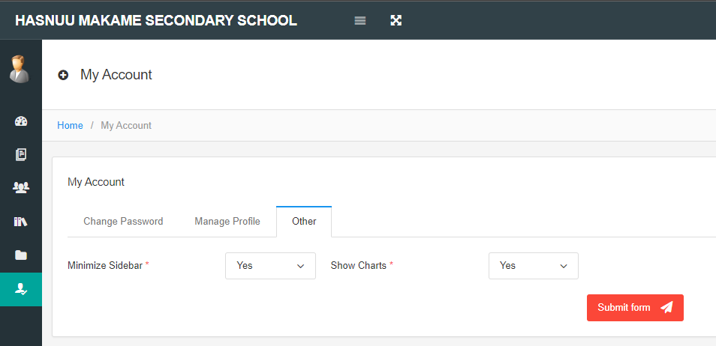

Figure : Minimized Sidebar

## **My Profile**

In this page you will find your profile information; it is accessed from this dropdown button

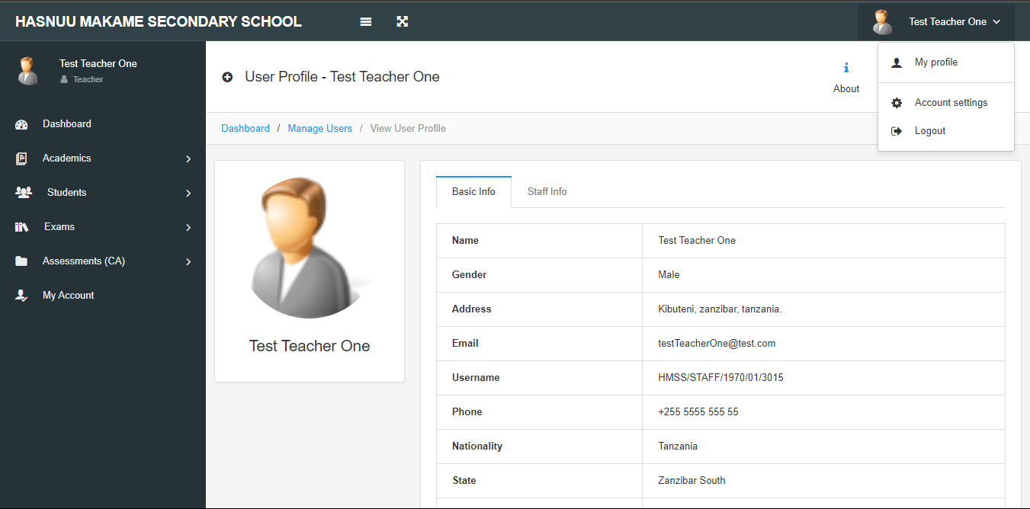

Figure : My Profile Page

## **Academics**

Under this section you can view timetables as well as creating and managing notices.

Click here

to view the timetable (if available) for the particular class. When you click on “Show TimeTables” button, the available classes will drop down below the button. Then, you can click on the class you want to view its timetable.

Click on **Notices** to manage notices as seen in the *Figure 13* below.

In the “Manage Notices” tab you can create a notice, or manage it (edit or delete the notice). Also, you can see who viewed your notice(s) among the users of the system.

Figure : Manage Timetables

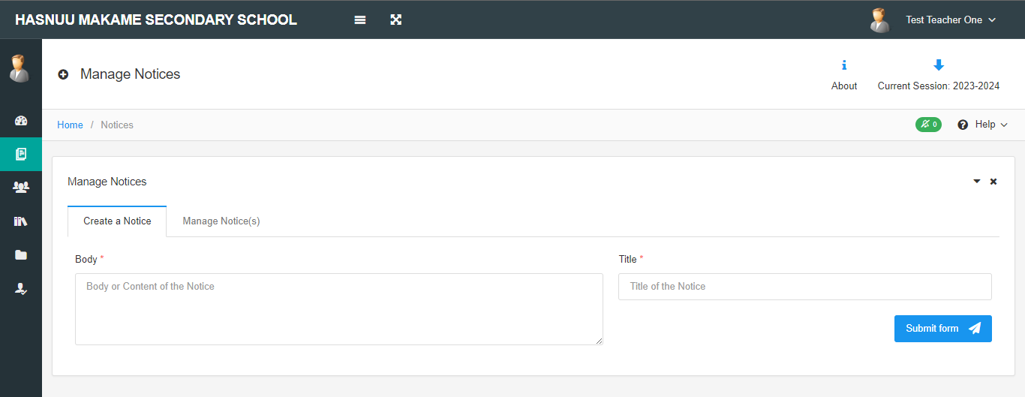

Figure : Manage Notices

## **Students**

Under this section you can view students’ related information of various classes and sections, depending on the registered classes and sections. The information you can view includes students’ personal and school information, students’ marksheet and students’ assessment sheet. The view will resemble with the *Figure 14* below.

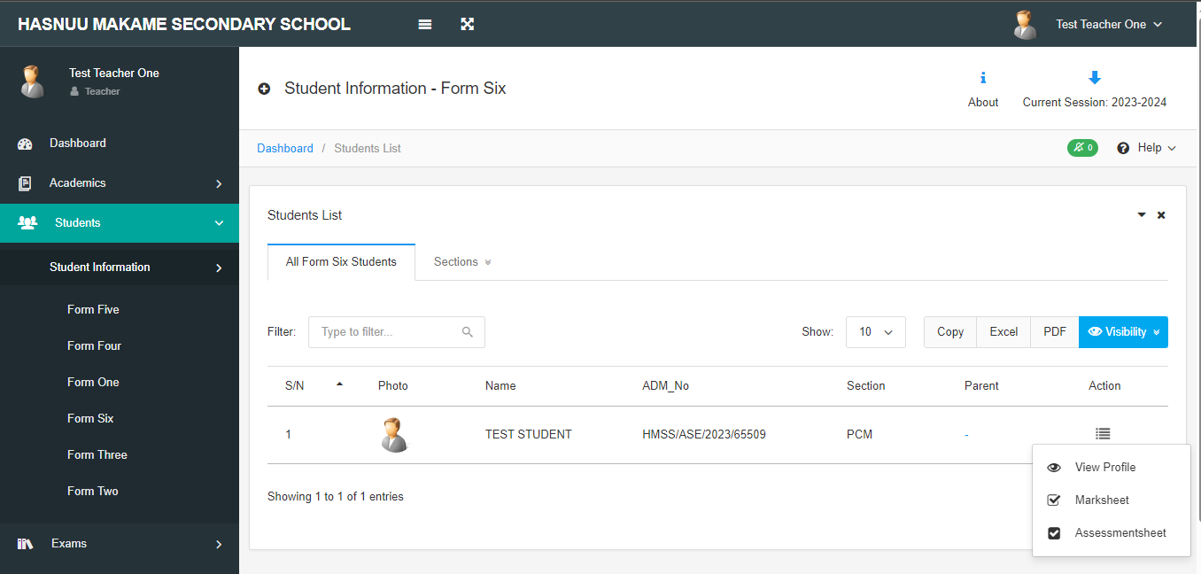

## **Exams**

# **LIST OF FIGURES**

Figure 1: Login Page 3

Figure 2: Login Section Looks like 3

Figure 3: Footer Section Part 3

Figure 4: Password Recovery Page 4

Figure 5: Dashboard Page 4

Figure 6: My Children Page 5

Figure 7: Menu Links 5

Figure 8: My Account Page 6

Figure 9: My Profile Page 6