Creator Penetration Analysis Report
Q1 2026

Generated: 2026-03-25 11:59

Definitions
• Sampled: Creators who have received product samples for review or promotional content creation.
• Posted: Creators who have published content related to the product or brand.
• Touched: Creators who have been either sampled OR posted (union/OR logic, deduplicated).
• Untapped: Creators who have neither been sampled nor posted - potential outreach targets.
• L3+ Tier: Creators meeting Tier 3+ criteria ( follower count, engagement rate, content quality).
• L4+ Tier: Top-tier creators meeting Tier 4+ criteria - highest priority for engagement.
• Izzy Recco List: Curated list of recommended creators based on manual review by team member Izzy.

L3+ Analysis
Metric | Value
Total Creators | 1,098
Sampled | 110 (10.0%)
Posted | 127 (11.6%)
Touched (Sampled ∪ Posted) | 127 (11.6%)
Untapped | 971 (88.4%)
Total GMV | $763,341.83
Average GMV per Creator | $695.21
GMV from Sampled Creators | $247,336.06
Growth Potential | 88.4% untapped creators

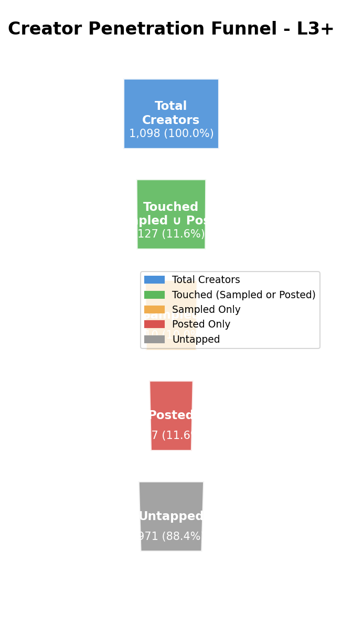

Key Findings
There is a room of 971 creators to outreach, representing 88.4% of total L3+ creators. With only 11.6% currently touched, significant growth potential exists. The sampled cohort shows a GMV of $247,336.06, indicating quality engagement. Focus on converting untapped creators through targeted campaigns.

L4+ Analysis
Metric | Value
Total Creators | 413
Sampled | 68 (16.5%)
Posted | 77 (18.6%)
Touched (Sampled ∪ Posted) | 77 (18.6%)
Untapped | 336 (81.4%)
Total GMV | $515,929.86
Average GMV per Creator | $1,249.22
GMV from Sampled Creators | $232,290.50
Growth Potential | 81.4% untapped creators

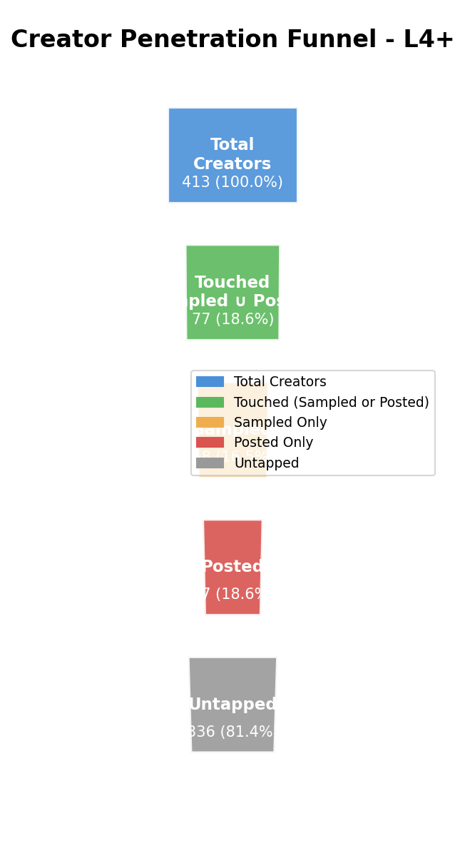

Key Findings
The 336 untapped L4+ creators represent 81.4% of high-value tier. With 16.5% sampled rate, premium creator activation remains a priority. L4+ creators demonstrate $1,249.22 average GMV, suggesting strong monetization potential. Strategic outreach to this segment could drive outsized revenue impact.

Izzy Recco Analysis
Metric | Value
Total Creators | 255
Sampled | 17 (6.7%)
Posted | 13 (5.1%)
Touched (Sampled ∪ Posted) | 17 (6.7%)
Untapped | 238 (93.3%)
Total GMV | $93,302.61
Average GMV per Creator | $365.89
GMV from Sampled Creators | $23,149.60
Growth Potential | 93.3% untapped creators

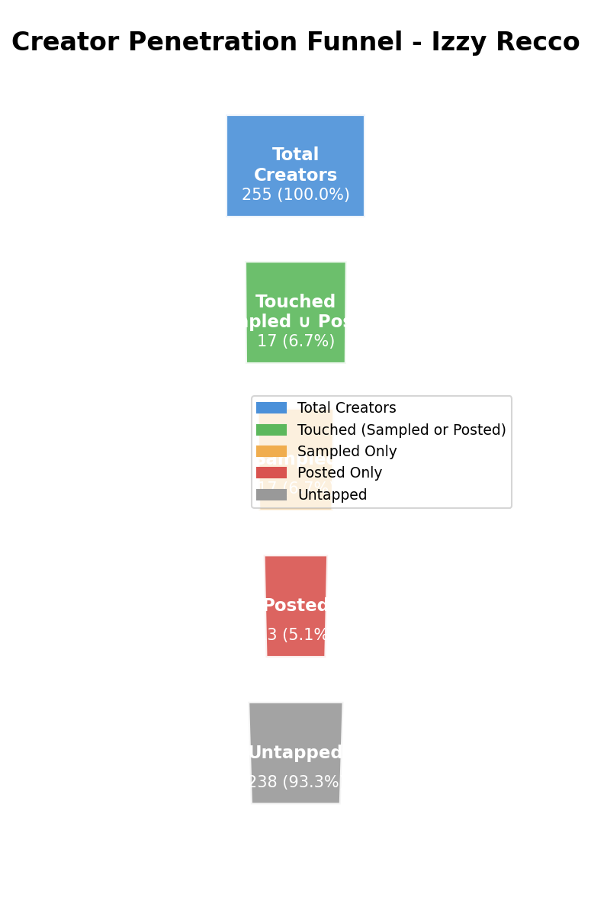

Key Findings
There are 238 creators (93.3%) from the Izzy Recco list yet to be engaged. This curated list shows 6.7% sampling penetration, indicating room for expansion. The list's selective nature suggests high-quality prospects within untapped pool. Leveraging Izzy's recommendations for outreach prioritization is recommended.

Key Takeaway
Based on comprehensive analysis across all creator tiers, several key insights emerge:
1. Significant Untapped Potential
With a combined 1,545 untapped creators out of 1,766 total (87.5% coverage),
there is substantial opportunity for outreach expansion across all segments.
2. Tier-Specific Strategy Recommended
• L3+ Tier: Focus on scaling outreach given 88.4% untapped rate
• L4+ Tier: Prioritize premium engagement given higher GMV potential
• Izzy Recco List: Leverage curated recommendations for targeted sampling
3. Resource Allocation
Sampled creators show higher GMV contribution, validating investment in sampling programs.
Consider increasing sample allocation to untapped high-potential creators.
4. Next Steps
• Develop tier-specific outreach cadences
• Create personalized pitch templates by tier
• Implement tracking for conversion metrics
• Set quarterly penetration targets

