1. Load the “breast-cancer-wisconsin.data.csv” from canvas into R and perform the EDA analysis by:

setwd("/Users/jiayinhuang/SIT-homework/CS/cs513-homework")

data <- read.csv("breast-cancer-wisconsin.csv", na.strings = "?")

View(data)

1. Summarizing each column (e.g. min, max, mean )

?summary

summary(data)

Sample F1 F2 F3 F4

Min. : 61634 Min. : 1.000 Min. : 1.000 Min. : 1.000 Min. : 1.000

1st Qu.: 870688 1st Qu.: 2.000 1st Qu.: 1.000 1st Qu.: 1.000 1st Qu.: 1.000

Median : 1171710 Median : 4.000 Median : 1.000 Median : 1.000 Median : 1.000

Mean : 1071704 Mean : 4.418 Mean : 3.134 Mean : 3.207 Mean : 2.807

3rd Qu.: 1238298 3rd Qu.: 6.000 3rd Qu.: 5.000 3rd Qu.: 5.000 3rd Qu.: 4.000

Max. :13454352 Max. :10.000 Max. :10.000 Max. :10.000 Max. :10.000

F5 F6 F7 F8 F9

Min. : 1.000 Min. : 1.000 Min. : 1.000 Min. : 1.000 Min. : 1.000

1st Qu.: 2.000 1st Qu.: 1.000 1st Qu.: 2.000 1st Qu.: 1.000 1st Qu.: 1.000

Median : 2.000 Median : 1.000 Median : 3.000 Median : 1.000 Median : 1.000

Mean : 3.216 Mean : 3.545 Mean : 3.438 Mean : 2.867 Mean : 1.589

3rd Qu.: 4.000 3rd Qu.: 6.000 3rd Qu.: 5.000 3rd Qu.: 4.000 3rd Qu.: 1.000

Max. :10.000 Max. :10.000 Max. :10.000 Max. :10.000 Max. :10.000

NA's :16

Class

Min. :2.00

1st Qu.:2.00

Median :2.00

Mean :2.69

3rd Qu.:4.00

Max. :4.00

1. Identifying missing values

sum(is.na(data))

missingDataF6 = data[which(is.na(data$F6)),]

View(missingDataF6)

1. Replacing the missing values with the “mean” of the column.

# Calculate the mean of the "F6" column

mean_F6 <- mean(data$F6, na.rm = TRUE)

# Replace missing values with the mean of the "F6" column

data$F6 <- replace(data$F6, is.na(data$F6), mean_F6)

View(data)

1. Displaying the frequency table of “Class” vs. F6

# Create a frequency table for "Class" and "F6"

freq <- table(class=data$Class, F6=data$F6)

View(freq)

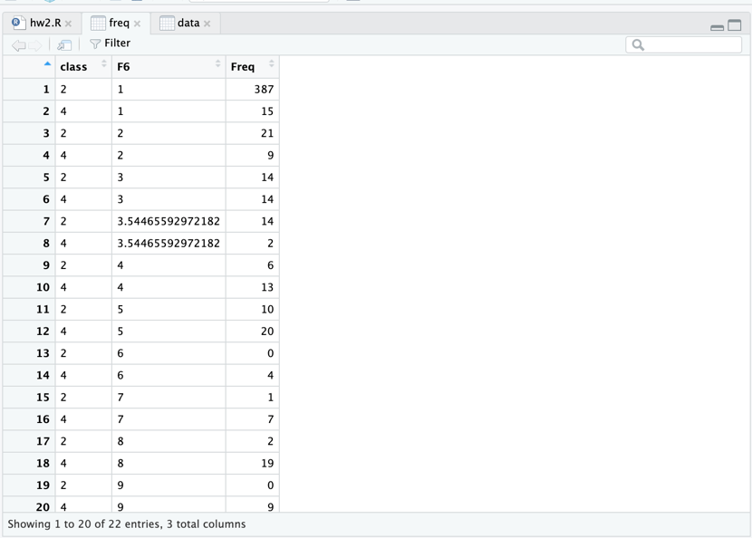

1. Displaying the scatter plot of F1 to F6, one pair at a time

?pairs

pairs(data[c(2,3)], main = "F1 & F2")

pairs(data[c(2,4)], main = "F1 & F3")

pairs(data[c(2,5)], main = "F1 & F4")

pairs(data[c(2,6)], main = "F1 & F5")

pairs(data[c(2,7)], main = "F1 & F6")

pairs(data[c(3,4)], main = "F2 & F3")

pairs(data[c(3,5)], main = "F2 & F4")

pairs(data[c(3,6)], main = "F2 & F5")

pairs(data[c(3,7)], main = "F2 & F6")

pairs(data[c(4,5)], main = "F3 & F4")

pairs(data[c(4,6)], main = "F3 & F5")

pairs(data[c(4,7)], main = "F3 & F6")

pairs(data[c(5,6)], main = "F4 & F5")

pairs(data[c(5,7)], main = "F4 & F6")

pairs(data[c(6,7)], main = "F5 & F6")

# Create scatter plots of each pair of columns

pairs(data[, 2:7], main = "Scatter Plots of F1 to F6")

1. Show histogram box plot for columns F7 to F9

# Create a histogram for each column

hist(data$F7, main = "Histogram of F7", xlab = "F7 Values")

hist(data$F8, main = "Histogram of F8", xlab = "F8 Values")

hist(data$F9, main = "Histogram of F9", xlab = "F9 Values")

# Create a box plot of columns F7 to F9

boxplot(data[, 8:10], main = "Box Plot of F7 to F9", xlab = "Column", ylab = "Value")

2- Delete all the objects from your R- environment. Reload the “breast-cancer-wisconsin.data.csv” from canvas into R. Remove any row with a missing value in any of the columns.

# Delete all objects from R environment

rm(list = ls())

# Load the dataset

data <- read.csv("breast-cancer-wisconsin.csv", na.strings = "?")

View(data)

# Replace missing values "?" with NA

data[data == "?"] <- NA

# Remove any rows with missing values

data <- na.omit(data)

View(data)

