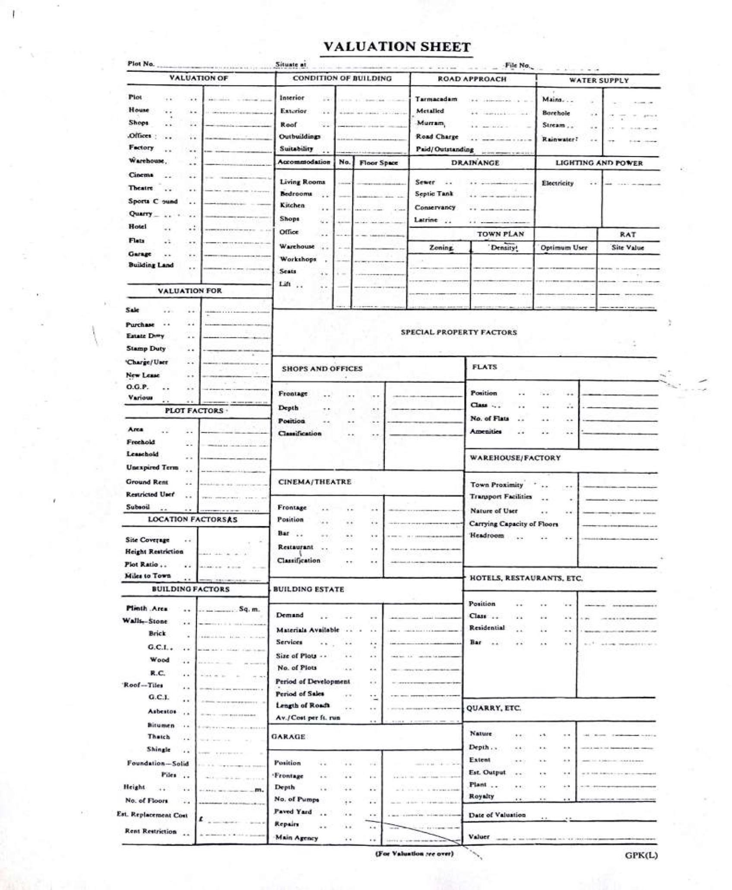

# REPORT AND VALUATION FOR STAMP DUTY PURPOSES

**L.R. No:** Nairobi/Block 222/13

**SITUATION:** The property is located off Komarock - Mwiki in Njiru estate, in Nairobi City County.

**AREA:** The plot measures 0.0484Ha approximately

**TENURE:** Leasehold interest from 1/2/1989

**SERVICES:** Mains electricity, water and sewer services are in the neighbourhood for connection to the property when need arises.

The immediate access road is murram surfaced.

**PLOT:** A regular shaped level black cotton soils plot whose boundaries are marked by perimeter fence.

**USER:** Residential

**IMPROVEMENTS:** The plot was vacant at the time of this valuation

# COMPARABLE PROPERTIES

|  |  |
| --- | --- |
| Vos. No | Ardhi sasa |
| LR. No | Nairobi/ block 222/62 |
| REA | 0.0607Ha |
| SITUATION | Njiru – Same subdivision scheme |
| DEVELOPMENT | Vacant |
| SOLD | Kshs. 2,000,000/= |
| VALUED | Kshs. 2,000,000 |
| LAND ANALYSIS | Kshs3300 PSM |
| DATE | 22/05/2023 |

|  |  |
| --- | --- |
| Vos. No |  |
| LR. No | NRB/BLK 120/121 |
| AREA | 0.0193Ha |
| SITUATION | Burburu Farmers scheme opposite Njiru |
| DEVELOPMENT | Vacant |

|  |  |
| --- | --- |
| SOLD | Kshs. 630,000/= |
| VALUED | Kshs. 630,000 |
| LAND ANALYSIS | (analysis 3300/= psm) |
| DATE | 19/09/2022 |

**OPINION**

In light of the above comparables and the nature of the development, I propose to adopt a value of Kshs. 3,300 PSM for land.

# VALUATION

0.0484 Ha/484M2 X Kshs. 3,300/= Kshs 1,597,200

# Call Kshs. 1,600,000 RECOMMENDATION

Raise the declared value of **Kshs. 1,000,000/= to Kshs 1,600,000/=** for stamp duty purposes as at June 9th 2023.