**Programming Assignment: Mountain Paths**

In this lab you will read a set of topographic (land elevation) data into a 2D array and write some methods to compute some paths through the mountains as well as visualize them.

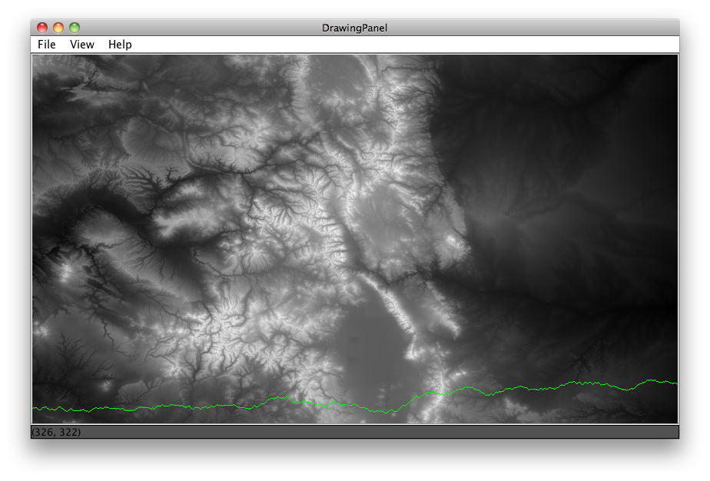**Background**:

There are many contexts in which you want to know the most efficient way to travel over land. When traveling through mountains (let's say you're walking) perhaps you want to take the route that requires the least total change in elevation with each step you take – call it the path of least resistance. Given some topographic data it should be possible to calculate a "greedy lowest-elevation-change walk" from one side of a map to the other.

In the map above, brighter shades mean higher elevation. The green line shows a lowest-elevation-change route for this map, traveling west-to-east.

**A Greedy Walk**

A "greedy" algorithm is one in which, in the face of too many possible choices, you make a choice that seems best at that moment. For the maps we are dealing with there are 7.24x10405 possible paths you could take starting from western side of the map and taking one step forward until you reach the eastern side.

Since our map is in a 2D grid, we can envision a "walk" as starting in some in some cell at the left-most edge of the map (column 0) and proceeding forward by taking a "step" into one of the 3 adjacent cells in the next column over (column 1). Our "greedy walk" will assume that you will choose the cell whose elevation is closest to the elevation of the cell you're standing in. (NOTE: this might mean walking uphill or downhill).

Shows a portion of the data. Greedy path shown in green.

The diagrams below show a few scenarios for choosing where to take the next step. In the case of a tie with the forward position, you should always choose to go straight forward. In the case of a tie between the two non-forward locations, you should flip a coin to choose where to go.



Case 4: smallest change is a tie (4), choose randomly between fwd-up or fwd-down

Case 3: smallest change is a tie (3), fwd is an option, so go fwd

Case 2: smallest change is 3, go fwd

Case 1: smallest change is 5, go fwd-down

There are other ways to choose a path through the mountains that can be explored in the "above and beyond" section of this assignment.

**Assignment Requirements**

The minimum requirements for the assignment are that you write code to produce something like the map shown in the picture above. To do that you need to complete the following 5 steps:

Step 1: Read the data into a 2D array

Step 2: Find min, max elevations, and other calculations on the data

Step 3: Draw the map

Step 4: Draw a lowest-elevation-change route starting from some row

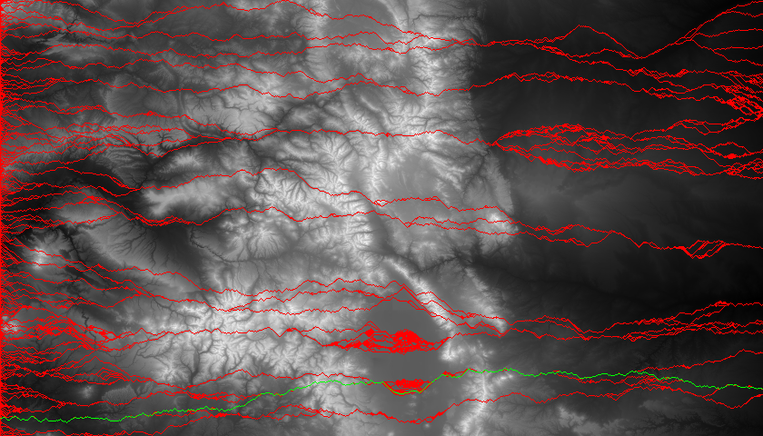Step 5: Find and draw the lowest-elevation-change route in the map

To fulfill the requirements you are provided with a class and method stubs for completing parts of the project. Here is the sketch:

**class MapDataDrawer**

//a class for maintaining a 2D array of ints

// representing a topographic map

**MapDataDrawer**(String filename, int rows, int cols)

//read data from given file into a 2D array

**int findMin()**

//return the minimum value in the map

**int findMax()**

//return the max value in the map

**void** **drawMap**(Graphics g)

//draw this map in B&W using given graphics context

**int indexOfMinRow**(int col)

//given a column, find the index of the row with min elevation

// return row number of

**int** **drawLowestElevPath**(Graphics g, int row)

//draw the lowest elevation path starting from the given row

// return total elev change from the path

**int** **indexOfLowestElevPath**(Graphics g)

//find the lowest elev change path in the map

//return the row it starts on

**Step 1 – Read the data into a 2D array**

Your first goal is to read the values into a private 2D array of ints in the MapDataDrawer class. The constructor of the class should read the given data file into a new 2D array of ints maintained as a private variable of the class.

**The data**

The data is a plain ascii text file from NOAA representing the average elevations of patches of land (roughly 700x700 meters) in the US. [1] The data file included with the project, colorado.dat, is the elevation data for most of the state of Colorado (mountains!). The data comes as one large, space-separated list of integers. There are 403,200 integers representing a 480-row by 844-col grid. Each integer is the average elevation in meters of each cell in the grid.

In the constructor:

* Instantiate a new 2D array of ints of the appropriate size
* Read the ints out of the data file (the data are listed in row-major order).
* WARNING: The data are given as a continuous stream of numbers - there are no line breaks in the file, so you can't use nextLine(). You need to use Scanner's nextInt() method to read each subsequent in. You also probably want to write nested loops to cover the exact rows/cols (480/844) needed.

After you’ve written the constructor**, test it on the object bench, and/or with the debugger.** Make sure that you’re actually reading data into the 2D array. Do a sanity check by looking at a specific row and col and comparing with a friend, or against the original data itself.

**Step 2 – Find the min and max values**

In order to draw the map you need to find the min and max values in the map first. Implement the **findMin()** and **findMax()** methods. These should return the smallest and largest values respectively in the 2D array. You’ll need to write code that scans the entire array and keeps track of the smallest and largest things found so far.

Test these functions independently first to make sure you’re getting decent values. Maybe check with a friend to see if s/he is getting the same thing.

**Step 3 – Draw the map**

Implement the **drawMap**(Graphics) method of the class. The method will be passed the Graphics object you should use to do the drawing.

The method should “draws” the 2D array of ints with the given Graphics object as a series filled 1x1 rectangles with the color set to a grayscale value between white and black.

The shade of gray should be scaled to the elevation of the map. Recall, in RGB color, if each of RGB values are the same, you’ll get a shade of gray. Thus, there are 256 possible shades of gray from black (0,0,0) to middle gray (128,128,128), to white (255,255,255)

To make the shade of gray**,** you should use the min and max values in the 2D array (you just wrote helper methods to find these!) to scale each int to a value between 0 and 255 inclusive. (**Note:** this requires math! Think about it.) Once you have found your value between 0 and 255, call you need to set the fill color just before drawing the rectangle.

int c = //calculated grayscale value

g.setColor(new Color(c, c, c));

g.fillRect(x,y,1,1)

**WARNING**: the 2D array represents the data in row-major order (that’s how it came out of the data file). But the graphics are drawn in column-major order x,y format. Thus, remember to flip row and col (or x and y) if using them as variables to access the array or draw the graphics

grid[row][col] 🡺 g.fillRect(col,row,1,1)  
 or  
grid[y][x] 🡺 g.fillRect(x,y,1,1)

This step is easier to test because there is graphical output to verify you're doing it right. Your map should look something like this: 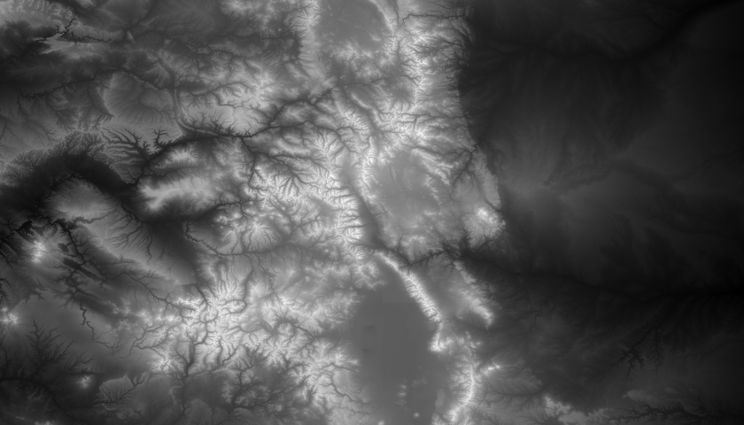

**Step 4 – Draw a lowest-elevation-change path from some row**

Implement the **drawLowestElevPath**(Graphics, startRow) method. Note that this method does two things: 1) it draws the path, 2) it calculates and returns to the total elevation change on that path.

The method should draw a line by drawing 1x1 filled rects in a different color on top of the existing drawing. The path should be drawn going West-to-East, starting from the given row using the greedy lowest-elevation-change technique described in earlier pages.

You will need to do the following things in some order.

1. Starting from the given row, and column 0, color it green (or whatever color you want to draw your path).
2. Write a loop that generates every possible column across the map from 1 to 840 (you start at column 0, but column 1 is the first column you need to make choice about where to step). For each column you will decide which row to take your next “step” to – fwd, fwd-and-up, or fwd-and-down - using the greedy choice strategy described.
3. Color the chosen location to step to green (or whatever color you choose).
4. Use a variable that keeps track of the ‘current row’ you’re on, and update it each time you take a step forward – row may stay the same, or go up or down by 1 depending how you walk.
5. Use Math.abs(…) to get the absolute value of the difference between two elevations.
6. Continue finding the lowest neighboring cell and coloring it green as you go.
7. Keep a running total of the total elevation change that would be 'experienced' by a person walking this path. Since we consider an elevation change the absolute value (i.e. going 'uphill' 10 meters is the same amount of change as going 'downhill' 10 meters) this running total will be non-decreasing and will end up being a pretty large positive number

When you’re done you should see a line tracing the lowest elevation-change path from west to east.

**Step 5 – find the lowest elevation path for the whole map**

Implement the **indexOfLowestElevPath**() method which finds the overall lowest-elevation-change path and returns the row it starts on.

You will find the lowest-elevation-change route by noting that the method you wrote in step 4 returns the total elevation change for a path starting at a given row. If you write a loop that generates every possible starting row from 0 to 480, and call your method using each possible starting row, you should find the lowest route for the whole map. (Since that method also draws all of the routes it's good feedback that the method is running properly.) You might end up with something that looks like this:

KLUGE NOTE: Even though the indexOfLowestPath method accepts a Graphics object, this method should not use it to draw anything, but rather simply pass it onto drawLowestElevPath method to that it can use it to draw. (This is possibly a flaw in the program design, but a flaw designed to protect you from some complicated Object coupling that we could avoid.)

If you want to, you can clear the map after this calculation and simply draw the one line. The result should look *something* close to the image above or the one shown on the first page of the assignment.

**Sanity Check:**

**NOTE:** The greedy walk should always produce a *slightly* different path due to the fact that you are flipping a coin in some cases to determine which direction to go.

The best greedy walk for the Colorado.dat map should return a total elevation change somewhere around 16,000 +/- 1000 (meters). The best path should start somewhere close to the southern edge of the map, something between row 460 and 475 or so.

**Above and Beyond**

**Path Finding**

Note that our greedy lowest-elevation-change algorithm is flawed. It is not guaranteed to find the absolute lowest elevation change route from west to east since our decisions are limited to what's in front of us.

* Another, only slightly more complicated way to do a greedy walk is to start at an arbitrary x,y location in the map and do a greedy walk to the east from that point and a greedy walk to the west from that point. Using this method you could calculate the lowest elevation-change route that passes through every possible x,y coordinate. (Note, this will take some time to calculate…might not want to draw it live).
* A different kind of path you might want to follow in the mountains is to travel the path that stays as low as possible, elevation-wise, regardless of the change. Think of this as a greedy algorithm that always prefers to go downhill if possible, and uphill as little as possible. You can use a greedy method for this by always choosing to step to the location with the lowest elevation, not necessarily the lowest change in elevation. Show a comparison of these two paths.
* Write a method that finds, and highlights, the lowest elevation point for each possible column in the map. Compare that to the lowest elevation path you calculated for the problem and see If any of your paths pass through that point. If you do a greedy walk going east and west, from each of those points, do you end up finding a better elevation-change route?
* Do your walk considering more than the three forward locations. You could consider the 5, or even 7 surrounding locations. This can get pretty tricky: to do this you need to keep track of which direction you are heading, or where your last step was, so that you don't back track.
* 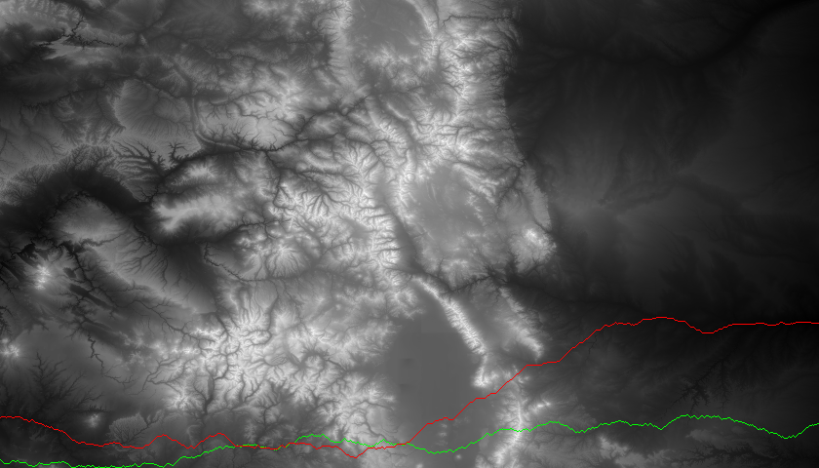Find the best possible west-to-east walk using a version of the [Floyd–Warshall Shortest Path algorithm](http://en.wikipedia.org/wiki/Floyd%E2%80%93Warshall_algorithm). You may discuss how to do this with your instructor but you should see what you can figure out from the Wikipedia page.

In essence, iIt is possible to compute all of the possible paths from west-to-east, using a separate 2D array to keep track of the best cumulative elevation change possible for each cell in the grid. You construct this grid column-by-column "moving" from west-to-east and choosing the best of three possible values to put into each cell - since each cell can be arrived at from up to three different locations in the previous column, you need to choose which of the three elevation-changes affects the cumulative total the least, and put that value in the cell.

The green line shows the one of the best west-to-east elevation-change paths produced by a greedy walk. The red line is actually the best possible path. It was found using a modified version of the Floyd-Warshall algorithm

Since that grid of best values does not tell you the path you need to follow to realize those small elevation changes, you need to maintain another 2D array in parallel, in which you store the row index that should be traveled through to achieve the best path. The best path can then be reconstructed by walking backwards and following the row values.

The best possible path gives a total elevation change of 7,056 meters (fully half of the best greedy walk) and should start around row 428.

* Can you think of a different algorithm for choosing a "good" path through the mountains? It depends on your definition of 'good' of course, but if you can think of an interesting idea, go for it (just run it by Mr. Franke first).

**Graphics**

* You could also shade the pixels you draw for the path to indicate their relative elevations. You could get the shading for “free” by using the alpha channel of the color you select.
* Do a drawing of the mountain in colors other than a monochromatic scale. This would give you more than 256 shades of color to work with. For example, what if you shaded the lower elevations green (for lush valleys) and the highest elevations some sort of rock color brown/tan. To do this arithmetically you need to look up how to 'interpolate' colors.

1. <http://maps.ngdc.noaa.gov/viewers/wcs-client/>