This is a summary about my data analysis project on Ustacky    
  
Writing my project and  figuring out how to download the dataset needed to work on the different tasks with the use of Excel and Tableau for the project.

Starting with the project overview to discuss the various approach use to work on Excel, Tableau, power bi and SQL for the duration of the training and the career trajectory in the data analysis field.

With Excel I had to take my time to watch the videos on how to problem solve using Excel to fully understand the technical know-how and I downloaded more videos to assist me in answering the questions correctly,

|  |  |
| --- | --- |
| **Row Labels** | **Sum of Sales** |
| Machines | 17744.49 |
| Phones | 15851.448 |
| Chairs | 9348.726 |
| Supplies | 8893.722 |
| Storage | 8848.104 |
| **Grand Total** | **60686.49** |

Decided to work on tableau which was a hassle for me, had technical issues due to my laptop however I was able to rectify that by fixing my laptop. Getting back to working on my projects able to answer the analysis question one after another by deliberately asking myself how to go about the dataset for the  project and I came to the realization I needed to start with writing down my execution steps following it up with the action plan to answer the questions.

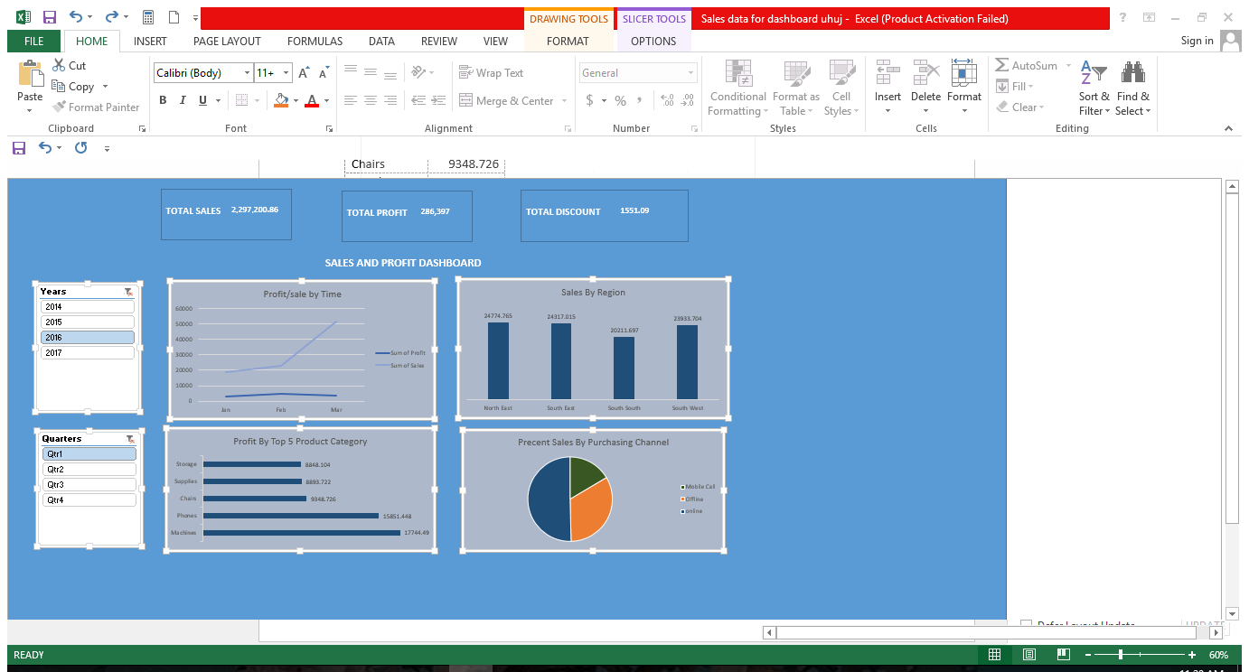

For recommendation, conducted a research for close tech firm open to up-scaling my knowledge of data analysis on the job I came across Octave analytics limited applying for an internship

  I got the desired results from watching the ustacky videos, pinterest videos and youtube and practicing on my project. I hope to continue practicing with the ustacky videos on future projects to improve on my knowledge on the various tools used in data analysis to get a good job   
Thank you.