Roll No. Date:
Student Name:

EXPERIMENT 1

Title: Provide the PEAS description and TASK Environment for a given AI problem. Identify suitable Agent Architecture for the problem

Aim:To analyze PEAS representation of AI applications.

Theory:

PEAS Representation:

PEAS stand for Performance Measures, Environment, Actuators, and Sensors.
Performance Measure: If the objectives function to judge the performance of the agent. For example, in case of pick and place robot, no of correct parts in a bin can be the performance measure.
Environment: It the real environment where the agent need to deliberate actions.
Actuators: These are the tools, equipment or organs using which agent perform actions in the environment. This works as output of the agent.
Sensors: These are tools, organs using which agent captures the state of the environment. This works as input to the agent.

PEAS descriptor for Automated Car Driver:

Performance Measure: Safety: Automated system should be able to drive the car safely without dashing anywhere. Optimum speed: Automated system should be able to maintain the optimal speed depending upon the surroundings. Comfortable journey: Automated system should be able to give a comfortable journey to the end user.

Environment: Roads: Automated car driver should be able to drive on any kind of a road ranging from city roads to highway. Traffic conditions: You will find different sort of traffic conditions for different type of roads.

Actuators: Steering wheel: used to direct car in desired directions. Accelerator, gear: To increase or decrease speed of the car.

Sensors: To take i/p from environment in car driving example cameras, sonar system etc.
In this way, an AI problem can be identified, and its PEAS description is to be stated.

Problem Statement: Smart Watch

- Performance Measures:
Accurate health tracking (heart rate, steps, sleep), timely notifications, fast response. Low battery consumption, high reliability. User comfort and data accuracy.

- Environment:
Human user and daily activities. Indoor and outdoor surroundings. Connected smartphone and network environment.

- Actuators:
Display notifications on screen. Vibration and sound alerts. Touch and button-based controls.

- Sensors:
Heart rate sensor, Blood pressure sensor, Blood oxygen (SpO₂) sensor, Blood sugar sensor, ECG sensor, Body temperature sensor, Accelerometer, Gyroscope, Sleep monitoring sensor, GPS sensor, Microphone, Ambient light sensor, Touch sensor

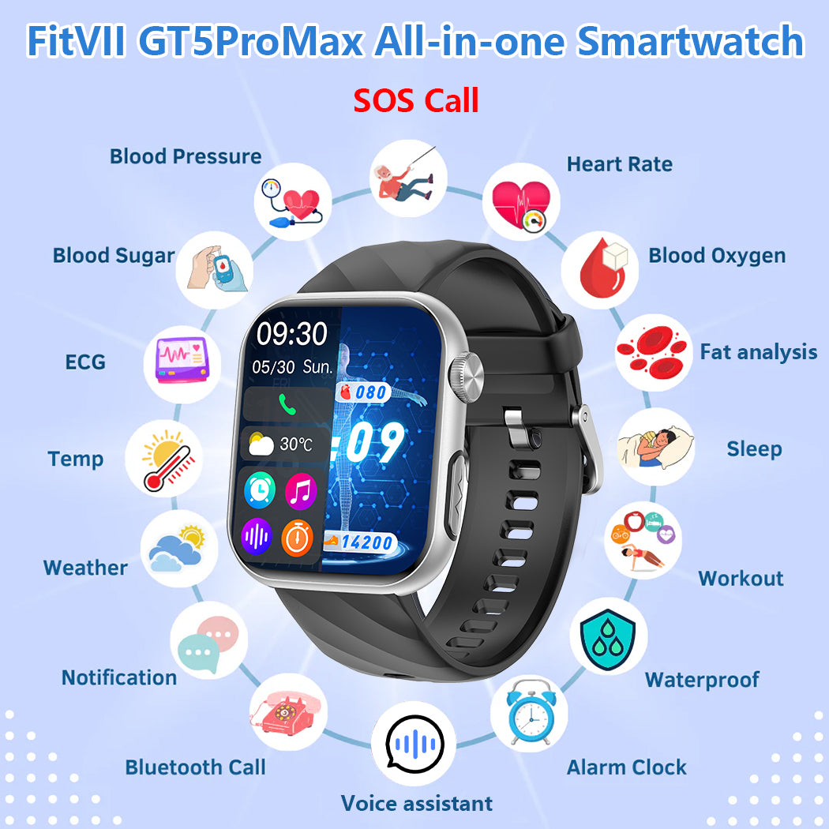

Conclusion: Thus, we were assigned individual topics to form the PEAS document; in this case, using the smartwatch, we were able to form the PEAS document by properly identifying the performance measures, environment, actuators, and sensors. This has given us an insight into how the smartwatch is considered an intelligent agent as it observes health as well as responds to the environment.

