Roll No.224A7064 Date:9/3/26
Student Name:Adil Arkate

EXPERIMENT 10

- Aim: Implement Graphical simulation of network with Routing Protocols and traffic consideration (TCP or UDP).
- Objectives:
Routing Information Protocol (RIP) is an active routing protocol that operates hop count as a routing metric to find the most suitable route between the source and the destination network. It is a distance-vector routing protocol that has an AD value of 120 and works on the Network layer of the OSI model.
- Theory:
- Steps:
Steps to Configure and Verify Three Router Connections in Cisco Packet Tracer using RIP Routing:
Step 1: First, open the Cisco packet tracer desktop and select the devices given below:
S.NO | Device | Model Name | Qty.
1. | PC | PC | 6
2. | Switch | PT-Switch | 3
3. | Router | PT-router | 3

IP Addressing Table:
S.NO | Device | IPv4 Address | Subnet mask | Default Gateway
1. | PC0 | 192.168.10.2 | 255.255.255.0 | 192.168.10.1
2. | PC1 | 192.168.10.3 | 255.255.255.0 | 192.168.10.1
3. | PC2 | 192.168.20.2 | 255.255.255.0 | 192.168.20.1
4. | PC3 | 192.168.20.3 | 255.255.255.0 | 192.168.20.1
5. | PC4 | 192.168.30.2 | 255.255.255.0 | 192.168.30.1
6. | PC5 | 192.168.30.3 | 255.255.255.0 | 192.168.30.1

- Then, create a network topology as shown below the image.
- Use an Automatic connecting cable to connect the devices with others.
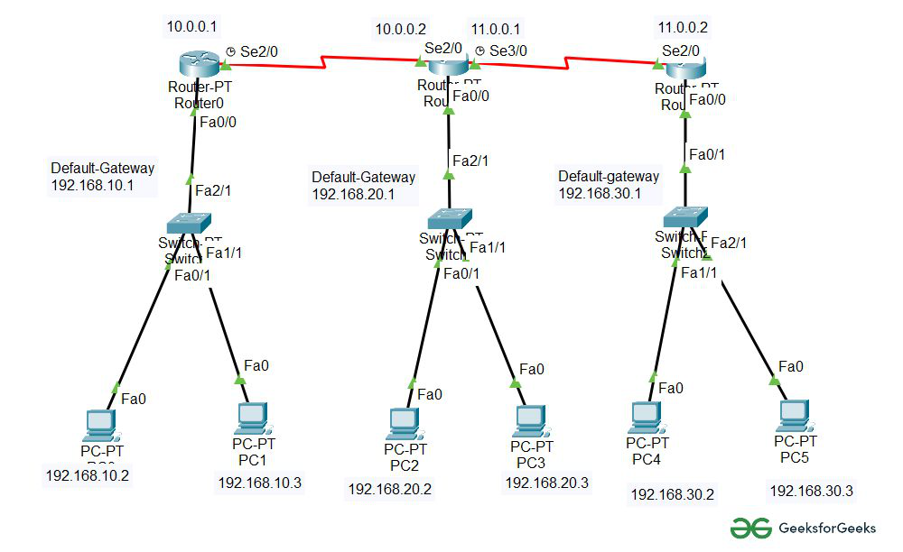
Step 2: Configure the PCs (hosts) with IPv4 address and Subnet Mask according to the IP addressing table given above.
- To assign an IP address in PC0, click on PC0.
- Then, go to desktop and then IP configuration and there you will IPv4 configuration.
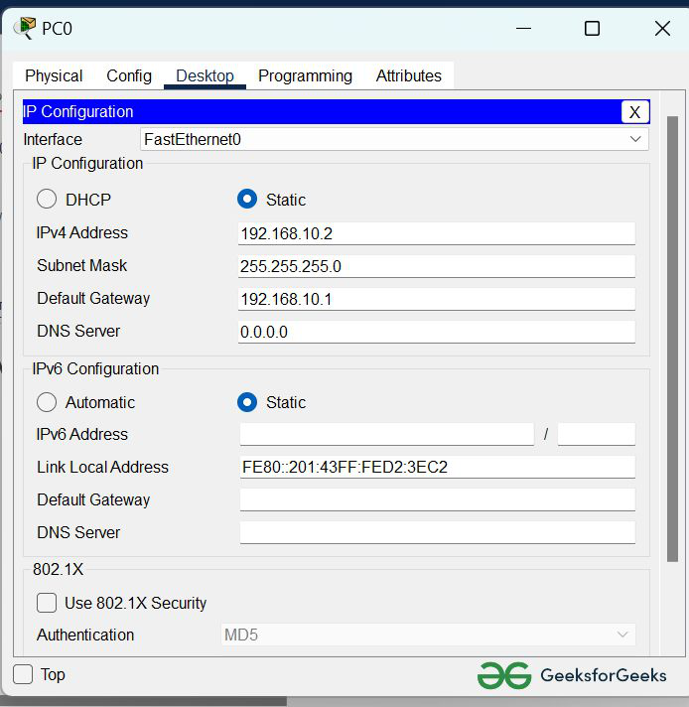
- Fill IPv4 address and subnet mask.
- Assigning an IP address using the ipconfig command, or we can also assign an IP address with the help of a command.
- Go to the command terminal of the PC.
- Then, type iPConfig <IPv4 address><subnet mask><default gateway>(if needed)
Example: iPConfig 192.168.10.2 255.255.255.0 192.168.10.1
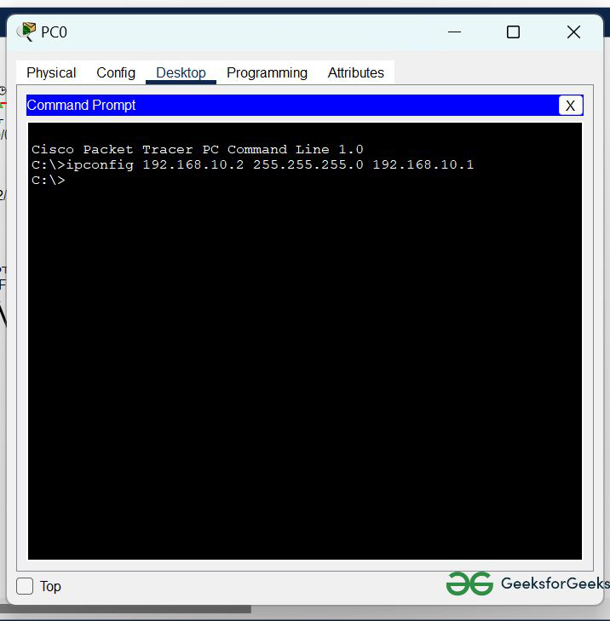
- To assign an IP address in router0, click on router0.
- Then, go to config and then Interfaces.
- Make sure to turn on the ports.
- Then, configure the IP address in FastEthernet and serial ports according to IP addressing Table.
- Fill IPv4 address and subnet mask.

- Repeat the same procedure with other routers to configure them thoroughly.

Step 4: After configuring all of the devices we need to assign the routes to the routers.
To assign RIP routes to the particular router:
- First, click on router0 then Go to CLI.
- Then type the commands and IP information given below.
CLI command : router rip
CLI command : network <network id>
RIP Routes for Router0 are given below:
Router(config)#router rip
Router(config-router)#network 192.168.10.0
Router(config-router)#network 10.0.0.0
RIP Routes for Router1 are given below:
Router(config)#router rip
Router(config-router)#network 192.168.20.0
Router(config-router)#network 10.0.0.0
Router(config-router)#network 11.0.0.0
RIP Routes for Router2 are given below:
Router(config)#router rip
Router(config-router)#network 192.168.30.0
Router(config-router)#network 11.0.0.0
Step 5: Verifying the network by pinging the IP address of any PC.
- We will use the ping command to do so.
- First, click on PC0 then Go to the command prompt.
- Then type ping <IP address of targeted node>.
- As we can see in the below image we are getting replies which means the connection is working properly.
Example : ping 192.168.20.2
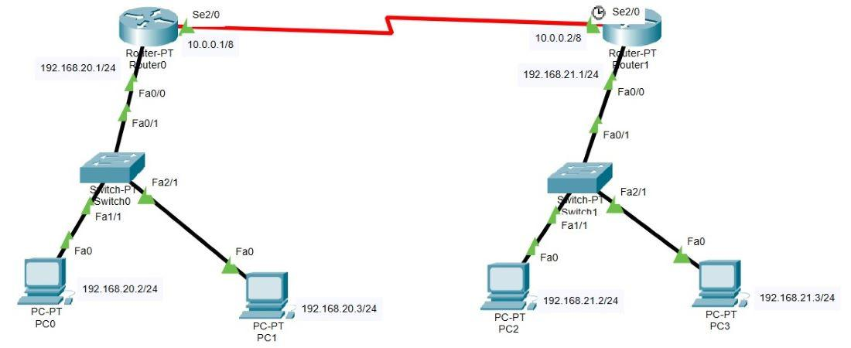
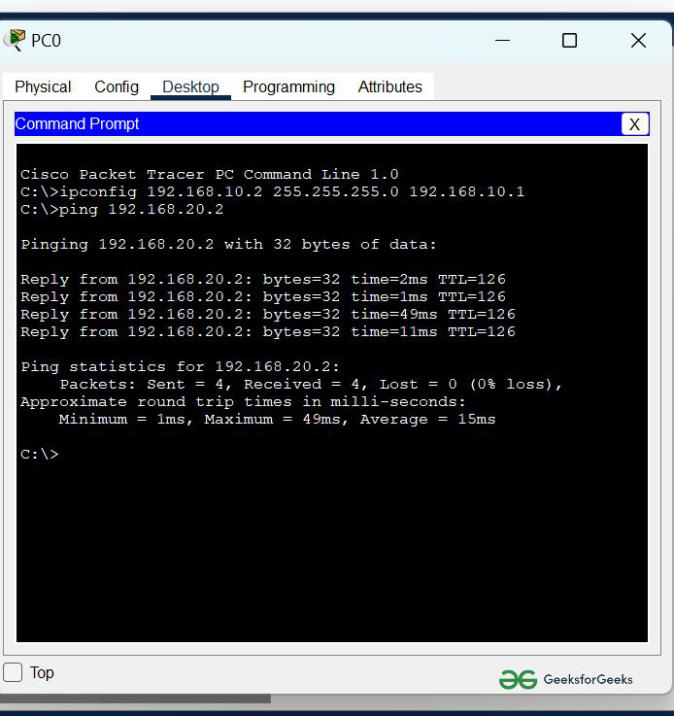
Results:

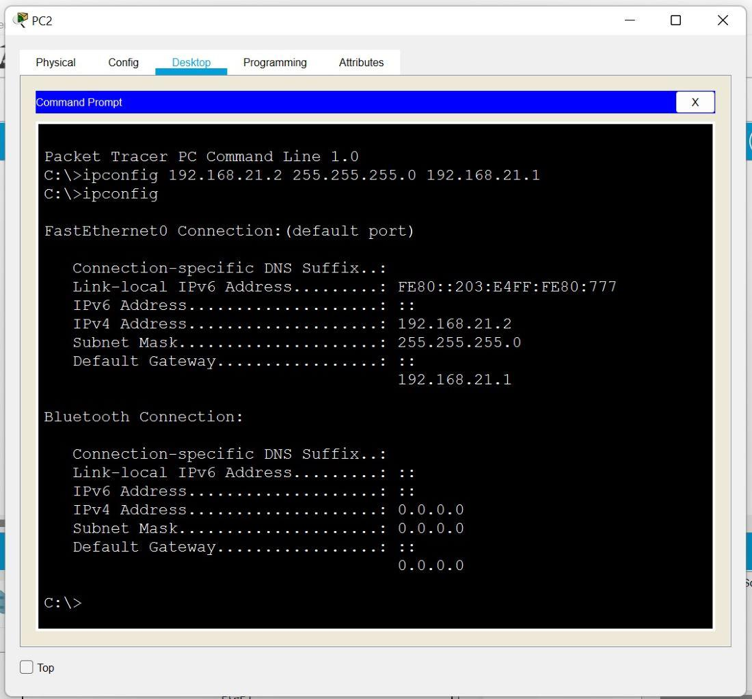
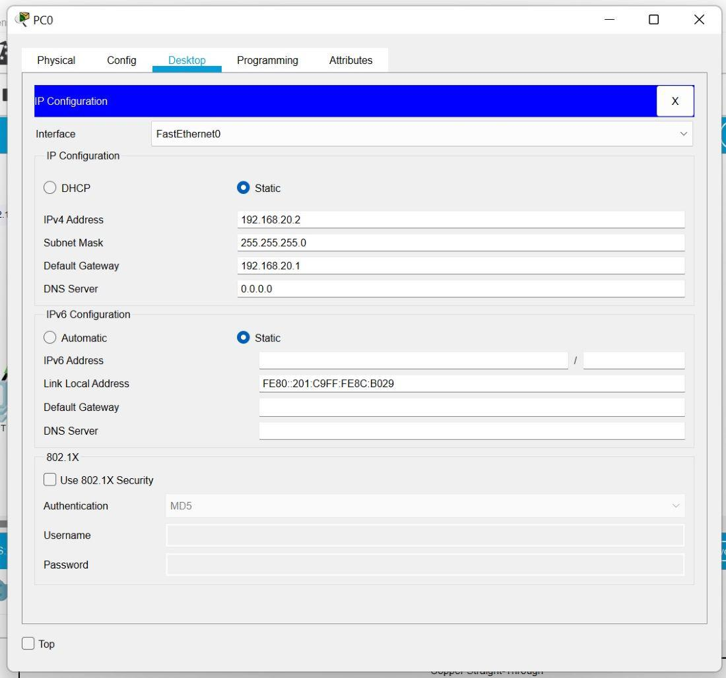
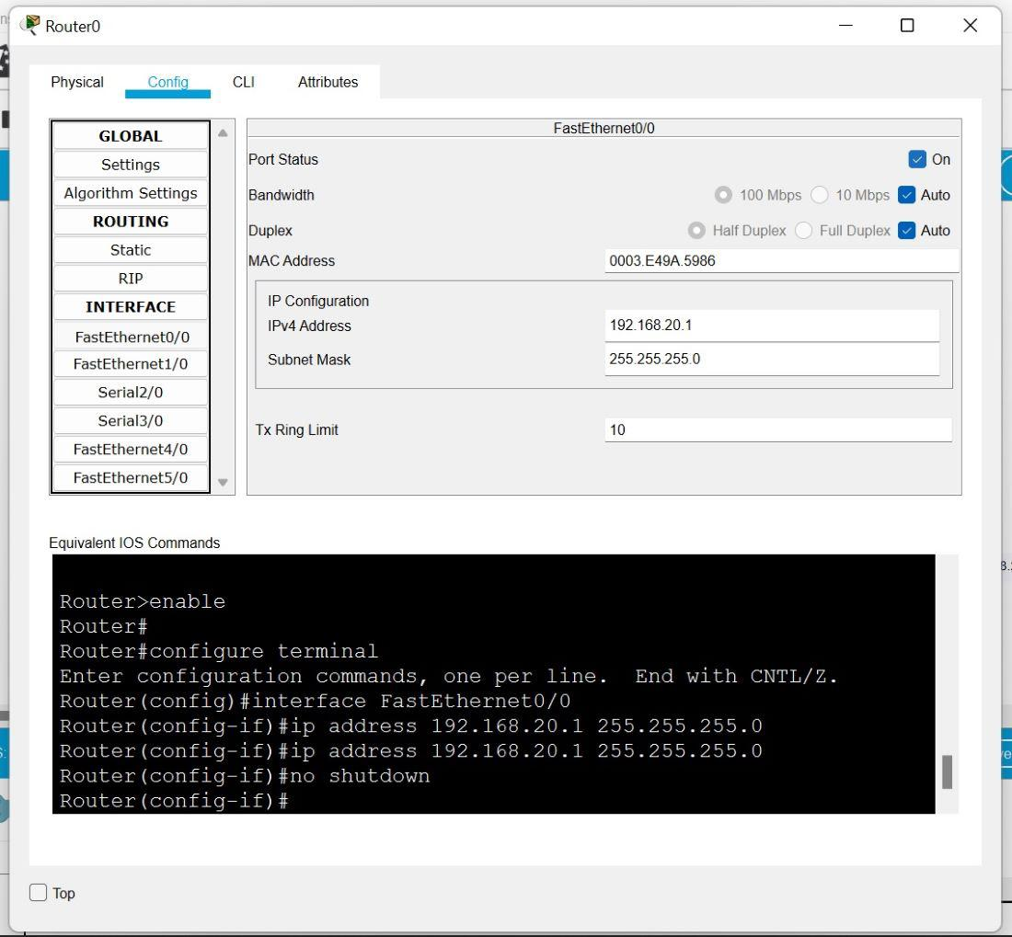
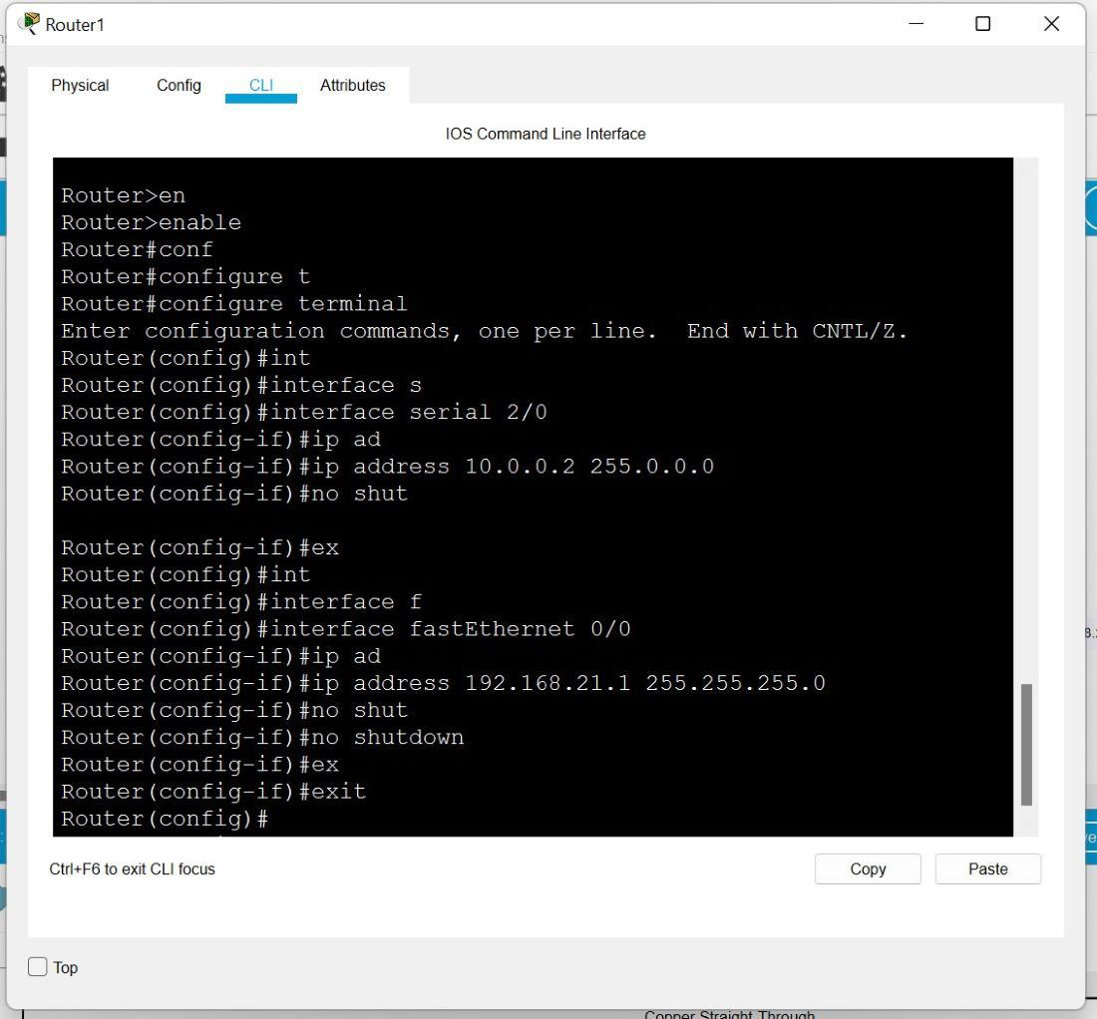
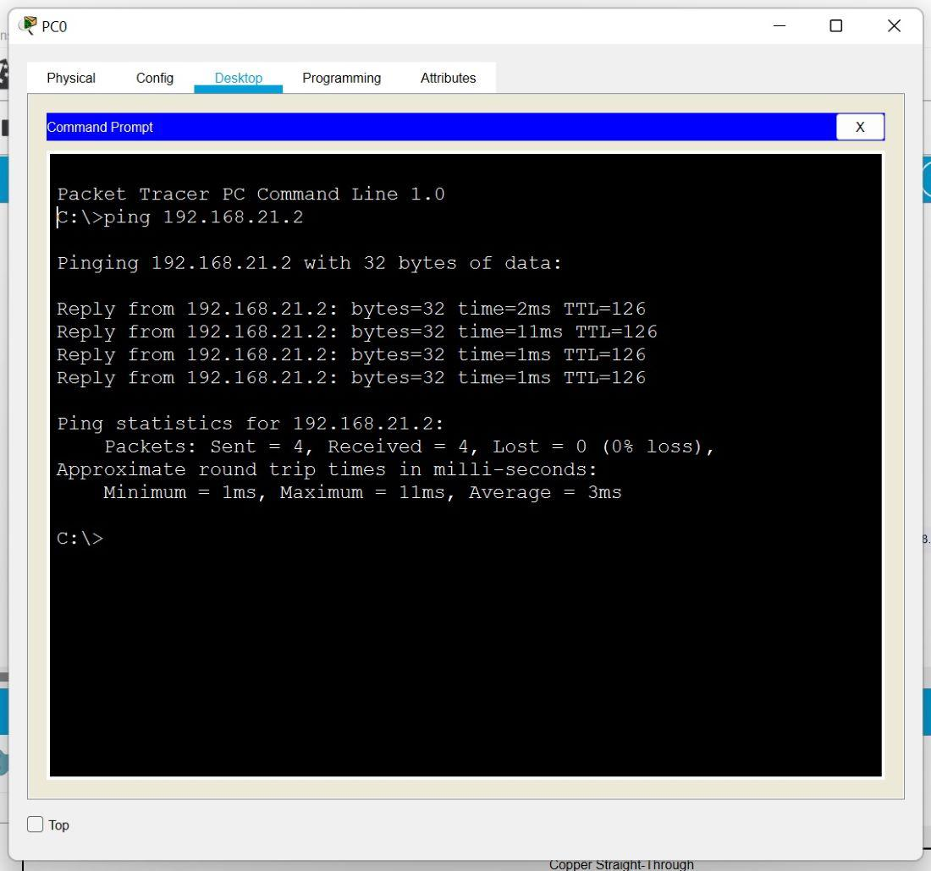
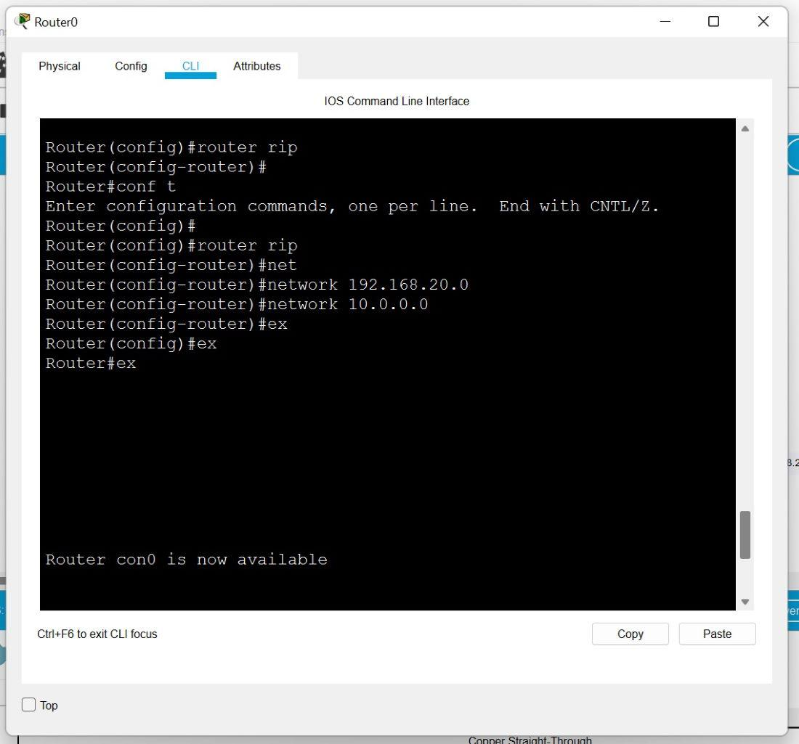

- Conclusion:
The experiment demonstrated the implementation of a network using routing protocols in Cisco Packet Tracer. It helped in understanding the working of Routing Information Protocol and how routing tables are created using network commands. The connectivity between multiple routers and PCs was successfully established and verified using the ping command. It also provided practical knowledge of IP addressing, routing configuration, and traffic flow using TCP/UDP. Overall, the experiment enhanced understanding of network routing and communication.

