Roll No.224A7064 Date:16/3/26
Student Name:Adil Arkate

EXPERIMENT 11

- Aim: Packet Sniffing using Wireshark.
- Objectives:
- Understand the concept of packet sniffing and how data travels across a network.
- Use Wireshark to capture, inspect, and analyze network packets in real-time.
- Identify various protocols (such as HTTP, TCP, UDP, DNS, ARP, etc.) within captured traffic.

- Theory:
Wireshark is a free and open-source network protocol analyzer used to capture and inspect network traffic in real time. It helps engineers, analysts, and security professionals understand what is happening inside a network at the packet level.
- Captures live network traffic across multiple interfaces
- Provides deep visibility into protocols and packet structure
- Helps troubleshoot network issues and analyze performance
- Essential for security investigations and protocol debugging

- Steps:
install wireshark from
Wireshark Download: https://www.wireshark.org
HTTP port 80
1. open wireshark
2. from the listed connections select wifi double click and press the red box to stop default capture
3.Now open cmd and type ipconfig to get your address. note it down.
4. Go to wireshark again and under the filter area (which shows apply a display filter) type the following
ip.addr == 192.168.0.106 && http
5.Press blue shark fin icon to start capturing http packets to and from your ip address
6. now open any browser and try to acess http://www.siesgst.edu.in/campuslife/studentclub.php
7. once the page loads, go to wireshark and press red box to stop the capture
8. now analyze the capture packets
*************************************************************************
PING
ip.addr == 192.168.0.106 && icmp
0. ensure that your phone and your pc are connected to the same wifi
1. open wireshark
2. from the listed connections select wifi double click and press the red box to stop default capture
3. open cmd and type ipconfig to get your address. note it down.
4.now open settings in your mobile and search for ip. generally you will find it under "about phone-status-ip address" and note it down.
5. Go to wireshark again and under the filter area (which shows apply a display filter) type the following
ip.addr == 192.168.0.106 && icmp
6.Press blue shark fin icon to start capturing icmp packets to and from your ip address
7. now open cmd prompt and try to ping your mobile ip address using following command
ping 192.168.0.105 -n 2
8. once the ping finishes, go to wireshark and press red box to stop the capture
9. now analyze the capture packets
*************************************************************************
TCP HANDSHAKES
ip.addr == 192.168.0.106 && tcp
1. open wireshark
2. from the listed connections select wifi double click and press the red box to stop default capture
3.now open cmd and type ipconfig to get ur address. note it down.
4. Go to wireshark again and under the filter area (which shows apply a display filter) type the following
ip.addr == 192.168.0.106 && tcp
5.press blue shark fin icon to start capturing http packets to and from ur ip address
6. now open any browser and try to acess http://www.siesgst.edu.in
7. once the page loads, go to wireshark and press red box to stop the capture
8. now analyze the capture packets

To find www.siesgst.edu.in ip address:
nslookup www.siesgst.edu.in
Server: dlinkrouter
Address: 192.168.0.1
Non-authoritative answer:
Name: www.siesgst.edu.in
Address: 169.38.89.3
- There are many reasons why Wireshark is so popular :
- It has a great GUI as well as a conventional CLI(T Shark).
- It offers network monitoring on almost all types of network standards (ethernet, wlan, Bluetooth etc)
- It is open-source with a large community of backers and developers.
- All the necessary components for monitoring, analyzing and documenting the network traffic are present. It is free to use.
- Wireshark installation:
Windows:
- You can do a proper installation or run Wireshark as a portable app on your windows system. To download the installation executable or the portable app go to Wireshark Downloads
- Run the executable and follow on-screen instructions to complete the installation.
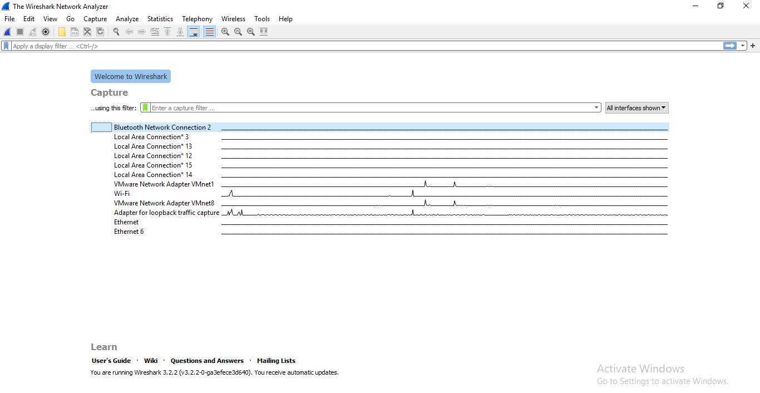
- Getting Up and Running: After installation launch Wireshark, approve the administrator or superuser privileges and you will be presented with a window that looks like this:
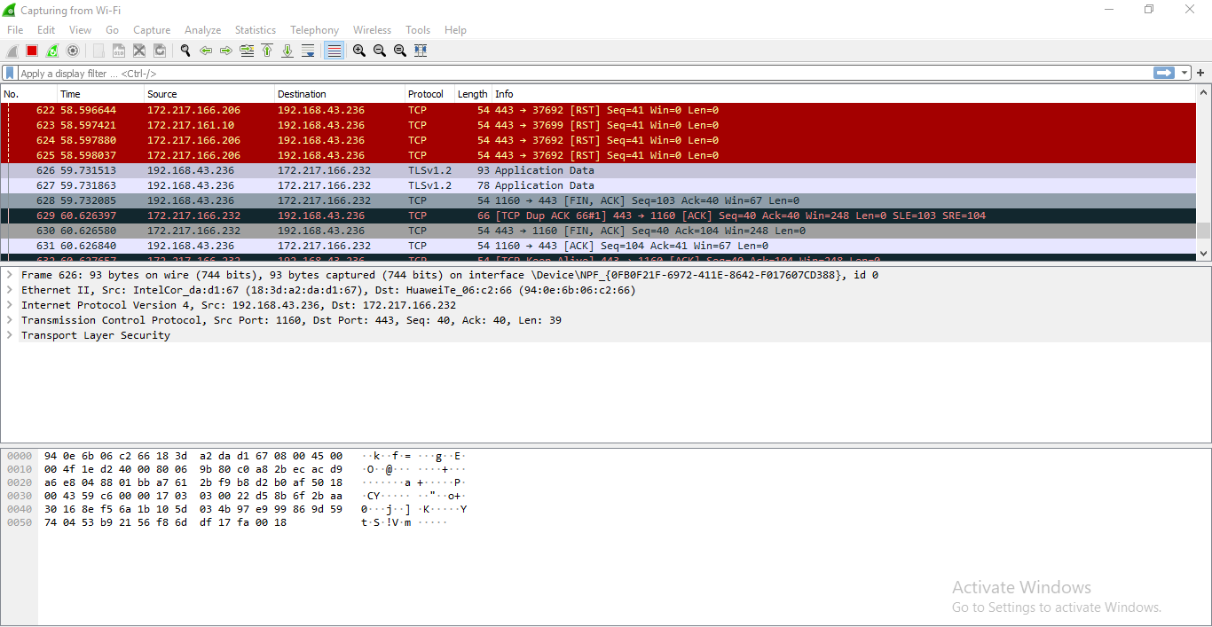
- This window shows the interfaces on your device. To start sniffing select one interface and click on the bluefin icon on the top left. The data capture screen has three panes. The top pane shows real-time traffic, the middle one shows information about the chosen packet and the bottom pane shows the raw packet data. The top pane shows source address(IPv4 or IPv6) destination address, source and destination ports, protocol to which the packet belongs to and additional information about the packet.

- Since there are a lot of packets going in and out every second, looking at all of them or searching for one type of packets will be tedious. This is why packet filters are provided. Packets can be filtered based on many parameters like IP address, port number or protocol at capture level or at display level. As obvious a display level filter will not affect the packets being captured.
- Some of the general capture filters are:
- host (capture the traffic through a single target)
- net( capture the traffic through a network or sub-network). “net” can be prefixed with “src” or “dst” to indicate whether the data coming from or going to the target host(s).)
- port (capture the traffic through or from a port). “port” can be prefixed with “src” or “dst” to indicate whether the data coming from or going to the target port.
- “and”, “not” and “or” logical connectives.(Used to combine multiple filters together).
There are some more basic filters and they can be combined very creatively. Another range of filters, display filters are used to create abstraction on captured data. These basic examples should provide a basic idea of their syntax:
- tcp.port==80/udp.port==X shows the tcp/udp traffic at port X.
- http.request.uri matches “parameter=value$” shows packets that are HTTP requests at the application layer level and their URI ends with a parameter with some value.
- The logical connective and or and not work here too.
- ip.src==192.168.0.0/16 and ip.dst==192.168.0.0/16 will show traffic to and from workstations and servers.
There is also a concept of coloring rules. Each protocol/port/other element is provided a unique color to make it easily visible for quick analysis. More details on coloring rules is here
Plugins are extra pieces of codes that can be embedded into the native Wireshark. Plugins help in analysis by:
- Showing parameter specific statistics and insights.
- Handling captures files and issues related to their formats.
- Collaborating with other tools and frameworks to set up an all-in-one network monitoring solution.
With just the basic capability to see all the traffic going through your device or in your LAN and the tools and plugins to help you in analysis, you can do a great deal of things with your device. Like:
- Troubleshooting Internet connectivity problems with your device or WiFi.
- Monitoring your device for unwanted traffic that may be an indication of a malware infection.
- Testing the working of your application that involve networking.
- Using it to just understand how computer networks work.
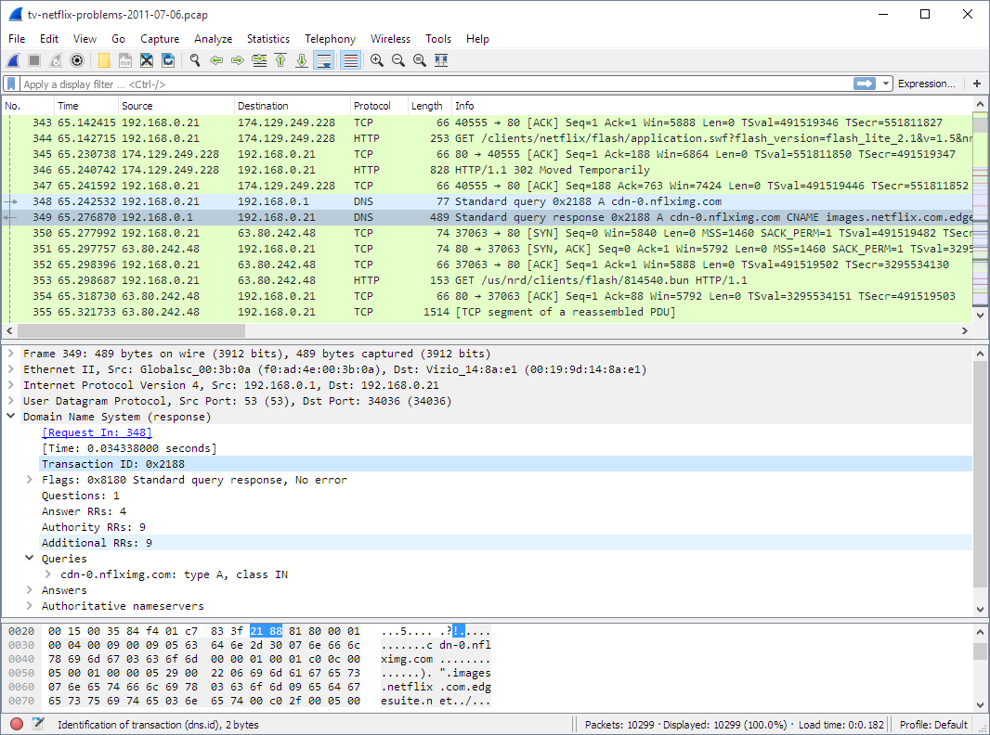
- Results:
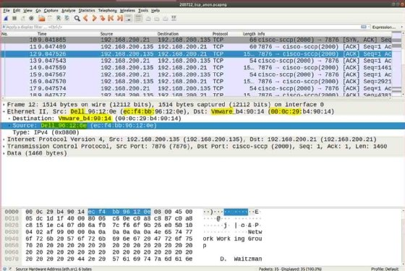
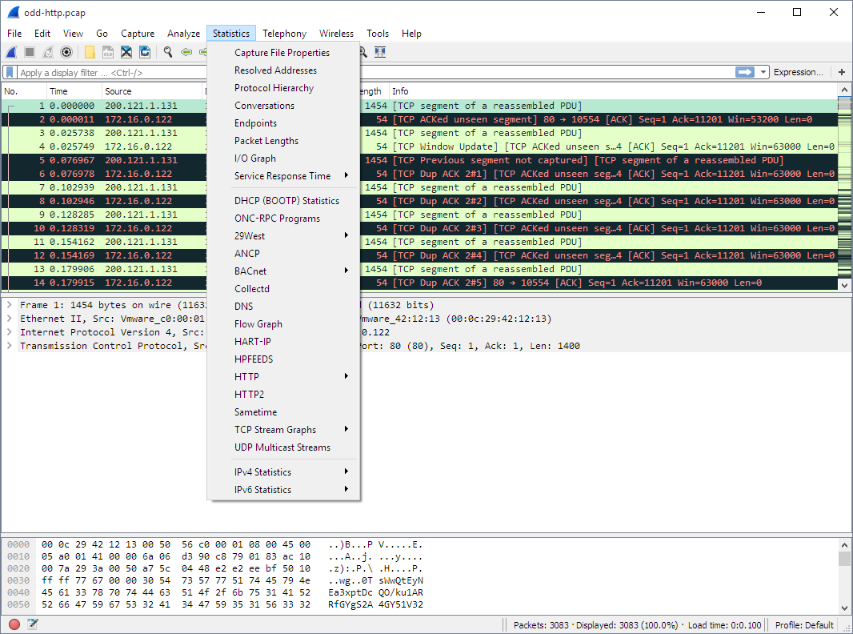
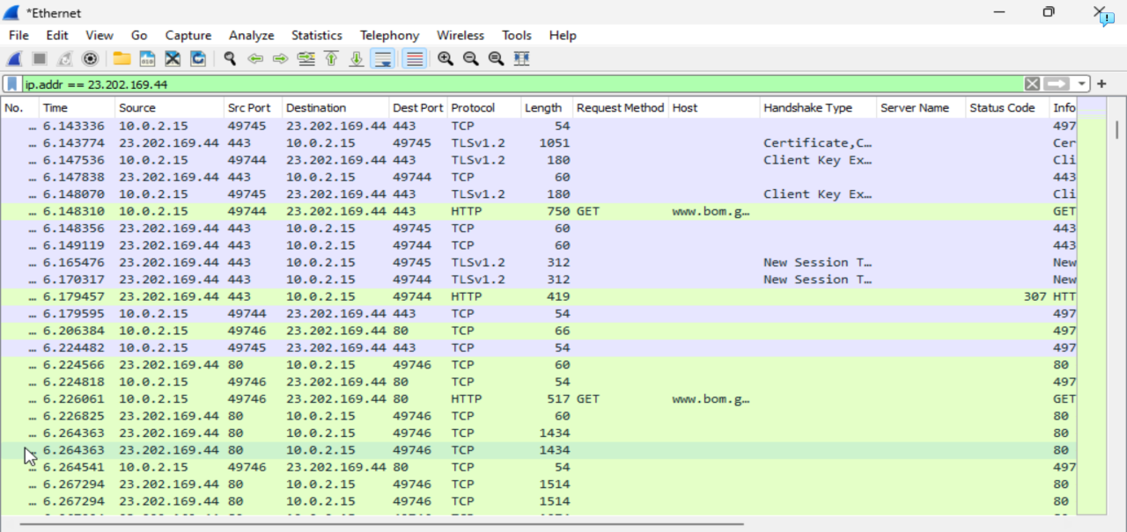
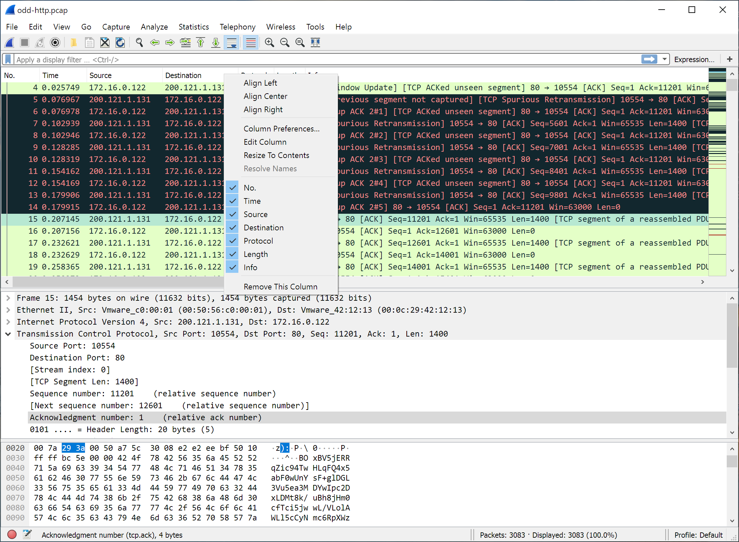

- Conclusion
The experiment demonstrated packet sniffing using Wireshark to capture and analyze network traffic. It helped in identifying different protocols such as HTTP, TCP, and ICMP, and understanding how data travels across a network. The use of filters and packet analysis provided clear insights into network communication. Overall, the experiment enhanced practical knowledge of network monitoring and troubleshooting.

