Roll No. 224A7064 Date:12/1/26
Student Name:Adil Arkate

EXPERIMENT 2

Title: Program to implement uninformed method (DFS) using python.
Theory:
- To understand uninformed search strategy.
- To implement DFS search method
Uninformed search algorithm DFS (Depth First Search)-
- Depth-first search isa recursive algorithm for traversing a tree or graph data structure.
- It is called the depth-first search because it starts from the root node and follows each path to its greatest depth node before moving to the next path.
- DFS uses a stack data structure for its implementation.
- The process of the DFS algorithm is like the BFS algorithm.

Time Complexity of DFS -
The time complexity of the Depth-First Search algorithm is represented within the sort of O(V + E), where V is that the number of nodes and E is that the number of edges.
The space complexity of the algorithm is O(V).
Applications -
Depth-First Search Algorithm has a wide range of applications for practical purposes. Some of them are as discussed below:

- For finding the strongly connected components of the graph
- For finding the path
- To test if the graph is bipartite
- For detecting cycles in a graph
BFS (Breadth First Search)-
  - Breadth-first search is the most common search strategy for traversing a tree or graph. This algorithm searches breadthwise in a tree or graph, so it is called breadth-first search.
  - BFS algorithm starts searching from the root node of the tree and expands all successor node at the current level before moving to nodes of next level.
  - The breadth-first search algorithm is an example of a general-graph search algorithm.

  - Breadth-first search implemented using FIFO queue data structure.

Time Complexity of BFS -
The time complexity of the Breadth first Search algorithm is in the form of O(V+E), where V is the representation of the number of nodes and E is the number of edges. Also, the space complexity of the BFS algorithm is O(V).
Applications –
Breadth-first Search Algorithm has a wide range of applications in the real-world. Some of them are as discussed below:

- In GPS navigation, it helps in finding the shortest path available from one point to another.
- In pathfinding algorithms

DFS

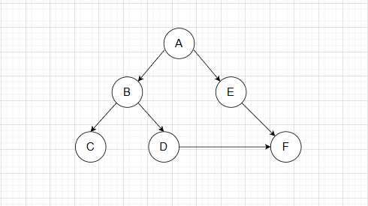
Graph:

Code:
graph = {
'A': ['E', 'B'],

'E': ['F'],
'F': [],
'B': ['D', 'C'],
'D': ['F'],
'C': []
}
def dfs(graph, current, goal, visited=None):
if visited is None:
visited = set()
print(current, end=" ")
visited.add(current)
if current == goal:
return True
for node in graph[current]:
if node not in visited:
if dfs(graph, node, goal, visited):
return True
return False
dfs(graph, 'A', 'F')

Output:

BFS

Graph:
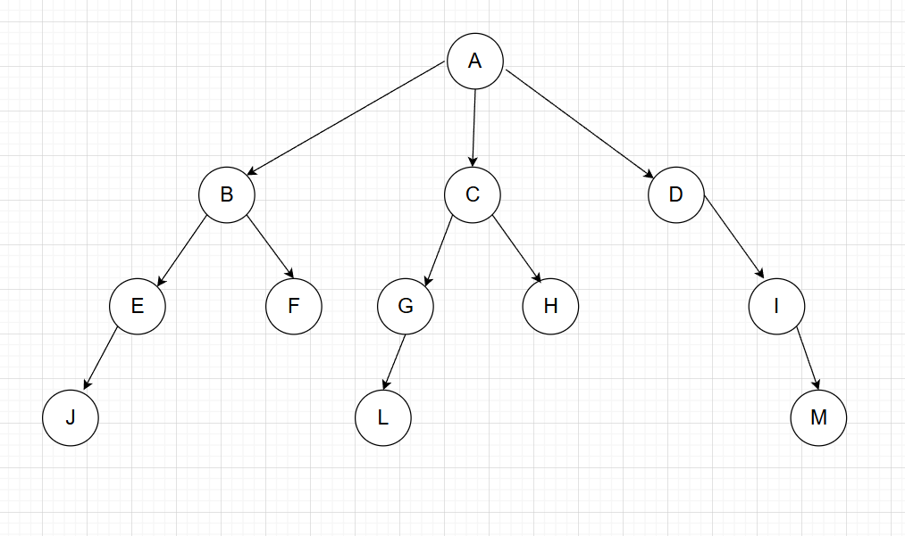
Code:

from collections import deque
graph = {
'A': ['B', 'C', 'D'],'B': ['E', 'F'],'C': ['G', 'H'],'D': ['I'],'E': ['J', 'K'],'F': [],'G': ['L'],'H': [],'I': ['M'],'J': [], 'K': [],'L': [], 'M': []
}

def bfs_all_paths(graph, start):
queue = deque([[start]])
while queue:

path = queue.popleft()
node = path[-1]
print(path)
for neighbor in graph[node]:
new_path = path + [neighbor]
queue.append(new_path)
bfs_all_paths(graph, 'A')

Output:
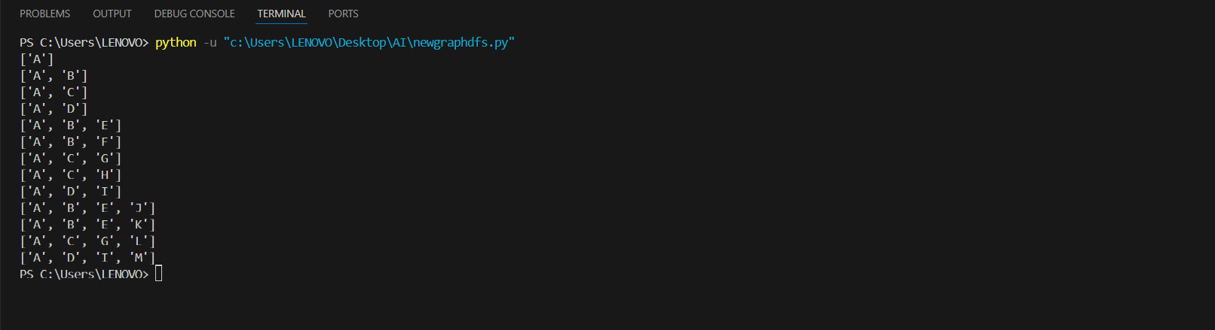

Conclusion:
Hence throughut this experiment we have learned uninformed search method using BFS and DFS ,where DFS is incomplete and not optimal for searching and BFS has Completeness but Also not optimal

