Roll No. 224A7064 Date:31/1/26
Student Name:Adil Arkate

EXPERIMENT 3
Title: Program to implement informed (A*) method using python.

- Objectives:
- To understand informed search strategy.
- Implementing A star search method.
- Theory: Informed Searching algorithm: (A star Search)-

The A* algorithm combines features of uniform-cost search and pure heuristic search to efficiently compute optimal solutions. A* algorithm is a best-first search algorithm in which the cost associated with a node is f(n) = g(n) + h(n), where g(n) is the cost of the path from the initial state to node n and h(n) is the heuristic estimate or the cost or a path from node n to a goal. Thus, f(n) estimates the lowest total cost of any solution path going through node n.
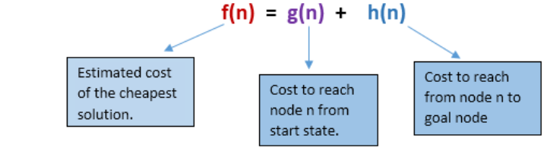
At each point a node with lowest f value is chosen for expansion. Ties among nodes of equal f value should be broken in favour of nodes with lower h values. The algorithm terminates when a goal is chosen for expansion.
A* algorithm guides an optimal path to a goal if the heuristic function h(n) is admissible, meaning it never overestimates actual cost. For example, since airline distance never overestimates actual highway distance, and Manhattan distance never overestimates actual moves in the gliding tile.For Puzzle, A* algorithm, using these evaluation functions, can find optimal solutions to these problems. In addition, A* makes the most efficient use of the given heuristic function in the following sense:
among all shortest-path algorithms using the given heuristic function h(n). A* algorithm expands the fewest number of nodes.
The main drawback of A* algorithm and indeed of any best-first search is its memory requirement. Since at least the entire open list must be saved, A* algorithm is severely space-limited in practice and is no more practical than breadth-first search on current machines. For example, while it can be run successfully on the eight puzzle, it exhausts available memory in a matter of minutes on the fifteen puzzles.
- Advantages:
- A* search algorithm is the best algorithm than other search algorithms.
- A* search algorithm is optimal and complete.
- This algorithm can solve very complex problems.

- Disadvantages:
- It does not always produce the shortest path as it mostly based on heuristics and approximation.
- A* search algorithm has some complexity issues.
- The main drawback of A* is memory requirement as it keeps all generated nodes in the memory, so it is not practical for various large-scale problems.

- Algorithm:
1: Firstly, Place the starting node into OPEN and find its f (n) value.
2: Then remove the node from OPEN, having the smallest f (n) value. If it is a goal node, then stop and return to success.
3: Else remove the node from OPEN and find all its successors.
4: Find the f (n) value of all the successors, place them into OPEN, and place the removed node into CLOSE.
5: Goto Step-2.
6: Exit.

- Graph:
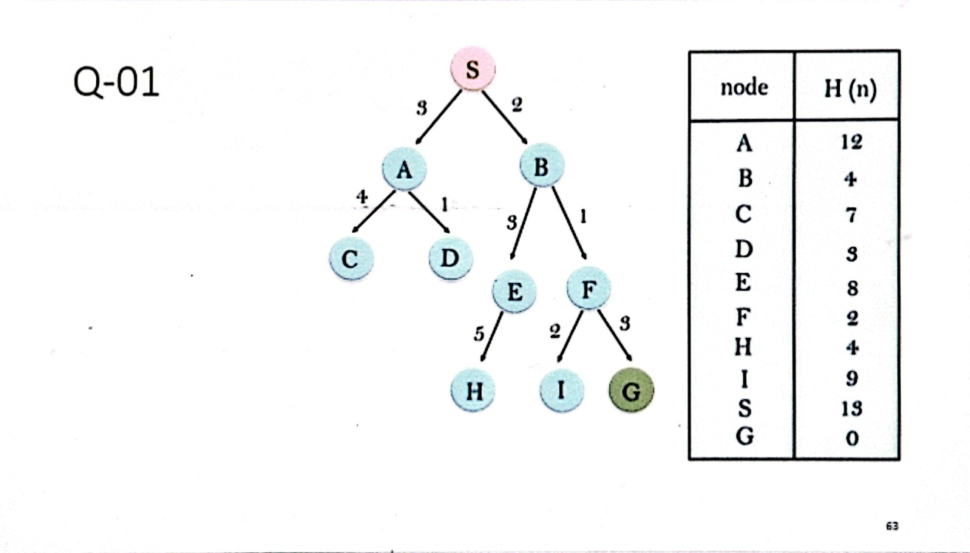
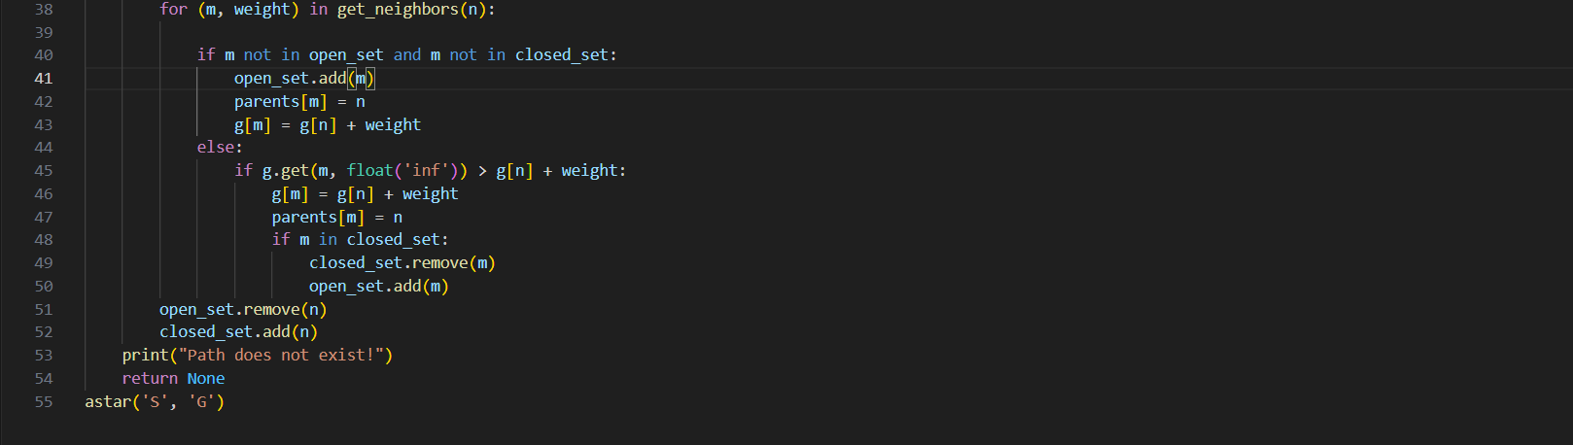
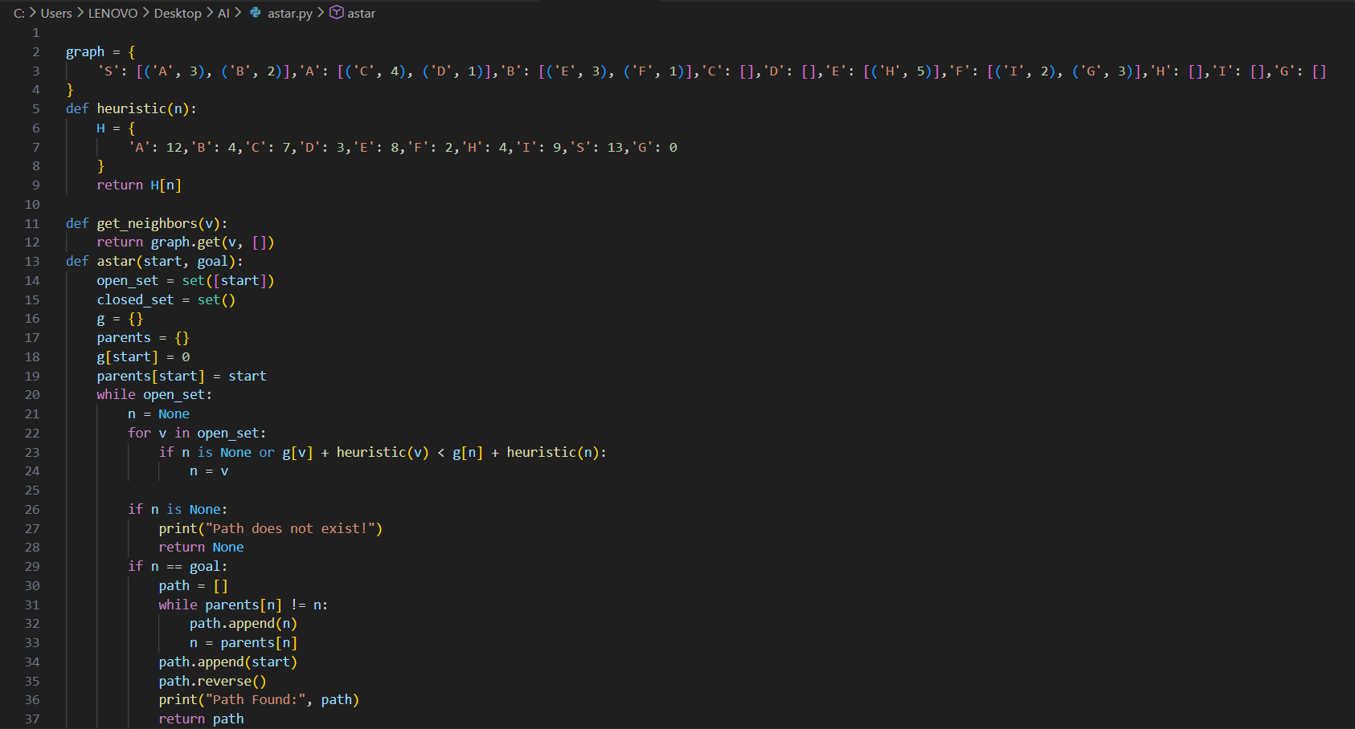
Code:

- Output:
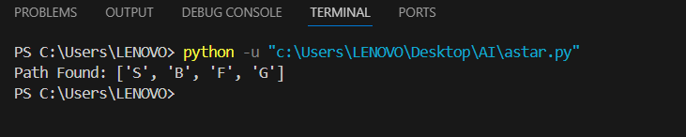
- Conclusion:
In this experiment, the A* algorithm was successfully implemented using Python. It helped in understanding informed search techniques and finding optimal paths efficiently using heuristics. The experiment demonstrated that the A* algorithm is complete and optimal if an admissible heuristic is applied, but it consumes high memory. This experiment has increased the knowledge of searching heuristic.

