Roll No.224A7064 Date:31/1/26
Student Name:Adil Arkate
EXPERIMENT 4
Title: Write a Program to implement Game playing algorithm Tic-Tac-Toe using python.

Objectives: To understand Mini Max algorithm
Theory: Mini max is a recursive algorithm which is used to choose an optimal move for a player assuming that the other player is also playing optimally. It is used in games such as tic-tac-toe, go, chess, Isola, checkers, and many other two-player games. Such games are called games of perfect information because it is possible to see all the possible moves of a particular game.
There can be two-player games which are not of perfect information such as Scrabble because the opponent’s move cannot be predicted. It is similar to how we think when we play a game: “if I make this move, then my opponent can only make only these moves,” and so on. Minimax is called so because it helps in minimizing the loss when the other player chooses the strategy having the maximum loss.
Performance Measure parameters of Mini Max algorithm:
- Completeness - Min-Max algorithm is Complete. It will definitely find a solution (if exist), in the finite search tree.
- Optimal- Min-Max algorithm is optimal if both opponents are playing optimally.
- Time complexity- As it performs DFS for the game-tree, so the time complexity of Min-Max algorithm is O(bm), where b is branching factor of the game-tree, and m is the maximum depth of the tree.
- Space Complexity- Space complexity of Mini-max algorithm is also similar to DFS which is O(bm).
Tic-Tac-Toe: A Tic-Tac-Toe is a 2 player game, who takes turns marking the spaces in a 3x3 grid. The player who succeeds in placing three of their marks in a horizontal, vertical, or diagonal row wins the game. The 2 players mode iteratively takes input from both the players, while making sure, if anyone has won or not. The single player mode uses Mini Max algorithm to make the computer unbeatable. Even if the player plays the most optimal move every time, the end result would be at most a draw. The game play of Single Player mode is show below. Every time you make a move, the computer plays automatically.
Game play:
- The initial state is the first layer that defines that the board is blank it’s MAX’s turn to play.
- Successor function lists all the possible successor moves. It is defined for all the layers in the tree.
- Terminal State is the last layer of the tree that shows the final state, i.e whether the player MAX wins, loses, or ties with the opponent.
- Utilities in this case for the terminal states are 1, 0, and -1 as discussed earlier, and they can be used to determine the utilities of the other nodes as well.
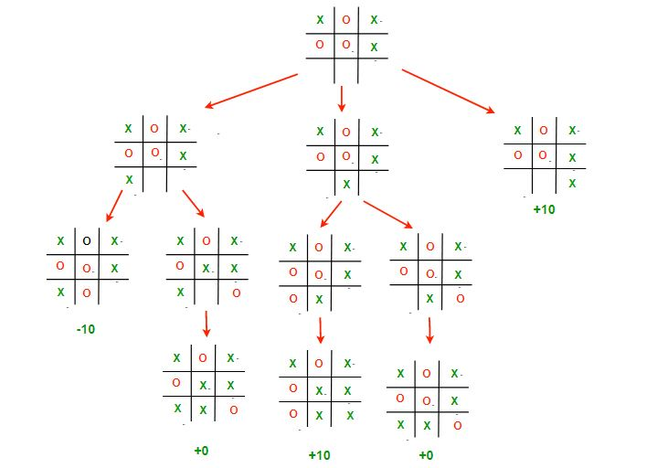

Code:
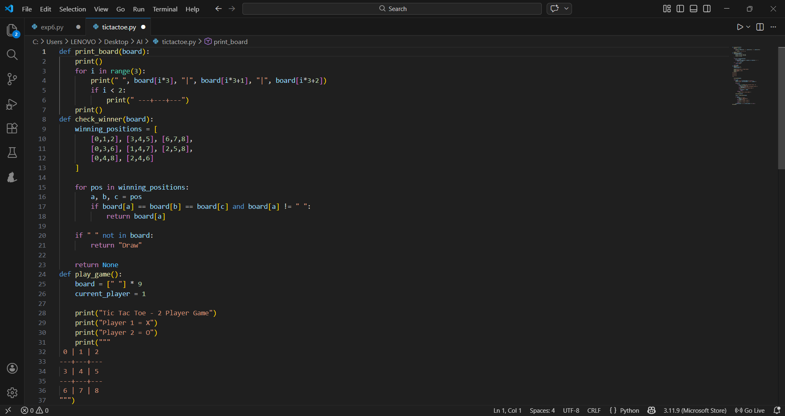
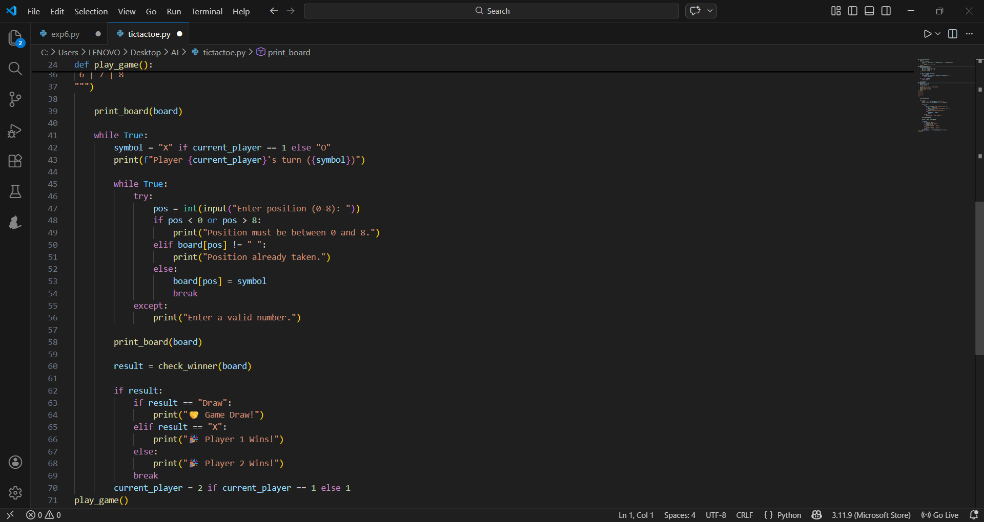

Output:
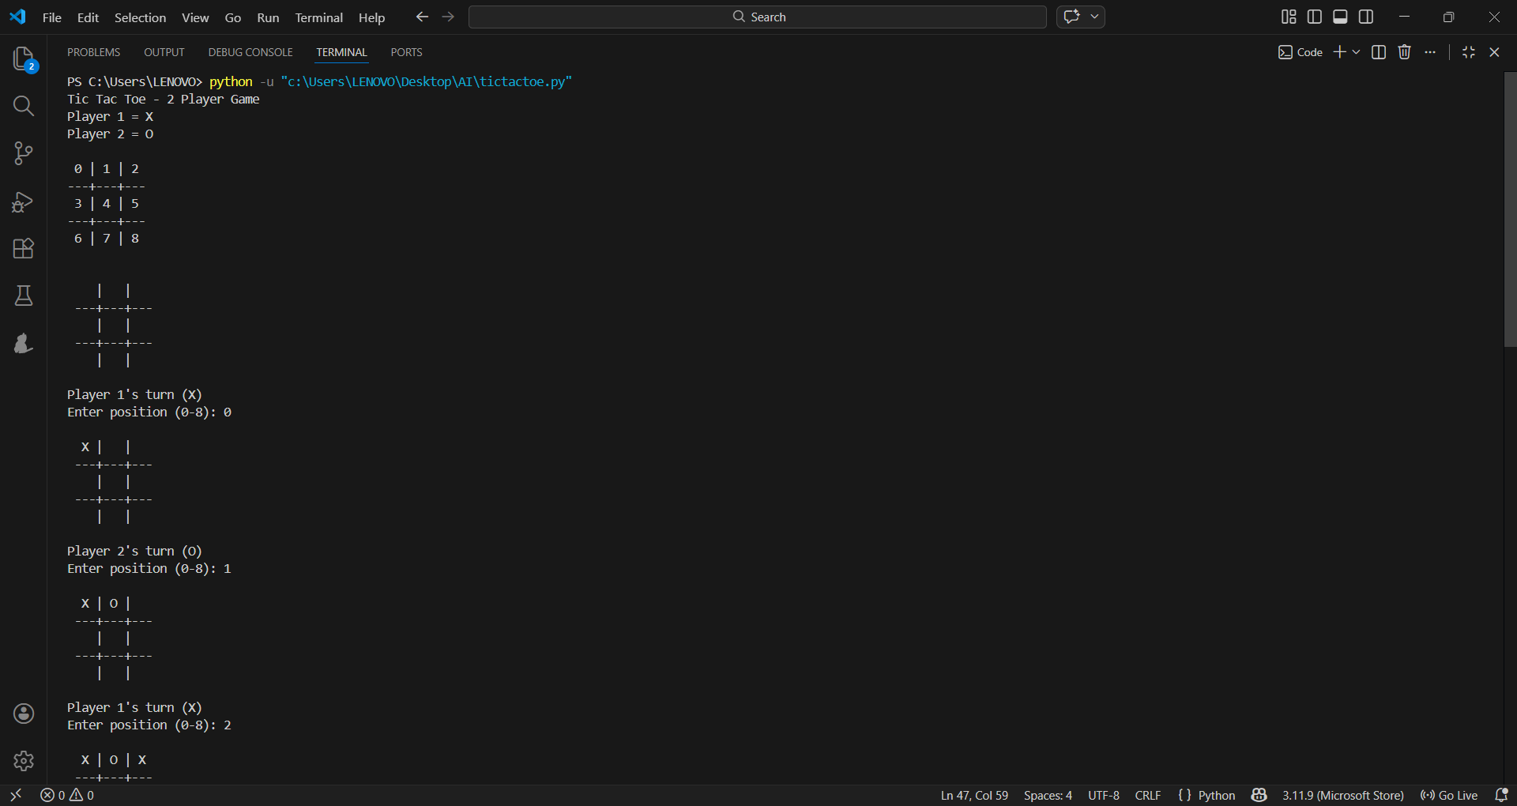
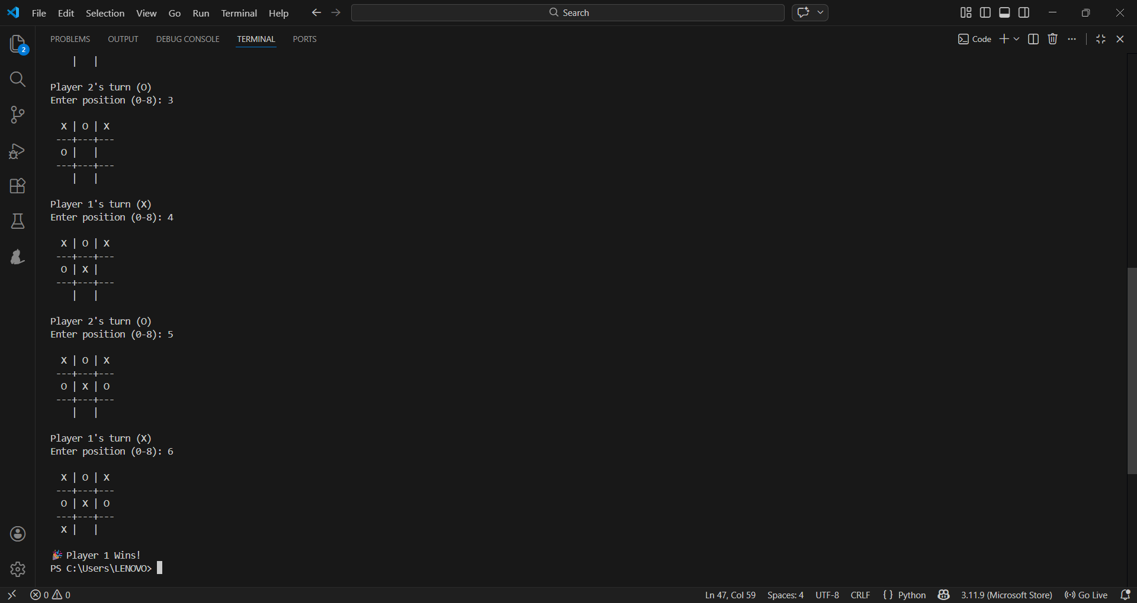

Conclusion:
In this experiment, a two-player Tic Tac Toe game has been implemented successfully using Python. In this game, two players will play one after the other by entering numbers ranging from 0 to 8. The system has been implemented to check the winning condition and confirm which one is Player 1 and Player 2 accordingly. This experiment helped in understanding the game logic behind a turn-based game. Therefore, the aim of implementing a simple game has been achieved successfully.

