Roll No.224A7064 Date:2/2/26
Student Name:Adil Arkate

EXPERIMENT 5

Title: Write simple program using prolog as an AI programming language.
Theory:
- Prolog stands for programming in logic. In the logic programming paradigm, prolog language is most widely available. Prolog is a declarative language, which means that a program consists of data based on the facts and rules (Logical relationship) rather than computing how to find a solution. A logical relationship describes the relationships which hold for the given application.
- To obtain the solution, the user asks a question rather than running a program. When a user asks a question, then to determine the answer, the run time system searches through the database of facts and rules.
- Prolog is a declarative language that means we can specify what problem we want to solve rather than how to solve it.
- Prolog is used in some areas like database, natural language processing, artificial intelligence, but it is pretty useless in some areas like a numerical algorithm or instance graphics.

Application of prolog:
The applications of prolog are as follows:
- Specification Language
- Robot Planning
- Natural language understanding
- Machine Learning
- Problem Solving
- Intelligent Database retrieval
- Expert System
- Automated Reasoning

Code:
Example 1
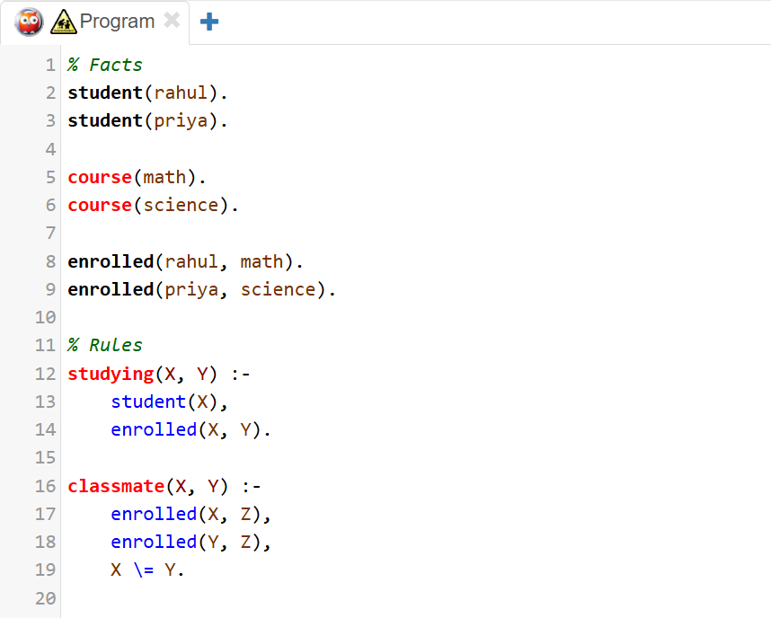
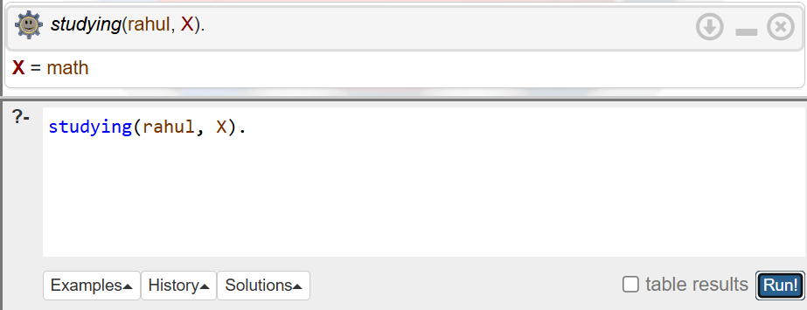
Queries

Example 2
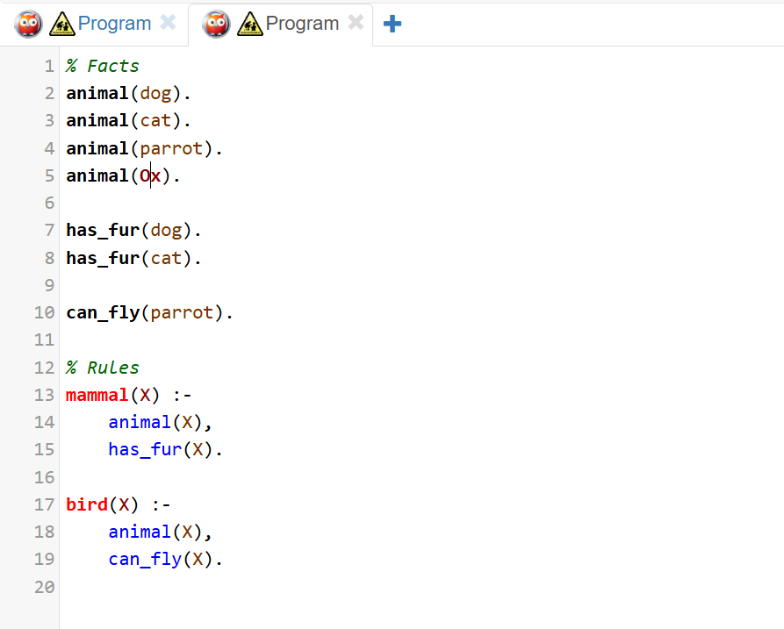

Output:
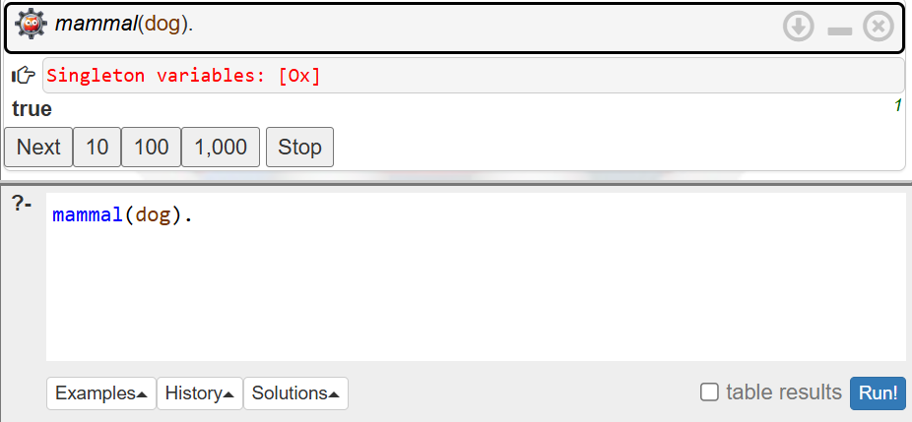

Example 3
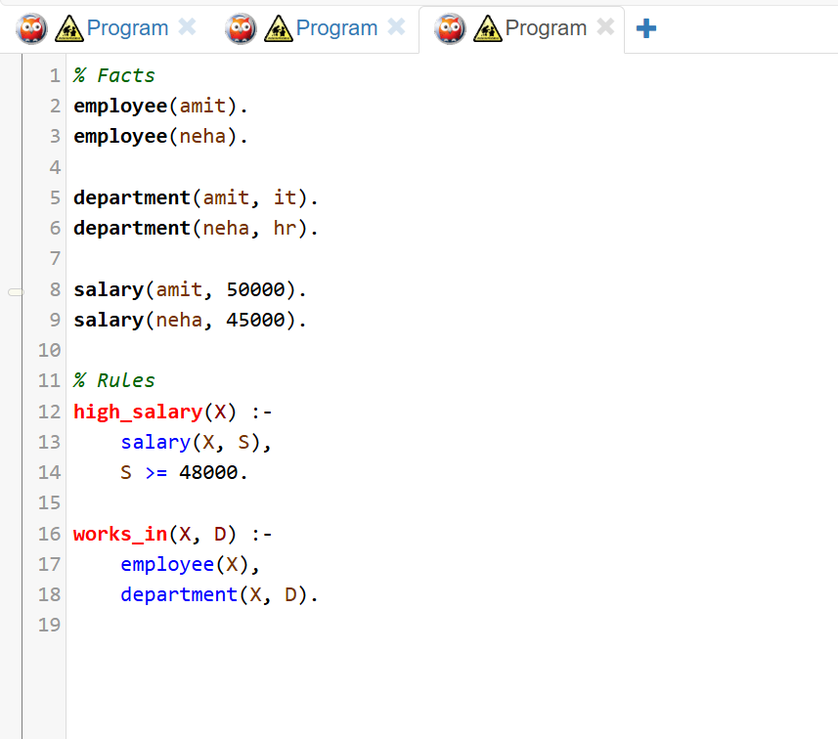
Output
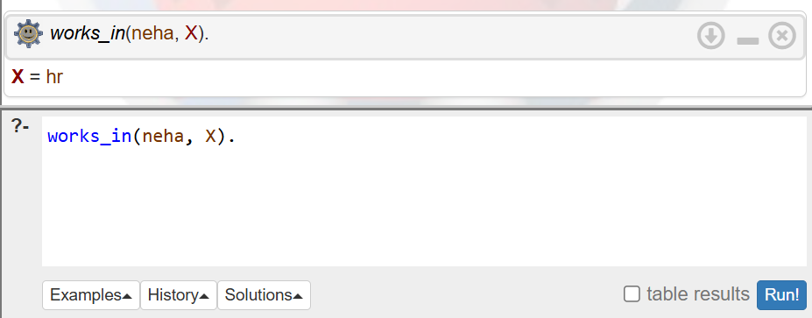

Conclusion:
In this experiment, we learned and implemented simple programs based on Prolog, which is an AI programming language. We understood how Prolog operates using facts, rules, and queries to solve problems logically. By writing different examples, we understood how relations are defined and how solutions are obtained using queries. This experiment helped us to understand the basic concepts of logic programming and the importance of Prolog in artificial intelligence applications. Therefore, the objectives of this experiment were achieved.

