Roll No.224A7064 Date:9/2/26
Student Name:Adil Arkate

EXPERIMENT 6

Title: Write a program to implement genetic algorithms.

Objectives:

- To understand genetic algorithm.
- To implement it on Python

Theory: Genetic Algorithm is a stochastic global search optimization algorithm.

Genetic Algorithms (GAs) are adaptive heuristic search algorithms that belong to the larger part of evolutionary algorithms. Genetic algorithms are based on the ideas of natural selection and genetics. It is inspired by the biological theory of evolution by means of natural selection. Specifically, the new synthesis that combines an understanding of genetics with the theory. These are intelligent exploitation of random search provided with historical data to direct the search into the region of better performance in solution space. They are commonly used to generate high-quality solutions for optimization problems and search problems.
Genetic algorithms simulate the process of natural selection which means those species who can adapt to changes in their environment are able to survive and reproduce and go to next generation. In simple words, they simulate “survival of the fittest” among individual of consecutive generation for solving a problem. Each generation consist of a population of individuals and each individual represents a point in search space and possible solution. Each individual is represented as a string of character/integer/float/bits. This string is analogous to the Chromosome.
Genetic algorithms are based on an analogy with genetic structure and behaviour of chromosomes of the population. Following is the foundation of GAs based on this analogy –
- Individual in population compete for resources and mate
- Those individuals who are successful (fittest) then mate to create more offspring than others
- Genes from “fittest” parent propagate throughout the generation, that is sometimes parents create offspring which is better than either parent.
- Thus each successive generation is more suited for their environment. Applications of Genetic Algorithms-

  - Recurrent Neural Network
  - Mutation testing
  - Code breaking
  - Filtering and signal processing
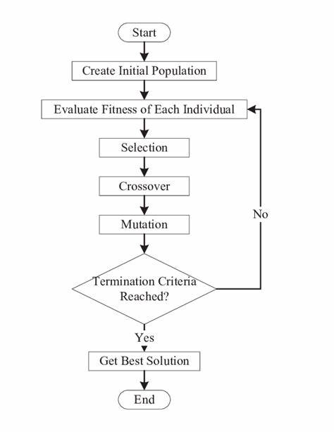
Code:
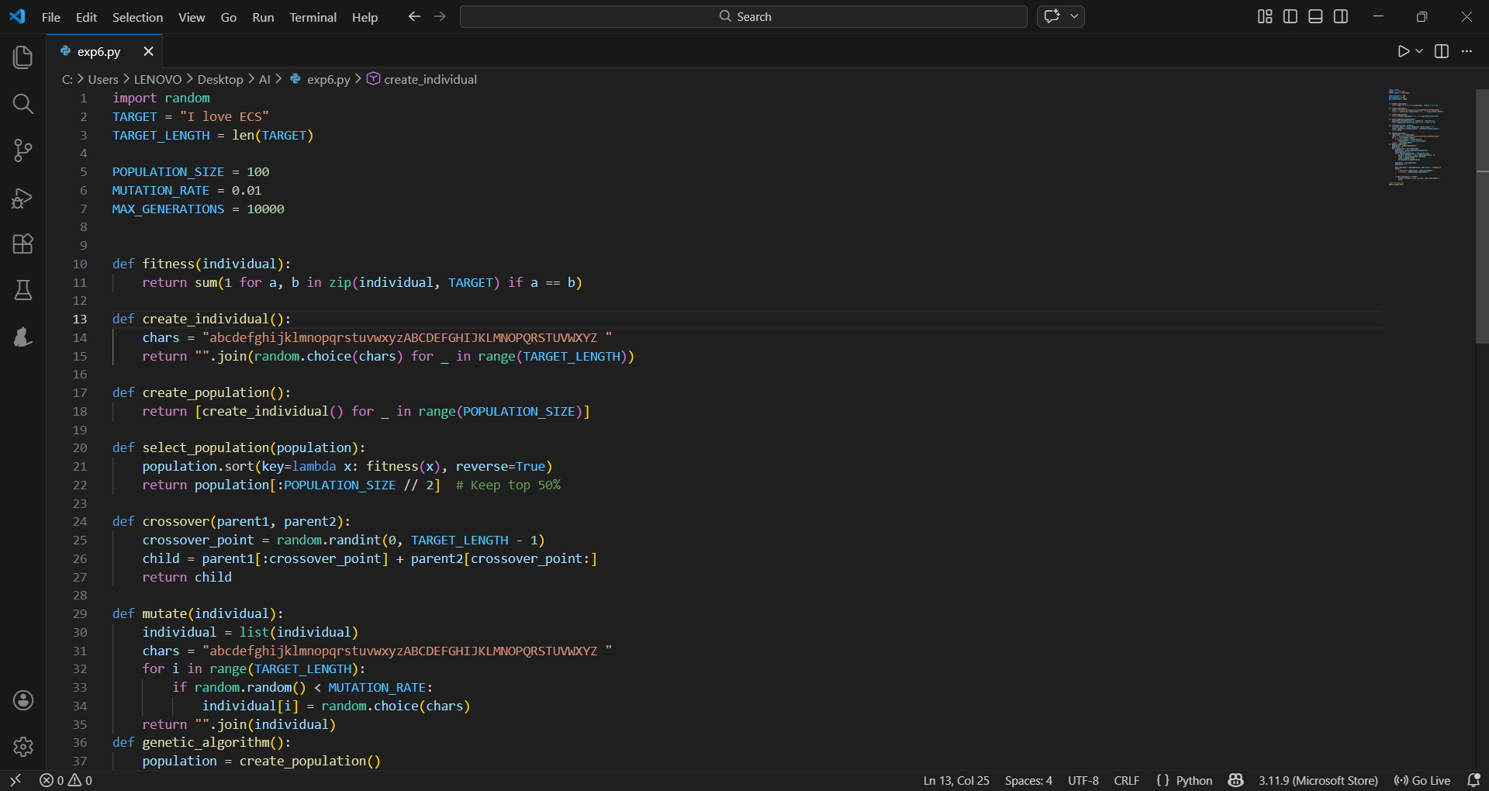
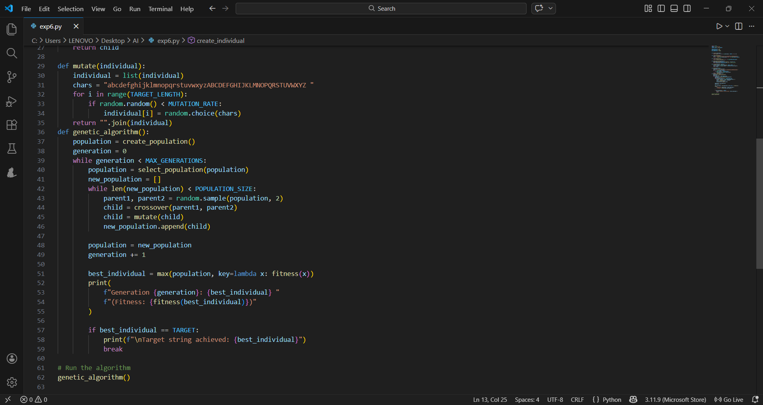

Output:
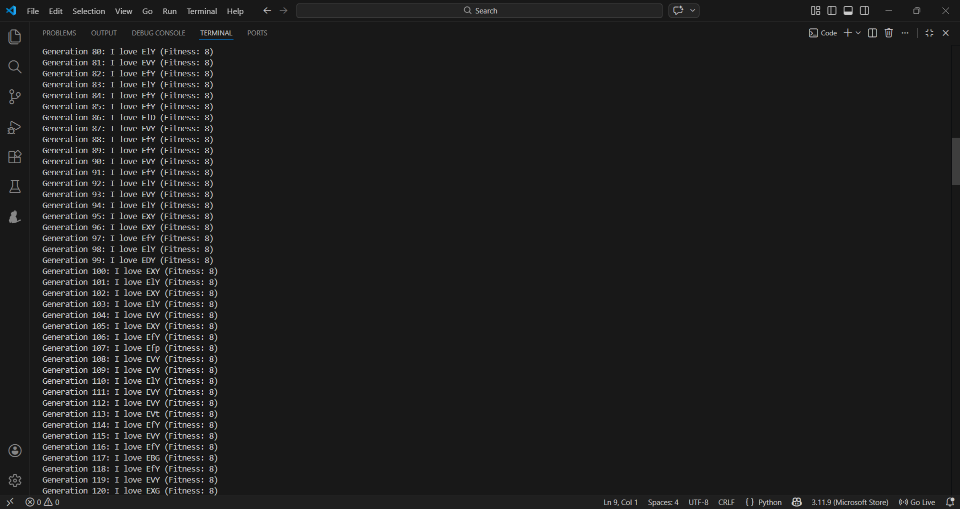
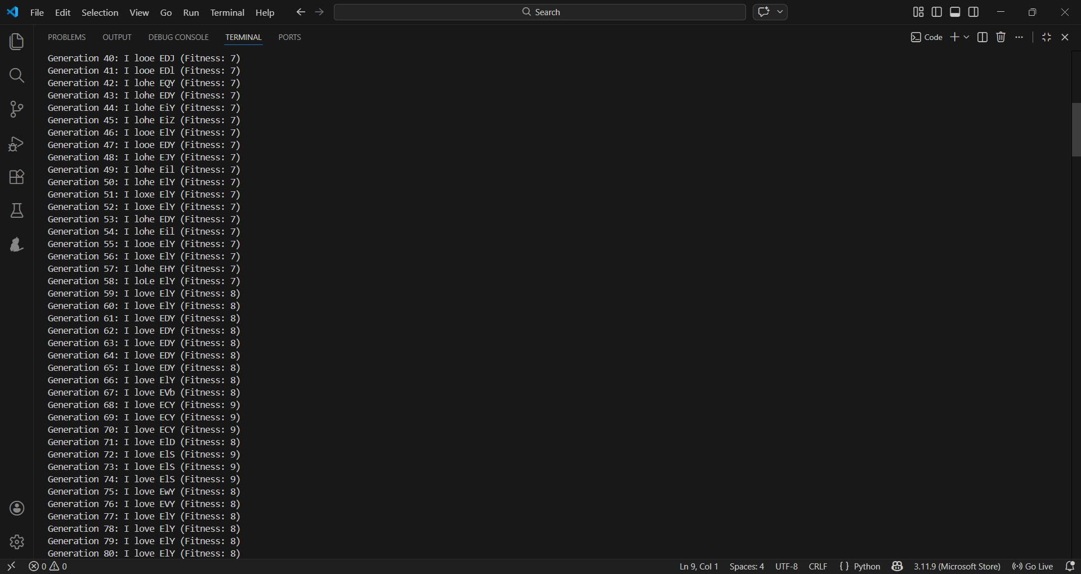
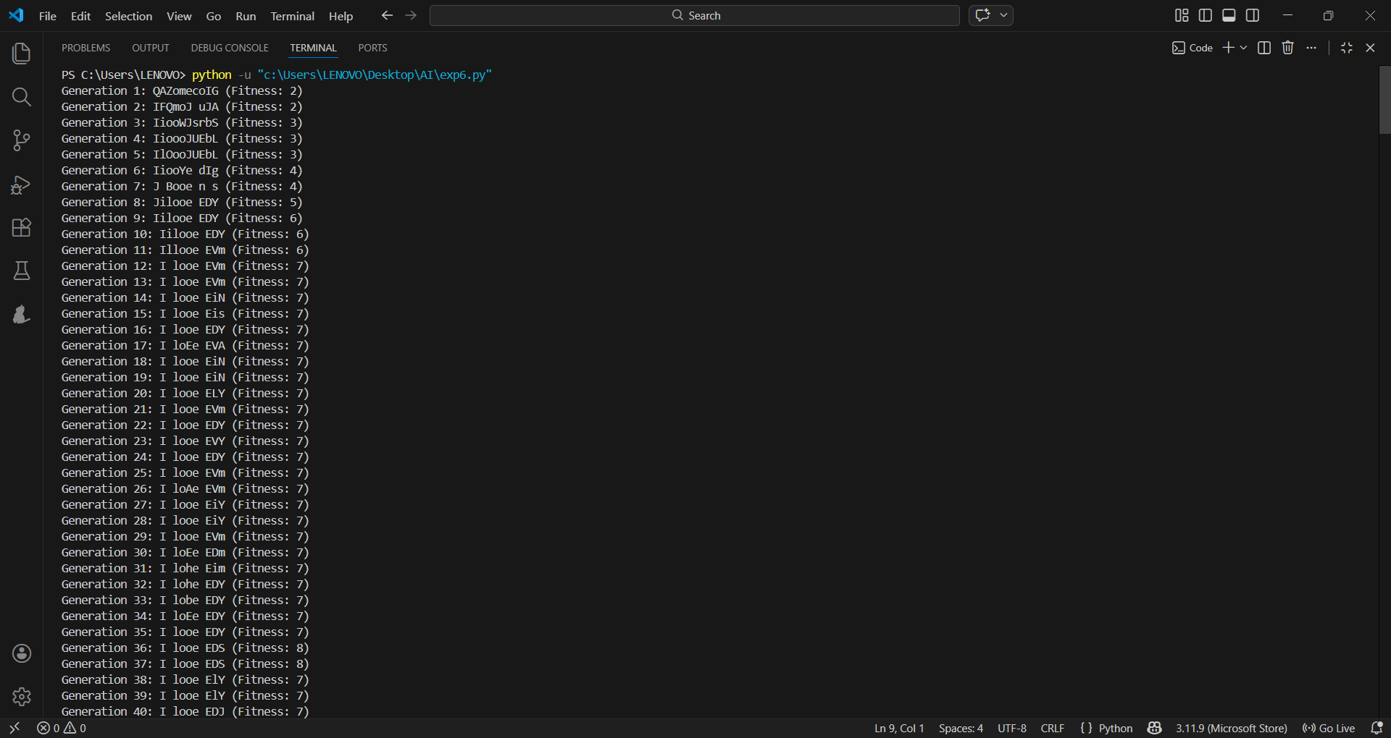
:
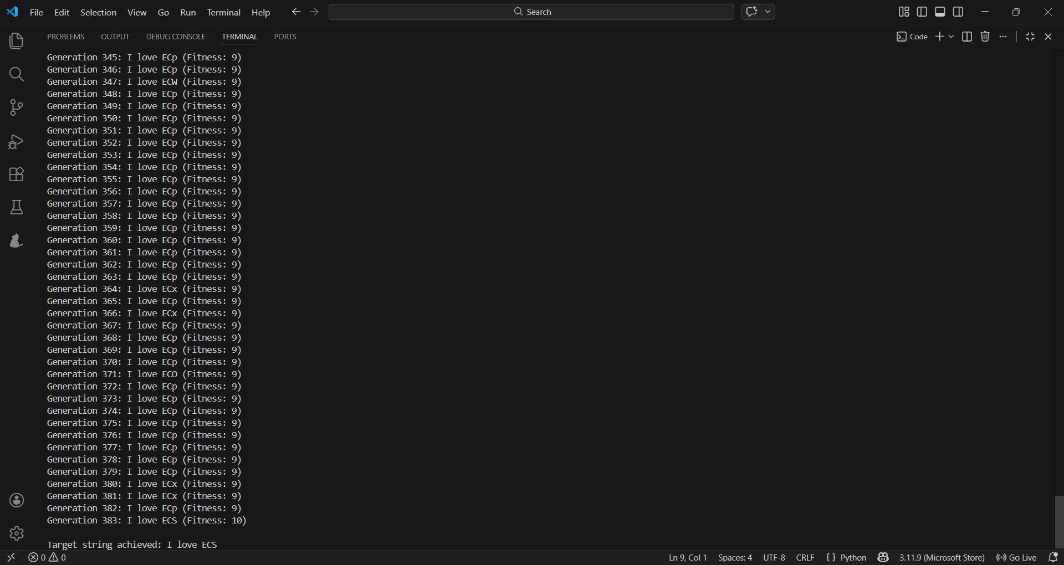
Conclusion:
In this experiment, a Genetic Algorithm was successfully implemented to evolve a random population of strings toward a target string, **“I love ECS”**. Key genetic operations like evaluation of fitness, selection, crossover, and mutation were employed by the algorithm in order to improve the population over successive generations. As generations progressed, the best individual's fitness increased, showing how effective evolutionary techniques are in finding an optimal solution. This experiment helped to understand how Genetic Algorithms work, along with their applications in artificial intelligence and optimization problems. Therefore, the objective of the experiment was accomplished successfully.

