Roll No.224A7064 Date:2/3/26
Student Name:Adil Arkate

EXPERIMENT 7

Title:
Use basic networking commands in Linux (ping, traceroute, nslookup, netstat, ARP, RARP, ip, ifconfig, dig, route, etc.) and set up a network environment with multiple IP addresses and configuration of ARP tables. Also set up a network environment in Windows platform.

Objectives:
- To understand Linux networking commands
- To implement Linux networking commands such as ping, traceroute, nslookup, netstat, ARP, RARP, ip, ifconfig, dig, and route

Theory:
What is a Network?
A network consists of multiple computers connected together to share data and resources. It can range from a small home network to a large global network like the Internet.

Networking Commands:
Networking commands are used to monitor, configure, and troubleshoot network connections between computers.

ARP (Address Resolution Protocol):
ARP is used to map an IP address to a MAC address in a local network. It maintains a table called the ARP cache which stores IP-to-MAC mappings.
Why ARP is Necessary:
ARP helps in translating logical addresses (IP) into physical addresses (MAC), enabling communication within a network.

RARP (Reverse ARP):
RARP is used to obtain an IP address from a MAC address. It is mainly used by diskless systems.

PING:
Ping is used to check connectivity between two systems. It sends packets and receives responses to verify communication.

TRACEROUTE:
Traceroute shows the path taken by packets from source to destination and displays each hop along the way.

IPCONFIG (Windows):
Displays IP configuration details such as IP address, subnet mask, and gateway.

NETSTAT:
Displays active connections, listening ports, and network statistics.

Displaying IP Address Configuration using ip a and ifconfig
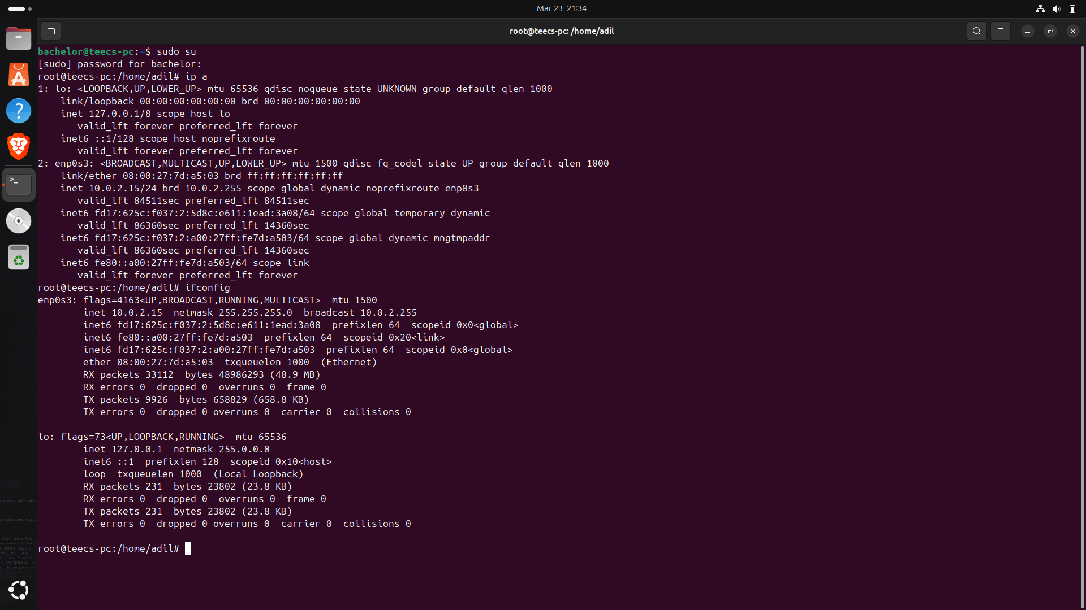
Testing Network Connectivity using ping google.com
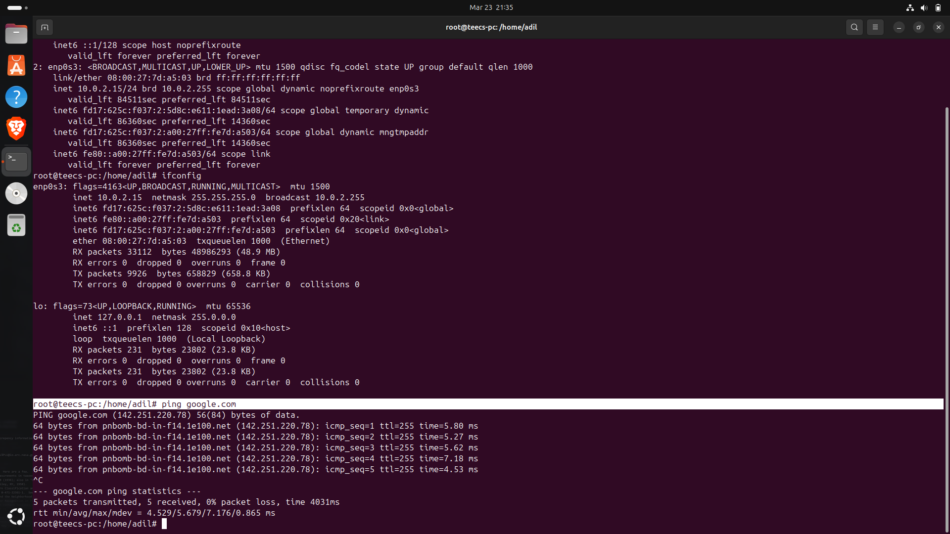
Tracing Network Path using traceroute google.com
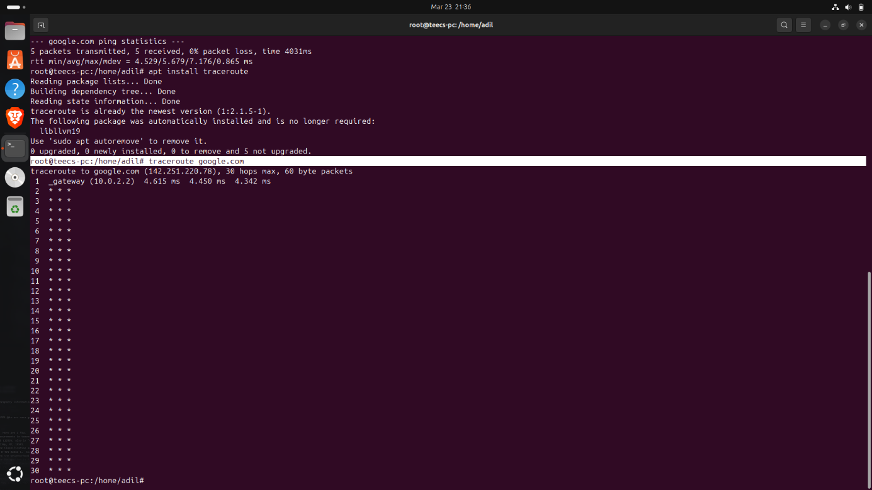
Performing DNS Lookup using nslookup google.com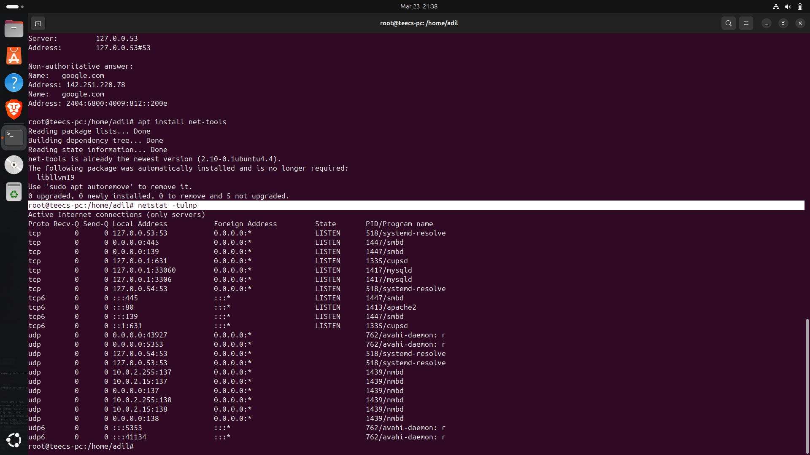

Displaying Active Network Connections using netstat -tulnp
Viewing ARP Table and Routing Table using arp -a, route -n, and ip route
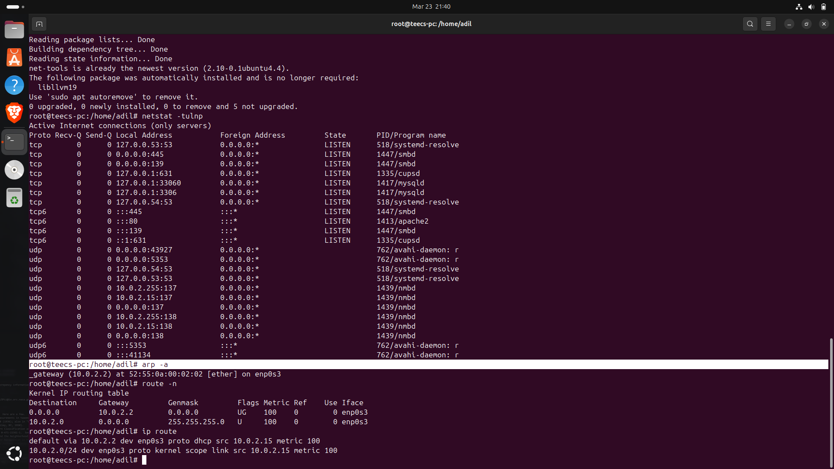
Conclusion: The experiment was successfully conducted with the aim of analyzing and implementing basic network commands using the Linux operating system. The basic network commands, which included ping, trace route, nslookup, net stat, arp, route, ip, etc., were executed, which helped in analyzing the network connectivity, network paths, DNS, etc. The experiment helped in obtaining a better idea of network concepts and their real-time applications.

