Roll No.224A7064 Date:16/3/26
Student Name:Adil Arkate

EXPERIMENT 8

Title: Implementation of Various Network Topologies using Cisco Packet Tracer

Objectives:
To simulate and understand different types of network topologies using Cisco Packet Tracer and observe how devices communicate within each topology.

Theory: Network Topology

Network topology refers to the arrangement of network devices (like PCs, switches, routers) and how they are connected physically or logically.

Types of Network Topologies:
Topology | Description | Key Features
Bus | All devices connected to a single backbone cable. | Simple, cost-effective, but difficult to troubleshoot.
Star | All devices connect to a central switch or hub. | Easy to manage; failure in one link doesn't affect others.
Ring | Devices connected in a circular loop. | Data flows in one direction; a break affects the whole network.
Mesh | Devices are interconnected with many redundant links. | Highly reliable and fault-tolerant.
Hybrid | Combination of two or more topologies. | Flexible and scalable; complex to design.
Steps:
- Open Cisco Packet Tracer.
- Drag and drop devices (PCs, switches, routers) as needed for the chosen topology.
- Connect devices using appropriate cables:
- Straight-through cable: PC to switch
- Crossover cable: PC to PC or switch to switch (if needed)
- Assign IP addresses to PCs using the IP configuration tab.
- Test connectivity:

- Use the ping command from one PC to another.
- Observe successful replies or error messages.
- Repeat steps for each topology: Bus, Star, Ring, Mesh, and Hybrid.

Topology Diagrams:
Bus Topology :
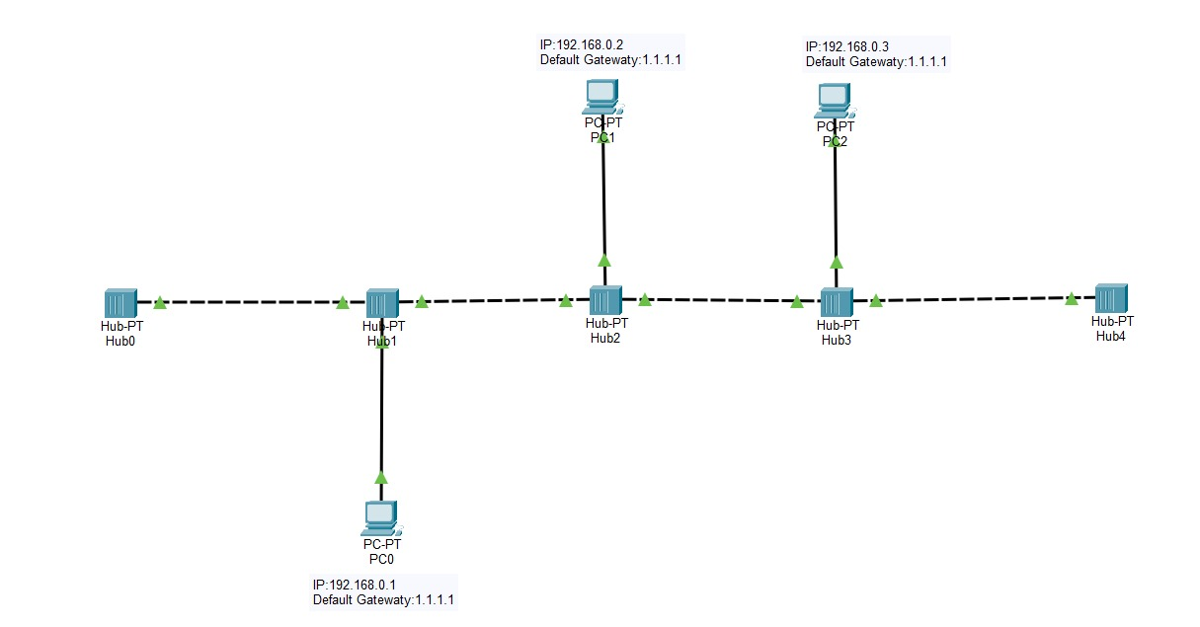
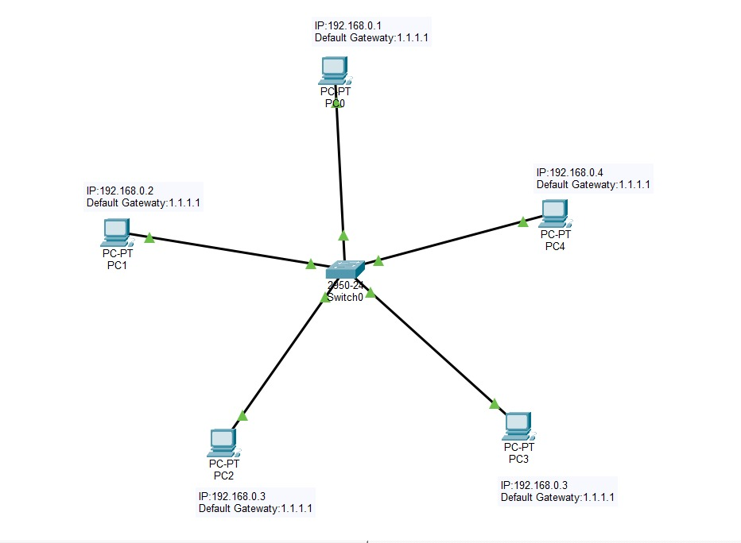
Star Topology :

Ring Topology :
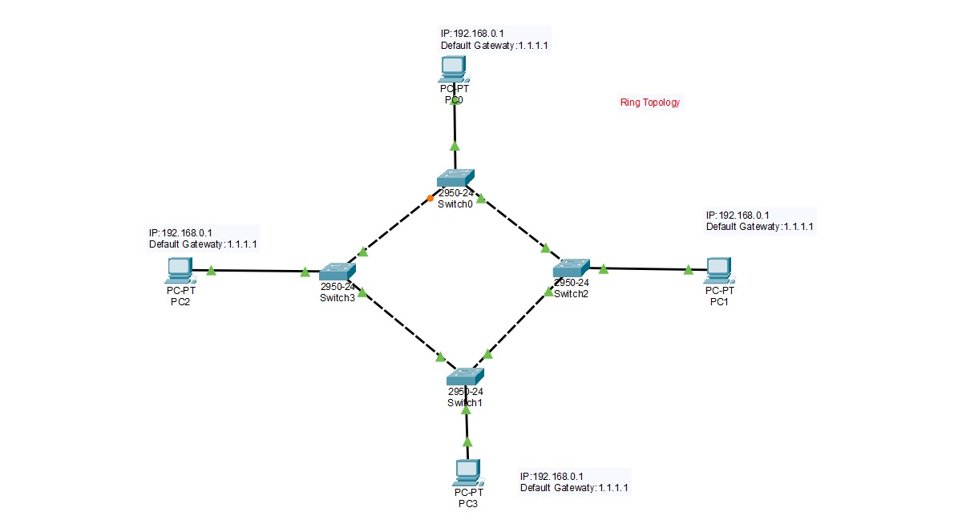
Mesh Topology :
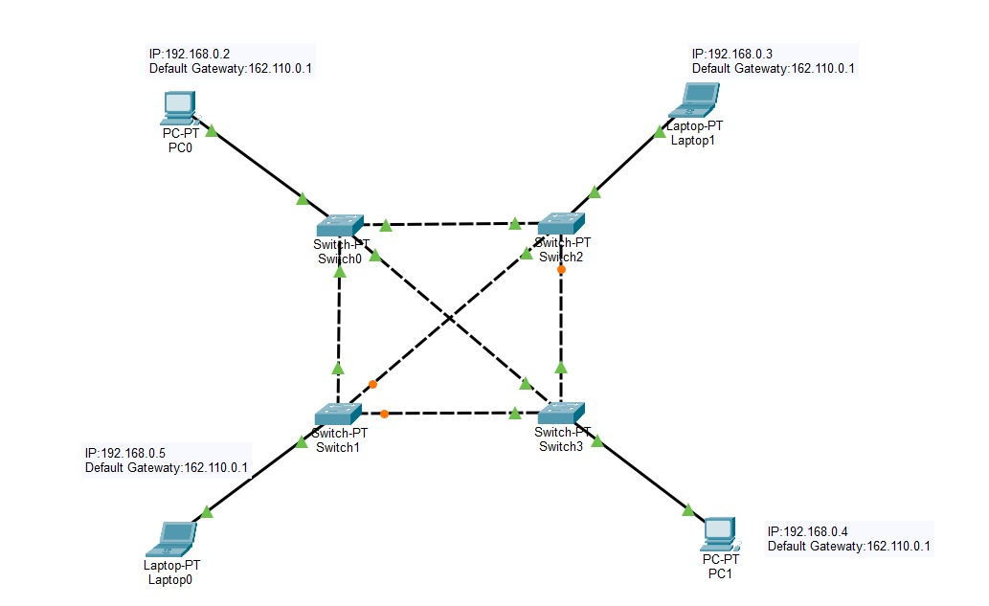
Results:
Bus Topology :
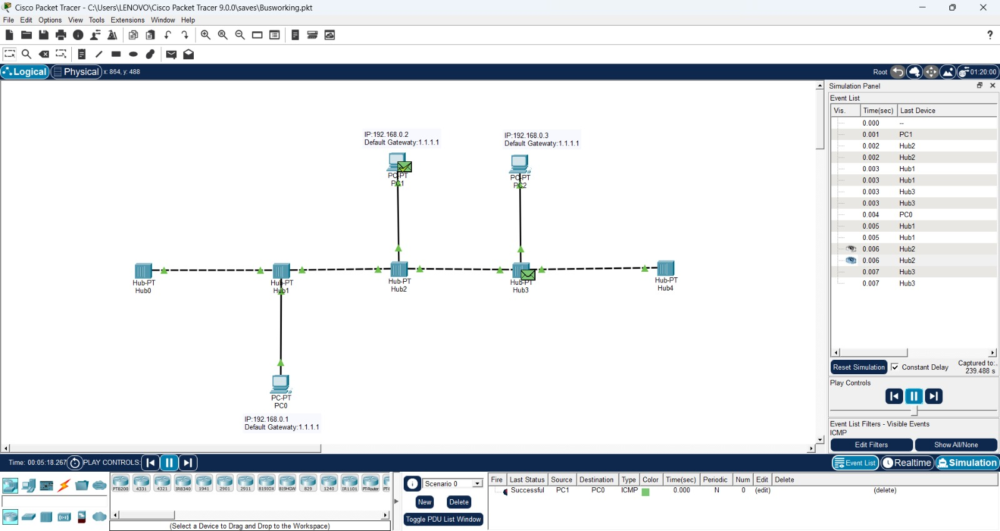
Star Topology :
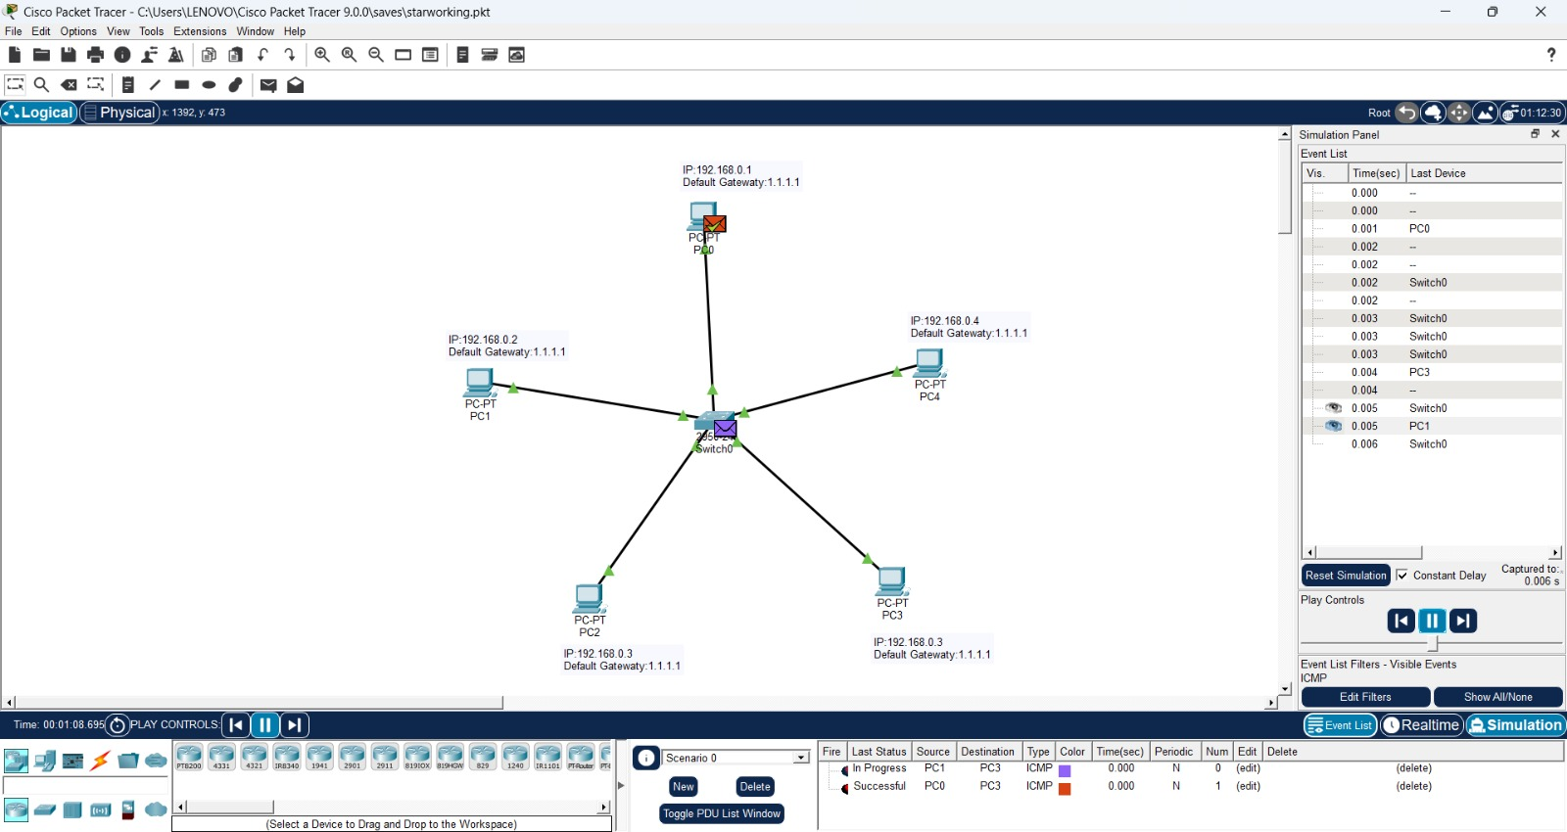
Ring Topology :
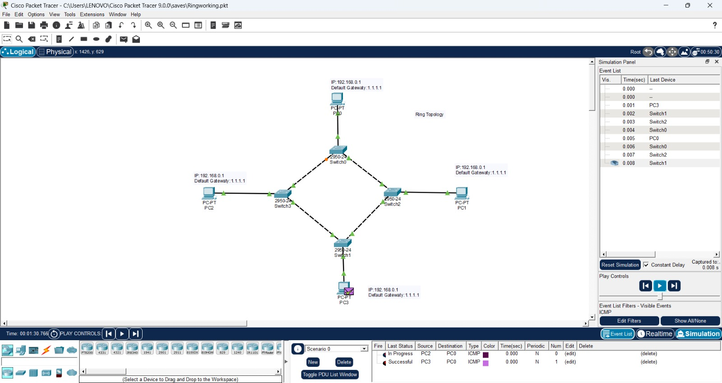

Mesh Topology :
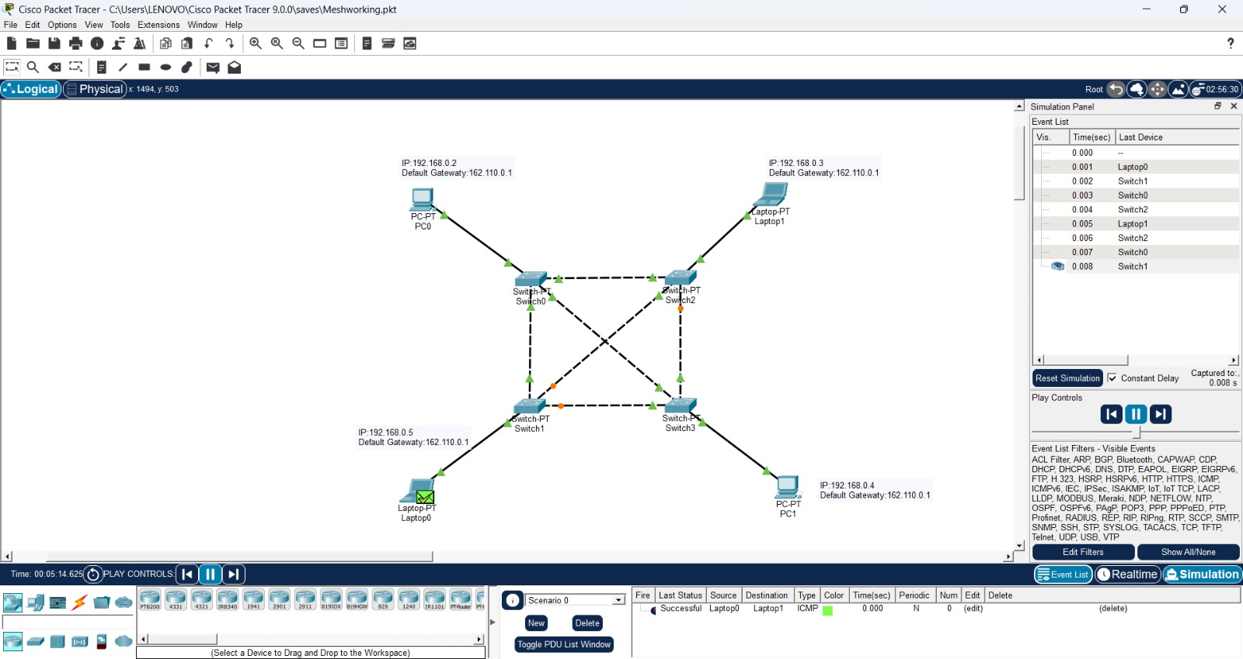

Conclusion:
Thus, all the major network topologies—bus, star, ring, and mesh—were successfully implemented. Through simulation in Cisco Packet Tracer, we were able to observe and understand the functioning and behavior of each topology in a practical manner.

