Roll No.224A7064 Date:9/3/26
Student Name:Adil Arkate

EXPERIMENT 9

Title: Implement Socket programming using TCP or UDP using Python

Objectives:
To establish connection and transmit information between two processes between client and server using Socket.

Theory:

Sockets in computer networks are used for allowing the transmission of information between two processes of the same machines or different machines in the network.
The socket is the combination of IP address and software port number used for communication between multiple processes.
Sockets allow communication of two processes that are running on the same or different machines. Sockets are the end of two-way communication between two programs that are running on the networks.

- Sockets are mostly used in client-server architecture for communication between multiple applications.
- Socket programming tells us how we can use socket API for creating communication between local and remote processes.
- The socket is created by the combination of the IP address and port number of the software. With this combination, the process knows the system address and address of the application where data is to be sent.
: is used to separate IP address and port number. For e.g.: 192.168.1.67:80, 155.2.12.23:77, etc.

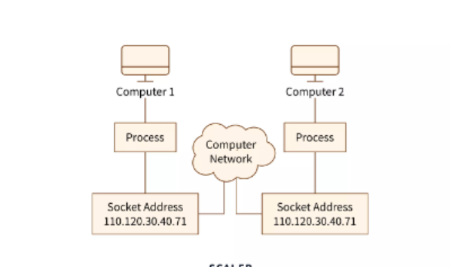
Results:
There are two basic protocols can be used to transmitting the message
1.) TCP/IP - Connection-Oriented Protocol
2.) UDP - Connection-less Protocol (You need to send the sender address for every packet transmitted).
Socket Programming in TCP

TCP stands for Transmission Control Protocol. TCP is a reliable connection-oriented protocol of the transport layer. TCP establishes the connection before data transmission. Steps for TCP socket programming for establishing TCP socket at the client-side:

- The first step is to create a socket and use the socket () function to create a socket.
- Use the connect () function for connecting the socket to the server address.
- Transmit data between two communicating parties using read () and write () functions.
- After data transmission completion close the connection using close () function.
Following are steps to be followed for establishing a TCP socket on the server-side:
- Use socket () for establishing a socket.
- Use the bind () function for binding the socket to an address.
- Then for listening client connections use listen () function.
- The accept () function is used for accepting the connection of the client.
- Transmit data with the help of the read () and write () function.
Below image to show TCP Socket connection
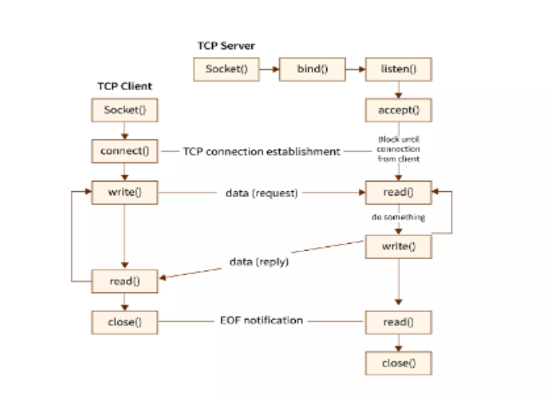
CODE:
Client side
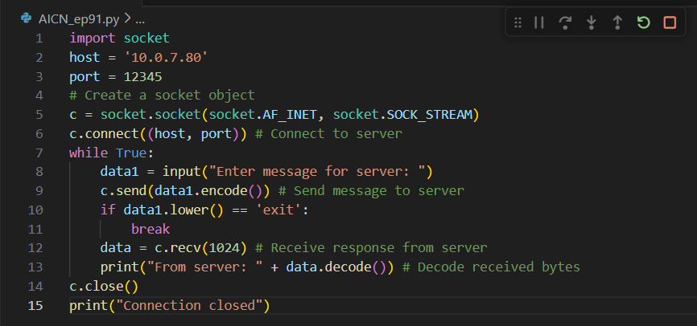
Server Side
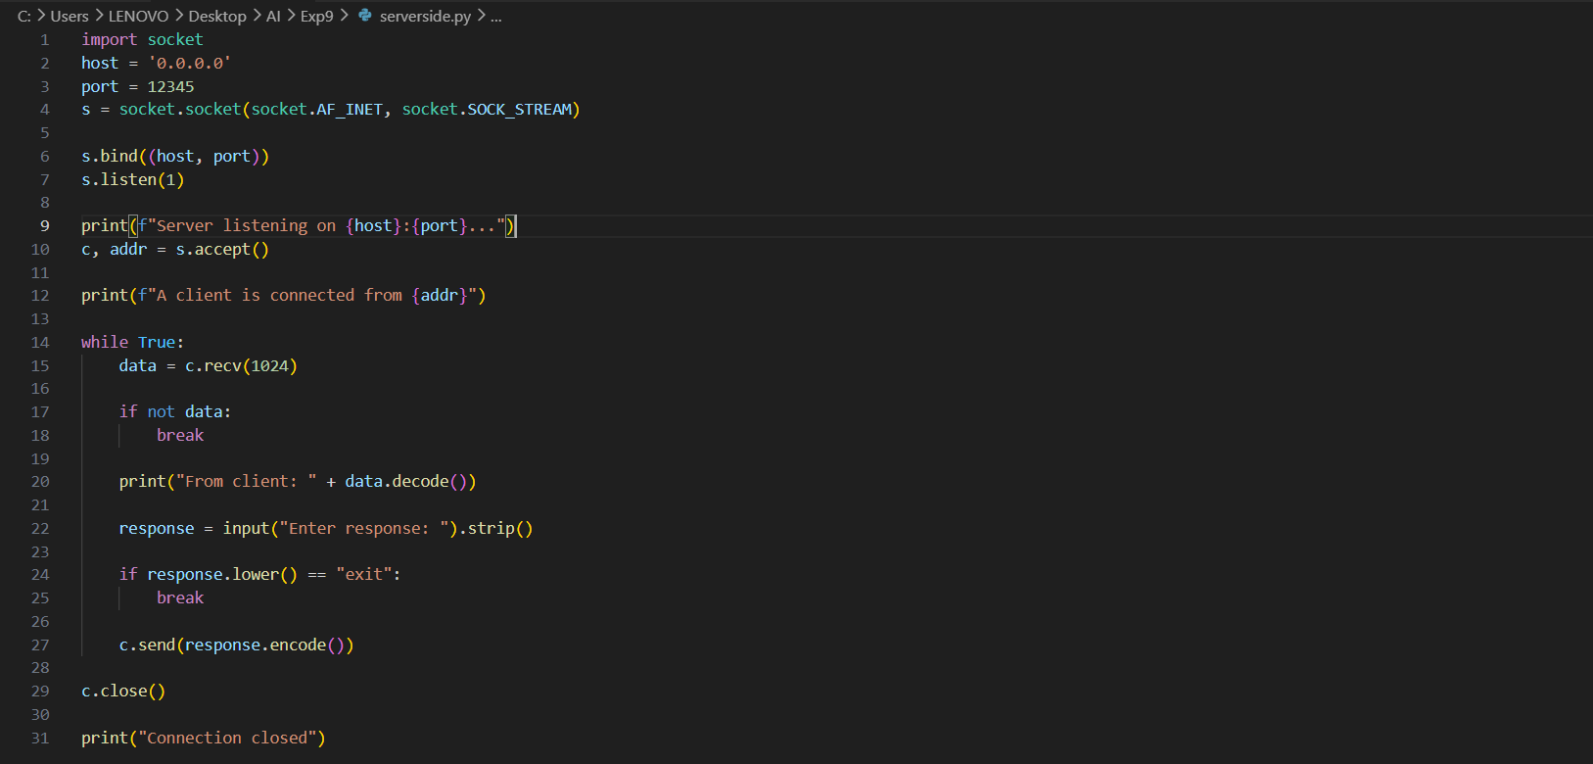

OUTPUT:
PC-1(Adil)
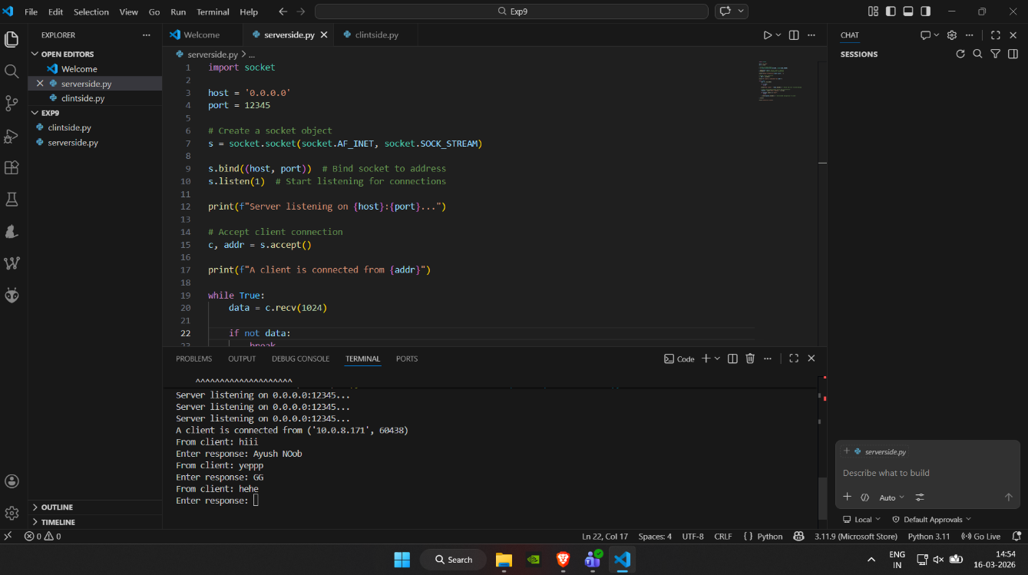
PC-2(Soham)
CONCLUSION:
The experiment was successfully implemented using TCP socket programming in Python. A client-server model was created to establish connection and exchange messages reliably. The results confirmed successful communication between processes using socket functions.

