EXPERIMENT NO.1
Interfacing of LEDs /switches with embedded core

Name: Adil Arkate Batch:B3
Roll No.:224A7064 Date:8/1/26

Aim : To interface Light Emitting Diodes (LEDs) and switches with an embedded controller and to control the LED operation based on switch input.

Objectives
- To understand digital input and output pins of an embedded controller
- To interface LEDs as output devices
- To interface switches as input devices
- To write and execute a simple embedded C program for GPIO control

Apparatus Required
S.No | Component | Specification | Quantity
1 | Embedded development board | Arduino UNO / 8051 / ARM | 1
2 | LED | Red/Green | 1–2
3 | Resistor | 220Ω (LED), 10kΩ (Switch) | As required
4 | Push Button Switch | Momentary | 1
5 | Breadboard | – | 1
6 | Connecting Wires | – | As required
7 | Power Supply / USB Cable | 5V | 1

Theory
An embedded system interacts with the external world using General Purpose Input Output (GPIO) pins.
- LED Interfacing:
LEDs are output devices. When a GPIO pin is configured as OUTPUT and driven HIGH, current flows through the LED causing it to glow (with a current-limiting resistor).
- Switch Interfacing:
A switch is an input device. When pressed, it changes the logic level at the GPIO pin. Pull-up or pull-down resistors are used to avoid floating inputs.

Circuit Diagram Description
- LED anode connected to a GPIO output pin through a 220Ω resistor
- LED cathode connected to GND
- One terminal of the switch connected to GPIO input pin
- Other terminal connected to GND
- Internal or external pull-up resistor enabled
Circuit Diagram :
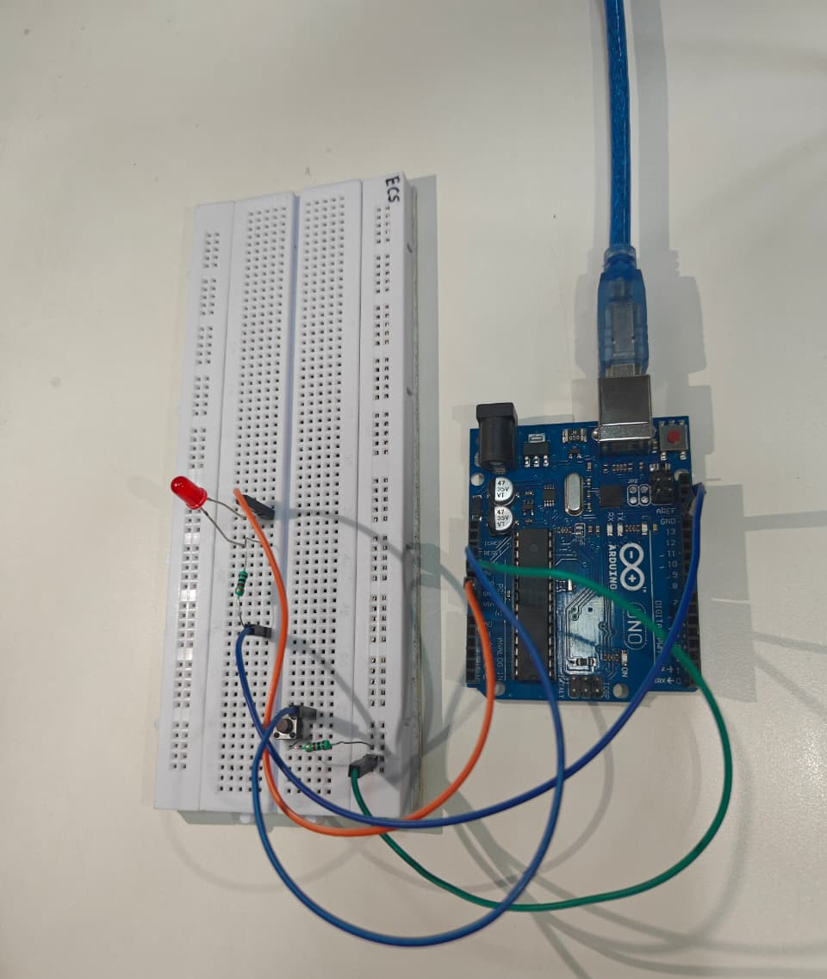

Pin Configuration ( Arduino UNO)
Device | Pin
LED | Digital Pin 8
Switch | Digital Pin 7
Power | 5V, GND

Algorithm
- Start
- Configure LED pin as OUTPUT
- Configure switch pin as INPUT (with pull-up)
- Read switch status
- If switch is pressed, turn ON LED
- Else turn OFF LED
- Repeat continuously

Program (Embedded C – Arduino )
int buttonState = 0;

void setup()
{
pinMode(2, INPUT);
pinMode(LED_BUILTIN, OUTPUT);
}

void loop()
{
// read the state of the pushbutton value
buttonState = digitalRead(2);
// check if pushbutton is pressed. if it is, the
// buttonState is HIGH
if (buttonState == HIGH) {
digitalWrite(LED_BUILTIN, HIGH);
} else {
// turn LED off
digitalWrite(LED_BUILTIN, LOW);
}
delay(10); // Delay a little bit to improve simulation performance
}
Procedure
- Connect the components as per the circuit diagram
- Power ON the embedded board
- Write the program and compile it
- Upload the program to the controller
- Press the switch and observe the LED behavior

Observation Table
Switch Status | LED Status
Pressed | ON
Released | OFF

Output Screenshot:
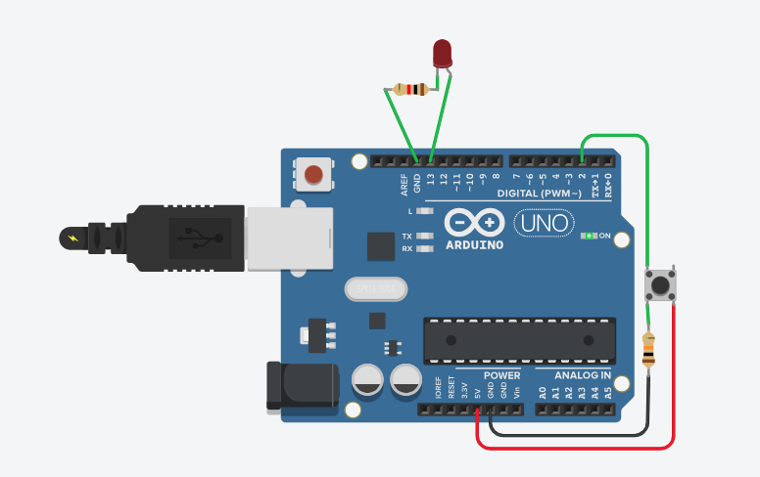

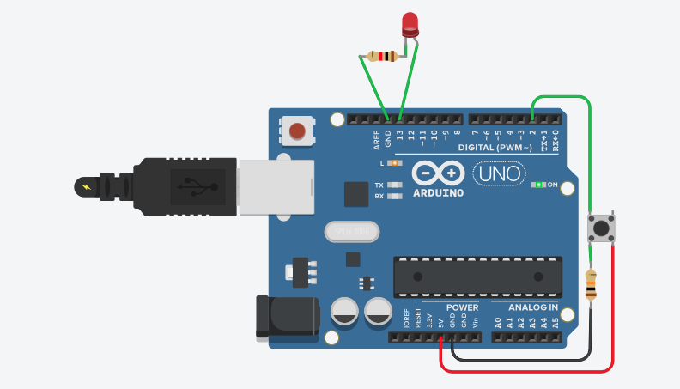

Conclusion:
In this experiment, LEDs and switches were successfully interfaced with an embedded controller using GPIO pins. The LED was controlled based on the input received from the switch, demonstrating the basic concept of digital input and output operations. By configuring the appropriate pins as input and output and using a simple embedded C program, real-time control of hardware components was achieved. This experiment helped in understanding GPIO functionality, switch debouncing basics, and practical implementation of embedded systems, forming a foundation for advanced embedded applications.

Applications
- Digital control systems
- Embedded user interfaces
- Home automation
- Industrial control panels

Precautions
- Use current-limiting resistors with LEDs
- Do not short power supply pins
- Ensure proper grounding
- Avoid loose connections

Viva Voce Questions
- Why is a resistor used with an LED?
- What is GPIO?
- Difference between pull-up and pull-down resistors
- What happens if the switch input is left floating?
- How can multiple LEDs be interfaced?

