EXPERIMENT NO.10
Write a program to illustrate the use of Binary and Counting Semaphore for Task Synchronization using Free RTOS.

Name: Adil Arkate Batch:B3
Roll No.:224A7064 Date:23/3/2026

Aim: Write a program to illustrate the use of Binary and Counting Semaphore for Task Synchronization using Free RTOS.
- Theory
FreeRTOS semaphores are synchronization primitives used to manage access to resources or synchronize tasks. Binary semaphores (0 or 1) act as flags for task/ISR signalling, while counting semaphores manage multiple resources, allowing up to tasks access simultaneously. Both use xSemaphoreTake to acquire and xSemaphoreGive to release.
- Binary Semaphores
Binary semaphores are used for signaling, such as waking a task when an interrupt occurs (deferred interrupt handling).
- Capacity: 1 token (value 0 or 1).
- Use Cases: Task-to-task synchronization, Interrupt-to-task synchronization.
- Creation: xSemaphoreCreateBinary().
- Functionality: If a task attempts to 'take' a binary semaphore with a value of 0, it blocks until an interrupt or another task 'gives' the semaphore, setting its value to 1.
- Alternative: Task Notifications are often faster and lighter.
- Counting Semaphores
Counting semaphores are used for managing resources with multiple instances or tracking occurrences of events.
- Capacity: N tokens (value 0 to Max).

- Use Cases: Resource management (e.g., managing a pool of buffers), event counting, limiting access rate.
- Creation: xSemaphoreCreateCounting(max_count, initial_count).
- Functionality: Each 'take' decrements the counter; each 'give' increments it. A task blocks only if it tries to take a token when the count is 0.
- Common FreeRTOS API Functions
- xSemaphoreTake(xSemaphore, xBlockTime)`: Acquires a semaphore token.
- xSemaphoreGive(xSemaphore)`: Releases a semaphore token.
- xSemaphoreGiveFromISR()`: Specialized version for giving a semaphore within an interrupt service routine.
- Key Implementation Details
- Ownership: Unlike mutexes, semaphores do not have ownership. Any task or ISR can "give" or "take" a semaphore.
- Interrupt Handling: xSemaphoreGiveFromISR is critical for signaling from ISR to tasks.
- Setup: Counting semaphores require a maximum count and an initial count. For resource management, the initial count is usually set to the max count.
- CODE:
- Part A: Binary Semaphore Example-
- Concept-
- Task1 waits for signal
- Task2 gives signal after delay
#include <STM32FreeRTOS.h>

// --- GLOBAL DECLARATIONS ---
// These must be outside setup() so all functions can see them
SemaphoreHandle_t xBinarySemaphore;

// Function Prototypes (telling the compiler these exist)
void TaskProducer(void *pvParameters);
void TaskConsumer(void *pvParameters);

void setup() {
Serial.begin(9600);
while (!Serial);

pinMode(PA5, OUTPUT); // Onboard LED

Serial.println("--- FreeRTOS Binary Semaphore Experiment ---");

// 1. Create the Semaphore
xBinarySemaphore = xSemaphoreCreateBinary();

if (xBinarySemaphore != NULL) {
// 2. Create Tasks
xTaskCreate(TaskProducer, "Producer", 128, NULL, 2, NULL);
xTaskCreate(TaskConsumer, "Consumer", 128, NULL, 1, NULL);

// 3. Start Scheduler
vTaskStartScheduler();
}
}

void loop() {
// Should be empty!
}

// --- TASK 1: PRODUCER ---
void TaskProducer(void *pvParameters) {
for (;;) {
Serial.println("Producer: Giving Semaphore...");
xSemaphoreGive(xBinarySemaphore);
vTaskDelay(pdMS_TO_TICKS(2000)); // Wait 2 seconds
}
}

// --- TASK 2: CONSUMER ---
void TaskConsumer(void *pvParameters) {
for (;;) {
// Wait for the flag
if (xSemaphoreTake(xBinarySemaphore, portMAX_DELAY) == pdTRUE) {
Serial.println("Consumer: Semaphore Taken! LED ON.");
digitalWrite(PA5, HIGH);
vTaskDelay(pdMS_TO_TICKS(200));
digitalWrite(PA5, LOW);
}
}
}

- Explanation:

- xSemaphoreTake() → Task waits
- xSemaphoreGive() → Signal sent
- Ensures proper task coordination

- Part B: Counting Semaphore Example-
- Concept-
- Semaphore count = 3
- 3 tasks can access resource simultaneously
#include <STM32FreeRTOS.h>

// --- Definitions ---
const int externalLed = PA10; // D2
const int buzzerPin = PB3; // D3

// Declare Counting Semaphore Handle
SemaphoreHandle_t xCountingSemaphore;

void TaskProducer(void *pvParameters);
void TaskConsumer(void *pvParameters);

void setup() {
Serial.begin(9600);
while (!Serial);

// Initialize Hardware
pinMode(PA5, OUTPUT);
pinMode(externalLed, OUTPUT);
pinMode(buzzerPin, OUTPUT);

Serial.println("--- Scheduler with Counting Semaphore ---");

// Create Semaphore: Max 3 tokens (one for each hardware task)
xCountingSemaphore = xSemaphoreCreateCounting(3, 0);

if (xCountingSemaphore != NULL) {
xTaskCreate(TaskProducer, "Producer", 128, NULL, 2, NULL);
xTaskCreate(TaskConsumer, "Consumer", 128, NULL, 1, NULL);
vTaskStartScheduler();
}
}

void loop() {}

// --- TASK 1: THE PRODUCER (Triggers the Sequence) ---
void TaskProducer(void *pvParameters) {
for (;;) {
Serial.println("\nProducer: Releasing 3 Tokens for the Hardware Cycle...");

// Give 3 tokens to signal that 3 tasks are ready to run
xSemaphoreGive(xCountingSemaphore);
xSemaphoreGive(xCountingSemaphore);
xSemaphoreGive(xCountingSemaphore);

vTaskDelay(pdMS_TO_TICKS(5000)); // Wait 5 seconds between cycles
}
}

// --- TASK 2: THE CONSUMER (Executes Hardware Tasks) ---
void TaskConsumer(void *pvParameters) {
int taskCount = 0;
for (;;) {
if (xSemaphoreTake(xCountingSemaphore, portMAX_DELAY) == pdTRUE) {
taskCount++;

if (taskCount == 1) {
Serial.println("Consumer: Task 1 - Onboard LED");
digitalWrite(PA5, HIGH); vTaskDelay(pdMS_TO_TICKS(500)); digitalWrite(PA5, LOW);
}
else if (taskCount == 2) {
Serial.println("Consumer: Task 2 - External LED");
digitalWrite(externalLed, HIGH); vTaskDelay(pdMS_TO_TICKS(500)); digitalWrite(externalLed, LOW);
}

else if (taskCount == 3) {
Serial.println("Consumer: Task 3 - Buzzer Beep");
digitalWrite(buzzerPin, HIGH); vTaskDelay(pdMS_TO_TICKS(200)); digitalWrite(buzzerPin, LOW);
taskCount = 0; // Reset for the next cycle
Serial.println(">> Full Scheduler Cycle Complete!");
}
}
}
}

- Explanation

- Max 3 tasks run simultaneously
- 4th task waits until resource is free

- CIRCUIT DIAGRAM: -
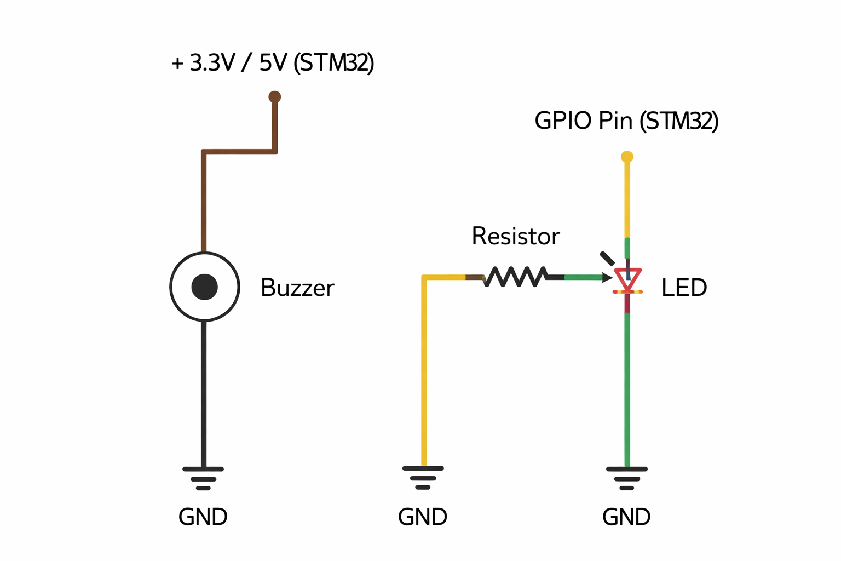

- OUTPUT:

- Binary Semaphore Operation-

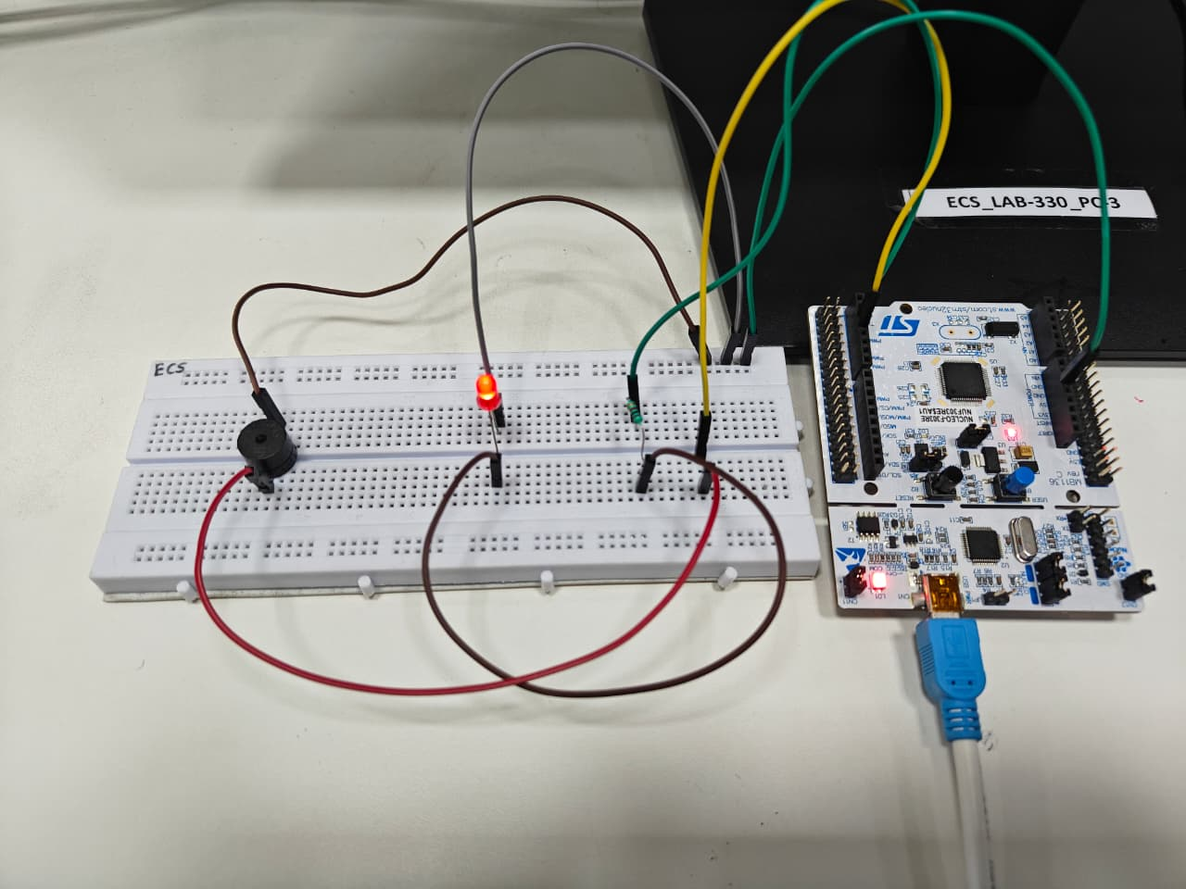
- Counting Semaphore Operation-
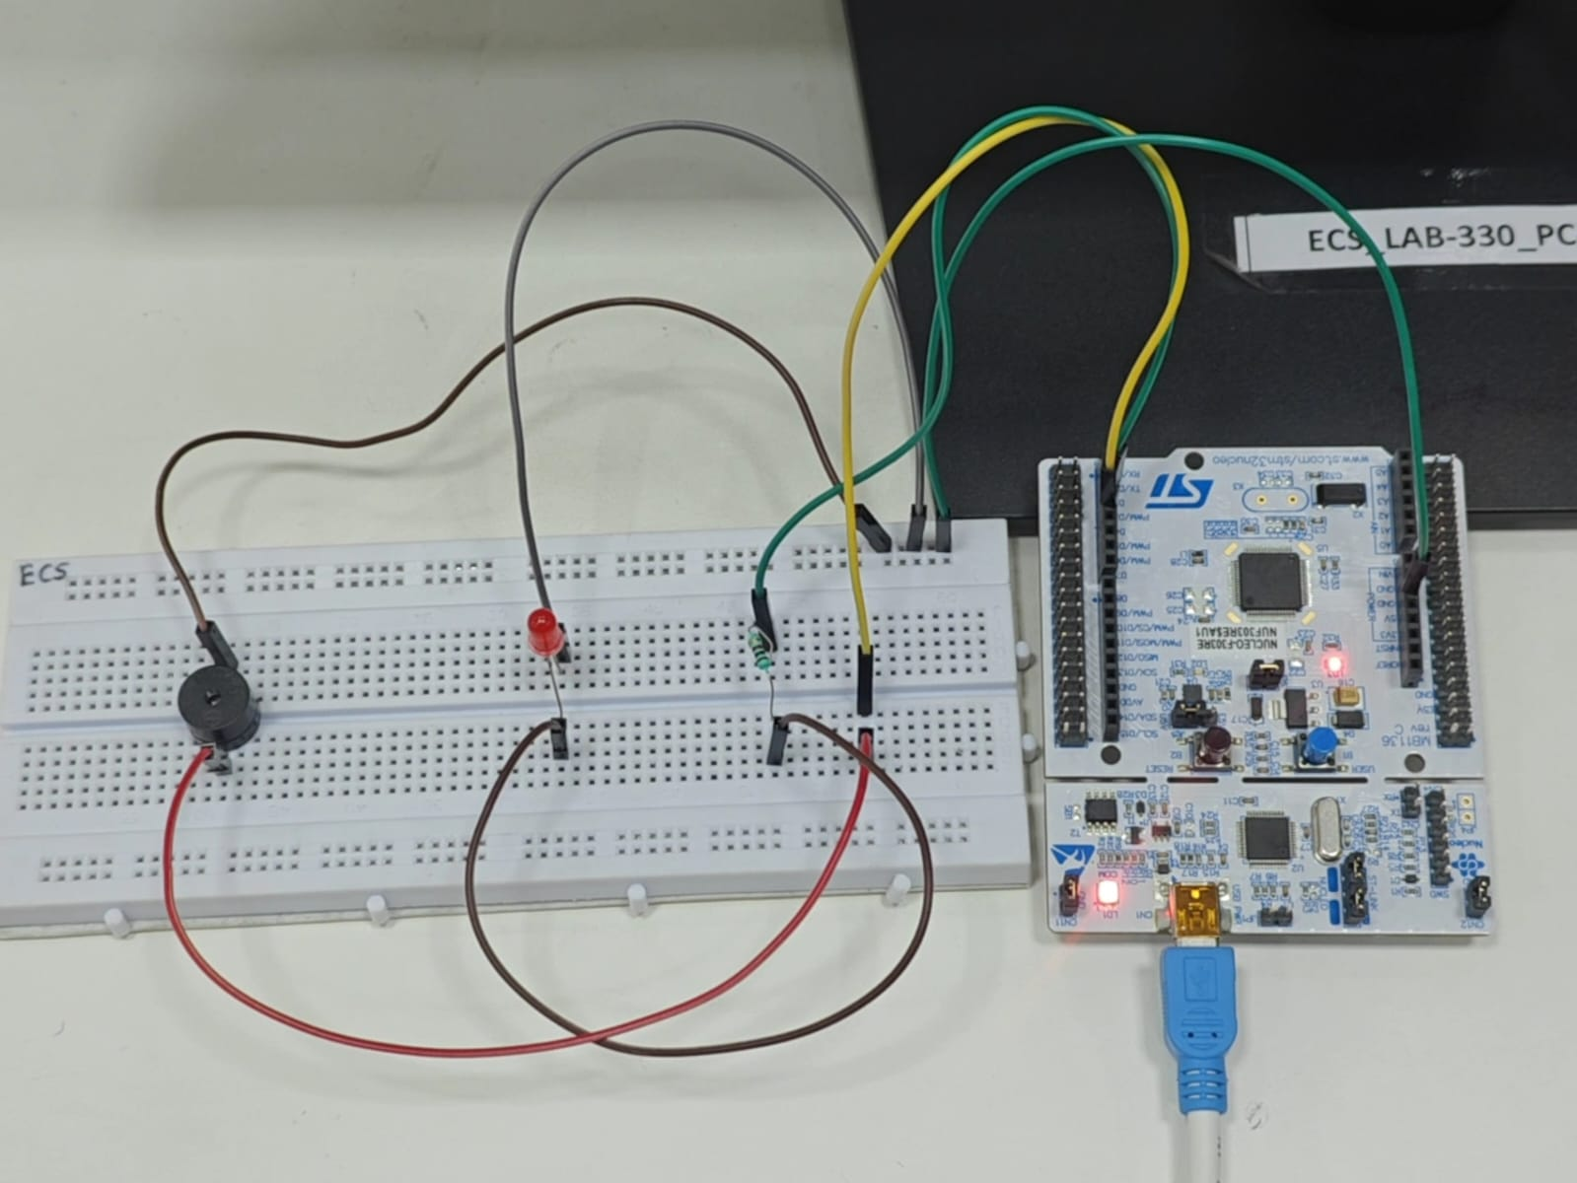
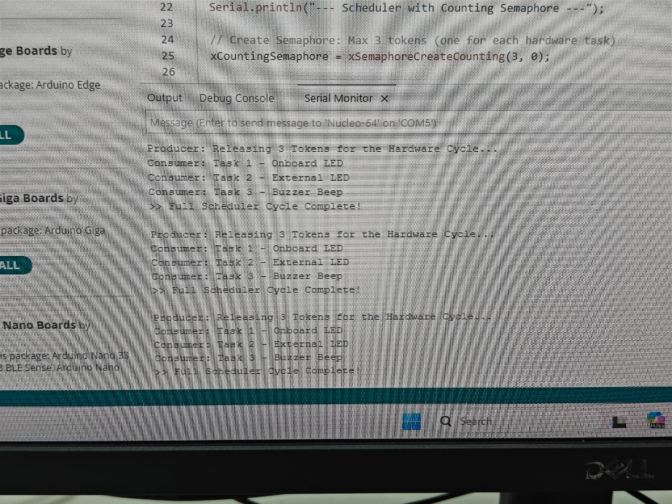

CONCLUSION:
"This experiment confirms that Binary Semaphores are ideal for one-to-one task signaling, while Counting Semaphores effectively manage access to multiple shared resources. By using xSemaphoreTake and SemaphoreGive, we successfully demonstrated how to prevent resource contention and ensure synchronized task execution in a real-time environment."

