EXPERIMENT NO.2
Interfacing DHT11 Temperature and Humidity Sensor with Arduino Uno

Name: Adil Arkate Batch:B3
Roll No.:224A7064 Date:15/1/26

Aim : To interface the DHT11 temperature and humidity sensor with Arduino Uno and display the measured temperature and relative humidity on the Serial Monitor.

Apparatus / Components Required :
- Arduino Uno
- DHT11 Temperature & Humidity Sensor
- 10 kΩ Pull-up Resistor (if not using DHT11 module)
- Breadboard
- Connecting Wires
- USB Cable
- Arduino IDE (Software)

Theory :
The DHT11 is a low-cost digital sensor used to measure temperature and relative humidity. It contains:
- A capacitive humidity sensor
- A thermistor for temperature measurement
- An internal ADC and digital signal output
The sensor communicates with the microcontroller using a single-wire serial communication protocol. The data is transmitted as a digital signal, making it less susceptible to noise compared to analog sensors.
Specifications of DHT11:
- Temperature range: 0°C to 50°C
- Humidity range: 20% to 90% RH
- Accuracy: ±2°C and ±5% RH
- Operating voltage: 3.3V – 5V
The Arduino Uno reads the sensor data using a dedicated DHT library and displays the values via the Serial Monitor.

Pin Configuration
DHT11 Pin | Description | Arduino Connection
VCC |  | Power Supply 5V
DATA | Data Output | Digital Pin 2
GND | Ground | GND
Note: If using a bare DHT11 sensor, connect a 10 kΩ pull-up resistor between VCC and DATA pin.

Circuit Diagram :
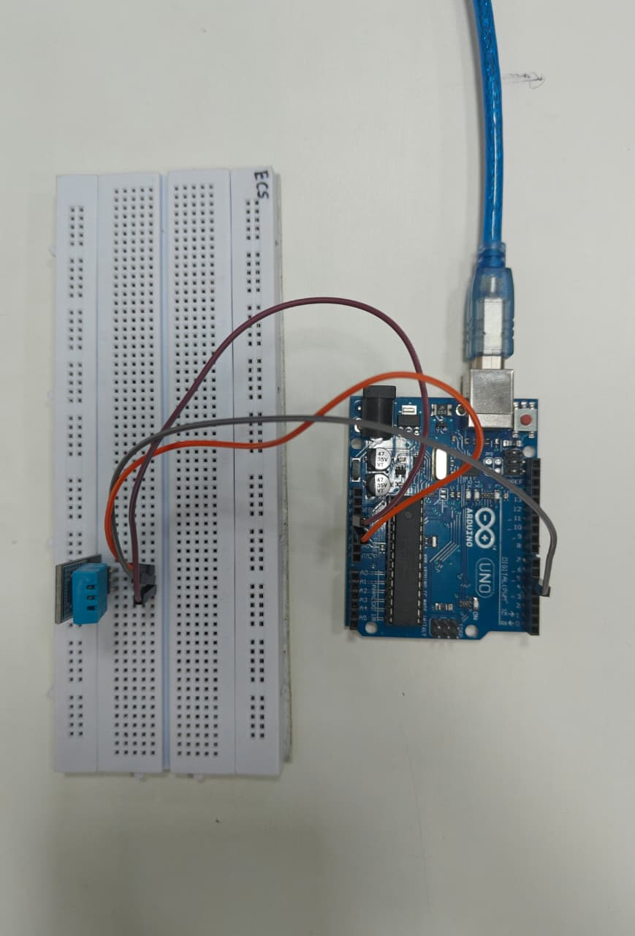

Circuit Diagram (Description) :
- Connect VCC of DHT11 to 5V of Arduino Uno
- Connect GND of DHT11 to GND of Arduino Uno
- Connect DATA of DHT11 to Digital Pin 2 of Arduino Uno
- Insert a pull-up resistor between VCC and DATA if required

Algorithm
- Start the program
- Initialize DHT11 sensor and serial communication
- Read temperature and humidity values from DHT11
- Check if sensor reading is valid
- Display temperature and humidity on Serial Monitor
- Repeat the process after a delay

Program Code
#include <DHT.h>

#define DHTPIN 2 // DHT11 data pin connected to Arduino pin 2
#define DHTTYPE DHT11 // Define DHT11 sensor type

DHT dht(DHTPIN, DHTTYPE);

void setup() {
Serial.begin(9600);
dht.begin();
Serial.println("DHT11 Sensor Reading");
}

void loop() {
float humidity = dht.readHumidity();
float temperature = dht.readTemperature();

// Check if any reads failed
if (isnan(humidity) || isnan(temperature)) {
Serial.println("Failed to read from DHT sensor!");
return;
}

Serial.print("Humidity: ");
Serial.print(humidity);
Serial.print(" %\t");

Serial.print("Temperature: ");
Serial.print(temperature);
Serial.println(" °C");

delay(2000);
}

Procedure :
- Assemble the circuit as per the connections described
- Open Arduino IDE
- Install the DHT Sensor Library using Library Manager
- Select Board: Arduino Uno and correct COM Port
- Upload the program to Arduino
- Open Serial Monitor and set baud rate to 9600 bps
- Observe temperature and humidity readings

Observation (Output Screenshot) :
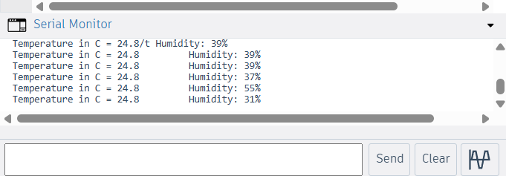
Parameter | Observed Value
Temperature | 24.8 °C
Humidity | 39 %

Conclusion: In this experiment, the DHT11 temperature and humidity sensor was successfully interfaced with the Arduino Uno. The sensor accurately measured the ambient temperature and relative humidity, and the readings were displayed on the Serial Monitor using the Arduino IDE. The obtained results confirmed proper working of the sensor and communication between the Arduino and DHT11. This experiment helped in understanding sensor interfacing, data acquisition, and real-time monitoring, which are essential concepts in embedded systems and IoT applications.

Applications :
- Weather monitoring systems
- Smart home automation
- HVAC control
- Environmental monitoring
- Agriculture and greenhouse systems

Precautions :
- Ensure correct pin connections
- Do not power the sensor with voltage above 5V
- Maintain proper delay between readings
- Handle the sensor carefully to avoid damage

