EXPERIMENT NO.3
Interfacing Seven Segment Display with Arduino in Embedded core

Name: Adil Arkate Batch:B3
Roll No.:224A7064 Date:22/1/26

Aim : To interface a seven-segment display (common anode or common cathode) with Arduino and display digits 0–9 sequentially.

2. Apparatus / Components Required
- Arduino Uno (or compatible board)
- Seven Segment Display (Common Anode/Common Cathode)
- 220Ω Resistors – 7 or 8 pcs
- Breadboard
- Jumper Wires
- USB Cable

3. Theory
A seven-segment display consists of 7 LEDs (segments a–g) and one decimal point (dp). Each segment lights up to form numeric digits (0–9).
Types:
- Common Cathode (CC): All LED cathodes are tied together to GND. Segments glow when HIGH is applied.
- Common Anode (CA): All LED anodes are tied together to VCC. Segments glow when LOW is applied.
Segment Labeling:
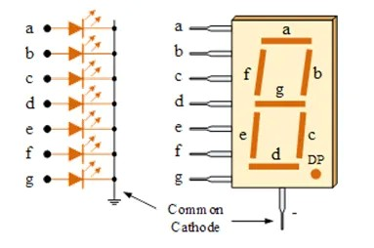

Each segment is controlled individually via Arduino pins.
4. Pin Configuration (Typical 7-Segment Display)
Segment | Pin No.
a | 7
b | 6
c | 4
d | 2
e | 1
f | 9
g | 10
dp | 5
Common | 3, 8

5. Circuit Diagram (Description)
- Connect Arduino digital pins 2–8 to the seven-segment segments a–g.
- Connect each segment through a 220Ω resistor.
- Connect the common pin:
  - CC → GND
  - CA → 5V
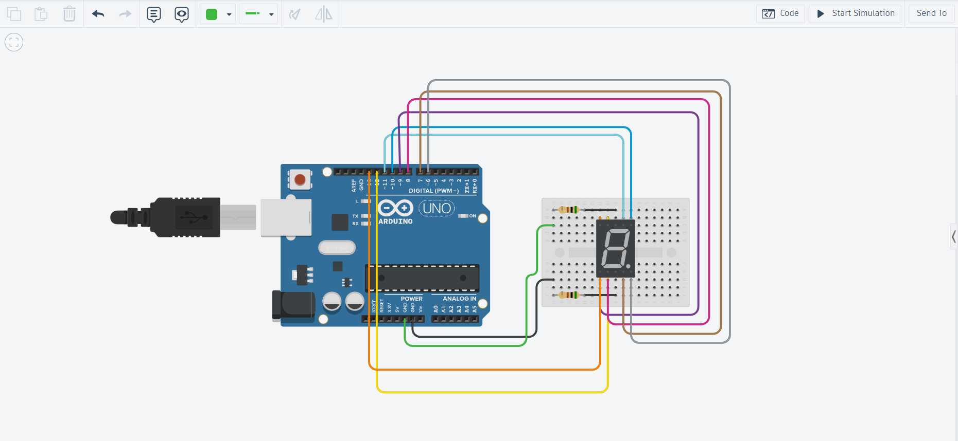

6. Arduino Code :
Displaying digits 0–9 sequentially
unsigned const int A = 13;
unsigned const int B = 12;
unsigned const int C = 11;
unsigned const int D = 10;
unsigned const int E = 9;
unsigned const int F = 8;
unsigned const int G = 7;
unsigned const int H = 6;

void setup(void)
{
pinMode(A, OUTPUT);
pinMode(B, OUTPUT);
pinMode(C, OUTPUT);
pinMode(D, OUTPUT);
pinMode(E, OUTPUT);
pinMode(F, OUTPUT);
pinMode(G, OUTPUT);
pinMode(H, OUTPUT);
}

//My Functions

void zero(void) {
digitalWrite(A, LOW);
digitalWrite(B, HIGH);
digitalWrite(C, HIGH);
digitalWrite(D, HIGH);
digitalWrite(E, HIGH);
digitalWrite(F, HIGH);
digitalWrite(G, HIGH);
digitalWrite(H, LOW);
}

void one(void) {
digitalWrite(A, LOW);
digitalWrite(B, LOW);
digitalWrite(C, LOW);
digitalWrite(D, HIGH);
digitalWrite(E, LOW);
digitalWrite(F, LOW);
digitalWrite(G, HIGH);
digitalWrite(H, LOW);
}

void two(void) {
digitalWrite(A, HIGH);
digitalWrite(B, LOW);
digitalWrite(C, HIGH);
digitalWrite(D, HIGH);
digitalWrite(E, HIGH);
digitalWrite(F, HIGH);
digitalWrite(G, LOW);
digitalWrite(H, LOW);
}

void three(void) {
digitalWrite(A, HIGH);
digitalWrite(B, LOW);
digitalWrite(C, HIGH);
digitalWrite(D, HIGH);
digitalWrite(E, LOW);
digitalWrite(F, HIGH);
digitalWrite(G, HIGH);
digitalWrite(H, LOW);
}

void four(void) {
digitalWrite(A, HIGH);
digitalWrite(B, HIGH);
digitalWrite(C, LOW);
digitalWrite(D, HIGH);
digitalWrite(E, LOW);
digitalWrite(F, LOW);
digitalWrite(G, HIGH);
digitalWrite(H, LOW);
}

void five(void) {
digitalWrite(A, HIGH);
digitalWrite(B, HIGH);
digitalWrite(C, HIGH);
digitalWrite(D, LOW);
digitalWrite(E, LOW);
digitalWrite(F, HIGH);
digitalWrite(G, HIGH);
digitalWrite(H, LOW);
}

void six(void) {
digitalWrite(A, HIGH);
digitalWrite(B, HIGH);
digitalWrite(C, HIGH);
digitalWrite(D, LOW);
digitalWrite(E, HIGH);
digitalWrite(F, HIGH);
digitalWrite(G, HIGH);
digitalWrite(H, LOW);
}

void seven(void) {
digitalWrite(A, LOW);
digitalWrite(B, LOW);
digitalWrite(C, HIGH);
digitalWrite(D, HIGH);
digitalWrite(E, LOW);
digitalWrite(F, LOW);
digitalWrite(G, HIGH);
digitalWrite(H, LOW);
}

void eight(void) {
digitalWrite(A, HIGH);
digitalWrite(B, HIGH);
digitalWrite(C, HIGH);
digitalWrite(D, HIGH);
digitalWrite(E, HIGH);
digitalWrite(F, HIGH);
digitalWrite(G, HIGH);
digitalWrite(H, LOW);
}

void nine(void) {
digitalWrite(A, HIGH);
digitalWrite(B, HIGH);
digitalWrite(C, HIGH);
digitalWrite(D, HIGH);
digitalWrite(E, LOW);
digitalWrite(F, HIGH);
digitalWrite(G, HIGH);
digitalWrite(H, LOW);
}

// Start
void loop(void)
{
zero();
delay(100);

one();
delay(100);

two();
delay(100);

three();
delay(100);

four();
delay(100);

five();
delay(100);

six();
delay(100);

seven();
delay(100);

eight();
delay(100);

nine();
delay(100);
}

7. Procedure
- Make connections according to the circuit diagram.
- Identify the display type (CA/CC). Adjust logic if using CA (invert segment values).
- Upload the code to Arduino.
- Observe digits 0–9 displayed sequentially.

8. Observations

Digit | Segments ON
0 | a b c d e f
1 | b c
2 | a b d e g
3 | a b c d g
4 | b c f g
5 | a c d f g
6 | a c d e f g
7 | a b c
8 | a b c d e f g
9 | a b c d f g

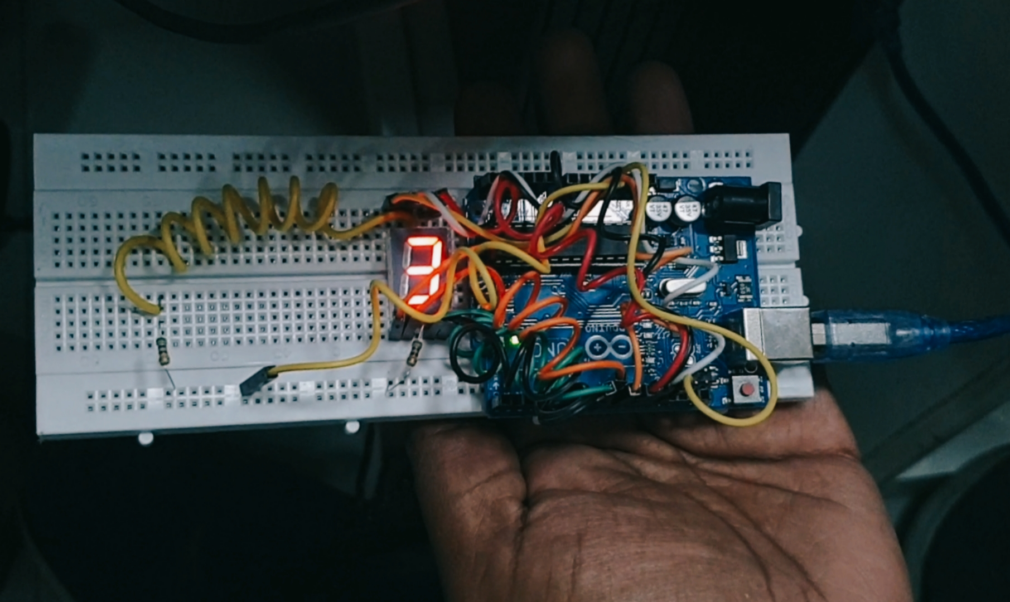

9. Conclusion :
In this experiment, a seven-segment display was successfully interfaced with Arduino to display digits from 0 to 9 sequentially. This helped in understanding digital output control and practical interfacing of display devices in embedded systems.

10. Viva Questions :
- What is a seven-segment display?
A seven-segment display is an electronic device made of seven LEDs used to show numbers from 0 to 9. It is commonly used in digital instruments and counters.
- Difference between common cathode and common anode.
In common cathode, all cathodes are connected to ground and segments glow when HIGH is applied. In common anode, all anodes are connected to VCC and segments glow when LOW is applied.
- Why are resistors used in the circuit?
Resistors limit the current flowing through the LEDs. They protect the display from damage due to excess current.
- How does Arduino control each segment?
Each segment is connected to a digital pin of Arduino. By setting the pin HIGH or LOW, Arduino turns the segment ON or OFF.
- Can we display alphabets on a 7-segment display?
Yes, some alphabets like A, b, C, d, E, and F can be displayed. However, all letters cannot be shown clearly due to limited segments.

11. Applications :
- Digital clocks
- Counters
- Instrument panels
- Calculators
- Scoreboards

