EXPERIMENT NO.4
Interfacing LCD 16 x 2 display using I2C module with arduino

Name: Adil Arkate Batch:B3
Roll No.:224A7064 Date:29/1/26

Aim : Interfacing LCD 16 x 2 display using I2C module with arduino
Theory :
- LCD Fundamentals:
- LCDs contain a liquid crystal material sandwiched between two polarizing filters.
- Applying an electric field to specific LCD segments alters their light- modulating properties, creating visible characters.
- I2C LCD modules typically have an onboard controller chip that manages communication and display updates.
- I2C Communication:
- I2C operates in a master-slave configuration. Arduino acts as the master,
initiating communication and controlling data flow. o The I2C module on the LCD acts as the slave, responding to commands from the master. o Data is transmitted serially, one bit at a time, using the SDA and SCL lines.
- Arduino-LCD Interaction:
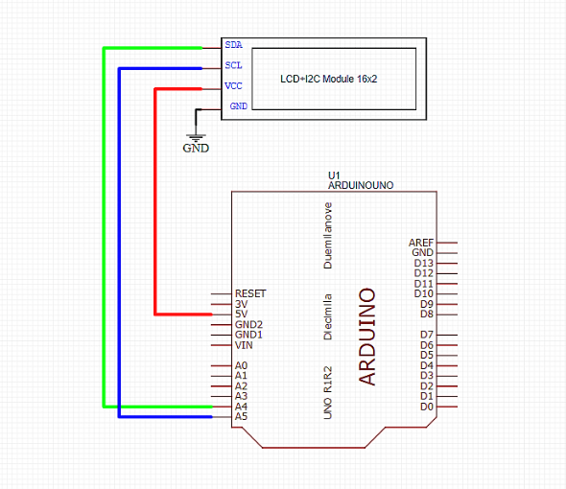
- The LiquidCrystal_I2C library (download from [Arduino library manager]) simplifies communication between Arduino and I2C LCDs.
- The library provides functions for initialization, backlight control, clearing the display, setting cursor position, and printing text.
- Connection Diagram o Connect VCC of the LCD module to the 5V pin on Arduino. o Connect GND of the LCD module to the GND pin on Arduino. o Connect SDA of the LCD module to the A4 (SDA) pin on Arduino (or the
Circuit Diagram:
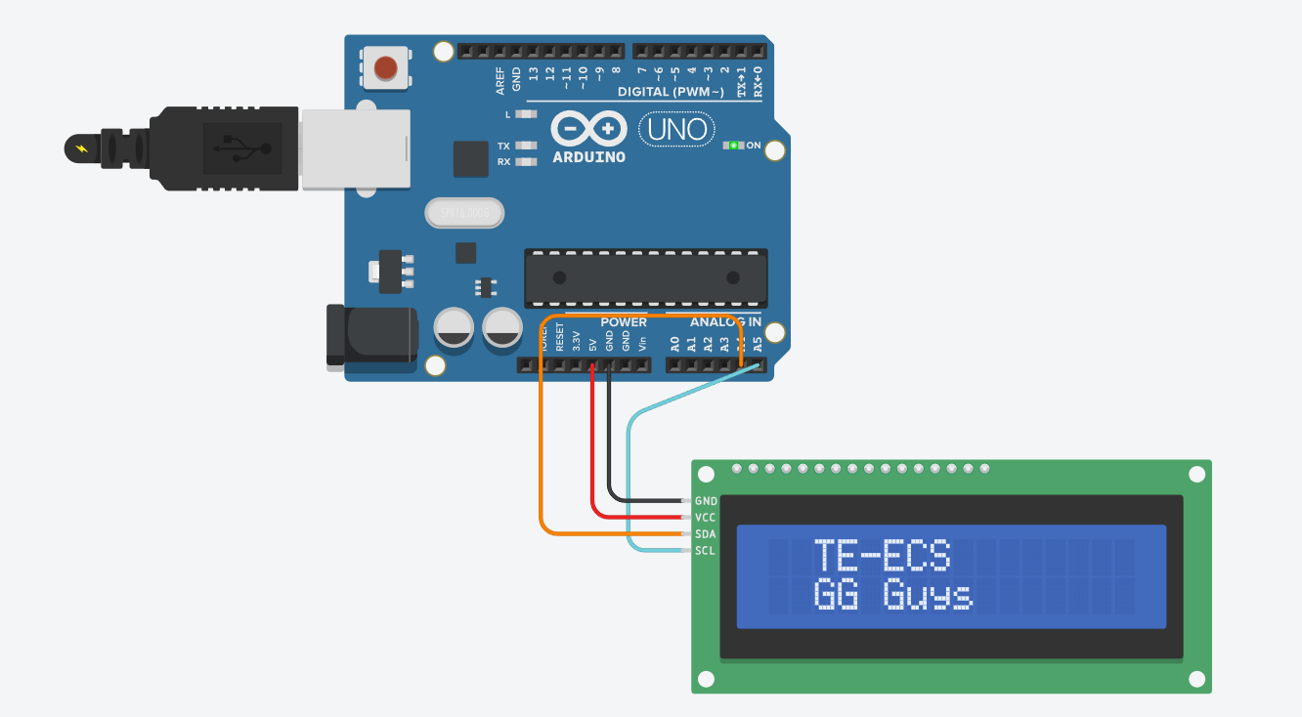

CODE :
#include <LiquidCrystal_I2C.h>
LiquidCrystal_I2C lcd(0x20,16,2);
void setup()
{
lcd.init();
lcd.clear();
lcd.backlight(); // Make sure backlight is on
lcd.setCursor(2,0); //Set cursor to character 2 on line 0
lcd.print("TE-ECS");
lcd.setCursor(2,1); //Move cursor to character 2 on line 1
lcd.print("GG Guys");
}
void loop()
{
}
Output Screenshot:
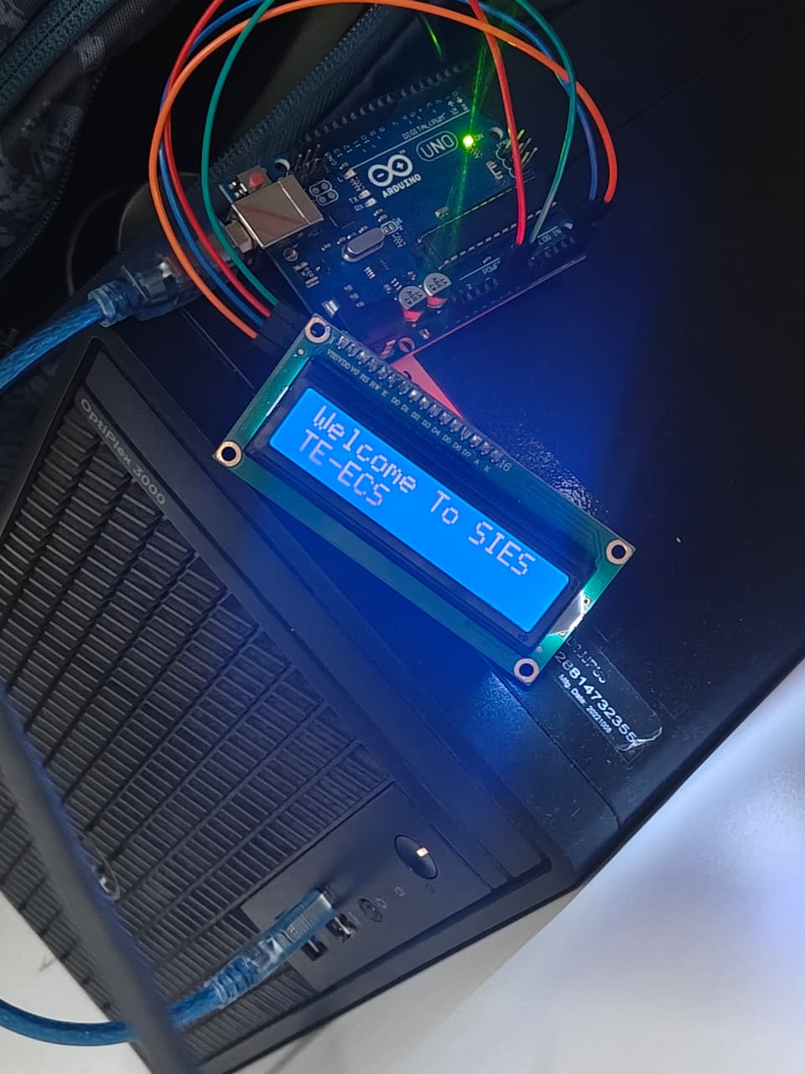

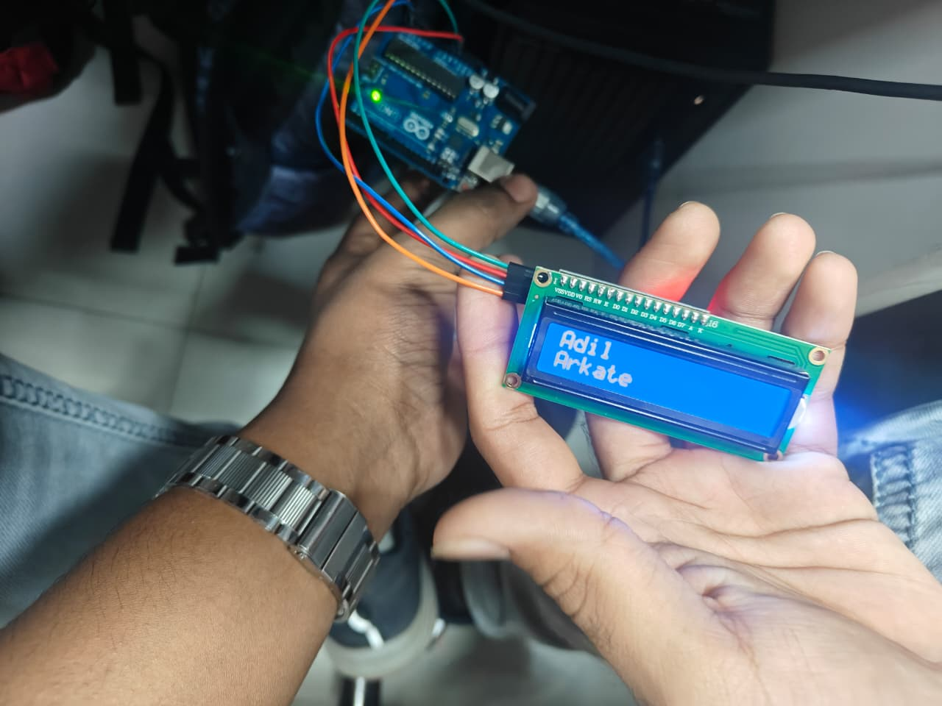

Conclusion :
The experiment successfully demonstrated interfacing a 16x2 LCD display with an Arduino using the I2C communication protocol. By utilizing the I2C module, the number of required connection pins was reduced significantly, making the circuit simpler and more efficient compared to parallel communication.
The Arduino was able to send data and commands to the LCD through the I2C interface, and the desired messages were displayed correctly. This experiment highlights the effectiveness of I2C in minimizing wiring complexity while maintaining reliable communication between devices.
Thus, the objective of displaying text on a 16x2 LCD using Arduino via I2C was achieved successfully.

