EXPERIMENT NO.5
Interfacing and programming of Ultrasonic sensor with ARM based board STM 32

Name: Adil Arkate Batch:B3
Roll No.:224A7064 Date:24/2/2026

Aim : To Interfacing and programming of Ultrasonic sensor with ARM based board STM 32

Apparatus / Components Required :
- ARM based STM32 board
- Ultrasonic Sensor
- Breadboard
- Connecting Wires
- USB Cable
- Arduino IDE (Software)/ Cube IDE (Software)

Theory :
The HC-SR04 ultrasonic sensor measures distance using ultrasonic sound waves.
Working principle:
- The STM32 sends a 10 µs trigger pulse to the sensor.
- The sensor emits 8 ultrasonic bursts at 40 kHz.
- The waves reflect from the object and return to the sensor.
- The sensor outputs a HIGH pulse on the Echo pin for the duration of the travel time.
- The microcontroller measures the pulse width to calculate distance.
Distance Formula:
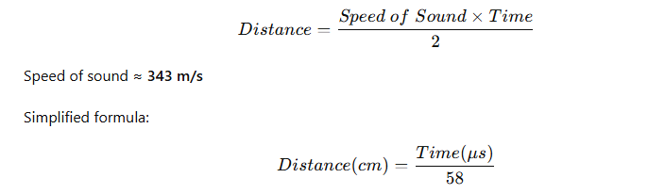

Pin Configuration
Ultrasonic Sensor Pin | STM32 Pin
VCC | 5V
GND | GND
TRIG | GPIO Output (e.g., PA1)
ECHO | GPIO Input / Timer Input (e.g., PA2)

Note: If using a bare DHT11 sensor, connect a 10 kΩ pull-up resistor between VCC and DATA pin.

Circuit Diagram:
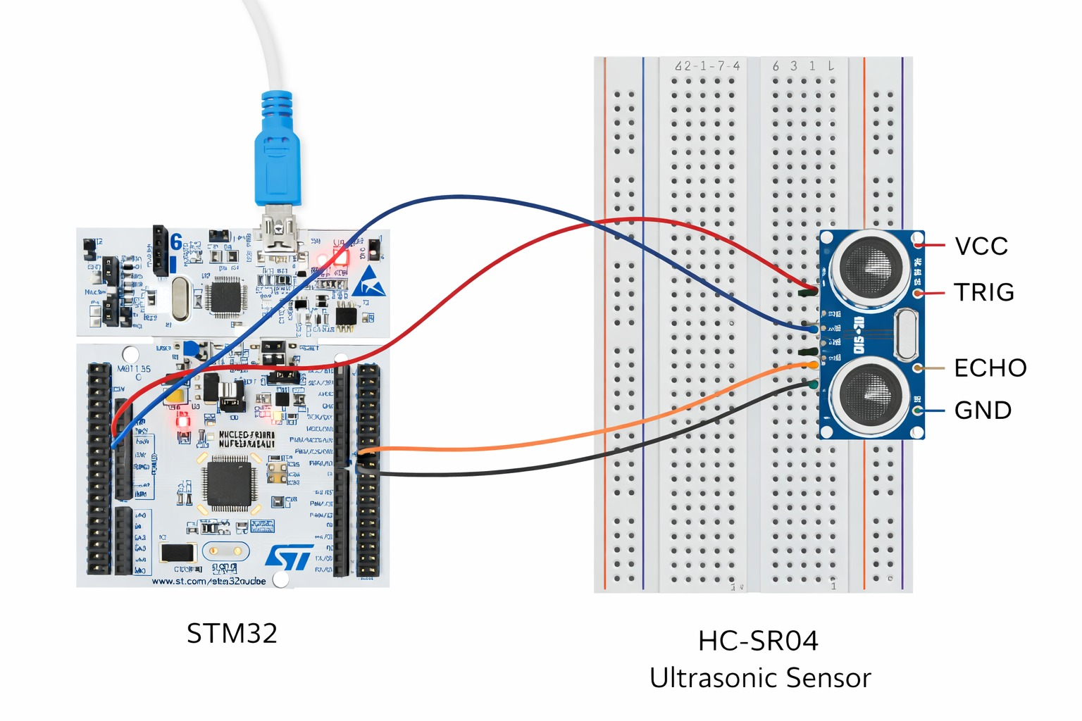

Connections:
- TRIG → PA1 (Output)
- ECHO → PA2 (Input)
- VCC → 5V
- GND → GND
Note: Some STM32 boards require a voltage divider for the Echo pin because the sensor outputs 5V logic.

Procedure
- Open STM32CubeIDE.
- Create a new STM32 project.
- Configure GPIO:
  - TRIG → Output
  - ECHO → Input (or Timer Input Capture).
- Configure a timer for microsecond delay.
- Write code to:
  - Generate 10 µs trigger pulse.
  - Wait for echo HIGH.
  - Measure pulse duration.
  - Convert time to distance.
- Compile and upload the program using ST-Link.
- Open the serial monitor to observe distance readings.

Program Code:
#include "main.h"
#define TRIG_PIN GPIO_PIN_1
#define TRIG_PORT GPIOA
#define ECHO_PIN GPIO_PIN_2
#define ECHO_PORT GPIOA
uint32_t time = 0;
float distance = 0;
void delay_us(uint16_t us)
{
__HAL_TIM_SET_COUNTER(&htim1,0);
while(__HAL_TIM_GET_COUNTER(&htim1) < us);
}
int main(void)
{
HAL_Init();
SystemClock_Config();
MX_GPIO_Init();
MX_TIM1_Init();
HAL_TIM_Base_Start(&htim1);
while (1)
{
HAL_GPIO_WritePin(TRIG_PORT, TRIG_PIN, GPIO_PIN_RESET);
delay_us(2);
HAL_GPIO_WritePin(TRIG_PORT, TRIG_PIN, GPIO_PIN_SET);
delay_us(10);
HAL_GPIO_WritePin(TRIG_PORT, TRIG_PIN, GPIO_PIN_RESET);
while(HAL_GPIO_ReadPin(ECHO_PORT,ECHO_PIN)==GPIO_PIN_RESET);
uint32_t start = __HAL_TIM_GET_COUNTER(&htim1);
while(HAL_GPIO_ReadPin(ECHO_PORT,ECHO_PIN)==GPIO_PIN_SET);
uint32_t stop = __HAL_TIM_GET_COUNTER(&htim1);
time = stop - start;
distance = (time * 0.0343)/2;
}
}

Observation (Output Screenshot) :

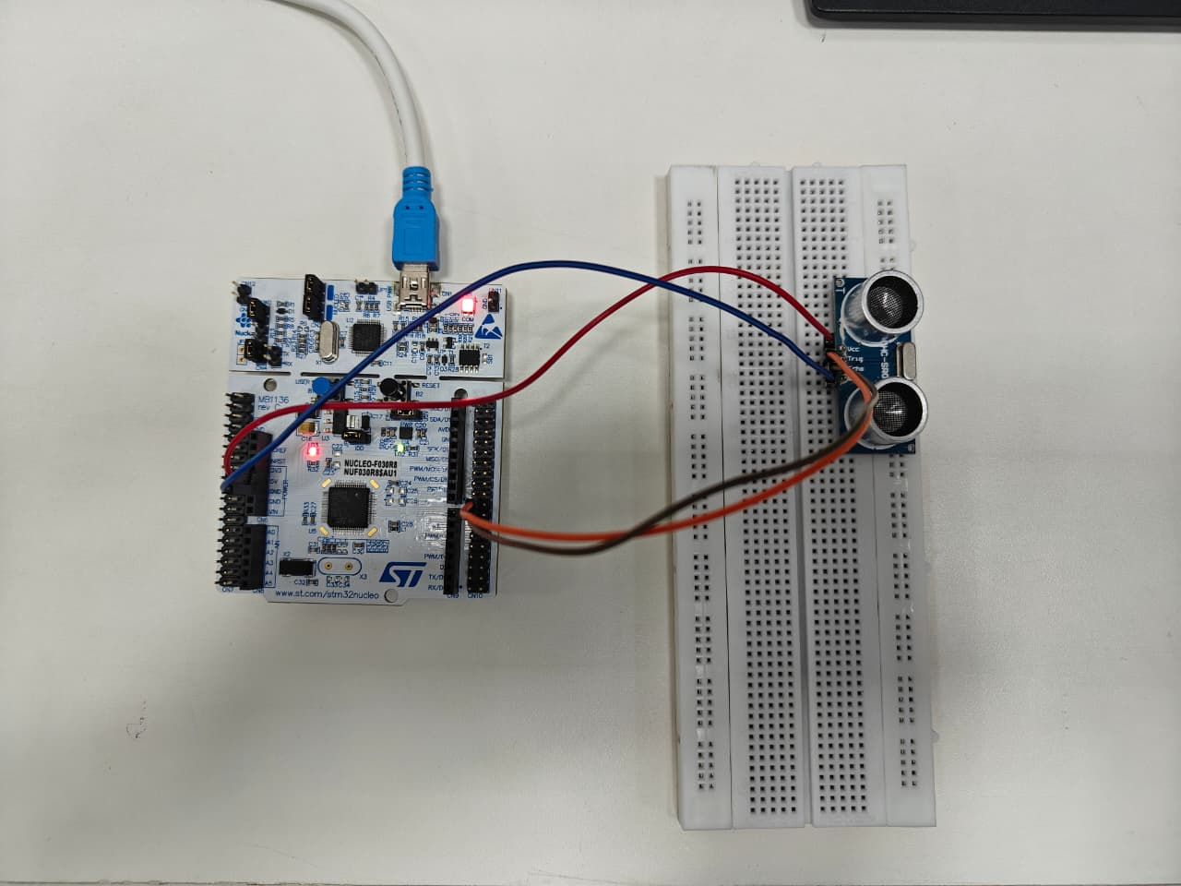

Expected Output :The STM32 calculates the distance to the nearest object and displays values such as:
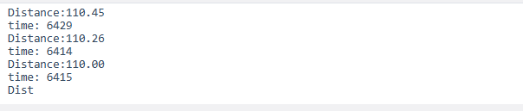
Conclusion:
This experiment demonstrates how an STM32 microcontroller measures distance using the HC-SR04 Ultrasonic Sensor. The sensor sends an ultrasonic pulse and calculates distance based on the echo return time. This method is widely used in robotics and obstacle detection systems.

Applications :
1.Obstacle detection in robots
2. Parking assistance systems
3. Water level monitoring
4. Distance measurement devices
5. Smart automation systems

Precautions :
1.Ensure proper 5V power supply to the sensor.
2. Use voltage divider if STM32 GPIO pins are not 5V tolerant.
3. Avoid measuring soft surfaces that absorb sound waves.
4. Keep sensor stable for accurate readings.

