EXPERIMENT NO.6
Interface and control the position of a servo motor using PWM signals generated by an STM32 microcontroller.

Name: Adil Arkate Batch:B3
Roll No.:224A7064 Date:3/3/2026

Aim : To interface and control the position of a servo motor using PWM signals generated by an STM32 microcontroller.

Apparatus / Components Required :
Sr. No | Component | Quantity
1 | STM32F103C8T6 Blue Pill / STM32 Development Board | 1
2 | SG90 Micro Servo Motor | 1
3 | Breadboard | 1
4 | Jumper wires | As required
5 | ST-Link programmer | 1
6 | Computer with STM32CubeIDE | 1

Theory :
A servo motor is a rotary actuator that allows precise control of angular position. It contains:
- DC motor
- Gear system
- Control circuit
- Feedback potentiometer
The position of the servo motor is controlled using PWM (Pulse Width Modulation) signals.
Typical servo motor specifications:
- Operating voltage: 4.8V – 6V
- PWM frequency: 50 Hz
- Pulse width:
  - 1 ms → 0°
  - 1.5 ms → 90°
  - 2 ms → 180°
STM32 timers generate PWM signals that vary the pulse width to control the servo angle.

Pin Configuration
Servo Motor Pin
Connection
Red (VCC) | 5V
Brown/Black (GND) | GND
Orange/Yellow (Signal) | PWM pin (e.g., PA0 / TIM2_CH1)

Circuit Diagram:
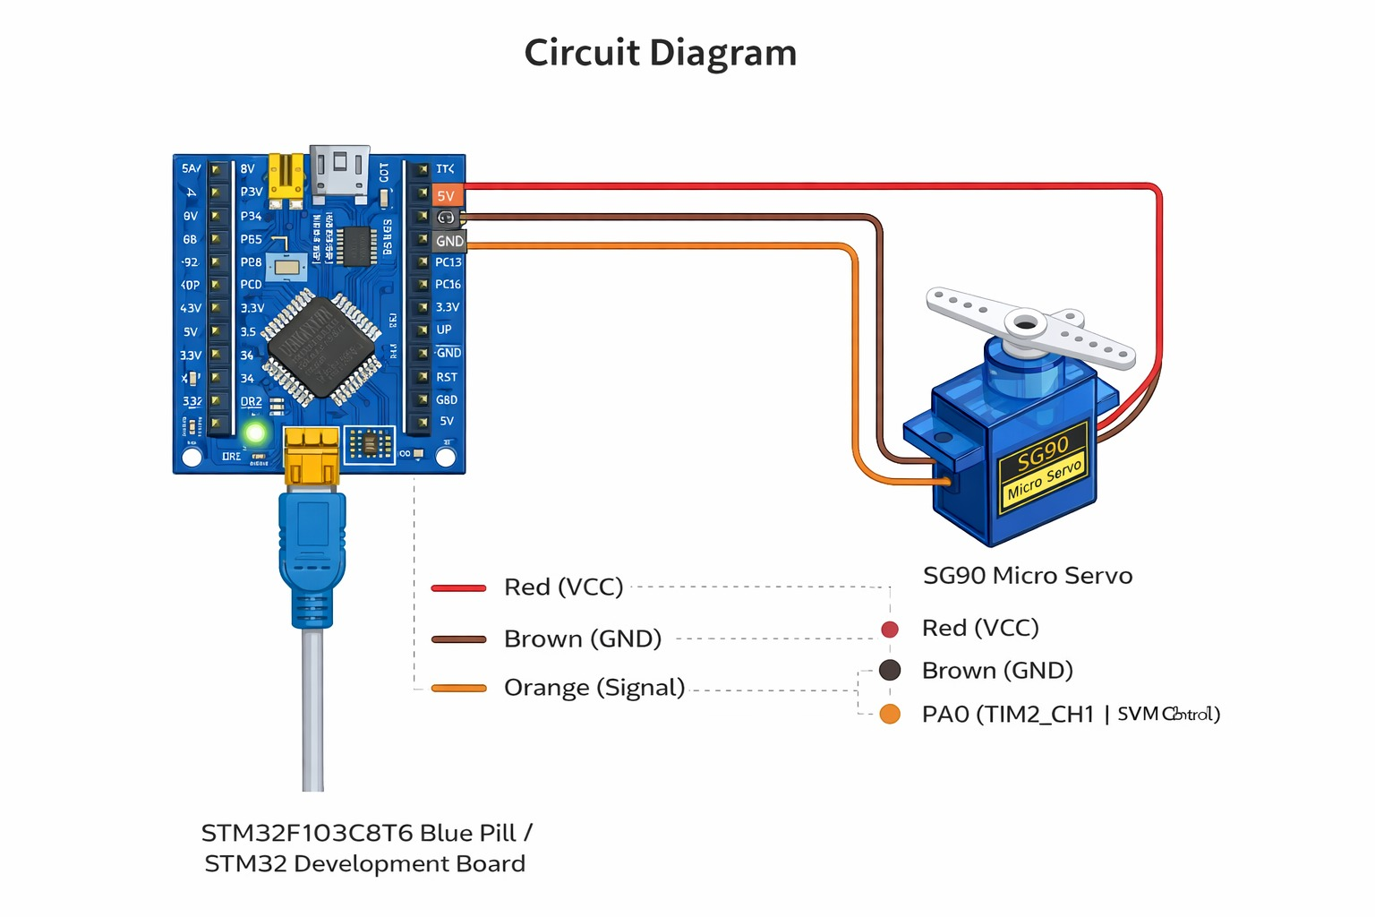

Connections:
- Servo VCC → 5V
- Servo GND → GND
- Servo Signal → PA0 (PWM Output)
Procedure
- Open STM32CubeIDE.
- Create a new STM32 project.
- Configure Timer (TIM2) in PWM Mode.
- Set PWM frequency to 50 Hz.
- Configure GPIO pin as PWM Output.
- Generate the project code.
- Write program to vary PWM duty cycle to control servo angle.
- Compile and upload the code using ST-Link programmer.
- Observe the rotation of the servo motor.

PWM Calculation:
Servo motors require 50 Hz PWM frequency.

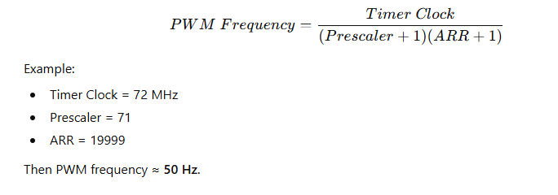
Example:
- Timer Clock = 72 MHz
- Prescaler = 71
- ARR = 19999
Then PWM frequency ≈ 50 Hz.
Program Code:
#include "main.h"

extern TIM_HandleTypeDef htim1;

uint16_t servo_position = 75; // default center

void set_servo_angle(uint8_t angle)
{
uint16_t pulse;

pulse = 50 + (angle * 5) / 9;
// converts 0–180° into PWM duty (approx)

__HAL_TIM_SET_COMPARE(&htim1, TIM_CHANNEL_1, pulse);
}

int main(void)
{

HAL_Init();
SystemClock_Config();
MX_GPIO_Init();
MX_TIM1_Init();

HAL_TIM_PWM_Start(&htim1, TIM_CHANNEL_1);

while (1)
{

set_servo_angle(0);
HAL_Delay(1000);

set_servo_angle(90);
HAL_Delay(1000);

set_servo_angle(180);
HAL_Delay(1000);

}
}

Observation (Output Screenshot) :
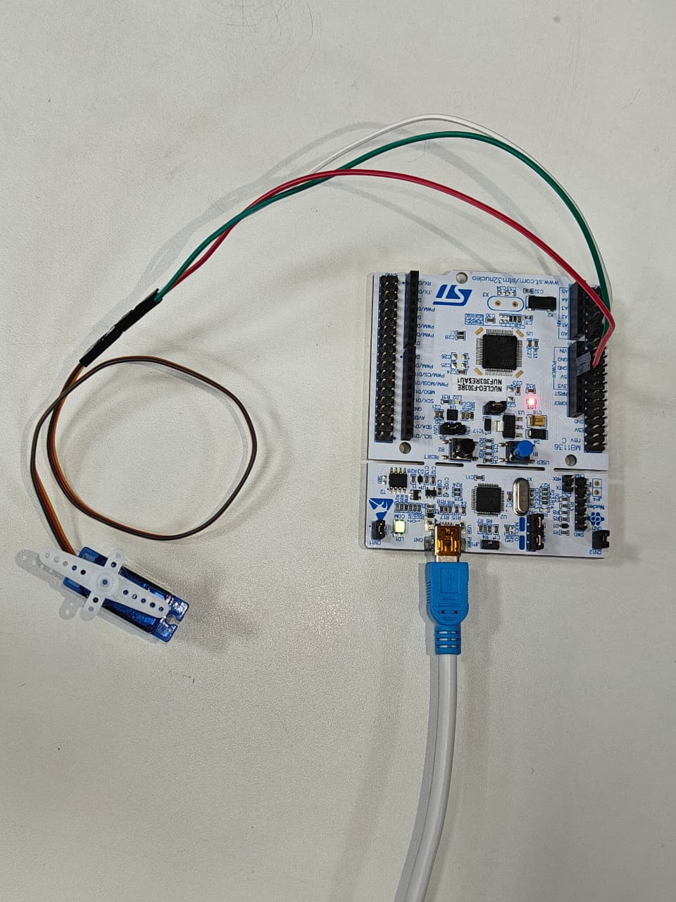
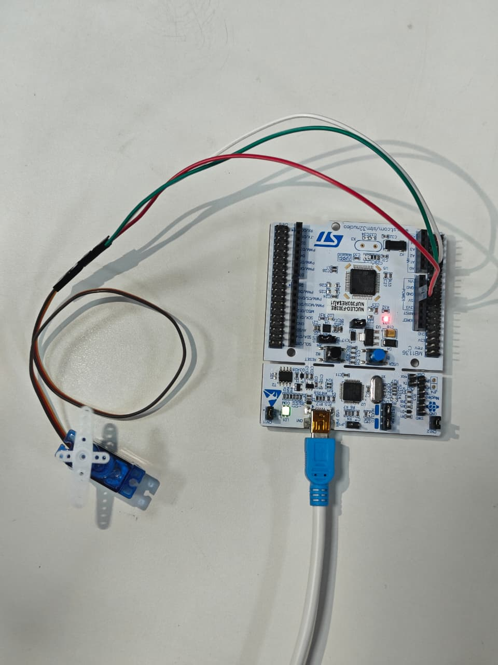

Expected Output :
PWM Pulse Width | Servo Angle
1 ms | 0°
1.5 ms | 90°
2 ms | 180°

The servo motor rotates to different angles based on PWM duty cycle.

Conclusion: This experiment shows how an STM32 microcontroller can control a SG90 Micro Servo Motor using PWM signals. By adjusting the pulse width of the PWM signal, the servo rotates to different angles such as 0°, 90°, and 180°.
It demonstrates how timers and GPIO pins in embedded systems can be used to control motor movement accurately. This method is commonly used in robotics and automation where precise positioning is required.

Applications :
1. Robotic arms
2. Camera positioning systems
3.Automatic door systems
4.Drone control systems
5.Industrial automation

Precautions :
1. Ensure proper 5V power supply for the servo motor.
2.Do not power the servo directly from STM32 if current requirement is high.
3. Avoid continuous mechanical blocking of the servo shaft.
4.Avoid measuring soft surfaces that absorb sound waves.

