EXPERIMENT NO.7
Create multiple task and understand the task management feature of free RTOS.

Name: Adil Arkate Batch:B3
Roll No.:224A7064 Date:17/3/2026

Aim : Write a program to create multiple task and understand the task management feature of free RTOS.
Theory:
RTOS
Most operating systems appear to allow multiple programs to execute at the same time. This is called multi-tasking. In reality, each processor core can only be running a single thread of execution at any given point in time. A part of the operating system called the scheduler is responsible for deciding which program to run when, and provides the illusion of simultaneous execution by rapidly switching between each program.
Free RTOS-
FreeRTOS is a class of RTOS that is designed to be small enough to run on a microcontroller - although its use is not limited to microcontroller applications.
A microcontroller is a small and resource constrained processor that incorporates, on a single chip, the processor itself, read only memory (ROM or Flash) to hold the program to be executed, and the random access memory (RAM) needed by the programs it executes. Typically the program is executed directly from the read only memory.
Microcontrollers are used in deeply embedded applications (those applications where you never actually see the processors themselves, or the software they are running) that normally have a very specific and dedicated job to do. The size constraints, and
dedicated end application nature, rarely warrant the use of a full RTOS implementation - or indeed make the use of a full RTOS implementation possible. FreeRTOS therefore provides the core real time scheduling functionality, inter-task communication, timing and synchronisation primitives only.

This means it is more accurately described as a real time kernel, or real time executive. Additional functionality, such as a command console
interface, or networking stacks, can then be included with add-on components.

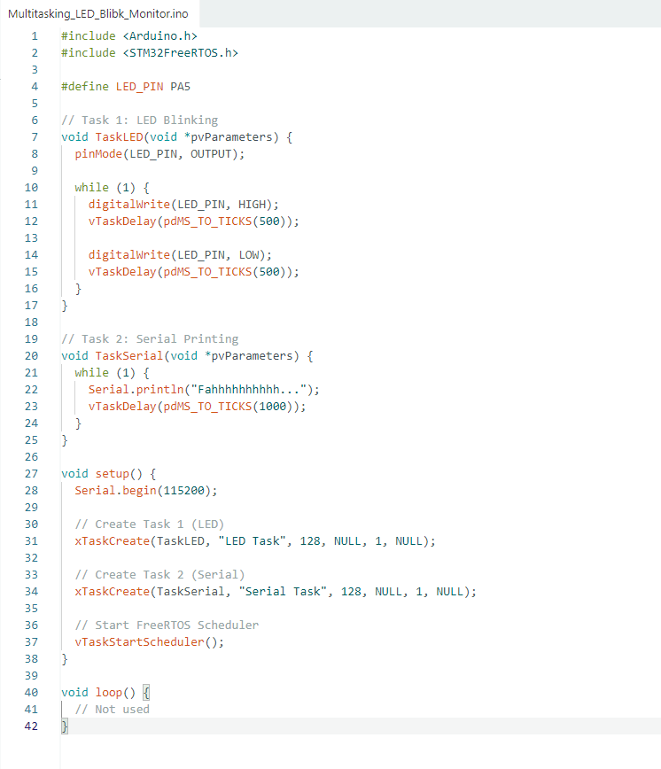
CODE:

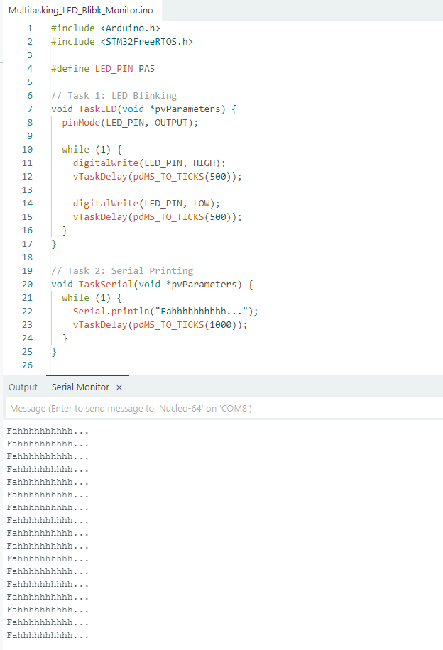

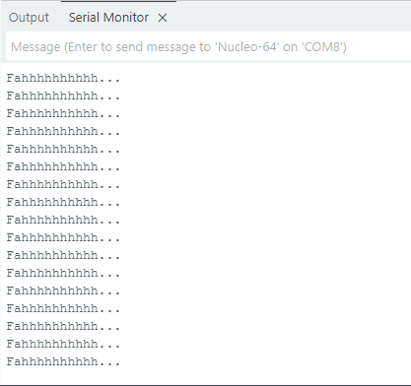
OUTPUT:
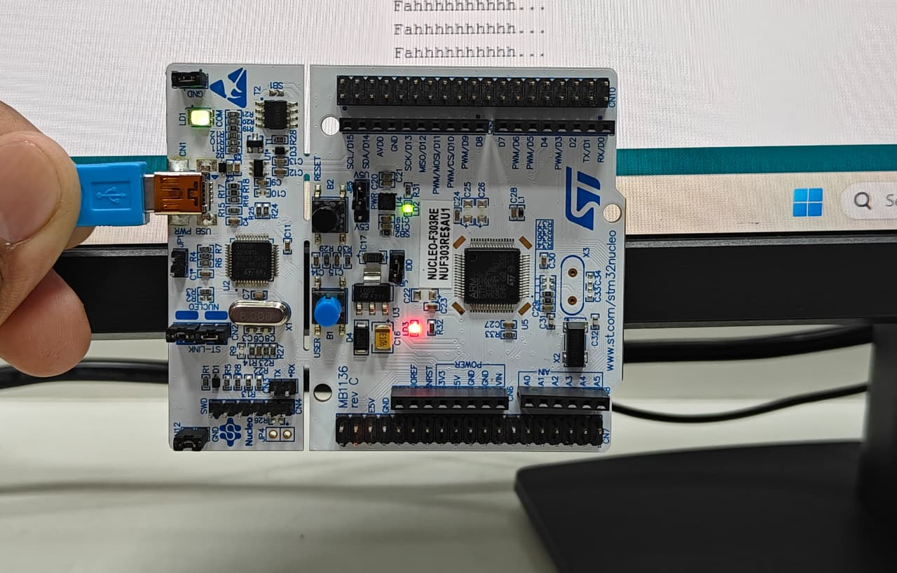

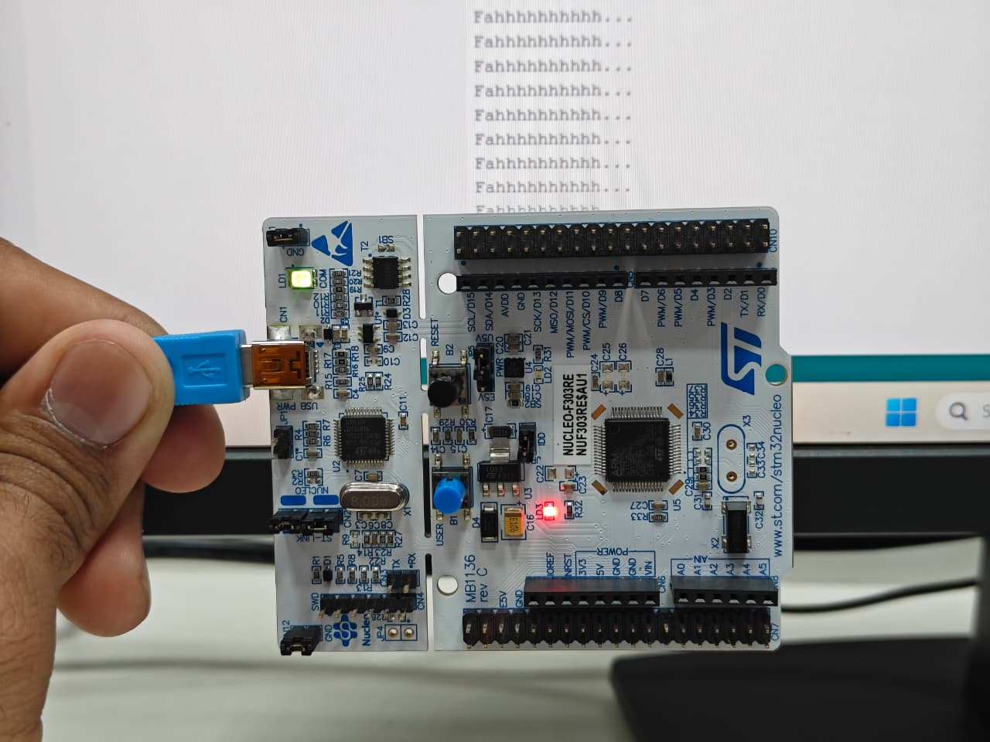
Conclusion- The FreeRTOS task management experiment demonstrates how a real-time scheduler creates the illusion of simultaneous execution by rapidly switching between independent tasks. It highlights that even on resource-constrained microcontrollers, multitasking can be achieved through efficient context switching and task prioritization within a minimal memory footprint.
Would you like a simple code snippet showing how to define and create these tasks in C?

