EXPERIMENT NO.9
Write a program to illustrate Queue management feature of Free RTOS

Name: Adil Arkate Batch:B3
Roll No.:224A7064 Date:8/4/2026

AIM – Write a program to illustrate Queue management feature of Free RTOS
THEORY:
Queueing:
FreeRTOS queues provide thread-safe, FIFO (First-In-First-Out) communication between tasks and interruptions. Key features include data copying (by value), blocking capabilities for producers/consumers on empty/full queues, support for multiple readers/writers, and ISR-safe API versions (e.g., xQueueSendFromISR)
Key Queue Management Features:
- Creation & Handling: xQueueCreate} initializes a new queue with a specified size and item length, returning a handle.
- Data Transfer (Send/Receive):
  - xQueueSend() / xQueueSendToBack(): Adds data to the end of the queue.
  - xQueueSendToFront(): Adds data to the front of the queue.
  - xQueueReceive(): Reads and removes an item from the head.
  - xQueuePeek(): Reads an item without removing it.
- Blocking Operations: Tasks can specify a block time when sending to a full queue or receiving from an empty one, allowing other tasks to run.
- ISR Support: Dedicated functions (xQueueSendFromISR(), xQueueReceiveFromISR()) enable communication between Interrupt Service Routines and tasks safely.
- Overwrite Capability: xQueueOverwrite() can be used to write data even if the queue is full, typically used for single-item storage.
- Status Monitoring: uxQueueMessagesWaiting() checks how many items are currently in the queue.
- Debugging: vQueueAddToRegistry() associates a name with a queue for easier debugging in GUI tools
In FreeRTOS, a queue is used for inter-task communication.
- One task (Sender) puts data into the queue.
- Another task (Receiver) reads data from the queue.
- This ensures safe data transfer without conflicts.
Example:
- Task 1 → sends sensor data
- Task 2 → receives and prints/logs it

CODE:
#include <Arduino.h>
#include <STM32FreeRTOS.h>

// 1. Create a queue handle [cite: 31]
QueueHandle_t myQueue;

// --- SENDER TASK --- [cite: 32]
void senderTask(void *pvParameters) {
int count = 0; // [cite: 34]
while (1) {
count++; // [cite: 36]

// Send data to queue [cite: 37]
// Uses portMAX_DELAY to wait if queue is full [cite: 15, 38]
xQueueSend(myQueue, &count, portMAX_DELAY);

Serial.print("Sent: "); // [cite: 39]
Serial.println(count); // [cite: 40]

vTaskDelay(1000 / portTICK_PERIOD_MS); // 1 second delay [cite: 41]
}
}

// --- RECEIVER TASK --- [cite: 44]
void receiverTask(void *pvParameters) {
int receivedValue; // [cite: 46]
while (1) {
// Receive data from queue [cite: 48, 49]
if (xQueueReceive(myQueue, &receivedValue, portMAX_DELAY)) {
Serial.print("Received: "); // [cite: 50]
Serial.println(receivedValue); // [cite: 51]
}
}
}

void setup() {
Serial.begin(9600); // [cite: 56]

// 2. Initialize the Queue: 5 elements, each of int type [cite: 57, 58]
myQueue = xQueueCreate(5, sizeof(int));

if (myQueue == NULL) { // [cite: 59]
Serial.println("Queue creation failed!"); // [cite: 60]
while (1); // [cite: 61]
}

// 3. Create tasks [cite: 63, 64, 65]
xTaskCreate(senderTask, "Sender", 128, NULL, 1, NULL);
xTaskCreate(receiverTask, "Receiver", 128, NULL, 1, NULL);

// 4. Start the scheduler [cite: 66, 67]
vTaskStartScheduler();
}

void loop() {
// Empty: FreeRTOS handles everything [cite: 69, 70]
}

Working
- Queue is created with capacity of 5 integers.
- Sender Task:
  - Increments a number every second.
  - Sends it to queue.
- Receiver Task:
  - Waits for data.
  - Reads and prints it via Serial Monitor.

CIRCUIT DIAGRAM:

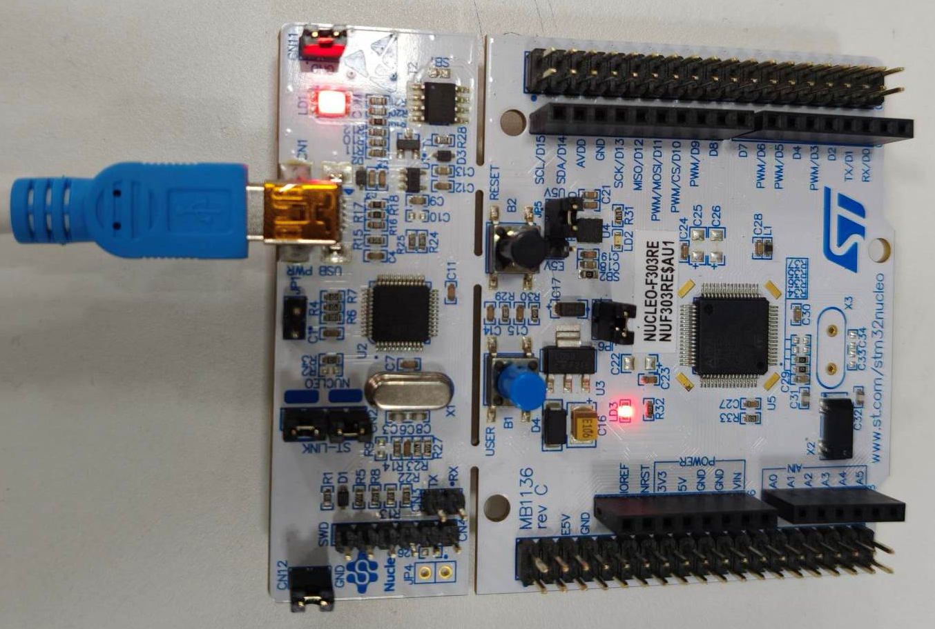

OUTPUT:

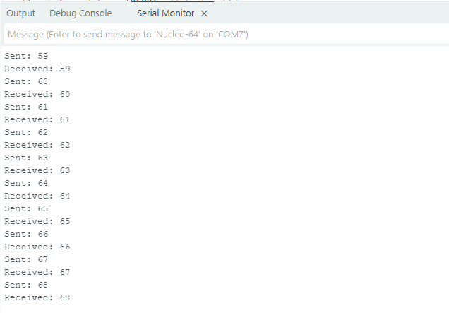

CONCLUSION: The experiment successfully demonstrated the queue management feature of FreeRTOS for inter-task communication. A queue was created to transfer integer data between two tasks, where the sender task continuously pushed data into the queue and the receiver task retrieved it in FIFO order. The results confirmed that FreeRTOS queues ensure safe and synchronized data exchange between tasks without conflicts. Additionally, the blocking mechanism allowed efficient CPU utilization by managing task execution based on queue availability. Hence, queues play a crucial role in multitasking systems for reliable communication between tasks.

