Sensitivity Analysis Report
Knowledge Graph Navigation Classification Impact Analysis
Revision: October 2026 | Analytic sample: N = 16,389 students; 85,815 AI interactions | Outcome: strict accuracy

1. Executive Summary
This sensitivity analysis examines how the classification of Knowledge Graph Navigation affects the aggregate findings of the manuscript, using the strict-accuracy outcome defined in Section 3.4.1: the percentage of valid response records with is_correct = 1. Reclassifying Knowledge Graph Navigation from Process-level to Task-level reverses the aggregate correlation between the effective-feedback composite and accuracy from r = −.103 (95% CI [−.118, −.088]) to r = +.025 (95% CI [+.009, +.040]; Spearman ρ = +.011, 95% bootstrap CI [−.004, +.026]). The aggregate composite correlation is therefore not robust to this single classification decision. As documented in the revised manuscript, the paper's empirical claims are anchored at the feature level (KG Navigation share), with estimates varying across operationalisations, strata, and model specifications.

2. Background and Rationale

2.1 Original Classification
The historical author mapping used in the primary analyses assigns AI features to Hattie–Timperley-informed categories as follows. These are author-defined operational categories, distinct from the raw coder classifications and adjudications documented in Online Resources 1 and 2:
• Process-level: KG Navigation; From MOOCCube; From Aminer
• Task-level: Preset Q&A; From Baidu; From Baike; Arithmetic Calculator; From Course Information
• Self-regulation: From FAQ; Ask TA (Human); TA Answer Browser; Pop-up Reflection Question
• Self-level: Poetry Composition; From Turing Bot
• Other (excluded from the composite numerator): System Cannot Answer; Inappropriate Input

2.2 Classification Ambiguity
Knowledge Graph Navigation presents a classification boundary challenge. While it can be viewed as Process-level feedback (enabling exploration of conceptual relationships), it can also be interpreted as Task-level support (information lookup or navigation without demonstrated deep conceptual engagement). This sensitivity analysis tests whether the aggregate association between the effective-feedback composite and accuracy is robust to this classification decision. Reassigning the category does not change the underlying KG interaction counts or feature-level usage shares.

3. Methodology

3.1 Data Source
Feature identification used the full AI interaction log (108,351 interactions from 21,436 users). All analyses involving accuracy use the main analytic sample (16,389 students; 85,815 AI interactions). Strict accuracy is 100 × the number of valid response records with is_correct = 1 divided by the total number of valid response records with is_correct equal to 0 or 1. The same strict-accuracy outcome is used under every feature mapping. Feature shares use each student's recorded AI interactions as the denominator, unless the mapped-only denominator check in Section 3.2 is explicitly specified.

3.2 Classification and Other-Category Sensitivity Checks
The primary classification check moves Knowledge Graph Navigation, including all its label variants, from Process-level to Task-level. Historical EF% = 100 × (Process count + Self-Regulation count) / total AI interaction count. After moving KG to Task, EF% = 100 × (historical Process count − KG count + historical Self-Regulation count) / total AI interaction count. Thus, the alternative composite equals historical EF% minus KG share; the denominator is unchanged:
Original Task-level: Preset Q&A, Baidu search, Baike search, calculations, course info
Conservative Task-level: Original Task + Knowledge Graph Navigation (all variants)
After moving KG to Task, the Process category contains From MOOCCube and From Aminer, together with four Baike-variant interactions retained as Process by the historical pipeline. This KG-only check changes no other historical assignments; the Baike exception is documented in Online Resource 1, Appendix A.6. System Cannot Answer and Inappropriate Input remain Other under both schemes. They account for 922 interactions in the full dataset (0.85%) and 817 in the main analytic sample (0.95%). Their interactions remain in the denominator of both composites but are excluded from the effective-feedback numerator.
Table 2 also reports two separate checks of Other-category handling: the standalone historical Other share, calculated as 100 × Other count / total AI interaction count; and the historical EF share with a mapped-only denominator, calculated as 100 × (Process count + Self-Regulation count) / (total AI interaction count − Other count). The mapped-only denominator is zero for 52 students whose interactions are all Other; their values are undefined and excluded from that check, giving N = 16,337. Other is not added to the effective-feedback numerator.
Finally, the coder-anchored sensitivity analysis uses the original coder agreements and documented adjudications without subsequent author remapping, following the complete mapping in Online Resource 1, Appendix A.6. Under this mapping the Self-Regulation category contains no interactions, so the restored Process + Self-Regulation composite equals the restored Process share. This check changes the complete mapping and does not isolate the contribution of any single author's reassignment.
3.3 Performance Tertiles
Students were grouped by strict accuracy using the same fixed cutpoints as the main manuscript: Low, accuracy < 67.5%; Medium, 67.5% ≤ accuracy ≤ 84.0%; and High, accuracy > 84.0%. The group sizes are 5,540, 5,467, and 5,382, respectively. These fixed bands approximate thirds of the distribution; they are not newly estimated exact terciles. Group membership is held fixed across the historical and KG-to-Task classifications. Because the groups are defined using the outcome itself, their contrasts are descriptive and do not establish a causal help-seeking mechanism.

4. Results

4.1 Knowledge Graph Navigation Prevalence
Knowledge Graph Navigation dominates AI usage patterns in this dataset:
Table 1. Knowledge Graph Navigation Usage Statistics
Metric | Value
Mean per-student KG share of all AI interactions (N = 16,389) | 53.13% (SD = 45.07 percentage points)
Pooled KG share of main-sample AI interactions | 41,848 / 85,815 = 48.77%
Mean per-student KG share within historical Process (N = 12,391 with Process count > 0) | 77.82% (SD = 37.26 percentage points)
Median per-student KG share of all AI interactions | 63.64%
Pearson correlation of KG share with strict accuracy | r = −.107, 95% CI [−.122, −.092], p < .001
Note. Means and the median are calculated across students; the pooled percentage is calculated across interaction records. The KG-within-Process ratio is undefined for students with no historical Process interactions, so only the 12,391 students with positive Process counts enter that mean and SD. These two kinds of percentage should not be interchanged.

4.2 Correlation Comparison
Moving KG Navigation to Task changes the sign of the aggregate Pearson association from −.103 to +.025. Under this alternative mapping, the Pearson association is very small but statistically significant (p = .002; BH q = .003 within the manuscript's 48-test exploratory family), whereas the Spearman association is near zero and its interval includes zero (ρ = +.011, p = .16). The additional rows distinguish the standalone Other share, the mapped-only denominator, and the complete coder-anchored alternative; these checks answer different questions and are not interchangeable:
Table 2. Correlations with Strict Accuracy under Classification and Other-Category Sensitivity Checks
Operationalisation | N | Pearson r [95% CI] | Spearman ρ [95% bootstrap CI]
Historical mapping (KG in Process) | 16,389 | −.103 [−.118, −.088] | −.103 [−.118, −.087]
KG moved to Task | 16,389 | +.025 [+.009, +.040] | +.011 [−.004, +.026]
Historical Other share (standalone) | 16,389 | +.003 [−.013, +.018] | −.004 [−.019, +.012]
Historical EF with mapped-only denominator | 16,337 | −.103 [−.119, −.088] | −.104 [−.119, −.088]
Coder-anchored Process + Self-Regulation | 16,389 | −.113 [−.128, −.098] | −.122 [−.137, −.106]
Note. Pearson confidence intervals use Fisher's z transformation. Spearman intervals are percentile intervals from 10,000 paired-student bootstrap resamples, with ranks recomputed in each resample. N is the number of students with a defined value for the specified operationalisation. Historical Other share is a standalone predictor, not an effective-feedback composite. The mapped-only specification excludes Other interactions from the denominator while leaving the effective-feedback numerator unchanged. The coder-anchored result reflects a complete alternative mapping; it does not isolate any one feature reassignment.

4.3 Performance Tertile Analysis
The low–high contrast in the aggregate effective-feedback composite depends on the KG classification: it is +12.27 percentage points under the historical mapping and −1.58 percentage points after moving KG to Task. The feature-level KG share itself is unchanged by reassignment and averages 58.80%, 55.43%, and 44.95% in the Low, Medium, and High groups, respectively. These are descriptive associations in outcome-defined groups, not evidence that the classifications identify learning effects:
Table 3. Effective Feedback (EF) by Performance Tertile Across Classification Schemes
Performance group | N | Historical EF% | KG-to-Task EF% | Δ (percentage points)
Low (<67.5%) | 5,540 | 76.02% | 17.21% | 58.80
Medium (67.5%–84.0%, inclusive) | 5,467 | 74.27% | 18.84% | 55.43
High (>84.0%) | 5,382 | 63.75% | 18.80% | 44.95
Low - High Difference | — | +12.27 pp | −1.58 pp | —
Note. EF denotes the operational effective-feedback composite, not measured feedback efficacy. Entries are means of per-student percentages. Δ = historical EF% − KG-to-Task EF%, which equals the mean KG share in each group. The final row reports Low minus High. Differences are calculated from unrounded values; pp = percentage points.

4.4 Statistical Tests: Low vs. High Performers
Table 4. Welch Comparisons of Effective-Feedback Shares between Low and High Strict-Accuracy Groups
Statistic | Historical mapping | KG moved to Task
Group sizes | Low n = 5,540; High n = 5,382 | Low n = 5,540; High n = 5,382
Low group EF% | M = 76.02, SD = 36.50 | M = 17.21, SD = 31.01
High group EF% | M = 63.75, SD = 43.01 | M = 18.80, SD = 32.98
Mean difference (Low − High), 95% CI | +12.27 pp [+10.77, +13.77] | −1.58 pp [−2.79, −0.38]
Welch t statistic | t(10535.2) = 16.05 | t(10831.3) = −2.59
Two-sided p value | p < .001 | p = .010
Hedges’ g (Low − High), 95% CI | g = +0.308 [+0.270, +0.346] | g = −0.050 [−0.087, −0.012]
Note. Both columns use the same strict-accuracy groups. Mean differences and t statistics are oriented as Low minus High. Confidence intervals for mean differences use the Welch–Satterthwaite degrees of freedom. Hedges' g uses the sample-size-weighted pooled SD with the small-sample correction; its interval is an approximate analytic 95% interval. The p values are unadjusted descriptive comparisons of outcome-defined groups and do not estimate causal effects. The KG-to-Task p value is .00975 before rounding.

4.5 Visual Comparison
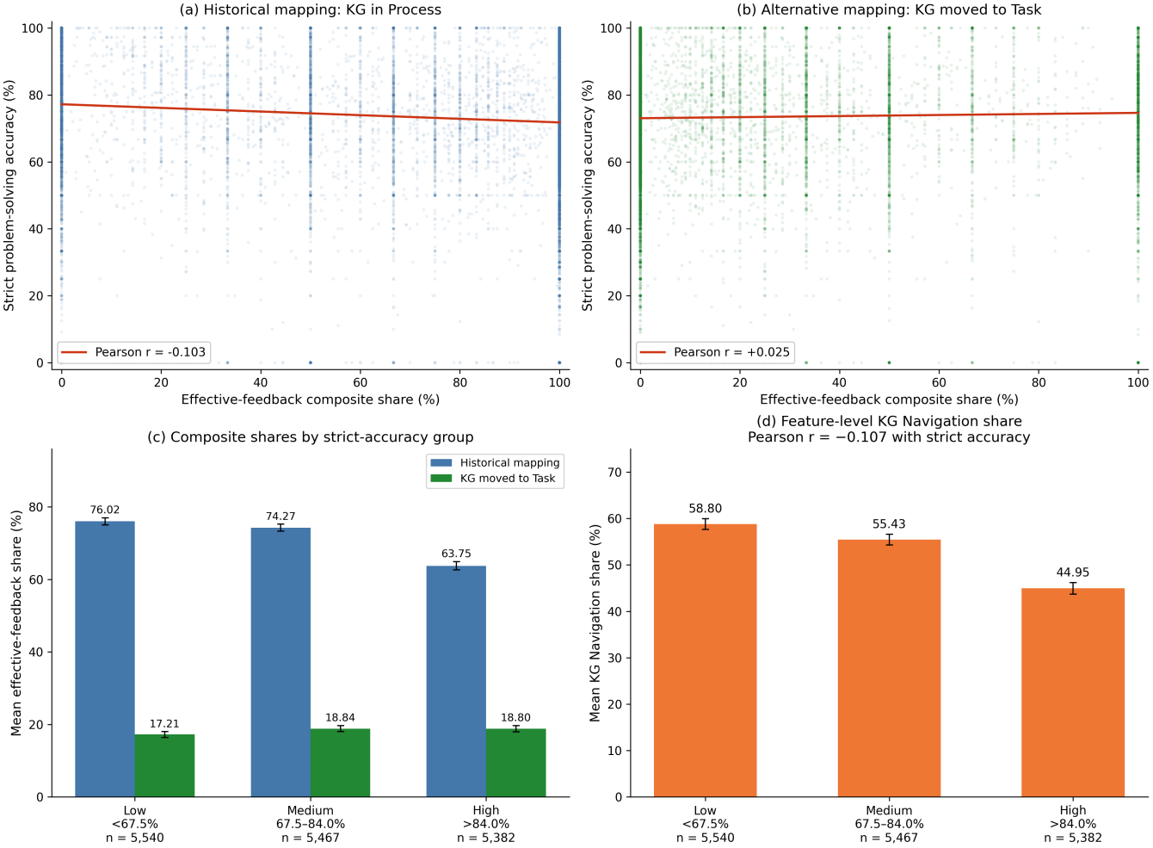
Figure 1. Classification sensitivity using strict accuracy (N = 16,389). (a) Historical mapping with KG Navigation in Process; Pearson r = −.103. (b) Alternative mapping with KG Navigation moved to Task; Pearson r = +.025. Scatter points represent students; solid lines are unadjusted ordinary least-squares fits. (c) Mean effective-feedback shares under both mappings in the same fixed strict-accuracy groups. (d) Mean KG Navigation shares, which do not change when the feature is reassigned. The groups are Low (<67.5%, n = 5,540), Medium (67.5%–84.0%, inclusive, n = 5,467), and High (>84.0%, n = 5,382). Error bars in (c) and (d) are 95% t-based confidence intervals for group means. These outcome-defined group comparisons are descriptive.

5. Implications for the Manuscript
Relation to the revised manuscript. The reversal documented here is reported in Section 4.6 of the revised manuscript, which no longer treats the four-level composite correlation as a headline result. The paper's empirical claims are anchored at the feature level (KG Navigation share), which is examined under within-tertile stratification, feature decomposition, crossed user/course multilevel modelling, and attempts-stratified robustness analyses (Sections 4.7.1–4.7.5).

6. Conclusion
This sensitivity analysis demonstrates that the classification of Knowledge Graph Navigation is a critical boundary condition for interpreting the aggregate four-level effective-feedback composite. Its correlation with accuracy is not robust to the classification of this single feature. This sensitivity is reported transparently in the revised manuscript (Section 4.6) and motivates the paper's feature-level framing. Reassigning KG Navigation does not change its underlying counts, usage shares, or zero-order association with strict accuracy. This invariance to relabelling does not imply that feature-level estimates are invariant across operationalisations, strata, or model specifications (Section 4.7 of the manuscript).

Appendix: Raw Data Summary

A.1 Question Type Distribution in Original Data
Total AI interactions in the full dataset: 108,351 from user-xiaomu.json. Table A1 reports exact raw question_type labels, not frequencies aggregated over the 16 base features. These full-dataset counts differ from the main analytic sample counts used in Tables 1–4.
Table A1. Frequencies of Selected Exact Raw Question-Type Labels in the Full AI Dataset
Exact raw question-type label | Count | Percentage
知识图谱点击 (Knowledge Graph Click) | 50,883 | 46.96%
预设问答 (Preset Q&A) | 15,705 | 14.49%
来自mooccube (From MOOCCube) | 12,953 | 11.95%
来自图灵机器人 (Turing Bot) | 6,426 | 5.93%
来自baidu (From Baidu) | 4,373 | 4.04%
来自baike (From Baike) | 3,831 | 3.54%
作诗 (Poetry) | 3,133 | 2.89%
来自Faq (FAQ) | 3,033 | 2.80%
来自Aminer (Academic Search) | 2,415 | 2.23%
All remaining raw labels (including variants) | 5,599 | 5.17%
Note. The first nine rows count the exact raw labels shown. The final row combines all remaining labels, including variants of these features, and is not the analytical Other category. For example, the exact label “知识图谱点击” has 50,883 interactions, whereas KG Navigation including all variants has 50,971; From MOOCCube has 14,968 after combining variants, From Aminer 2,422, From Baike 3,835, and Pop-up Reflection Question 822. The two historical Other features, System Cannot Answer and Inappropriate Input, together contribute 922 full-dataset interactions, not 5,599. Full base-feature frequencies are preserved in Online Resource 2; main-sample counts and the four-record Baike exception are documented in Online Resource 1, Appendix A.6.

A.2 Analysis Code
The calculations use Python 3.13.5, pandas 2.3.3, NumPy 2.2.6, and SciPy 1.16.3; the updated figure uses Matplotlib 3.10.7. The strict student-level input is strict_student_model_data.csv from stage 02. The classification checks are defined in 04_remaining_analyses.py and corrected by 04b_corrections.py and 04c_mapping_and_pvalues.py. The superseded stage-04 specification that adds Other to the effective-feedback numerator is not reported here.
For Table 2, the historical, KG-to-Task, standalone Other, and mapped-only rows use the Pearson and Spearman intervals in run04b_outputs/spearman_bootstrap_cis.csv; the coder-anchored row uses run04c_outputs/restored_mapping_sensitivity.csv. The final correlation p values and reported BH q value are from run04c_outputs/multiplicity_v3.csv. Pearson intervals use Fisher's z transformation; Spearman intervals use 10,000 paired-student percentile bootstrap resamples with ranks recomputed. The corresponding bootstrap seeds are 20260920, 20260925, 20260926, 20260927, and 20260918 for the five rows, respectively.
OR3_recompute_and_plot.py reproduces the descriptive summaries in Tables 1, 3, and 4 and generates Figure 1 from the strict student-level input, using fixed accuracy cutpoints of 67.5% and 84.0%. Its outputs are OR3_verified_statistics.json, OR3_tertile_descriptives.csv, OR3_welch_comparisons.csv, and OR3_Figure1_strict.png. Table A1 uses exact-label counts from feature_mapping_audit.csv. No coder ratings are altered by these analyses.

