Python compilation for Nokia Series 60

Contents

1. Introduction
2. Compiling the Python interpreter
3. Extending Python

1. Introduction

This guide is made to help you extend the Python for Series 60 Platform, so it is possible to add c++ modules to the Python for Series 60 platform.
This document provides all the information required for you to install the necessary programs and compiling a new Python Platform to the Series 60 and how to download it to the Series 60 phones.

2. Compiling the Python interpreter

Basis Requirements
- Microsoft Windows XP SP1a or Microsoft Windows 2000 SP3
Java Runtime version 1.4.1_02 or later is required.
- When developing Bluetooth applications, a desktop >2GHz with 512
MB memory is recommended.

Required programs
S60 Platform SDK’s for Symbian OS, for C++
From Nokia’s forum download the SDK ‘2nd Ed, FP 2 (146268 kB)’ file. Find it in the scroll menu to the right.

The Python source files for the S60 mobile phones
From Sourceforge download the pys60-1.3.1_src.zip

Python
From pyton.org download Python 2.4.2 Windows installer (9,22MB)

Perl from Activestate
ActivePerl 5.8.7 MSI installer

You also need a C++ compiler. Microsoft Visual C++ 6.0, Studio .NET 2003 Professional or Borland C++ BuilderX 1.5 will do fine.
In this guide is Microsoft Visual C++ used. So if you use Borland, the guide will probably not be a big help.

You need to update Microsoft Visual C++ to Service Pack 3. You can download the update from Microsoft here. Download the files VS6sp61.exe to VS6sp65.exe

How to install
To install the S60 Platform unzip the file and run the setup.exe. The Platform will be installed to <location>\Symbian\8.0a\S60_2nd_FP\
Unzip the Python source files to <location>\Symbian\8.0a\S60_2nd_FP\ so that the src library is located in this folder.
Install Perl by running Perl MSI installer.
Install Python the same way as Perl

Now it is important that the path to the programs is in your system PATH list.
First locate where the program LINK.EXE (part of your C++ compiler) is on your computer and make a PATH to it by going to:
System -> Advanced -> Environment variabels -> path. Put the path here.

To get LINK.EXE to work, it needs a dll called MSPDB60.DLL it should be located in the folder C:\Programmer\Microsoft Visual Studio\Common\MSDev98\Bin, copy the file to your Windows\system32 folder.

Check that Python 2.4 and Perl also is in the PATH, you can check it by typing ‘perl’ and ‘python’ in the prompt, this should start the programs.
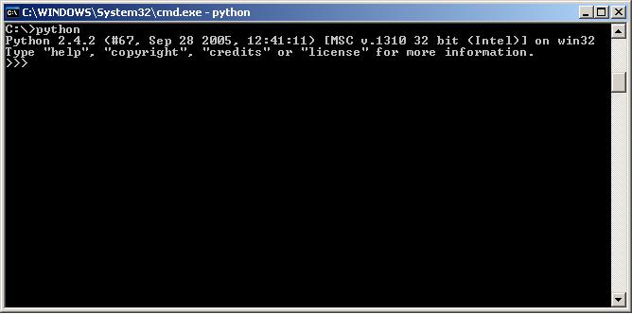
Your PATH should look something like this, if the paths already are included
PATH= C:\Programmer\Microsoft Visual Studio\VC98\Bin;C:\Perl\bin\;C:\Python24\;

How to compile
Now to compile a new Python Platform to the Series 60 you have to start a command prompt.
The build system assumes that it is being run from a subst'ed drive pointed at the root of your SDK and that EPOCROOT is \. To create a subst’ed drive and set the EPOCROOT type:

subst t: <drive><location>\Symbian\8.0a\S60_2nd_FP
set EPOCROOT=\

Now go to the source folder t:\src.

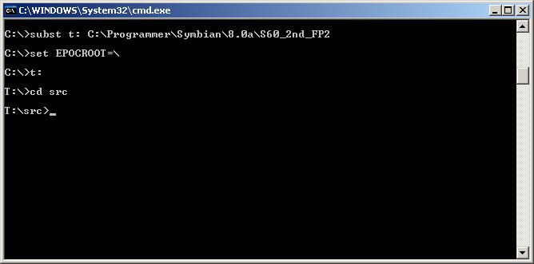

Because the location and messaging modules not are include in this SDK version, the two modules have to be disable when you configure the source files. To configure the source for a particular SDK, run

setup.py configure 26 WITH_MESSAGING_MODULE=0 WITH_LOCATION_MODULE=0

Note that when you try to build the first time, you might get an error, about missing mspdb60.dll. No worries, the file is located in your c++ folder C:\Programmer\Microsoft Visual Studio\Common\MSDev98\Bin, copy the file to your C:\WINDOWS\system32 folder, and the problem should be solved.
If you just write ‘setup.py configure’ will list the available SDK's. ‘configure 26’ is the S60 2nd Ed. FP2 SDK.
To compile for the device and the emulator, run:

setup.py build

To install the compiled code directly into the emulator environment, run

setup.py install

When you start the emulator there should now be a Python icon in the main menu.
To install the new Python Platform compiled code to the device, the software need to go into a SIS package for installation on a device, run

setup.py bdist_sis

This will create a SIS package of the compiled code. Note that this command packages the code, as it exists on disk at the time. It does not recompile anything automatically.

Another way to do these things (configure, build, bdisk_sdk and bdisk_sis) in only one step, run

setup.py obb 26 WITH_MESSAGING_MODULE=0 WITH_LOCATION_MODULE=0

3. Extending Python

There are two ways to add a new module to Python, a HARD and EASY way, both ways are described here in the guide, We will start with the hard way including a description of the files you need.

The Hard Way (including a module in the interpreter)
To add a new module to the distribution, you need to the do the following:
Create a directory for it under ext.
To create a module you need the following files under the module directory:

bld.inf
<module>.mmp
<source>.cpp

In the bld.inf file you need to specify which platforms you want to compile to and the name of the mmp file like this:

PRJ_PLATFORMS
wins winscw armi

PRJ_MMPFILES
<module>.mmp

In the <module>.mmp file you need to specify target, target type, target path, includes, libraries and the source file like this:
Note that the included library “MediaClientAudio.lib” is an example and not needed if you doesn’t use its features.

TARGETTYPE dll
TARGET <module>.pyd

TARGETPATH \system\libs

SYSTEMINCLUDE \epoc32\include
SYSTEMINCLUDE \epoc32\include\libc

userinclude ..\..\core\Symbian
userinclude ..\..\core\Include
userinclude ..\..\core\Python

USERINCLUDE .

LIBRARY python222.lib
LIBRARY euser.lib

LIBRARY MediaClientAudio.lib
LIBRARY estlib.lib /* Necessary only if you use the C
standard library */

SOURCE <module>.cpp

An example of a source code is shown below. This simple module takes two integers and returns the sum of them.

#include "Python.h"
#include "symbian_python_ext_util.h"
#include <e32std.h>

///////////////////////////////////////////
//// PYTHON INTEGRATION CODE //////////////
///////////////////////////////////////////

static PyObject* sum_args(PyObject* /*self*/, PyObject* args)
{
int number1, number2;
//TInt freqInt, durationInt;
if (!PyArg_ParseTuple(args, "ii", &number1, &number2))
{
return NULL;
}

int sum = number1 + number2;
return Py_BuildValue("i", sum);
}

//List of methods. "sum" is the corresponding Python method

static const PyMethodDef sum_methods[] = {
{"sum", (PyCFunction)sum_args, METH_VARARGS, "sums numbers"},
{0, 0}
};

//This function initializes the module in Python
//where it can be imported as "summe"

DL_EXPORT(void) MODULE_INIT_FUNC()
{
Py_InitModule("summe", sum_methods);
}

//This function is mandatory in Symbian DLL's.

GLDEF_C TInt E32Dll(TDllReason)
{
return KErrNone;
}

After you have the source ready you need to add it to the main source, which is done like this:

Add the inf file to T:\src\ext\bld.inf.in like so:

#include "<directory>\bld.inf"

Add the mmp file to T:\src\bld.inf.in like so

ext\<directory>\<module>.mmp

Add the .pyd file and possible .py files your extension requires by writing the following line to pythonfors60.pkg. It is located about 100 lines down the file where all the other pyd files are included.

“\Epoc32\release\${{DEVICE_PLATFORM}}\${{DEVICE_BUILD}}\<module>.pyd" - "!:\system\libs\<module>.pyd"

You also have to include the .pyd and .py files to T:\src\tools\sdk_files.py
The two different files need to be added two different places in the file! You add the .pyd file inside the if sentence at line 66,like so.

('_contacts.pyd',
'_sysinfo.pyd',
'zlib.pyd',
'<module>.pyd')+

You add the .py file to the sentence at line 87 like so
'ext/socket/<module.py>',

Note that you do not always have .py files to include when you make extensions.

The Easy Way

Like the “hard way” you also need to make some files like:
bld.inf
<module>.mmp
<source>.cpp

But unlike the “hard way” you can compile the module as a stand-alone file that can be added to the python directory.

To compile the module you have to go to your module directory

Example t:\src\ext\<module>

Run:
bldmake bldfiles

This creates an abld.bat file needed for the compiler

Then run either:

abld build wins udeb
This compiles a <module>.pyd file in your \epoc32\release\wins\udeb\ directory for the debug emulator.

Or

abld build armi urel
This compiles a <module>.pyd file in your \epoc32\release\armi\urel\ directory for the phone.

The module works straight away for the emulator but to get the module to work in the phone you need to send the <module.pyd> file from the \epoc32\release\armi\urel\ directory via Bluetooth to your phone.

