ViewToolRanger Version 0.0.0.3
Description
- enable Voice Navigation of route files in ViewRanger
- enable the use of Mobile Atlas Creator to generate offline map areas for ViewRanger

Requirements
- ViewRanger (http://www.viewranger.com) – ViewRanger is the best offline navigation tool for creating, editing, tracking and navigating routes using professional maps or free open street maps (OSM). It is available for Symbian, Android and iPhone.
- Mobile Atlas Creator (http://mobac.sourceforge.net) – best tool for creating offline cached maps of open street maps (OSM) and others.

Installation
- Download and unzip the file ViewToolRangerVx.x.x.x.zip into a folder and start ViewToolRanger.exe. Do not start the tool before unzipping into a folder. Copy a voice navigation file set e.g. all files in “Voices German” onto your smartphone into a folder e.g. E:\VR_Voices. Read the Manual.

Quick Usage Guide
- Voice Navigation
  - Create a route .gpx file (no track file!) by any program (e.g. ViewRanger) or a Website (e.g. www.gpsies.com or my.viewranger.com)
  - Select the .gpx file as an input file
  - The output file name can be selected or will be created automatically
  - Select the voice file folder on your smart phone (e.g. E:\VR_Voices) and the extension of your voice files (e.g. .mp3)
  - Select “Create New Voice File Tags”
  - Click Process
  - Import the output .gpx file into ViewRanger as a route.

- Mobile Atlas Creator
  - Create a new atlas in Mobile Atlas Creator using the OSM Tracker tile storage format
  - Select the area, add the new selection and create the atlas
  - Select the Mobile Atlas Creator atlas folder in ViewToolRanger
  - Select the Atlas you want to transfer
  - Select the ViewRanger map cache folder on your connected smartphone e.g. O:\ViewRanger\MapCache\_PalbTN
  - Click Process
  - Important: Do not cache large areas as this is causing download costs to the OSM community. Use the new gpx feature in Mobile Atlas Creator, where you can select only the track area with a .gpx file for generating the smallest map area you need.

Detailed Usage Guide Voice Navigation

The idea for voice navigation is very simple but powerful: As ViewRanger is supporting sound links in the comment field of a .gpx route file, this feature is used to output a static voice instruction by creating an alarm tag of the format
<alarm><sound filename> name </sound></alarm>
When importing a .gpx file into a route file in Viewranger, this tag is used to play a sound once the approach distance to a way point is smaller than the threshold value in the settings.
For each way point excluding the first and the last one an alarm tag is added, which has been calculated from the static direction along the route as shown in Figure 3.
If the angle between the waypoints is within the predefined interval, the corresponding voice file tag is added and the sound file will be played during navigating along the route once the next way point is within approach distance. There are 8 symmetric intervals, where each interval is corresponding to a unique voice file giving the direction.

WPi-1
WPi+1
WPi
0Degree.mp3
„Straight Ahead“
45Degree.mp3
„Right Ahead“
90Degree.mp3
„Right Turn“
180Degree.mp3
„Backward“
125Degree.mp3
„Right Backward“
270Degree.mp3
„Left Turn“
315Degree.mp3
„Left Ahead“
225Degree.mp3
„Left Backward“
For voice navigation you can record your own voice set in your own language in any format for your smartphone if you select the correct file extension in ViewToolRanger. You can use the audacity freeware. Please ensure there is no silence before and after the voice command.
A complete .mp3 Voice set consists of the following files:
- 0Degree.mp3 from 337.5 degee to 22.5 degree “Straight Ahead”
- 45Degree.mp3 from 22.5 degree to 67.5 degree “Right Ahead”
- 90Degree.mp3 from 67.5 degree to 112.5 degree “Right Turn”
- 135Degree.mp3 from 112.5 degree to 157.5 degree “Right Backwards”
- 180Degree.mp3 from 157.5 degree to 202.5 degree “Backwards”
- 225Degree.mp3 from 202.5 degree to 247.5 degree “Left Backwards”
- 270Degree.mp3 from 247.5 degree to 292.5 degree “Left Turn”
- 315Degree.mp3 from 292.5 degree to 337.5 degree “Left Ahead”
- Start.mp3 for the first way point “Starting Route”
- End.mp3 for the last way point “Final Endpoint”
If a file is missing it just will be ignored.
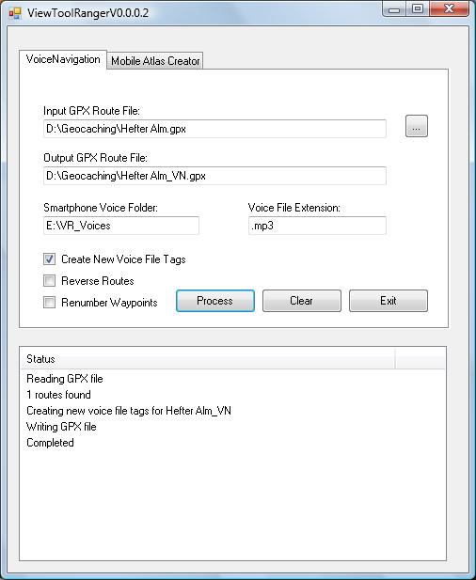

The input GPX route file can be any .gpx route file containing a single or multiple routes. You can generate them within ViewRanger or at my.viewranger.com. The outputfile can be manually selected or will be automatically generated if the line is blank. The output .gpx file contains modified route names and way point names. So you can see in viewranger which routes do have navigation information attached. The default name tag is _VN (voice navigation). The smartphone voice folder is the path on the smart phone, where you have stored your voice files. The voice files in this folder must be identical to the names above, where the extension (e.g. .mp3) must fit the line in Voice File Extension. Then click process. The status window will show you the status and show “Completed” in the end.
If the checkbox Create New Voice File Tags” is unchecked all alarm tags will be deleted in the output file. You can use this to undo the voice navigation information. For creating new voice information this check box must always be checked. If the checkbox “Reverse Routes” is checked the reverse route will be created in the output .gpx file. The default file extension for reverse routes is _RVN (this can be defined in the .ini file). If the checkbox “Renumber Waypoints” is checked the route will be renumbered starting from WT0001 in increments of 1. This can be used for a new sorting of your routepoints.

Detailed Usage Guide Mobile Atlas Creator
The usage for this converter is only temporary as ViewRanger will be directly integrated into Mobile Atlas Creator. Until this is done you can use this converter and generate the following maps for ViewRanger using the cached map files. The mapfiles are located on a Symbian phone in O:\ViewRanger\MapCache\_PalbTN\ followed by a number, where the number means:
84 Open Street Map Mapnik
85 Open Cycle Map (Topo) OSM Cycle Map
87 Open Street map (Direct) MapQuest
88 OSM Midnight Commander OSM CloudMade 999
89 OSM-Fresh OpenStreetMap Hikebikemap.de
129 OpenPiste Map OpenPisteMapBCL

If you are using in Mobile Atlas Creator a map source different to the ones above the conversion will not work.
The first line needs to point to the Mobile Atlas Creator atlas folder. Then you can select with the Atlas combobox your atlas created from MOBAC. You can specify your smartphone destination folder, which for symbian looks like O:\ViewRanger\MapCache\_PalbTN.
If you have a slow memory card it takes some time to complete the copying, so stay patient until the status window shows Completed. It can be faster to select a destination folder on the harddrive and then manually copy the folder to your smart phone. Convert png into you can leave empty for the latest Viewranger version, but users of older versions reported the need of .png files. Then click process and wait for a Completed message.

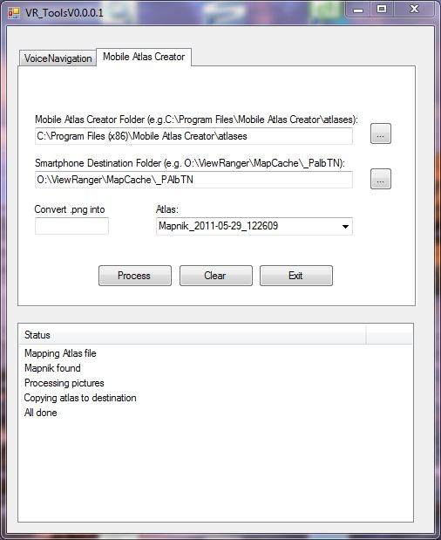

In order to support the Midnight commander you have to create with a text editor an xml file e.g. C:\Program Files \Mobile Atlas Creator\mapsources\MidNightCommander.xml which looks like:

<?xml version="1.0" encoding="UTF-8" standalone="yes"?> <cloudMade> <displayName>OSM Midnight Commander</displayName> <styleID>999</styleID> </cloudMade>

FAQ and Tips
- Do not edit route gpx files after you have processed the voice navigation tags – lock the file in ViewRanger
- The voice navigation will output wrong commands if you miss the route and approach the next way point from a different direction than the last way point
- Do not use reverse navigation in ViewRanger or left and right will be mirrored
- On my Nokia 5800 the following settings worked well for walking:
  - XTE distance: 70m
  - Approach distance: 15m
  - Next WPT: 15m
- For biking try an approach distance of 50m
- If your voice command comes too late increase the approach distance, if it comes too early decrease the approach distance. You will need different settings for walking, biking and driving.
- Do not place way points too close too each other (at least 2 x the approach distance e.g. > 30m
- Place the way points before intersections and turns of new paths. Ensure that the next way point creates a clear direction for the path.

Change Log
- Version 0.0.0.3 tested with ViewRanger Android V4.0.6
  - bug fix start.mp3, end.mp3 replaced by capital letters
  - bug fix in mp3 path fixed
  - bug fix for empty path (default)
- Version 0.0.0.2 tested with ViewRanger Symbian V2.9.2 and Mobile Atlas Creator V1.9beta5
  - bug fix on MOBAC atlas combo box
  - bug fix on multiple exceptions
  - new: reverse routes
  - new: renumber waypoints
  - improved autorenaming of output gpx file
  - German voice set improved (no silence before command)
- Version 0.0.0.1 tested with ViewRanger Symbian V2.9.2 and Mobile Atlas Creator V1.9beta5
  - Initial release
License
/*
* Copyright (C) 2011 huha
*
* This Program is free software; you can redistribute it and/or modify
* it under the terms of the GNU General Public License as published by
* the Free Software Foundation; either version 2, or (at your option)
* any later version.
*
* This Program is distributed in the hope that it will be useful,
* but WITHOUT ANY WARRANTY; without even the implied warranty of
* MERCHANTABILITY or FITNESS FOR A PARTICULAR PURPOSE. See the
* GNU General Public License for more details.
*
* You should have received a copy of the GNU General Public License
* along with GNU Make; see the file COPYING. If not, write to
* the Free Software Foundation, 675 Mass Ave, Cambridge, MA 02139, USA.
* http://www.gnu.org/copyleft/gpl.html

