S60 3.2
OMA SUPL POS Message Plugin
Reference Implementation
Design Document

Team name | Author
Location Technology Team | Sridhar Krishna

Change history:

Version | Date | Status | Comments
2.0 | 23.08.2006 | Approved | Figure 4.3 caption corrected.
1.0 | 29.05.2006 | Approved

Table of contents:

1. Document control 4
1.1 References 4
1.2 Documentation conventions 4
1.3 Abbreviations 4
1.4 Definitions 4
2. General 5
2.1 Introduction 5
2.2 Component environment 5
2.3 Services required 6
2.3.1 From the Symbian OS subsystems 6
2.3.2 From the Domestic OS subsystems 6
2.3.3 From HW 6
3. UI control hierarchy 7
4. Design 8
4.1 Class diagram 8
4.2 Class descriptions 9
4.3 Operations 10
4.3.1 Loading and initializing POS Handler 11
4.3.2 Creating and initializing POS Session 12
4.3.3 Retrieving SUPL Message parameters 13
4.3.4 Processing POS payload 14
4.3.5 Generating POS payload 15
4.3.6 Retrieving position information 16
4.3.7 Terminating POS Session 17
5. Variation 18
6. System resource usage 19
6.1 Files 19
6.2 Databases 19
6.3 Central Repository 19
6.4 Memory consumption 19
6.5 Task allocation 19
6.6 Performance 19
6.7 Timers 19
7. Security 20
7.1 Capabilities of this component 20
7.2 Environmental assumptions 20
7.3 Additional enforcements 20
8. Exception handling 21
9. Usage 22
9.1 Building 22
9.2 User's guide 22

Document control

References
- S60 3.2 SUPL Subsystem Architecture Description
- S60 SUPL Subsystem Design Document
- S60 SUPL POS Message Plug-in API Specification

Documentation conventions
Code is shown with the Courier New font.

Abbreviations
API | Application Programming Interface
FW | Framework
HW | Hardware
OMA | Open Mobile Alliance
OS | Operating System
RRC | Radio Resource Control
RRLP | Radio Resource LCS Protocol
SET | SUPL Enabled Terminal
SLP | SUPL Location Platform
SUPL | Secure User Plane Location
TIA-801 | Telecommunications Industry Association – 801
UI | User Interface
UID | Unique Identifier

Definitions
ECom | Framework defined in Symbian OS for realizing plug-in architectures.
Framework | Usually denotes the collection of an engine and associated programming interfaces. This document mentions the SUPL framework and the Symbian OS ECom framework. There is also a subsystem in Symbian OS called Application Frameworks.
Platform Security | Definition for security design principles and features in Symbian OS.

General
This document describes the OMA SUPL POS Message Plugin component which is a reference implementation of POS Message Plugin API of SUPL Framework. The SUPL Framework subsystem design is described in reference document [2] and the architecture is described in reference document [1].

Introduction
OMA SUPL POS Message Plugin is an adaptation component that facilitates the exchange of control plane positioning protocol messages (POS Messages) between SUPL FW and the DOS component that implements the control plane positioning protocol component (e.g. RRLP, RRC, TIA-801).
The OMA SUPL POS Message Plugin reference implementation is an ECom plug-in that demonstrates the functionality of processing the POS messages received from the network. It also demonstrates retrieval of SUPL message parameters that include:
- POS payload
- SET capabilities
- Position
- Velocity
- Requested assistance data

This reference implementation plug-in does not however implement any of the control plane positioning protocol components but only provides a set of default values for the SUPL parameters.

Component environment
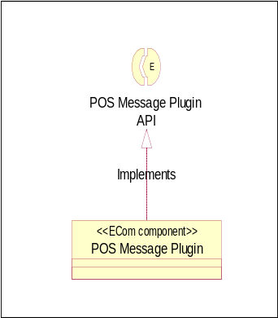
Figure 2.1 OMA SUPL POS Message Plugin component diagram

Services required

From the Symbian OS subsystems
Subsystem | Purpose
Base | Base provides the programming framework for all the other components of Symbian OS. The SUPL subsystem uses Base for the basic data types such as buffers, descriptors and arrays, active objects, process related calls, etc.
App Protocols | The Application Protocols subsystem provides various application level utilities such as the ECom plug-in architecture providing a generalized mechanism to plug-in different DLLs.

From the Domestic OS subsystems
The OMA SUPL POS Message Plugin reference implementation does not have any direct interfaces to the Domestic OS side subsystems as this component provides default implementations to retrieve SUPL parameters.
Other licensee implementations of this plug-in, however, may provide interfaces to DOS components that implement one of the control plane positioning protocols (e.g. RRLP, RRC, TIA-801).

From HW
This component has no direct HW interfaces.

UI control hierarchy
This component does not contain any UI or UI controls design.

Design

Class diagram
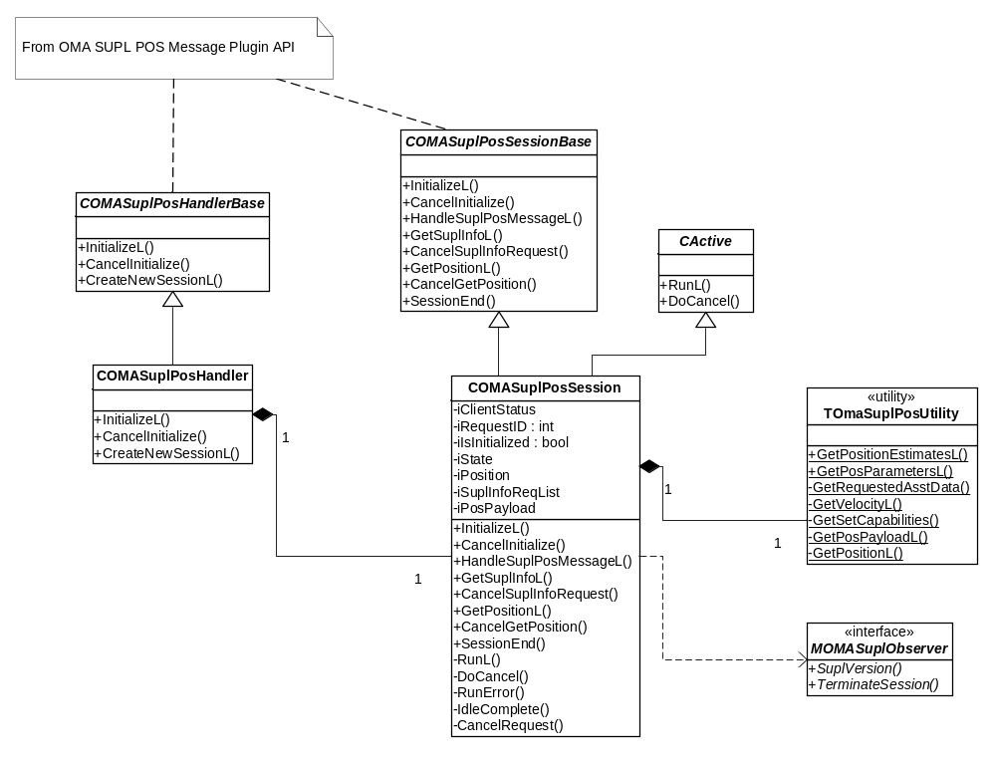
Figure 4.2 OMA SUPL POS Message Plugin

Class descriptions
Class | Description | Header file
COMASuplPosHandler | - This class implements COMASuplPosHandlerBase which is the base class for all POS Message Plugin implementations.  - This class provides the functionality of creating an instance of COMASuplPosSession which is used by SUPL FW to perform operations related to retrieving and processing SUPL POS messages. This class does not take ownership of the instance of COMASuplPosSession created but returns the handle to SUPL FW. | epos_comasuplposhandler.h
COMASuplPosSession | - This class implements COMASuplPosSessionBase which is used by SUPL FW to create POS Sessions.  - This class provides the implementations to retrieve SUPL parameters (see Section 2.1), position information and process POS messages. | epos_comasuplpossession.h
TOMASuplPosUtility | - This is a utility class that is used by COMASuplPosSession to obtain position information and POS parameters (see Section 2.1).  - The implementation of this class provides COMASuplPosSession with default values of Position estimates and POS parameters that are only used to demonstrate the working of the reference implementation of POS Message Plugin API. | epos_tomasuplposutility.h

Operations
Table 4.1 Parameter values returned by OMA SUPL POS Message Plugin reference Implementation
Parameter | Values
Velocity (Horizontal Velocity) | Bearing = 1  Horizontal Speed = 2
SET Capabilities | Positioning Technology  - A-GPS SET Assisted = ETrue  - GPS SET Based = ETrue  - Autonomous GPS = ETrue  - AFLT = ETrue  - EOTD = ETrue  - OTDOA = ETrue  Control Plane Positioning Protocol  - TIA 801 = ETrue  - RRLP = ETrue  - RRC = ETrue  Preferred Method = EOMANoPreferred
POS Payload | Payload = “PayLoadData”  Payload Type = ETIA801
Requested Assistance Data | Almanac indicator = ETrue  UTC model = ETrue  Ionospheric model = ETrue  DGPS correction = ETrue  Reference Indication = ETrue  Reference Time = ETrue  Acquisition assistance = ETrue  Real-time integrity = ETrue
Position | Position Estimates  - Latitude Sign = ENorth  - Latitude = 100  - Longitude = 100  Velocity  - Bearing = 1  - Horizontal Speed = 2

Loading and initializing POS Handler
Operation | Loading and initializing POS Handler.
Preconditions | SUPL FW has loaded the Protocol Handler plug-in.
Description | The Protocol Handler component of SUPL FW initializes OMA SUPL POS Message Plug-in by invoking the InitializeL method. This is the first operation that is invoked by SUPL FW. This operation needs to be completed before any other operation can be initiated.  POS Handler only completes the client request with KErrNone and does not perform any other operation specific to initialization.
Inputs | A reference to the client request status.
Modifies | Completes the client request with KErrNone.
Outputs
Postconditions | POS Handler is successfully initialized.
Related To
Related Event
Exceptions | KErrNoMemory If creating an instance of POS Handler fails.

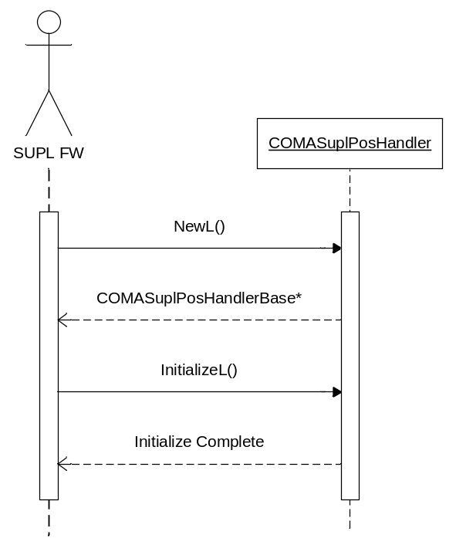
Figure 4.3 Loading and initializing POS Handler

Creating and initializing POS Session
Operation | Creating and initializing POS Session.
Preconditions | POS Handler is successfully instantiated.
Description | The Protocol Handler component of SUPL FW creates the instance of COMASuplPosSession by invoking the CreateNewSessionL method of COMASuplPosHandler. This instance of COMASuplPosSession is then initialized by invoking the InitializeL method. This is the first operation that is invoked by SUPL FW. This operation needs to be completed before any other operation can be initiated.
Inputs | Request ID and a reference to the client request status.
Modifies | Sets internal state to initialized and completes the client request with KErrNone.
Outputs
Postconditions | POS Session is successfully initialized.
Related To
Related Event | Loading and initializing POS Handler.
Exceptions | KErrNoMemory if creating an instance of POS Session fails.

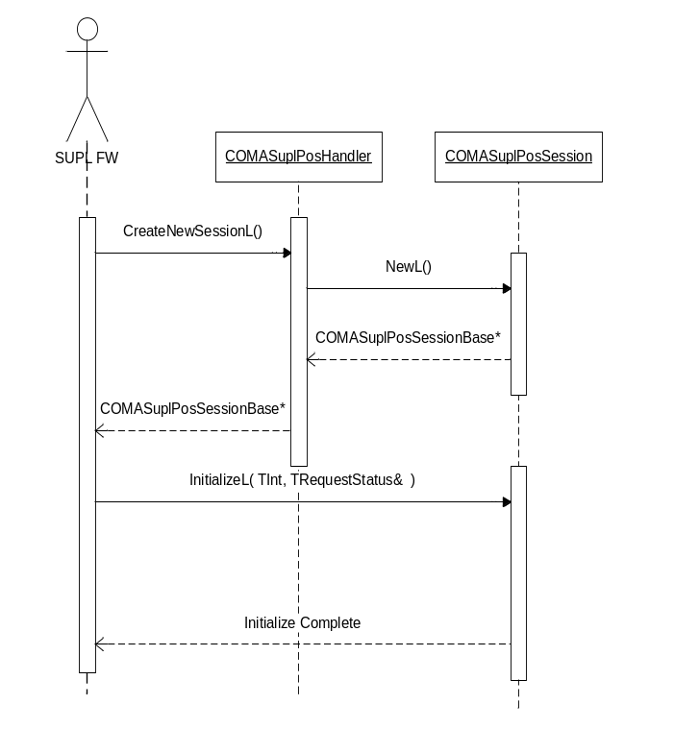
Figure 4.4 Creating and initializing POS Session

Retrieving SUPL Message parameters
Operation | Retrieving SUPL Message parameters.
Preconditions | POS Handler and POS Session are successfully initialized.
Description | SUPL FW invokes GetSuplIfnoL by setting COMASuplInfoRequestList with the parameter types for which the information needs to be retrieved.  OMA SUPL POS Message Plugin sets the specified parameters with the values provided by the TOMASuplPosUtility class. The values for each of the SUPL parameters are listed in Table 4.1.
Inputs | Reference to COMASuplInfoRequestList.
Modifies | COMASuplInfoRequest instances to contain the desired parameter information.
Outputs
Postconditions | COMASuplInfoRequestList is set with the instances of COMASuplInfoRequest instances containing the requested parameter values.
Related To
Related Event
Exceptions | - KErrOMASuplPosInActive if POS Session is not initialized before performing this operation or when an existing session has been terminated.  - KErrOMASuplParamNotSet if there is an error when retrieving SUPL parameter values.

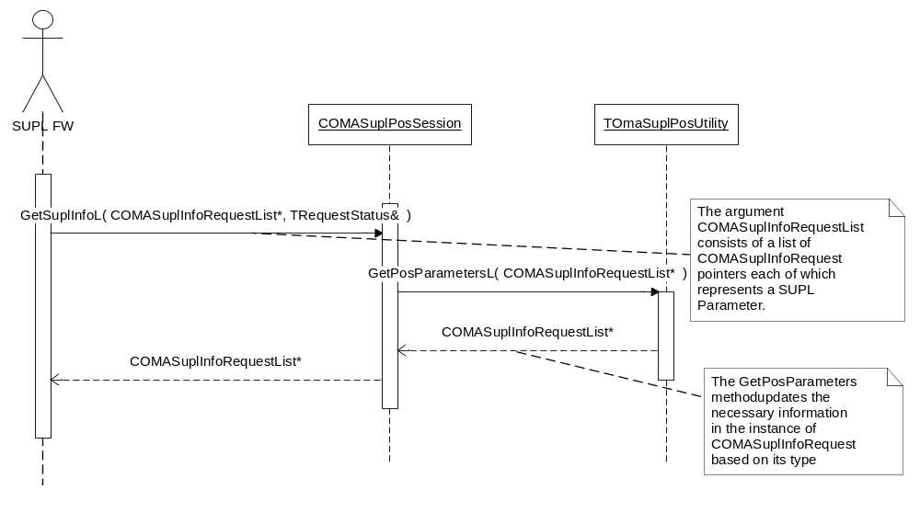
Figure 4.5 Retrieving SUPL Message parameters

Processing POS payload
Operation | Processing POS payload.
Preconditions | POS Handler and POS Session are successfully initialized.
Description | When a POS payload is received from SLP, SUPL FW invokes the HandleSuplPosMessageL method of OMA SUPL POS Message Plugin.  The reference implementation of the plug-in only saves the received POS payload internally and does not perform any specific operation related to processing of the payload information.
Inputs | Reference to COMASuplPosPayload containing the POS payload.
Modifies
Outputs
Postconditions | The POS payload is saved internally by the plug-in.
Related To
Related Event
Exceptions | - KErrOMASuplPosInActive if POS Session is not initialized before performing this operation or when an existing session is terminated.  - KErrNoMemory if creating a buffer for storing POS payload fails.

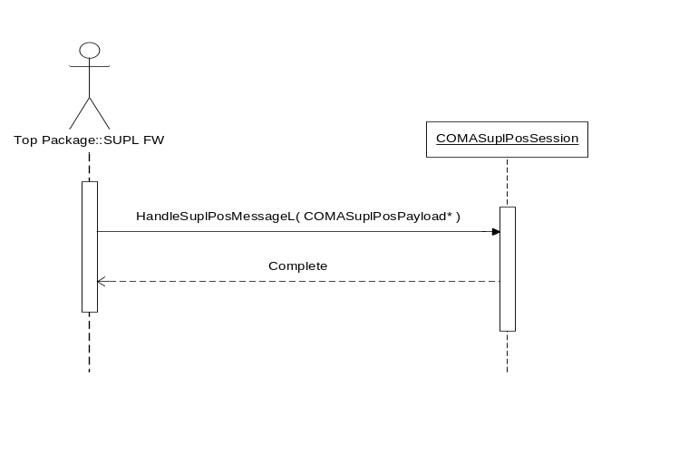
Figure 4.6 Processing POS payload

Generating POS payload
Operation | Generating and processing POS payload.
Preconditions | POS Handler and POS Session are successfully initialized.
Description | SUPL FW invokes the GetSuplInfoL method by setting the COMASuplInfoRequestList with an instance of COMASuplInfoRequest specifying the requested parameter type as EOMASuplPosPayload.  OMA SUPL POS Message Plugin sets the POS payload information and sets the status of the instance of COMASuplInfoRequest to KErrOMASuplLastPosMsg to indicate that it is the last POS payload. COMASuplInfoRequestList containing this instance is returned to SUPL FW. The POS payload parameters are as shown in Table 4.1.
Inputs | Reference to COMASuplInfoRequestList containing the instance of COMASuplInfoRequest to be updated.
Modifies | The COMASuplInfoRequest instance to contain the POS payload.
Outputs
Postconditions | COMASuplInfoRequestList is set with the instance of the COMASuplInfoRequest instance containing the requested POS payload information.
Related To
Related Event
Exceptions | - KErrOMASuplPosInActive if POS Session is not initialized before performing this operation or if an existing POS Session is terminated.  - KErrNoMemory if creating a buffer for storing the POS payload fails.

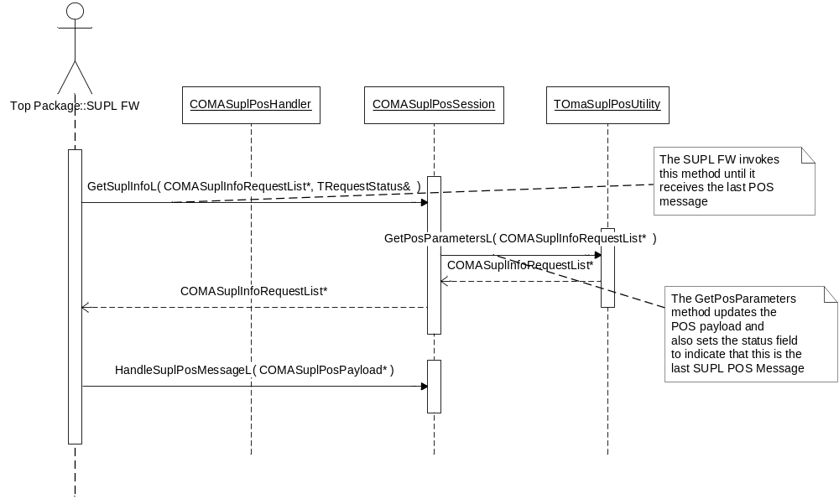
Figure 4.7 Generating POS payload

Retrieving position information
Operation | Retrieving position information.
Preconditions | POS Handler and POS Session are successfully initialized
Description | SUPL FW requests position information from OMA SUPL POS Message Plugin when this information is not available in the SUPL END message provided by SLP in case of terminal initiated request. This operation is performed by invoking the GetPositionL method of the plug-in.  OMA SUPL POS Message Plugin sets the position estimates with the values provided by the TOMASuplPosUtility class. The parameters set for the position estimates are described in Table 4.1.
Inputs | Reference to an instance of COMASuplPosition whose values are to be updated.
Modifies | The instance of COMASuplPosition with the updated position estimates.
Outputs
Postconditions | The requested position estimates are successfully returned to SUPL FW.
Related To
Related Event
Exceptions | KErrOMASuplPosInActive if the InitializeL method is not invoked by SUPL FW.

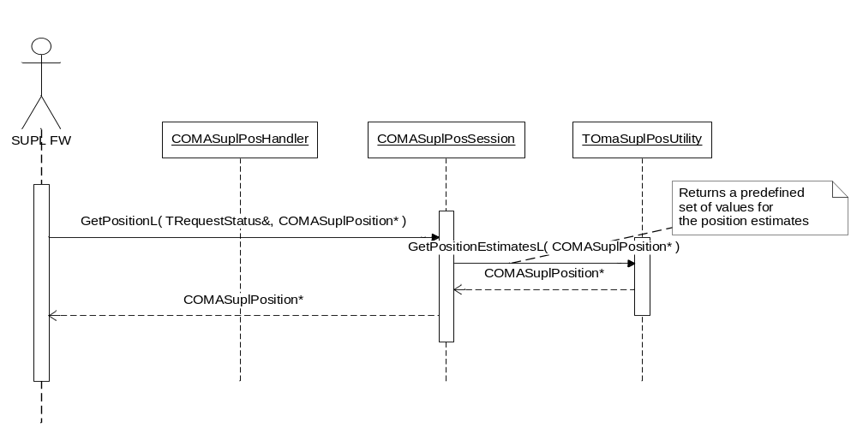
Figure 4.8 Retrieving position information

Terminating POS Session
Operation | Terminating POS Session.
Preconditions | OMA SUPL POS Message Plugin is successfully initialized.
Description | SUPL FW invokes the SessionEnd method of OMA SUPL POS Message Plugin to indicate the end of POS Session. The plug-in terminates any outstanding requests and sets its internal state as un-initialized.
Inputs
Modifies
Outputs
Postconditions | All outstanding requests are terminated successfully
Related To
Related Event
Exceptions

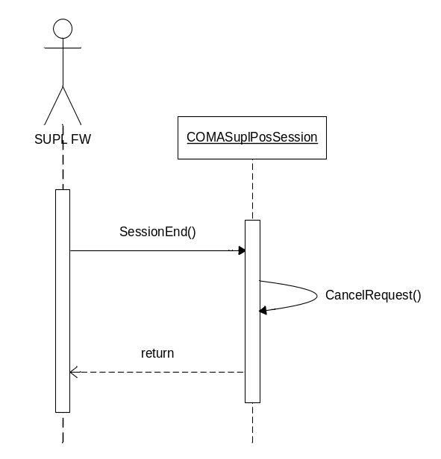
Figure 4.9 Terminating POS Session

Variation
The reference implementation of OMA SUPL POS Message Plugin API does not support any variation mechanism other than application wide image creation time variation defined in reference document [2].

System resource usage

Files
OMA SUPL POS Message Plugin provides a resource file containing ECom registration information. The format of the resource file is as follows.

Resource name | Purpose | Default value
Component: OMA SUPL POS Message Plugin Reference Impl
Resource file: 1027509D.rss
interface_uid | Provides the interface UID reserved for OMA SUPL POS Message Plugin API. | 0x102073D4
implementation_uid | Provides the implementation UID of the ECom plug-in. | 0x1027509C
Version | Provides version information. | 1.0
Display Name | A string that identifies the plug-in. | POS Handler Reference implementation

Databases
This component does not use any databases.

Central Repository
This component does not use Central Repository.

Memory consumption
Memory/Build | Consumption
WINSW UDeb | 214,132 bytes
ARMV5 URel | 2,091 bytes

Task allocation
This component runs in the thread in which it is launched.

Performance
There is no significant performance impact on the SUPL subsystem due to this component.

Timers
This component does not make use of any timers.

Security

Capabilities of this component
Capability | Justification
CAP_ECOM_PLUGIN | {ALL –Tcb} Default capabilities required by all ECom plug-in implementations are provided to this component.

Environmental assumptions
This component does not make any assumptions about its environment.

Additional enforcements
This component does not have any additional security enforcements.

Exception handling
The leave mechanism of the Symbian OS environment is used to handle memory exhaustion.

Exception | Description
KErrOMASuplPosInActive | If SUPL FW requests any operation from OMA SUPL POS Message Plugin before invoking InitializeL.
KErrOMASuplParamNotSet | If there is an attempt to retrieve an optional parameter not set by OMA SUPL POS Message Plugin.

Other errors returned by OMA SUPL POS Message Plugin include system wide error codes.

Usage

Building
The directory paths are relative to /Adaptation/stub.

Component name | Directory | MMP file name | DLL or EXE name
POS Message Plugin Reference Implementation | /posmsgpluginreferenceimpl/ | epos_omasuplposmessage  plugin_ref.mmp | eposomasuplposref  app.dll

Building is done by running the following commands in the /group subdirectory of the directory listed in the table:
bldmake bldfiles
abld build <TARGET> <BUILD>
where <TARGET> is one of winscw, or armv5 and
<BUILD> is one of udeb or urel

User's guide
This application is not used by other components and therefore does not require a user’s guide.

