S60 3.2
ISC Data Transmission Plug-in Reference API
Specification

Team name | Author
 | Rami Potinkara

Change history:

Version | Date | Status | Comments
2.0 | 07.03.2007 | Approved | Changes to reference component.
1.0 | 07.09.2005 | Approved

Table of contents:

1. Document control 4
1.1 References 4
1.2 Documentation conventions 4
1.3 Abbreviations 4
1.4 Definitions 4
2. Purpose 5
2.1 List of the required interfaces 5
2.2 Constraints 5
3. Technical specification 6
3.1 Type of the interface 6
3.2 Interface class structure 6
3.3 Usage 7
3.3.1 Protocol 7
3.3.2 Error handling 7
3.3.3 Memory overhead 7
3.3.4 Extensions to the API 7
3.4 Detailed description 8
3.4.1 DIscDataTransmissionBase 8
3.4.1.1 Pure virtual methods 8
3.4.1.1.1 Install2ndPhase 8
3.4.1.1.2 InitializeDataTransmission 8
3.4.1.1.3 SendFrame 9
3.4.1.1.4 ConnectionStatus 10
3.4.1.2 Virtual methods 11
3.4.1.2.1 AllocBuffers 11
3.4.1.2.2 Connect 11
3.4.1.2.3 ReserveMemoryBlock 11
3.4.1.2.4 ReleaseMemoryBlock 12
3.4.1.2.5 IsWritePending 12
3.4.1.3 Non-virtual methods 12
3.4.1.3.1 ReceiveFrame 12
3.4.1.3.2 NotifyConnectionStatus 14
3.4.1.3.3 Install 14
3.4.2 Code architecture 14
4. Index 15
4.1 Alphabetical list of classes and methods 15
4.2 ISC initialization file 15

Document control

References
- S60 ISC Multiplexer Plug-in Reference API Specification Document
- S60 3.2 Intersystem Communication Subsystem Architecture Description
- S60 Inter-System Communication Design Document
- S60 Inter-System Communication API Specification Document

Documentation conventions
Code is shown with the Courier New font. All diagrams in this document follow the UML notation.

Abbreviations
DFC | Delayed Function Call
DLL | Dynamic Link Library
DMA | Direct Memory Access
EKA2 | Enhanced Kernel Architecture 2
ISC | Inter-System Communication
LDD | Logical Device Driver
PDD | Physical Device Driver

Definitions
ISC Data Transmission driver | This definition is used to refer to the licensee/hardware-specific realization of ISC Data Transmission Plug-in API.
ISC Driver | The driver implementing the services provided through ISC API.
ISC Multiplexer | This name is used to refer to the licensee/messaging protocol-specific ISC Multiplexer; i.e. the realization of ISC Multiplexer Plug-in API (see reference document [1]).

Purpose
This document defines the reference implementation of a public interface (API) of S60 Inter-System Communications Data Transmission. The ISC Data Transmission Plug-in API is used for:
- Connecting ISC Driver and ISC Multiplexer to Domestic OS.
- Sending and receiving frames between ISC Driver and Domestic OS.
- Notifying the Domestic OS connection status to ISC Driver.

Every licensee must realize this API in order to enable Inter-System Communication with the Domestic OS modem. The API does not care whether the modem is located physically in the same or another processor than the S60 one. ISC Data Transmission Plug-in API is basically for frame sending from ISC Driver to the modem and vice versa.

List of the required interfaces
ISC Data Transmission Plug-in API itself does not require any external interfaces.

Constraints
This interface has been available since S60 release 2.8.

Technical specification

Type of the interface
Figure 3.1 illustrates the structure of the interface. This reference interface is used by ISC Driver reference to send frames to Domestic OS. This API realizes the pure data transfer specific part of ISC API; i.e. this API is meant for sending data that has already been formatted to the correct format.
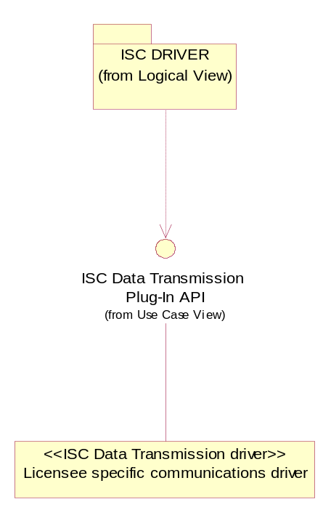
Figure 3.1 Interface structure

Interface class structure
ISC Data Transmission Plug-in API defines the interface for the ISC Data Transmission driver that every licensee has to implement.
The interface is composed of the DIscDataTransmissionBase class that has to be realized by the device class of the ISC Data Transmission driver.
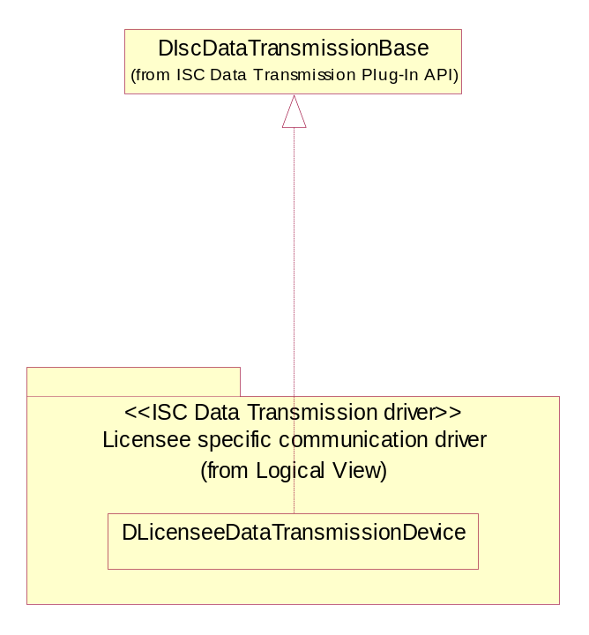
Figure 3.2 Interface class structure
The inheritance from the base classes must be done using a public inheritance method.

Usage
ISC Driver and the driver that realizes this API are the only ones to use it.

Protocol
The initialization methods are Install, Install2ndPhase, Connect, InitializeDataTransmission and AllocBuffers.
Methods for using the service methods ConnectionStatus, IsWritePending, NotifyConnectionStatus, ReceiveFrame, ReleaseMemoryBlock, ReserveMemoryBlock and SendFrame.
For other related API protocols, see reference document [4].

Error handling
Not applicable for this component.

Memory overhead
Not applicable for this component.

Extensions to the API
This API must be extended with a licensee-specific communications driver.

Detailed description

DIscDataTransmissionBase
The class DIscDataTransmissionBase defines an abstract API that ISC Driver uses. It is inherited from the DLogicalDevice class of Device Driver Framework (see reference document [3]). Every licensee must implement this API. The methods are described in detail in the following sections.
The methods are split into three sections. The first section introduces the pure virtual methods that have to be implemented. The second section describes the virtual methods that can be implemented. The third section introduces the rest of the methods (the services that the base class offers). For some of the methods, a sequence diagram is also presented to clarify the desired functionality. In all the diagrams, the class DLicenseeDataTransmissionDevice represents a class inherited from DIscDataTransmissionBase.

Pure virtual methods
All licensees must implement the methods described in this section.

Install2ndPhase

Method | virtual TInt Install2ndPhase() = 0;
Description | Normally device drivers must implement a method called Install, but in ISC Data Transmission the Install method is already implemented in the base class and must not be overwritten. From the base class, this method is called to provide the similar possibility to do initializations.
Caller context | Kernel-thread context. Any memory allocations needed in the ISC Data Transmission driver must be done in this function or in InitializeDataTransmission.
Preconditions
Parameters
Return value | KErrNone if the operation was successful, otherwise some of the system wide error codes.
Modifies
Postconditions
Exceptions

InitializeDataTransmission

Method | virtual void InitializeDataTransmission( TDesC8& aParameters, TDfc* aDfc, TInt& aErrorCode ) = 0;
Description | This method allows the ISC Data Transmission driver to do any licensee-specific initializations needed.
Caller context | Kernel-thread context. Memory allocations/deallocations allowed.
Preconditions
Parameters | - aParameters: Optional parameters that are passed from the INI file to ISC Multiplexer, see Section 4.2 for more information.  - aDfc: A pointer to the DFC that must be queued after the ISC Data Transmission driver has done its initializations.  - aErrorCode: An error code to notify ISC Driver if the initialization failed. If set to something else than KErrNone, the ISC initialization fails and the error code will be notified to the caller of RIscApi::InitilizeModemInterface().
Return value
Modifies
Postconditions | After aDfc has been queued, the ISC Data Transmission driver must be ready to transfer frames to and from Domestic OS.
Exceptions

SendFrame

Method | virtual void SendFrame( TDes8& aFrame, TDfc* aDfc, TAny* aFrameInfo ) = 0;
Description | This method is used to send frames to Domestic OS.
Caller context | DFC. Memory allocations/deallocations are allowed.
Preconditions | A channel is open.
Parameters | - aFrame: The frame to be sent to the modem via some communication bus/shared memory/etc. Note that the frame is allocated with ReserveMemoryBlock and it has to be deallocated with ReleaseMemoryBlock when the frame has been sent.  - aDfc: This DFC must be queued when the sending has been successfully completed. This indicates to ISC Driver that the next frame can be sent; i.e. SendFrame can be called again.  - aFrameInfo: An ICF Multiplexer implementation specific pointer to the structure or class containing additional information for the ISC Data Transmission driver.
Return value
Modifies
Postconditions | The frame is sent to Domestic OS and aDfc is queued by the driver realizing this plug-in API. If the frame sending fails for some reason (in practice, when the communication bus dies), ISC Driver should be notified by calling NotifyConnectionStatus with the value EIscConnectionNotOk, see Section 3.4.1.3.2.
Exceptions

Figure 3.3 describes the desired SendFrame functionality.
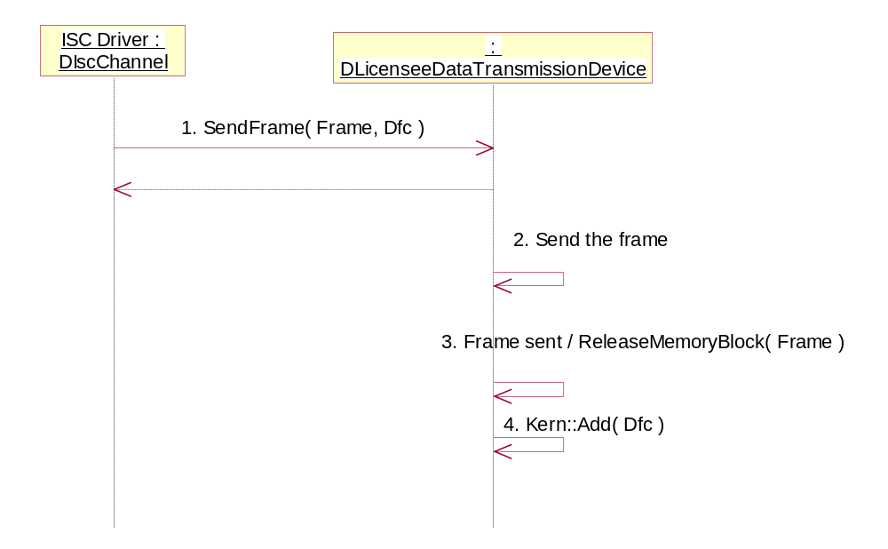
Figure 3.3 Frame sending
The sequence is explained in the following:
- ISC Driver starts sending data by calling SendFrame.
- The ISC Data Transmission driver sends the data to Domestic OS.
- After the data has been sent, the ISC Data Transmission driver must free the memory block containing the data that was sent.
- Finally, the ISC Data Transmission driver must signal ISC Driver by running the DFC given as a parameter to SendFrame. This informs ISC Driver that the data has been sent and more data can be passed to the ISC Data Transmission driver. Note that its up to the ISC Data Transmission driver to make sure that the data is really transferred to Domestic OS. There is no mechanisms in ISC e.g. for data re-transmission.

ConnectionStatus

Method | virtual TInt ConnectionStatus() = 0;
Description | Gets the current status of the connection between the Symbian OS side and the modem.
Caller context | User-thread context. If memory allocations/deallocations are needed in the user-thread context, use NKern::ThreadEnterCS and NKern::ThreadLeaveCS.
Preconditions
Parameters
Return value | The possible values are the following:  - EIscConnectionOk  - EIscConnectionNotOk
Modifies
Postconditions
Exceptions

Virtual methods
The following methods are implemented in the base class and they can be overwritten if needed. However, in most cases these methods should not be overwritten since these methods implement the pre-allocated memory block handling and allocation.

AllocBuffers

Method | void AllocBuffers( TIscBufferEntry* aBufferConfig );
Description | This method makes the buffer allocations according to the configuration specified by ISC Multiplexer with the method GetConfiguration (see reference document [1]).
Caller context | Kernel-thread context. Memory allocations/deallocations are possible.
Preconditions | This method is called after the ISC Data Transmission driver is loaded and its Install2ndPhase is called.
Parameters | aBufferConfig: A pointer to the buffer configuration table (see reference document [1]).
Return value
Modifies
Postconditions | The pre-allocated buffers are allocated.
Exceptions

Connect

Method | void Connect(DIscDevice* aDevice);
Description | Connects ISC Driver to the ISC Data Transmission driver.
Caller context | Kernel-thread context. Memory allocations/deallocations are possible.
Preconditions
Parameters | aDevice: A pointer to the ISC Driver device.
Return value
Modifies
Postconditions
Exceptions

ReserveMemoryBlock

Method | void ReserveMemoryBlock( TDes8*& aPtr, const TUint16 aSize );
Description | This method reserves a pre-allocated memory block for sending/receiving frames.
Caller context
Preconditions
Parameters | - aPtr: A reference to the pointer of the descriptor. In practice, a TDes8* variable.  - aSize: The minimum size of the needed memory block.
Return value
Modifies | Writes the address of the reserved descriptor into aPtr. If the memory allocation was successful, aPtr is other than NULL, but if the allocation failed, aPtr is NULL.
Postconditions
Exceptions

ReleaseMemoryBlock

Method | void ReleaseMemoryBlock( TDes8* aPtr );
Description | This method releases the memory block allocated with ReserveMemoryBlock.
Caller context
Preconditions
Parameters | aPtr: A pointer to the descriptor pointing to the memory block allocated with ReserveMemoryBlock.
Return value
Modifies
Postconditions
Exceptions

IsWritePending

Method | TBool IsWritePending();
Description | This method is used to check if a write operation is pending.
Caller context | DFC. Memory allocations/deallocations are allowed.
Preconditions
Parameters
Return value | - ETrue: There are pending write operations.  - EFalse: There are no pending write operations.
Modifies
Postconditions
Exceptions

Non-virtual methods
The following methods are declared as protected in the base class. The methods are needed by the ISC Data Transmission driver in order to communicate with ISC Driver.

ReceiveFrame

Method | void ReceiveFrame( TDesC8& aFrame );
Description | This method transfers the incoming frame to ISC Driver, which will handle it. The ISC Data Transmission driver should call this method when there is a frame received from Domestic OS.
Preconditions
Parameters | aFrame: A reference to the descriptor containing the received frame. Note that the frame is allocated with ReserveMemoryBlock and it has to be deallocated with ReleaseMemoryBlock when the frame has been delivered to the ISC client.
Return value
Modifies
Postconditions
Exceptions

Figure 3.4 illustrates the frame receiving procedure.
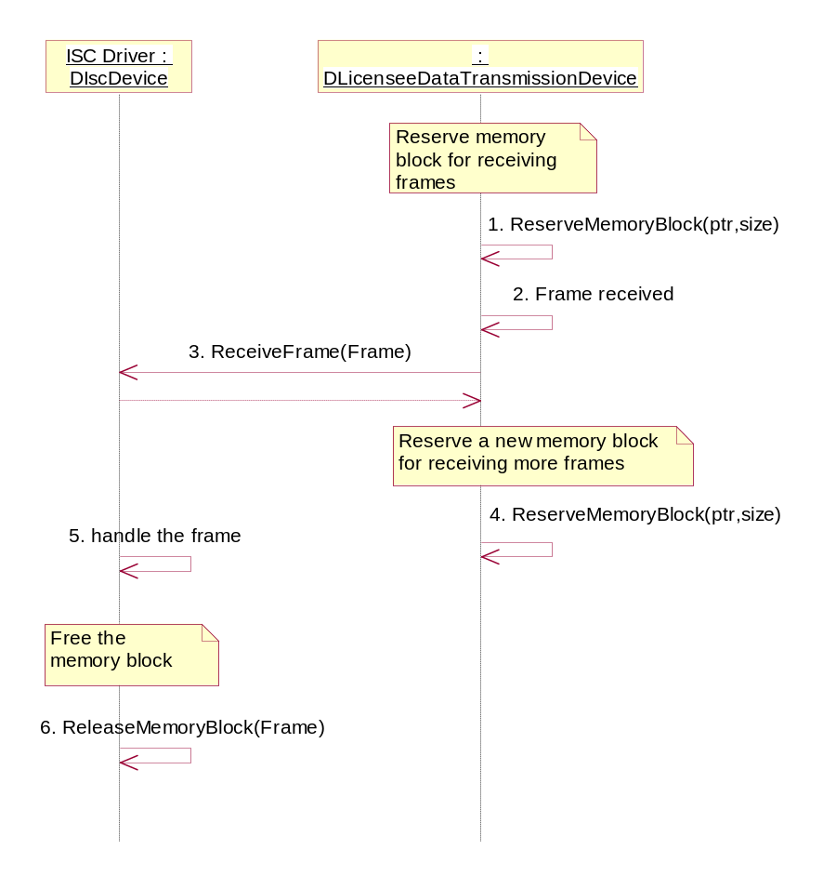
Figure 3.4 Frame receiving
The sequence is explained in the following:
- The ISC Data Transmission driver reserves memory for receiving by using ReserveMemoryBlock.
- A frame is received via DMA and the data is copied directly into the buffer allocated in step 1.
- The frame is delivered into ISC Driver by calling ReceiveFrame.
- The ISC Data Transmission driver reserves a new memory block for receiving more data.
- ISC Driver handles the incoming data.
- After ISC Driver has handled the data, the memory block is released.

NotifyConnectionStatus

Method | void NotifyConnectionStatus( TInt aStatus );
Description | This method notifies ISC Driver of changes in the connection status between the Symbian side and Domestic OS. This method should be called for the first time when the connection is successfully established between Symbian OS and Domestic OS.
Preconditions
Parameters | aStatus: The status to be notified to ISC Driver. The possible values are the following:  - EIscConnectionOk  - EIscConnectionNotOk
Return value
Modifies | The connection status variable in ISC Driver changes to reflect the new connection status.
Postconditions
Exceptions

Install

Method | TInt Install();
Description | This function is called after the LDD has been successfully loaded and the factory object has been successfully created on the kernel heap. Handles the second phase construction and sets the name of the device. Calls the Install2ndPhase method, see Section 3.4.1.1.1.
Preconditions
Parameters
Return value | An integer value, which depends on the implementation of Install2ndPhase.
Modifies | Sets the name of the device.
Postconditions | The name of the device is set.
Exceptions

Code architecture
- Headers: IscDataTransmissionBase.H, IscBufferAllocator.H and IscBufferQueue.H
- Library: IscDataTransmissionBase.LIB
- DLL: IscDataTransmissionBase.DLL

Index

Alphabetical list of classes and methods

class DIscDataTransmissionBase
IMPORT_C virtual void AllocBuffers( TIscBufferEntry* aBufferConfig );
IMPORT_C virtual void Connect(DIscDevice* aDevice);
virtual TInt ConnectionStatus() = 0;
IMPORT_C DIscDataTransmissionBase();
IMPORT_C virtual ~DIscDataTransmissionBase();
IMPORT_C TInt Install();
virtual TInt Install2ndPhase() = 0;
virtual void InitializeDataTransmission( TDesC8& aParameters, TDfc* aDfc,TInt& aErrorCode ) = 0;
virtual TBool IsWritePending();
IMPORT_C void NotifyConnectionStatus( TInt aStatus );
IMPORT_C void ReceiveFrame(TDesC8& aFrame);
IMPORT_C virtual void ReleaseMemoryBlock( TDes8* aPtr );
IMPORT_C virtual void ReserveMemoryBlock( TDes8*& aPtr, TUint16 aSize);
virtual void SendFrame( TDes8& aFrame, TDfc* aDfc, TAny* aFrameInfo ) = 0;

class DIscBufferAllocator
IMPORT_C TInt AllocBuffers();
IMPORT_C void ReleaseMemoryBlock( TDes8* aPtr );
IMPORT_C void ReserveMemoryBlock( TDes8*& aPtr, TUint16 aSize );

ISC initialization file
ISC API uses an initialization file called Z:\\resource\\ISC\\isc_config.INI. It is the responsibility of the licensee to export the initialization file into \epoc32\release\xxx and to make sure that it is taken into the ROM image to the correct path.
The format of the initialization-file is the following:

########################################################
# This is a comment
########################################################
DataTransmissionPdd=ExampleDataTransmission.PDD
DataTransmissionLdd=ExampleDataTransmission.LDD; [parameters]
MultiplexerLdd=ExampleISCMultiplexer.LDD; [parameters]
#PDD=Example.PDD
#LDD=Example.LDD
########################################################

The mandatory fields in the initialization file are the following:
- DataTransmissionLdd: The name of the ISC Data Transmission driver LDD.
- MultiplexerLdd: The name of the ISC Multiplexer to load.

parameters is the initialization string that is passed to the corresponding driver during ISC initialization. The string is passed as a parameter to DIscDataTransmissionBase::InitializeDataTransmission().parameters can be left out if not needed. It is used for pre-allocated buffers configuration (see reference document [3]).
The optional fields in the initialization file are the following:
- DataTransmissionPdd: The name of the PDD for the ISC Data Transmission driver.
- PDD & LDD: If there are more drivers that are required to be loaded, they can be specified here.

