S60 3.x
ISC Multiplexer Plug-in Reference API
Specification Document

Team name | Author
 | Jari Issakainen

Change history:

Version | Date | Status | Comments
14.0 | 07.03.2007 | Approved | Changes to reference component
13.0 | 14.08.2006 | Approved | Editorial changes
12.0 | 08.06.2006 | Approved | Changed document ID from B-DN04115822 11.0  to C-DN04115822 11.0a
11.0 | 10.08.2005 | Approved | Updated CopyFromUserBuffer and CopyToUserBuffer. Added GetThreadPtr, updated Alphabetical List of classes and methods.
10.0 | 27.04.2005 | Approved | Updated IsPending, CopyFromUserBuffer and CopyToUserBuffer return values.
9.0 | 11.03.2005 | Approved | Changed offset to point user buffer in CopyFromUserBuffer-method
8.0 | 02.03.2005 | Approved | SetInitializationParameters, CancelSending, CopyTo/FromUserBuffer added, parameter changes.
7.0 | 15.11.2004 | Approved | Custom function parameter change TDesC8& -> TDes8&, channelDataRcvQueueSize added to TIscConfiguration struct
5.0 | 19.10.2004 | Approved | KErrNoMemory return value added to QueueFrame
4.0 | 14.10.2004 | Approved | Changed some channelid types from TUint8 to TUint16
3.0 | 30.09.2004 | Approved | Changes to chapter 4.1.1.
2.0 | 06.08.2004 | Approved
1.0 | 27.07.2004 | Approved

Table of contents:

1. Document control 5
1.1 References 5
1.2 Documentation conventions 5
1.3 Abbreviations 5
1.4 Definitions 5
2. Purpose 6
2.1 List of required interfaces 6
2.2 Constraints 6
3. Technical specification 7
3.1 Type of interface 7
3.2 Interface class structure 7
3.3 Usage 8
3.3.1 Error handling 8
3.3.2 Memory overhead 8
3.3.3 Extensions to the API 8
3.4 Detailed description 8
3.4.1 DIscMultiplexerBase 8
3.4.1.1 Pure virtual methods 9
3.4.1.1.1 Install2ndPhase 9
3.4.1.1.2 InitializeMultiplexer 9
3.4.1.1.3 OpenDLC 10
3.4.1.1.4 CloseDLC 11
3.4.1.1.5 Send 12
3.4.1.1.6 DataSend 14
3.4.1.1.7 GetFrameInfo 14
3.4.1.1.8 GetRcvChannelId 15
3.4.1.1.9 DLFlowControl 17
3.4.1.1.10 HandleControlFrame 17
3.4.1.1.11 CancelNotify 17
3.4.1.1.12 MaximumDataSize 18
3.4.1.1.13 NotifyConnectionStatus 18
3.4.1.1.14 GetConfiguration 18
3.4.1.2 Virtual methods 19
3.4.1.2.1 SetInitializationParameters 19
3.4.1.2.2 GetChannelInfo 19
3.4.1.2.3 CustomFunction 20
3.4.1.3 Non-virtual methods 20
3.4.1.3.1 CancelSending 20
3.4.1.3.2 CompleteRequest 21
3.4.1.3.3 IsPending 21
3.4.1.3.4 QueueFrame 21
3.4.1.3.5 FlushQueues 22
3.4.1.3.6 ULFlowControl 22
3.4.1.3.7 ReserveMemoryBlock 23
3.4.1.3.8 ReleaseMemoryBlock 23
3.4.1.3.9 CopyFromUserBuffer 24
3.4.1.3.10 CopyToUserBuffer 24
3.4.1.3.11 GetThreadPtr 25
3.4.2 TIscFrameInfo 26
3.4.3 TIscConfiguration 27
3.4.4 Code architecture 27
3.5 Other requirements for the implementation 28
3.5.1 ISC initialization file 28
4. Index 29
4.1 List of constants and enumerations 29
4.1.1 Fault reasons 29
4.2 Alphabetical list of classes and methods 30

Document control

References

- S60 Inter System Communication API Specification
- S60 ISC Data Transmission Plug-in Reference API Specification
- 3GPP TS 07.10 V7.2.0 Terminal Equipment to Mobile Station (TE-MS) multiplexer protocol (Release 1998) | http://www.etsi.org/
- S60 Intersystem Communication Subsystem Architecture Description

Documentation conventions
Code is shown with Courier New font. All diagrams in this document follow the UML notation.

Abbreviations

DFC | Delayed Function Call
DLC | Data Link Connection
DLCI | Data Link Connection Identifier
DOS | Domestic OS
EKA1 | Enhanced Kernel Architecture 1
EKA2 | Enhanced Kernel Architecture 2
ISC | Inter System Communication

Definitions

ISC Data Transmission driver | This definition is used to refer to the licensee/hardware –specific realization of ISC Data Transmission Plug-in API, see reference document [2] for details.
ISC Driver | The driver implementing the services provided through ISC API.
ISC Multiplexer | This name is used to refer to the licensee/messaging protocol specific multiplexer.

Purpose
This document defines the ISC Multiplexer Plug-in Reference API. The API is used by ISC Driver Reference, which provides the services provided in the ISC API (see reference document [1]). ISC Multiplexer Plug-in Reference API provides the following services:
- Handling multiplexer initialization.
- Opening multiplexer channel.
- Encoding the correct frame structure and sending the frames.
- Decoding incoming frames.

This is a reference implementation and every licensee must realize this API in order to enable Inter System Communication with the modem.

List of required interfaces
None.

Constraints
This interface is available starting from Series 60 Platform release 2.8. The interface works on both Symbian EKA1 and EKA2 based systems, that is, Symbian OS 8.xb and Symbian OS 8.xa.

Technical specification

Type of interface
The following figure illustrates the structure of the interface. This interface is used by ISC Driver to send data to the Domestic OS. This API realizes the messaging protocol specific part of the ISC API.
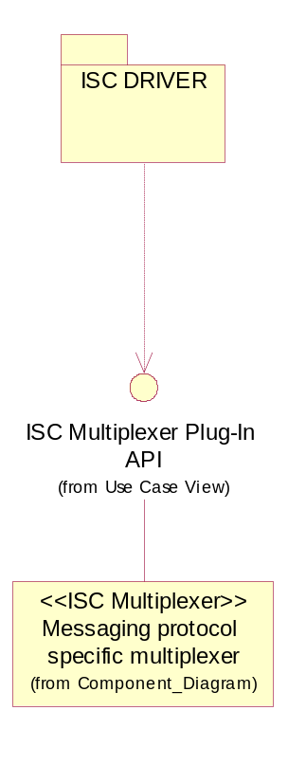
Figure 3.1. Interface structure

Interface class structure
The Plug-in API defines the interface to ISC Multiplexer that every licensee has to implement. The ISC Multiplexer is basically messaging protocol specific, but some variations may have to be done for each licensee even if they were using the same messaging protocol. One good example of a widely used messaging protocol is the AT Multiplexer protocol (see reference document [3]).
The interface is composed of one class that contains pure virtual methods.
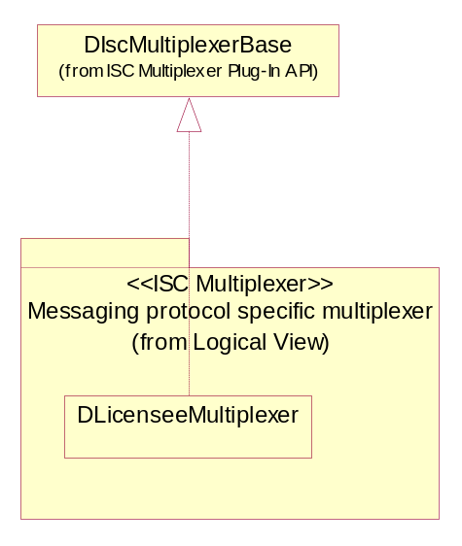
Figure 3.2. The structure of the ISC Multiplexer Plug-in interface
The inheritance from the base class must be done using public inheritance method.

Usage
This API is used only by ISC Driver and must not be used by any other entity. The ISC Driver uses this API to provide the messaging protocol specific functionality.

Error handling
Not applicable for this component.

Memory overhead
Not applicable for this component.

Extensions to the API
The API extension can be handled via CustomFunction, see Section 3.4.1.2.3 for more information.

Detailed description

DIscMultiplexerBase
Class DIscMultiplexerBase defines an abstract API that ISC Driver uses. Every licensee/messaging protocol must implement this API. Every method is described in detail in the following sections.
The methods are split into three sections: The first section introduces the pure virtual methods that have to be implemented. The second section describes the virtual methods that can be implemented. The third section introduces the rest of the methods (the services that the base class offers to the multiplexer). For some of the methods a sequence diagram is also presented to clarify the desired functionality. In all the diagrams, class DLicenseeMultiplexer represents the class inherited from DIscMultiplexerBase.

Pure virtual methods
All ISC Multiplexers must implement the following methods.

Install2ndPhase

Method | virtual TInt Install2ndPhase() = 0;
Description | Normally device drivers must implement a method called Install but in ISC Multiplexer the Install method is already implemented in the base class and must not be overwritten! From the base class Install this method is called to provide the similar possibility to do initializations in the ISC Multiplexer.
Caller context | Kernel-Server call. Any memory allocations needed in ISC Multiplexer must be done in this function or in SetInitializationParameters.
Preconditions | ISC Data Transmission driver is not ready to transfer frames yet.
Parameters | -
Return value | KerrNone, if successful, otherwise some of the system wide error codes.
Modifies | -
Postconditions | ISC Multiplexer should have done all needed static memory allocations.
Exceptions | -

InitializeMultiplexer

Method | virtual void InitializeMultiplexer( const TUint16 aOperation, const TDesC8& aParameters, const TAny* aChannelPtr ) = 0;
Description | This method allows the multiplexer to do any licensee specific initializations for the multiplexer.
Caller context | DFC. No memory allocations can be done.
Preconditions | The ISC Driver has already initialized ISC Data Transmission driver. So the framework for sending frames exists and ISC Multiplexer can send frames starting from this point forward.
Parameters | aOperation, the request number that must be completed after the multiplexer is initialized.  aParameters, optional parameters that are passed from the INI file to the multiplexer, see Section 3.5.1 for more information.  aChannelPtr, pointer to ISC channel object.
Return value | -
Modifies | -
Postconditions | ISC Multiplexer must complete the request specified by aOperation on channel 0 (zero). The request must be completed with KErrNone if no errors occurred during initialization. ISC Multiplexer should be ready to handle outgoing/incoming data.
Exceptions | -

OpenDLC

Method | virtual void OpenDLC( const TUint16 aDLCI, const TDesC8* aOpenParams, const TAny* aChannelPtr ) = 0;
Description | This method allows the licensee/messaging protocol specific multiplexer to do any asynchronous operations regarding channel opening. This might contain, for example, some communication with the modem.
Caller context | Kernel-Server call. Memory allocations/deallocations possible.
Preconditions | ISC Driver has already created a kernel-side channel object (DIscChannel object) for the channel. Asynchronous Open request (EIscAsyncOpen) is pending.
Parameters | aDLCI, the DLC number to open.  aOpenParams, additional (optional) parameters passed by the ISC API user. This is NULL if the user did not input any additional parameters to channel opening.  aChannelPtr, pointer to ISC channel object.
Return value | -
Modifies | -
Postconditions | After the channel opening is done, the multiplexer must complete the user’s asynchronous Open request. This is done by completing request EIscAsyncOpen on the corresponding channel. If the channel opening for some reason fails, the ISC Multiplexer must also complete the error code to the user.
Exceptions | -

The following sequence describes the channel opening sequence from user-side to ISC Multiplexer.
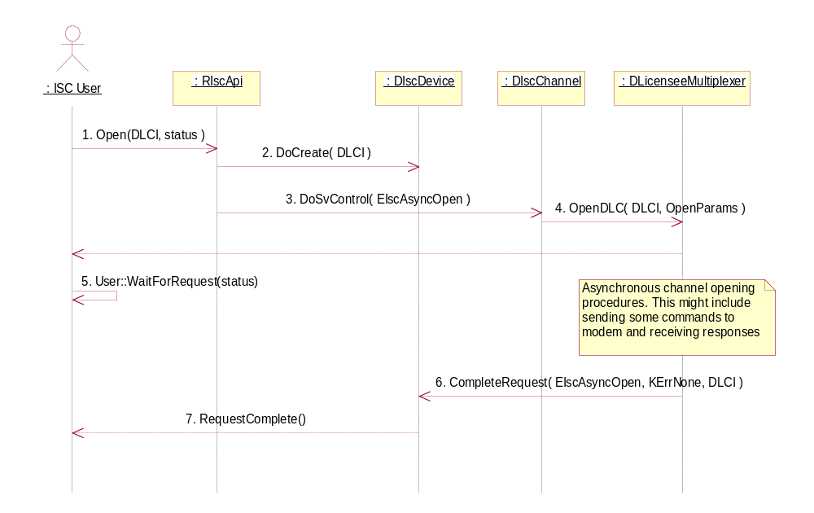
Figure 3.3 Channel opening procedure
The Sequence is explained below:
- ISC API user calls Open.
- ISC API creates kernel-side channel object by calling DoCreate (from RBusLogicalChannel).
- ISC API calls DoSvControl on the created channel to finalize the channel opening procedure.
- The ISC channel calls ISC Multiplexer Plug-in API method OpenDLC.

At this point the ISC Multiplexer can send some channel opening commands to the modem if needed and the ISC Multiplexer should return from the OpenDLC function. If there is nothing ‘asynchronous’ to do, ISC Multiplexer should do actions described in step 6.
- ISC API user starts to wait for the asynchronous request to complete. User::WaitForRequest is shown just for example. The preferred way of handling asynchronous requests is active objects framework.
- After the ISC Multiplexer has received the expected reply from the modem or the channel opening procedure is otherwise finished, it must complete the asynchronous EIscAsyncOpen request by calling ISC Multiplexer Plug-in API method CompleteRequest (see Section 3.4.1.3.1).
- Request completed to user thread.

CloseDLC

Method | virtual void CloseDLC( const TUint16 aDLCI, const TAny* aChannelPtr ) = 0;
Description | This method closes the channel. This method allows the ISC Multiplexer to do required channel closing procedures. The channel closing operation is synchronous to the ISC API user, that is, there is no possibility for the ISC Multiplexer to return any errors to user.
Caller context | Kernel-Server call. Memory allocations/deallocations possible.
Preconditions | -
Parameters | aDLCI, the DLC to close.  aChannelPtr, pointer to ISC channel object.
Return value | -
Modifies | -
Postconditions | The multiplexer channel for the corresponding channel must be inactive, that is, no frames can be sent on the channel.
Exceptions | -

Send

Method | virtual TInt Send( const TUint16 aOperation, const TUint16 aSenderChannel, const TDesC8& aData, const TAny* aChannelPtr ) = 0;
Description | ISC Driver uses this method to send data to the Domestic OS. This method is responsible for framing the data to be sent. The multiplexer is also responsible for copying the data to kernel-side memory block. In some cases it is necessary to frame raw-data in a different way from normal data (commands, data, and so on), therefore there are two separate methods, Send and DataSend. If there is no need to implement two different methods, only the DataSend method should be implemented.
Caller context | Kernel-Executive call. No memory allocations/deallocations are allowed.
Preconditions | ISC Multiplexer is initialized and ready to handle outgoing data.
Parameters | aOperation: This variable can be used by the multiplexer to distinguish the synchronous and asynchronous Send. Possible values are EIscAsyncSend or EIscSyncSend.  aSenderChannel: This indicates which ISC Driver channel is sending the message. This information might be needed by the multiplexer in order to encode the frame correctly. This is also needed for ISC Multiplexer in order to complete the request onto correct channel.  aData: A reference to descriptor containing the data to be sent to the Domestic OS. At this point the reference points to user-side memory.
Return value | Return value has relevance only in the case of synchronous Send (aOperation = EIscSyncSend). ISC Multiplexer should return KErrNone if the operation is successful and in other cases some of the system-wide error codes. KErrNotSupported should be returned if the ISC Multiplexer does not support the operation.  In case of asynchronous Send the return value should be completed with CompleteRequest, see Section 3.4.1.3.1. However, it is up to the ISC Multiplexer to define when to complete the user’s Send-request. The request can be completed right after the frame(s) have been sent, or the ISC Multiplexer can wait for a response for some command and so on, before completing the request. The request should be completed with KErrNone if no errors occurred. If the ISC Multiplexer does not support the operation, it should return KErrNotSupported.  TAny* aChannelPtr, pointer to ISC channel object.
Modifies | -
Postconditions | -
Exceptions | -

The following sequence describes the data sending procedure from the user-side API to ISC Multiplexer. The following sequence is applicable also to DataSend (Section 3.4.1.1.6).
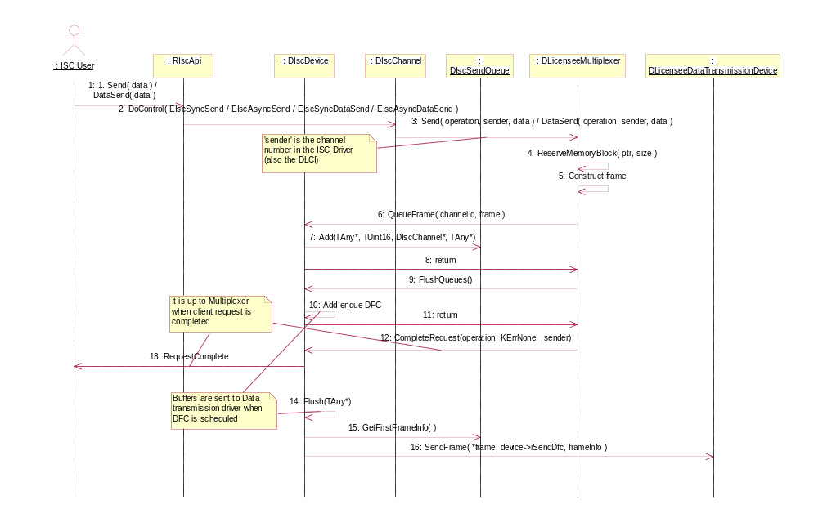
Figure 3.4. Data sending sequence
The sequence is explained below:
- ISC API user calls Send/DataSend method to send data to the Domestic OS.
- ISC API forwards the call to the corresponding channel object.
- ISC channel calls ISC Multiplexer Plug-in API method Send or DataSend.
- ISC Multiplexer must reserve memory for the frame(s) by calling ISC Multiplexer Plug-in API method ReserveMemoryBlock (see Section 3.4.1.3.7).
- ISC Multiplexer constructs the frame and copies the needed data from the parameter ‘data’ into the frame.
- ISC Multiplexer calls QueueFrame (see Section 3.4.1.3.4) for the constructed frame.

If the ‘data’ does not fit into single frame the ISC Multiplexer should repeat steps 4 to 6 until the ‘data’ has been fully processed.
- Frame is added to send queue
- Control returns to multiplexer
- After all data has been framed, ISC Multiplexer must call FlushQueues (Section 3.4.1.3.5) method in order to signal ISC Driver to start sending the frames.
- DFC is added / enqued
- Control returns back to multiplexer
- ISC Multiplexer must complete users’ Send or DataSend at some point. This can be done right after the frames are queued and FlushQueues is called, or after a response from the Domestic OS.
- Request completed to user thread.
- DFC is scheduled to run.
- Flush will check whether there are frames in send queue or in control queue.
- Frame is send to data transmission driver

DataSend

Method | virtual TInt DataSend( const TUint16 aOperation, const TUint16 aSenderChannel, const TDesC8& aData, const TAny* aChannelPtr ) = 0;
Description | This method is used to send data to the Domestic OS. In some cases it is necessary to frame raw-data in a different way from normal data (commands, data, and so on), therefore there are two separate methods, Send and DataSend. If there is no need to implement two different methods, only the DataSend method should be implemented.
Caller context | Kernel-Executive call. No memory allocations/deallocations are allowed.
Preconditions | ISC Multiplexer is initialized and ready to handle outgoing data.
Parameters | aOperation: This variable can be used by the multiplexer to distinguish the synchronous and asynchronous DataSend. Possible values are EIscAsyncDataSend or EIscSyncDataSend.  aSenderChannel: This indicates which ISC Driver channel is sending the message. This information might be needed by the multiplexer in order to encode the frame correctly. This is also needed for ISC Multiplexer in order to complete the request onto correct channel.  aData, a reference to descriptor containing the data to be sent to the Domestic OS. At this point, the reference points to user-side memory.  aChannelPtr, pointer to ISC channel object.
Return value | Return value has relevance only in the case of synchronous DataSend (aOperation = EIscSyncDataSend). ISC Multiplexer should return KErrNone if the operation is successful and in other case some of the system-wide error codes. KErrNotSupported should be returned if the ISC Multiplexer does not support the operation.  In case of asynchronous DataSend the return value should be completed with CompleteRequest, see Section 3.4.1.3.1. However, it is up to the ISC Multiplexer to define when to complete the user’s DataSend-request. The request can be completed right after the frame(s) have been sent, or the ISC Multiplexer can wait for a response for some command, and so on, before completing the request. The request should be completed with KErrNone if no errors occurred. If the ISC Multiplexer does not support the operation it should return KErrNotSupported.
Modifies | -
Postconditions | -
Exceptions | -

GetFrameInfo

Method | virtual void GetFrameInfo( const TDesC8& aFrame, TIscFrameInfo& aFrameInfo ) = 0;
Description | This method should decode the frame and give ISC Driver the required information on the frame. The information is returned in aFrameInfo.
Caller context | DFC. No memory allocations/deallocations are allowed.
Preconditions | -
Parameters | aFrame, the incoming frame.  aFrameInfo, structure defined in Section 3.4.1.3.11.
Return value | -
Modifies | aFrameInfo is modified according to the frame structure.
Postconditions | -
Exceptions | -

GetRcvChannelId

Method | virtual void GetRcvChannelId( TDesC8& aFrame, TUint16& aRcvChannelId, const TAny* aChannelPtr ) = 0;
Description | The multiplexer must return the receiver channel number for the ISC Driver so that the message can be forwarded to the correct channel for processing.
Caller context | DFC. No memory allocations/deallocations are allowed.
Preconditions | -
Parameters | aFrame, the incoming frame.  aRcvChannelId: This field tells to ISC Driver to which channel this message is going to.  Note: Returning channel ID zero is interpreted as the multiplexer control channel. These channel numbers refer to the logical channel numbers in ISC Driver. In some systems there might be need to do some mapping with the multiplexer channels and logical ISC Driver channels. Returning KIscFrameReceiverNotFound will cause ISC Driver to delete the frame.  aChannelPtr, pointer to ISC channel object.
Return value | -
Modifies | aRcvChannelId is modified to point to correct ISC channel.
Postconditions | The frame is routed according to the returned channel ID.
Exceptions | -

The following sequence describes the sequence of receiving data. The sequence involves both GetRcvChannelId and GetFrameInfo methods.
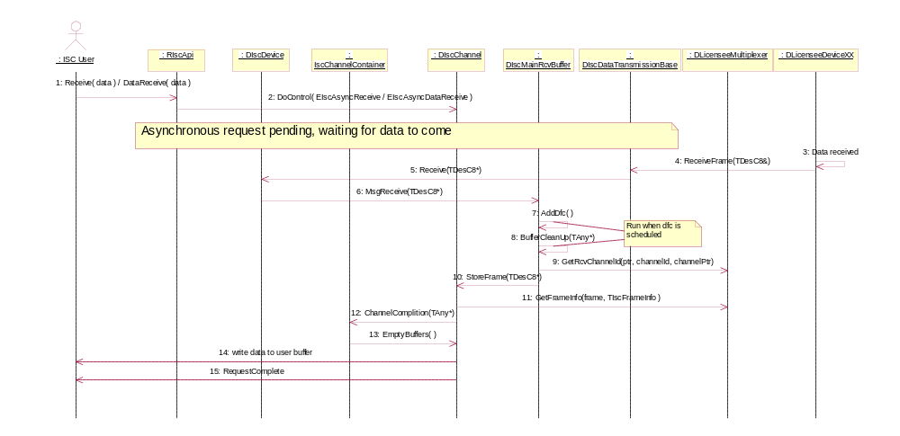
Figure 3.5. Data receiving procedure
The sequence is explained in the following:
- ISC API user calls Receive/DataReceive and starts waiting for data to arrive.
- ISC API forwards the request to ISC Driver.
- Data is received in the ISC Data Transmission driver.
- ISC Data Transmission driver passes the data to base.
- Base passes data to the ISC driver device class
- Device routes buffer to the main receiver buffer
- DFC is enqued/added
- DFC is scheduled
- In DFC main receiver buffer calls GetRcvChannelId from ISC Multiplexer Plug-in API to determine to which channel the data is going.
- Frame is stored to correct channel
- ISC channel retrieves detailed information on the frame from ISC Multiplexer by calling GetFrameInfo. The structure of the ‘frameInfo’ is defined in Section 3.4.1.3.11.
- ISC driver goes through all channels using IscChannelContainer class
- Calls for each particular channel empty receive buffers
- Write the data into user address space according to ‘frameInfo’.
- The request is completed by ISC channel.

DLFlowControl

Method | virtual void DLFlowControl( const TInt aFlowStatus, TUint16 aChannelId, const TAny* aChannelPtr ) = 0;
Description | This method is called by ISC Driver to request flow control on/off in case ISC Driver internal ringbuffers for incoming data are filling up.
Caller context | DFC. No memory allocations/deallocations are allowed.
Preconditions | -
Parameters | aFlowStatus, the requested status of flow control. Possible values:  - EIscFlowControlOn  - EIscFlowControlOff  aChannelId, the channel id of the channel which has it is buffers filling up.  aChannelPtr, pointer to ISC channel object.
Return value | -
Modifies | -
Postconditions | Flow control should be set to value specified in aFlowStatus.
Exceptions | -

HandleControlFrame

Method | virtual void HandleControlFrame( const TDesC8& aFrame ) = 0;
Description | This method handles all control frames for the multiplexer. After the ISC Multiplexer has handled the frame it should release the memory block by calling ReleaseMemoryBlock (see Section 3.4.1.3.8) for the frame pointer.
Caller context | DFC. No memory allocations/deallocations are allowed.
Preconditions | -
Parameters | aFrame The control frame to handle.
Return value | -
Modifies | -
Postconditions | -
Exceptions | -

CancelNotify

Method | virtual void CancelNotify( const TUint16 aChannelId, const TUint16 aOperation, const TAny* aChannelPtr ) = 0;
Description | This method notifies ISC Multiplexer if some asynchronous is cancelled by the ISC API user.
Caller context | Kernel-Executive call. No memory allocations/deallocations are allowed.
Preconditions | -
Parameters | aChannelId: The channel number which cancelled the operation.  aOperation: The asynchronous operation that was cancelled.  aChannelPtr, pointer to ISC channel object.
Return value | -
Modifies | -
Postconditions | -
Exceptions | -

MaximumDataSize

Method | virtual TInt MaximumDataSize( const TUint16 aChannelId ) = 0;
Description | This method should return the maximum amount of data that user can send and may receive at one call to Send/DataSend to a particular channel.
Caller context | Kernel-Executive call. Memory allocations/deallocations are not allowed.
Preconditions | -
Parameters | aChannelId, specifies the channel.
Return value | The maximum data size in bytes. If this information is irrelevant or not supported by the ISC Multiplexer it should return zero (0).
Modifies | -
Postconditions | -
Exceptions | -

NotifyConnectionStatus

Method | virtual void NotifyConnectionStatus( const TInt aConnectionStatus ) = 0;
Description | This method notifies the ISC Multiplexer whenever changes occur in the connection status.
Caller context | DFC. Memory allocations/deallocations are not allowed.
Preconditions | -
Parameters | aConnectionStatus Possible values:  - EIscConnectionOk  - EIscConnectionNotOk
Return value | -
Modifies | -
Postconditions | -
Exceptions | -

GetConfiguration

Method | virtual void GetConfiguration( TIscConfiguration& aConfig ) = 0;
Description | This method retrieves ISC configuration data from the ISC Multiplexer. The configuration data includes pre-allocated buffer sizes, and so on.
Caller context | DFC. Memory allocations/deallocations are not allowed.
Preconditions | -
Parameters | aConfig: Configuration structure that the ISC Multiplexer is required to fill. The structure is specified in Section 3.4.3.
Return value | -
Modifies | aConfig structure must be modified to correspond the desired system configuration.
Postconditions | -
Exceptions | -

Virtual methods
The following methods are declared as virtual in base class and their default implementation always returns KErrNotSupported. The ISC Multiplexer can implement the methods if they are needed.

SetInitializationParameters

Method | IMPORT_C virtual void SetInitializationParameters( const TDesC8& aParameters );
Description | Set initialization parameters before Data transmission driver initialization has been done (e.g. if buffer configurations are given in isc_config.ini).
Caller context | Kernel-Server call. Any memory allocations needed in ISC Multiplexer must be done in this function or in Install2ndPhase.
Preconditions | ISC Data Transmission driver is not ready to transfer frames yet.
Parameters | aParameters: optional parameters that are passed from the INI file to the multiplexer, see Section 3.5.1 for more information. These are also passed in InitializeMultiplexer function call
Return value | -
Modifies | -
Postconditions | If buffer configurations are given from INI file, multiplexer can give buffer configurations when ISC is initializating
Exceptions | -

GetChannelInfo

Method | virtual TInt GetChannelInfo( const TUint16 aChannelNumber, TDes8& aInfo ) = 0;
Description | This user can retrieve some licensee specific information on configuration, and so on, with method RIscApi::GetChannelInfo. The call is forwarded directly to ISC Multiplexer into this method. This is a synchronous method that returns the data immediately to the user-side client.
Caller context | Kernel-Executive call. No memory allocations/deallocations are allowed.
Preconditions | -
Parameters | aChannelNumber, the channel number which information to retrieve.  aInfo, reference to the descriptor where the multiplexer should write the information.
Return value | - KErrNone, if the operation has been successfully done.  - KErrNotSupported, if the operation is not supported by the ISC Multiplexer.  In other cases some other error code depending on the ISC Multiplexer implementation.
Modifies | ISC Multiplexer writes required information into aInfo.
Postconditions | -
Exceptions | -

CustomFunction

Method | virtual TInt CustomFunction( const TUint16 aChannelId, const TUint16 aOperation, TAny* aParameters, const TAny* aChannelPtr );
Description | This method allows licensees to do any API extension that is needed. The call to RIscApi::CustomFunction is routed directly into this function. There are 5 asynchronous and 5 synchronous operations that are possible to handle via CustomFunction. The possible values are from EIscAsyncCustomOperation1 to EIscAsyncCustomOperation5 and from EIscSyncCustomOperation1 to EIscSyncCustomOperation5. The values are defined in the IscDefinitions.H file. ISC Multiplexer should re-assign the used values into some meaningful constant that the user ISC API can use.
Caller context | Kernel-Server call. Memory allocations/deallocations are allowed.
Preconditions | -
Parameters | aChannelId, channel id.  aOperation, Operation code to be executed. Licensee specific.  aParameters, free formatted data for parameters.  aChannelPtr, pointer to channel.
Return value | -
Modifies | Should complete clients request when the operation is completed.
Postconditions | -
Exceptions | -

Non-virtual methods
The following methods are declared as protected in the base class. The methods are needed by the multiplexer in order to communicate with ISC Driver.

CancelSending

Method | IMPORT_C TInt CancelSending( const TUint16 aChannelId, const TAny* aChannelPtr );
Description | Cancels sending of frames to Domestic OS.
Preconditions | -
Parameters | aChannelId, Channel identification.  aChannelPtr, a pointer to channel object.
Return value | -
Modifies | -
Postconditions | -

CompleteRequest

Method | void CompleteRequest( TUint16 aReqNumber, TInt aStatus, const TAny* aChannelPtr );
Description | Completes specified request on the ISC Driver.
Preconditions | -
Parameters | aReqNumber, request number to complete.  aStatus, the status to complete request with. Usually if no errors have occurred this should be KErrNone.  aChannelPtr, the channel whose request is to be completed.
Return value | -
Modifies | Completes the specified request in ISC Driver
Postconditions | -
Exceptions | -

IsPending

Method | TInt IsPending( const TUint16 aReqNumber, const TAny* aChannelId );
Description | Checks if the specified request is pending in ISC Driver.
Preconditions | -
Parameters | aReqNumber, request number to check.  aChannelId, the channel on which to check for the pending request.
Return value | Possible values:  - KRequestPending, the request is pending.  - KErrNone, the request is not pending.  - KErrNotFound, channel ptr not found from ChannelContainer i.e. channel is not open.
Modifies | -
Postconditions | -
Exceptions | -

QueueFrame

Method | TInt QueueFrame( const TUint16 aChannelId, TDesC8* aFrame, const TAny* aChannelPtr, TAny* aFrameInfo = NULL );
Description | Queue frame to ISC driver for sending. This function may be called multiple times in a row. After all frames are queued, the multiplexer must call FlushQueues to signal ISC Driver to start sending the data.
Preconditions | The frame that is sent must be allocated with ReserveMemoryBlock (see Section 3.4.1.3.7).
Parameters | aChannelId: Specifies the channel, which is sending the frame. Possible user side values are from 0 to 63. However, this is not a limitation for multiplexer -- values higher than 63 can also be used. If the aChannelId is 0 (zero), it is interpreted as control channel frame and is sent with high priority (it bypasses all frames in other channels). With control channel aChannelPtr can be NULL  aFrame: Frame to be sent.  aChannelPtr, Channel pointer.  aFrameInfo, optional information on frame.
Return value | Possible values:  - KErrNone, if successful.  - KErrNotFound, the channel specified in aChannelId was not open.  - KErrNoMemory, the send queue is full -> frame cannot be added into queue
Modifies | -
Postconditions | -
Exceptions | -

FlushQueues

Method | void FlushQueues();
Description | Flushes ISC Drivers send queue. This function is called after one or more sequential calls to QueueFrame.
Preconditions | -
Parameters | -
Return value | -
Modifies | -
Postconditions | ISC Driver starts sending the frames.
Exceptions | -

ULFlowControl

Method | void ULFlowControl( const TUint16 aULFlowStatus, const TUint16 aChannelId, TAny* aChannelPtr = NULL );
Description | This method should be called by the multiplexer in case the modem side wants to turn flow on/off. This method informs ISC Driver on the situation and it will stop sending more data to the modem. ISC Driver will also notify user-side clients that flow control is turned on/off.
Preconditions | -
Parameters | aULFlowStatus The flow control status in uplink direction (outgoing messages), possible values:  - EIscFlowControlOn  - EIscFlowControlOff  - EIscTransmissionEnd  aChannelId: The channel id on which the flow control affects.  aChannelPtr: The channel pointer on which the flow control affects. By default the value is NULL, and it means that flow controlling affects all ISC channels (all clients) within that channel id. The flow control might also affect only to one channel and in that case the specific channel pointer should be given here.
Return value | -
Modifies | -
Postconditions | -
Exceptions | -

ReserveMemoryBlock

Method | void ReserveMemoryBlock( TDes8*& aPtr, const TUint16 aSize );
Description | This method reserves pre-allocated memory block for sending/receiving frames.
Preconditions | -
Parameters | aPtr, a reference to pointer of descriptor. In practice TDes8* variable.  aSize, the size of needed memory block.
Return value | -
Modifies | Writes the address of the reserved descriptor into aPtr. If the memory allocation was successful aPtr is different from NULL, but if the allocation failed aPtr is NULL.
Postconditions | -
Exceptions | -

ReleaseMemoryBlock

Method | void ReleaseMemoryBlock( TDes8* aPtr );
Description | This method releases memory block allocated with ReserveMemoryBlock.
Preconditions | -
Parameters | aPtr, a pointer to descriptor pointing to the memory block allocated with ReserveMemoryBlock.
Return value | -
Modifies | -
Postconditions | -
Exceptions | -

CopyFromUserBuffer

Method | IMPORT_C TInt CopyFromUserBuffer( const TDesC8& aUserBuffer, TDes8& aKernelBuffer, const TAny* aChannelPtr, const TInt aOffset = 0 );
Description | This method copies data from user buffer to kernel buffer.  NOTE! This will be deprecated use GetThreadPtr instead to get thread pointer to user memory space, which provides same kind of services.
Preconditions | -
Parameters | aUserBuffer, User mode buffer - source.  aKernelBuffer, Kernel buffer – destination.  aChannelPtr, Specifies the channel.  aOffset, Offset in user buffer
Return value | Possible values:  - KErrNone, if successful.  - KErrBadDescriptor, if source descriptor is an invalid.  - KErrDied, if thread is dead.  - KErrNotFound, channel ptr not found from ChannelContainer i.e. channel is not open.
Modifies | -
Postconditions | -
Exceptions | -

CopyToUserBuffer

Method | IMPORT_C TInt CopyToUserBuffer( TAny* aUserBuffer, const TDes8C& aKernelBuffer, const TAny* aChannelPtr, TInt aOffset );
Description | This method copies data to user buffer from kernel buffer.  NOTE! This will be deprecated use GetThreadPtr instead to get thread pointer to user memory space, which provides same kind of services.
Preconditions | -
Parameters | aUserBuffer, User mode buffer - destination.  aKernelBuffer, Kernel buffer – source.  aChannelPtr, Specifies the channel.  aOffset, Offset of the user buffer.
Return value | Possible values:  - KErrNone, if successful.  - KErrBadDescriptor, if source descriptor is an invalid.  - KErrDied, if thread is dead.  - KErrArgument, if Offset is negative.  - KErrNotFound, channel ptr not found from ChannelContainer i.e. channel is not open.
Modifies | -
Postconditions | -
Exceptions | -

GetThreadPtr

Method | IMPORT_C DThread* GetThreadPtr( const TAny* aChannelPtr );
Description | This method returns a DThread pointer which provides access to given channel’s user side memory space. Ownership of DThread pointer is not given.
Preconditions | Channel is open.
Parameters | aChannelPtr, Specifies the channel.
Return value | Possible values:  - DThread*, pointer to DiscChannel’s user side thread.  - NULL, returned if channel is NULL or not open.
Modifies | -
Postconditions | -
Exceptions | -

TIscFrameInfo
This structure is meant for communication between ISC Driver and ISC Multiplexer. ISC Driver passes a reference of this structure as a parameter to DIscMultiplexerBase::GetFrameInfo() method and ISC Multiplexer must fill in all the fields in the structure presented below.

typedef struct
{
TIscFrameType frameType;
TIscFrameConcatenation concatenation;
TUint16 totalLength;
TUint16 writeStartIndex;
TUint16 writeLength;
} TIscFrameInfo;

TIscFrameInfo
- FrameType: This field selects whether to complete Receive or DataReceive request in ISC Driver.
- Concatenation: This field is used to tell whether this frame is a part of a concatenated data.
- TotalLength: If the frame is a part of a concatenated data block this field tells the total length of the data block. The data block might be, for example, IP package or long AT command response. If total length is not known, set it to zero. In this case, ISC Driver will fill client’s buffer until multiplexer gives EIscConcatenationDataEnd or client’s buffer fills up. When buffer fills up, client will get the data so far and Receive/DataReceive will be completed with KErrUnderflow
- WriteStartIndex: This field tells the ISC Driver where to start writing. This is an index value pointing to the frame that is being processed. The value must be greater than or equal to zero.
- WriteLength: This fields indicates how long the piece of data is in the current frame that is to be written into user-side buffer.

The following presents the possible combinations of the TIscFrameInfo fields:

Frame type | frameType | concatenation | totalLength | writeStartIndex | writeLength
Single data frame. | EIscNonDataFrame/ EIscDataFrame | EIscNoConcatenation | N/A | >= 0 | > 0
First frame of a data chunk (for example ip-package) to be combined into one package. | EIscNonDataFrame/ EIscDataFrame | EIscConcatenationDataStart | Zero or positive, must indicate the total length of the package. This is used to check that client memory buffer is big enough. | >= 0 | > 0
Frame belonging to a larger data package (for example ip-package). | EIscNonDataFrame/ EIscDataFrame | EIscConcatenationData | Zero or positive, must indicate the total length of the package. | >= 0 | > 0
Last frame of a large data package. | EIscNonDataFrame/ EIscDataFrame | EIscConcatenationDataEnd | Zero or positive, must indicate the total length of the package. | >= 0 | > 0

TIscConfiguration

typedef struct
{
TUint16 size;
TUint16 count;
} TIscBufferEntry;

typedef struct
{
TUint16 mainRcvQueueSize;
TUint16 channelRcvQueueSize;
TUint16 channelDataRcvQueueSize;
TUint16 channelSendQueueSize;
TIscBufferEntry bufferConfig[10];
} TIscConfiguration;

TIscBufferEntry
- size: The size of the desired buffer in bytes.
- count: The amount of buffers to allocate (size of buffer specified in member ‘size’).

TIscConfiguration
- mainRcvQueueSize: The size of the ISC Driver queue for incoming frames. This queue holds the incoming frames before they are routed to the correct channel.
- channelRcvQueueSize: Size of the receive queue in each of the ISC Driver channel. This queue holds all incoming frames for each channel before the frames are written into user address space.
- channelDataRcvQueueSize: Size of the data receive queue in each of the ISC Driver channel. This queue holds all incoming data frames for each channel before the frames are written into user address space.
- channelSendQueueSize: Size of the send queue for an ISC channel. All the ISC Driver channels have a send queue for outgoing frames.
- bufferConfig: Configuration for the pre-allocated memory blocks. A maximum of 10 different buffer sizes. If there is need for fewer than 10 different buffer sizes, the unused entries in the bufferConfig must be zeroed.

Code architecture
- Header: IscMultiplexerBase.H
- Library: IscMultiplexerBase.LIB
- DLL: IscMultiplexerBase.DLL

Other requirements for the implementation

ISC initialization file
ISC API uses an initialization-file named “Z:\System\Isc_config.INI”. It is in the responsibility of the licensee to export the initialization file into \epoc32\release\xxx and to make sure that it is taken into the ROM image to correct path.
########################################################
# This is comment
########################################################
DataTransmissionPdd=ExampleDataTransmission.PDD
DataTransmissionLdd=ExampleDataTransmission.LDD; [parameters]
MultiplexerLdd=ExampleISCMultiplexer.LDD; [parameters]
#PDD=Example.PDD
#LDD=Example.LDD
########################################################

Mandatory fields:
- DataTransmissionLdd, the name of the data transmission driver LDD.
- MultiplexerLdd, the name of the ISC Multiplexer to load.

Parameters = initialization string that is passed to the corresponding driver during ISC Initialization e.g. configuration of pre-allocated buffers. The string is passed as parameter to DIscMultiplexerBase::InitializeMultiplexer()and DIscMultiplexerBase::SetInitializationParameters() / DIscDataTransmissionBase::InitializeDataTransmission(). The ‘parameters’ can be left out if not needed.

Optional fields:
- DataTransmissionPdd, the name of the PDD for data transmission driver.
- PDD & LDD, if there’s more drivers that are required to be loaded they can be specified here.

Index

List of constants and enumerations

Fault reasons
In some cases when a critical and unrecoverable error occurs, the ISC Driver faults the system with Plat::Fault() or Kern::Fault(). In that case the name of the component is shown in the fault information with the corresponding fault code. The possible fault codes in ISC are defined in IscDefinitions.H in enum TIscIfFault.

Fault enumeration | Value | Description
EIscPanicSetChannel | 1 | Critical error in ISC Driver while opening channel.
EIscPanicCreateLogicalDevice | 2 | This fault occurs if the creation of device drivers’ device class fails.
EIscMainRcvBufferOverflow | 3 | The main receive queue in ISC Driver overflows. The system is jammed or the buffer is configured to be too small.
EIscNotAllowedCallToDoRequest | 4 | All calls to ISC Driver should go through DoControl, if not, fault occurs.
EIscNotAllowedCallToDoCancel | 5 | All calls to ISC Driver should go through DoControl, if not, fault occurs.
EIscUnknownCommand | 6 | This panics only the current user-side thread. This occurs when there is an unknown command (operation) passed to ISC Driver. This should never happen.
EIscNullIscDriverPointer | 7 | This fault occurs if the pointer that ISC Driver passes to Data Transmission driver of ISC Multiplexer is NULL.
EIscMemoryAllocationFailure | 8 | This fault occurs if the memory allocations during the initialization fail.
EIscRequestAlreadyActive | 9 | This fault occurs if asynchronous request is already pending.
EIscDriverNotFound | 10 | This fault occurs if the ISC Driver extension is not able to find ISC Driver. This occurs if the ISC Driver extension is loaded before the ISC Driver.
EIscLogicalDevicesNotFound | 11 | ISC Driver was not able get the kernel-container for logical devices
EIscMultiplexerNotFound | 12 | ISC Driver was unable to find pointer to ISC Multiplexer. In practice. the only possible reason for this is that ISC Multiplexer is not loaded.
EIscDataTransmissionDriverNotFound | 13 | ISC Driver was unable to find pointer to ISC Data Transmission driver. In practice the only possible reason for this is that ISC Data Transmission module is not loaded.
EIscMainRcvBufferInitialize | 14 | This panic occurs if MainRcvBuffer initialization fails.
EIscBufferAllocationFailure | 15 | This fault occurs if the configuration of the pre-allocated memory blocks is wrong.
EIscControlBufferOverflow | 16 | This fault occurs if ISC control buffer queue overflows.
EIscInvalidChannelPtr | 17 | This fault occurs if channel pointer is not valid. Used only in debug builds.

Alphabetical list of classes and methods

class DiscMultiplexerBase
IMPORT_C TInt CancelSending( const TUint16 aChannelId, const TAny* aChannelPtr );
virtual void CancelNotify( const TUint16 aChannelId, const TUint16 aOperation, const TAny* aChannelPtr ) = 0;
virtual void CloseDLC( const TUint16 aDLCI, const TAny* aChannelPtr ) = 0;
IMPORT_C void CompleteRequest( TUint16 aReqNumber, TInt aStatus, const TAny* aChannelPtr );
IMPORT_C void Connect( DIscDevice* aDevice );
IMPORT_C TInt CopyFromUserBuffer( const TDesC8& aUserBuffer, TDes8& aKernelBuffer, const TAny* aChannelPtr, const TInt aOffset = 0 );
IMPORT_C TInt CopyToUserBuffer( TAny* aUserBuffer, const TDesC8& aKernelBuffer, const TAny* aChannelPtr );
IMPORT_C virtual TInt CustomFunction( const TUint16 aChannelId, const TUint16 aOperation, const TAny* aParameters, const TAny* aChannelPtr );
IMPORT_C DIscMultiplexerBase();
IMPORT_C virtual ~DIscMultiplexerBase();
virtual TInt DataSend( const TUint16 aOperation, const TUint16 aSenderChannel, const TDesC8& aData, const TAny* aChannelPtr ) = 0;
virtual void DLFlowControl( const TInt aFlowStatus, const TUint16 aChannelId, const TAny* aChannelPtr ) = 0;
IMPORT_C void FlushQueues();
IMPORT_C DThread* GetThreadPtr( const TAny* aChannelPtr );
IMPORT_C virtual TInt GetChannelInfo( const TUint16 aChannelNumber, TDes8& aInfo ) = 0;
virtual void GetConfiguration( TIscConfiguration& aConfig ) = 0;
virtual void GetFrameInfo( const TDesC8& aFrame, TIscFrameInfo& aFrameInfo ) const = 0;
virtual void GetRcvChannelId( const TDesC8& aFrame, TAny*& aRcvChannelId ) = 0;
virtual void HandleControlFrame( const TDesC8& aFrame ) = 0;
virtual void InitializeMultiplexer( const TUint16 aOperation, const TDesC8& aParameters, const TAny* aChannelPtr ) = 0;
IMPORT_C TInt Install();
virtual TInt Install2ndPhase() = 0;
IMPORT_C TInt IsPending( const TUint16 aReqNumber, const TAny* aChannelPtr );
virtual TInt MaximumDataSize( const TUInt16 aChannelId ) = 0;
virtual void NotifyConnectionStatus( const TInt aConnectionStatus ) = 0;
virtual void OpenDLC( const TUint16 aDLCI, const TDesC8* aOpenParams, const TAny* aChannelPtr ) = 0;
IMPORT_C TInt QueueFrame( const TUint16 aChannelId, const TDesC8* aFrame, const TAny* aChannelPtr, TAny* aFrameInfo = NULL );
IMPORT_C void ReserveMemoryBlock( TDes8*& aPtr, const TUint16 aSize );
IMPORT_C void ReleaseMemoryBlock( TDes8* aPtr );
virtual TInt Send( const TUint16 aOperation, const TUint16 aSenderChannel, const TDesC8& aData, const TAny* aChannelPtr ) = 0;
IMPORT_C void ULFlowControl( const TInt aULFlowStatus, const TUint16 aChannelId, const TAny* aChannelPtr = NULL );

