S60 5.0
SSY Reference
Design Document

Team name | Author
System SW | Pekka Karjalainen

Change history:

Version | Date | Status | Comments
1.0 | 04.01.2007 | Approved

Table of contents:

1. Document control 5
1.1 References 5
1.2 Documentation conventions 5
1.3 Abbreviations 5
1.4 Definitions 5
2. General 6
2.1 Introduction 6
2.2 Component environment 6
2.3 Use cases 6
2.3.1 Load SSY reference 7
2.3.2 Open Channel 7
2.3.3 Start channel data 8
2.3.4 Get Property 8
2.3.5 Set Property 8
2.4 Services required 8
2.4.1 From the Symbian OS subsystems 8
2.4.2 From the Domestic OS subsystems 9
2.4.3 From HW 9
2.5 Services provided 9
2.5.1 UI 9
2.5.2 SW IF 9
3. UI control hierarchy 10
4. Design 11
4.1 Class diagrams 11
4.2 Class descriptions 12
4.2.1 Structs, type definitions and enumerations 12
4.2.1.1 Ssyreferencechannel Structs/Definitions/Enumerations 12
4.2.1.2 Ssyreferenceconfig Structs/Definitions/Enumerations 12
4.3 Operations 13
4.3.1 Loading SSY reference 13
4.3.2 Open Channel 14
4.3.3 Producing data 15
4.4 Backup and Restore 16
5. Variation 17
6. System resource usage 18
6.1 Files 18
6.2 Other data 18
6.2.1 Databases 18
6.2.2 Central Repository 18
6.2.3 Publish and Subscribe 18
6.3 Memory consumption 18
6.4 Task allocation 18
6.5 Performance 18
6.6 Timers 18
7. Security 20
7.1 Capabilities of this component 20
7.2 Input and output validation 20
7.3 Environmental assumptions 20
7.4 Additional enforcements 20
8. Exception handling 21
9. Usage 22
9.1 Building 22
9.2 User's guide 22
9.2.1 Main parts of the XML config file 22
9.2.2 Channel information 23
9.2.3 Properties 23
9.2.4 Channel data items 24
9.2.5 Channel data types 24

Document control

References
- S60 5.0 Sensor Server Design Document

Documentation conventions
Code is shown with the Courier New font.

Abbreviations
Sensrv | Sensor Server
SSY | Sensor System
XML | Extensible markup language

Definitions
SSY | Sensor server provider module. SSY is an ECom plug-in DLL loaded by Sensor server. It handles the one or more physical sensors and provider one or more channels.
Channel | Abstraction of a sensor. Data from one physical sensor may be mapped to several channels. For example, acceleration sensor may provide raw acceleration data on one channel and preprocessed tap-events on another.
SensorServer | S60 service for handling client access to data channels provided by various SSY plug-ins.
XML Config File | Configurations file of SSY reference in XML format.

General
SSY reference is an emulator stub that can be used in emulator. SSY reference can be configured with XML config file that contains all relevant information concerning to SSY itself, for example each channel definition, properties and even specific data that each channel produces.

Introduction
SSY reference is an ECom plug-in and it is loaded by SensorServer and it is deleted when SensorServer shuts down. On creation the SSY reference parses XML config file; generates channel informations, registers and creates all channels. It also reads SSY specific properties from XML config file.

Component environment
SSY reference runs in SensorServers procsss, but on its own thread.
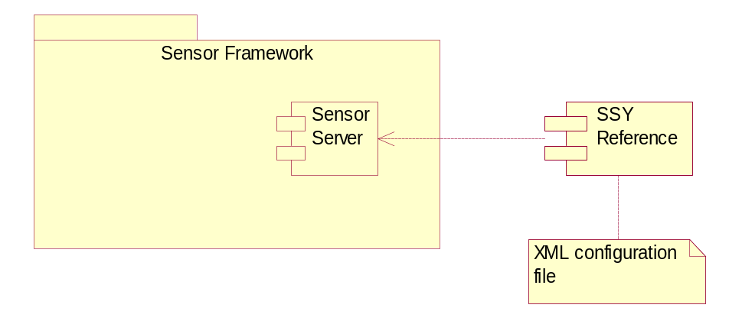
Figure 2.1 SSY reference dependencies

Use cases
SSY reference use cases has sensor server as an Actor since SensorServer is the ‘client’ of the SSY reference.
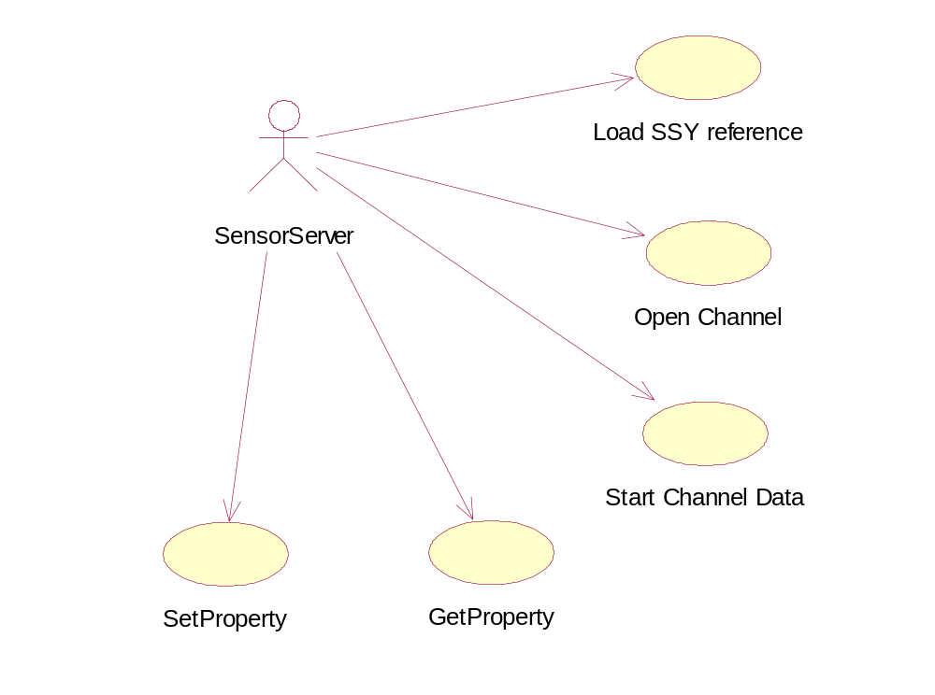
Figure 2.2 SSY reference use cases

Load SSY reference
Summary | SensorServer loads SSY reference ECom plug-in
Actor(s) | SensorServer
Frequency | Low
Preconditions | Client application connects to SensorServer and it is not yet started
Description | SensorServer loads SSY reference ECom plug-in. SSY reference parses XML config file, generates and registers channels
Exceptions | SSY reference not found.  XML config file is not found.
Postconditions | SSY reference is loaded and is ready for opening channels
Illustrations | Figure 4.4

Open Channel
Summary | SSY opens channel. Channel is ready for start receiving data
Actor(s) | SensorServer
Frequency | Low
Preconditions | SSY is loaded successfully by SensorServer
Description | SSY asks channel to open itself. Channel generates channel properties from XML config file. When opening channel completes, SSY notifies SensorServer by calling MSsyCallBack::ChannelOpened with or without error code
Exceptions | Requested channel is not found. SSY reports SensorServer with KErrNotFound error
Postconditions | Requested channel is open and ready for starting to receive data
Illustrations | Figure 4.5

Start channel data
Summary | Requested channel starts producing channel specific data
Actor(s) | SensorServer
Frequency | Low
Preconditions | Channel has been opened.
Description | SSY reference generates channel data information from XML config file and starts producing items one by one in requested channel. Time interval before next item is produced is configureable in XML config file
Exceptions | Channel data information cannot be found from XML config file. Channel does not produce any data
Postconditions | Channel is producing data items and every now and then informs SensorServer with MSsyCallback::BufferFilled when expected number of data items are produced.
Illustrations | Figure 4.6

Get Property
Summary | Requested channel finds wanted property and returns property information
Actor(s) | SensorServer
Frequency | Low
Preconditions | Channel has been opened
Description | Channel searches wanted property by property ID and item index and returns information of found property
Exceptions | Channel or property not found. SSY completes with error code KErrNotFound
Postconditions | Property information is returned to SensorServer
Illustrations

Set Property
Summary | Requested channel finds wanted property and updates property information
Actor(s) | SensorServer
Frequency | Low
Preconditions | Channel has been opened
Description | Channel searches wanted property by property ID and item index and updates property information, if property is not ‘ReadOnly’
Exceptions | Channel or property not found. SSY completes with error code KErrNotFound
Postconditions | Property information is updated
Illustrations

Services required

From the Symbian OS subsystems
SSY reference uses XML parser API from Symbian OS side subsystems

API | Description
CMDXMLParser | Parser of the XML config file. After file is parsed, XML data is accessible through elements and nodes.

From the Domestic OS subsystems
SSY reference does not use any Domestic OS substystem.

From HW
SSY reference does not use any direct hardware interfaces.

Services provided

UI
SSY reference does not have any UI components.

SW IF
SSY reference does not provide any software interfaces.

UI control hierarchy
The SSY reference does not contain any UI or UI controls.

Design

Class diagrams
The class diagram of SSY reference. Main class is CSsyReferenceControl, which is derived from CSsyControl. CSsyReferenceConfig is responsible for parsing and generating information from XML config file. SSY may have none to more channels, which are representing by CSsyReferenceChannel class. CSsyReferenceChannelDataProvider is derived from MSsyChannelDataProvider and is responsible for handling channel data related services. CSsyReferencePropertyProvider is derived from MSsyPropertyProvider and is responsible for property related services. CSsyReferenceCmdHandler is handler class for SSYs internal commands. It also enables synchronous processes to be handled asynchronously.
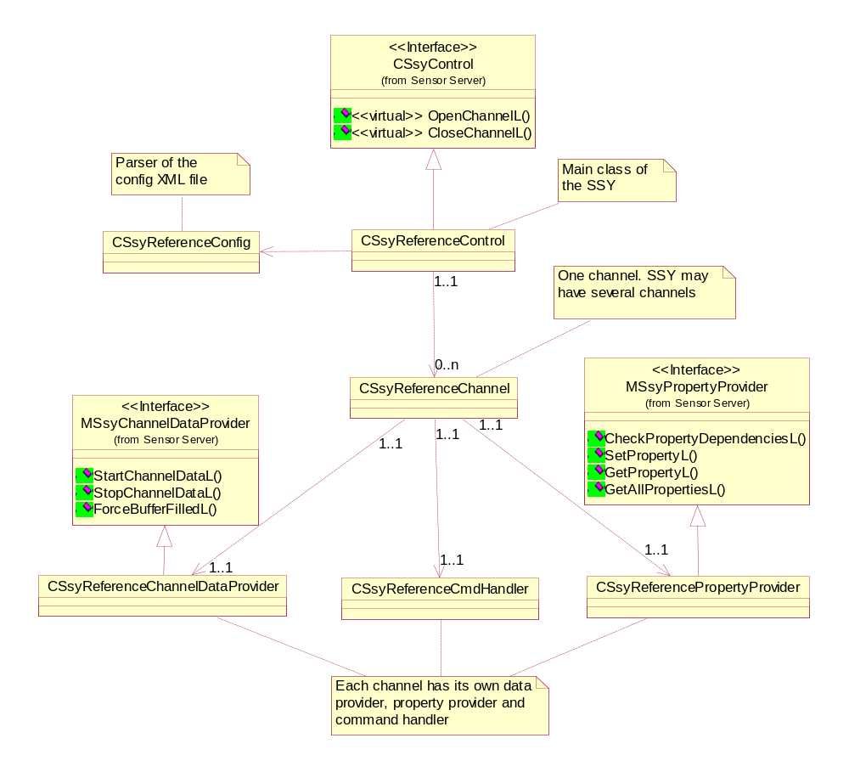
Figure 4.3 Class diagram of SSY reference

Class descriptions
Description of classes presented in class diagram.

Class | Description | Header file
CSsyReferenceControl | Main class of the SSY reference. SSY reference has only one instance of this class. | ssyreference.h
CSsyReferenceConfig | Parses and generates information from XML config file | ssyreferenceconfig.h
CSsyReferenceChannel | Represents a channel in SSY. SSY reference may have several channels | ssyreferencechannel.h
CSsyReferenceCmd  Handler | Command handler for internal SSY commands. Each channel has its own command handler. Command handlers purpose is to make synchronous requests asynchronous. | ssyreferencecmdhandler.h
CSsyReferenceChannelDataProvider | Channel data provider of one channel | ssyreferencechanneldataprovider.h
CSsyReference  PropertyProvider | Channel property provider of one channel | ssyreferencepropertyprovider.h

Structs, type definitions and enumerations
SSY reference defines some structs and enumerations which are only for SSY reference’s internal use.

Ssyreferencechannel Structs/Definitions/Enumerations
TSsyReferenceChannelState | Represents the state of one channel
ESsyReferenceChannelIdle | Channel created, not opened
ESsyReferenceChannelOpening | Channel initialization is ongoing
ESsyReferenceChannelOpen | Channel is opened
ESsyReferenceChannelReceiving | Channel is receiving data
ESsyReferenceChannelClosing | Channel is closing, after this, state is Idle

Ssyreferenceconfig Structs/Definitions/Enumerations
TSsyReferenceFunctions | Identifiers for SSYs internal command handling. These are used by CSsyReferenceCmdHandler
ESsyReferenceOpenChannel | Request for opening channel
ESsyReferenceOpenChannelResp | Response for opening channel. According to response, channel is opened or not.
ESsyReferenceDataItemReceived | Indication that one data item has been received
ESsyReferenceCloseChannel | Request for closing channel
ESsyReferenceCloseChannelResp | Response for channel closing
ESsyReferenceStartChannelData | Request to start receiving data
ESsyReferenceStopChannelData | Request to stop receiving

Structs / classes | Description of the struct / class
TSsyRefChannelDataBase | Base class for channel generated data
TSsyRefChannelDataTapping | Data item for tapping channels
TSsyRefChannelDataAxis | Data item for axis measuring channels
TSsyRefChannelDataScroll | Data item for scrolling sensor channels
TSsyRefChannelDataScrollEvent | Event item for scrolling sensor channels
TSsyReferenceMsg | Message for internal command processing
TSsyRefChannelIdPair | Contains SensorServer generated channel id and channel id from XML config file

Operations
Operations of SSY, not all of the use cases but, more complex operations are explained here.

Loading SSY reference
Operation | Loading of SSY reference
Preconditions | Client application connects to SensorServer and it is not yet started
Description | SensorServer loads SSY reference ECom plug-in. SSY reference parses XML config file, generates and registers channels
Inputs | Reference to MSsyCallback for call back operations
Modifies | Creates SSY reference ECom plug-in.
Outputs | Registers channels in SensorServer side
Postconditions | SSY reference is loaded and is ready for opening channels
Related To | Use case Load SSY reference
Related Event
Exceptions | SSY reference not found. Only solution is to compile SSY reference again and try again.  XML config file is not found. Solutions is to check that XML config file is exported to correct place and it is spelled correctly

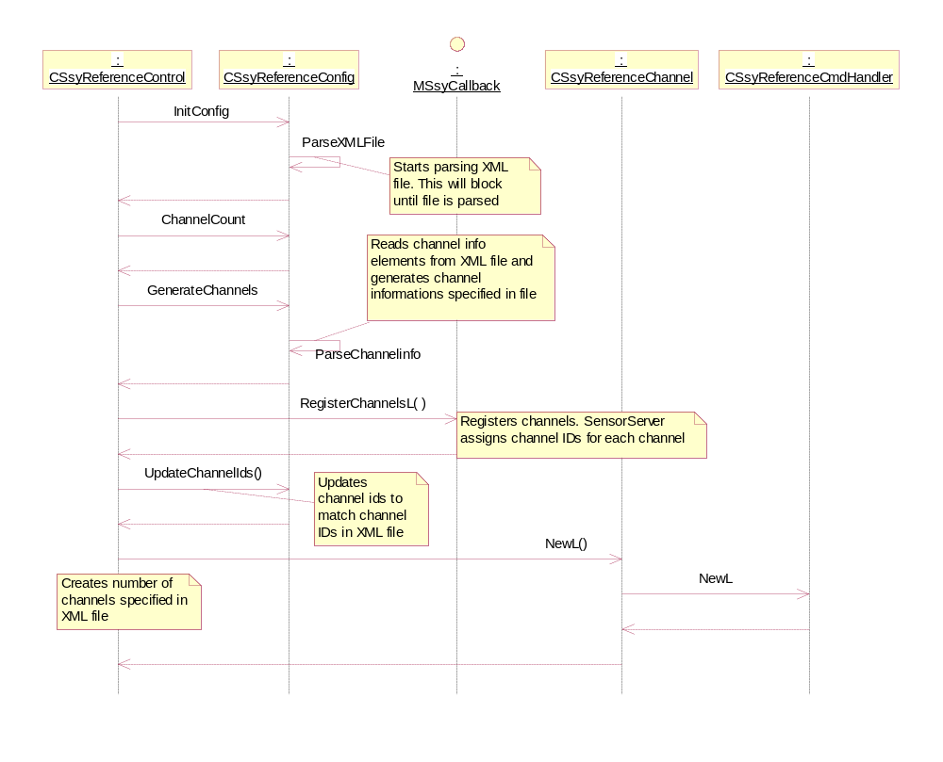
Figure 4.4 Loading of SSY reference

Open Channel
Operation | Open Channel
Preconditions | SSY is loaded successfully.
Description | SSY asks channel to open itself. Channel generates channel properties from XML config file. When opening channel completes, SSY notifies SensorServer by calling MSsyCallBack::ChannelOpened with or without error code.
Inputs | Channel ID to be opened.
Modifies | Channel state changes from idle to open.
Outputs
Postconditions | Channel is ready to start receiving data.
Related To | Use case .
Related Event
Exceptions | Requested channel is not found. SSY reports SensorServer with KErrNotFound error.

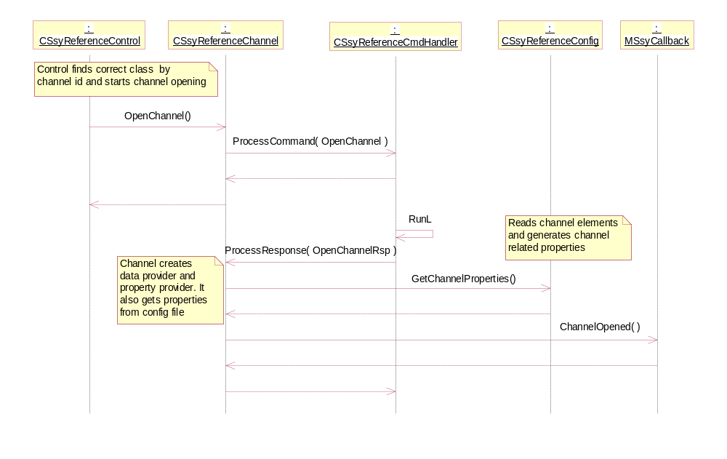
Figure 4.5 Opening channel

Producing data
Operation | Start channel data
Preconditions | Channel is open
Description | SSY reference generates channel data information from XML config file and starts producing items one by one in requested channel. Time interval before next item is produced is configureable in XML config file. Channel data is depended for the channel type and data values can be configured in XML configuration file. Data is produced as long as receiving is stopped or channel closed.
Inputs | ID of the channel to start producing data.
Modifies | Channel state changes from open to receiving.
Outputs | Number of channel data items in predefined timeperiods.
Postconditions | Channel is in receiving data state and produces predefined data items.
Related To | Use case .
Related Event
Exceptions | Requested channel is not found. SSY reports SensorServer with KErrNotFound error.

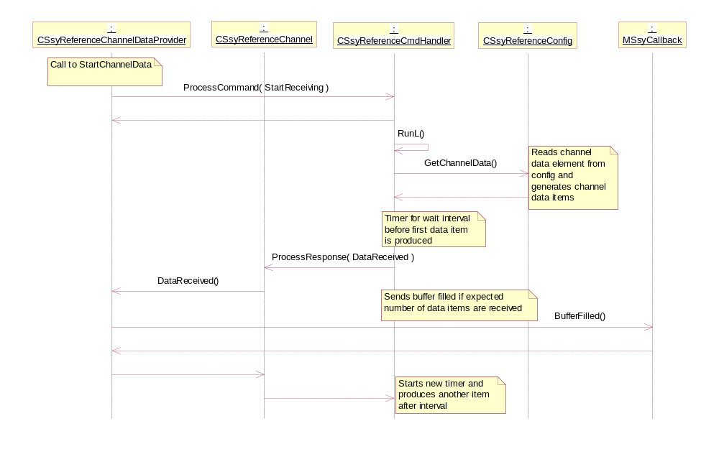
Figure 4.6 Producing data

Backup and Restore
This component does not participate in backup and restore.

Variation
This component is meant to run only in emulator as a stub. It has also dependency to SensorServer so if SensorServer is missing, there won’t be SSY reference either.

System resource usage

Files
SSY reference is configured by the information from XML config file. When SSY reference is loaded, it parses the XML config file and acts as configured.

File | SsyReferenceConfig.xml
Type | Private
Location | Z:\private\1020507e\reference\
Format | XML
Sharing | Not shared
Encryption | Not encrypted
Size estimate | 15 kilobytes
Description | Contains all configuration data related to SSY reference.

Other data

Databases
This component does not use any databases.

Central Repository
This component does not use Central Repository.

Publish and Subscribe
This component does not use Publish and Subscribe.

Memory consumption
Memory/Build | Consumption
User data area | 15 kB for files specified in Section 6.1
WINS UDeb | 381 788 bytes

Task allocation
SSY reference runs in SensorServers process. Sensor server creates new thread for all SSY ECom plug-ins.

Performance
Parsing of XML file is time consuming, but this component is meant to run only in emulator.

Timers
SSY reference uses timers when producing data

Timer | Purpose | Interval | Lifetime
Next Data item timer | Wait interval before next data item is produced | Configured in XML config file | Timer is used only when channel is in receiving state

Security
Security aspects are not taken into account because this component is only stub implementation. Only normal platform security issues like capabilities.

Capabilities of this component
Capability | Justification
CAP_ECOM_PLUGIN | Component is ECom plug-in of Sensor Server

Input and output validation
This component does not require or make any validation for data as all data this component produces is configurable.

Environmental assumptions
This component does not make any assumptions about its environment.

Additional enforcements
This component does not have any additional security enforcements.

Exception handling
In any error case in SSY reference, proper error code is passed to SensorServer. It is up to SensorServer how to act in different error cases.

Usage
This chapter explains the usage of XML config file. How to change values, add new data items and properties and even adding new channels.

Building
bldmake bldfiles
abld reallyclean
abld build winscw

User's guide
When building this component, it exports XML config file in predefined location. XML config file is the heart of SSY reference, it identifies SSY reference and tells what kind of properties it has, how many channels it has, what kind of data it produces etc.
XML config file can be roughly slit in two categories; general part which tells the SSY’s properties, and in channel information part which identifies channels.

Main parts of the XML config file
<SsyReferenceConfig> is the root tag of XML config file. General part starts with tag <SsyGeneralInformation> and it contains properties of this SSY reference. None of these properties are mandatory, so it is possible that general part is empty. Properties are explained later.

<SsyReferenceConfig>
<SsyGeneralInformation>
<Properties>
<PropertyItem
PropertyId="0x0000000011"
ItemIndex="0"
PropertyValue="SsyRef model 123"
MaxValue="0"
MinValue="0"
ReadOnly="1"
PropertyType="3">
</PropertyItem>
<PropertyItem
PropertyId="0x0000000013"
ItemIndex=""
PropertyValue="SsyRef descript."
MaxValue=""
MinValue=""
ReadOnly="1"
PropertyType="3">
</PropertyItem>
</Properties>
</SsyGeneralInformation>

Channel information part starts with <ChannelInformationGroup> tag and it has one attribute, ‘ChannelCount’. It tells the number of channels, <ChannelItem>, this XML config file contains. If new channels are added or removed, this attribute must be updated also or the SSY reference does not work as expected.

<ChannelInformationGroup ChannelCount="2">

Channel information
Here is an example of channel part. It starts with <ChannelItem> tag and it has six attributes.
‘ChannelId’ identifies one channel in XML config file, it is not the same ID that sensor server assigns.
‘ContextType’ is enum value of SensorServer defined enumeration TSensrvContextType defined in sensrvtypes.h.
‘Quantity’ is also enum value of TSensrvQuantity, also defined in sensrvtypes.h.
‘ChannelType’ tells the type of channel and somewhat tells what kind of data this channel produces, channel types are defined in sensrvsensorchannels.h.
‘Location’ is a string value of the location of the channel. SensorServer has some predefined locations, but this is somewhat a free text.
‘Vendor’ is also a string value of the vendor of the sensor. ‘Location’ and ‘Vendor’ string sizes are limited to SensorServer defined lengths, also found from sensrvtypes.h.

<ChannelItem
ChannelId="4"
ContextType="2"
Quantity="10"
ChannelType="0x00010001"
Location="SsyRefAxisChan"
Vendor="SsyRefVendor">
<!—- Channel spesific information like properties and channel data items -->
</ChannelItem>

Properties
Properties can be set in general part, when they are SSY specific properties, and in channel part, when they are channel specific properties. Property group starts with <properties> tag and it contains number of properties. <PropertyItem> tag is a start tag of one property. It has seven attributes.
‘PropertyId’ identifies the property. Property IDs are defined by SensorServer.
‘ItemIndex’ tells if this property concerns a specific item in channel data item. For example there can be channel data that contains items A and B. A has item index 1 and B has item index 2. If property affects only for item B, then item index is 2. If same kind of property affects to item A also, it needs own property configuration with item index 1.
‘PropertyValue’ is the value of the property. Datatype of value is defined in ‘PropertyType’ attribute. Possible types are integer, real and string
‘MaxValue’ tells the maximum possible value of this property
‘MinValue’ tells the minimum possible value of this property
‘ReadOnly’ tells is this property read-only or can clients update this property’s values
‘PropertyType’ tells the datatype of the property value, maxvalue and minvalue. These are defined in TSensrvPropertyType in sensrvproperty.h

<Properties>
<PropertyItem
PropertyId="0x00000002"
ItemIndex="0"
PropertyValue="100"
MaxValue="150"
MinValue="0"
ReadOnly="0"
PropertyType="1">
</PropertyItem>

Channel data items
Each channel can produce only one type of channel data item. For example one channel cannot produce tapping data and axis measure data, these both needs own channel. In XML config file there can be number of different channel data item configurations as long as they are same type as can be seen from example below. There is two different channel data items, both have different values.
<ChannelData> tag is the start for the channel item group. It has one attribute ‘StartIntervalMs’ which tells SSY the time interval in milliseconds to start producing data items after StartChannelData request.
<ChannelDataItem> tag starts one channel data item definition. It has three attributes.
‘DataTypeId’ identifies the type of the channel data so that SSY can map data information to correct form. Data type ids are defined by SensorServer along with channel data type definitions.
‘Count’ indicates the number of data items to produce. This means exact same data items with same values but different timestamp.
‘IntervalMs’ tells SSY the interval in milliseconds to wait before producing next channel data item.
<SsyRefChannelDataTapping> is specific tag for channel data. Each type of channel data has its own tag and in this example there is tapping data datatype. Data types are handled in next chapter.

<ChannelData StartIntervalMs="3000">
<ChannelDataItem DataTypeId="0x00010002" count="1" IntervalMs="3000">
<SsyRefChannelDataTapping Direction="25"></SsyRefChannelDataTapping >
</ChannelDataItem>
<ChannelDataItem DataTypeId="0x00010002" count="1" IntervalMs="5000">
<SsyRefChannelDataTapping Direction="2"></SsyRefChannelDataTapping>
</ChannelDataItem>
</ChannelData>

Channel data types
Each channel can produce only one kind of channel data. In <ChannelData> group there can be only one type of data tag in each channel. These data types are:
<SsyRefChannelDataTapping> refers to TSsyRefChannelDataTapping and <SsyRefChannelDataAxis> refers to TSsyRefChannelDataAxis.
These are located between <ChannelDataItem> and </ChannelDataItem> tags.

<SsyRefChannelDataTapping Direction="25"></SsyRefChannelDataTapping>
<SsyRefChannelDataAxis XAxis="50" YAxis="32" ZAxis="44"></SsyRefChannelDataAxis>

