S60 3.1
TARM Application Management
Design Document

Team name | Author

Change history:

Version | Date | Status | Comments
1.0 | 11.12.2006 | Approved

Table of contents:

1. Document control 5
1.1 References 5
1.2 Documentation conventions 5
1.3 Abbreviations 5
1.4 Definitions 5
2. General 7
2.1 Introduction 7
2.2 Component environment 7
2.3 Use cases 8
2.3.1 Delivering the Deployment component 8
2.3.2 Fetching the Deployment component 9
2.3.3 Installing the Deployment component 9
2.3.4 Updating the Deployment component 9
2.3.5 Removing the Deployment component 10
2.3.6 Downloading the Deployment component 10
2.3.7 Parsing InstallOptions 11
2.3.8 Serializing InstallOptions 11
2.4 Services required 11
2.4.1 From the Symbian OS subsystems 11
2.4.2 From the Domestic OS subsystems 12
2.4.3 From HW 12
2.5 Services provided 12
2.5.1 UI 12
2.5.2 SW IF 12
3. UI control hierarchy 13
4. Design 14
4.1 Class diagrams 14
4.1.1 Framework 14
4.1.2 Component 15
4.1.3 State diagrams 15
4.2 Backup and Restore 16
5. Variation 17
5.1 AM adapter __AM_LASTERROR_NODE 17
5.2 ApplicationManagementServer __SAP_POLICY_MANAGEMENT 17
5.3 ApplicationManagementServer __SERIES60_30__ 17
6. System resource usage 18
6.1 Files 18
6.2 Other data 18
6.2.1 Databases 18
6.2.2 Central Repository 19
6.2.3 Publish and Subscribe 19
6.3 Memory consumption 19
6.4 Task allocation 19
6.5 Performance 19
6.6 Timers 19
7. Security 20
7.1 Capabilities of this component 20
7.2 Input and output validation 20
7.3 Environmental assumptions 20
7.4 Additional enforcements 20
8. Exception handling 21
9. Usage 22
9.1 Building 22
9.2 User's guide 22
9.2.1 Parsing AM install options 22
9.2.2 Generating install options XML 22

Document control

References

- S60 3.2 Application Management Subsystem Architecture Description
- S60 SyncML How To Implement The DM Plug-in Adapter
- Series 60 Developer Platform 2.0: ECom Plug-In | http://www.forum.nokia.com
- SyncML Device Management Tree and Description | http://www.openmobilealliance.org

Documentation conventions
Code is shown with Courier New font.

Abbreviations

ACL | Access Control List
AP | Access Point
API | Application Programming Interface
DDF | Device Description Framework
DM | Device management
DNS | Domain Name Server
ECom | Symbian OS plugin system
GPRS | General Packet Radio Service
HTTP | Hypertext Transfer Protocol
HTTPS | Hypertext Transfer Protocol Secure
LUID | Local unique identifier
NAP | Network Access Point
OOD | Out of Disk
OS | Operating System
SyncML | Synchronization Mark-up Language
URI | Uniform Resource Indicator
UID | Unique identifier. Refers to UID used in SIS packages.

Definitions

Admin | A device management administrator who uses DM server to send DM commands to devices.
CenRep | Central Repository.
Deployment Component | An abstraction of installation package. Practically can be either a MIDlet (Jar/Jad combination) or SIS file.
Local unique identifier | DM client provides service to map a DM URI to a local unique ID, which in this case is a Deployment Component internal ID.
UID | A SIS package or software UID. Totally different from LUID.

General
Application Management is a subsystem that provides application management features for Device Management. The management works in terms of Deployment Components, which roughly are SISX or MIDlet packaged native or Java applications. The features include Deployment Component delivery, download, install and uninstall. From DM Admin point of view, the deployment components are identified as dynamic nodes in the tree, and the properties are defined as leafs of them. More information about can found from the reference document [4].

Introduction
Application Management for S60 is a subsystem consisting of DM Plugin Adapter, Client-Server Engine and the InstallOptions utility DLL. It has dependencies for example to installer (SW Installer Launcher API) and Java Registry.
This document is valid for S60 releases 3.1 and later.

Component environment
Application Management is component division and non trivial dependencies are shown below. The AM DM Adapter is loaded via ECom by the DM client, and it uses DM Tree Module API to change ACLs and Luid mappings. AM Server contains most of the functionality, and thus has dependencies to many other components.
AM InstallOptions is utility DLL for mapping XML format install options to SW Installer UI defined structs and vice versa. It is used by ScreenSaver and Themes customization adapters.
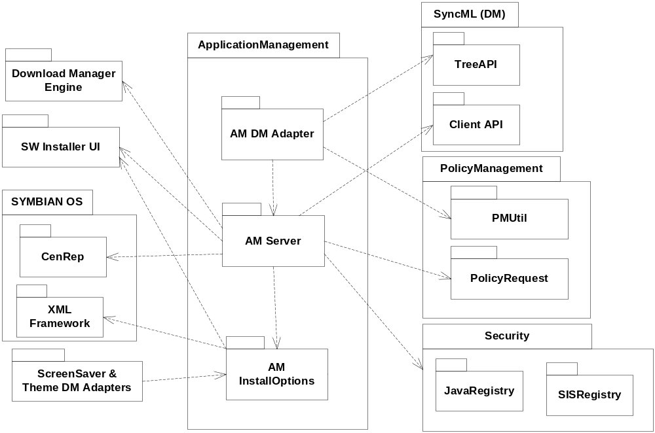
Figure 2.1 Component environment

Use cases
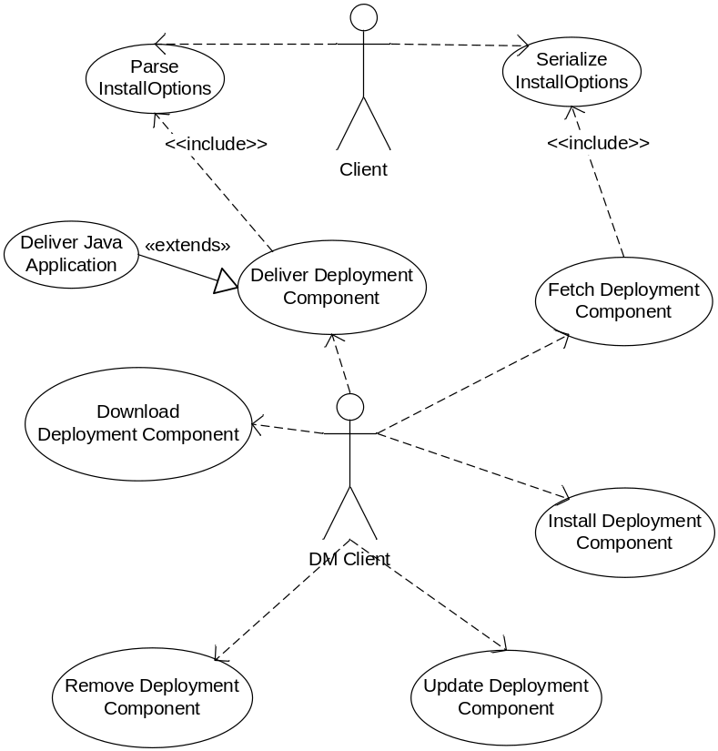
Figure 2.2 Application Management use cases

Delivering the Deployment component
Summary | A new Deployment Component is delivered to device.
Actor(s) | DM Admin, DM Client, Application Management
Frequency | Low
Preconditions | DM profile exists and is usable by DM server.
Description | DM admin (server) sends specified sequence of DM commands in order to build up a deployment component, and DM client forwards the commands to Application Management Adapter, which maps them to Application Management commands. Server first adds a node under Delivered node, then at least Data, and InstallOpts leafs under the created node to make deployment component to be installable. The received Data is analyzed to prevent overriding deployment component of another admin. In SIS case that is done by examining the UID of the SIS file. (See Section ) for Java case. If there’s a corresponding Deployed deployment component having same UID, or a Delivered that is not owned by the admin, the data is discarded and error code sent back to admin. However, if the same UID is found in the same admin’s Deployed state component, and the name of the node is same, data is not rejected but it is assumed that the new component is an update to the Deployed one. See use case (See Section ) for update procedure.
Exceptions | If the UID already exists, an Error code is returned to DM admin and the data is ignored.
Post conditions | The deployment component is delivered and may be seen under the Delivered node.
Illustrations

Fetching the Deployment component
Summary | Deployment Component information is fetched from device.
Actor(s) | DM Admin, DM Client, Application Management
Frequency | Low
Preconditions | DM profile exists and is usable by DM server.
Description | DM Admin makes a DM Get command targeted to URI of a deployment component root node or deployment component leaf. DM client thus forwards the command to Application Management. The existence of deployment component is checked, and the appropriate attribute fetched from the model. When fetching deployed deployment components, Application Management checks whether the component still exists from Application and Java registries, and if not, the deployment component is considered to be removed.
Exceptions | The application details could not be fetched if the application is on the MMC and the MMC is temporarily removed.
Post conditions | DM Admin has got the deployment component information it wished.
Illustrations

Installing the Deployment component
Summary | Deployment Component is installed.
Actor(s) | DM Admin, DM Client, Application Management
Frequency | Low
Preconditions | DM profile exists and is usable by DM server; Deployment Component has been delivered with installable data.
Description | DM Admin makes a DM Exec command targeted to URI of a deployment component Install operation leaf. DM client thus forwards the command to Application Management. The existence of deployment component is checked, and the appropriate attributes checked from the model (InstallOpts and Data must be there). Then the data is copied to a temporary location accessible by the installer, and the installer is silently launched using the install options. When installation is complete, state if the Deployment Component is automatically updated, and DM adapter updates the DM Client mappings and ACLs appropriately.
Exceptions | If the component cannot be installed, the DM error status code is returned to DM admin, and if the _AM_LAST_ERROR flag is on, installation status is put in version to SCM/Ext/LastError.
Post conditions | Deployment Component is installed and its status updated, and it can be found under Deployed node in the tree.
Illustrations

Updating the Deployment component
Summary | Deployment Component is updated.
Actor(s) | DM Admin, DM Client, Application Management
Frequency | Low
Preconditions | DM profile exists and is usable by DM server, and a Deployment Component to be updated has been already deployed.
Description | DM Admin first delivers a new Deployment component having same UID and same dynamic leaf name as an existing Deployment component. (See Section 2.3.1 for details.) Then he makes a DM Exec command targeted to the URI of a deployment component Update operation leaf. DM client thus forwards the command to Application Management. The existence of deployment component is checked, and the appropriate attributes checked from the model (InstallOpts and Data must be there). Then the data is copied to temporary location accessible by installer, and installer is silently launched using the install options. When the installation is complete, state if the Deployment Component is automatically updated, and DM adapter updates the DM Client mappings and ACLs appropriately. The to-be-updated Deployment component is effectively removed and new Deployment component is moved to Deployed node.
Exceptions | If the component cannot be installed, the DM error status code is returned to DM admin, and if the _AM_LAST_ERROR flag is on, installation status is put in version to SCM/Ext/LastError. The old package remains as it was.
Post conditions | The Deployment component has updated the old, and is seen in the same URI as the updated one.
Illustrations

Removing the Deployment component
Summary | Deployment component is removed.
Actor(s) | DM Admin, DM Client, Application Management
Frequency | Low
Preconditions | DM profile exists and is usable by DM server, and a Deployment component to be removed exists in device.
Description | DM Admin knows (or finds out) about the existence of a Deployment component and knows its dynamic node name. Then he makes a DM Exec command targeted to the URI of a deployment component Remove operation leaf. DM client thus forwards the command to Application Management. The existence of deployment component is checked. If deployment component is in Deployed state, it is first uninstalled. Then the deployment component is removed.
Exceptions
Post conditions | The Deployment component has been removed and cannot be seen by DM admin. Also all data related to Deployment component has been erased from the device.
Illustrations

Downloading the Deployment component
Summary | Download state Deployment component is delivered and download executed.
Actor(s) | DM Admin, DM Client, Application Management
Frequency | Low
Preconditions | DM profile exists and is usable by DM server.
Description | DM Admin creates a new Download state deployment component, and adds at least URI leaf value to it. If ConRef property is not there, the default browser access point is used for download. Then he makes a DM Exec command to deployment component Download operation, which causes download to be started, unless connectivity settings are bad. If downloads start ok, then the status code is returned to DM admin, and the operation proceeds. When download is completed successfully, the status is placed in LastStatus leaf, and
Exceptions | If the connectivity settings are bad, for example, if ConRef does not point to a valid and accessible access point, then download fails immediately.
Post conditions | The Deployment component has been downloaded, and is now visible in Delivered or Deployed state.
Illustrations

Parsing InstallOptions
Summary | InstallOptions in a descriptor are parsed to TAMInstallOpts.
Actor(s) | Client, Application Management
Frequency | Low
Preconditions | Normal DLL usage preconditions
Description | Client calls a static method taking descriptor and TAMInstallOpts or TInstallOpts reference. Application Management parses the descriptor using XML parser, and sets the TInstallOpts members accordingly. The unknown XML attributes are ignored.
Exceptions | In case of invalid XML, the XML document must be well-formed in order to be parsed.
Post conditions | The TInstallOpts struct contains all the data the given descriptor contains.
Illustrations

Serializing InstallOptions
Summary | Installoptions in TAMInstallOpts struct are written to a descriptor.
Actor(s) | Client, Application Management
Frequency | Low
Preconditions | Normal DLL usage preconditions.
Description | Client calls a static method taking descriptor and TAMInstallOpts or TInstallOpts reference. Application Management generates XML according to given TInstallOpts and places it to the given descriptor.
Exceptions | None (expect normal memory allocation problems).
Post conditions | The descriptor contains all the data the given TInstallOpts struct contains.
Illustrations

Services required

From the Symbian OS subsystems
Following is a short description of interfaces to Symbian OS side services / subsystems used by this SW.
API | Description
SW Launcher API | The silent install related structures and functions.
JavaRegistry | The Java installation registry.
SISRegistry | The SIS installation registry.
XML Framework | The XML parsing framework.
CenRep | The Central Repository.
Download Manager Engine | Provides file download services.
SyncML Tree API | Provides API to change ACL and LUID mappings.
SyncML Client API | Provides API to manage SyncML sessions.
PolicyRequest API | Provides means to query Policy Management authorization for a operation.
PMUtil API | Provides DM session certificate.
smldmadapter | ECom plug-in API for adding new settings to be managed.

From the Domestic OS subsystems
This component does not have any direct interfaces to the Domestic OS side subsystems.

From HW
This component has no direct HW interfaces.

Services provided

UI
This component does not provide any UI.

SW IF
Provided Service | Description | Protected
Parse InstallOptions | Utility to parse XML install options to SwiUI::TInstallOptions or NApplicationManagement::TAMInstallOptions struct instance. See use case . | No
Serialize InstallOptions | Utility to generate XML from SwiUI::TInstallOptions or NApplicationManagement::TAMInstallOptions struct instance. See use case . | No

UI control hierarchy
The component does not contain any UI or UI controls.

Design
The Design of the component is explained in the following sections.

Class diagrams
Yellow colored boxes are from other components.
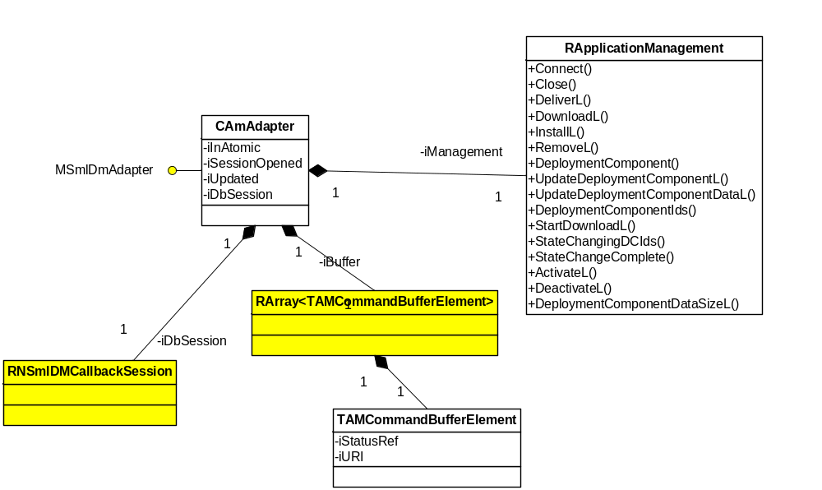
Figure 4.3 Adapter class diagram

Framework
The common Device Management framework is used in the adapter. For details, see reference document [2].

Component
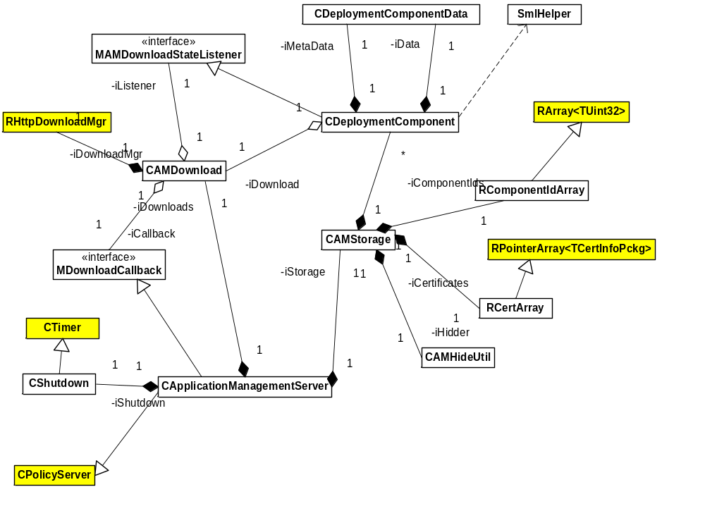
Figure 4.4 Component diagram

State diagrams
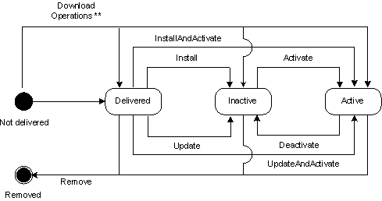
Figure 4.5 State diagram

Backup and Restore
The files mentioned in Section 6.1 are backed up by active backup. Central Repository data is also passively backed up.

Variation
Application Management can be included in or excluded from a ROM image.
The variation is done according to compilation flag __SAP_APPLICATION_MANAGEMENT.
When the flag is defined, files of application management components – adapter, RFS plugin, server and client – are included in the ROM image, in the image creation IBY file.

AM adapter __AM_LASTERROR_NODE
Defining __AM_LASTERROR_NODE in amadapter.mmp enables a new node /SCM/Ext/LastError which may contain additional information on the last error.

ApplicationManagementServer __SAP_POLICY_MANAGEMENT
If __SAP_POLICY_MANAGEMENT is defined, then Policy Management library is linked with and Policy Management is used for determining access to the Application Management functionality.

ApplicationManagementServer __SERIES60_30__
If __SERIES60_30__ is defined, menueng.lib is linked with to enable the hiding of applications in the menu (which basically is the inactive state of the Deployment component).
If the flag is not defined (in S60 3.1 and above) hiding is done via a Central Repository key using AMAppHideUtil.cpp, which is not included in source files if the flag is not defined.

System resource usage
Application Management uses files in a private directory to store Deployment component data.

Files
File | $Privatedir$\[DeploymentComponentInternalId]_M.txt
Type | Private
Location | RAM
Format | File
Sharing | No
Encryption | No
Size estimate | Not known
Clean up | When the Deployment component is removed.
Description | The files in private directory named as stated above hold the data DM admin has put to a Descriptor leaf.

File | $Privatedir$\ [DeploymentComponentInternalId]_D.txt
Type | Private
Location | RAM
Format | File
Sharing | No
Encryption | No
Size estimate | Not known.
Clean up | When the Deployment component is removed.
Description | The files in private directory named as stated above hold the data DM admin has put to a Data leaf.

File | C:\temp\[DeploymentComponentInternalId]_D.txt
Type | Public
Location | RAM
Format | File
Sharing | No
Encryption | No
Size estimate | Not known.
Clean up | When installation is complete.
Description | The data file is temporarily copied to a temp directory to allow the installer to access it. When the installation is complete, the file is removed.

Other data

Databases
This component does not directly use any databases.

Central Repository
This component uses Central Repository to persist Deployment component states. Reference document [1] outlines the usage. There are no Actual Central Repository APIs.

Publish and Subscribe
This component does not use Publish and Subscribe.

Memory consumption
Memory consumption has not been checked.

Task allocation
Application Management server runs in own process and one thread. It uses several components, which may start threads or processes of their own.

Performance
Performance has not been measured.

Timers
Timer | Purpose | Interval | Lifetime
ShutdownTimer | Stop server when there is no activity. | 30 seconds | Is started when the last session to server is closed.

Security

Capabilities of this component
Application Management Server
Capability | Justification
CAP_SERVER | Default capabilities for server.
TrustedUI | Required to do silent install.

Application Management Client
Capability | Justification
CAP_CLIENT_DLL | Default DLL capabilities.

AmAdapter, Rfs plugin
Capability | Justification
CAP_ECOM_PLUGIN | Default ECom plugin capabilities.

Input and output validation
AMInstallOptions uses XML framework to parse InstallOptions XML format. The parser requires XML to be well-formed, and AMInstallOptions component ignores the unknown attributes and elements.
Apart from that, there is very little input validation. Probably Installer will do validation for deployment component data, and download manager for download URIs. Other data is mainly used only by DM administrator.

Environmental assumptions
- C drive is non-removable", "the only API to access XYZ data is ABC API").
- Data that is stored in a private directory is assumed to be writable only by this component.
- c:\temp is writable by this component and readable by the installer.

Additional enforcements
If Policy Management is supported (see Section 5.2), policy engine is consulted on every service request. Apart from that, this component does not have any additional security enforcements.

Exception handling
The leave mechanism of Symbian OS environment is used for handling memory exhaustion.

Usage

Building
There are no special tricks in building, use normal bldmake bldfiles, abld build sequence.
- Client–server mmp can be found in: \s60\tarm\appmng\appmng\group
- Adapter mmp files are in \s60\tarm\appmng\appmng\amadapter2\group
- RFS plugin mmp file is in \s60\tarm\appmng\appmng\rfsplugin\group
- InstallOptions mmp file is in: \s60\tarm\appmng\appmng\options\group

User's guide

Parsing AM install options

#include <aminstalloptions.h>

using namespace NApplicationManagement;

// Example method that parses TAMInstallOptions
void exampleL( const TDesC8& aXML )
{
TAMInstallOptions opts;
InstallOptionsParser::ParseOptionsL( aXML, opts );
// now opts contains parsed XML options
}

// Example method that parses SwiUI::TInstallOptions only
void example2L( const TDesC8& aXML )
{
SwiUI::TInstallOptions opts;
InstallOptionsParser::ParseOptionsL( aXML, opts );
// now opts contains parsed XML options
}

Generating install options XML
#include <aminstalloptions.h>

using namespace NApplicationManagement;

// Example method that generates xml from TAMInstallOptions
void example3L()
{
TAMInstallOptions opts;
// write the values to options…

CBufBase *buf = CBufFlat::NewL(12);
InstallOptionsParser::SerializeOptionsL( opts, *buf);
// now buf contains generated XML
}

// Example method that generates xml from SwiUI::TInstallOptions
void example4L()
{
TInstallOptions opts;
// write the values to options…

CBufBase *buf = CBufFlat::NewL(12);
InstallOptionsParser::SerializeOptionsL( opts, *buf);
// now buf contains generated XML
}

