S60 3.x
OMA Client Provisioning
Destination Network Adapter
Design Document

Team name | Author
D RD CT ASW Connectivity Internet Access FI | Leni Oikarinen

Change history:

Version | Date | Status | Comments
1.0 | 17.06.2008 | Approved

Table of Contents:

1. Document control 4
1.1 References 4
1.2 Documentation conventions 4
1.3 Abbreviations 4
1.4 Definitions 5
2. General 6
2.1 Introduction 6
2.2 Subsystem environment 6
2.2.1 Receiving the settings 7
2.2.2 Saving the settings 8
2.2.3 Deleting the settings 8
2.3 Services required 8
2.3.1 From the Symbian OS subsystems 8
2.3.2 From the Domestic OS subsystems 9
2.3.3 From HW 9
2.4 Services provided 9
2.4.1 UI 9
2.4.2 SW IF 9
3. UI control hierarchy 10
4. Design 11
4.1 Class diagrams 11
4.1.1 Framework 12
4.1.2 Component 12
4.2 Class descriptions 12
4.2.1 Flag definitions 13
4.2.2 State diagrams 13
4.3 Operations 14
4.3.1 Importing the APPLICATION characteristic 14
4.3.2 Saving destination network settings 15
4.4 Backup and Restore 15
5. Variation 16
5.1 Variable component/feature 16
6. System resource usage 17
6.1 Files 17
6.2 Other data 17
6.2.1 Databases 17
6.2.2 Central Repository 17
6.2.3 Publish and Subscribe 17
6.3 Memory consumption 17
6.4 Task allocation 18
6.5 Performance 18
6.6 Timers 18
7. Security 19
7.1 Capabilities of this component 19
7.2 Input and output validation 19
7.3 Environmental assumptions 19
7.4 Additional enforcements 19
8. Exception handling 20
9. Usage 21
9.1 Building 21

Document control

References

- S60 OMA Provisioning Design Document
- S60 Coding Conventions Document
- OMA accepted change request, Doc# OMA-DM-2004-0211R01-CR_AC.doc | www.openmobilealliance.org
- S60 OMA Provisioning UI Specification
- S60 Connection Method Manager Design Document
- S60 Connection Method Manager Users Guide

Documentation conventions
Code is shown with the Courier New font.

Abbreviations

BIO | Bearer Independent Object
CP | Client Provisioning
DLL | Dynamic Link Library
DOS | Domestic Operating System
GPRS | General Packet Radio Service
IAP | Internet Access Point
MMS | Multimedia Messaging Service
OMA | Open Mobile Alliance
OOM | Out Of Memory
OS | Operating System
ROM | Read Only Memory
SNAP | Service Network Access Point (i.e. Destination Network)
UI | User Interface
VoIP | Voice over Internet Protocol
WAP | Wireless Access Protocol
WBXML | WAP Binary XML
XML | Extensible Markup Language

Definitions

BIO Control | An SW component that is executed to handle a message of the registered type.
Connection Method | Access Point.
Destination Network | A destination network is an abstraction to hide the technical specific settings from the users of applications. Instead of access points, the user can select destinations with its name, like ‘Internet’ or ‘Intranet’ etc. Each destination can contain numerous access technologies (hence “connection methods”) that can be used to access the destination or service domain in question. When a connection to a destination is going to be established, the device can automatically select the best one available.
ECom | Generic plug-in framework from Symbian.
OMA Client Provisioning | Method of receiving settings via WAP Push. See further information on http://www.openmobilealliance.org.

General
This document describes the design of the OMA Client Provisioning Framework Plug-in component (wpdestinationnwadapter.dll) that is called Destination Network Adapter or SNAP Adapter in this document.

Introduction
Provisioning is a way of sending various settings to the terminal to be used in configuration of the terminal device. S60 supports OMA Client Provisioning. OMA Client Provisioning handles settings as packages called contexts. One context includes all the needed settings delivered by mobile phone or some other operator (e.g. GPRS, MMS, e-mail, WAP, VoIP). An OMA Client Provisioning message is called a provisioning document. Provisioning document is WBXML encoded XML code. A Destination Network Provisioning message is received by a Destination Network Provisioning capable terminal via WAP Push in WBXML format and is after receiving handled by BIO messaging framework and OMA Client Provisioning Framework. OMA Provisioning message is identified by its BIO type and then carried to OMA Client Provisioning Framework that is responsible for storing the message in the Message Centre. When a terminal user gets notification of a new received message and opens it in the Message Centre, the provisioning BIO Control is used to show the message information to the terminal user. Data used in BIO Control is delivered by OMA Provisioning Framework that makes use of Destination Network Adapter, which is responsible for handling message data in semantic means.
Terminal user can save the destination network settings by opening the Options menu and choosing a command to save settings. When destination network settings are saved, Destination Network Adapter creates destination network(s) that were provisioned and links to them IAPs that have been linked using OMA Client Provisioning linking methods.
Terminal user can delete the context, but not manage individual settings in any way by using OMA Client Provisioning. User can however manage the settings via Settings UI.
Destination Network Adapter is an ECom plug-in component of Provisioning Engine and it understands the semantics of destination network settings in the provisioning document (see reference document [1]). Destination Network Adapter provides information for user interface.
See reference document [1] for more detailed information on OMA Provisioning Framework.
See reference document [5] for more information about Destination Networks.

Subsystem environment
Key dependencies of Destination Network Adapter are shown in Figure 2.1.
- OMA Provisioning Framework (especially the Provisioning Engine component) for accessing characteristic and parameter data.
- Connection Method Manager, interface for SNAP settings storage.

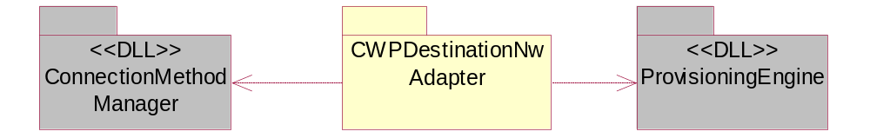
Figure 2.1 Dependencies of SNAP Adapter’s context; ConnectionMethodManager and ProvisioningEngine
ProvisioningEngine is dependent on ECom plug-ins, which implement the OMA Client Provisioning Framework CWPAdapter interface. ProvisioningEngine loads all OMA Client Provisioning adapter components into the collection owned by it when the framework is loaded. ProvisioningEngine then makes calls to the methods of CWPAdapter in sequence for every adapter in its collection. ProvisioningEngine controls the lifecycle of the adapters and the timing of method execution. An individual adapter must have a place to store its setting values into. Destination Network Adapter uses ConnectionMethodManager for storing destination networks.
Since Destination Network Adapter is an ECom plug-in it needs four UIDs in total:
- ECom plug-in UID which is common to all ECom plug-ins (UID2)
- UID with which the MMP file specifies the UID for the component (DLL UID or UID3)
- ECom implementation UID which specifies implementation of an interface
- ECom interface UID (in this case, inherited from base class CWPAdapter)

Destination Network Adapter’s UIDs are as follows:

UID2 | 0x10009D8D (ECom UID)
UID3 | 0x2000B4AF
Implementation UID | 0x2000B4AE
Interface UID | 0x101F84D5 (from CWPAdapter)

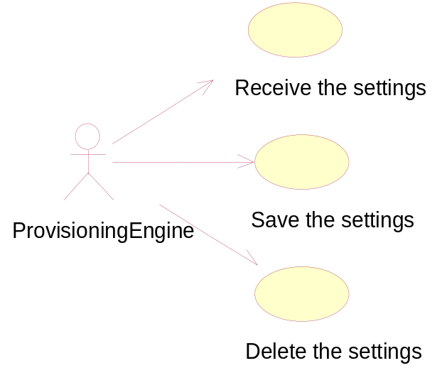
Figure 2.2 Use cases which are implemented by the adapter. Provisioning Engine controls the life-cycle and execution of the adapter.

Receiving the settings

Summary | Receiving the settings.
Actor(s) | ProvisioningEngine.
Frequency | This use case is executed every time, the settings become available and ProvisioningEngine makes the adapters receive the settings after the end-user has opened the configuration message in Message Centre.
Preconditions | The configuration message is opened.
Description | The adapter receives the settings and builds the data structure base on the received settings values.
Exceptions | None.
Postconditions | The Destination Network Adapter’s internal data structures created.
Illustrations | None.

Saving the settings

Summary | Saving the settings.
Actor(s) | ProvisioningEngine.
Frequency | This use case is executed when the end-user wants to save the settings.
Preconditions | Use case in Section 2.2.1 has been executed.
Description | Destination Network Adapter saves the received settings.
Exceptions | None.
Postconditions | Settings saved.
Illustrations | None.

Deleting the settings

Summary | Deleting the settings.
Actor(s) | ProvisioningEngine.
Frequency | This use case is executed every time when the end-user wants to destroy the settings context (via UI).
Preconditions | There is a settings context stored on the terminal.
Description | When the adapter’s DeleteL() method is called, the SNAP Adapter removes all access points from the SNAP(s) it has created and then deletes the SNAP(s).
Exceptions | None.
Postconditions | Pointed settings deleted.
Illustrations | None.

Services required

From the Symbian OS subsystems
The following services of Symbian OS infrastructure (including Stream Store, Messaging) and S60 UI Application framework are required.
Table 2.1 Destination Network Adapter dependencies
Module name | Explanation of dependency
provisioningengine.lib | Provides the data to the adapter implementations (CWPCharacteristic, CWPParameter and CWPAdapter).
cmmanager.lib | Storage interface of destination networks.

From the Domestic OS subsystems
This component has no interfaces to the DOS side subsystems.

From HW
This component has no direct HW interfaces.

Services provided

UI
The user interface is described in reference document [4]. Destination Network Adapter has no UI of its own but provides information to the UI which is controlled by BIO control via the OMA Client Provisioning Framework (a Provisioning Engine component).

SW IF
This component does not provide services for other components.

UI control hierarchy
The component does not contain any UI or UI controls.

Design

Class diagrams
The class CWPDestinationNwAdapter inherits the OMA Client Provisioning Framework class CWPAdapter (abstract class), which is inherited by all adapters of the framework. It provides the basic functionality of Destination Network Adapter. CWPAdapter provides the capabilities of visit and adapter design pattern. The framework (ProvisioningEngine) and Destination Network Adapter communicate through a visitor pattern. See Figure 4.3 Destination Network Adapter base classes for class diagram.
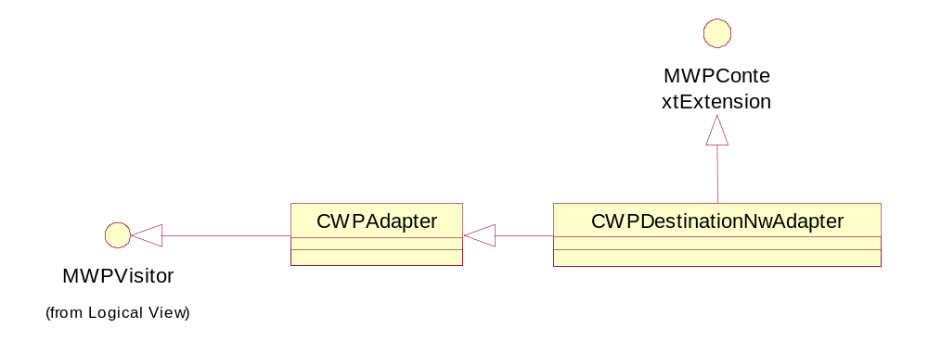
Figure 4.3 Destination Network Adapter base classes
Classes and dependencies of Destination Network Adapter can be broken down to two groups by their nature. The first group of classes is used to interface with OMA Client Provisioning Framework (CWPAdapter, CWPDestinationNwAdapter, CWPCharacteristic, CWPParameter). The second group makes use of VoIP specific classes (ConnectionMethodManager). There still remain classes that are not included in Error: Reference source not found. CWPParameter (see reference document [1]) and utility classes are not shown. CWPParameter objects are used to carry SNAP settings one by one from the OMA Client Provisioning framework to the Destination Network Adapter.
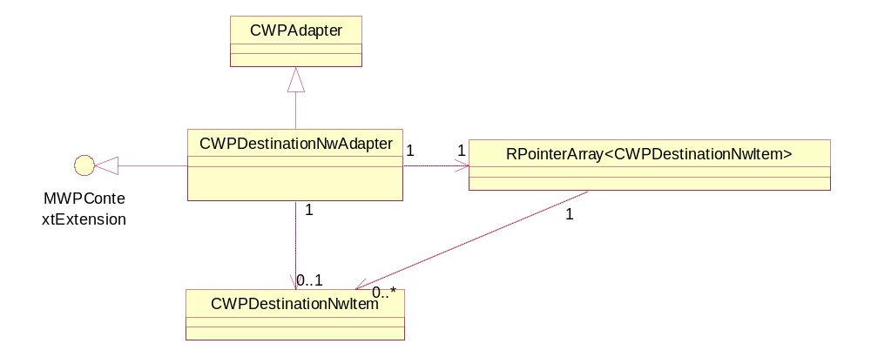
Figure 4.4 Destination Network Adapter design. RPointerArray is used to hold SNAP items until they are saved.
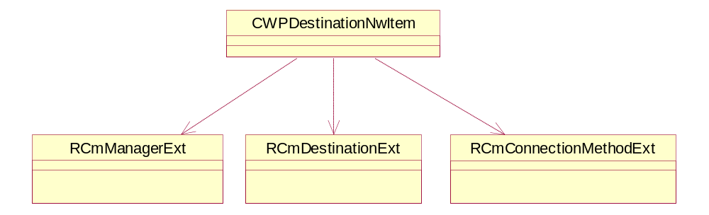
Figure 4.5 Destination Network Item design. Destination Network item is a class that holds and saves one SNAP.
The Destination Network Adapter and provisioning classes:
- CWPDestinationNwAdapter inherits the CWPAdapter class (provided by OMA Client Provisioning Framework) and it is the controlling part of the Destination Network Adapter plug-in component. It also inherits the MWPContextExtension interface from OMA Client Provisioning Framework.
- Individual SNAP settings belonging to the same context (i.e. received in the same provisioning document) are stored in private member variables of class CWPDestinationNwItem which stores them via Connection Method Manager API (classes RCmManagerExt, RCmDestinationExt and RCmConnectionMethodExt).

Framework
The Symbian platforms and OMA Client Provisioning framework.

Component
See Section 4.1.

Class descriptions

Class | Description | Header file
CWPDestinationNwAdapter | Realizes Client Provisioning Destination Network Adapter. SNAP Adapter sets the received settings to the class CWPDestinationNwItem. | cwpdestinationnwadapter.h
CWPDestinationNwItem | Stores received SNAP settings (i.e. creates SNAP(s)) via Connection Method Manager API. | wpdestinationnwitem.h

Flag definitions
Destination Network Adapter does not have flag definitions of its own. The following common flags are used:

Flag | Description
_DEBUG | This flag enables adapters debug prints.
RD_VOIP_REL_2_2 | This flag is used for the whole component since Nokia VoIP release 3 features must be flagged.

State diagrams
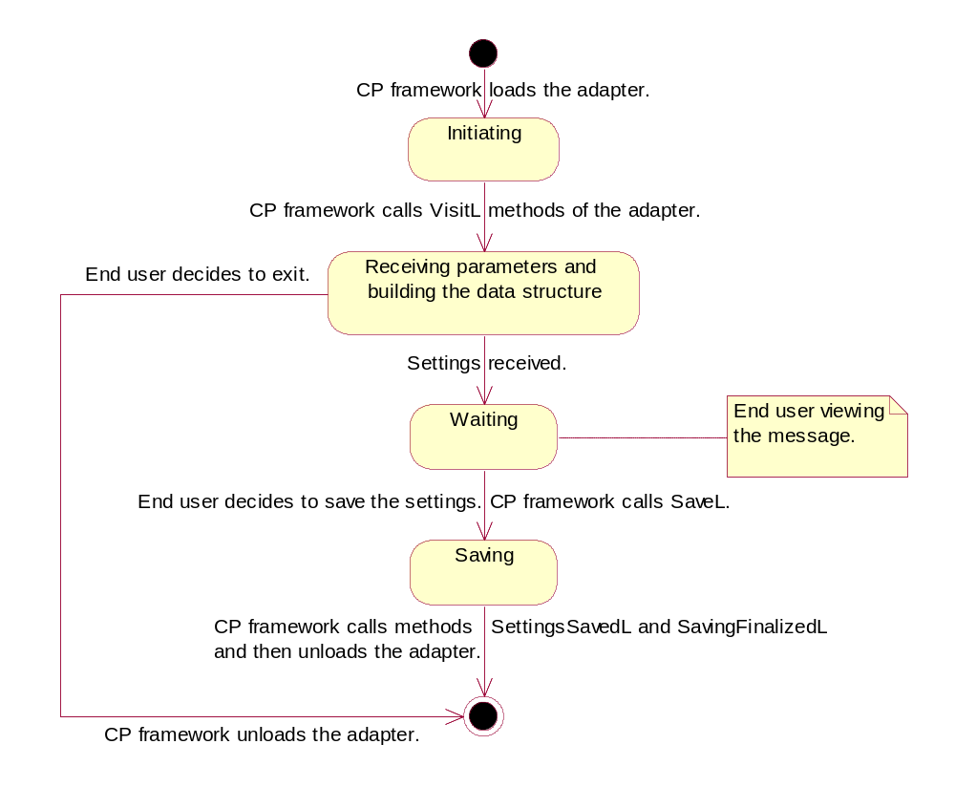
Figure 4.6 Lifecycle of the Destination Network Adapter. OMA Client Provisioning framework controls the lifecycle of the adapter.

Operations

Importing the APPLICATION characteristic
The operation description of importing the Network Destination settings APPLICATION characteristic is provided here as an example.

Operation | Importing destination network settings APPLICATION characteristic
Preconditions | Destination Network Adapter has been created by the framework.
Description | APPLICATION characteristic with the application parameters are imported.
Inputs | CWPCharacteristic reference. This refers to the APPLICATION characteristic in the data structure that is owned by the framework.
Modifies | Private member variables of CWPDestinationNwItem using item class’ public setter methods.
Outputs | None.
Postconditions | At least one setting has been received.
Related To | CWPCharacteristic, CWPDestinationNwItem.
Related Event | Calling VisitL (CWPCharacteristic).
Exceptions | Out of memory.

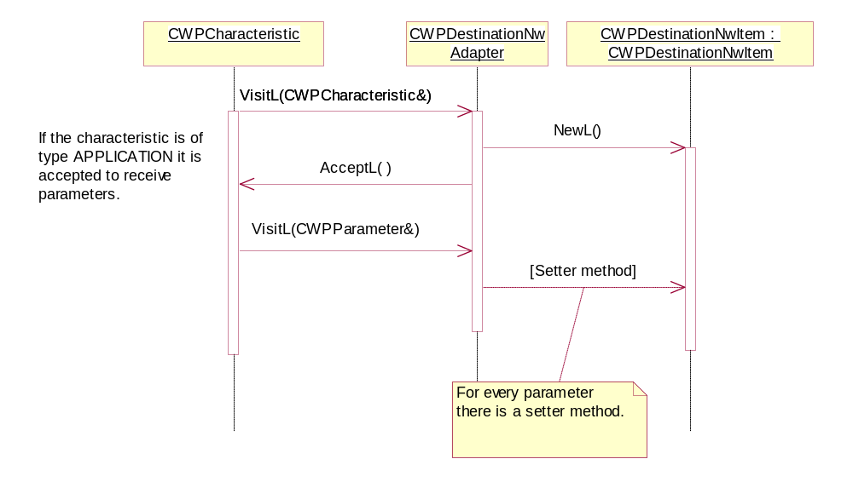.
Figure 4.7 Importing destination network APPLICATION characteristic parameters via Network Destination Adapter into CWPDestinationNwItem class’ member variables

Saving destination network settings

Operation | Saving destination network settings.
Preconditions | Data has been received by Destination Network Adapter.
Description | CWPDestinationNwItem stores the settings via interface provided by Connection Method Manager.
Inputs | The setting values have been temporarily stored in CWPDestinationNwItem.
Modifies | Opens, modifies and closes RCmManagerExt, RCmDestinationExt and RCmConnectionMethodExt.
Outputs | Settings into permanent storage via Connection Method Manager interface.
Postconditions | A new SNAP has been created.
Related To | Classes RCmManagerExt, RCmDestinationExt and RCmConnectionMethodExt.
Related Event | SaveL()from CWPDestinationNwAdapter and CWPDestinationNwItem.
Exceptions | Out of memory, Connection Method Manager API exceptions.

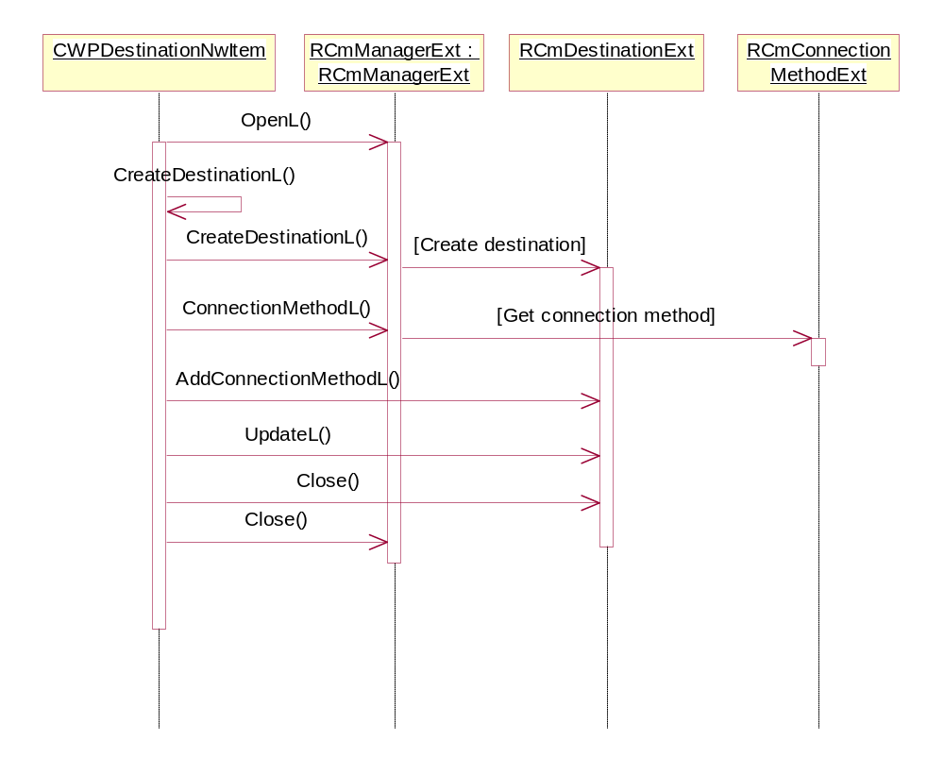
Figure 4.8 Saving Destination Network settings

Backup and Restore
This component does not participate in backup and restore.

Variation
Variation has been realized by flagging the whole component in the bld.inf file with flags __VOIP and RD_VOIP_REL_2_2.

Variable component/feature
__VOIP: The whole component.
RD_VOIP_REL_2_2: The whole component (Nokia VoIP release 3.0 features must be flagged).

System resource usage

Files
Resource files are read from the disk.

File | 2000B4AF.rss
Type | Read only.
Location | ROM.
Format | Resource file.
Sharing | Not shared.
Encryption | No encryption.
Size estimate | 2 kB.
Clean up | Persistent.
Description | Destination Network Adapter specific descriptors.

File | wpdestinationnwadapter.rss
Type | Read only.
Location | ROM.
Format | Resource file.
Sharing | Not shared.
Encryption | No encryption.
Size estimate | 2 kB.
Clean up | Persistent.
Description | Destination Network Adapter specific descriptors.

Other data

Databases
This component does not use any databases.

Central Repository
Central repository is used only for local variation.

Publish and Subscribe
This component does not use Publish and Subscribe.

Memory consumption

WINSCW UDeb | 241 664 bytes
ARMV5 URel | 4 096 bytes

Task allocation
This component runs in the same thread as the ProvisioningBC.

Performance
The system described in this document is used only occasionally and contains no time critical parts.

Timers
This component does not use any timers.

Security

Capabilities of this component

Capability | Justification
CAP_ECOM_PLUGIN | As other Client Provisioning Adapter components.

Input and output validation
This component does not require or make any validation for data.

Environmental assumptions
This component does not make any assumptions about its environment.

Additional enforcements
This component does not have any additional security enforcements.

Exception handling
The leave mechanism of the Symbian OS environment is used to handle memory exhaustion.

Usage
The user does not directly use Destination Network Adapter. See reference document [1] for details of the use of Provisioning BIO Control, which is executed by the user.

Building
For building use the standard S60 build approach in the folder cpdestinationnwadapter\group.
Open Command Prompt in the directory mentioned above and write the following commands.

bldmake bldfiles
abld build

