S60 5.1
Mail Application
Design Document

Team name | Author

Change history:

Version | Date | Status | Comments
14.0 | 16.06.2009 | Approved | Document update. Editorial changes.
13.0 | 30.03.2009 | Approved | SyncML email references removed
12.0 | 09.05.2008 | Approved | Document name changed from S60 3.x Mail Application Design Document to S60 3.x Mail Application Design Document.
11.0 | 09.01.2007 | Approved | Template updated.
10.0 | 13.12.2006 | Approved | - Update for 3.2 features.  - New chapters 2.3.10 and 4.5.11.
9.0 | 24.5.2006 | Approved | - Added Reply via message case
8.0 | 2.3.2006 | Approved | - Fixed broken cross-references
7.0 | 21.10.2005 | Approved | - Updated template  - Updates for 3.x
6.0 | 24.2.2004 | Approved | - Figure 1.1 updated  - 4.2.2 Added CMsgMailCharacterSetHandler class  - 7.1 Added WINSCW  - 5.3 Updated memory consumption table
5.0 | 5.11.2003 | Approved | - 7.1 Build commands in List number format  - 4.2 Removed detailed class methods  - 4.2 Added class descriptions  - 4.2 Added flag definitions  - 4.3.1 Added Mail editor launching operation  - 4.3.1 Added figure 4.4 Launching the Email editor  - 5.3 Added table for static memory consumption  - Updated table of contents
4.0 | 6.10.2003 | Approved | Added MailUtils class description and off-line support
3.0 | 4.9.2003 | Approved | Added sequence diagram for check names, removed duplicate class descriptions.

Table of contents:

1. Document control 5
1.1 References 5
1.2 Documentation conventions 5
1.3 Abbreviations 5
1.4 Definitions 6
2. General 7
2.1 Introduction 7
2.2 Component environment 7
2.3 Use cases 8
2.3.1 Mail editor use cases 8
2.3.2 Edit mail message 8
2.3.3 Manage attachments 9
2.3.4 Send mail message 9
2.3.5 Mail viewer use cases 10
2.3.6 View mail message 10
2.3.7 Delete mail message 10
2.3.8 View message attachments 11
2.3.9 Forward/Reply to message 11
2.3.10 Call to sender 11
2.4 Services required 11
2.4.1 From the Symbian OS subsystems 11
2.4.2 From the Domestic OS subsystems 12
2.4.3 From HW 12
2.5 Services provided 12
2.5.1 UI 12
2.5.2 SW IF 12
3. UI control hierarchy 13
3.1 Framework 13
3.2 Component 13
4. Design 14
4.1 Class diagrams 14
4.1.1 Framework 14
4.1.2 Component 15
4.2 Class descriptions 16
4.2.1 MsgMailEditor 16
4.2.2 MsgMailViewer 17
4.2.3 MsgMailUtils 18
4.2.4 MsgPlainView 19
4.2.5 Structs, type definitions and enumerations 19
4.2.5.1 CMailMessage.h Structs/Definitions/Enumerations 19
4.2.5.2 CMailCRHandler.h Structs/Definitions/Enumerations 19
4.2.5.3 MailUtils.h Structs/Definitions/Enumerations 19
4.2.5.4 MsgMailAppUi.h Structs/Definitions/Enumerations 19
4.2.5.5 MsgMailPreferences.h Structs/Definitions/Enumerations 19
4.2.5.6 MsgMailCharacterSetHandler.h Structs/Definitions/Enumerations 20
4.2.6 Flag definitions 20
4.3 Operations 20
4.4 Mail editor operations 20
4.4.1 Launching the mail editor 20
4.4.2 Sending a message 21
4.4.3 Saving a message 23
4.4.4 Deleting a message 24
4.4.5 Open Send options dialog 25
4.4.6 Adding an attachment 26
4.4.7 Removing an attachment 27
4.4.8 Adding a recipient 28
4.4.9 Check names 29
4.5 Mail viewer operations 30
4.5.1 Open a message 30
4.5.2 Copy a message 32
4.5.3 Moving a message 32
4.5.4 Forwarding a message 33
4.5.5 Replying to a message 34
4.5.6 Replying via message 35
4.5.7 Opening a message attachment 36
4.5.8 Opening an attachment 37
4.5.9 MHTML conversion 38
4.5.10 Matching Sender Address for Call 41
4.6 Backup and Restore 42
5. Variation 43
5.1 Compile time variation 43
5.2 Image creation time variation 43
5.3 Runtime variation 43
6. System resource usage 44
6.1 Files 44
6.2 Other data 44
6.2.1 Databases 44
6.2.2 Central Repository 44
6.2.3 Publish and Subscribe 44
6.3 Memory consumption 44
6.4 Task allocation 44
6.5 Performance 44
6.6 Timers 44
7. Security 45
7.1 Capabilities of this component 45
7.1.1 Mail editor application 45
7.1.2 Mail viewer application 45
7.1.3 Mail utils dll 45
7.1.4 MailPlainView ECOM plugin 45
7.2 Input and output validation 45
7.3 Environmental assumptions 45
7.4 Additional enforcements 45
8. Exception handling 46
9. Usage 47
9.1 Building 47
9.2 User's guide 47

Document control

References
- S60 Mail UI Specification
- S60 Message Editor Base Design Document
- S60 SendUI Design Document
- S60 Mailboxes and Mail Settings UI Specification

Documentation conventions
Code is shown with the Courier New font.

Abbreviations
APPARC | Symbian OS application architecture framework
AppUI | Applications UI class
AVKON | UIKON extended GUI
BT | Bluetooth
DLL | Dynamic Link Library
CONE | Symbian OS control environment framework
EUSER | Symbian OS user library
ESTOR | Symbian OS stream store library
HTML | Hypertext Markup Language
IAP | Internet Access Point
IMCM | Mail (SMTP, POP3, IMAP4) client MTMs
IMUM | Internet Mail UI MTMs
IF | Interface
IMAP4 | Internet Mail Access Protocol 4
IR | Infra Red
MCE | Message Centre application
MSGS | Message Server
MTUR | UI (Data) MTM Base
MTM | Message Type Module
MUIU | Messaging UI Utils
MVC | Model/View/Controller (application architecture)
OOM | Out Of Memory
POP3 | Post Office Protocol 3
Send UI | Send UI common component
SMTP | Simple Mail Transfer Protocol
SW | Software
UI | User Interface
URL | Universal Resource Locator

Definitions
Find Item Component | Common component that provides “Find Item” menu, phone number, mail address and URL parser, UI for search results and related operations.
Message Server | Standard Symbian OS server, which has two main functions: it controls access to message data and delegates requests for server-side MTMs.
Template text | Standard and user created pieces of (short) text strings. Stored in Message Centre Templates folder.
Insert Template Component | Common component that provides “Insert Template” menu so that user can insert template text to message body.
Mail UI | Common name for both Mail Editor and Mail Viewer applications.

General
This document describes the design of the S60 Mail Editor and Mail Viewer applications. It contains the subsystem environment description and the operation descriptions.

Introduction
Mail Editor and Mail Viewer are standalone applications. However, they are not directly visible to the user via Application Shell but are launched either by Messaging Centre or any other application that supports the Send as Mail function. Launching of the Mail applications is shown in Figure 2.1
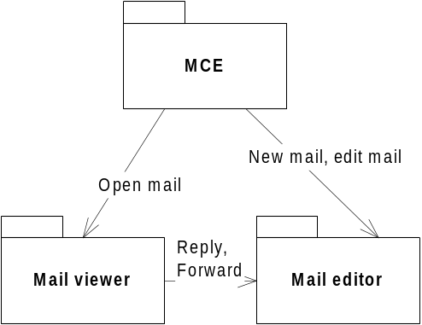
Figure 2.1 Mail application architecture
The architecture of the Mail Editor and Mail Viewer applications is MVC based and uses the base classes from the MsgEditor module (see reference document [2]).
The requirements for the Mail Editor and Mail Viewer applications are specified in Mail UI specification [1].

Component environment
The Mail Editor and Mail Viewer applications are standard view-based applications and use the system components typical to these applications.
The applications are implemented in the following modules:

MsgMailEditor.exe | Mail Editor Application.
MsgMailViewer.exe | Mail Viewer Application.
MsgMailUtils.DLL | Module with common routines used only by Mail Editor and Mail Viewer applications.

The dependencies between the components, the main Symbian OS components and other S60 components are shown in Figure 2.2. For clarity, some of the common Symbian OS components are omitted from the diagram.
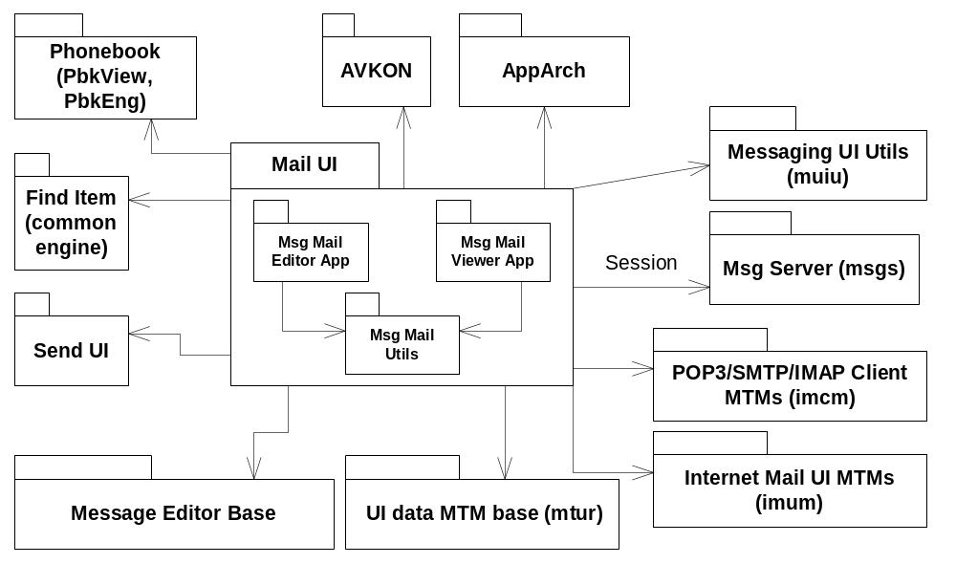
Figure 2.2 Component environment

Use cases

Mail editor use cases
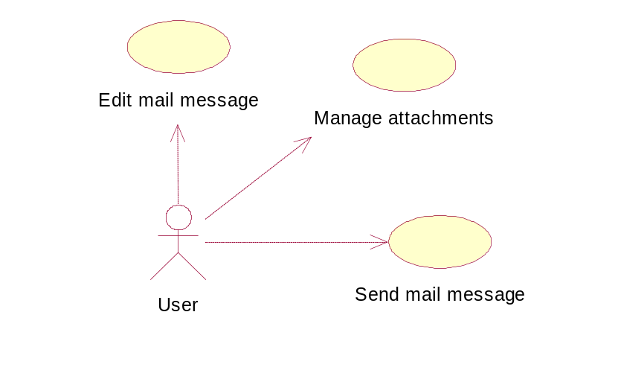
Figure 2.3 Mail editor use cases

Edit mail message
Summary | User edits mail message.
Actor(s) | User.
Frequency | Low.
Preconditions | User has created malbox settings successfully.
Description | User edits mail message. If message store is located on removable media there will be exception when media is removed. [MMC removed].
Exceptions | [MMC removed], Message is saved if possible and mail editor is closed.
Postconditions | User has edited mail message content.
Illustrations | None

Manage attachments
Summary | User edits mail message attachments.
Actor(s) | User.
Frequency | Low.
Preconditions | User has created malbox settings successfully.
Description | User adds, opens or removes mail attachments. There might be exeption if user tries to add attachments in low memory case [OOM].
Exceptions | [OOM], Out of memory error.
Postconditions | User has added/removed attachments to the mail message.
Illustrations | None

Send mail message
Summary | User sends mail message.
Actor(s) | User.
Frequency | Low.
Preconditions | User has created malbox settings successfully.
Description | Mail message is sent via selected mailbox. If mailbox is deleted before message is sent there will be exeption [Mailbox deleted error].
Exceptions | [Mailbox deleted error], Show error note and close mail editor.
Postconditions | Mail message is sent to the recipients.
Illustrations | None

Mail viewer use cases
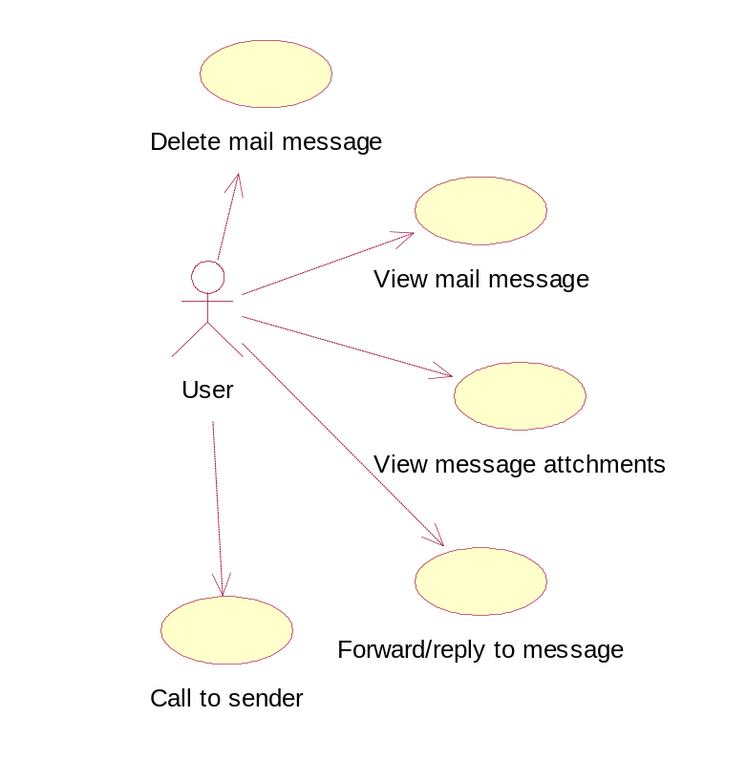
Figure 2.4 Mail viewer use cases

View mail message
Summary | User opens a mail message.
Actor(s) | User.
Frequency | Low.
Preconditions | User has created mailbox settings successfully and received some mail messages.
Description | Mail message is opened from the selected mailbox.
Exceptions | None.
Postconditions | Mail message is opened.
Illustrations | None

Delete mail message
Summary | User deletes mail message.
Actor(s) | User.
Frequency | Low.
Preconditions | User has created malbox settings successfully and received some mail messages.
Description | Mail message is deleted from selected mailbox.
Exceptions | None.
Postconditions | Mail message is deleted.
Illustrations | None

View message attachments
Summary | User opens a mail message attachment.
Actor(s) | User.
Frequency | Low.
Preconditions | User has created malbox settings successfully and received some mail messages that contains attachments.
Description | Mail message attachments are shown to the user. Attachment file can not be opened nor saved if device does not recognize the file [Unsupported].
Exceptions | [Unsupported], Device does not recognize attached file.
Postconditions | Attachments can be opened and saved.
Illustrations | None

Forward/Reply to message
Summary | User replies or forwards mail message.
Actor(s) | User.
Frequency | Low.
Preconditions | User has created mailbox settings successfully and received some mail messages.  Protected files can not be forwarded [ForwardLock].
Description | User creates reply or forward message.
Exceptions | [ForwardLock], Protected file types can not be forwarded via email.
Postconditions | Forward or reply message is created.
Illustrations | None

Call to sender
Summary | User calls to sender of received email.
Actor(s) | User.
Frequency | Low.
Preconditions | User has created malbox settings successfully and received some mail message. User information is stored in the phonebook and it has one or more telephone numbers.
Description | List of phonenumbers that match for senders email adderss is shown. After user selects one of those call is generated.
Exceptions | Phonebook doesn’t have any telephone numbers for mail sender.
Postconditions | Phone call is created.
Illustrations | None

Services required

From the Symbian OS subsystems
API | Description
AVKON | UI Components
APPARC | Common application architecture
CONE | For graphics
Message Server | Symbian messaging engine
UI and Client MTMs | For accessing message Server
Send UI | For sending attachments
Phonebook | For accessing contacts information
Feature Manager | For checking feature variation statuses

From the Domestic OS subsystems
This component does not have any direct interfaces to the Domestic OS side subsystems.

From HW
This component has no direct HW interfaces.

Services provided

UI
The main user interface of this module is described in reference document [1].

SW IF
Mail Editor and Mail Viewer are standalone applications and do not provide services for other subsystems. The subsystems that use the Send as Mail functionality do this through Send UI (for further details, see reference document [3]).

UI control hierarchy

Framework
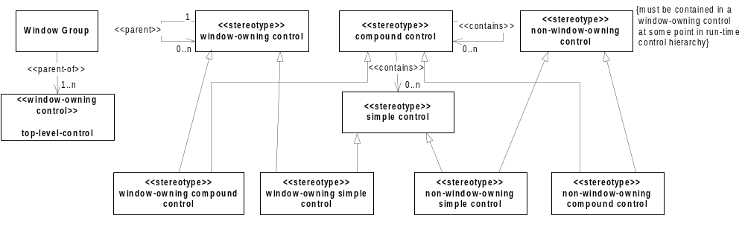
Figure 3.5 Control metamodel

Component
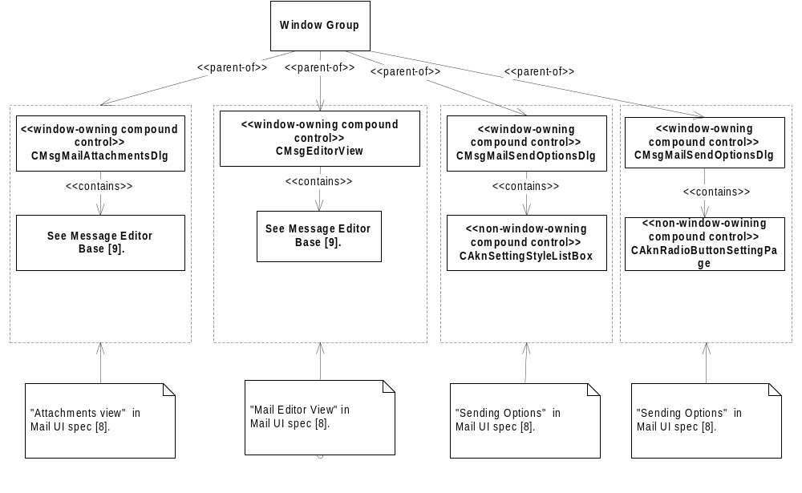
Figure 3.6 Mail editor control hierarchy
Figure 3.6 shows the control hierarchy of the Mail Editor application. The dashed boxes enclose the control hierarchies that implement the View in reference document [1]. The comments attached to the dashed boxes describe the corresponding View (or dialog) in the UI specification.
The main (and only) view of Mail Editor and Mail Viewer containing controls that display the message header and body are implemented in Message Editor Base (see reference document [2]).

Design
Figure 4.7 shows the different views in the Mail Editor and Mail Viewer applications. Both applications are launched from MCE (see top of the picture). The Mail Editor application can also be launched from Send UI, but this is not shown in the diagram. The user can navigate into the Sending options view or the Attachment view. Launching Phonebook is possible from both applications.
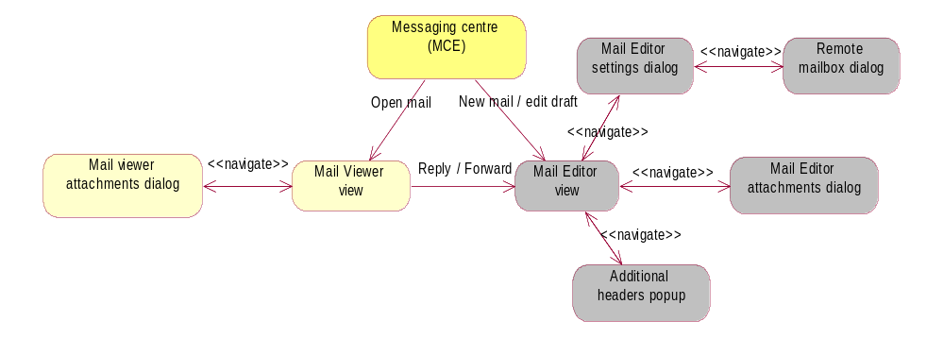
Figure 4.7 Mail Editor and Viewer views

Class diagrams

Framework
The metamodel of applications based on the Message Editor Base is shown below in Figure 4.8.
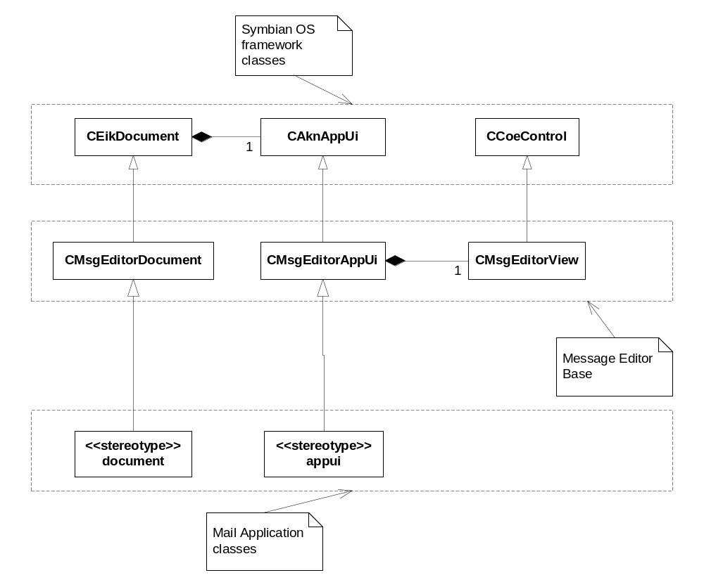
Figure 4.8 Metamodel definition

Component
The diagram of the most essential Message Editor classes is shown in Figure 4.9. The diagram of the Mail Viewer classes is similar.
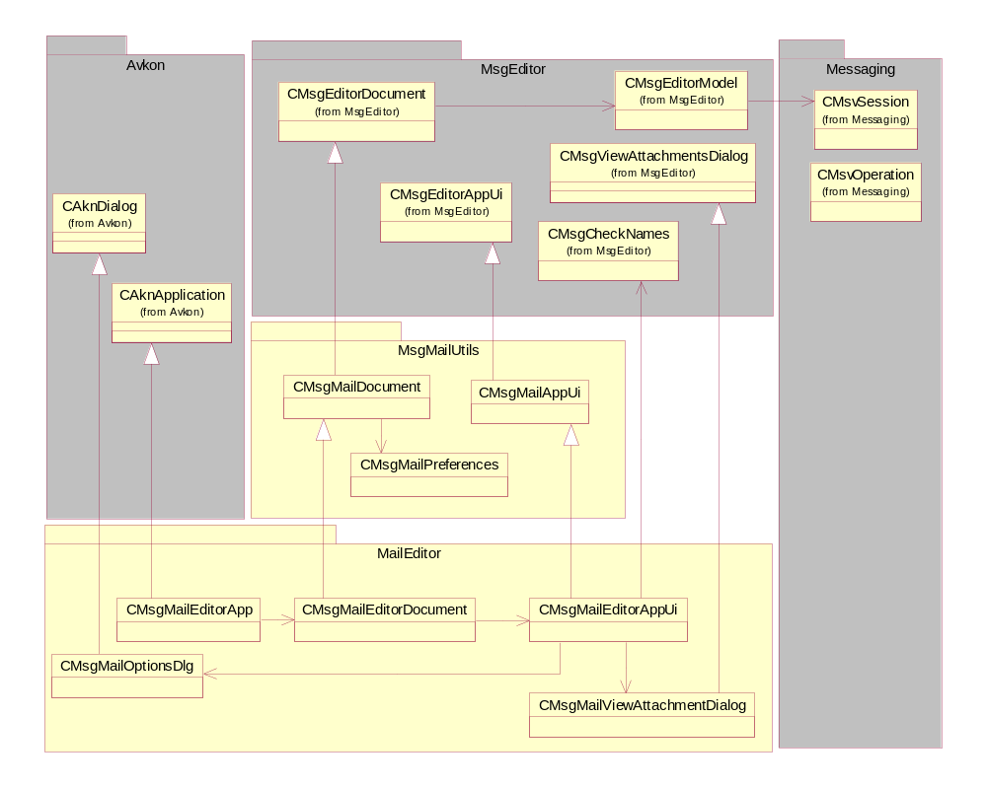
Figure 4.9 Message Editor classes
Instead of deriving directly from CMsgEditorDocument, Mail Editor and Mail Viewer Documents have a common base class, CMsgMailDocument. It contains the methods for accessing the header and body parts of the mail message in a convenient format. It also provides entry, session and MTM-level access to Message Server.
In Mail Editor, certain sending options (for example the option of which remote mailbox to use, whether to send a message immediately or upon the next connection, whether a copy of the sent message is also sent to the sender) are changeable on a per message basis. The CMsgMailPreferences class is used for storing the preferences; the CMsgMailOptionsDlg class is the UI used to view and change them.
For attachment handling, the class CMsgMailViewAttachmentsDlg is used in Mail Editor and CMsgMailViewerAttachmentsDlg in Mail Viewer. The classes contain a dialog where the user can add, remove, save or open attachments. The user can also fetch attachments from a remote mailbox. If attachment type is not recognized it can’t be saved or opened.

Class descriptions

MsgMailEditor
Class | Description | Header file
CMailEditorSettingList | Provides methods for Settings list.. | cmsgmaileditorsettinglist.h
CMsgAddMailHeadersDlg | Additional headers dialog. | CMsgAddMailHeadersDlg.h
CMsgAttachmentVerifier | Attachment verifier. | MsgAttachmentVerifier.h
CMsgMailBaseOp | Base class for state machine -based long-running operations | cmsgmailbaseop.h
CMsgMailEditorApp | Mail editor application | MsgMailEditorApp.h
CMsgMailEditorAppServer | Editor app server class. | MsgMailEditorAppServer.h
CMsgMailEditorAppUi | Mail editor application UI | MsgMailEditorAppUi.h
CMsgMailEditorDocument | Mail editor document | MsgMailEditorDocument
CMsgMailEditorEncodingSettingItem | Encoding setting item and setting page. | cmsgmailencodingsetting.h
CMsgMailEditorHeader | Mail editor header content handler | cmsgmaileditorheader.h
CMsgMailEditorPrioritySettingItem | Priority setting item and setting page. | cmsgmailprioritysetting.h
CMsgMailEditorRemoteMailboxSettingItem | Remote mailbox setting item and setting page. | CMsgMailEditorRemoteMailboxSetting.h
CMsgMailEditorReplyToSettingItem | Reply-to setting item and setting page. | cmsgmailreplytosetting.h
CMsgMailEditorShedulingSettingItem | Send sheduling setting item and setting page | cmsgmailshedulingsetting.h
CMsgMailFetchFileOp | Operation for fetching files as attachments | cmsgmailfetchfileop.h
CMsgMailLaunchOp | Operation for mail editor view launching | cmsgmaillaunchop.h
CMsgMailNameSearch | Phonebook name search. | MsgMailEditorNameSearch.h
CMsgMailNaviPaneUtils | Navi pane handling utilities. | cmsgmailnavipaneutils.h
CMsgMailOptionsDlg | Implements a dialog for view/edit sending options | MsgMailOptionsDlg. h
CMsgMailRestoreAttaOp | Operation for restoring sinle attachment | cmsgmailrestoreattaop.h
CMsgMailRestoreAttasOp | Operation for restoring message's attachments | cmsgmailrestoreattasop.h
CMsgMailRestoreAttMsgsOp | Operation for restoring attached messages | cmsgmailrestoreattmsgsop.h
CMsgMailRestoreSuperOp | Operation for restoring attachments and attached messages | cmsgmailrestoresuperop.h
CMsgMailSendOp | Operation for sending mail message | cmsgmailsendop.h
CMsgMailViewAttachmentsDlg | Attachment dialog. | MsgMailViewAttachmentsDlg.h
MMsgMailOpObserver | Observer interface for operations | cmsgmailbaseop.h
RMsgMailEditorSettingsArray | Internal setting array. | MsgMailEditorSettingsArray.h

MsgMailViewer
Class | Description | Header file
CMailBaseControlAdapter | Body control adapter. | CMailBaseControlAdapter.h
CMailForwardOperation | Operation for forwarding mail. | CMailForwardOperation.h
CMailViewManager | Manages mail viewer ECOM plug-in view components. | CMailViewManager.h
CMailWaitOperation | Wait operation for async operations. | CMailWaitOperation.h
CMsgMailCharacterSetHandler | Character set menu handler. | MsgMailCharacterSetHandler.h
CMsgMailViewerApp | Mail viewer application. | MsgMailViewerApp.h
CMsgMailViewerAppServer | Mail viewer application server. | MsgMailViewerAppServer.h
CMsgMailViewerAppUi | Mail viewer application UI. | MsgMailViewerAppUi.h
CMsgMailViewerAttachmentsDlg | Mail viewer attachment dialog. | MsgMailViewerAttachmentsDlg.h
CMsgMailViewerCharConv | Character converter. | MsgMailViewerCharConv.h
CMsgMailViewerContactCaller | Creates call for a given contact. | CMsgMailViewerContactCaller.h
CMsgMailViewerContactMatcher | Mail viewer contact finder. | CMsgMailViewerContactMatcher.h
CMsgMailViewerDocument | Mail viewer document. | MsgMailViewerDocument.h
CMsgMailViewerFindItemHandler | Handles CAknItemFinder and CFindItemMenu for mail viewer. | CMsgMailViewerFindItemHandler.h
CMsgMailViewerRemoveAttachmentOp | Attachment removing operation. | MsgMailViewerRemoveAttachment.h
CMsgMailViewerReplyToMatcher | Mail viewer reply to address matcher. | CMsgMailViewerReplyToMatcher.h
CMsgMailViewerVoIPExtension | Internal class to get count of VoIP profiles. | MsgMailViewerVoIPExtension.h
MMailAppUiInterface | App UI call-back API. | MMailAppUiInterface.h

MsgMailUtils
Class | Description | Header file
CMailCRHandler | Central Repository key handler. | CMailCRHandler.h
CMailMessage | Mail message data. | CMailMessage.h
CMsgMailAppUi | Base class for mail editor and viewer. | MsgMailAppUi.h
CMsgMailDocument | Base document for mail editor and viewer. | MsgMailDocument.h
CMsgMailPreferences | Mail settings. | MsgMailPreferences.h
MailLog | Logging utils. | MailLog.h
MailMessageUtils | Static helper methods related to CMailMessage. | mailmessageutils.h
MailUtils | Common static utilities. | MailUtils.h
MailViewFactory | Factory methods for creating mail view plugins. | CMailViewFactory.h
MsgMailDRMHandler | DRM utilities. | MsgMailDRMHandler.h
TAdditionalHeaderStatus | Internal status class for additional headers. | MsgMailPreferences.h

MsgPlainView
Class | Description | Header file
CLoadAttachedMessages | Attached messages loading state. | MailLoadStateMessageAttachment.h
CLoadAttachments | State for loading message attachments | CLoadAttachments.h
CLoadHtmlFile | HTML content loading state. | MailLoadStateHtml.h
CLoadInlineImages | HTML inline image loading state. | MailLoadStateInline.h
CLoadStateMachine | State machine for message loading. | MailLoadStateMachine.h
CLoadStateMachine | Async load state machine | MailLoadStateMachine.h
CMailMessagePlainView | Plain view plugin. | CMailMessagePlainView.h
CMsgMailViewerHtmlConv | HTML to plain text converter. | MsgMailViewerHtmlConv.h
MLoadState | State machine call back api | MMailState.h

Structs, type definitions and enumerations

CMailMessage.h Structs/Definitions/Enumerations
Struct/Definition/Enumeration's name | Description
TLoadState | Message loading states.
MessageFlags | Attributes of the active message

CMailCRHandler.h Structs/Definitions/Enumerations
Struct/Definition/Enumeration's name | Description
ERepository | Repository ids.

MailUtils.h Structs/Definitions/Enumerations
Struct/Definition/Enumeration's name | Description
TQueryState | Defines confirmation query parameters.

MsgMailAppUi.h Structs/Definitions/Enumerations
Struct/Definition/Enumeration's name | Description
TCommonFlags | Common state flags for editor and viewer UIs.

MsgMailPreferences.h Structs/Definitions/Enumerations
Struct/Definition/Enumeration's name | Description
EHeaderStatus | Additional header status flag.
TMsgMailScheduling | Message send-scheduling flag.

MsgMailCharacterSetHandler.h Structs/Definitions/Enumerations
Struct/Definition/Enumeration's name | Description
TData | Character set menu item data struct.

Flag definitions
Flag | Description
MAIL_ENABLE_LOGGING | Define this flag in the MailLogDef.h to enable logging. By default this is enabled in debug builds.
MAIL_LOG_TO_FILE | Define this flag in the MailLogDef.h to enable logging in the file. Notice that flag MAIL_ENABLE_LOGGING must be also set and folder c:\logs\email must be made. By default this is enabled in debug builds.

Operations
The operations of Mail Editor and Mail Viewer are described in the following subsections.

Mail editor operations

Launching the mail editor
Operation | Launch the mail editor
Preconditions
Description | User starts to create new mail message.
Inputs
Modifies | Mail message is created to the Drafts folder.
Outputs | New message entry is created to the Drafts folder and editor is opened.
Postconditions | Editor is opened and ready to edit draft message.
Related To | class CMsgMailEditorAppUi, class CMsgMailEditorDocument
Related Event | Creation of the instance of CMsgMailEditorApp by the application framework.
Exceptions | In case of OOM, an Error note is shown by the framework.

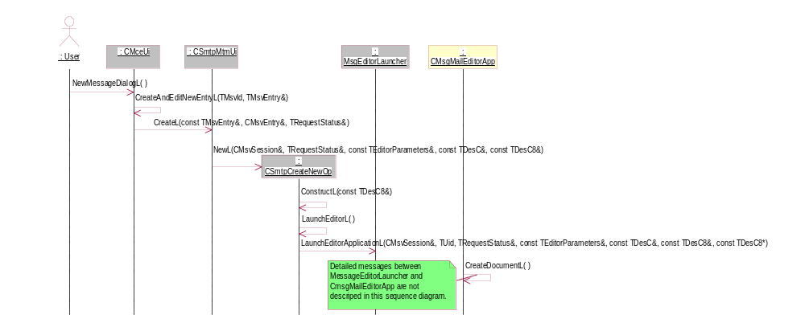
Figure 4.10 Launch the mail editor 1/2
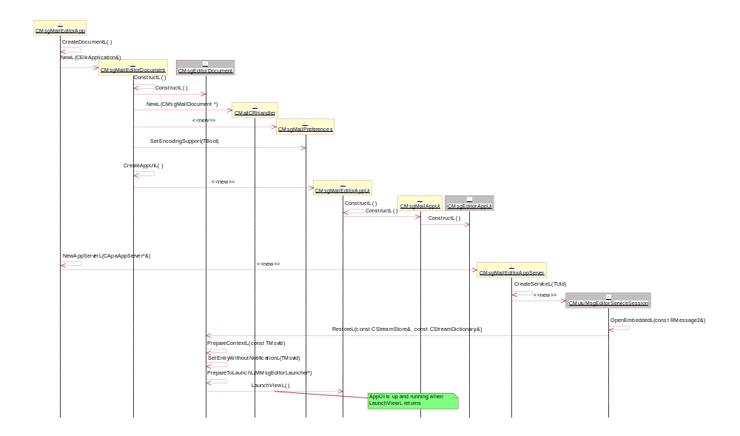
Figure 4.11 Launch the mail editor 2/2

Sending a message
Operation | Sending a message.
Preconditions | Mail editor has been successfully launched.
Description | Message is sent and mail editor is closed.
Inputs | The user selects Send from the Options menu in the main view or presses the Call creation key when message has at least one valid recipient.
Modifies | The message is saved to the Drafts folder (if there was unsaved data) and moved to the Outbox folder in Message Store.
Outputs | A Wait note with an animation is displayed.
Postconditions | Mail editor is closed. The system returns to the state in which the mail editor was launched. The message is in the Outbox folder.
Related To | class CMsgMailEditorAppUi, class CMsgMailEditorDocument, class CBaseMtmUi, class CBaseMtm
Related Event | None
Exceptions | In case of OOM, an Error note is shown by the framework.

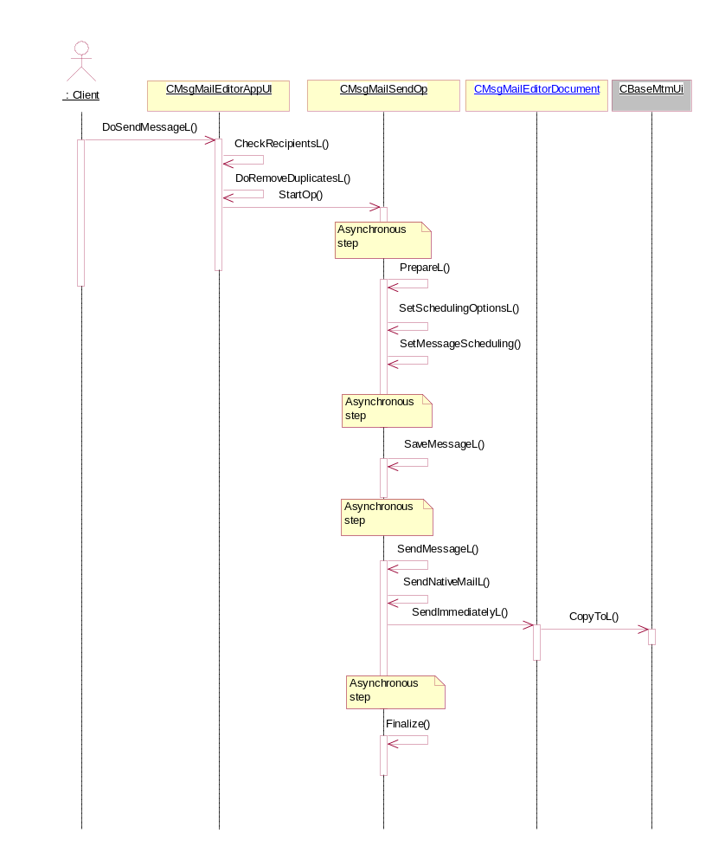
Figure 4.12 Sending a message

Saving a message
Operation | Saving a message.
Preconditions | Mail Editor has been successfully launched and there is message content to be saved in at least one of the fields, or alternatively an attachment.
Description | A message is saved in the Drafts folder and Mail Editor is closed.
Inputs
Modifies | The Drafts folder content.
Outputs | A Wait note with an animation is displayed.
Postconditions | The Mail Editor application is closed and the system returns to the state in which Mail Editor was launched. The message is saved in the Drafts folder.
Related To | class CMsgMailEditorAppUi, class CMsgMailEditorDocument
Related Event
Exceptions | In case of OOM, an Error note is shown by the framework.

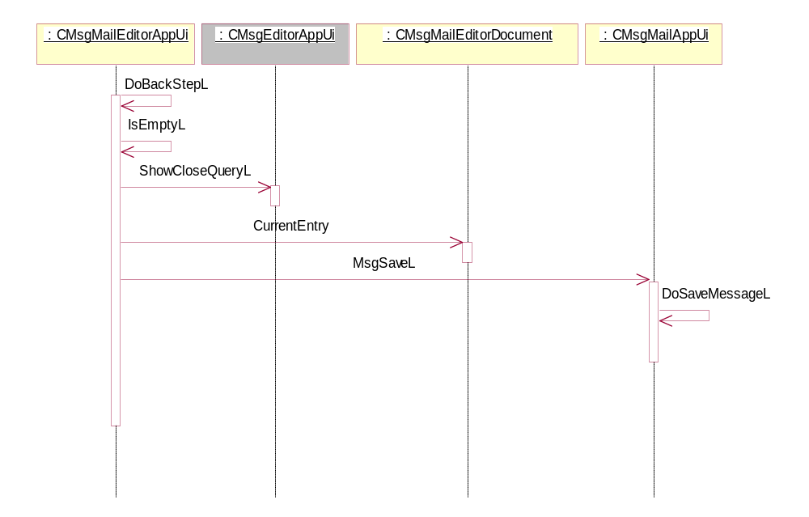
Figure 4.13 Saving a message

Deleting a message
Operation | Deleting a message.
Preconditions | Mail Editor has been successfully launched.
Description | A message is deleted and Mail Editor is closed.
Inputs
Modifies | The Drafts folder content.
Outputs | A Confirmation query is shown in Mail Editor.
Postconditions | Mail Editor is closed. The system returns to the state in which Mail Editor was launched. The message is deleted.
Related To | class CMsgMailEditorAppUi, class CMsgMailEditorDocument, class CBaseMtmUi, class CBaseMtm
Related Event
Exceptions | In case of OOM, an Error note is shown by the framework.

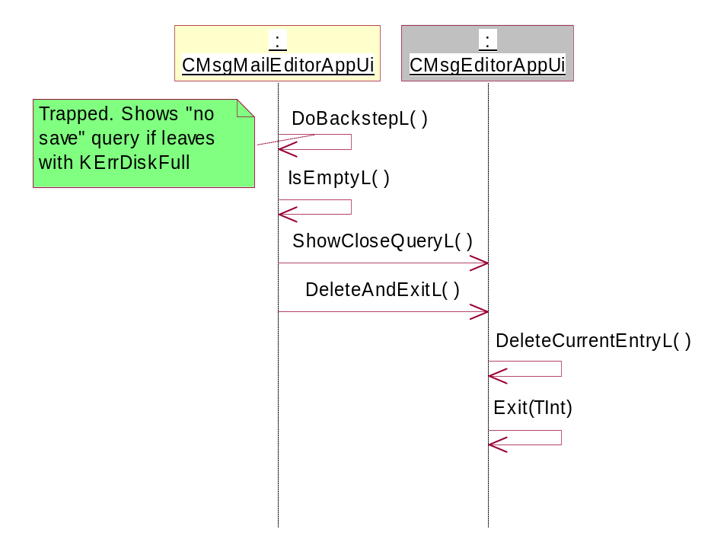
Figure 4.14 Deleting a message

Open Send options dialog
Operation | Open send options dialog.
Preconditions | Mail Editor has been successfully launched.
Description | Opens send options dialog.
Inputs | User selections.
Modifies | Class CMsgMailPreferences
Outputs | Settings are stored to mail message.
Postconditions | Mail Editor is closed. The system returns to the state in which Mail Editor was launched. The message is deleted.
Related To | class CMsgMailEditorAppUi, class CMsgMailEditorDocument, class CMsgMailPreferences
Related Event
Exceptions | In case of OOM, an Error note is shown by the framework.

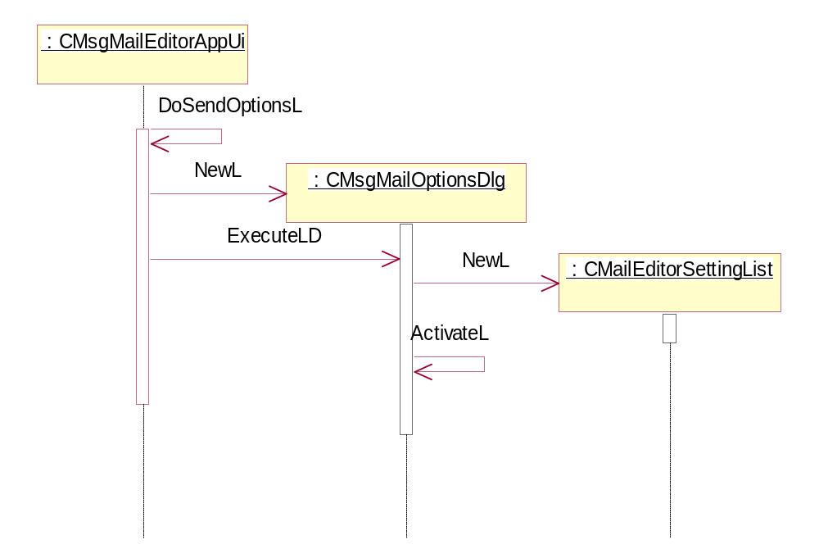
Figure 4.15 Open send options dialog

Adding an attachment
Operation | Adding an attachment.
Preconditions | Mail editor is running and there is some file to be added.
Description | Inserts an attachment to edited mail message.
Inputs | User selections.
Modifies | Class CImMailMessage
Outputs | A confirmation note to the user.
Postconditions | Selected attachment is added to the mail message.
Related To | class CMsgMailEditorAppUi, class CMsgMailEditorDocument, class MMsvAttachmentManager, class CImEmailMessage, class CMsgAttachmentModel
Related Event
Exceptions | In case of OOM, an Error note is shown by the framework.

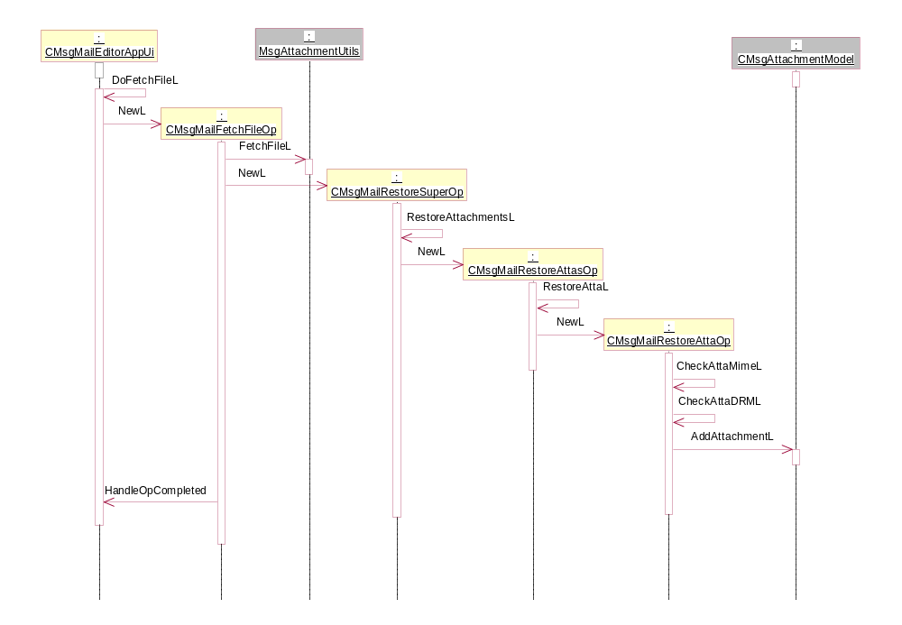
Figure 4.16 Adding an attachment

Removing an attachment
Operation | Removing an attachment.
Preconditions | Mail editor is running and there is some attachment added.
Description | Removes attachment from edited mail message.
Inputs | User selections.
Modifies | Class CImMailMessage
Outputs | A confirmation note to the user.
Postconditions | Selected attachment is removed from the mail message.
Related To | class CMsgMailEditorAppUi, class CMsgMailEditorDocument, class MMsvAttachmentManager, class CImEmailMessage, class CMsgAttachmentModel
Related Event
Exceptions | In case of OOM, an Error note is shown by the framework.

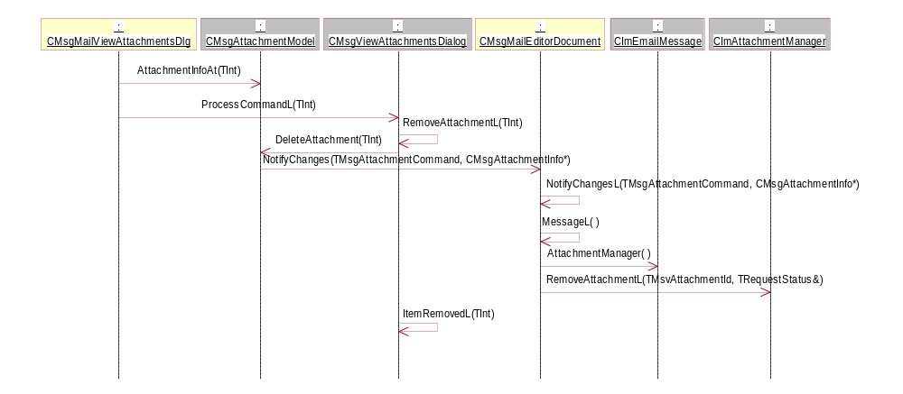
Figure 4.17 Removing an attachment

Adding a recipient
Operation | Adding a recipient.
Preconditions | Mail editor has been launched and phonebook contains some entries with email addresses.
Description | Add recipient from phonebook. If recipient address is not valid email address operation is cancelled [InvalidAddress].
Inputs | User selections.
Modifies | Class CMsgRecipientItem, class CMsgAddressControl
Outputs | Selected recipients are added to address control.
Postconditions | Recipient is added to mail message.
Related To | class CMsgMailEditorAppUi, class CPbkMultipleEntryFetchDlg, class CPbkContactItem
Related Event
Exceptions | [InvalidAddress], Invalid address note.  In case of OOM, an Error note is shown by the framework.

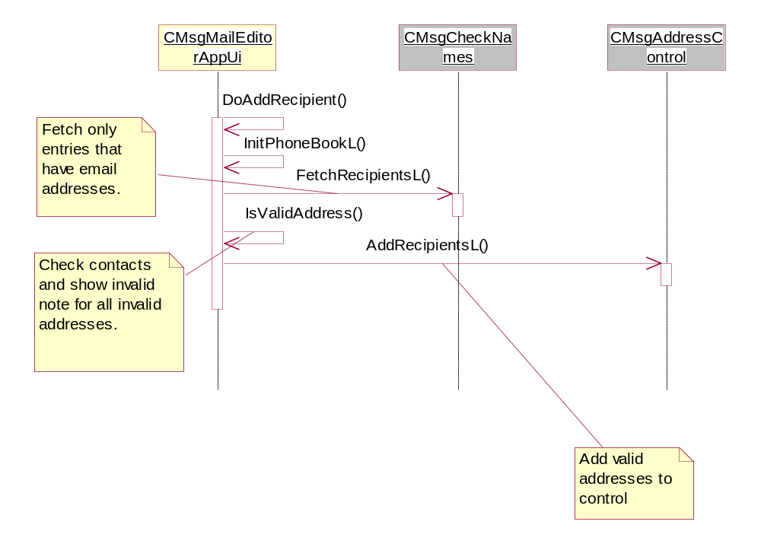
Figure 4.18 Adding a recipient

Check names
Operation | Check names.
Preconditions | Mail editor has been launched and alias name is written to address field.
Description | Search recipient addresses from phonebook by alias name. If found recipient address is not valid, check names operation is cancelled [InvalidAddress].
Inputs | User selections.
Modifies | Class CMsgRecipientItem, class CMsgAddressControl
Outputs | Found recipients addresses are added to address control.
Postconditions | Recipient is added to mail message.
Related To | class CMsgMailEditorAppUi, class CMsgMailNameSearch
Related Event
Exceptions | [InvalidAddress], Invalid address note.  In case of OOM, an Error note is shown by the framework.

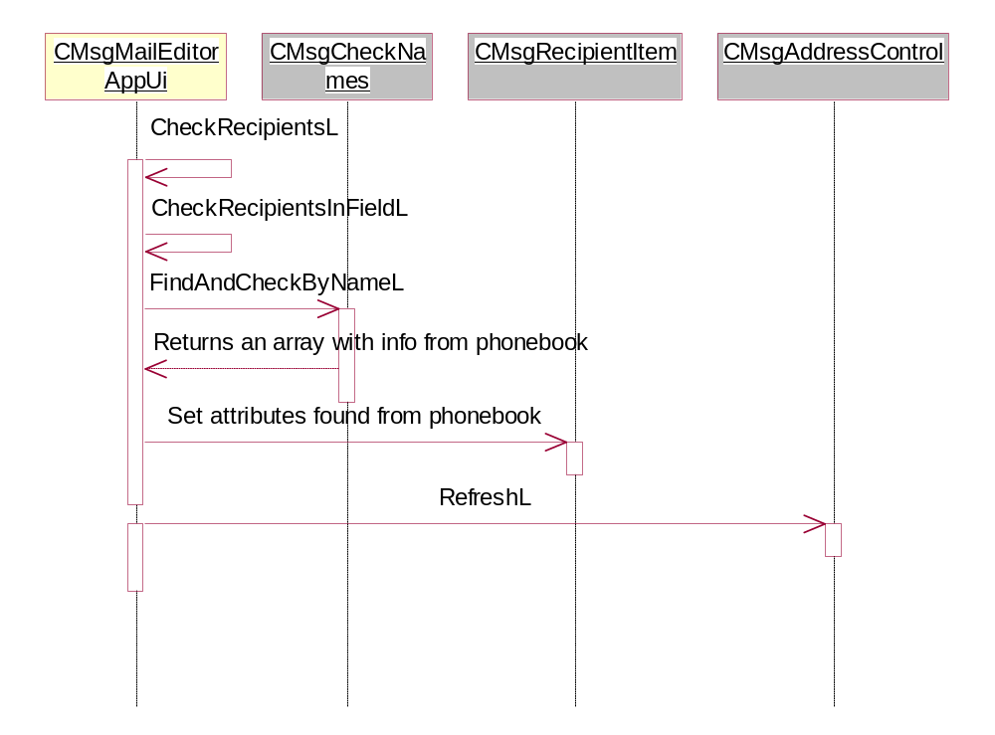
Figure 4.19 Check names

Mail viewer operations

Open a message
Operation | Open a message (IMAP).
Preconditions | Mail message is successfully received from the server.
Description | Opens a message.
Inputs | User selections.
Modifies
Outputs
Postconditions | The mail viewer is launched.
Related To | class CMsgMailViewerAppUi, class CMsgMailViewerDocument, class CBaseMtmUi, class CBaseMtm
Related Event
Exceptions | In case of OOM, an Error note is shown by the framework.

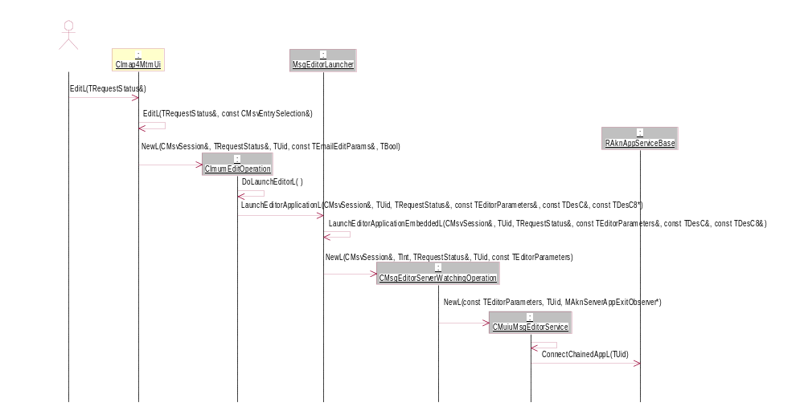
Figure 4.20 Open a message 1/2
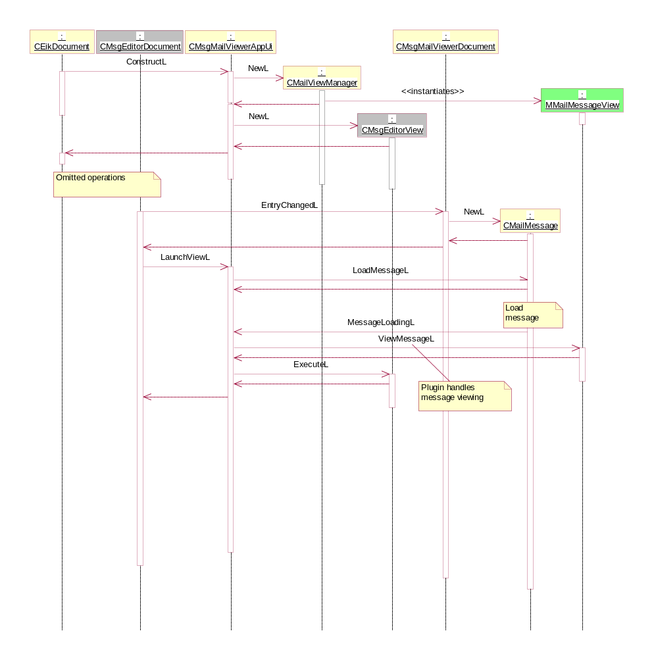
Figure 4.21 Open a message 2/2

Copy a message
Operation | Copying a message.
Preconditions | Mail viewer has been successfully launched to view remote entry.
Description | Copies a message from server to local folder.
Inputs | User selections.
Modifies | Class CImEmailMessage
Outputs | Message is copied to selected local folder.
Postconditions | The message is copied and mail viewer has been closed.
Related To | class CMsgMailViewerAppUi, class CMsgMailViewerDocument, class CBaseMtmUi, class CBaseMtm
Related Event | None
Exceptions | In case of OOM, an Error note is shown by the framework.
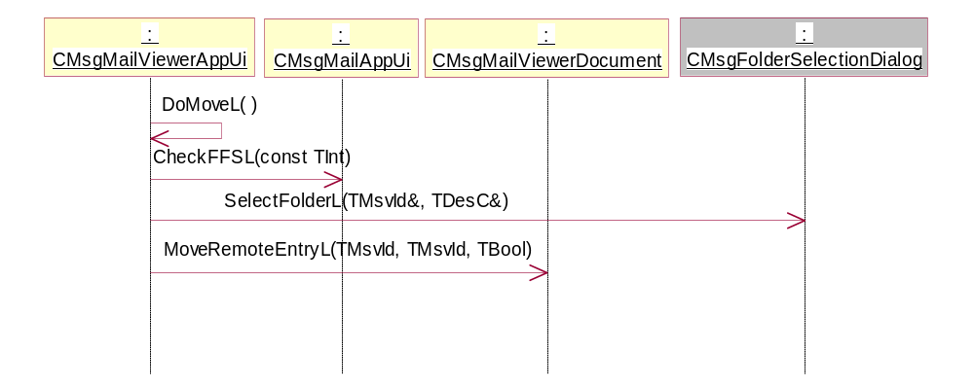
Figure 4.22 Copying a message

Moving a message
Operation | Moving a message.
Preconditions | Mail viewer has been successfully launched to view local entry.
Description | Moves message to another folder.
Inputs | User selections.
Modifies | Class CImEmailMessage
Outputs | Message is moved to new location.
Postconditions | The message is moved and mail viewer has been closed.
Related To | class CMsgMailViewerAppUi, class CMsgMailViewerDocument, class CBaseMtmUi, class CBaseMtm
Related Event
Exceptions | In case of OOM, an Error note is shown by the framework.

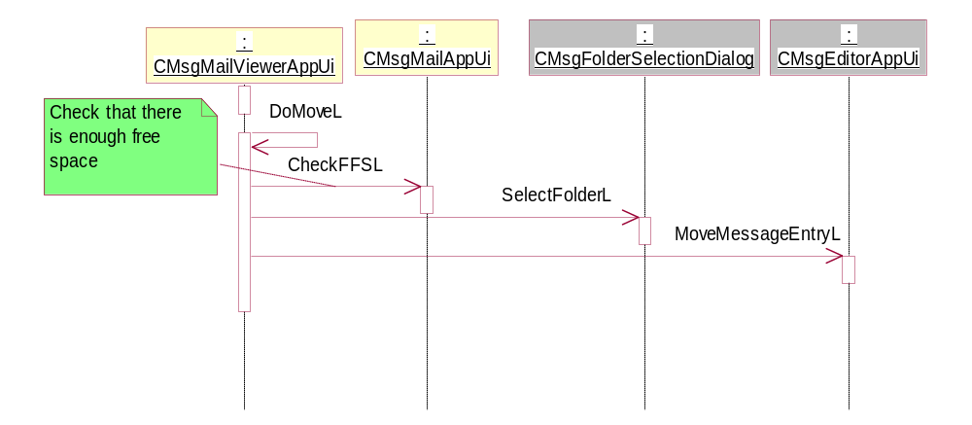
Figure 4.23 Moving a message

Forwarding a message
Operation | Forwarding a message.
Preconditions | Mail viewer has been successfully launched.
Description | Forwards a mail message
Inputs | User selections.
Modifies | Class CImEmailMessage
Outputs | Mail editor is opened with forward message.
Postconditions | The message is forwarded and mail editor and viewer are closed.
Related To | class CMsgMailViewerAppUi, class CMsgMailEditorAppUi, class CBaseMtmUi, class CBaseMtm
Related Event
Exceptions | In case of OOM, an Error note is shown by the framework.

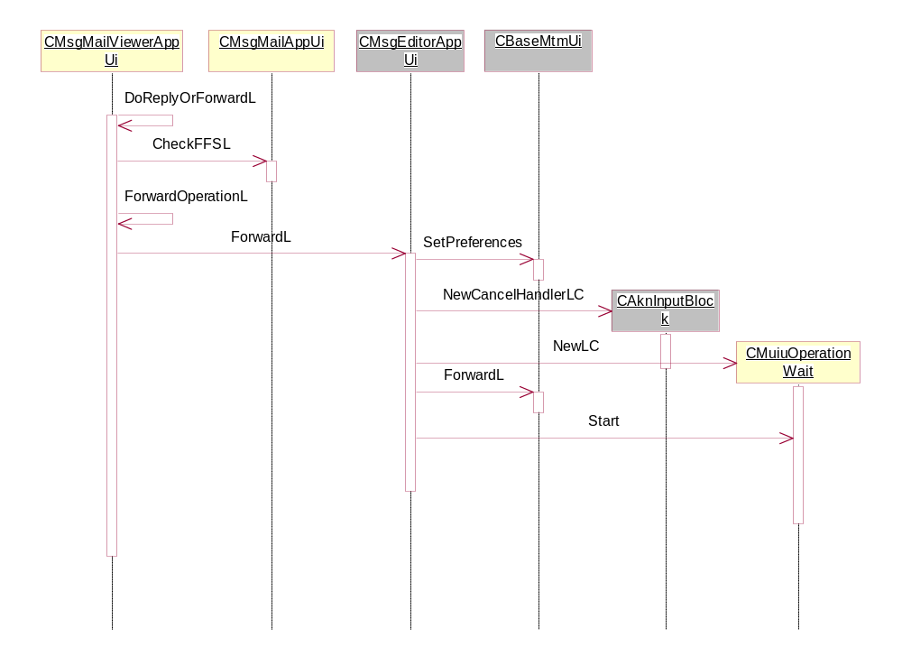
Figure 4.24 Forwarding a message

Replying to a message
Operation | Replying to a message.
Preconditions | Mail viewer has been successfully launched.
Description | Creates reply message.
Inputs | User selections.
Modifies | Class CImEmailMessage
Outputs | Mail editor is opened with reply message.
Postconditions | The message is replied and mail editor and viewer are closed.
Related To | class CMsgMailViewerAppUi, class CMsgMailViewerDocument, class CBaseMtmUi, class CBaseMtm
Related Event
Exceptions | In case of OOM, an Error note is shown by the framework.

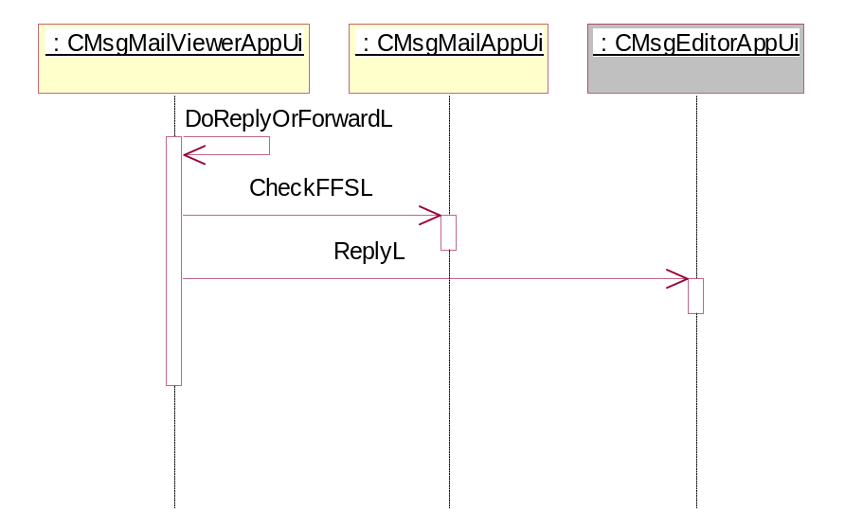
Figure 4.25 Replying to a message

Replying via message
Operation | Replying via message.
Preconditions | Mail viewer has been successfully launched. Device supports MMS / Audio messages
Description | Creates reply message of selected type.
Inputs | User selections.
Modifies | Creates new draft message of selected type
Outputs | Selected editor is opened.
Postconditions | Message is replied and mail viewer is closed.
Related To | class CMsgMailViewerAppUi, class CMsgMailViewerDocument, class CSendUI, class CMessageData
Related Event
Exceptions | In case of OOM, an Error note is shown by the framework.

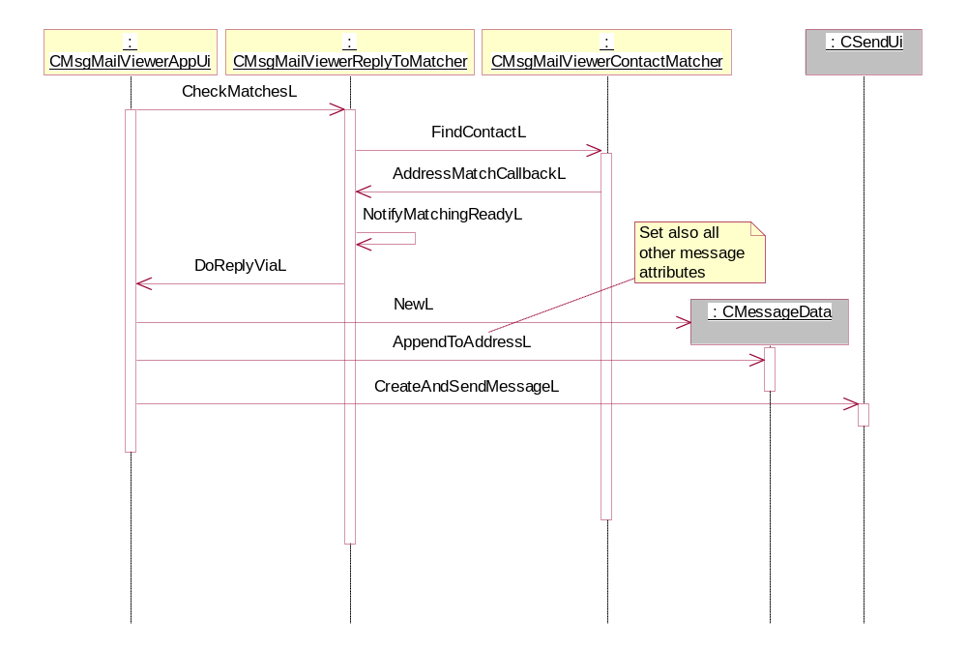
Figure 4.26 Replying via message

Opening a message attachment
Operation | Opening a message attachment.
Preconditions | Mail viewer has been launched and attachment view is opened.
Description | Opens the selected attached mail message.
Inputs | User selections.
Modifies
Outputs | Opens the attached message in the mail viewer.
Postconditions | The mail viewer application shows the attachment.
Related To | class CMsgMailViewerAttachmentsDlg, class CMsgMailViewerDocument, class CBaseMtmUi
Related Event
Exceptions | In case of OOM, an Error note is shown by the framework.

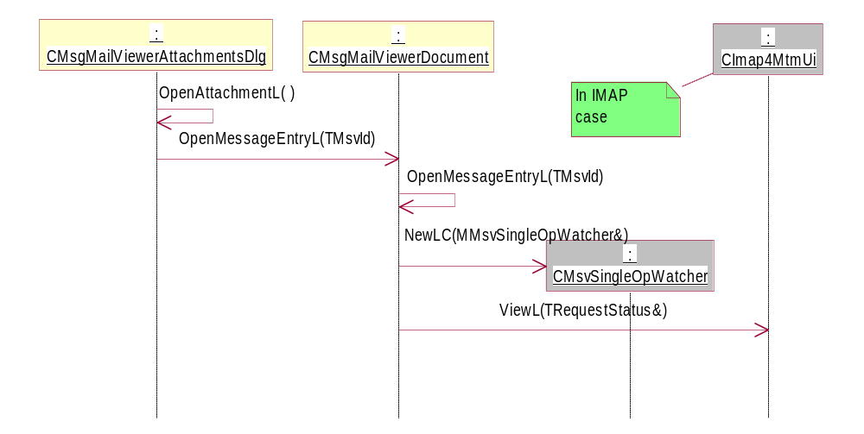
Figure 4.27 Opening a message attachment

Opening an attachment
Operation | Opening an attachment.
Preconditions | Mail viewer has been launched and attachment view is opened.
Description | Opens the selected attachment file.
Inputs | User selections.
Modifies
Outputs | Opens the attachment in the appropriate application.
Postconditions | The appropriate application shows the attachment.
Related To | class CMsgMailViewerAttachmentsDlg, class RApaLsSession
Related Event
Exceptions | In case of OOM, an Error note is shown by the framework.

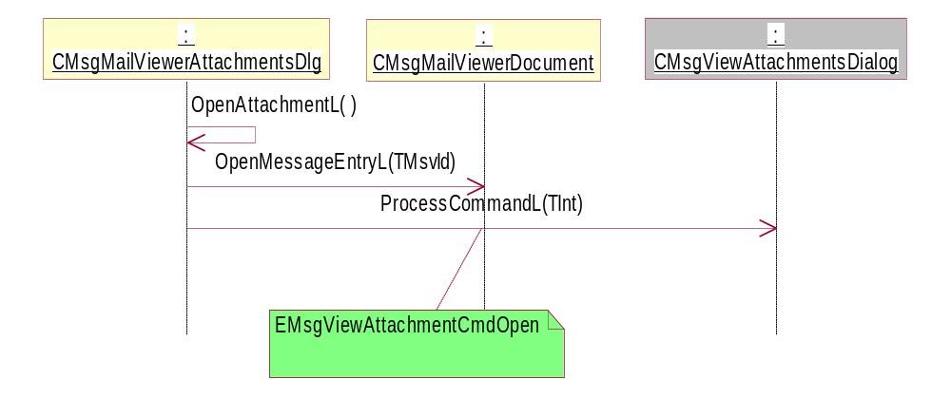
Figure 4.28 Opening an attachment

MHTML conversion
Operation | MHTML conversion.
Preconditions | Mail viewer has been launched and MHTML message is opened.
Description | Opens the selected MHTML message.
Inputs | User selections.
Modifies
Outputs | Plain text representation of a MHTML message.
Postconditions | The message content is shown to the user.
Related To | class CMsgMailViewerAppUi, class CMailMessagePlainView, class CMsgMailViewerHtmlConv, class CLoadStateMachine, class CLoadHtmlFile, class CLoadInlineImages, class CLoadAttachedMessages
Related Event
Exceptions | In case of OOM, an Error note is shown by the framework.

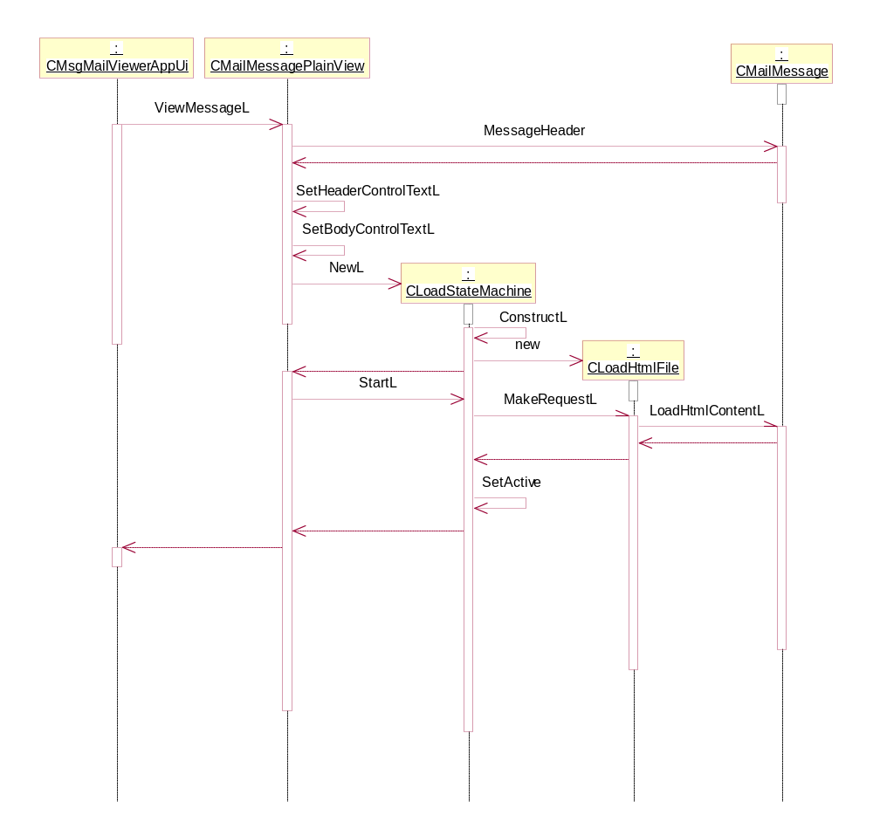
Figure 4.29 MHTML conversion start
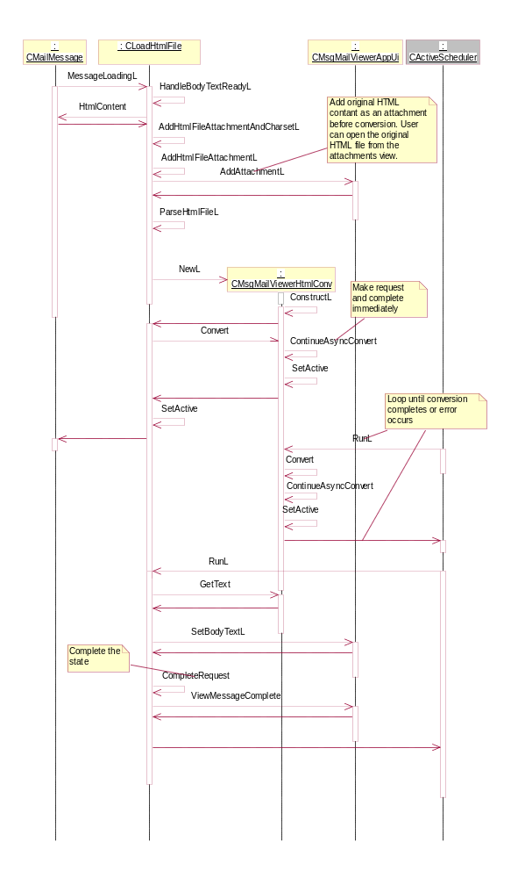
Figure 4.30 MHTML conversion

Matching Sender Address for Call
Operation | Matching sender address to phonebook.
Preconditions | Mail viewer has been launched.
Description | Matches sender’s mail address with phonebook. If contact with this mail address is found from phonebook matcher fetches phonenumber(s) for that contact.
Inputs | User selections.
Modifies
Outputs | Phonenumber of matching contact.
Postconditions | Found phonenumber is received and phonecall is generated.
Related To | class CMsgMailViewerAppUi, class CMsgMailViewerContactMatcher
Related Event
Exceptions | In case of OOM, an Error note is shown by the framework.

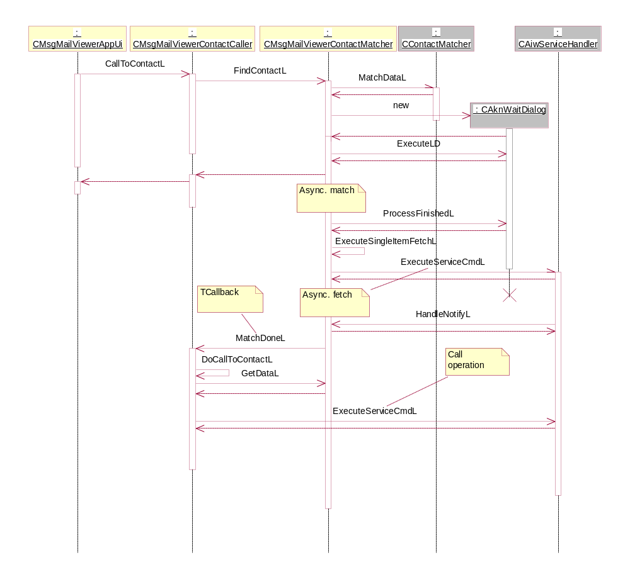
Figure 4.31 Matching sender address

Backup and Restore
Mail owns Central Repository data that is under backup/restore.
- Filename and path: private\10202be9\101F8850.txt
- Passive backup method.

Variation
Mail UI uses following variation techniques:
- Compile time variation
- Image creation time variation
- Run time variation

Compile time variation
Flag | Description
__VOIP | VOIP extensions are compiled to mail viewer.
__MEETING_REQUEST_SUPPORT | Meeting request view plugin is compiled

Image creation time variation
Flag | Description
__EMAIL_UI | Mail UI is taken into ROM
__MEETING_REQUEST_SUPPORT | Meeting request view plugin is taken in ROM
__FF_S60_HELPS_IN_USE | S60 Mail UI help content is taken in ROM

Runtime variation
Flag | Description
KCRUidMail | Run time variation flags for mail UI.
KCRUidMuiuVariation | MUIU Run time variation flags.
KFeatureIdHelp | Help visibility in UI
KFeatureIdDrmFull | Affects DRM notifications in UI
KFeatureIdChinese | Determine the available character sets in UI
KFeatureIdJapanese | Determine the available character sets in UI

System resource usage

Files
This component does not use any files. The Mail Editor and Mail Viewer applications use the Symbian OS stream storage facility when handling messages. The applications do not use any actual files but access the messages in the store via the MTM services.

Other data

Databases
This component does not use any databases.

Central Repository
This component uses Central Repository for storing internal status information and Local variation flags. Internal status information is stored when taking device backup. See Section 4.6.

Publish and Subscribe
This component does not use Publish and Subscribe.

Memory consumption
Memory/Build | Consumption
WINSCW UDeb | 3500 Kb
ARMV5 URel | 83500 bytes

When handling large messages and/or large attachments, an unusually high demand for heap storage may arise. Also during the MHTML conversion heap, storage is used to have a temporary copy of the message. Memory consumption is linearly dependent on the message size.

Task allocation
The application runs in the thread in which the application was launched.

Performance
No performance optimization.

Timers
This component does not use timers.

Security

Capabilities of this component

Mail editor application
Capability | Justification
CAP_APPLICATION | Common application capabilities.
NetworkControl | For creating calls

Mail viewer application
Capability | Justification
CAP_APPLICATION | Common application capabilities.
NetworkControl | For creating calls via find item.

Mail utils dll
Capability | Justification
CAP_GENERAL_DLL | General dll capabilities.

MailPlainView ECOM plugin
Capability | Justification
CAP_ECOM_PLUGIN | General ECOM plugin capabilities.

Input and output validation
This component does not require or make any validation for data.

Environmental assumptions
This component does not make any assumptions about its environment.

Additional enforcements
This component does not have any additional security enforcements.

Exception handling
The leave mechanism of the Symbian OS environment is used to handle memory exhaustion. The panic mechanism is used only in debug builds.

Usage

Building
On the command line type:
- cd \sf\app\messaging\email\mail\group
- bldmake bldfiles
- abld build

This builds binaries for all default platforms.

User's guide
This application is not used directly by other subsystems. Some subsystems launch the Mail application, but this is done via Send UI (see reference document [3] for details). Message Centre launches Mail using the appropriate MTM UI.

