S60 3.x
AlmAlert Component
Design Document

Team name | Author
S60 PIM | Aki Lempinen

Change history:

Version | Date | Status | Comments
4.0 | 22.08.2006 | Approved | Document updated for S60 3.x releases.
3.0 | 15.03.2004 | Approved | Updates after major code redesign/restructuring
2.0 | 01.10.2003 | Approved | Minor changes to document layout
1.0 | 28.04.2003 | Approved

Table of contents:

1. Document control 4
1.1 References 4
1.2 Documentation conventions 4
1.3 Abbreviations 4
1.4 Definitions 4
2. General 5
2.1 Introduction 5
2.2 Subsystem environment 5
2.3 Services required 5
2.3.1 From the Symbian OS subsystems 5
2.3.2 From the Domestic OS subsystems 5
2.3.3 From HW 5
2.4 Services provided 6
2.4.1 UI 6
2.4.2 SW IF 6
3. UI control hierarchy 7
3.1 Framework 7
3.2 Subsystem 7
4. Design 8
4.1 Class diagrams 8
4.1.1 Subsystem 8
4.2 State handling in CAlmAlarmControl 9
4.2.1 States 9
4.2.2 Signals 9
4.2.3 State machine 10
4.3 Class descriptions 10
4.3.1 CAlmAlarmControl 11
4.3.2 CAlmAlarmPlayer 11
4.3.3 CAlmAlarmInfo 11
4.4 Operations 12
4.4.1 Initializing AlmAlert 12
4.4.2 Showing the alarm Confirmation query 13
4.4.3 Playing the alarm tone 13
4.4.4 Hiding the alarm Confirmation query with auto-snooze 14
4.4.5 Pressing the Power key 15
4.4.6 Pressing the End key 16
4.4.7 Pressing the Stop softkey 17
4.4.8 Pressing the Snooze softkey 17
5. System resource usage 19
5.1 Files 19
5.2 Databases 19
5.3 Memory consumption 19
5.4 Task allocation 19
5.5 Timers 19
6. Exception handling 20
6.1 Leave in AlmAlert 20
7. Usage 21
7.1 User's guide 21

Document control

References
- S60 Calendar Application Design Document
- S60 Clock Application Design Document
- Symbian OS System Documentation | www.symbian.com

Documentation conventions
Code is shown with the Courier New font.

Abbreviations
AlmAlert | Alarm UI module
CalenSvr | Calendar Server

Definitions
AVKON | UIKON extended GUI.
CONE | Control Environment, graphical UI framework for Symbian OS.
EikServer | Provides the basic service in UIKON.
Media Server | The Multimedia subsystem's Media Server provides audio recording and playback and image related functionality.
UIKON | GUI library for Symbian OS.

General

Introduction
The AlmAlert subsystem of the S60 software is an alarm UI module. AlmAlert is responsible for handling alarm notifications coming from Symbian Alarm Server through UIKON.

Subsystem environment
The key relationships between the AlmAlert module and the components in its environment are shown in Figure 2.1.
AlmAlert consists of two DLLs: AlmAlert and AknAlarmService. The original AlmAlert DLL was split into two parts because EikSrv (or the EikAlert DLL) did not have capabilities to load the AlmAlert DLL. Now the AlmAlert DLL is a lightweight proxy between EikSrv and the actual AlmAlert implementation part inside the AknAlarmService DLL.
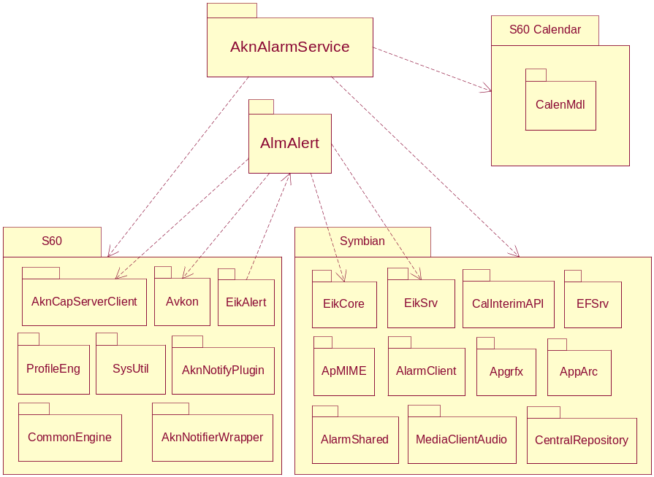
Figure 2.1 Subsystem environment

Services required

From the Symbian OS subsystems
Services of the Symbian OS infrastructure (including audio, UIKON, EikServer, CONE and timer service), AVKON and Common Engine are required.

From the Domestic OS subsystems
AlmAlert does not have any direct interfaces to the Domestic OS side subsystems.

From HW
This component has no direct HW interfaces.

Services provided

UI
The main user interface of this module is specified in reference documents [1] and [2].

SW IF
This module provides services only for the EikAlert subsystems.

UI control hierarchy

Framework
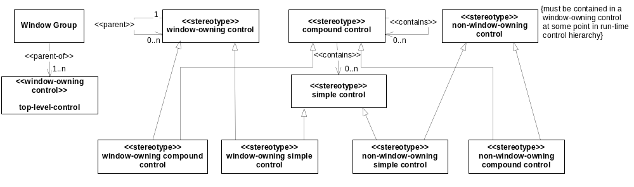
Figure 3.2 Control metamodel

Subsystem
AlmAlert does not do any drawing because the UI is provided by AVKON Global Notes. AlmAlert only has one simple control for capturing key events.
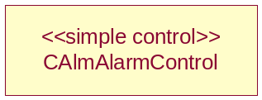
Figure 3.3 AlmAlert control hierarchy

Design

Class diagrams

Subsystem
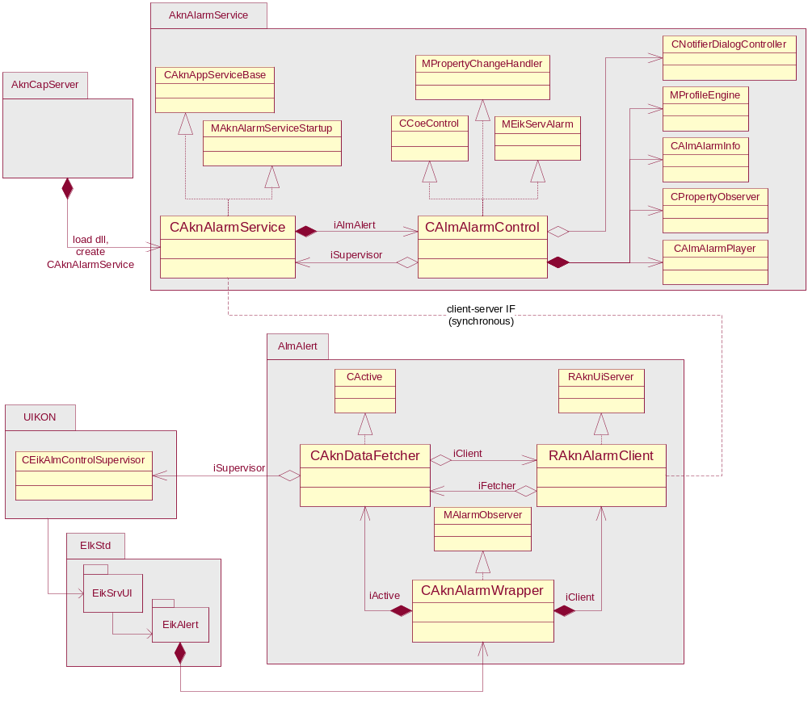
Figure 4.4 AlmAlert subsystem
Figure 4.4 shows the AlmAlert subsystem. CAlmAlarmControl is the main part of AlmAlert.
CAlmAlarmControl is called from EikServer through MAlarmObserver. CAlmAlarmControl notifies its state to Alarm Server through CEikAlmControlSupervisor. CEikAlmControlSupervisor is defined in EIKALSUP.h. See reference document [3] for details.
CAlmAlarmPlayer encapsulates the Media Server APIs.
CAlmAlarmInfo is used to fetch information (time, subject and location) for the current alarm.

State handling in CAlmAlarmControl

States
State | Description
EStateIdle | No pending actions.
EStateWaitingShowRequest | Alarm information acquired. Waiting for a request to show the alarm.
EStateWaitingDisplayRequest | Alarm is ready and an AVKON note is requested. Waiting for the AVKON notification.
EStateWaitingInput | Waiting for user input. Auto-snooze timer is running.
EStateBeforeAskingWakeup | Used to allow AskWakeupPhoneL() to cancel the dialog (see CAlmAlarmControl::CancelDialog()).  This state is only for transition between EStateWaitingInput and EStateAskingWakeup.
EStateAskingWakeup | Only for Clock alarms and when the phone is off or in the Charging state. If the user selects Stop, the startup query is shown.
EStateAfterInput | The alarm has been handled. Waiting for HideAlarm() or UpdateAlarmInfo().

Signals
All the signals come from CEikAlmControlSupervisor via CAknAlarmWrapper and CAknAlarmService.

Signal | Description
UpdateAlarmInfo() | Initialization (data) for the new alarm.
ShowAlarm() | Request to show the alarm notification.
HideAlarm() | Request to hide the alarm notification.
DisplayDialog() | Alarm notification dialog ready.
CancelDialog() | Alarm notification dialog was cancelled.
NoteCompleted() | Alarm notification dialog closed by the user.
KSysHideAlarm | Request to stop alarm and hide the notification dialog.
[Auto-snooze] | Auto-snooze timer expiration.

State machine
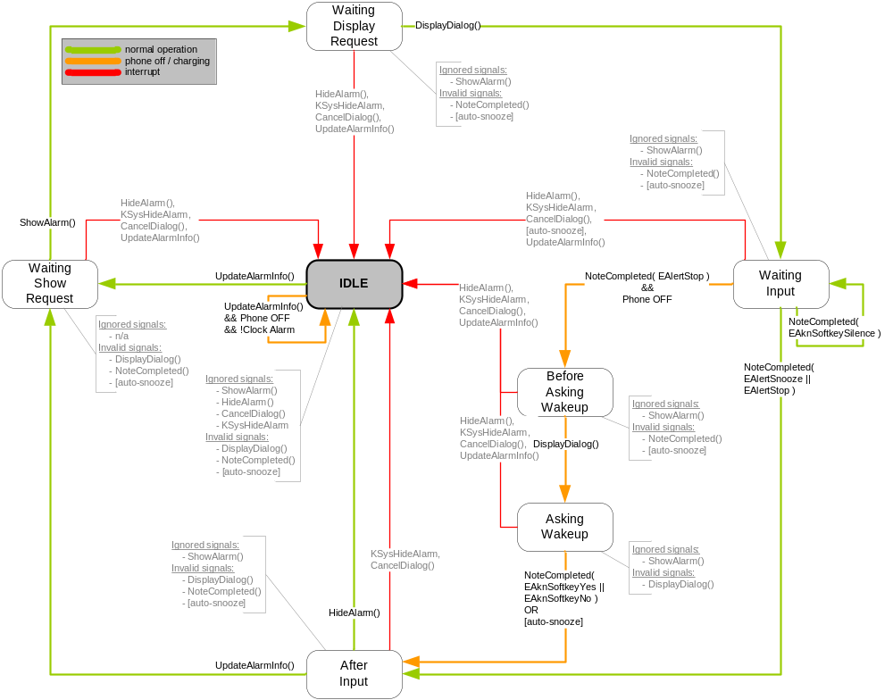
Figure 4.5 State machine

Class descriptions
Class | Description | Header file
CAlmAlarmControl | Handles all the key events. Requests AVKON to display the Alarm note. Stops or snoozes an alarm. Implements UIKON’s MEikServAlarm I/F and the Alarm UI state machine shown in Figure 4.5. | AlmAlarmControl.h
MEikServAlarm | The alarm I/F. | eiksvfty.h
CAlmAlarmPlayer | Plays the alarm tone using CMdaAudioToneUtility and CMdaAudioPlayerUtility. | AlmAlarmPlayer.h
CAlmAlarmInfo | Fetches alarm information according to the alarm category and creates the appropriate strings to display. | AlmAlarmInfo.h
CPropertyObserver + MPropertyChangeHandler | An observer and I/F class to observe Publish and Subscribe key changes. | PropertyObserver.h
CAknAlarmService | The application server implementation derived from CAknAppServiceBase.  Works as a proxy together with RAknAlarmClient and CAknAlarmWrapper between EikAlert and CAlmAlarmControl.  The AknAlarmService DLL is loaded and CAknAlarmService is created by AknCapServer when RAknAlarmClient open a connection to CAknAlarmService. | AlarmService.h
RAknAlarmClient | Client side for service support for CAknAlarmService. | AlarmWrapper.h
CAknDataFetched | An active object used as a callback channel from CAknAlarmService for stop and snooze operations. Always active after a connection to CAknAlarmService has bee formed. | AlarmWrapper.h
CAknAlarmWrapper | This is the MAlarmObserver I/F implementation instantiated and used directly by EIkAlert.  Owns both RAknAlarmClient and CAknDataFetched. | AlarmWrapper.h

CAlmAlarmControl
CAlmAlarmControl | A class that contains most of the Alarm UI functionality.
CAlmAlarmControl() | A constructor.
~CAlmAlarmControl() | A destructor.
CProfileAPI* ProfileAPI() const | This returns CProfileAPI. CProfileAPI is used by CAlmAlarmPlayer for setting the volume.

CAlmAlarmPlayer
CAlmAlarmPlayer | Encapsulates CMdaAudioToneUitility.
static CAlmAlarmPlayer* NewL(const CAlmAlarmControl* aAlmAlert) | A Symbian OS constructor. The parameter aAlmAlert refers to CAlmAlarmControl for the profile API.
~CAlmAlarmPlayer() | A destructor.

CAlmAlarmInfo
CAlmAlarmInfo | A compound control for label and icons.
CAlmAlarmInfo() | A constructor.
~CAlmAlarmInfo() | A destructor.
void ConstructL() | A Symbian OS constructor.
void GetAlarmLabelL(const TASShdAlarm &aAlarm, HBufC *&aText, const TAlarmType &aAlarmType, CNotifierDialogController &aNotifierDialogController) | Sets aText and aTime for the Confirmation query. aAlarm is the alarm information.
void GetWakeupLabelL(HBufC*& aLabel) | Sets aLabel.

Operations

Initializing AlmAlert
Operation | Initializing AlmAlert.
Preconditions | The user has started the phone (or the phone is starting itself to show a Clock alarm).
Description | After the phone has been started using the services provided by the Symbian OS environment, AlmAlert is initialized by calling the DLL entry point NewAlarm() during the Symbian OS startup.
Inputs
Modifies | Creates an instance of CAknAlarmWrapper.
Outputs
Postconditions | CAknAlarmWrapper and all the required classes have been successfully created. CAknAlarmWrapper is ready to accept alarm requests.
Related To | The classes CEikServAppUi and CEikAlarmControl, the AlmAlert module’s NewAlarm(), the class CAknAlarmWrapper.
Related Event | Creation of an instance of CAknAlarmWrapper by the Alarm Server initialization.
Exceptions

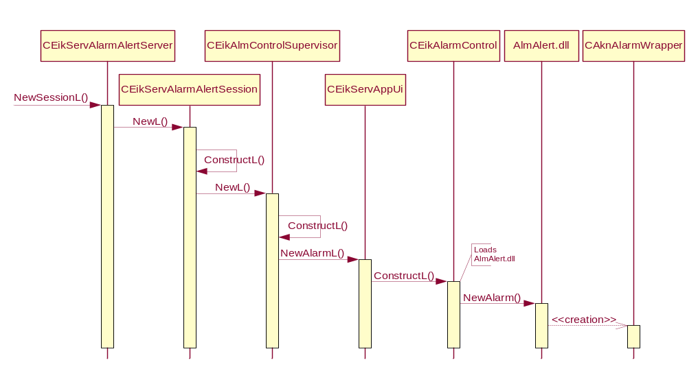
Figure 4.6 Initializing AlmAlert

Showing the alarm Confirmation query
Operation | Showing the alarm Confirmation query.
Preconditions | A Clock alarm has expired. CAlmAlarmControl has been notified about the alarm (UpdateAlarmInfo()).
Description | The alarm Confirmation query is shown. If the user lets the alarm continue until the auto-snooze timeout, CAlmAlarmControl snoozes the alarm. Alarms can be snoozed only five times. The sixth alarm can only be stopped.
Inputs
Modifies | The alarm Confirmation query is shown.
Outputs
Postconditions | The alarm Confirmation query is shown. The auto-snooze timer is activated.
Related To | EikServer, the classes CPeriodic, CAlmAlarmControl and CNotifierDialogControl.
Related Event | The phone’s backlight flashes, key lock is opened.
Exceptions

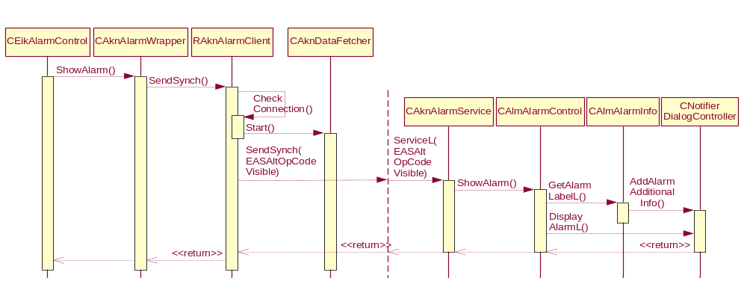
Figure 4.7 Showing the alarm notification

Playing the alarm tone
Operation | Playing the alarm tone.
Preconditions | The alarm Confirmation query is shown.
Description | When the alarm Confirmation query is shown, CAlmAlarmPlayer is created.
Inputs
Modifies
Outputs
Postconditions | The alarm sound is played.
Related To | EikServer, Media Server, the classes CAlmAlarmControl, CAlmAlarmPlayer, CProfileAPI, CmdaAudioPlayerUtility, CMMFMdaAudioPlayerUtility and CMMFMdaAudioPlayerCallback.
Related Event
Exceptions

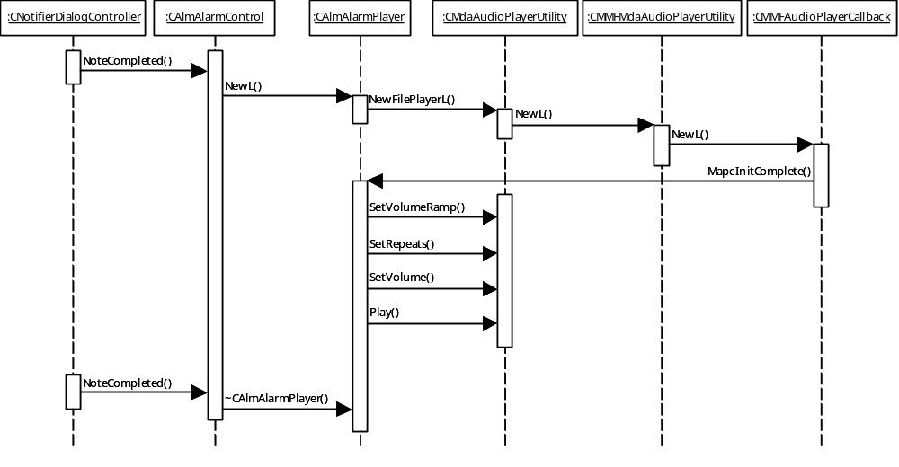
Figure 4.8 Playing the alarm tone

Hiding the alarm Confirmation query with auto-snooze
Operation | Hiding the alarm Confirmation query with auto-snooze.
Preconditions | The alarm Confirmation query is displayed.
Description | The alarm Confirmation query is hidden.
Inputs
Modifies | The alarm Confirmation query is hidden when the auto-snooze time expires.
Outputs
Postconditions | If the user lets the alarm continue until the auto-snooze timer expires, the alarm is snoozed automatically and the alarm notification is hidden.
Related To | EikServer, the classes CPeriodic, CAlmAlarmControl, CEikAlmControlSuperVisor, CNotifierDialogController and RWindowGroup.
Related Event | The phone’s backlight flashes. A timeout from CPeriodic.
Exceptions

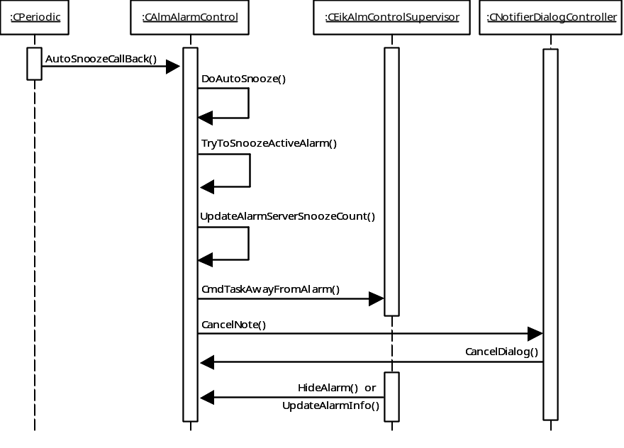
Figure 4.9 Hiding the alarm Confirmation query with auto-snooze

Pressing the Power key
Operation | Pressing the Power key.
Preconditions | The alarm Confirmation query is shown.
Description | If the Power key is pressed, the alarm Confirmation query is hidden. Unlike other keys, the Power key is handled using Publish and Subscribe.
Inputs | The Power key is pressed.
Modifies | The alarm is stopped. The alarm notification is hidden.
Outputs
Postconditions | If the user lets the alarm continue until the auto-snooze timer expires, the alarm is snoozed and the alarm notification is hidden.
Related To | EikServer, the classes CPeriodic, CAlmAlarmControl, CAknAlarmService and CPropertyObserver.
Related Event
Exceptions

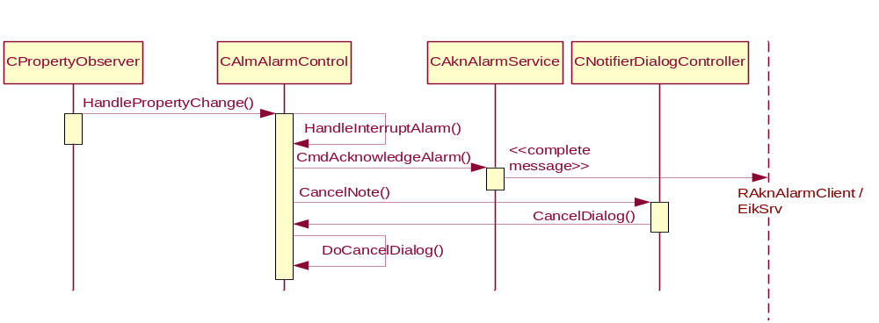
Figure 4.10 Pressing the Power key

Pressing the End key
Operation | Pressing the End key.
Preconditions | The alarm Confirmation query is shown.
Description | Pressing the End key causes the AVKON Global Notes system to cancel all dialogs. The alarm is snoozed and the notification is hidden.
Inputs | The End key is pressed.
Modifies | The alarm is snoozed. The alarm notification is hidden.
Outputs
Postconditions | If the user lets the alarm continue until the auto-snooze timer expires, the alarm is snoozed and the alarm notification is hidden.
Related To | EikServer, the classes CPeriodic, CAlmAlarmControl, CAknAlarmService and CNotifierDialogController.
Related Event | After calling CAknAlarmService::CmdTaskAwayFromAlarm(), CAlmAlarmControl is called to hide the alarm.
Exceptions

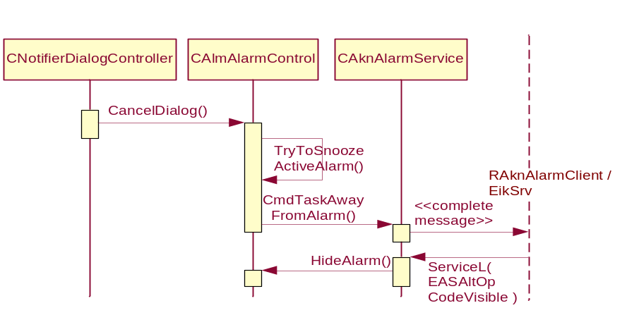
Figure 4.11 Pressing the End key

Pressing the Stop softkey
Operation | Pressing the Stop softkey.
Preconditions | The alarm Confirmation query is shown.
Description | If the Stop softkey is pressed, the alarm Confirmation query is hidden.
Inputs | The Stop softkey is pressed.
Modifies | The alarm Confirmation query is hidden.
Outputs
Postconditions | The alarm Confirmation query is hidden.
Related To | The classes CAlmAlarmControl, RSharedDataClient and CEikAlmControlSupervisor.
Related Event | After calling CAknAlarmService::CmdAcknowledgeAlarm(), CAlmAlarmControl is called for hiding the alarm Confirmation query.
Exceptions

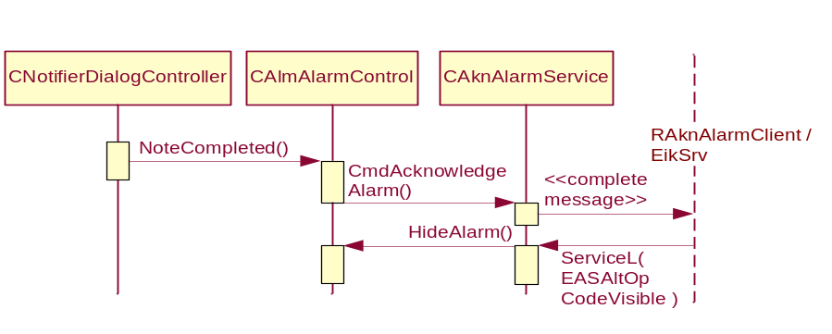
Figure 4.12 Pressing the Stop softkey

Pressing the Snooze softkey
Operation | Pressing the Snooze softkey.
Preconditions | The alarm Confirmation query is shown.
Description | If the Snooze softkey is pressed, the alarm Confirmation query is hidden.
Inputs | The Snooze softkey is pressed.
Modifies | A snoozed alarm is created. The alarm Confirmation query is hidden.
Outputs
Postconditions | If the user lets the alarm continue until the auto-snooze, a snoozed alarm is created. The alarm Confirmation query is hidden.
Related To | EikServer, the classes CPeriodic, CAlmAlarmControl, CEikAlmControlSuperVisor and RSharedDataClient.
Related Event | After calling CAknAlarmControl::CmdAcknowledgeAlarm(), CAlmAlarmControl is called for hiding the alarm Confirmation query.
Exceptions

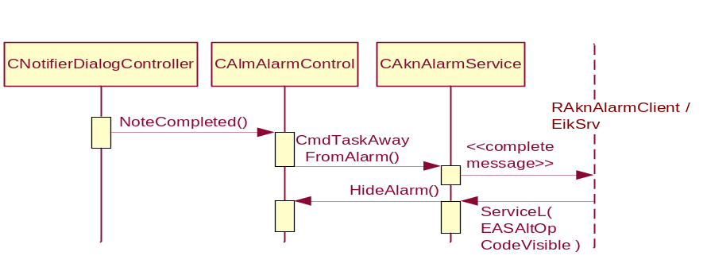
Figure 4.13 Pressing the Snooze softkey

System resource usage

Files
This component does not use any files.

Databases
This software does not use any databases.

Memory consumption
Memory consumption has been taken into consideration and kept to minimum in the implementation of this sub-module.

Task allocation
This software runs in the same thread with AknCapServer.

Timers
Alarm UI uses two CPeriodic timers. The first timer is used to auto-hide and snooze an alarm if the user does not respond to the alarm within 60 seconds. The second timer is used to ignore any key presses just before showing the alarm notification.

Exception handling
The leave mechanism of the Symbian OS environment is used to handle memory exhaustion.

Leave in AlmAlert
In AlmAlert, almost none of the methods are capable of leaving due to the fact that AlmAlert’s interface does not provide the necessary L functions. The only function that may leave is CAlmAlarmControl::ConstructL().
However, when any of the non-leaving AlmAlert functions are called, AlmAlert TRAPs any functions that it calls that have the possibility of leaving. This occurs in the following functions:
- In CAlmAlarmControl::PlayAlarmSound(), CAlmAlarmPlayer::NewL() is called.
- In CAlmAlarmControl::TryToSnoozeActiveAlarm().
- In CAlmAlarmControl::AskWakeupPhone().
- In CAlmAlarmControl::ShowAlarm().
- In CAlmAlarmControl::UpdateAlarmInfo().
- In CAlmAlarmInfo::FetchCalendarEntryL().
- In CAlmAlarmPlayer::GetToneSettings().
- In CAlmAlarmPlayer::GetProfileSettings().
- In CAlmAlarmPlayer::MatoPrepareComplete().
- In CAlmAlarmPlayer::MapcInitComplete().

However, these codes seldom leave in low memory situations.

Usage

User's guide
EikServer uses this software.

