S60 3.x
Versit2 / AgnVersit2
Design Document

Team name | Author
S60 Apps PIM Contacts & Organiser | Charles McKenna

Change history:

Version | Date | Status | Comments
1.0 | 01.08.2006 | Approved

Table of contents:

1. Document control 5
1.1 References 5
1.2 Documentation conventions 5
1.3 Abbreviations 5
1.4 Definitions 5
2. General 6
2.1 Introduction 6
2.2 iCalendar objects 6
2.2.1 iCalendar syntax 6
2.2.2 Example iCalendar object 7
2.2.3 iCalendar object 7
2.2.4 iCalendar components 7
2.3 Component environment 8
2.4 Use cases 8
2.4.1 Import iCalendar data 9
2.4.2 Export iCalendar data 9
2.5 Services required 9
2.5.1 From the Symbian OS subsystems 9
2.5.2 From the Domestic OS subsystems 10
2.5.3 From HW 10
2.6 Services provided 10
2.6.1 UI 10
2.6.2 SW IF 10
3. UI control hierarchy 11
4. Versit2 design overview 12
4.1 Versit2 class diagram 12
4.2 Versit2 class descriptions 13
4.3 Versit2 structs, type definitions and enumerations 13
4.3.1 ICalRuleSegment.h enumerations 13
4.3.2 ICalValue.h enumerations 14
4.3.3 ICalBase.h enumerations 14
4.3.4 ICalErrors.h 14
4.4 Versit2 class reference 14
4.4.1 CICalParser 14
4.4.2 CICalContentLineReader 14
4.4.3 CICalBase 14
4.4.4 CICal 15
4.4.5 CICalComponent 15
4.4.6 CICalProperty 15
4.4.7 CICalPropertyParam 15
4.4.8 CICalValue 16
4.4.9 CICalRuleSegment 16
4.5 Versit2 state diagram 17
4.6 Importing iCalendar objects 17
4.6.1 Construction and internalization 17
4.7 Exporting iCalendar objects 19
4.8 iTip validation 20
4.9 Backup and Restore 20
5. AgnVersit2 design overview 21
5.1 AgnVersit2 class diagram 21
5.2 AgnVersit2 structs, type definitions and enumerations 22
5.2.1 AgnVersit2Strings.hrh enumerations 22
5.2.2 AgnImportObserver.h enumerations 22
5.2.3 AgnExportObserver.h enumerations 22
5.2.4 AgnExternalInterface.h enumerations 22
6. iCalendar to Agenda Model data mapping 23
6.1 iCalendar 23
6.1.1 Properties 23
6.1.2 ICalendar components 23
6.2 VEVENT 23
6.2.1 Properties 23
6.3 VALARM 24
6.3.1 Properties 24
6.4 VTIMEZONE 25
6.4.1 Properties 25
6.5 VTODO 26
6.6 VFREEBUSY 26
6.7 VJOURNAL 26
6.8 RRULE 26
6.9 Compatibility issues 27
7. Importing and exporting with AgnVersit2 28
7.1 Creation of CAgnVersit2 28
7.2 Use of CAgnICal 28
7.3 CAgnVersit2::ImportL 28
7.4 CAgnICal::ExportL 29
7.5 MAgnImportObserver::AgnImportError 30
8. Variation 31
9. System resource usage 32
9.1 Files 32
9.2 Other data 32
9.2.1 Databases 32
9.2.2 Central Repository 32
9.2.3 Publish and Subscribe 32
9.3 Memory consumption 32
10. Security 33
10.1 Capabilities of this component 33
10.2 Input and output validation 33
10.3 Environmental assumptions 33
10.4 Additional enforcements 33
11. Exception handling 34
12. Usage 35
12.1 Building the release 35
12.2 Build order 35
12.3 Importing to agenda 35
12.4 Exporting from CCalEntry objects 36

Document control

References
- RFC 2445: Internet Calendaring and Scheduling Core Object Specification | http://www.ietf.org/rfc/rfc2445.txt
- RFC 2446: iCalendar Transport-Independent Interoperability Protocol (iTIP) Scheduling Events, BusyTime, To-dos and Journal Entries | http://www.ietf.org/rfc/rfc2446.txt

Documentation conventions
Code is shown with the Courier New font.

Abbreviations
iTIP | iCalendar Transport Independent Interoperability Protocol

Definitions
Versit2 | A DLL that provides parsing support for importing and exporting iCalendar components.
AgnVersit2 | An ECom plug-in that converts between the intermediate format used by Versit2 and Symbian OS Calendar (Agenda) entries.
iCalendar | A specification for holding and transferring calendaring information as defined in reference document [1]. iCalendar is also known as vCalendar 2.0.
CRLF | A Carriage Return character (US-ASCII decimal 13) followed by a Line Feed character (US-ASCII decimal 10).
Property | A known tag defining the type of property. In practical terms, the part of a content line before the first colon or semicolon.
Property parameter | A known tag that specifies an extra detail about the property. In practical terms, the part of a content line between a semicolon and an equals sign (or between two semicolons if the parameter has no associated value).
Property parameter value | The value of the property parameter, its type is determined by the property parameter. In practical terms, the part of a content line between an equals sign following a property parameter and the next colon or semicolon.
Property value | The value of the property, its type is determined by the property. In practical terms, the part of the content line after the colon.
Content line | A complete property line, which may be folded across several individual lines.
Line folding | Escaping a line break to spread a content line over multiple physical lines.
CalInterimAPI | Interim API to Symbian OS Agenda model.

General

Introduction
This document represents the detailed design for the iCalendar parsing components: Versit2 and AgnVersit2.
The Versit2 component converts between iCalendar information as specified in reference document [1] and an (intermediate) object-oriented database structure as defined in Section 4.1. The classes defining this intermediate structure are also responsible for converting themselves both to and from the iCalendar format and so encapsulate both the data storage and the conversion algorithms. Versit2 is delivered as a standalone DLL.
The AgnVersit2 component provides conversion between the intermediate database structure created by Versit2 and the interim Symbian OS Agenda API CalInterimAPI. AgnVersit2 is delivered as an ECom plug-in.
Imported and exported data can also be validated against reference document [2].

iCalendar objects
The iCalendar format is used to exchange calendar and scheduling information. The full specification is defined in reference document [1].

iCalendar syntax
An iCalendar object consists of a number of content lines delimited by a line break (CRLF). Each line of an iCalendar can be no more than 75 octets in length (note that Microsoft Outlook is known to break this limit.), but a content line may be folded over multiple lines by inserting a single white space character immediately following the line break. Folded lines must be unfolded before they can be parsed.
A content line can be described in terms of properties, property parameters, and property values. Each content line begins with a property, followed by either a colon (‘:’) or semicolon (‘;’) character. The value for the property appears after the final colon character in the content line. Multiple values are allowed and are separated by the comma (‘,’) character.
Property parameters can appear in between a property and its associated value. Property parameters consist of a name and an optional value, separated by an equals sign (‘=’). Again, multiple values are allowed and are separated by a comma (‘,’) character. Property parameters with values containing a colon, a semicolon, or a comma character must be placed in quoted text.
The syntax of a content line is shown below, where brackets (‘[‘, ‘]’) indicate optional elements and asterisks (‘*’) indicate elements that may be repeated. Note that in reality this line may be folded over multiple physical lines.

Property[;Property Parameter[=Property Parameter Value[,Property Parameter Value]*]]*:Property Value[,Property Value]*

Note that it is possible to escape “special” characters such as colons and semicolons in a property parameter by enclosing the parameter in double quotes (‘"’); double quotes themselves are not legal characters in a parameter. It is also possible to escape commas and semicolons in a parameter value by using the backslash character (‘\’). This character is also used to escape itself and line breaks through the “\n” sequence.

Example iCalendar object
Below is an example of a simple iCalendar object exported from Microsoft Outlook. DTSTART and DTEND have property parameters specified and UID is folded.

BEGIN:VCALENDAR
PRODID:-//Microsoft Corporation//Outlook 9.0 MIMEDIR//EN
VERSION:2.0
METHOD:PUBLISH
BEGIN:VEVENT
ORGANIZER:MAILTO:Pat.Nicholls@emccsoft.com
DTSTART;VALUE=DATE:20050217
DTEND;VALUE=DATE:20050218
TRANSP:TRANSPARENT
SEQUENCE:0
UID:040000008200E00074C5B7101A82E0080000000020B634CF1215C5010000000000000000100
00000E0585571B8773845A95058C5D112EC2B
DTSTAMP:20050217T170458Z
SUMMARY:Example iCalendar
PRIORITY:5
CLASS:PUBLIC
END:VEVENT
END:VCALENDAR

iCalendar object
The start and end of an iCalendar object are delimited by the following strings:

BEGIN:VCALENDAR
END:VCALENDAR

Furthermore, as defined by reference document [1], the VERSION property of the iCalendar must have the value 2.0.
Note also that an iCalendar file may contain multiple iCalendar objects.

iCalendar components
Within an iCalendar object, iCalendar components are delimited by the following strings:

BEGIN:<Component Type>
END:<Component Type>

where <Component Type> is one of the following component types:

VEVENT
VTODO
VJOURNAL
VALARM
VFREEBUSY
VTIMEZONE
DAYLIGHT
STANDARD

An iCalendar object may contain multiple components. In addition, components may be nested: for example, a VEVENT or VTODO may contain a nested VALARM. DAYLIGHT and STANDARD are always subcomponents of a VTIMEZONE component.
The component type specified in the END: delimiter must always match the component type of the previous BEGIN: delimiter in a valid iCalendar object.

Component environment
The relationships between the iCalendar parsing components Versit2 and AgnVersit2 and the key Symbian OS components are shown in Figure 2.1. The implementation does not have any dependency to any AVKON components. Dependencies to the Symbian File Server (RFs), and BAFL libraries are omitted from the figure.
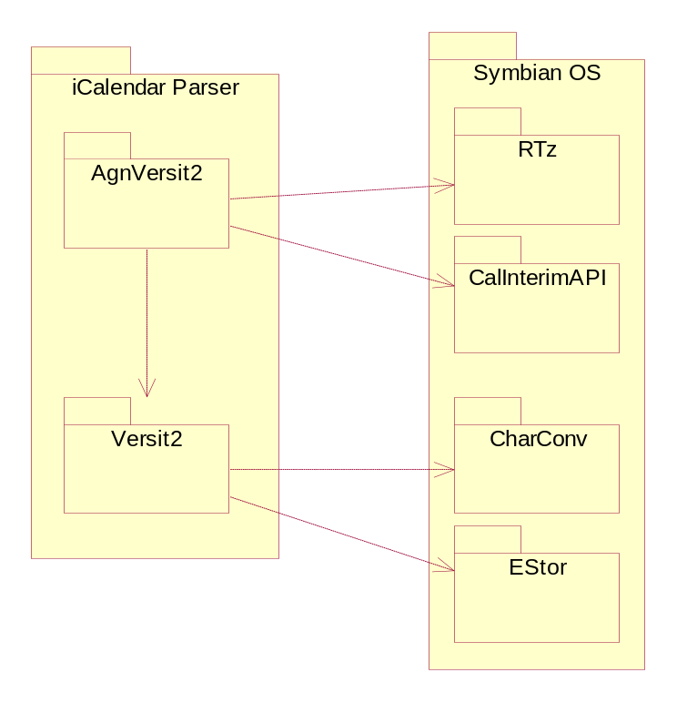
Figure 2.1 Relationship between the iCalendar parser components and the key Symbian OS components

Use cases
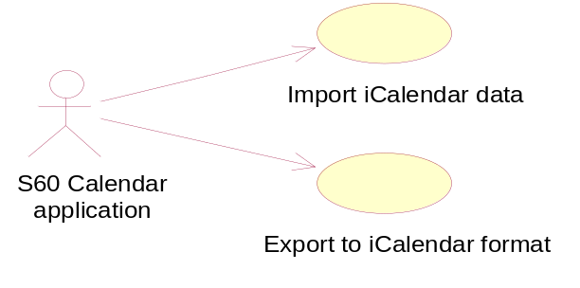
Figure 2.2 iCalendar parser use cases

Import iCalendar data
Summary | Import data from the iCalendar format to a Symbian OS Agenda entry.
Actor(s) | Any client of Symbian OS Agenda, e.g. the S60 Calendar application.
Frequency | Every time a client has iCalendar data to be imported to the Symbian Agenda format.
Preconditions | The client has iCalendar data to import.
Description | The client passes the iCalendar data in the RReadStream format to AgnVersit2.  Upon completion, the client owns an array of Symbian Agenda entries.
Exceptions | In case the iCalendar data is invalid or corrupt, the client will receive a callback where the client can decide on the appropriate action.
Postconditions | The iCalendar data is imported to the Symbian OS Agenda entry format.
Illustrations | See Figure 2.2.

Export iCalendar data
Summary | Export data from a Symbian OS Agenda entry to the iCalendar format.
Actor(s) | Any client of Symbian OS Agenda, e.g. the S60 Calendar application.
Frequency | Every time a client has an agenda entry to be exported to the iCalendar format.
Preconditions | The client has one or more Agenda entries to export.
Description | The client passes the Symbian Agenda entries to AgnVersit2 to export.  Upon completion, the client owns an RWriteStream containing the iCalendar data.
Exceptions | in case the Agenda entry is invalid or corrupt, the client will receive a callback where the client can decide on the appropriate action.
Postconditions | The Agenda entry is exported to the iCalendar format.
Illustrations | See Figure 2.2.

Services required

From the Symbian OS subsystems
Versit2 makes use of Character Conversion API (syslibs\charconv) for performing conversions between Unicode and UTF-8 and Store API for stream functionality

API | Description
CharConv | Symbian OS Character Conversion API.
Estor | Symbian OS Store API.

AgnVersit2 has a direct dependency on the Symbian OS Time Zone Server (app-services\Tz) and Symbian CalInterimAPI to Agenda. AgnVersit2 also uses the parsing functionality provided by Versit2 directly.

API | Description
RTz | Symbian OS Time Zone Server.
CalInterimAPI | Symbian Interim Agenda API.
Versit2 | Generic iCalendar parser.
BAFL | Symbian OS Basic Application Framework Library.
RFs | Symbian OS File Server.

From the Domestic OS subsystems
This component does not have any direct interfaces to the Domestic OS side subsystems.

From HW
This component has no direct HW interfaces.

Services provided

UI
This component does not provide any UI.

SW IF
Provided service | Description | Protected
Import from iCalendar format | Imports iCalendar data in an RReadStream-derived class to a CCalEntry object as used by Symbian Agenda.
Export to iCalendar format | Exports from a CCalEntry object used by Symbian Agenda to iCalendar data stored in an RWriteStream-derived class.

UI control hierarchy
The component does not contain any UI or UI controls.

Versit2 design overview
This chapter describes the class design of the Versit2 component. It uses the composite design pattern to form a tree structure of the components and allow clients to treat them uniformly. The abstract CICalBase class is the composite, which means that every leaf node will inherit the storage overhead of the composition, but the number of instances will be low and this homogenizes the design.
This component is built as a DLL: it is the responsibility of the calling client to delete the class structure from memory when it is no longer needed. Deleting the parent node results in all the child nodes also being deleted.

Versit2 class diagram
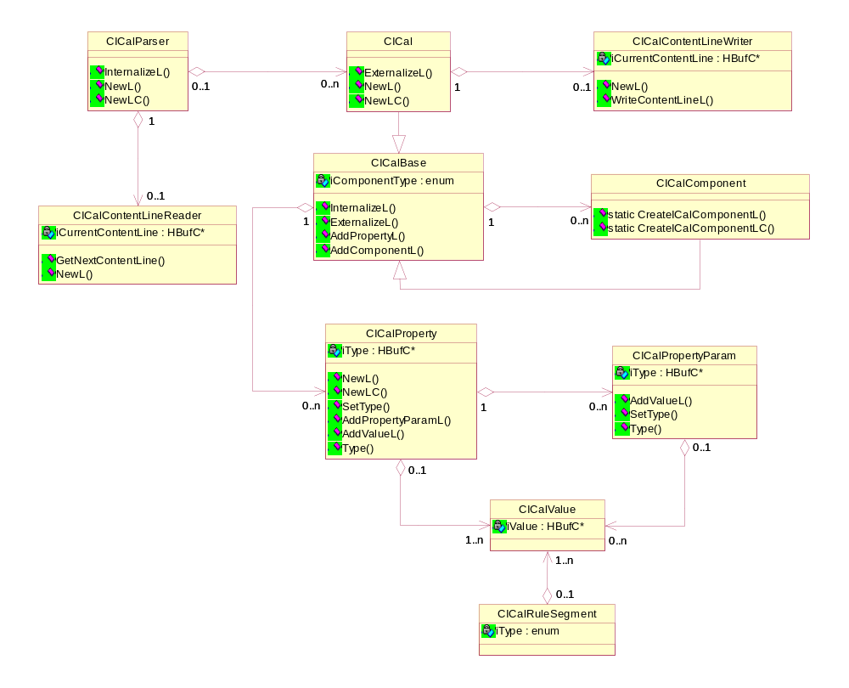
Figure 4.3 Versit2 class diagram
Figure 4.3 shows the main class structure with the most important methods. The explanation of the classes is given in Section 4.2.

Versit2 class descriptions
The following classes make up the Versit2 component.

Class | Description | Header file
CICal | A class representing a VCALENDAR component. | ICal.h
CICalAlarm | A class representing a VALARM component | lCalAlarm.h
CICalBase | An abstract base class of all the classes representing iCalendar components. | ICalBase.h
CICalComponent | An abstract base class of all the classes representing specific iCalendar components. | ICalComponent.h
CICalContentLineReader | A class for reading in content lines from a stream. | ICalContentLineReader.h
CICalContentLineWriter | A class for writing out content lines to a stream. | ICalContentLineWriter.h
CICalEvent | A class representing a VEVENT component. | ICalEvent.h
CICalFreeBusy | A class representing a VFREEBUSY component. | ICalFreeBusy.h
CICalJournal | A class representing a VJOURNAL component. | ICalJournal.h
CICalParser | Directs parsing of iCalendar streams. | ICalParser.h
CICalProperty | A class representing a property. | ICalProperty.h
CICalPropertyParam | A class representing a property parameter. | ICalPropertyParam.h
CICalRuleSegment | A class representing a recurrence rule value segment. | ICalRuleSegment.h
CICalTimeZone | A class representing a VTIMEZONE component. | ICalTimeZone.h
CICalTimeZoneInterval | A class representing a VTIMEZONE DAYLIGHT/STANDARD component. | ICalTimeZoneInterval.h
CICalTodo | A class representing a VTODO component. | ICalTodo.h
CICalValue | A class representing a property, property parameter, or rule segment value. | ICalValue.h

Versit2 structs, type definitions and enumerations

ICalRuleSegment.h enumerations
Enumeration | Description
TSegmentType | Indicates the type of a rule segment, e.g. FREQ / COUNT, etc.
TFreq | Indicates the frequency value for a FREQ segment (Hourly, Secondly, etc).

ICalValue.h enumerations
Enumeration | Description
TTimeZoneType | The type of the time zone (UTC / Standard / user-specified).

ICalBase.h enumerations
Enumeration | Description
TICalComponentType | The type of component (VEVENT / VTODO, etc)
TICalMethod | The iTip method for the component (PUBLISH / REFRESH, etc).
TICalComponentMethodBit  Masks | A bitmask for every combination of a component with every valid iTip method.
TICalComponentMethodFlags | A flag for every valid property, dictates which properties may appear in which components.

ICalErrors.h
The file ICalErrors.h defines the Versit2 specific error codes.

Versit2 class reference

CICalParser
An instance of the CICalParser class is created by clients wishing to import iCalendar objects. Calling InternalizeL() on CICalParser with RReadStream containing valid iCalendar information causes the information to be parsed into the Versit2 internal format. After the parsing completes, CICalParser contains a collection of CICal objects representing the iCalendar objects in the parsed stream. This allows multiple iCalendar objects to be contained sequentially in the stream, although typically each stream only contains one iCalendar object. CICalParser creates a CICalContentLineReader object, which is used to manage the data stream throughout the import.

CICalContentLineReader
The class CICalContentLineReader is constructed by CICalParser and initialized with a reference to RReadStream containing the data to be imported. It alone is responsible for reading from the stream. A reference to this class is passed to the InternalizeL() method of the CICalBase class.
The method CICalContentLineReader::GetNextContentLine() reads the next content line from the stream into a buffer, returning a reference to that buffer. Any character set conversion or unfolding required is performed during the reading so that the returned value is a complete (unbroken) content line in the native character set.

CICalBase
CICalBase is a common (abstract) base class shared by CICal and CICalComponent. CICalBase handles the storage requirements for both the subclasses, owning collections of both nested components and properties. It offers generic operations for internalizing and externalizing and for adding properties and subcomponents. The business logic defining the validity and behavior is defined in the derived concrete classes.

CICal
CICal is the Versit2 internal representation of an iCalendar object. CICal derives from CICalBase, and as such can own an array of nested components as well as a collection of (iCalendar global) properties.

CICalComponent
CICalComponent is the (abstract) Versit2 internal representation of an iCalendar component object. It may contain nested Calendar components under certain circumstances (for example, a VEVENT can contain a VALARM) with the logic defining which components can contain others defined in its derived types.
The static method CICalComponent::CreateICalComponentL() provides a factory for creating new instances of derived component classes. The actual type of the instantiated class is determined by the value passed in, which is overloaded to accept either an enumerated value (used during iCalendar export) or a descriptor (used during iCalendar import). The descriptor passed during an iCalendar import is the component type string directly following the BEGIN: parameter as described in Section 2.2.4.
Figure 4.4 shows the derived classes available. A concrete class is supplied for each Calendar component available (see Section 2.2.4) (note that the STANDARD and DAYLIGHT time zone subcomponents are both modeled by the CICalTimeZoneInterval class as there is a negligible difference between them), with each derived class containing the business logic defining the properties it will support.
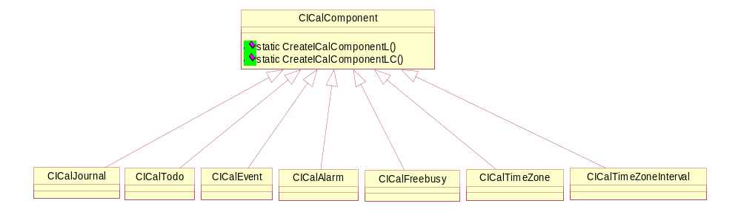
Figure 4.4 Concrete Calendar component classes

CICalProperty
A property can have a number of parameters and a number of values (see Section 2.2.1 for the syntax). The CICalProperty class stores the type of the property as a descriptor and provides overloaded methods to return it as either a descriptor (for extensible “X-“ types) or an enumerated value.
Property parameters can be added to CICalProperty by means of the AddPropertyParamL() method. This creates a new CICalPropertyParam object, which is owned by the CICalProperty instance and returns a modifiable reference to it.
Similarly, the AddValueL() method returns a modifiable reference to a newly created CICalValue instance, which is also owned by CICalProperty.

CICalPropertyParam
A property parameter can contain a type and a number of values. The property parameter type is stored as a descriptor and the property parameter values are stored as instances of the generic value class CICalValue, with values added through the AddValueL() method. As with CICalProperty, AddValueL() creates a new CICalValue instance owned by CICalPropertyParam and returns a modifiable reference to it.

CICalValue
The CICalValue class provides generic storage for property, property parameter, and rule segment (see Section 4.4.9) values. The initial value is stored as a descriptor with access methods supplied, which will convert it to the fourteen different data types supported by reference document [1]. The read methods that can be legitimately called depend on the value contained: if an incorrect accessor is called for the current value, it will leave (or return meaningless data if it cannot detect a fault). Thus, it is up to the client to check the type of the parent CICalProperty or CICalPropertyParam class and call the appropriate method.
The access methods of CICalValue are shown in Figure 4.5.
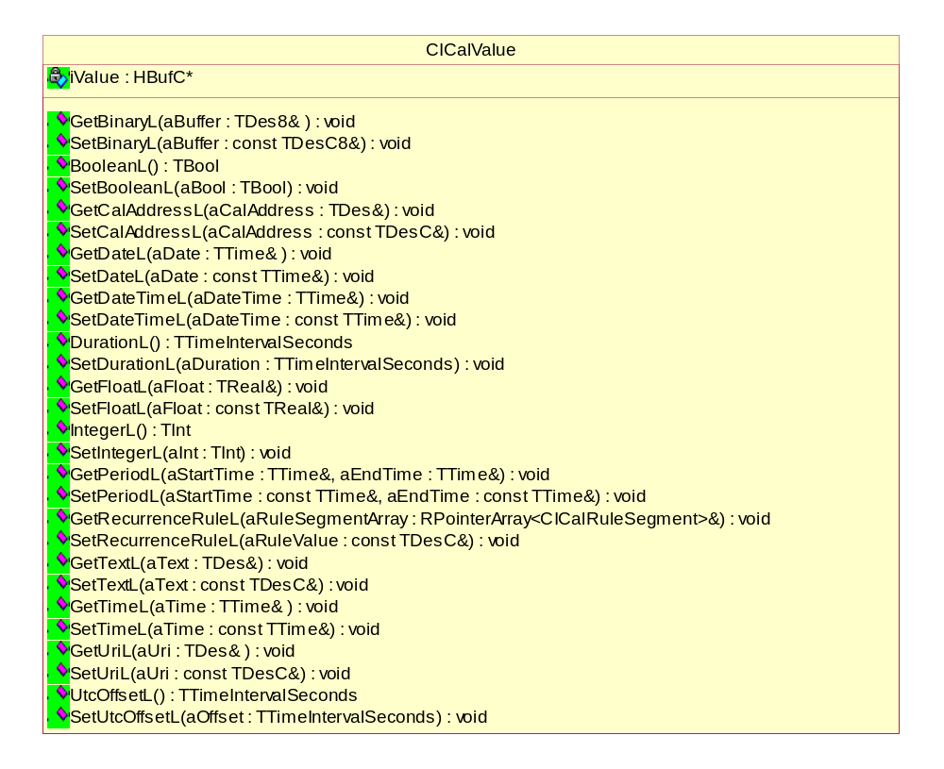
Figure 4.5 CICalValue API

CICalRuleSegment
CICalRuleSegment is a wrapper class containing a type (which is stored as an enumeration as it is not expandable) and a collection of CICalValue instances. An array of CICalRuleValues can be returned from the method CICalValue::GetRecurrenceRuleL() and this is its only use; no CICalRuleSegment instances are actually stored within the model.
This class is provided for convenience as the value of an RRULE property consists of one or more segments each containing a type and value(s). The corresponding CICalValue::SetRecurrenceRuleL() takes a descriptor containing the whole property value as there is no added value in breaking this down when setting an RRULE value.

Versit2 state diagram
A parent component calls InternalizeL() on its child component(s), passing in the CICalContentLineReader reference. Each new component then requests the next content line from the line reader, reads the property name from the stream, and so on until it reaches an END: property corresponding to its type. In this way, each component is responsible for internalizing itself as shown in Figure 4.6.
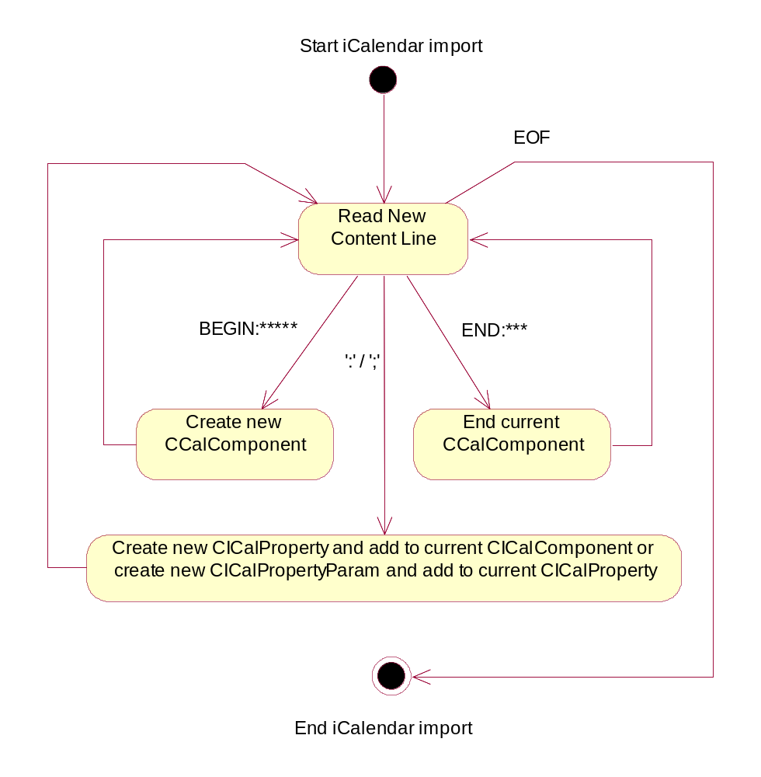
Figure 4.6 Versit2 state diagram

Importing iCalendar objects

Construction and internalization
To import iCalendar information, clients first create an instance of the class CICalParser and then call InternalizeL(), passing in an RReadStream reference. This creates an instance of CICalContentLineReader and calls CICalContentLineReader::GetNextContentLine() to read the first line as shown in Figure 4.7.
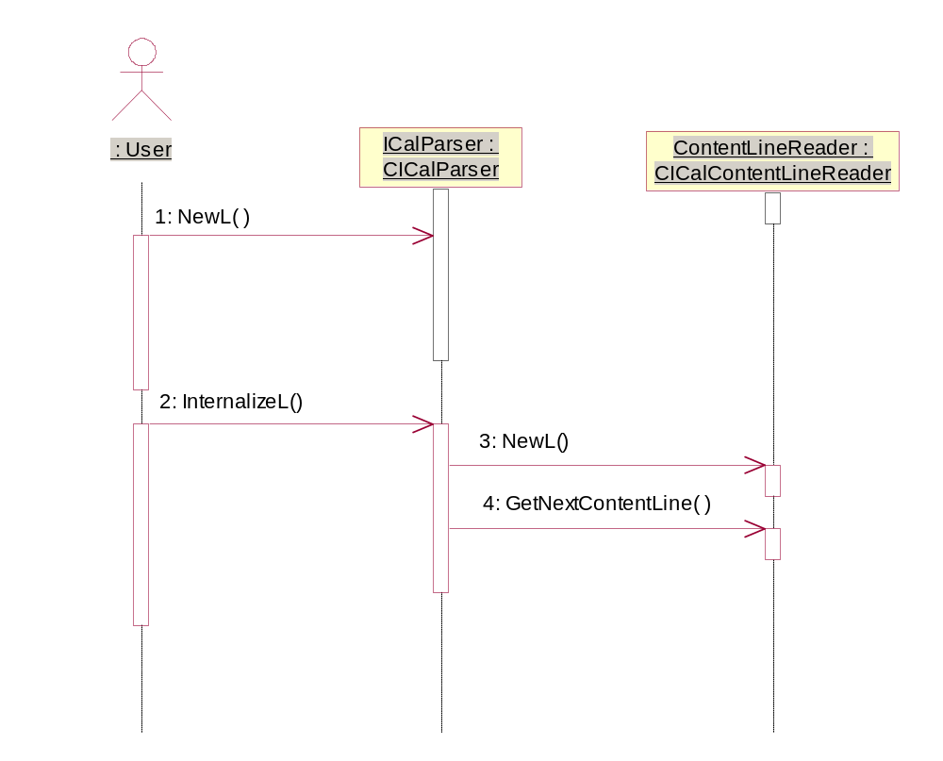
Figure 4.7 Creating CICalParser and CICalContentLineReader
If the stream contains a valid iCalendar object, then CICalContentLineReader contains the text BEGIN:VCALENDAR, in which case CICalParser then creates a new CICal instance and adds it to an internal collection of CICal objects. It then calls InternalizeL() on CICal, passing in a reference to the CICalContentLineReader instance it owns.
If CICalContentLineReader does not contain the BEGIN:VCALENDAR directive, then GetNextContentLine() is called (and any information read is ignored) until it does contain BEGIN:VCALENDAR or the end of the stream is reached.
The newly created CICal object can now control the parsing of the stream through its CICalContentLineReader reference. The first step is to retrieve the next content line from the stream using the method GetNextContentLine(). The line property can now be read from the stream and compared against the properties supported by CICal.
If CICal does not support the property, the line is ignored and the next line is retrieved. If the property is supported, a new CICalProperty instance is created and populated with the parameters and values from the current content line.
If the property is the END: property, CICal checks that the property value is equal to VCALENDAR. If this condition is true, the VCALENDAR has been successfully parsed and InternalizeL() should return without an error. If another property value is given, the stream is corrupt.
If a BEGIN: property is read from the stream, CICal contains nested components. The value of the BEGIN: property is passed to the static method CICalComponent::CreateICalComponentL(), which takes a descriptor and creates the relevant concrete component class.
The business logic defining which components can contain nested components is contained within each class; the value of a BEGIN: property must be validated for the current type before creating a new instance. Similarly, the properties and property parameters for each component are validated against reference documents [1] and [2] wherever possible.

Exporting iCalendar objects
Clients wishing to export calendar and scheduling information should first create a CICal instance to store the data. Note that it is only possible to export one iCalendar object at a time: the CICalParser class has no ExternalizeL() method.
Components, properties and property parameters can then be created and added to the tree structure owned by CICal through the AddComponentL(), AddPropertyL(), AddPropertyParamL() and AddValueL() methods. It is the responsibility of the calling client to create a valid tree before calling ExternalizeL() on CICal. It is also the responsibility of the client to destroy the tree (via the root CICal node) when it has finished with it.
Exporting CICal creates CICalContentLineWriter. This class is the converse of CICalContentLineReader, performing any required character conversion and folding before writing to the stream. ExternalizeL() uses CICalContentLineWriter to first write the iCalendar header (BEGIN:VCALENDAR) and all the owned properties to the stream. CICal then iterates through all the owned components, calling ExternalizeL() on each in turn and passing in a reference to CICalContentLineWriter.
Each component writes itself out to CICalContentLineWriter and calls ExternalizeL() on any nested components. After all of the properties of a component are written out, the END: property for the component is written and the ExternalizeL() method returns as shown in Figure 4.8.
When all the components have been written, the ExternalizeL() method on CICal writes out the iCalendar END:VCALENDAR property and returns to the calling function. It is then safe to externalize further CICal objects to the same stream, if required.
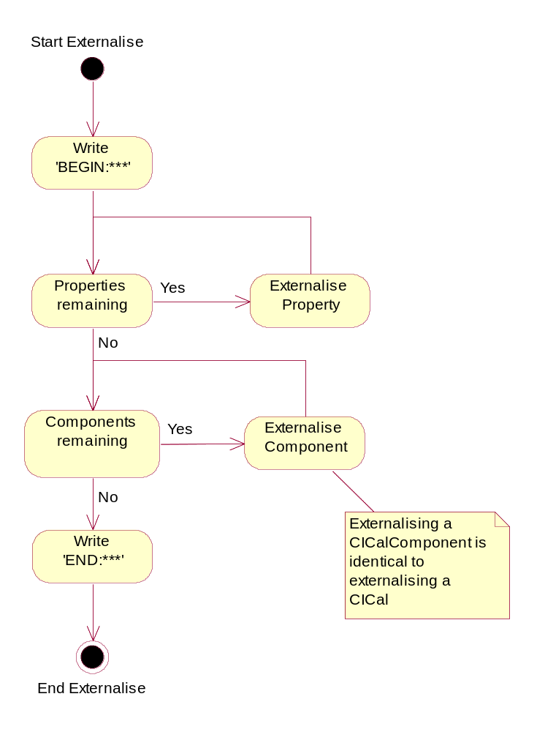
Figure 4.8 Exporting iCalendar objects

iTip validation
Versit2 validates all imports and exports against reference document [2]. In practice, this means that only certain properties may be present in certain components, and exactly which properties may or may not appear depends on the value of the METHOD property.
CICalBase defines the enumeration TICalComponentMethodFlags, which contains a bitmask for each property. This bitmask governs which combination of a component and iTip method the property is allowed to appear in. When a property is added to a component, the component’s iComponentMethodBitMask member is compared to the bitmask to decide if the property can appear in the component or not.

Backup and Restore
This component does not participate in backup and restore.

AgnVersit2 design overview

AgnVersit2 class diagram
Figure 5.9 shows the main class structure with the most important methods.
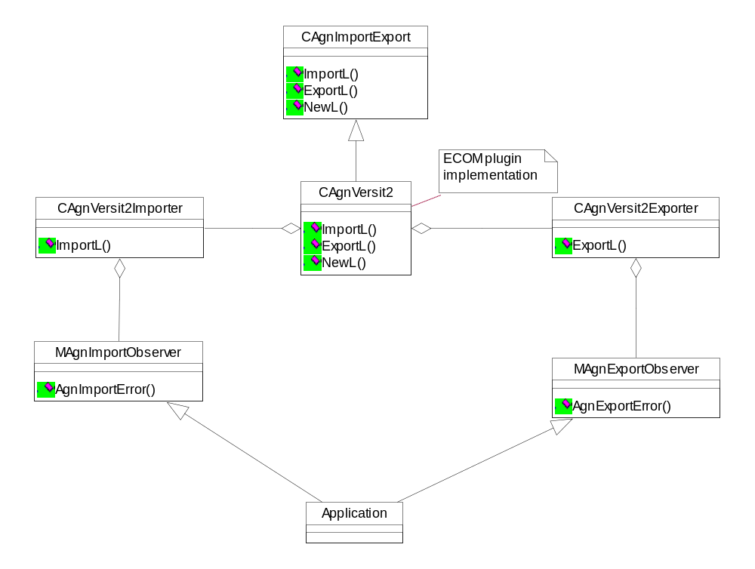
Figure 5.9 AgnVersit2 class diagram
The following classes make up the AgnVersit2 component.

Class | Description | Header file
CAgnExternalInterface | An ECom plug-in interface. | AgnExternalInterface.h
CAgnVersit2 | Implementation of CagnExternalInterface. | AgnVersit2.h
CAgnVersit2Importer | Handles the import of iCalendar data. | AgnVersit2Importer.h
CagnVersit2Exporter | Handles the export of iCalendar data. | AgnVersit2Exporter.h
TCleanupPointerArray | A class for simplifying the cleanup of RPointerArrays using ResetAndDestroy. | CleanupPointerArray.h
MAgnImportObserver | An interface for reporting errors during the import of iCalendar data from an external source. | AgnImportObserver.h
MAgnExportObserver | An interface for reporting errors during the export of Agenda data to an external | AgnExportObserver.h
CAgnVersit2StringProvider | A class to load and cache strings from resource files. | AgnVersit2StringProvider.h

AgnVersit2 structs, type definitions and enumerations

AgnVersit2Strings.hrh enumerations
Enumeration | Description
TStringId | The string identifier to load from the resource file.

AgnImportObserver.h enumerations
Enumeration | Description
TImpResponse | The action to take on an import error.
TImpError | The possible import errors.

AgnExportObserver.h enumerations
Enumeration | Description
TExpResponse | The action to take on an export error.
TExpError | The possible export errors.

AgnExternalInterface.h enumerations
Enumeration | Description
TAgnEntryExport | Flags to determine which fields to export from Agenda entries.

iCalendar to Agenda Model data mapping
The iCalendar specification lists six component types, VEVENT, VTODO, VALARM, VTIMEZONE, VJOURNAL and VFREEBUSY. The Agenda model provides types of Appointment, Event, Todo, Reminder and Anniversary, in keeping with the original (current) implementation.

iCalendar
Agenda takes the properties specified on the iCalendar as a whole as individual properties on each entry generated from the components within it. In other words, these properties are duplicated for each Agenda entry generated from an iCalendar component (a single iCalendar can contain several events; each event maps to an Agenda entry).

Properties
ICalendar
Priority | Property | Maps to Agenda entries as:
High | METHOD | The TMethod method.
High | VERSION | Only supported when 2.0.
High | PRODID | Ignored on input. On output, set to:  -//NOKIA//NONSGML Agenda Series60 R3.0//EN
Medium | CALSCALE | Only supported when Gregorian.

ICalendar components
The VEVENT and VTODO components map directly onto the types of CCalEntry in Agenda. VALARM and VTIMEZONE map onto the properties of CCalEntry. VJOURNAL and VFREEBUSY do not map onto Agenda, and when importing and exporting, they can be ignored. Agenda entries with the types EAnniv, EReminder and EAppt map onto iCalendar VEVENTS, but the original Agenda data type is retained in a custom x-param in the iCalendar so that it can be re-imported without loosing information.

VEVENT
This component maps directly to CCalEntry with an Event type.

Properties
VEVENT
Priority | Property | Maps to Agenda entries as:
High | ATTENDEE | A CCalAttendee attendee.
High | CATEGORIES | A CCalCategory category.
High | CLASS | A TReplicationStatus replication status.
High | COMMENT | Not supported.
High | CREATED | Ignored on input. On output, set to DTSTAMP.
High | DESCRIPTION | A TDesC description.
High | DTEND | The TCalTime end time.
High | DTSTAMP | A TCalTime DT stamp.
High | DTSTART | The TCalTime start time.
High | DURATION | This is re-interpreted as DTEND.
 | EXDATE | RArray<TCalTime>. Note: Agenda does not support periods.
 | LAST-MODIFIED | TCalTime LastModifiedDate
 | LOCATION | A TDesC location.
 | ORGANIZER | A CCalUser organizer.
 | RDATE | RArray<TCalTime>. Note: Agenda does not support periods.
 | RRULE | A TCalRRule rule. Note: Agenda supports only one of these per entry.
 | RECURRENCE-ID | A TCalTime recurrence ID.
 | SEQUENCE | A TUint sequence number.
 | STATUS | A TStatus status.
 | SUMMARY | A TDesC summary.
 | UID | An HBufC8 UID.
Medium | X-PROPERTY | Ignored apart from X-EPOC-AGENDA-TYPE (see Section 6.1.2).
Medium | ATTACH | Not supported.
Medium | CONTACT | Not supported.
Medium | EXRULE | Not supported.
Medium | GEO | Not supported.
Medium | PRIORITY | A TUint priority.
Medium | RELATED-TO | Not supported.
Medium | REQUEST-STATUS | Not supported.
Medium | RESOURCES | Not supported.
Medium | TRANSP | Not supported.
Medium | URL | Not supported.

VALARM
This component maps to CCalAlarm, which may be owned by CCalEntry.

Properties
VALARM
Priority | Property | Maps to Agenda as:
High | ACTION | Not supported.
High | DESCRIPTION | Not supported.
High | TRIGGER | TTimeIntervalMinutes. Only supported as a time offset from the event start.
Medium | X-PROPERTY | Ignored.
Medium | ATTACH | Not supported.
Medium | SUMMARY | Not supported.
Medium | DURATION | Not supported.
Medium | REPEAT | Not supported.

VTIMEZONE
Time zones are supported as CTzRules, which are owned by CCalEntry. Times are all converted into UTC for Agenda. If a component references more than one time zone and it repeats, then it is not supported.
When importing an iCalendar, all the time zone components are handled first so that components that make a reference to them can use them to convert times into UTC.

Properties
Multiple sets of BEGIN/END:DAYLIGHT/STANDARD in an iCalendar map to multiple TTzRule objects within CTzRules.

VTIMEZONE
Priority | Property | Maps to Agenda as:
High | TZID | Understood during import, but not stored.
Medium | LAST-MODIFIED | Not supported.
Medium | COMMENT | Not supported.
Medium | TZURL | Not supported.
Medium | TZNAME | Not supported.
Medium | X-PROPERTY | Ignored.

VTIMEZONE : DAYLIGHT / STANDARD
Priority | Property | Maps to Agenda as:
High | DTSTART | TUint16 iFromYear
High | TZOFFSETFROM | TInt16 iOldLocalTimeOffset
High | TZOFFSETTO | TInt16 iToLocalTimeOffset
Medium | RDATE | Not supported.

VTIMEZONE : DAYLIGHT / STANDARD : RRULE
Priority | Property | Maps to Agenda as:
High | FREQ | Not supported (Agenda always acts as though this is set to YEARLY).
High | UNTIL | TUint16 iToYear
High | COUNT | TUint16 iToYear (after conversion).
High | INTERVAL | Not supported (Agenda always acts as though this is set to 1).
High | BYMONTH | TMonth iMonth. Only supported if only one month is specified. If no month is specified, the month is taken from DTSTART.
High | BYDAY  BYMONTHDAY | TTzRuleDay iDayRule  TUint8 iDayOfMonth  TUint8 iDayOfWeek  Only supported if only one day is specified.
High | BYSECOND  BYMINUTE  BYHOUR  BYYEARDAY  BYWEEKNO  BYSETPOS | Not supported.
High | WKST | Not supported.

VTODO
A VTODO maps to CCalEntry with the Todo type. The VTODO component contains similar properties as the VEVENT component, with the following exceptions:
- A VTODO cannot have the following components: TRANSP, DTEND, COMMENT.
- A VTODO can have the following components, not present in VEVENT:

VTODO
Priority | Property | Maps to Agenda as:
Medium | COMPLETE | TCalTime completedTime
Medium | PERCENT | Not supported.
Medium | DUE | TCalTime endtime

VFREEBUSY
Not supported.

VJOURNAL
Not supported.

RRULE
Recurrence rules are handled in Agenda as instances of TCalRRule, except in the case of VTIMEZONE components, which are discussed separately in Section 6.4.1. Recurrence rules have a value that consists of a sequence of name/value pairs, which are listed below.

RRULE
Priority | Property | Maps to Agenda as:
High | FREQ | Type (secondly, minutely and hourly are not supported).
High | UNTIL | TCalTime
High | COUNT | TUint
High | INTERVAL | TInt
High | BYMONTH | RArray<TMonth>  Only supported for yearly frequencies.
High | BYDAY | RArray<TDay> and RArray<TDayOfMonth>  Only days supported, i.e. MO or TO. Does not handle +2SA or –1SU. Only supported for weekly and monthly frequencies.
High | BYSECOND | Not supported.
High | BYMINUTE | Not supported.
High | BYHOUR | Not supported.
High | BYMONTHDAY | RArray<TInt>  Only supported for monthly frequencies.
High | BYYEARDAY | Not supported.
High | BYWEEKNO | Not supported.
High | BYSETPOS | Not supported.
High | WKST | TDay aDay  Only supported for weekly frequencies.

Compatibility issues
Components and properties do not have an exact one-to-one relationship between Agenda and iCalendar, and each one has to be dealt with individually.
Where it is not possible to perform an import or export through AgnVersit2, the parent application needs to be informed, but under most circumstances it must also be possible to continue with the rest of the data.
In the case of exporting, default values may be provided in place of unsupported properties. For example, when exporting time zone information, a default TZID can be generated based on the UTC offset, such as: GMT +0200 (Standard) / GMT +0300 (Daylight).

Importing and exporting with AgnVersit2

Creation of CAgnVersit2
The functionality required by AgnVersit2 is provided in the form of an ECom plug-in. This means that there is an interface definition and a single implementation provided for handling iCalendar data.
The interface definition is CAgnExternalInterface. This provides a static NewL function that takes a TDesC8 specifying the MIME type of the data to be handled. The implementation is CAgnVersit2, and it is created for the MIME type of text/calendar.

Use of CAgnICal
CAgnExternalInterface provides two methods: ImportL and ExportL. On the Agenda side, these deal with CCalEntry objects and the related classes from Agenda API. On the Versit2 side, these act on RReadStreams and RWriteStreams respectively.
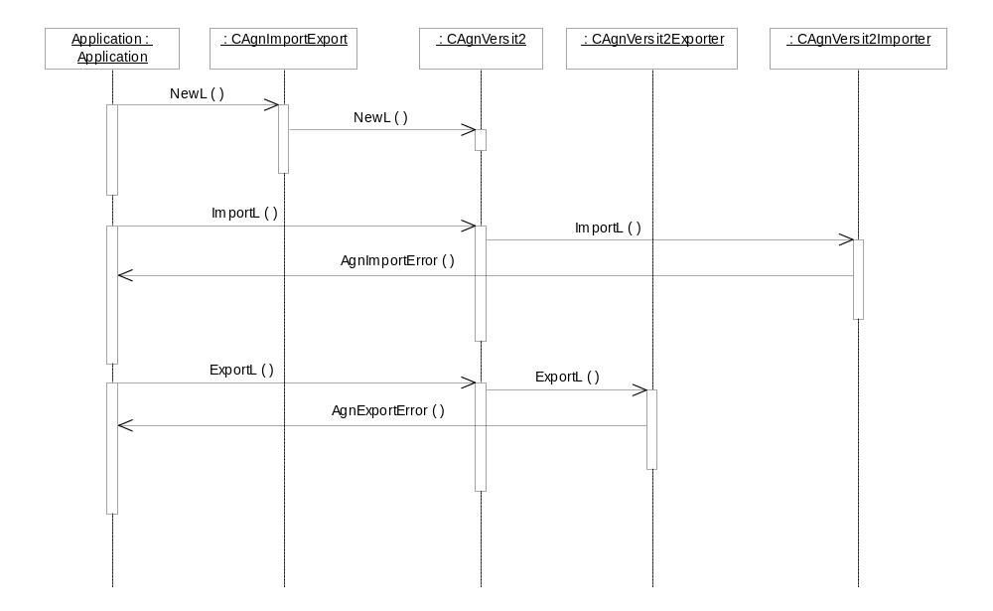
Figure 7.10 Creating CAgnICal and calling the Import and Export methods

CAgnVersit2::ImportL
virtual void ImportL(
RPointerArray<CCalEntry>& aEntries,
RReadStream& aReadStream,
TUint aFlags,
MAgnImportObserver& aObserver) = 0;

This takes an open read stream and passes it to Versit2 for parsing. The resulting data is then converted into CCalEntry objects and added to the entries array. The ownership of the entries is passed to the caller. Calling import does not alter the contents of the Agenda database; this is the responsibility of the caller.
The aFlags argument is not used.
An import may fail due to a corrupt input file, in which case Versit2 reports the error in the usual manner and ImportL leaves with the same code as returned from Versit2.
An import may also fail due to individual components being invalid or because the data in the components cannot be represented in Agenda. In this case, the AgnImportError member function of aObserver is called.

CAgnICal::ExportL
virtual void ExportL(
const RPointerArray<CCalEntry>& aEntries,
RWriteStream& aWriteStream,
TUint aFlags,
MagnExportObserver aObserver) = 0;

This takes an array of agenda entries and converts them into Versit2 components. These are then written to RWriteSteam by Versit2. This function does not take ownership of or modify the CCalEntry objects.
The export of a CCalEntry object to an iCalendar file requires a TUint parameter, aFlags, which is used to determine which properties should be exported from CCalEntry.
The enumeration TAgnExportMethod found in AgnVersit2ExportFlags.h contains predefined flags for the various iTip methods, e.g. EVEventPublish should be used when exporting to a VEVENT with an ITip method of PUBLISH.

interface->ExportL(entry, writeStream, EVEventPublish, exportObserver);

To reduce the amount of exported data and the size of the generated ICS file, properties can be excluded from the export. For example, the STATUS property is excluded from the export with the following code:

TInt flags = EVEventPublish;
flags ^= KAgnExportStatus;
interface->ExportL(entry, writeStream, flags, exportObserver);

The properties that can be excluded are defined in the enumeration TAgnEntryExport in AgnExternalInterface.h.
EExportAll can be used to allow all the supported properties of CCalEntry to be exported.
An export may fail for the same reasons as Versit2, in which case the same leave code is be used to report the problem.
An export may also fail due to individual entries being invalid, or due to being a component type that is not supported by iCalendar. In this case, the AgnExportError member function of aObserver is called.

MAgnImportObserver::AgnImportError
virtual MAgnImportError::TResponse AgnImportError(
MAgnImportError::TError aType,const TDesC8& aUid,
const TDesC& aContext) = 0;

This is called to indicate that an error with an import has occurred. The nature of the error is indicated by the aType argument, which may be EErrorBadSyntax (the data being imported is corrupt and cannot be interpreted), EErrorInvalidData (the data is syntactically correct but invalid), EErrorMissingData (required data is not present) or EErrorNotSupported (the input data is correct, but it is not possible to handle it in Agenda).
Where known, the UID of the component within which the error occurred is reported as aUid. If this is unknown, KNullDesC8 is used instead.
aContext is a text string containing some information about the nature of the error. For invalid or missing data, this is likely to be the name of the property or parameter that failed. For not supported errors, this may be a more verbose explanation. In some unlikely situations, this can be KNullDesC.
The return value from this function can be EResponseContinue (in which case the import tries to ignore the error as best it can), EResponseSkip (in which case the current component is ignored), EResponseStop (which causes the import to return immediately) or EResponseLeave (which causes the import to leave with the error code KErrAbort).

Variation
The iCalendar parsing components do not support any other variation mechanism than application-wide image creation time variation, i.e. the application can be included in or excluded from a ROM image.

System resource usage

Files
File | \\Resource\\Agnversit2\\agnversit2strings.rsc
Type | Private
Location | ROM
Format | Compiled Symbian resource.
Size estimate | Less than 800 bytes.
Description | Stores common strings used by AgnVersit2 when exporting iCalendar files.

Other data

Databases
This component does not use any databases.

Central Repository
This component does not use Central Repository.

Publish and Subscribe
This component does not use Publish and Subscribe.

Memory consumption
Memory consumption has been taken into consideration and kept to minimum in the implementation of these components. The memory consumption is dependent on the size of the Calendar entries imported / exported.

Security

Capabilities of this component
Capability | Justification
All – TCB | The capability required so that applications can use this service.

Input and output validation
Input data is validated against reference document [1].
Output data is validated against reference documents [1] and [2].

Environmental assumptions
This component does not make any assumptions about its environment.

Additional enforcements
This component does not have any additional security enforcements.

Exception handling
See Section 7.5 for details of how AgnVersit2 deals with invalid data.

Usage

Building the release
Extract the agnversit2 and versit2 directories to a path under EPOCROOT.
Build in the standard way:
bldmake bldfiles
abld build <target> <release>

Build order
The components must be built in the following order:
- \src\common\generic\app-engines\agnmodel
- \src\common\generic\app-engines\CalInterimAPI
- \s60\Versit2
- \s60\AgnVersit2

After building the components shown above, ICS files can be imported and converted to Symbian Agenda entry objects (CCalEntry).
CCalEntry objects can also be exported to ICS files.

Importing to agenda
- Create a session with Agenda Server if an existing session does not exist. This step is only required for console applications:

iAgendaServer = RAgendaServ::NewL();
User::LeaveIfError(iAgendaServer->Connect());

- Create an instance of CAgnExternalInterface using the MIME type text/calendar. This loads AgnVersit2 using the ECom plug-in framework:

CAgnExternalInterface* interface = CAgnExternalInterface::NewL(KICalMimeType);

- Derive a class from the mixin class MAgnImportObserver, implementing the function AgnImportErrorL(). This class can be used to control the response of AgnVersit2 to any syntax errors in the parsed iCalendar stream.
- Get some iCalendar information into RReadStream, for example by opening an ICS file and opening RFileReadStream on it.
- Declare RPointerArray of CCalEntry objects. Upon the successful completion of an import, this array contains the CCalEntry objects that can be added to the Agenda model.
- Start the import by calling ImportL with the entry array, read stream and import observer. The interface also takes TUint aFlags, which is not used by this implementation:

interface->ImportL(entries, readStream, 0, importObserver);

- Loop through the entries, adding each to Agenda if required.

Exporting from CCalEntry objects
Export using AgnVersit2 is similar to the import. In the case of an export, a class must be derived from MAgnExportObserver to handle any export errors. This can be the same class that derives from MAgnImportObserver. AgnVersit2 requires CCalEntry& to export, RWriteStream to export the entry to, and an export observer. Like import, export requires TUint aFlags, which is used to determine which properties should be exported from CCalEntry.
The enumeration TAgnExportMethod found in AgnVersit2ExportFlags.h contains predefined flags for various iTip methods, e.g. EVeventPublish should be used when exporting to a VEVENT with an iTip method of PUBLISH. EExportAll can be used to allow all the supported properties of CCalEntry to be exported.

interface->ExportL(entry, writeStream, EExportAll, exportObserver);

Note that during both import and export, AgnVersit2 expects RReadStream and RWriteStream to be opened before they are passed as arguments. AgnVersit2 does not close these streams after use; it is the responsibility of the caller to ensure that these objects are properly closed.

