S60 2.x
Calendar Import Wrapper
Design Document

Team | Author
K3 | Nobuhiro Shinkai

Change history:

Version | Date | Status | Comments
1.0 | 26.03.2003 | Approved

Table of contents:

1. Document control 4
1.1 References 4
1.2 Documentation conventions 4
1.3 Abbreviations 4
1.4 Definitions 4
2. General 5
2.1 Introduction 5
2.2 Subsystem environment 5
2.3 Services required 5
2.3.1 From the Symbian OS subsystems 5
2.3.2 From the Domestic OS subsystems 5
2.3.3 From HW 5
2.4 Services provided 5
2.4.1 UI 5
2.4.2 SW IF 6
3. Design 7
3.1 Class diagrams 7
3.1.1 Subsystem 7
3.2 Class descriptions 7
3.2.1 CCalenImporter 7
3.2.2 CCalenImportedModel 8
3.3 Operations 9
3.3.1 Initializing Calendar Importer 9
3.3.2 Importing Agenda data 9
3.3.3 Getting a repeat type 10
3.3.4 Getting an alarm date and time 11
4. System resource usage 12
4.1 Files 12
4.2 Databases 12
4.3 Memory consumption 12
4.4 Task allocation 12

Document control

References
- S60 Coding Conventions Document
- S60 Calendar Application Design Document

Documentation conventions
Code is written with the Courier New font.

Abbreviations
CalenMdl | Calendar Model
CalenImp | Calendar Importer
PIM | Personal Information Manager
AgnMdl | Agenda Model
AgnSrv | Agenda Server
SMV | Smart Message Viewer

Definitions
vCalendar | The vCalendar format allows the capture of information, which is normally stored within a calendar and schedule application.
Agenda | A PIM application of a Symbian OS based environment.
TCalImp | A test program of CalenImp.DLL.
Agenda Model | Simplifies the access of Agenda Server.
Agenda Server | Provides access to the Agenda database.
DB | A database file.

General

Introduction
The Calendar Import Wrapper subsystem is a module that imports vCalendar data to Agenda data.
Basically, the Smart Messaging subsystem uses this subsystem for decoding received data.
Calendar Import Wrapper is also used when a Calendar note is sent to another device via Smart Messaging (the Smart Messaging Calendar viewer needs a reference to an Agenda entry to use the vCalendar parser in Versit).

Subsystem environment
The key relationships between Calendar Import Wrapper and the components in its environment are shown in Figure 2.1. The engine is dependent on Calendar Model.
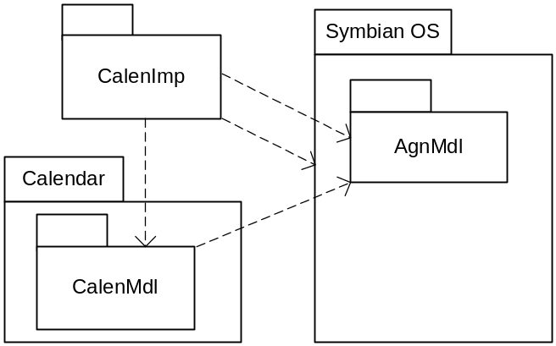
Figure 2.1 Subsystem environment

Services required

From the Symbian OS subsystems
Services of the Symbian OS infrastructure (including StreamStore, Timer Service) and Agenda Server (and Agenda Model) are required.

From the Domestic OS subsystems
The Calendar Import Wrapper subsystem does not have any direct interfaces to the Domestic OS side subsystems.

From HW
This module has no direct HW interfaces.

Services provided

UI
This module has no UI.

SW IF
The Calendar Import Wrapper subsystem provides some interfaces that import vCalendar data to Agenda data.

Design

Class diagrams

Subsystem
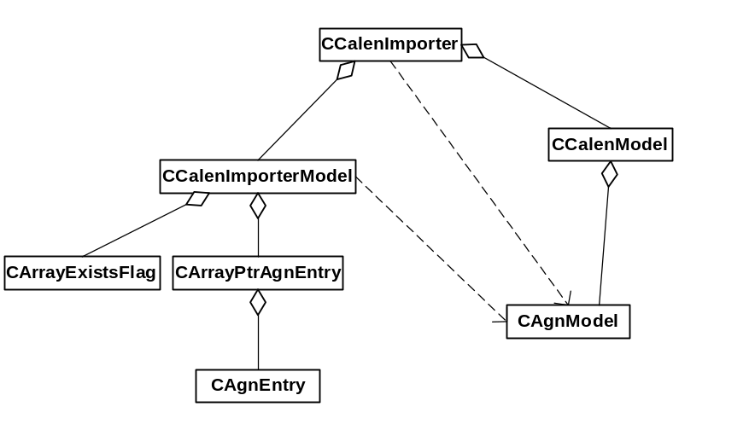
Figure 3.2 Calendar Import relationship
Figure 3.2 shows the Calendar Importer module’s relationship. CCalenImporter has two classes. CCalenImportedModel is imported data. CCalenModel has CAgnModel.

Class descriptions
Class Name | Description
CCalenImporter | A class that imports a vCalendar entry into a Series 60 Calendar compatible CAgnEntry.
CCalenImportedModel | This class wraps CAgnEntry and offers services for saving to Calendar.

CCalenImporter
CCalenImporter | A class that imports a vCalendar entry into a Series 60 Calendar compatible CAgnEntry.  If no Series 60 relevant data is found when importing, it is signaled by returning NULL, and by leaving.
// construct/destruct/copy
static CCalenImporter* NewL  (RFs& aFs) | A two-phased constructor.
~CCalenImporter() | A destructor
// update
CCalenImportedModel* ImportVCalendarL(RReadStream&) | Imports a vCalendar entry.
void Reset() | Deletes all entries.
static TCalenRepeatIndex RepeatIndex(const CAgnEntry& aEntry) | Returns an index of a repeat type.  aEntry: Agenda note's entry.  Return value:  enum TCalenRepeatIndex  {  ERepeatNotRepeated,  ERepeatDaily,  ERepeatWeekly,  ERepeatBiWeekly,  ERepeatMonthly, // Monthly By Date  ERepeatYearly, // Yearly By Date  ERepeatOther  };
static TBool GetAlarmDateTime(  const CAgnEntry& aEntry, Time& aAlarmDateTime) | If the note has an alarm, the alarm time is set to aAlarmDateTime and ETrue is returned. aAlarmDateTime has a dd/mm/yy, hh:mm part, e.g. 15/Sep/2002, 13:00.  If the note has no alarm, aAlarmDateTime is not changed and EFalse is returned.  aEntry: an Agenda note's entry.  aAlarmDateTime: the alarm date and time.

CCalenImportedModel
CCalenImportedModel | This class wraps CAgnEntry and offers services for saving it to the Calendar database.
// construct/destruct/copy
CCalenImportedModel  (CArrayPtrAgnEntry* aArray, CArrayExistsFlag* aFalgs, CAgnModel* aModel) | A constructor.  aArray: an array of the entries.  aFlags: flags that indicate if the entry already exists in Calendar or not. These flags are stored in aArray.
~CCalenImportedModel() | A destructor
// query
TInt Count() | Gets a count of the entries.
CAgnEntry& Entry(TInt aIndex) | Accesses the entry.  aIndex: the index of the entry.  Return value: a reference to the entry.
TBool ExistsAlreadyInCalendar  (TInt aIndex) | Checks if the entry already exists in Calendar.  aIndex: a reference to the entry.  Return value: ETrue if the entry already exists in Calendar, and EFalse if the entry does not exist.
// update
void CommitL(TInt aIndex) | Saves the entry to Calendar.  aIndex: an index of the entry.

Operations

Initializing Calendar Importer
Operation | Initializing Calendar Importer.
Preconditions
Description | Calendar Importer opens CCalenModel and the Calendar DB.
Inputs | c:\system\data\calendar is opened.
Modifies
Outputs
Postconditions
Related To | The classes CCalenImporter, and CCalenModel.
Related Event
Exceptions | No handling. Returns the Symbian OS standard error code.

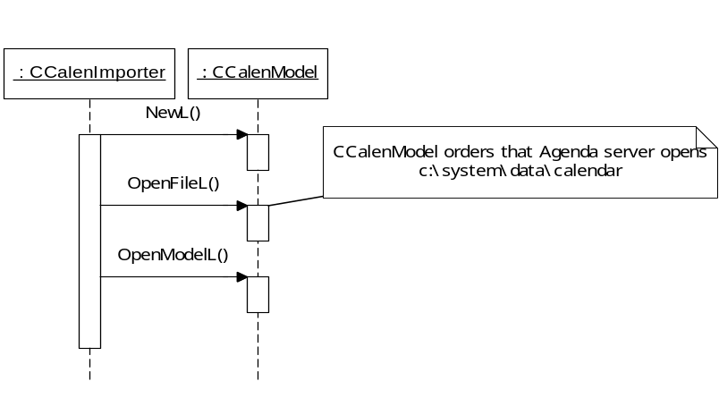
Figure 3.3 Initializing Calendar Importer

Importing Agenda data
Operation | Importing Agenda data.
Preconditions | c:\system\data\calendar already exists.
Description | Imports a vCalendar consisting of one or more vCalendar entries.
Inputs
Modifies | c:\system\data\calendar
Outputs | The imported Agenda data is saved into the Calendar DB.
Postconditions
Related To | The classes CCalenImporter, CCalenImportedModel, CAgnModel, and CArrayPtrAgnEntry.
Related Event
Exceptions | Calendar Importer TRAPs while saving an entry. Agenda Server rarely returns an error (KErrNotFound) on saving a note.  The Calendar application checks if the error code is KErrNotFound. If the error code is KErrNotFound, Calendar Importer saves the note again.

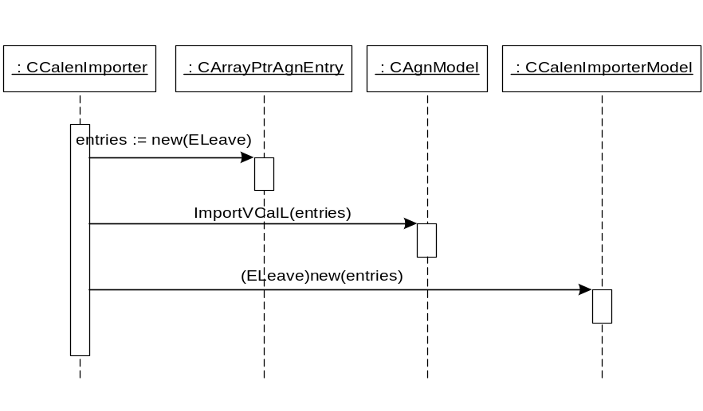
Figure 3.4 Importing Agenda data

Getting a repeat type
Operation | Getting a repeat type.
Preconditions
Description | Converting from an Agenda repeat type to a Series 60 Calendar repeat type.
Inputs
Modifies
Outputs | Returns a Series 60 Calendar repeat type.
Postconditions
Related To | The classes CCalenImporter, CalenNoteDataUtil, and CAgnEntry.
Related Event
Exceptions

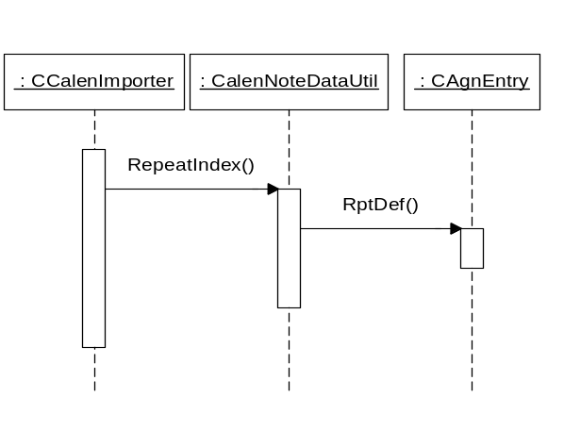
Figure 3.5 Getting a repeat type

Getting an alarm date and time
Operation | Getting an alarm date and time.
Preconditions
Description | Getting an alarm date and time.
Inputs
Modifies
Outputs | If the note has an alarm, ETrue is returned.
Postconditions
Related To | The classes CCalenImporter, CalenNoteDataUtil, and CAgnEntry.
Related Event
Exceptions

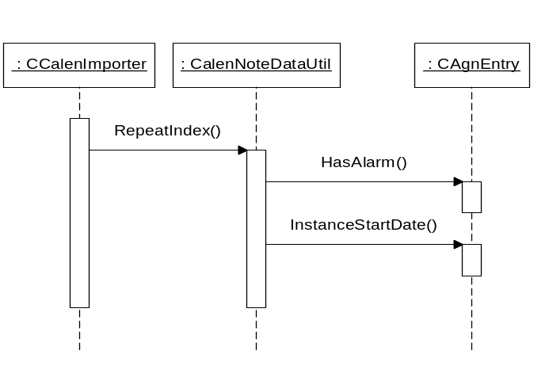
Figure 3.6 Getting an alarm date and time

System resource usage

Files
CalenImp.DLL updates c:\system\data\calendar.

Databases
This software uses the Agenda database.

Memory consumption
Memory consumption has been taken into consideration and kept to a minimum in the implementation of this component.

Task allocation
This component runs in the same thread in which the application is launched.

