S60 3.1
CalenInterimUtils2
Design Document

Team name | Author
 | Charles McKenna

Change history:

Version | Date | Status | Comments
1.0 | 27.07.2006 | Approved

Table of contents:

1. Document control 4
1.1 References 4
1.2 Documentation conventions 4
2. General 5
2.1 Introduction 5
2.2 Component environment 5
2.3 Services required 5
2.3.1 From the Symbian OS subsystems 5
2.3.2 From the Domestic OS subsystems 6
2.3.3 From HW 6
2.4 Services provided 6
2.4.1 UI 6
2.4.2 SW IF 6
3. UI control hierarchy 7
4. Design 8
4.1 Class diagrams 8
4.1.1 CCalenInterimUtils2 9
4.2 Class descriptions 9
4.2.1 Structs, type definitions and enumerations 10
4.2.2 Flag definitions 10
4.3 Operations 10
4.3.1 Creation of a Globally Unique ID 10
4.3.2 Populating a child entry from a parent entry 11
4.3.3 MRViewersEnabledL 11
4.3.4 IsMeetingRequestL 12
4.3.5 StoreL 12
4.4 CCalenEComWatcher 13
4.5 Backup and Restore 15
5. Variation 16
6. System resource usage 17
6.1 Files 17
6.2 Other data 17
6.2.1 Databases 17
6.2.2 Central Repository 17
6.2.3 Publish and Subscribe 17
6.3 Task allocation 17
6.4 Performance 17
6.5 Timers 17
7. Exception handling 18

Document control

References
- S60 Calendar Application Design Document
- WebDav UUIDs and GUIDs Internet Draft | http://www.webdav.org/specs/draft-leach-uuids-guids-01.txt
- S60 Calendar Meeting Request Enabler Framework Design Document

Documentation conventions
Code is shown with the Courier New font.

General

Introduction
CalenInterimUtils2 contains utility functions related to Meeting Requests available for both Calendar’s own components as well as third party components to be used.

Component environment
The key relationships between CalenInterimUtils2 and the components in its environment are shown in Figure 2.1.
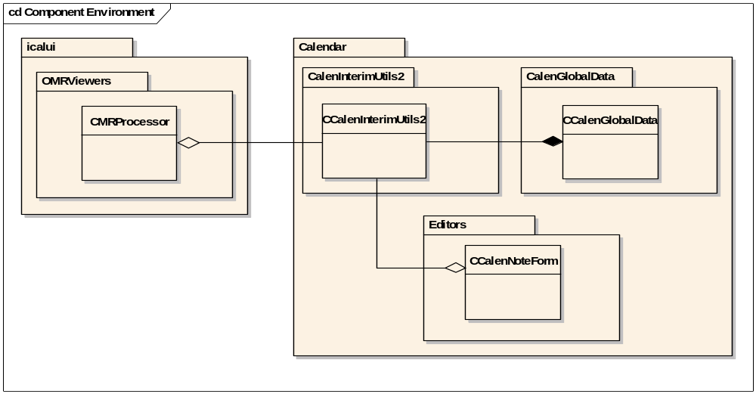
Figure 2.1 Component environment

Services required

From the Symbian OS subsystems
CalenInterimUtils2 uses the following Symbian OS subsystems:

API | Description
CalInterimAPI.lib | Symbian Calendar access.
Charconv.lib | Conversion between 8- and 16-bit descriptors.
Etel.lib | Telephony functions for retrieving IMEI.
EtelMM.lib | Telephony functions for retrieving IMEI.
FeatMgr.lib | Checking which features are enabled on the terminal.

From the Domestic OS subsystems
This component does not have any direct interfaces to the Domestic OS side subsystems.

From HW
This component has no direct HW interfaces.

Services provided

UI
This component does not provide any UI.

SW IF
Provided Service | Description | Protected
Generate Globally Unique ID | Creates a new GUID, to use when creating a new Agenda entry. | No
Check if entry is a Meeting request | Checks to see if a given entry has properties consistent with a Meeting request. | No
Check if Meeting request viewers are enabled | Checks to see if the terminal supports Meeting Requests and has a viewer implementation ready to use. More information can be found in reference document [3]. | No
Populate child entry from parent entry | Takes a parent entry and a child entry, and copies data from all fields in the parent entry to the child entry. | No
Store entry | Takes an entry and stores it in Agenda using the appropriate call. | No

UI control hierarchy
The component does not contain any UI or UI controls.

Design

Class diagrams
Both CCalenInterimUtils2 and CCalenInterimUtils2Impl inherit directly from CBase.
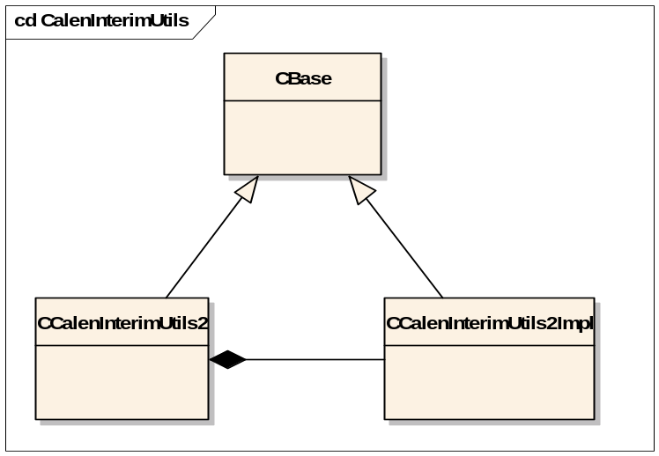
Figure 4.2 CCalenInterimUtils2 class diagram

CCalenInterimUtils2
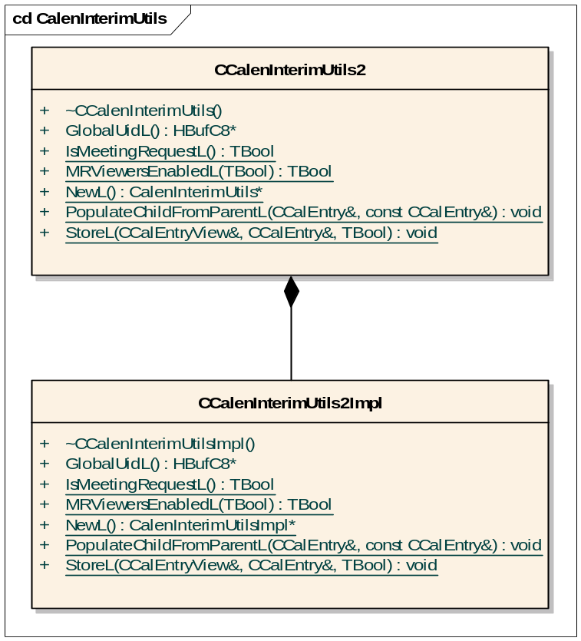
Figure 4.3 CCalenInterimUtils2 implementation
Figure 4.3 shows the implementation structure of CCalenInterimUtils2. CCalenInterimUtils2 privately owns a CCalenInterimUtils2Impl object, which contains the full implementation of the functions.
The use of the private implementation class is to hide the class’s private functions from the exported header.

Class descriptions
CCalenInterimUtils2 is the class visible to the external components. It contains pass-throughs to the implementation class, CCalenInterimUtils2Impl. Although CCalenInterimUtils2 is a C class and contains methods to allow construction (NewL()), only the functions GlobalUidL() and MRViewersEnabledL() require an object pointer, the rest of the methods can be called statically, without an object pointer.
The descriptions of the methods are described in the C++ header files as comments.

Class | Description | Header file
CCalenInterimUtils2 | Contains the exported functions. All functions simply call the respective equivalent in CCalenInterimutils2Impl. | CalenInterimUtils2.h
CCalenInterimUtils2Impl | Contains the full implementation of the exported functions. This class is privately owned by CCalenInterimUtils2 and not exported. | CalenInterimUtils2Impl.h

Structs, type definitions and enumerations
This component does not have any public structs, type definitions or enumerations.

Flag definitions
Flag | Description
__WINSCW__ | This is used in the function GlobalUidL(). This function attempts to retrieve the IMEI of the device, which is not possible on the emulator. When running the program in WINSCW, the IMEI is set to an arbitrary value (123456789012345).

Operations

Creation of a Globally Unique ID
CalenInterimUtils2 creates a new Global UID for use when creating a new entry. The generated UID is based on reference document [2].
The algorithm uses three components:
- Node (in this case the IMEI of the terminal)
- Timestamp (number of 100-nanosecond ticks from 00:00:00, 15th October 1582)
- Clock sequence (see below)

These three values get bit-shifted and bit-masked together, to form a 128-bit GUID (16 x 8bit digits).
Most processors "tick" at a prescribed time value. This is one tick of the system timer interrupt, and typically occurs about 100 times a second. However, by calling the GUID generator many times within a very short space of time, it would be possible to call the GUID generator without a "tick" having occurred - in this case the GUID generated would be exactly the same as the previous one. To counteract this, the clock sequence is introduced into the algorithm.
In the web draft of the algorithm, the clock sequence was a value set to 0 the first time the algorithm is called. On every subsequent call, during the same tick, the value gets incremented, then appended to the GUID. However, this would require accessing permanent storage or using writable static data, so it has been replaced by a pseudo-random number from Symbian's Math library. Although this is not as safe as incrementing the clock sequence value every generation, it only creates a non-unique GUID once in several billion iterations on the same tick.
It should be noted that generating more than one GUID per tick is a very rare occurrence in itself. Combined with the extremely minute chance of duplication occurring when this does happen, it is safe to assume the algorithm never produces a duplicate.

Operation | GlobalUidL
Preconditions | A CCalenInterimUtils2 object has been instantiated by the user.
Description | The iCal specification requires calendar entries to have a globally unique identifier; this function implements a web-based spec for producing this (see reference document [2]).
Inputs
Modifies | Stores the IMEI of the terminal into the class’ member data in order to save time in subsequent calls
Outputs | ASCII text with virtually no chance of being the same as any other text generated from this function.
Postconditions | The class will not poll the terminal for the IMEI again, as long as the same CCalenInterimUtils2 object is used.
Related To | Creating a new CCalEntry.
Related Event
Exceptions

Populating a child entry from a parent entry
A parent entry and a child entry are taken, and data from all fields in the parent entry are copied to the child entry. This may be used when creating a new exception programmatically.

Operation | PopulateChildFromParentL
Preconditions
Description | Populates empty fields of a child entry with data from the parent entry
Inputs | Reference to a child entry, Reference to a parent entry
Modifies | Empty data fields in the child entry
Outputs
Postconditions | Child entry contains data from parent entry
Related To | Creating an exception to a recurring Calendar entry
Related Event
Exceptions

MRViewersEnabledL
Returns ETrue if the Meeting Request functionality is available on the terminal. The logic is described in reference document [3]. This call is synchronous, and requires REcomSession to list all implementations matching one of two UIDs.

Operation | MRViewersEnabledL
Preconditions
Description | Checks to see if Meeting Request functionality is available on the terminal.
Inputs
Modifies
Outputs | Boolean value.
Postconditions
Related To | Loading third party meeting request viewers.
Related Event
Exceptions

IsMeetingRequestL
Takes a CCalEntry and returns a Boolean value indicating if the entry is a meeting request or not. The current logic used is that an entry is a meeting request if it has a type of EAppt and the Organizer field (CCalEntry::OrganizerL()) is not NULL.

Operation | IsMeetingRequestEnabledL
Preconditions
Description | Checks to see if the aEntry is a meeting request.
Inputs | CCalEntry to check.
Modifies
Outputs | Boolean value.
Postconditions
Related To | Loading third party meeting request viewers.
Related Event
Exceptions

StoreL
StoreL adds a CCalEntry into the Agenda database, using the passed CCalEntryView. Ultimately calls either CCalEntryView::StoreL or CCalEntryView::UpdateL, depending on the nature of the entry passed in. If the aCopyToChildren flag is set to ETrue, changes to plain text fields (e.g. Summary, Location, etc) in the parent entry are copied to all child entries unless the changed field is the reason for the exception that created the child. The full logic used is shown in Figure 4.4

Operation | StoreL
Preconditions
Description | Adds an entry to the Agenda database or updates an existing entry.
Inputs | CCalEntryView, CCalEntry to add / update.
Modifies | Agenda database.
Outputs
Postconditions | Entry added to database.
Related To | All Calendar editor operations.
Related Event
Exceptions

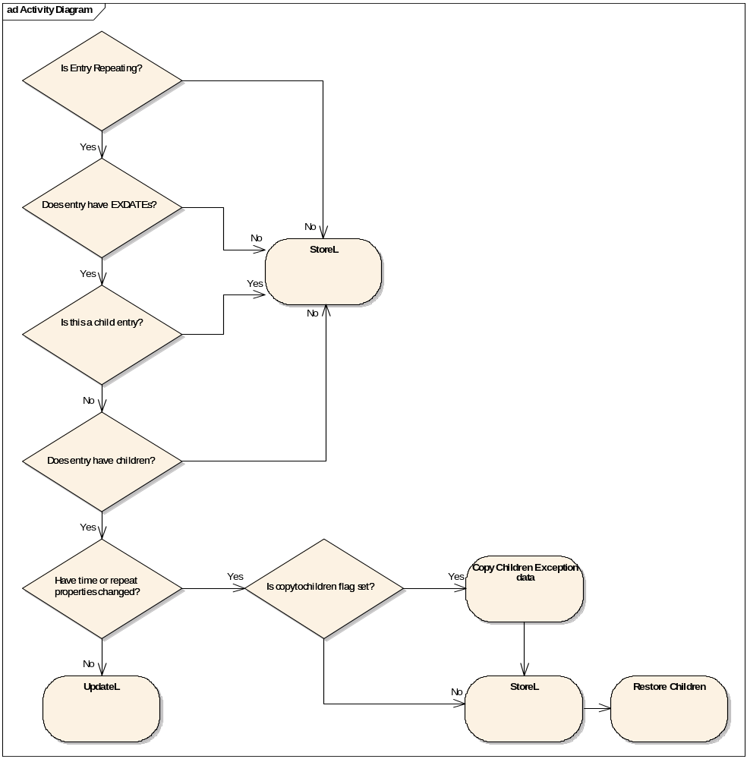
Figure 4.4 StoreL logic

CCalenEComWatcher
CCalenEComWatcher is an active object that watches for changes to the ECom registry. These changes are important as the change to the ECom registry could be a new meeting request solution being installed or removed. If a change to the ECom registry is detected, the availability of the Meeting Request functionality is rechecked. The class design of CCalenEComWatcher is shown in Figure 4.5. CCalenEComWatcher is only created if the flags KFeatureIdMeetingRequestEnabler or KFeatureIdMeetingRequestSupport are set at compile time.
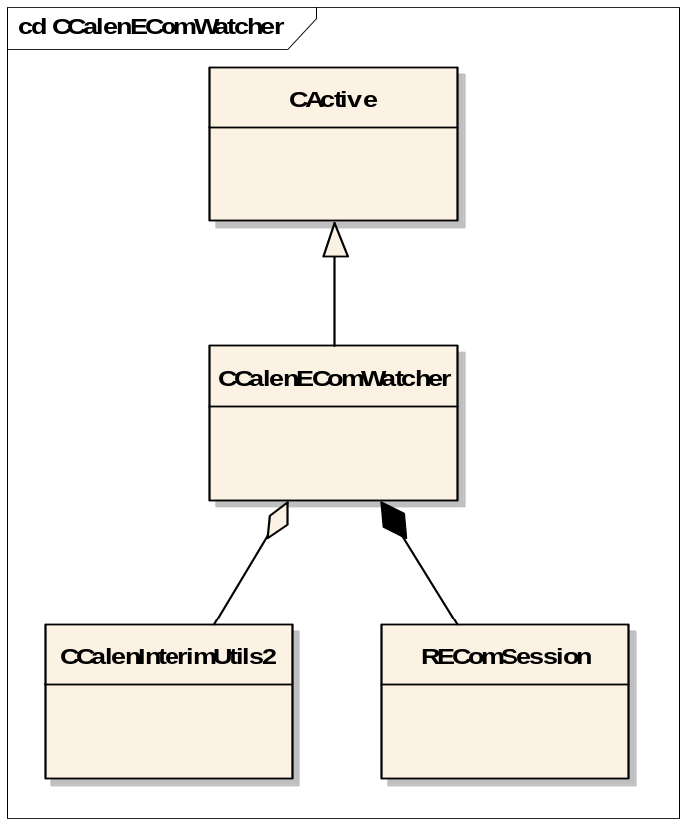
Figure 4.5 CCalenEComWatcher class design
Upon construction CCalenEComWatcher requests notification of ECom changes from REComSession and adds itself to CActiveScheduler. If a change is detected, CCalenEComWatcher::RunL is called, which in turn calls CCalenInterimUtils2::MRViewersEnabledL with a parameter of ETrue. This forces CCalenInterimUtils2 to recheck the availability of installed Meeting Request solutions. CCalenEComWatcher then issues another request for ECom changes and then completes. This sequence is shown in Figure 4.6.
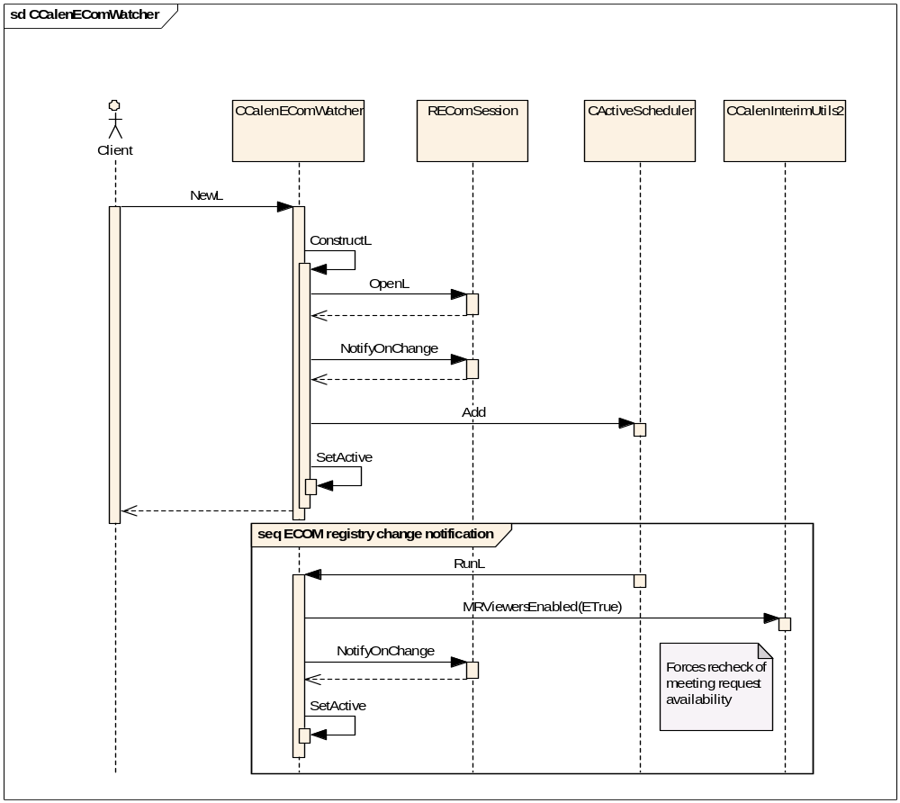
Figure 4.6 CCalenEComWatcher forces a recheck of Meeting Request availability

Backup and Restore
This component does not participate in backup and restore.

Variation
CalenInterimUtils2 is part of the Calendar application and supports variation of Meeting Request Enabler’s functionality. This is described in reference document [3].

System resource usage

Files
This component does not use any files.

Other data

Databases
This component does not use any databases.

Central Repository
This component does not use Central Repository.

Publish and Subscribe
This component does not use Publish and Subscribe.

Task allocation
This component runs in the same thread as the Calendar application, or it can be loaded by a third party application.

Performance
In the function GlobalUidL(), the IMEI of the device is retrieved. This could potentially be a long running process, lasting a number of seconds. In order to minimize the performance loss, the IMEI is stored in the memory the first time the function is run, allowing subsequent calls to bypass the long running call. This does however mean that the global UID function cannot be called statically, and requires the instantiation of a CCalenInterimUtils object.

Timers
This component does not use any timers.

Exception handling
Exception handling is described in reference document [1].

