S60 3.1
Active Idle Agenda Plug-ins
Design Document

Team name | Author
S60 PIM | Aki Lempinen

Change history:

Version | Date | Status | Comments
1.0 | 25.07.2006 | Approved

Table of contents:

1. Document control 5
1.1 References 5
1.2 Documentation conventions 5
1.3 Abbreviations 5
1.4 Definitions 5
2. General 6
2.1 Introduction 6
2.2 Component environment 6
2.3 Use cases 6
2.4 Services required 7
2.4.1 From the Symbian OS subsystems 7
2.4.1.1 Plug-ins 7
2.4.1.2 Agenda Plug-in Engine 8
2.4.2 From the Domestic OS subsystems 8
2.4.3 From HW 8
2.5 Services provided 8
2.5.1 UI 8
2.5.2 SW IF 8
3. UI control hierarchy 9
3.1 Framework 9
3.2 Component 9
4. Design 10
4.1 Class diagrams 10
4.2 Class descriptions 11
4.2.1 Structs, type definitions and enumerations 12
4.2.1.1 AIAgendaPluginEngine.h enumerations 12
4.2.1.2 AIAgendaPluginEngineImpl.h enumerations 12
4.2.1.3 GeneralPluginConstants.hrh enumerations 12
4.2.1.4 CalendarPluginConstants.hrh definitions 13
4.2.1.5 ToDoPluginConstants.hrh definitions 13
4.2.2 State diagrams 13
4.2.2.1 CAIAgendaPluginEngineImpl 13
4.3 Operations 14
4.3.1 Fetching data from Calendar database 14
4.3.2 Fitting Calendar Plug-in items 15
4.4 Backup and Restore 16
5. Variation 17
6. System resource usage 18
6.1 Files 18
6.2 Other data 18
6.2.1 Databases 18
6.2.2 Central Repository 18
6.2.3 Publish and Subscribe 18
6.3 Memory consumption 18
6.4 Task allocation 18
6.5 Timers 19
7. Security 20
7.1 Capabilities of this component 20
7.2 Input and output validation 20
7.3 Environmental assumptions 20
7.4 Additional enforcements 20
8. Exception handling 21
9. Usage 22
9.1 Building 22
9.2 User's guide 22

Document control

References
- S60 Idle UI Specification
- Symbian OS System Documentation | www.symbian.com

Documentation conventions
Code is shown with the Courier New font.

Abbreviations
AI | Active Idle
PIM | Personal information management

Definitions
Agenda | Calendar and To-Do.

General
Active Idle Agenda Plug-ins are components displaying Calendar information in Active Idle. There are three Active Idle Agenda Plug-ins: Calendar Plug-in, To-Do Plug-in and Agenda Plug-in Engine. Calendar Plug-in shows information about today’s day notes, anniversaries and upcoming and ongoing meetings. To-Do Plug-in shows the total amount of uncompleted to-dos. Agenda Plug-in Engine is the data provider for agenda plug-ins.

Introduction
Active Idle Agenda Plug-ins are part of S60 PIM SW and Active Idle.
This document is valid from S60 release 3.1 onwards.

Component environment
The key relationships between Active Idle Agenda Plug-ins, Agenda Plug-in Engine and the components in its environment are shown in Figure 2.1.
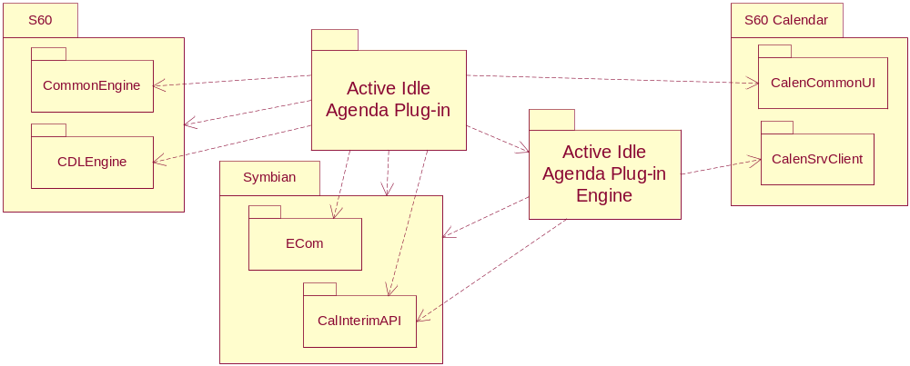
Figure 2.1 Component environment

Use cases
Active Idle Agenda Plug-in Engine is the active part of Active Idle Agenda Plug-ins. Plug-ins are only used to display information provided by Agenda Plug-in Engine. Agenda Plug-in Engine observes a variety of system state changes and reads data from the Agenda database when needed. Agenda Plug-in Engine also takes care of sorting the data and removing obsolete entries.
See Section 4.3 for more information.
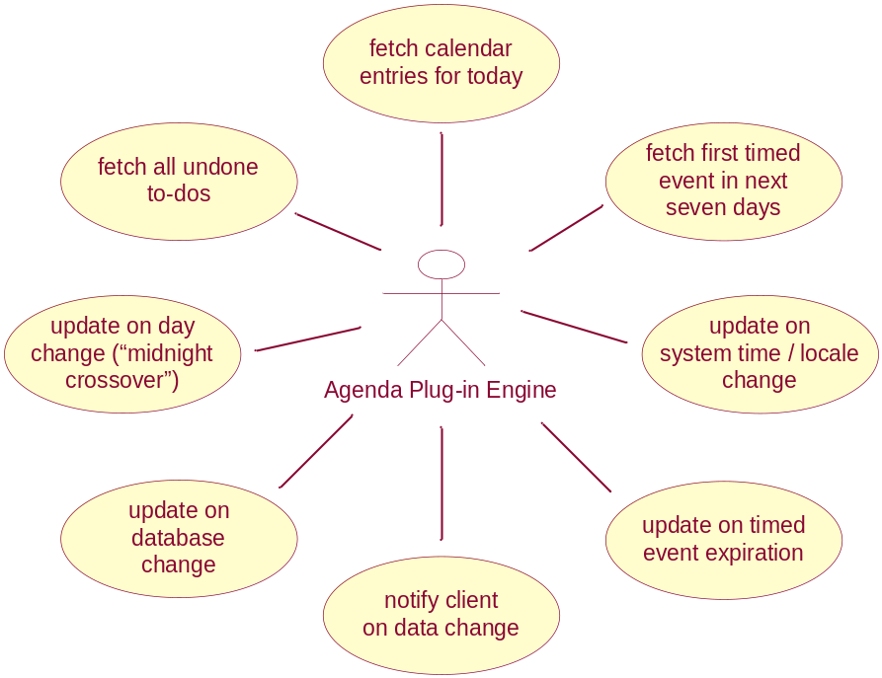
Figure 2.2 Active Idle Agenda Plug-in Engine use cases

Services required

From the Symbian OS subsystems
Services of Symbian OS infrastructure (including stream store, CONE and timer service) and S60 UI Application Framework are required.

Plug-ins
API | Description
AknIcon | AVKON icon utilities.
AknLayout2Scalable | AVKON scalable layout API.
AknSkins | AVKON skinning utilities.
AppArc, ApGrFx | For launching Calendar application.
AVKON | AVKON layout utilities.
BafL | For resource file loading.
CalInterimAPI | New Symbian agenda API.
CDL Engine | AVKON layout information API.
Common Engine | For String Loader.
CONE | Basic Symbian UI control utilities.
EGul | Symbian icon and drawing utilities.
EikCoCtl | For CEikLabel.
EUser | Basic Symbian utilities.
GDI | Symbian graphics utilities.

Agenda Plug-in Engine
API | Description
BafL | For CEnvironmentChangeNotifier.
CalInterimAPI | New Symbian agenda API.
EUser | Basic Symbian utilities.

From the Domestic OS subsystems
This component does not have any direct interfaces to the Domestic OS side subsystems.

From HW
This component has no direct HW interfaces.

Services provided

UI
The main user interface of this module is specified in reference document [1].

SW IF
This component does not provide services for other components.

UI control hierarchy

Framework
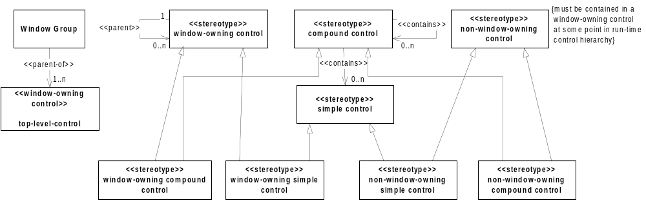
Figure 3.3 Control metamodel
The stereotypes defined in Figure 3.3 can be used for presenting the control hierarchy of the component.

Component
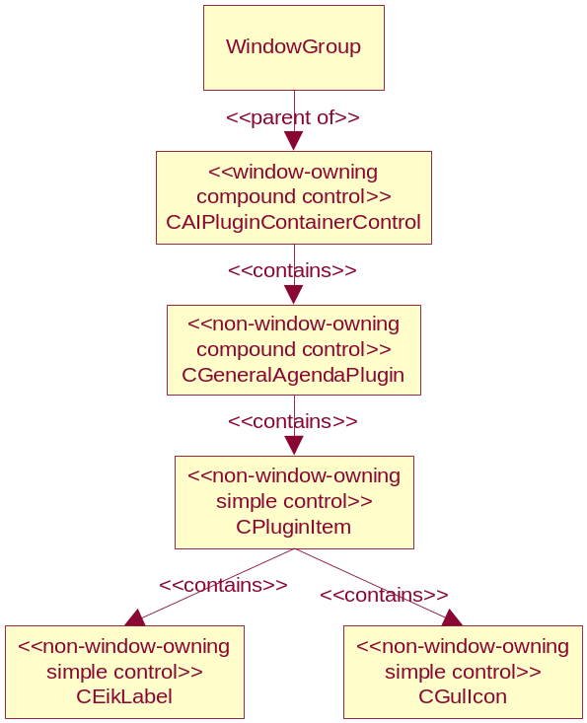
Figure 3.4 Control hierarchy of Active Idle Agenda Plug-in

Design

Class diagrams
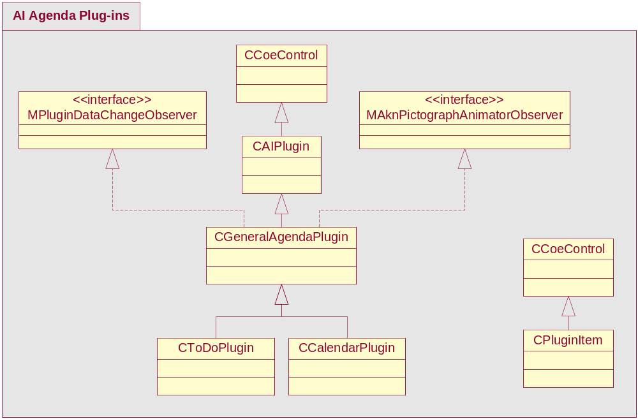
Figure 4.5 Class hierarchy for Active Idle Agenda Plug-ins
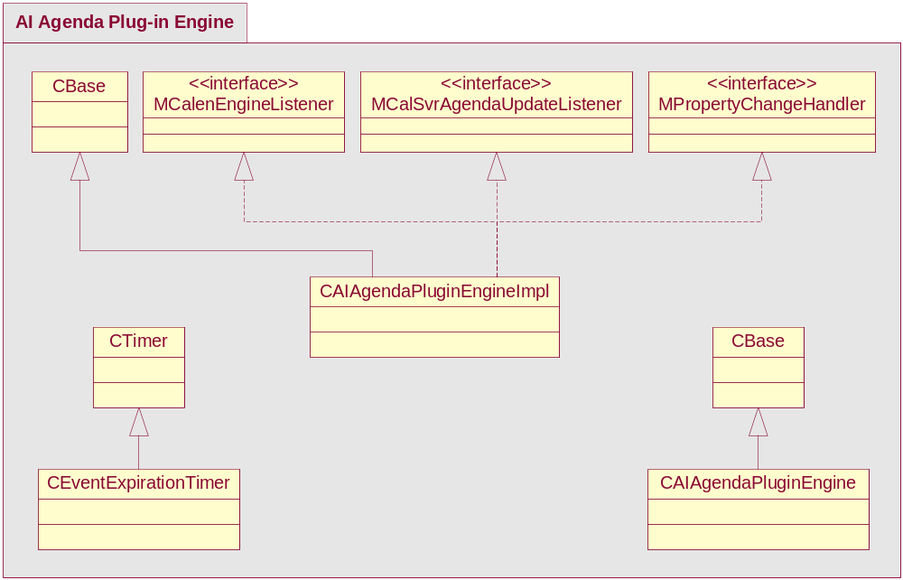
Figure 4.6 Class hierarchy for Active Idle Agenda Plug-in Engine
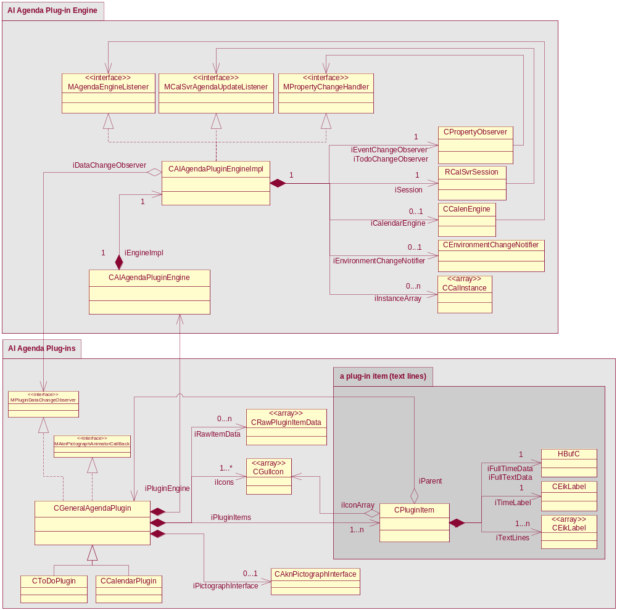
Figure 4.7 Full class diagram of Active Idle Agenda Plug-ins and Active Idle Agenda Plug-in Engine

Class descriptions
Class | Description | Header file
CAIPlugin | Base class for all Active Idle plug-ins. | CAIPlugin.h
CGeneralAgenda  Plugin | Holds common functionality for both Calendar plug-in and To-do plug-in and has default implementations required for CAIPlugin interface. | GeneralAgendaPlugin.h
CToDoPlugin | To-do Plug-in specific implementation. | ToDoPlugin.h
CCalendarPlugin | Calendar Plug-in specific implementation. | CalendarPlugin.h
CPluginItem | Class to represent one Calendar/To-Do entry. Can hold n lines of text. | PluginItem.h
CRawPluginItem  Data | Class to temporarily hold unformatted data for a new CPluginItem. | RawPluginItemData.h
CAIAgendaPlugin  EngineImpl | Contains the actual implementation of Agenda Plug-in Engine. | AIAgendaPluginEngineImpl.h
CAIAgendaPlugin  Engine | A wrapper class for CAIAgendaPluginEngineImpl to hide inclusion dependencies from anyone using it. | AIAgendaPluginEngine.h
MPluginDataChangeObserver | CAIAgendaPluginEngine’s callback interface. | PluginDataChangeObserver.h
CCalenEngine | Asynchronous functions for fetching calendar data. | CalenEngine.h
MAgendaEngine  Listener | CCalenEngine’s callback interface. | CalEngineCallback.h
RCalSvrSession | Used to open a session with Calendar server to make sure the Calendar database exists and to speed-up data fetching. | CalSvrClient.h
MCalSvrAgenda  UpdateListener | RCalSvrSession’s callback interface. | CalSvrClient.h
CPropertyObserver | Observer for Publish and Subscribe. | PropertyObserver.h
MPropertyChange  Handler | CPropertyObserver’s callback interface. Used to observe changes in the Calendar database. | PropertyObserver.h

Structs, type definitions and enumerations

AIAgendaPluginEngine.h enumerations
Enumeration's name | Description
TObserverType | Enumerates all available Agenda Plug-in Engine observer types.

AIAgendaPluginEngineImpl.h enumerations
Enumeration's name | Description
TDBState | Enumerates all states for Agenda Plug-in Engine.
TFetchState | Enumeration to tell if Agenda Plug-in Engine is fetching data for today or for the future.

GeneralPluginConstants.hrh enumerations
Definition/Enumeration's name | Description
TPluginItemType | Enumerates all plug-in item types. And extension of CAgnEntry::TType.
KDefaultMaxIcons | Maximum amount of icons to load.
KMaxItemTextLength | Maximum text length for two line plug-in item.
KMinItemTextLength | Minimum text length for one line plug-in item.
KSizeTimeFormatUsual | Buffer length for “usual” time format.
KSizeDateShort | Buffer length needed for a short date format.

CalendarPluginConstants.hrh definitions
Definition’s name | Description
KMaxItemSize | Maximum amount of text lines per CPluginItem.
KMinItemSize | Minimum amount of text lines per CPluginItem.

ToDoPluginConstants.hrh definitions
Definition’s name | Description
KMaxItemSize | Maximum amount of text lines per CPluginItem.
KMinItemSize | Minimum amount of text lines per CPluginItem.

State diagrams

CAIAgendaPluginEngineImpl
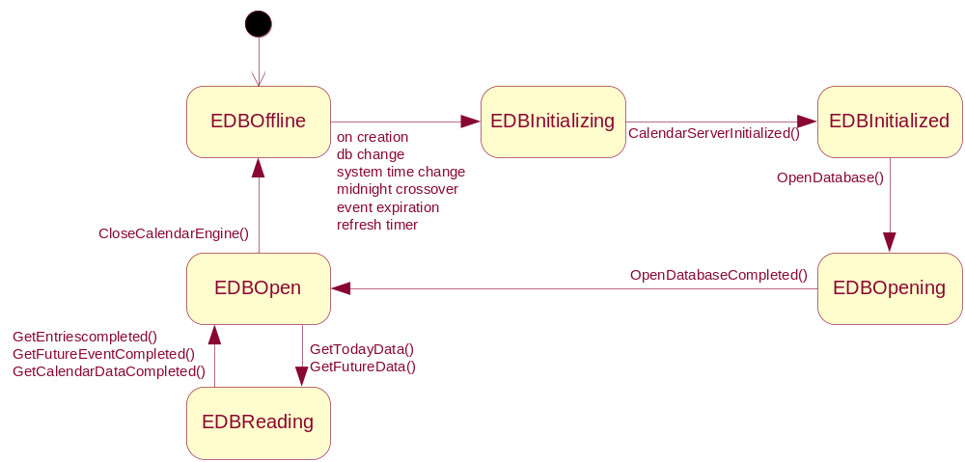
Figure 4.8 Active Idle Agenda Plug-in Engine’s state machine
Figure 4.8 does not include error handling or refresh requests on other than the EDBOffline state.
Error handling is implemented through CCalenEngine’s callback interface MCalenEngineListener::HandleError(). Agenda Plug-in Engine’s HandleError implementation resets the state machine (EDBOffline), deletes the CCalenEngine instance and closes the RCalSvrSession. Agenda Plug-in Engine then starts a refresh timer with one minute timeout. Internal errors (leaves) are all TRAPped and cause the state machine to reset. For more information, see Chapter 8.
Any refresh requests are ignored in other states than EDBOffline and EDBReading. Refresh request during state EDBReading causes Agenda Plug-in Engine to re-fetch the data as soon as it returns from EDBReading to EDBOpen.
State EDBOpen is just a transition state between state changes from EDBOpening to EDBReading and EDBReading to EDBOffline.
The normal (idle) state of the machine is EDBOffline. One full loop of the state machine is illustrated in Figure 4.9.

Operations

Fetching data from Calendar database
Operation | Fetching data from Calendar database.
Preconditions | Active Idle has been started and CAIAgendaPluginEngine is created.
Description | When CAIAgendaPluginEngine is created it starts to fetch data from the Calendar database and notifies the plug-in when the data is available.  Data is fetched asynchronously through CCalenEngine class. The sequence diagram can be found in Figure 4.9. All error situations during asynchronous operations in CCalenEngine are handled in Agenda Plug-in Engine’s HandleError() function.
Inputs | CAIAgendaPluginEngine class creation or any of the signals starting the state machine (see Figure 4.8).
Modifies | Opens the RCalSvrSession and creates CCalenEngine to populate the iInstanceArray seen in Figure 4.7.
Outputs | Array of calendar entries for the plug-in.
Postconditions | The plug-in has updated itself. Fetched data and CCalEngine has been deleted and RCalSvrSession closed.
Related To | The classes CAIAgendaPluginEngine, RCalSvrSession, CCalenEngine and MPluginDataChangeObserver.
Related Event | See the Active Idle Agenda Plug-in Engine state machine in Figure 4.8.
Exceptions | Error handling is implemented through CCalenEngine’s callback interface MCalenEngineListener::HandleError(). Agenda Plug-in Engine’s HandleError implementation resets the state machine (EDBOffline), deletes the CCalenEngine instance and closes RCalSvrSession. Agenda Plug-in Engine then starts a refresh timer with one minute timeout. Internal errors (leaves) are all TRAPped and cause the state machine to reset. For more information, see Chapter 8.

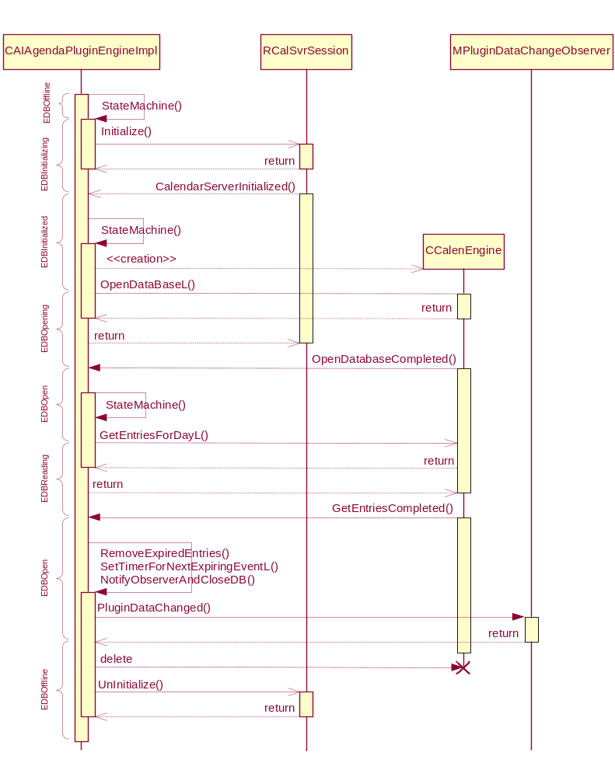
Figure 4.9 Sequence diagram of Agenda Plug-in Engine fetching Calendar data

Fitting Calendar Plug-in items
Operation | Fitting Calendar Plug-in’s contents on SizeChange().
Preconditions | Active Idle Framework has changed Calendar Plug-in’s size.
Description | Each time Calendar Plug-in’s size is changed it needs to re-fit as many items on the screen as possible. Item prioritization is described in reference document [1].
Inputs | CCoeControl::SizeChanged()
Modifies | Resets visibility and placement of all CPluginItems in iPluginItems array.
Outputs
Postconditions | Calendar Plug-in content has been re-laid out.
Related To | CCalendarPlugin::SizeChanged(), the class CPluginItem.
Related Event | Calling ReportEventL( MCoeControlObserver::EEventStateChanged ) to inform the Active Idle Framework about plug-in data change.

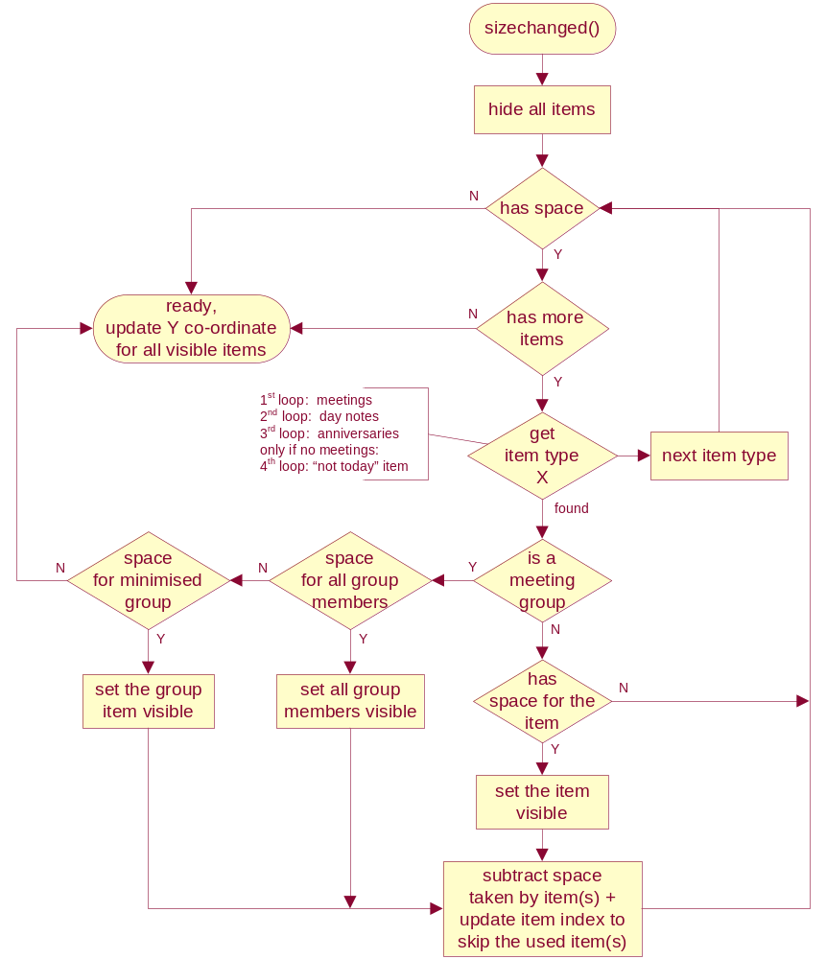
Figure 4.10 Calendar Plug-in’s item fitting algorithm

Backup and Restore
This component does not participate in backup and restore directly. Active Idle unloads all the plug-ins when it receives backup or restore notification.

Variation
Calendar Plug-in, To-Do Plug-in and Agenda Plug-in Engine use build time and image creation time variation. Plug-ins are built only if __ACTIVE_IDLE flag is enabled. The engine is built if either __ACTIVE_IDLE or RD_CUSTOMIZABLE_AI flag is enabled. Both flags are defined in epoc32/include/oem/bldvariants.hrh.

System resource usage

Files
This component does not use any files.

Other data

Databases
Active Idle Agenda Plug-in Engine uses the Calendar database through Symbian CalInterimAPI.

Central Repository
This component does not use Central Repository.

Publish and Subscribe
This component does not publish any Publish and Subscribe keys, but observes changes on the following keys:

Category | Key Name | Description
KCalPubSubCategory | ECalPubSubEventNotification | To get notifications on Calendar data changes.
KCalPubSubCategory | ECalPubSubTodoNotification | To get notifications on (To-Do specific) calendar data changes.

Memory consumption
Memory/Build | Consumption
User data | 0 bytes
Agenda Plug-in Engine
- WINSCW UDeb | ~227 KB
- ARMV5 URel | ~3.7 KB
Calendar Plug-in
- WINSCW UDeb | ~1.33 MB
- ARMV5 URel | ~12.2 KB
To-Do Plug-in
- WINSCW UDeb | ~1.30 MB
- ARMV5 URel | 9.2 KB

Task allocation
Active Idle Agenda Plug-ins run inside the Phone Idle thread.
Agenda Plug-in Engine causes Calendar Server to be started if it is not already running. Calendar Server is always started during the boot time even if Active Idle is not enabled.

Timers
Timer | Purpose | Interval | Lifetime
CAIAgendaPluginEngineImpl::iExpirationTimer | Calendar meeting expiration causes Agenda Plug-in Engine to re-fetch the data. | 0 – 1439 minutes | Only active when data contains ongoing or upcoming meetings.
CAIAgendaPluginEngineImpl::iRefreshTimer | Prevent excessive plug-in update by restarting the timer after each refresh request. | 1.5 seconds | Restarted on every refresh request.

Security

Capabilities of this component
Active Idle Agenda Plug-ins have no special capabilities. Calendar Plug-in and To-Do Plug-in use default ECom capabilities defined in CAP_GENERAL_DLL and Agenda Plug-in Engine uses the default DLL capabilities defined in CAP_GENERAL_DLL.

Input and output validation
This component does not require or make any validation for data.

Environmental assumptions
This component does not make any assumptions about its environment.

Additional enforcements
This component does not have any additional security enforcements.

Exception handling
Active Idle Plug-ins are not allowed to leave so all leaving functions need to be TRAPped.
Calendar Plug-in and To-Do Plug-in use the following macro to handle all internal error situations:

#define HANDLE_ERR(_s){ TRAPD(err, _s); if(err!=KErrNone) DiminishOnError(); }

DiminishOnError() causes all plug-in items to be deleted and the plug-in control to be hidden in the Active Idle. The plug-in may reappear during the next update from Agenda Plug-in Engine.
Agenda Plug-in Engine uses a similar macro to handle its internal errors:

#define HANDLE_ERR(_s){ TRAPD(err, _s); if(err!=KErrNone) CloseCalendarEngine(); }

CloseCalendarEngine() stops the state machine and ends all active operations with the Calendar database.
External Agenda Plug-in Engine errors (while opening or reading the database) are handled through the MCalenEngineListener’s HandleError() interface. This also calls CloseCalendarEngine(), but also starts the refresh timer to resume the operation after a minute.
Plug-ins keeps their state and do not get any error notifications or data updates on Agenda Plug-in Engine failure.

Usage

Building
In \s60\calendar\group:
- #> bldmake bldfiles
- #> abld build

User's guide
This application is not used by other components.

