S60 3.1
CalenGlobalData
Design Document

Team name | Author
 | Charles McKenna

Change history:

Version | Date | Status | Comments
1.0 | 28.07.2006 | Approved

Table of contents:

1. Document control 4
1.1 References 4
1.2 Documentation conventions 4
1.3 Abbreviations 4
2. General 5
2.1 Introduction 5
2.2 Component environment 5
2.3 Services required 6
2.3.1 From the Symbian OS subsystems 6
2.3.2 From the Domestic OS subsystems 6
2.3.3 From HW 6
2.4 Services provided 6
2.4.1 UI 6
2.4.2 SW IF 7
3. UI control hierarchy 8
4. Design 9
4.1 Class overview 9
4.1.1 Structs, type definitions and enumerations 9
4.2 CCalenGlobalData 9
4.2.1 CCalenGlobalData::InstanceL 10
4.2.2 CCalenGlobalData::Release 12
4.2.3 CCalenGlobalData::MailboxUtilsL 12
4.2.4 CCalenGlobalData::MeetingRequestUtilsL 12
4.2.5 CCalenGlobalData::CalSessionL 13
4.2.6 CCalenGlobalData::CalenSendL 13
4.2.7 CCalenGlobalData::InterimUtilsL 13
4.2.8 CCalenGlobalData::DbChangeNotifierL 13
4.2.9 CCalenGlobalData::InstanceViewL 13
4.2.10 CCalenGlobalData::EntryViewL 13
4.3 CCalenViewObserver 13
4.4 CCalenDbChangeNotifer 15
4.5 Backup and Restore 16
5. Variation 17
6. System resource usage 18
6.1 Files 18
6.2 Databases 18
6.3 Central Repository 18
6.4 Publish and Subscribe 18
6.5 Task allocation 18
6.6 Timers 18
6.7 Exception handling 18

Document control

References
- S60 Calendar Application Design Document
- S60 CalenInterimUtils2 Design Document
- S60 Calendar Meeting Request Enabler Framework Design Document

Documentation conventions
Code is shown with the Courier New font.

Abbreviations
TLS | Thread Local Storage

General

Introduction
CalenGlobalData is a singleton class used as a point of access to a number of objects commonly used throughout the Calendar application.

Component environment
The key relationships between CalenGlobalData and other Calendar components are shown in Figure 2.1.
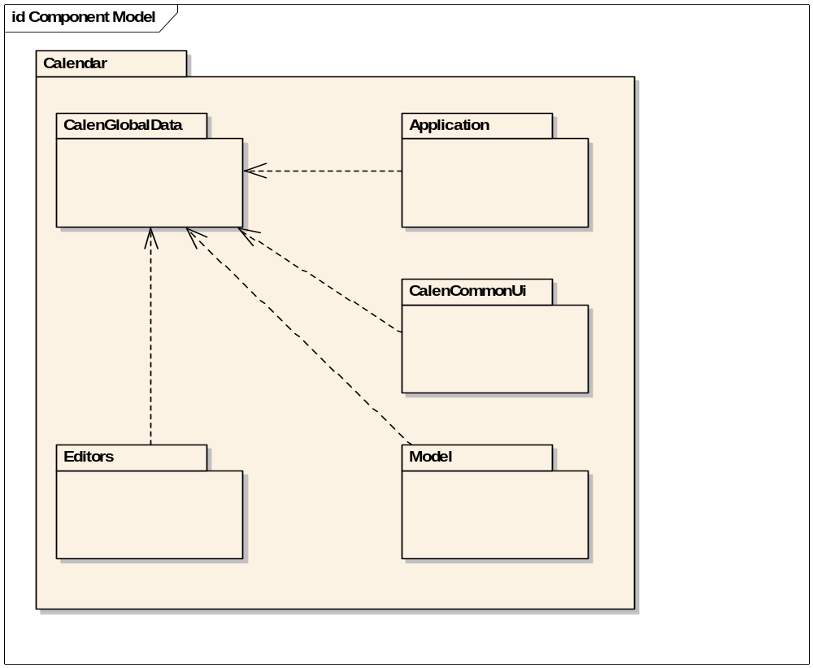
Figure 2.1 Component environment

Services required

From the Symbian OS subsystems
The table below shows the Symbian OS subsystems used by CCalenGlobalData.

API | Description
euser.lib | E32 base.
ecom.lib | ECom plug-in framework.
caleninterimutils2.lib | Calendar utilities.
calinterimapi.lib | Symbian calendar access.
calenimp.lib | Calendar importer.
charconv.lib | Conversion between 8-bit and 16-bit descriptors.
estor.lib | Stream store.
efsrv.lib | File server.
sendui.lib | CSendUi.
avkon.lib | AVKON framework.
sysutil.lib | System Utilities.
eikcoctl.lib | EIKON framework.
eikcore.lib | EIKON framework.
commonui.lib | Common application UI.
bafl.lib | Basic Application Framework Library.
commonengine.lib | Common Application Engine.
cone.lib | Control Environment.
etext.lib | Text manipulation APIs.
featmgr.lib | Feature Manager.

From the Domestic OS subsystems
This component does not have any direct interfaces to the Domestic OS side subsystems.

From HW
This component has no direct HW interfaces.

Services provided

UI
UI components are discussed in Chapter .

SW IF
The table below shows the external interface for CCalenGlobalData.

Provided Service | Description
NewL | Creates a new instance of the global data if none exists, or returns the existing instance.
Release | Releases an instance of the global data. If no other objects are using the global data it destroys itself.
MailboxUtilsL | Returns a reference to the mailbox utilities.
MeetingRequestUtilsL | Returns a reference to the Meeting Request utilities.
CalSessionL | Returns a reference to the Calendar session.
InstanceViewL | Returns a reference to the Calendar instance view.
EntryViewL | Returns a reference to the Calendar entry view.
InterimUtilsL | Returns a reference to the Calendar interim utilities 2.
DbChangeNotifierL | Returns a reference to the database change notifier.
AttemptToRetrieveDefaultMailboxL | Checks to see if any mailboxes are defined, and if so whether one has been previously selected as the default.

UI control hierarchy
The only UI provided is a CAknSinglePopupMenuStyleListBox, which may be displayed if the user has not yet selected a default mailbox to use for Meeting Requests, but the Meeting Request functionality is available on the device. Meeting Request support is discussed in reference document [3].

Design

Class overview
CalenGlobalData.lib contains the following classes:

Class | Description | Header file
CCalenDbChangeNotifier | Buffers notifications of database changes and notifies its observers after a set period has elapsed. | CalenDbChangeNotifier.h
MCalenDbChangeObserver | Observer class to receive notifications from CCalenDbChangeNotifier. | CalenDbChangeNotifier.h
CCalenGlobalData | Global data singleton. Provides convenient access to commonly used objects. | CalenGlobalData.h
CCalenSend | Handles sending of Calendar data. | CalenSend.h
TCalenVCalExport | Exports agenda entries to vCalendar format. | CalenVCalExport.h
CCalenViewObserver | Handles the construction of CCalInstanceView and CCalEntryView synchronously. | CalenViewObserver.h

Structs, type definitions and enumerations
This component does not have any public structs, type definitions or enumerations.

CCalenGlobalData
The main purpose of CCalenGlobalData is to act as a central point of access for a number of other classes. CCalenGlobalData is a standard CBase derived class, and implements one interface, MMRUtilsObserver. The class design is shown in Figure 4.2.
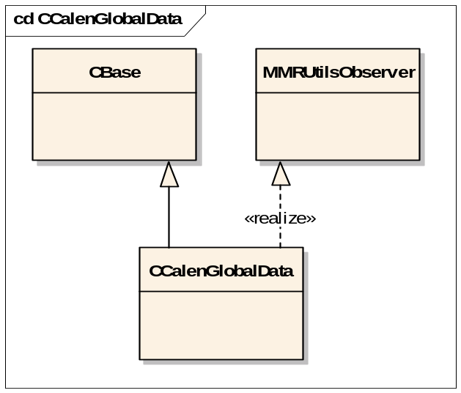
Figure 4.2 CCalenGlobalData class design
Data members owned by CCalenGobalData are shown in Figure 4.3.
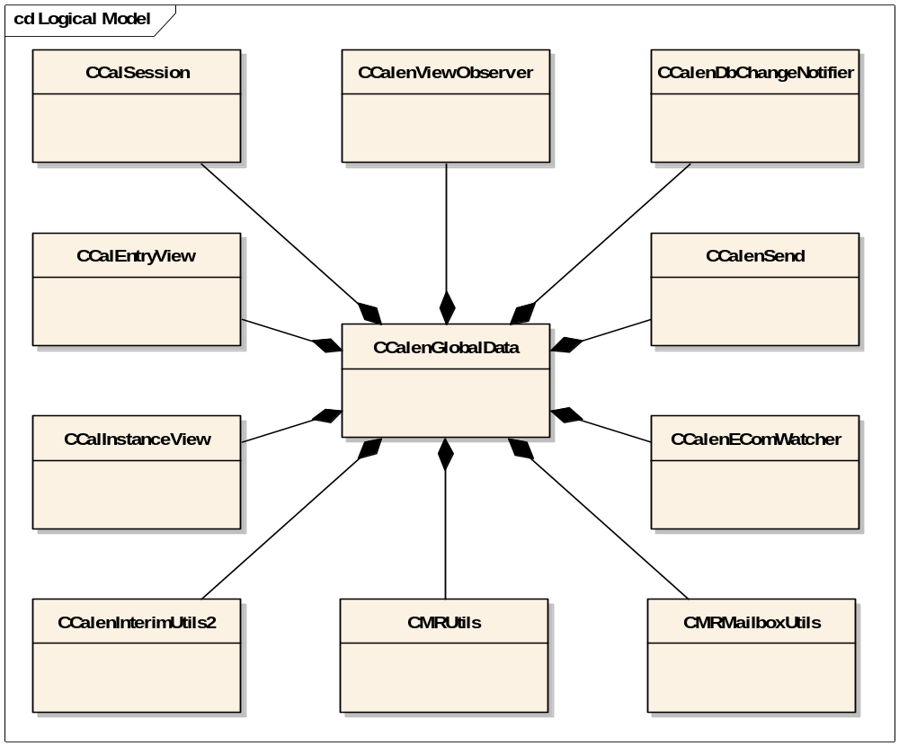
Figure 4.3 CCalenGlobalData member data

CCalenGlobalData::InstanceL
The first time CCalenGlobalData::InstanceL is called a new instance of CCalenGlobalData is created. A pointer to this instance is then stored in TLS. Subsequent calls to InstanceL return the pointer to this object, ensuring that only one instance of CCalenGlobalData can be created per thread. CCalenGlobalData uses reference counting to keep track of how many other objects are using this single instance.
It is also possible to create the instance of CCalenGlobalData with an existing CCalSession reference, allowing different Calendar databases to be used. When creating CCalenGlobalData with an existing CCalSession, it is the responsibility of the caller to maintain the session until CCalenGlobalData has been released by all clients, and to handle the cleanup of the session. Calling CCalenGlobalData::InstanceL with an existing CCalSession which is different to CCalSession used during construction causes this function to leave with KErrAlreadyExists.
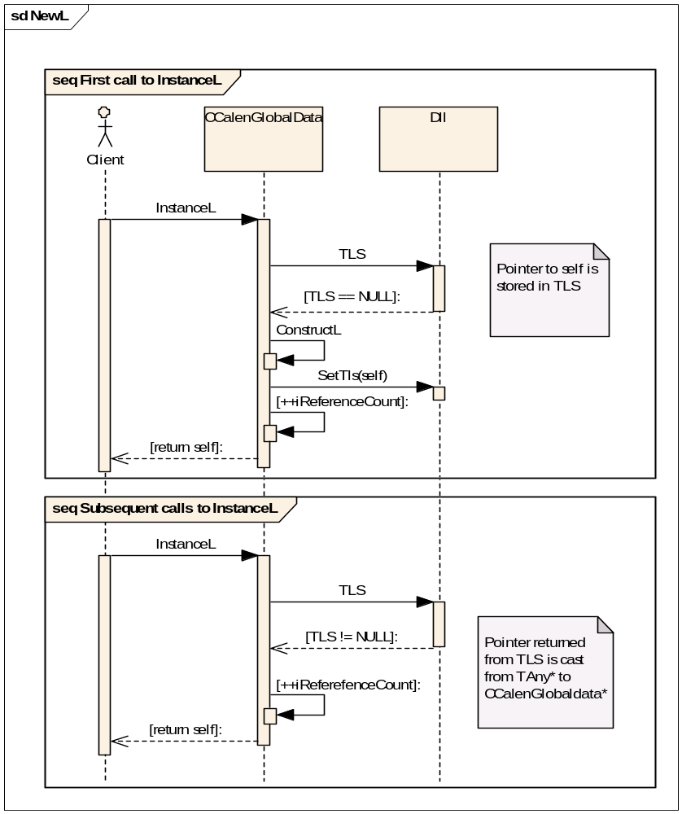
Figure 4.4 CCalenGlobalData::InstanceL

CCalenGlobalData::Release
The destructor of CCalenGlobalData is private to prevent deletion of the object while other classes are still using it. Clients should call Release when finished with the CCalenGlobalData object. This decrements the object’s reference count. When the reference count reaches 0, CCalenGlobalData destroys itself, cleaning up all allocated resources and freeing the TLS pointer.
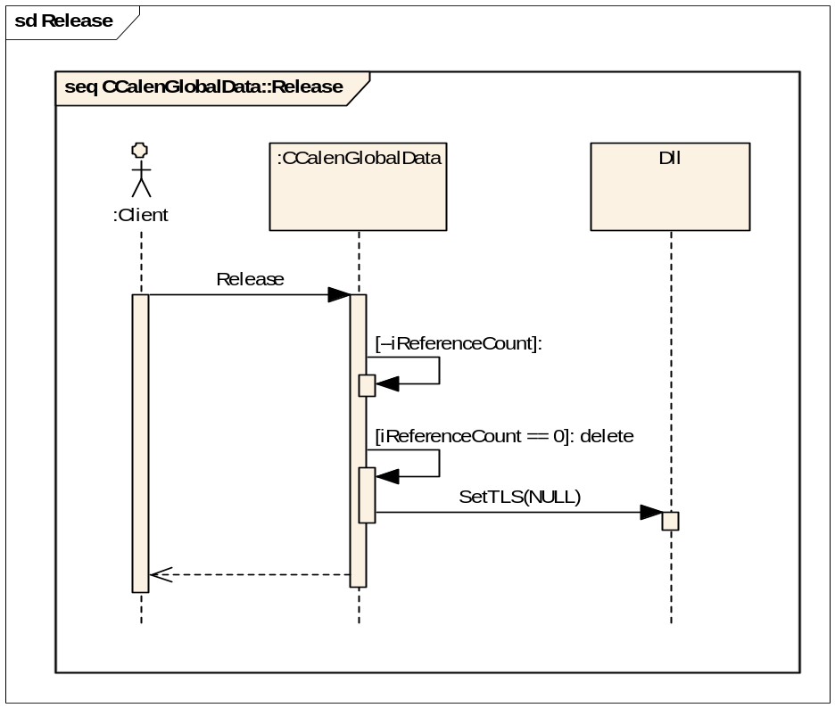
Figure 4.5 CCalenGlobalData::Release

CCalenGlobalData::MailboxUtilsL
CCalenGlobalData::MailboxUtilsL returns a reference to the instance of CMRMailboxUtils owned by CCalenGlobalData. CMRMailboxUtils is only created the first time this function is called. If the Meeting Request functionality is not available on the terminal then this function leaves with KErrNotSupported.

CCalenGlobalData::MeetingRequestUtilsL
CCalenGlobalData::MeetingRequestUtilsL returns a reference to the instance of CMRUtils owned by CCalenGlobalData. CMRUtils is only created the first time this function is called. If the Meeting Request functionality is not available on the terminal then this function leaves with KErrNotSupported. The creation of CMRUtils is normally an asynchronous operation, but this function returns synchronously. A CActiveSchedulerWait object is created and started. When the creation of CMRUtils is complete CCalenGlobalData::HandleCalEngStatus (defined in MMRUtilsObserver) is called. This stops CActiveSchedulerWait, causing CCalenGlobalData::MeetingRequestUtilsL to return the newly created CMRUtils. This function may leave with a standard error code when creating a new CMRUtils.

CCalenGlobalData::CalSessionL
CCalenGlobalData::CalSessionL returns a reference to an instance of CCalSession. If CCalenGlobalData was not constructed with an existing CCalSession reference, and this is the first time the function has been called, then a new CCalSession is created using the standard Calendar database file path defined by KCalendarDatabaseFilePath. If the Calendar database does not exist a new one is created. This function may leave with a standard error code when creating a new Calendar database, for example if there is not enough free disk space available.
If CCalenGlobalData was created using a CCalSession reference it is a reference to this session that is returned.

CCalenGlobalData::CalenSendL
CCalenGlobalData::CalenSendL returns a reference to an instance of CCalenSend owned by CCalenGlobalData. CCalenSend is only created the first time this function is called.

CCalenGlobalData::InterimUtilsL
CCalenGlobalData::InterimUtilsL returns a reference to an instance of CCalenInterimUtils2 owned by CCalenGlobalData. CCalenInterimUtils2 is only created the first time this function is called. CCalenInterimUtils2 is described in reference document [2].

CCalenGlobalData::DbChangeNotifierL
CCalenGlobalData::DbChangeNotifierL returns a reference to an instance of CCalenDbChangeNotifier owned by CCalenGlobalData. CCalenDbChangeNotifier is only created the first time this function is called.

CCalenGlobalData::InstanceViewL
CCalenGlobalData::InstanceViewL returns a reference to an instance of CCalInstanceView owned by CCalenGlobalData. CCalInstanceView is only created the first time this function is called. The creation of CCalInstanceView is synchronous and is managed by CCalenViewObserver. CCalenViewObserver is described in Section 4.3.

CCalenGlobalData::EntryViewL
CCalenGlobalData::EntryViewL returns a reference to an instance of CCalEntryView owned by CCalenGlobalData. CCalEntryView is only created the first time this function is called. The creation of CCalEntryView is synchronous and is managed by CCalenViewObserver. CCalenViewObserver is described in Section 4.3.

CCalenViewObserver
The main role of CCalenViewObserver is to handle the initial creation of CCalEntryView and CCalInstanceView synchronously. The creation of these objects is normally an asynchronous operation. The class design of CCalenViewObserver is shown in Figure 4.6.
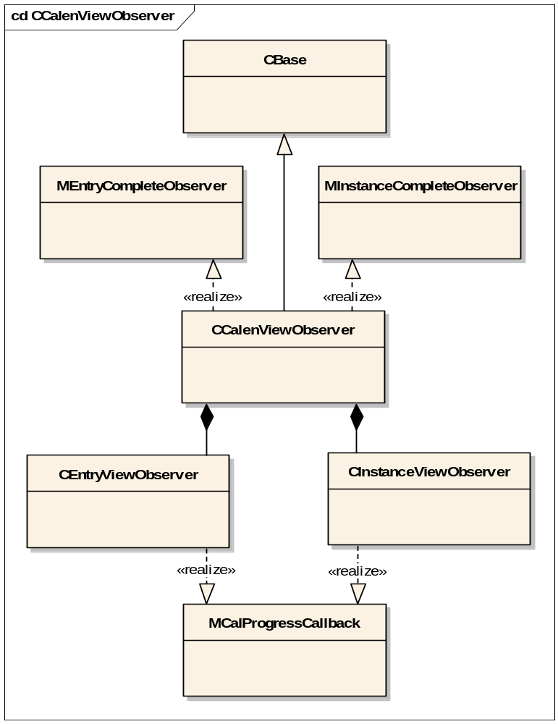
Figure 4.6 CCalenViewObserver class design
CCalenViewObserver also makes use of three CActiveSchedulerWait objects to handle the queuing of the asynchronous requests. One CActiveSchedulerWait is used to manage creation of CCalInstanceView, one is used to handle the creation of CCalEntryView and the third is used to queue requests. This means that calling CCalenGlobalData::EntryViewL while CCalenViewObserver is creating a CCalInstanceView blocks until CCalInstanceView has been created. The same logic applies if the requests are reversed, and a client requests creation of a CCalInstanceView while the creation of a CCalEntryView is in progress. A request to create a CCalInstanceView while a CCalInstanceView is being created (or a CCalEntryView while a CCalEntryView is being created) results in the function leaving with KErrInUse.
CCalenViewObserver delegates the creation of CCalEntryView and CCalInstanceView to CEntryViewObserver and CInstanceViewObserver respectively. Both CEntryViewObserver and CInstanceViewObserver implement MCalProgressCallback interface defined in CalInterimAPI.
After calling CCalEntryView::NewL, which returns synchronously, CActiveSchedulerWait::Start is called. This call blocks until CActiveSchedulerWait::AsyncStop is called. When CCalEntryView is ready for use, MCallProgressCallback::Complete is called. In this case, CCalEntryViewObserver implements the MCallProgressCallback interface. CCalEntryViewObserver notifies CCalenViewObserver through the MEntryCompleteObserver interface. CCalenViewObserver then stops CActiveSchedulerWait, causing the initial call to CActiveSchedulerWait::Start to complete. At this point, CCalEntryView is available for use, and ownership of the newly created CCalEntryView is passed to CCalenGlobalData. This sequence of events is shown in Figure 4.7.
The creation of CCalInstanceView is identical to the creation of CCalEntryView, except CCalInstanceViewObserver implements the MCallProgressCallback interface.
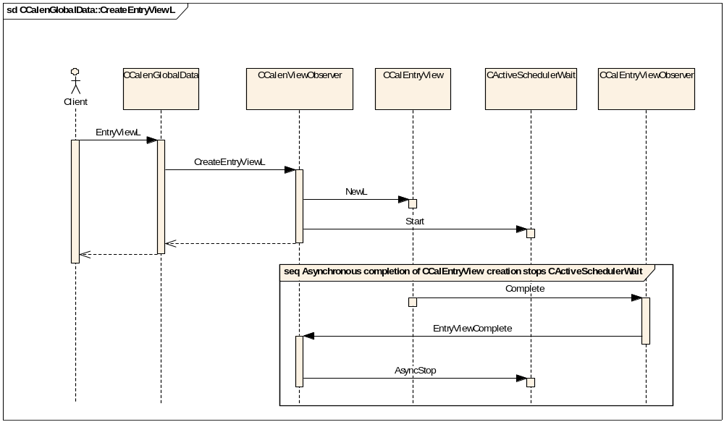
Figure 4.7 Synchronous creation of CCalEntryView

CCalenDbChangeNotifer
CCalenDbChangeNotifier is an active object that receives notification of an agenda database change from another CCalSession. The most common reason for this to occur is an external synchronous operation running while Calendar is open. CCalenDbChangeNotifier maintains an array of MCalenDbChangeObserver pointers, which may be added to or removed from at any time. The observers in the array are not owned by this class, and are not cleaned up automatically on destruction. Bulk synchronous operations may produce a large number of database change notifications, so CCalenDbChangeNotifier buffers these notifications and only notifies its observers at a rate defined by KTimerResolution. This value is currently fixed at one second, and can only be changed at compile time.
The class design for CCalenDbChangeNotifier is shown in Figure 4.8.
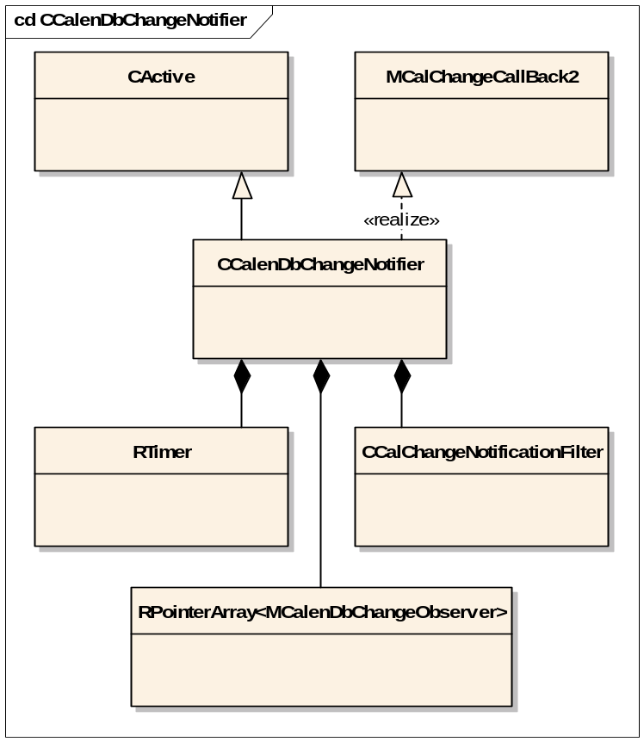
Figure 4.8 CCalenDbChangeNotifier class design
CCalenDbChangeNotifier implements MCalChangeCallBack2 for receiving database change notifications. The date range that notifications are received for is defined by CCalChangeNotificationFilter, and is currently set to include all types of event over the entire agenda date range.
When an external CCalSession modifies the agenda database, a callback to MCallBack2::CalChangeNotification is issued. If this is the first notification received since the timer last expired, the timer is started and expires after KTimerResolution. When the timer expires, CCalenDbChangeNotifier::RunL is called, and each MCalenDbChangeObserver in the observer array is notified. If a notification is received after the timer has been started but before the timer has expired then the timer is cancelled, then restarted. This limits the number of notifications sent to observers during large synchronous operations. Regardless of whether CCalenDbChangeNotifier notified its observers or not, the time of the last database change notification is always available through CCalenDbChangeNotifier::LastDbModificationTime.
CCalenDbChangeNotifier is currently used to force a refresh of the active view in Calendar when the database is externally modified. This prevents the active view potentially displaying out of date information to the user.

Backup and Restore
This component does not participate in backup and restore.

Variation
CalenGlobalData is part of the Calendar application and supports the variation of Meeting Request Enablers functionality. This is described in reference document [3].

System resource usage

Files
This component does not use any files.

Databases
This component does not use any databases directly.

Central Repository
This component does not use Central Repository.

Publish and Subscribe
This component does not use Publish and Subscribe.

Task allocation
This component runs in the same thread as the Calendar application.

Timers
Timer usage is described in Section 4.4.

Exception handling
Exception handling is described in reference document [1].

