S60 3.2
Calendar Regional Plug-ins
Design Document

Team name | Author
TP SP SWD PAS PIM & First Time Use | Antti Pietarinen

Change history:

Version | Date | Status | Comments
1.0 | 15.02.2007 | Approved

Table of contents:

1. Document control 4
1.1 References 4
1.2 Documentation conventions 4
1.3 Abbreviations 4
1.4 Definitions 4
2. General 5
2.1 Introduction 5
2.2 Component environment 5
2.3 Use cases 6
2.3.1 Show regional (lunar) data in Calendar views 6
2.3.2 Show Buddhist year in Calendar views 7
2.3.3 Show regional information via Options menu 7
2.3.4 Disable/enable Lunar Calendar 7
2.3.5 Disable/enable Thai Calendar 8
2.4 Services required 8
2.4.1 From the Symbian OS subsystems 8
2.4.2 From the Domestic OS subsystems 8
2.4.3 From HW 8
2.5 Services provided 9
2.5.1 UI 9
2.5.2 SW IF 9
3. Design 10
3.1 Class diagrams 10
3.1.1 Component 10
3.2 Class descriptions 10
3.2.1 Lunar Calendar 10
3.2.2 Thai Calendar 11
3.3 Operations 11
3.3.1 Opening the Calendar application 11
3.3.2 Showing lunar data in an extra row 12
3.3.3 Show the lunar data Information note 13
3.3.4 Disabling a regional Calendar 14
3.3.5 Showing the Buddhist year in the extra row 14
4. Variation 16
4.1 Chinese Lunar Calendar 16
4.2 Vietnamese Lunar Calendar 16
4.3 Thai Calendar 16
5. System resource usage 17
5.1 Other data 17
5.1.1 Databases 17
5.1.2 Central Repository 17
6. Exception handling 18
7. Usage 19
7.1 Building 19
7.2 User's guide 19
7.2.1 Other settings 19
APPENDIX A: SolarItems data file and MakeSolar.exe 20

Document control

References
- S60 Calendar Application Design Document
- S60 Calendar UI Specification
- 1921-2060 (ISBN 7-5345-3027-X)
- (ISBN 7-5326-0628-7)

Documentation conventions
Code is shown with the Courier New font.

Abbreviations
AVKON | UIKON extended library
CCON | Symbian ccon.dll. Calendar conversion library.
DLL | Dynamic Link Library
ECom | Symbian OS plug-in framework
UIKON | GUI library for Symbian OS.

Definitions
Regional plug-in | Chinese, Vietnamese or Thai calendar.
Lunar Calendar | Common definition for Vietnamese and Chinese Lunar Calendar. Requires the Chinese platform variant and one of the Chinese language variants OR the western platform variant and the Vietnamese language variant.
Chinese Lunar Calendar | A combined solar/lunar calendar in that it strives to have its years coincide with the tropical year and its months coincide with the synodic months. Chinese Lunar Calendar is used in China to determine festival days.
Vietnamese Lunar Calendar | Very similar to Chinese Lunar Calendar with some exceptions, e.g. in festival days.
Thai Calendar | A standard calendar extended with Buddhist years. Requires the Thai platform variant and the Thai language variant.
Gregorian Calendar | The standard calendar used in most parts of the world.
Jie Qi festivals | Agriculturally significant dates of a Chinese solar year. These are shown in Chinese Lunar Calendar. There are total of 24 Jie Qi dates in one year. The SolarItems file lists these dates for the period of 1.1.1980-30.12.2090. These dates are listed in reference documents [3] and [4].
Solar festivals | See Jie Qi festivals.
SolarItems | The SolarItems data file contains the Jie Qi festival dates.

General

Introduction
The Calendar regional plug-in framework functionality extends and modifies the standard S60 Calendar application in three ways:
- It shows regional Calendar information in the Calendar Month, Week and Day views (see reference documents [1] and [2].
- It extends the Options menu of the Month, Week and Day views.
- It extends the Settings view.

For a detailed description of the usage of the Regional Plug-in Framework interface, see Section 2.5.2.
Regional plug-ins are implemented as ECom plug-ins: CalenLunarPlugin.dll (Chinese and Vietnamese lunar calendar) and CalenThaiPlugin.dll. The functionality feature flag __SERIES60_LUNAR_CALENDAR is used to include CalenLunarPlugin.dll to a ROM image. The functionality feature flag __THAI_CALENDAR is used to include CalenThaiPlugin.dll to a ROM image.
CalenLunarPlugin.dll includes both Chinese and Vietnamese Lunar Calendars. Variation between the available regional plug-ins is done at runtime via the ECom resource files based on the used language setting.

Component environment
The key relationships and parts of the regional plug-ins are shown in Figure 2.1. The Calendar application uses the regional plug-ins through the Calendar UI Plug-in Interface. The SolarItems data file lists all the Jie Qi festival dates for the valid Calendar period (1980-2060). It is constructed with the conversion program MakeSolar.exe and delivered with S60. CCON is used for converting dates between Gregorian and Chinese Lunar Calendars.
Other Symbian services and S60 AVKON are used to provide UI modifications.
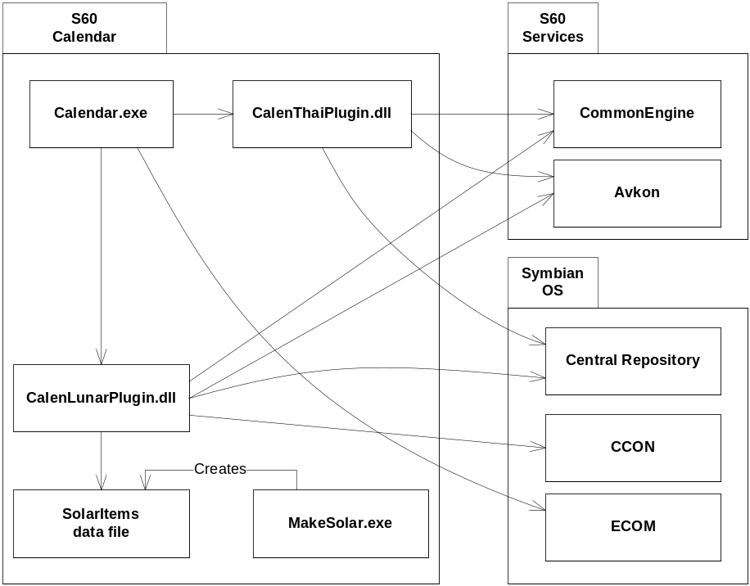
Figure 2.1 Component environment for regional plug-ins

Use cases
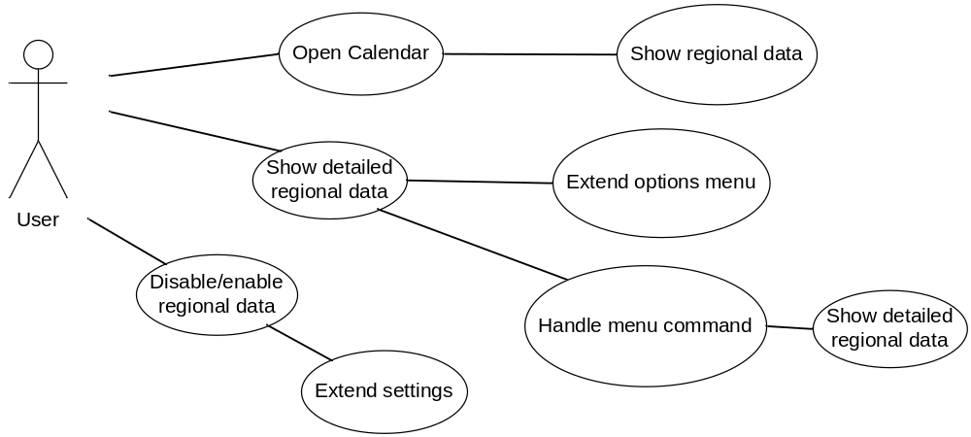
Figure 2.2 Regional plug-in use cases

Show regional (lunar) data in Calendar views
Summary | The user can see Lunar Calendar information in three Calendar views (month, week and day).
Actor(s) | The mobile phone user. The Calendar application. Lunar Calendar.
Frequency | Low.
Preconditions | The system contains the Lunar Calendar feature. The UI language is one of the Chinese languages or Vietnamese. The Calendar application is launched.
Description | The Month, Week and Day views are extended with an extra row and the regional plug-in modifies this row to contain the Lunar Calendar information.  The extra row shows all the important Lunar Calendar information if possible. If there is not enough space for showing everything, the content is diminished according to prioritization, see reference document [2].
Exceptions
Postconditions

Show Buddhist year in Calendar views
Summary | The user can see the Buddhist year in the three Calendar main views (month, week and day).
Actor(s) | The mobile phone user. The Calendar application. Thai Calendar.
Frequency | Low.
Preconditions | The system contains the Thai Calendar feature. The UI language is Thai. The Calendar application is launched.
Description | The Month, Week and Day views are extended with an extra row and the regional plug-in modifies this row to contain the Buddhist year.
Exceptions
Postconditions

Show regional information via Options menu
Summary | The user can see detailed Lunar Calendar information in a separate information dialog
Actor(s) | The mobile phone user. The Calendar application. Lunar Calendar.
Frequency | Low.
Preconditions | The system contains the Lunar Calendar feature. The Calendar application is launched. The UI language is one of the Chinese languages or Vietnamese.
Description | - The regional plug-in extends the Options menu of the Calendar application’s Day, Week and Month views with the Show lunar data menu item.  - The user selects Options -> Show Lunar data.  - Lunar Calendar shows the Lunar Calendar information dialog. See reference document [2] for lunar data details.  - The user presses Ok to hide the dialog.
Exceptions
Postconditions

Disable/enable Lunar Calendar
Summary | The user can disable and enable the Lunar Calendar functionality through the Calendar Settings view.
Actor(s) | The mobile phone user. The Calendar application. Lunar Calendar.
Frequency | Low.
Preconditions | The system contains the Lunar Calendar feature. The Calendar application is launched. The UI language is one of the Chinese languages or Vietnamese.
Description | - The user opens Calendar Options -> Settings.  - Lunar Calendar adds the Lunar Calendar setting item to the Calendar Settings view.  - The user changes the Lunar Calendar setting to Off.  - Lunar Calendar stores the new setting value.
Exceptions
Postconditions | Lunar Calendar functionality described in other use cases is not any more available. Setting item is available in Settings view and user can enable lunar calendar functionality.

Disable/enable Thai Calendar
Summary | The user can disable and enable the Thai Calendar functionality through the Calendar Settings view.
Actor(s) | The mobile phone user. The Calendar application. Thai Calendar.
Frequency | Low.
Preconditions | The system contains the Thai Calendar feature. The Calendar application is launched. The UI language is Thai.
Description | - The user opens Calendar Options -> Settings.  - Lunar Calendar adds the Lunar Calendar setting item to the Calendar Settings view  - The user changes the Lunar Calendar setting to Off.  - Lunar Calendar stores the new setting value.
Exceptions
Postconditions | The Lunar Calendar functionality is no longer available. The setting item is available in the Settings view and the user can enable the Lunar Calendar functionality.

Services required

From the Symbian OS subsystems
API | Description
Basic services of the Symbian OS infrastructure | File Server, Stream Store, CONE, Window Server.
Symbian OS CCON and Agenda Model | CCON is used to convert dates between Lunar Calendar and Gregorian Calendar.
S60 AVKON | AVKON is required for UI modifications that regional plug-ins perform for the Calendar application.
S60 Calendar application | Regional plug-ins extend the Calendar application.

From the Domestic OS subsystems
This component does not have any direct interfaces to the Domestic OS side subsystems.

From HW
This component has no direct HW interfaces.

Services provided

UI
This component modifies Calendar Application UI. The UI modifications are described in reference document [2].

SW IF
Regional plug-ins provide services by implementing the class CCalenUiPluginInterface.

Provided service | Description | Protected
Calendar extra row content | Provided through the class MCalenViewUiExtension. Shows the regional plug-in information in an extra row. | Yes/No
Calendar Options menu extension | Provided through the class MCalenMenuUiExtension. Adds the regional plug-in specific Options menu items.
Calendar Settings view extension | Provided through the class MCalenSettingUiExtension. Adds the regional plug-in setting item.

Design

Class diagrams

Component
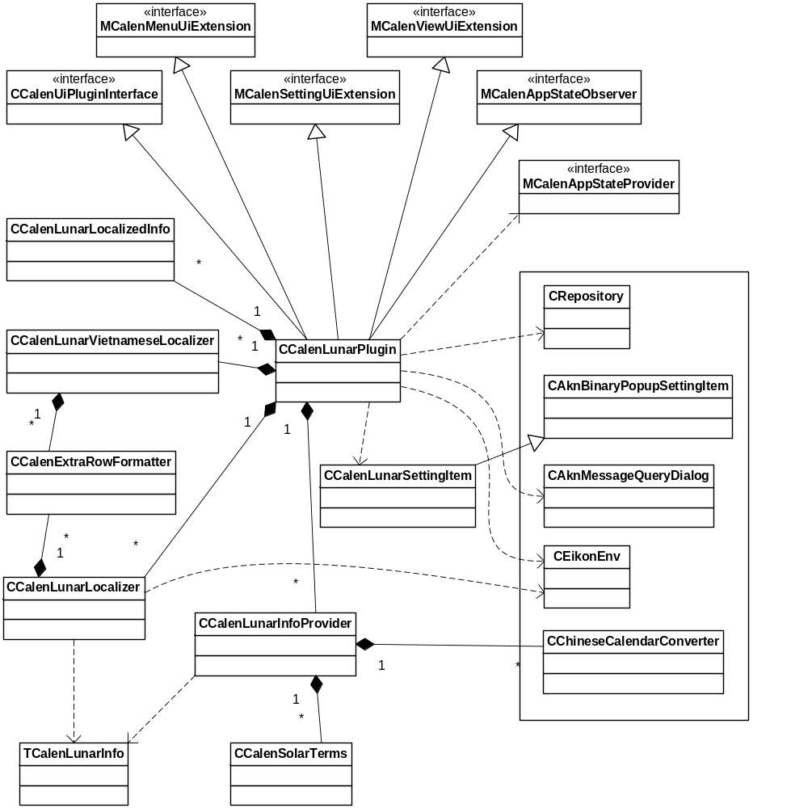
Figure 3.3 Lunar Calendar part of the application

Class descriptions

Lunar Calendar
Class | Description | Header file
CCalenExtraRowFormatter | Fits the lunar data into an extra row. | CalenExtraRowFormatter.h
CCalenLunarInfoProvider | Gathers the lunar information. | CalenLunarInfoProvider.h
CCalenLunarLocalizedInfo | Storage for localized lunar information. | CalenLunarLocalizedInfo.h
CCalenLunarLocalizer | Localizes lunar information. | CalenLunarLocalizer.h
CCalenLunarPlugin | Implements the UI plug-in interface. | CalenLunarPlugin.h
CCalenLunarSettingItem | Handles Lunar Calendar setting operations. | CalenLunarSettingItem.h
CCalenLunarVietnamese  Localizer | Localizes Vietnamese-specific lunar information. | CalenLunarVietnameseLocalizer.h
CCalenSolarTerms | Reads the solar terms data file and converts a date into solar term if possible. | CalenSolarTerms.h
CCalenUiPluginInterface | The interface to regional plug-in. | CalenUiPluginInterface.h
MCalenAppStateObserver | An interface class to observe day focus changes in the Calendar application. | MCalenAppStateProvider.h
MCalenAppStateProvider | An interface class to provide Calendar application state information to regional plug-ins. | MCalenAppStateProvider.h
MCalenMenuUiExtension | An interface class for extending the Options menu. | CalenUiPluginInterface.h
MCalenSettingUiExtension | An interface class for extending the settings. | CalenUiPluginInterface.h
MCalenViewUiExtension | An interface class for extending a view. | CalenUiPluginInterface.h
TCalenLunarInfo | A class to store lunar information. | CalenLunarInfo.h

Thai Calendar
Class | Description | Header file
CCalenThaiPlugin | Implements the UI plug-in interface. | CalenThaiPlugin.h
CCalenThaiSettingItem | Handles Thai Calendar setting operations. | CalenThaiSettingItem.h

Operations

Opening the Calendar application
Operation | Opening the Calendar application.
Preconditions | Lunar Calendar is included (Chinese or Vietnamese variant).
Description | The Lunar Calendar ECom plug-in is loaded.
Inputs
Modifies
Outputs
Postconditions | The regional plug-in is loaded.
Related To | The classes CCalenAppUi, CCalenUIPluginHandler and CCalenUIPluginInterface.
Related Event
Exceptions | Exceptions are handled by AVKON.

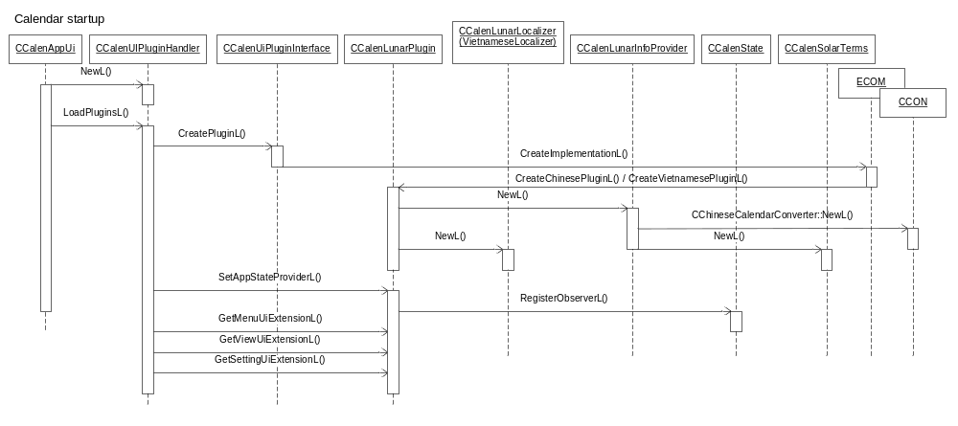
Figure 3.4 Lunar Calendar initialization

Showing lunar data in an extra row
Operation | Showing lunar data in an extra row.
Preconditions | Calendar is started and the Lunar calendar setting is set to On. Lunar Calendar is loaded (see Section 3.3.1). If Lunar Calendar is loaded, then the extra row layout is used and the sequence below is executed. Otherwise the extension label does not exist and is not updated like in Figure 3.5.
Description | The extra row shows the Chinese Calendar date information (the year name, the lunar month, the solar item). Chinese solar items are displayed in the extra row on special solar dates. These dates are read from the \System\apps\Calendar\SolarItems data file. The file data is cached so that it is read only the first time the extra row is created.
Inputs | \System\apps\Calendar\SolarItems is read.
Modifies
Outputs
Postconditions | The extra row is set a new text.
Related To | The classes CCalenMonthContainer (CCalenDayOnlyEventContainer or CCalenWeekContainer), CCalenAppUi and CCalenUIPluginHandler.
Related Event
Exceptions | Exceptions are handled by AVKON.

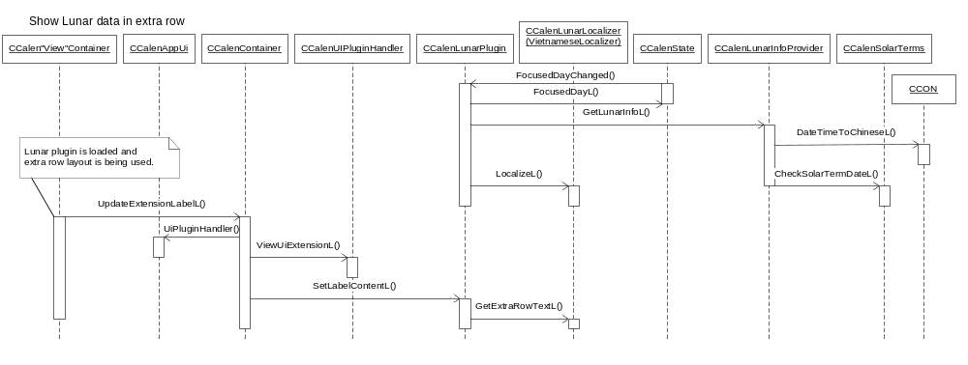
Figure 3.5 Showing the extra row when a lunar date is shown

Show the lunar data Information note
Operation | Showing the lunar data Information note.
Preconditions | The Calendar application is in the Idle state.
Description | The detailed lunar information is shown in a message dialog.
Inputs | \System\apps\Calendar\SolarItems is read.
Modifies
Outputs
Postconditions | The lunar data Information note is shown.
Related To | The classes CCalenView, CCalenAppUi, RFile and RFileReadStream.
Related Event
Exceptions | Exceptions are handled by AVKON.

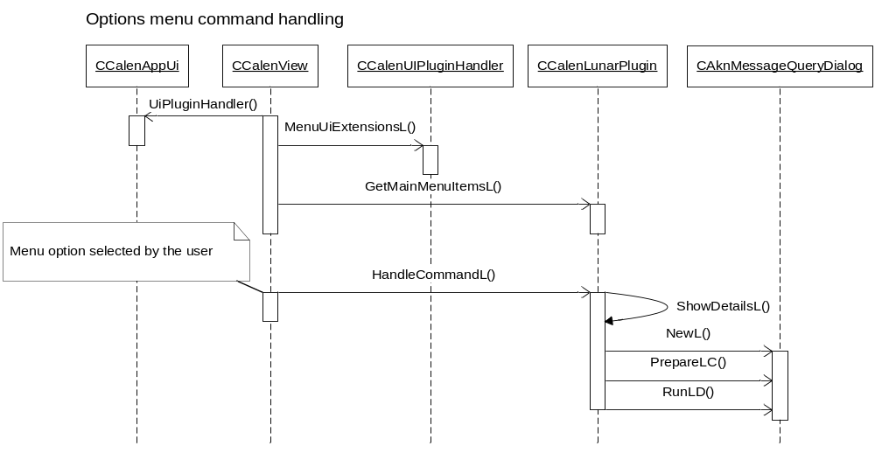
Figure 3.6 Showing the lunar data information dialog

Disabling a regional Calendar
Operation | Disabling a regional Calendar.
Preconditions | The Calendar application is in the Idle state.
Description | The extra row shows regional information. The user can disable the extra row by changing the regional setting from on (default) to off.
Inputs
Modifies
Outputs
Postconditions | The regional Calendar is disabled.
Related To | The classes CCalenSettingViewDlg and CCalenUIPluginHandler.
Related Event
Exceptions | Exceptions are handled by AVKON.

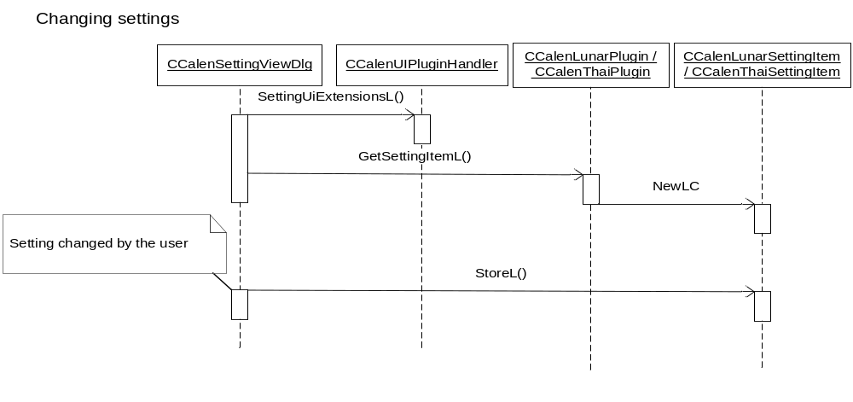
Figure 3.7 Lunar Calendar settings

Showing the Buddhist year in the extra row
Operation | Showing the Buddhist year in the extra row.
Preconditions | The Calendar application is in the Idle state.
Description | The extra row shows the Buddhist year.
Inputs
Modifies
Outputs
Postconditions | The Buddhist year is shown.
Related To | The classes CcalenSettingViewDlg and CCalenUIPluginHandler.
Related Event
Exceptions | Exceptions are handled by AVKON.

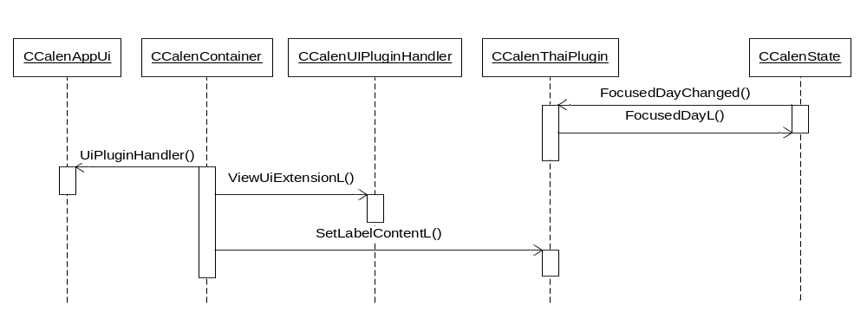
Figure 3.8 Thai Calendar extra row content

Variation

Chinese Lunar Calendar
Chinese Lunar Calendar in variated at ROM image creation time according to the __SERIES60_LUNAR_CALENDAR feature flag. This flag is defined in the Chinese platform variant.

Vietnamese Lunar Calendar
Vietnamese Lunar Calendar in variated at ROM image creation time according to the __SERIES60_LUNAR_CALENDAR feature flag. This flag is defined in the Western platform variant.

Thai Calendar
Thai Calendar in variated at ROM image creation time according to the __THAI_CALENDAR feature flag. This flag is defined in the Thai platform variant.

System resource usage

Other data

Databases
Lunar Calendar uses a database file to read the Chinese solar items between 1980 and 2090.

Database | Z:\private\10005901\SolarItems
Read Policy | Read only
Size | 4 824 bytes

Central Repository
Regional plug-ins use the following keys in Central Repository:
- KCRUidCalenLunarPlugin
- KCalenChineseLunarEnabled
- KCalenVietnameseLunarEnabled
- KCRUidCalenThaiPlugin
- KCalenThaiPluginEnabled

Exception handling
The leave mechanism of the Symbian OS environment is used to handle memory exhaustion. The panic mechanism is used when a resource file or SolarItems cannot be found or accessed.

Exception | Description
Panic: CalenLunarPlugin, 1 | Resource loading fails.
Panic: CalenThaiPlugin, 1 | Resource loading fails.

Usage

Building
The component is build normally as a part of the Calendar application building. The __SERIES60_LUNAR_CALENDAR and __THAI_CALENDAR flags are used to decide if the target files go to the ROM image.
For building the SolarItems file, MakeSolar.exe is used. See APPENDIX A.

User's guide
This component is used by the Calendar application. This component should not be used by other components than the Calendar application.

Other settings
Setting description | Key | Possible values | S60 defined initial value | Comments
Calendar user setting in Chinese builds: Is Chinese Lunar Calendar information shown | KCRUidCalenLunarPlugin  KCalenChineseLunarEnabled | 0 = Off  1 = On | 1 | This setting is only available if the Lunar Calendar functionality is included in the ROM image.
Calendar user setting in Vietnamese language setting: Is Vietnamese Lunar Calendar information shown | KCRUidCalenLunarPlugin  KCalenVietnameseLunarEnabled | 0 = Off  1 = On | 1 | This setting is only available if the Lunar Calendar functionality is included in the ROM image.
Calendar user setting in Thai builds: Is Thai Calendar information shown | KCRUidCalenThaiPlugin  KCalenThaiPluginEnabled | 0 = Off  1 = On | 1 | This setting is only available if the Thai Calendar functionality is included in the ROM image.

APPENDIX A: SolarItems data file and MakeSolar.exe
SolarItems file
Chinese Jie Qi Festival dates (solar items) are stored in the SolarItems data file. The SolarItems file has the solar items from the year 1980 to the year 2060. The SolarItems dates are based on reference documents [3] and [4].
For making the SolarItems file smaller, all solar items’ dates are TAgnDate. TAgnDate is 16-bit. Therefore, the size of SolarItems is 81 (years) x 24 (solar items) x 2 (bytes) = 3888 bytes. The file format of SolarItems is very simple. The solar items are sorted by the date from 1980.
The table below lists the contents of the SolarItems file.
Offset | Date | Solar item
Top of Solar Items +0 | 6/Jan/1980 | Xiao Han
+2 | 21/Jan/1980 | Da Han
+4 | 4/Feb/1980 | Li Chun
+6 | 19/Feb/1980 | Yu Shui
+8 | 5/Mar/1980 | Jing zhe
+10 | 20/Mar/1980 | Chun Fen
… | …
+24 | 6/Jan/1981 | Xiao Han
+26 | 21/Jan/1981 | Da Han
… | …

Creating the SolarItems file
SolarItems is a binary file. It is constructed from the text data file luntest_cns.txt using the MakeSolar.exe support program. Both the files are located in the MakeSolar directory under the Calendar component.
The SolarItems file is not constructed every time the Calendar application is built. It is delivered in precompiled binary format as a part of S60.
luntest_cns.txt contain the Chinese Jie Qi Festival dates in textual format and can be edited for error fixes. MakeSolar.exe is used to construct the SolarItems file.
To create SolarItems, do the following:
- Go to the directory Calendar\MakeSolar\
- Run MakeSolar.cmd (type MakeSolar and press Enter).
SolarItems will now be created into the Calendar\LunarSrc\ directory.

MakeSolar.cmd compiles MakeSolar.exe and runs it automatically to create the SolarItems file.

