S60 3.x
Calendar Meeting Request Enabler Framework
Design Document

Team name | Author
S60 Apps PIM Contacts & Organiser | Charles McKenna

Change history:

Version | Date | Status | Comments
1.0 | 27.07.2006 | Approved

Table of contents:

1. Document control 4
1.1 References 4
1.2 Documentation conventions 4
1.3 Abbreviations 4
2. General 5
2.1 Introduction 5
2.2 Feature flags 5
2.2.1 KFeatureIdICalSupport 5
2.2.2 KFeatureIdMeetingRequestEnabler 5
2.2.3 KFeatureIdMeetingRequestSupport 5
2.2.4 Feature ID to build flag mapping 5
2.3 MR_ENABLERS dependencies 6
2.4 Services required 7
2.4.1 From the Symbian OS subsystems 7
2.4.2 From the Domestic OS subsystems 7
2.4.3 From HW 7
2.5 Services provided 7
2.5.1 UI 7
2.5.2 SW IF 7
3. Design 8
3.1 MR_ENABLERS runtime checks 8
3.2 MR_ENABLERS UI features 13
3.2.1 Create New Meeting Request 13
3.2.2 Default mailbox setting 15
3.2.3 CMRUtils::DeleteWithUiL 15
3.3 MR_ENABLERS Framework 15
3.4 CCalenGlobalData 16
3.5 CCalenInterimUtils2 17
4. Variation 18
4.1 MR_ENABLERS compile time flags 18
4.2 Enabling iCalendar support 18
5. System resource usage 19
6. Exception handling 20

Document control

References
- S60 Calendar Application Design Document
- S60 Calendar UI Specification
- S60 Versit2 / AgnVersit2 Design Document
- RFC 2445: Internet Calendaring and Scheduling Core Object Specification (iCalendar) | http://www.ietf.org/rfc/rfc2445.txt
- S60 ICalUI Design Document
- S60 CalenGlobalData Design Document

Documentation conventions
Code is shown with the Courier New font.

Abbreviations
MR_ENABLERS | Meeting Request Enabler framework
MR_SUPPORT | Full Meeting Request support

General

Introduction
This document describes the functional and architectural changes made to the Calendar application in order to support the meeting request functionality. Two different levels of meeting request support are available. The basic level of support is the Meeting Request Enabler Framework (MR_ENABLERS). MR_ENABLERS allows the integration of third party Meeting Request Viewers and utility plug-ins with the S60 Calendar application. Full meeting request support (MR_SUPPORT) builds on MR_ENABLERS to provide a default Meeting Request Viewer implementation.

Feature flags
Calendar uses the Feature Manager component to determine at runtime the level of support for meeting request related functionality. The following feature flags can be set in the Feature Manager component at compile time, before building Calendar.

KFeatureIdICalSupport
KFeatureIdICalSupport allows Calendar to use the Versit2 and AgnVersit2 iCalendar parsing components. It is assumed that if this flag is set in Feature Manager, then Versit2 and AgnVersit2 will be present in ROM on the target device. With iCal support enabled, Calendar can import from and export to ICS files. More information on Versit2 and AgnVersit2 can be found in reference documents [3] and [4].

KFeatureIdMeetingRequestEnabler
MR_ENABLERS provides a framework for Meeting Request Viewers and utilities to be loaded by Calendar at runtime if available. If KFeatureIdMeetingRequestEnabler is set, third party Meeting Request Viewers will be dynamically loaded as required based on the default mailbox setting.

KFeatureIdMeetingRequestSupport
Full meeting request support is available if the KFeatureIdMeetingRequestSupport flag is set. With full meeting request support, a default Meeting Request Viewer will be available for all message types. As the default viewer makes use of MR_ENABLERS, third parties still have the ability to add their own customized viewer plug-ins for specific message types. This flag is not supported in S60 release 3.0 or S60 release 3.1.

Feature ID to build flag mapping
The following build flags are used to set the status of the required feature IDs:

Build flag | Feature ID
__ICAL_SUPPORT | KFeatureIdICalSupport
__MEETING_REQUEST_ENABLER | KFeatureIdMeetingRequestEnabler
__MEETING_REQUEST_SUPPORT | KFeatureIdMeetingRequestSupport

MR_ENABLERS dependencies
Figure 3.2 shows the dependencies between the main components modified for the MR_ENABLERS solution. Other Calendar dependencies can be found in reference document [1]. The key items of interest are the AgnEntryUi and MRMailboxUtils components. Calendar uses the MRMailboxUtils component to help determine if a Meeting Request Viewer plug-in should be loaded. Third parties implement a plug-in using the MAgnEntryUi interface. The plug-in is then loaded through ECom by Calendar. Plug-ins must specify the MTM UID of their associated mailbox in the default_data field of their ECom resource file to be resolved correctly. Detailed information on the implementation of a viewer plug-in can be found in reference document [5]. CCalenInterimUtils2 has a runtime dependency on MRMailBoxUtils.
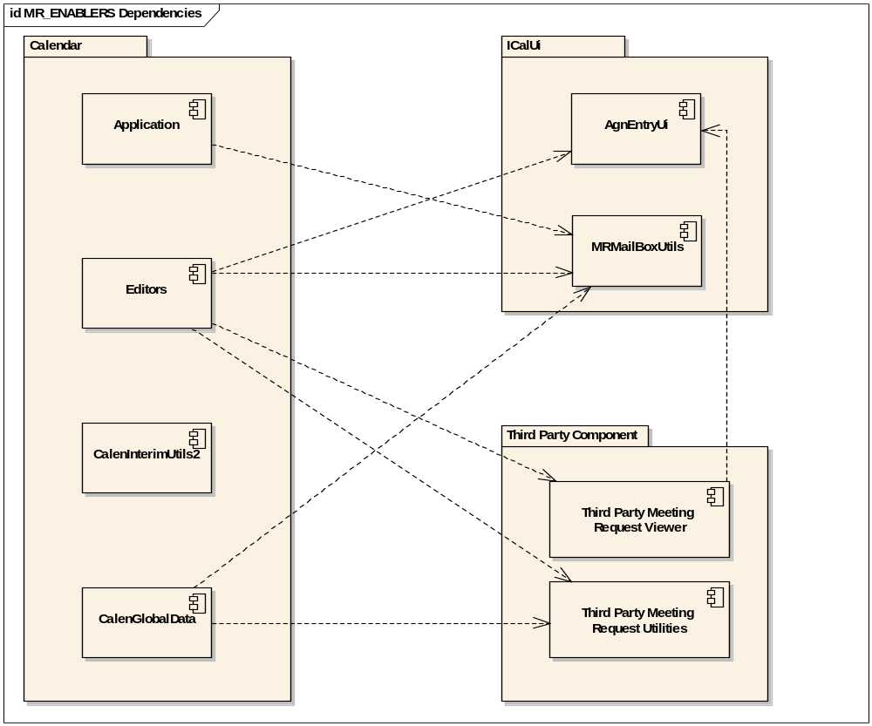
Figure 2.1 MR_ENABLERS dependencies

Services required

From the Symbian OS subsystems
The MR_ENABLERS functionality extends the Calendar application by enabling third party Meeting Request Viewers to be added to the terminal after production. MR_ENABLERS extends Calendar, and uses the following components and interfaces:

API | Description
MAgnEntryUi | A Calendar viewer plug-in interface.
MRUtils | Meeting request utilities.
MRMailboxUtils | Mailbox utilities.
CalenInterimUtils2 | Static utility functions.
CalenGlobalData | Data objects shared through Calendar.

From the Domestic OS subsystems
This solution does not use any services from the Domestic OS subsystems.

From HW
This solution has no direct HW interfaces.

Services provided

UI
The MR_ENABLERS solution does not specify a UI, but provides a framework for third parties to extend the existing Calendar UI.

SW IF
The MR_ENABLERS solution provides the CCalenInterimUtils2 library for use by other components. A brief description of the library can be found in Section 3.5, and a more detailed discussion can be found in reference document [1].

Design

MR_ENABLERS runtime checks
In order to determine whether Meeting Request Enabler support is available on a terminal, the following criteria must be met:
- The feature flag KFeatureIdMeetingRequestEnabler is set in Feature Manager.
- At least one mailbox has been defined.
- At least one implementation of a third party Meeting Request Viewer (MR Viewer) is available on the device.
- The MR Viewer implementation must be associated with a specific mailbox MTM.
- A Meeting Request Utilities (MR Utils) implementation associated with the same mailbox as the MR Viewer is available on the device.

CCalenInterimUtils2::MRViewersEnabledL() can be used to determine if the above is true at runtime. The first time this function is called, the above check is performed, and the result is buffered by CCalenInterimUtils2 and returned on subsequent calls to this function. This increases performance as the initial check is potentially time-consuming. If there is a need to re-evaluate the result of this decision while Calendar is running (for example, if a mailbox is deleted), it is possible to request this by calling CCalenInterimUtils2::MRViewersEnabledL(ETrue). This forces a recheck for this call only, with the new result buffered for subsequent calls. For more details on thye CCalenInterimUtils2 functions, see Section 3.5.
To associate a Meeting Request Viewer implementation with a mailbox MTM, it is necessary to include the MTM UID of the required mailbox in the ECom resource file in the default_data field, e.g.:

default_data = “[1000102A]” //IMAP4 mailbox MTM

All the required UIDs can be found in epoc32\include\oem\MeetingRequestUids.hrh.
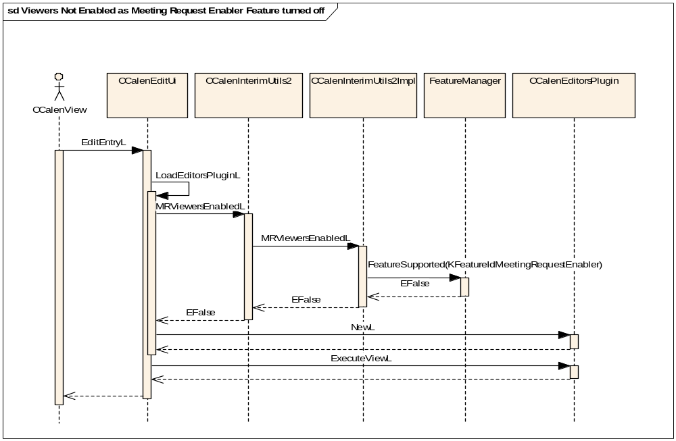
Figure 3.2 Meeting Request Viewer disabled: Enabler flag not active
In Figure 3.2 the call to FeatureManager::FeatureSupported
(KFeatureIdMeetingRequestEnabler) returns EFalse. There is no need to check for the existence of mailboxes or viewer plug-ins in this case, so an instance of the default editor, CCalenEditorsPlugin, is created. As previously mentioned, the result of this call is buffered internally, and as feature flags cannot be changed at runtime, this check would normally only be performed once during the lifetime of the CCalenInterimUtils2 object.
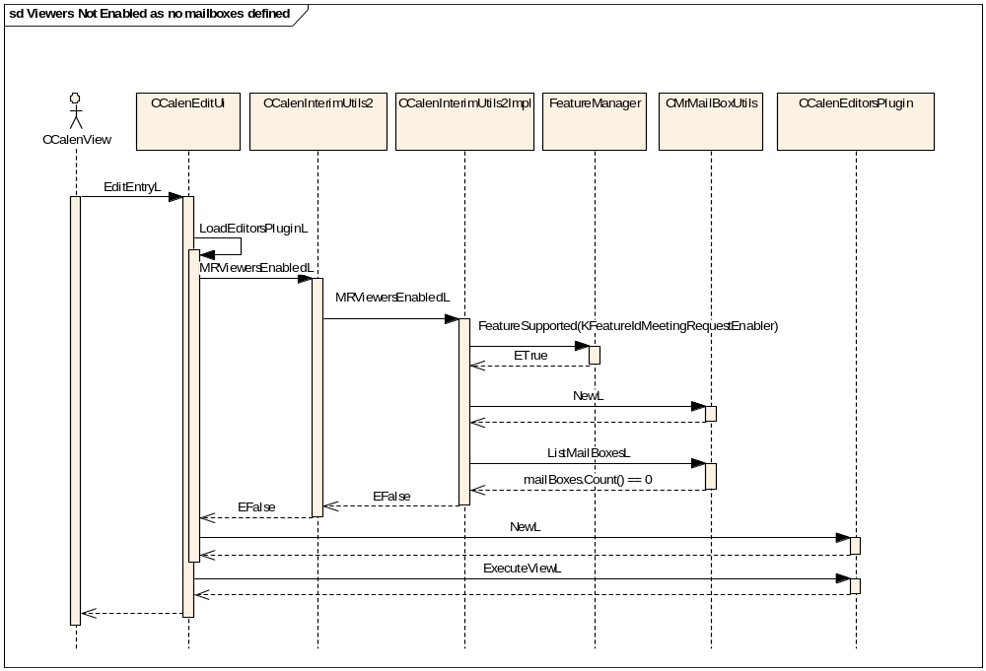
Figure 3.3 Meeting Request Viewer disabled: No mailboxes defined
In Figure 3.3, the feature flag check returns ETrue. An instance of CMRMailboxUtils is created, and then queried for a list of all the available mailboxes defined on the device. In this particular case, the user has not defined a mailbox yet (mailboxes.Count() == 0), so again the check returns EFalse and an instance of CCalenDefaultEditorsPlugin is created. If a new mailbox is defined on the device, this check should be performed again (by a call to CCalenInterimUtils2::MRViewersEnabledL(ETrue)).
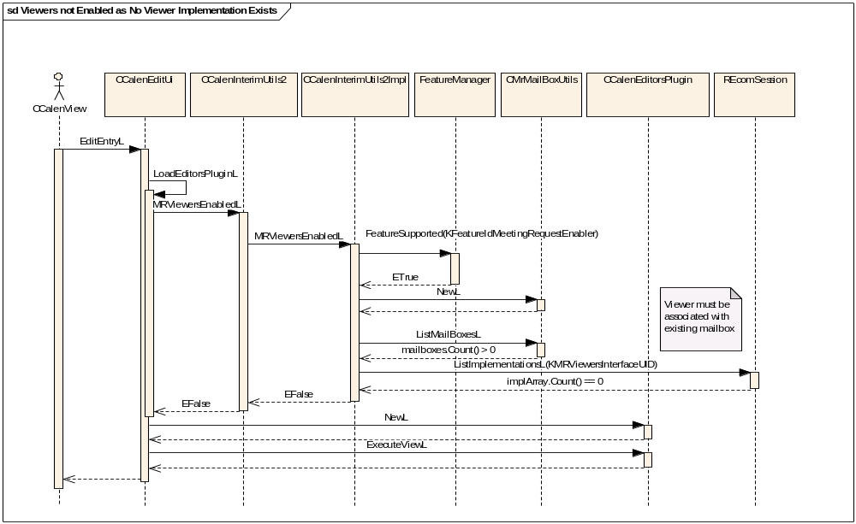
Figure 3.4 Meeting Request Viewer disabled: No viewer implementation available
If the Feature Manager check returns ETrue and CMRMailboxUtils::ListMailboxesL() reports at least one available mailbox, a call is issued to REComSession::ListImplementationsL passing the UID of the Meeting Request Viewer interface (KMRViewersInterfaceUID) as the resolving parameter. If no viewer implementations are found, then the check returns EFalse. This is shown in Figure 3.4. If a viewer implementation is found, then the value of the default_data field is checked against the known MTM UIDs from the list of the available mailboxes. The check continues only if a match is found. If the only available viewers are not associated with a currently defined mailbox, the check still returns EFalse.
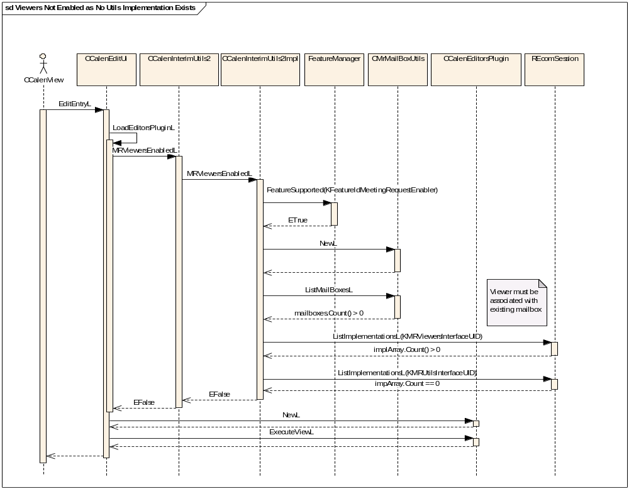
Figure 3.5 Meeting Request Viewer disabled: No utils implementation available
Once a match has been found between an available mailbox and a viewer implementation, REComSession is queried again, this time for an implementation of the meeting request utilities. KMRUtilsInterfaceUID is used to resolve the meeting request utilities plug-in. Again, if no meeting request utility implementation is found, the check returns EFalse and the meeting request functionality is disabled. This is shown in Figure 3.5.
If a meeting request utility implementation is found, the check returns ETrue, signaling that the meeting request functionality is enabled. Rather than creating an instance of CCalenDefaultEditorsPlugin, an instance of CAgnEntryUi is created instead. This can be seen in Figure 3.6. CAgnEntryUi is then responsible for deciding which plug-in to actually use. If the entry to be edited is a meeting request, then Meeting Request Viewer is loaded through ECom. If the entry to be edited is not a meeting request, then CCalenDefaultEditorsPlugin is loaded. More information on CAgnEntryUi can be found in Section 3.3 and reference document [5].
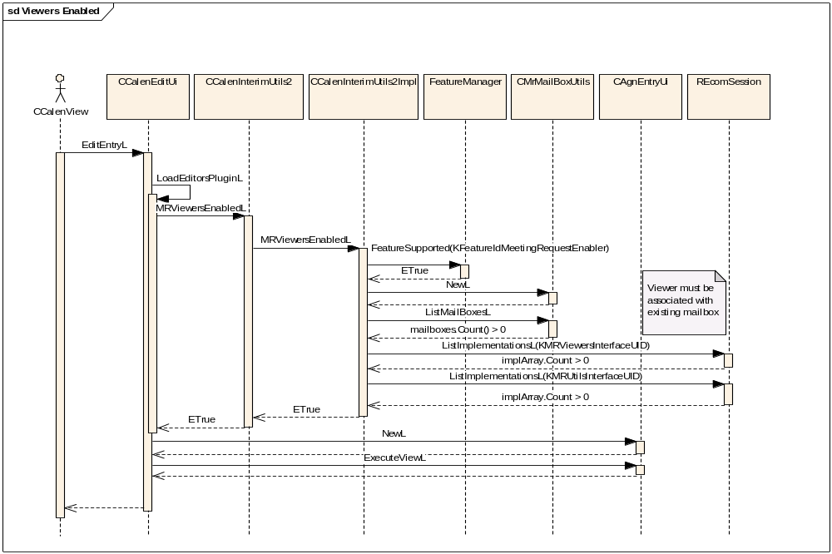
Figure 3.6 Meeting Request Viewer enabled

MR_ENABLERS UI features
The Calendar application has been extended to allow user selection of the default mailbox to be used. If the MR_ENABLERS runtime check described in Section 3.1 returns ETrue, third party Meeting Request Viewers are used to display meeting requests from within Calendar. In addition, the following UI elements are available:

Create New Meeting Request
This option appears under the New Entry sub-menu of the Options menu in the Calendar Day view, Week view and Month view.
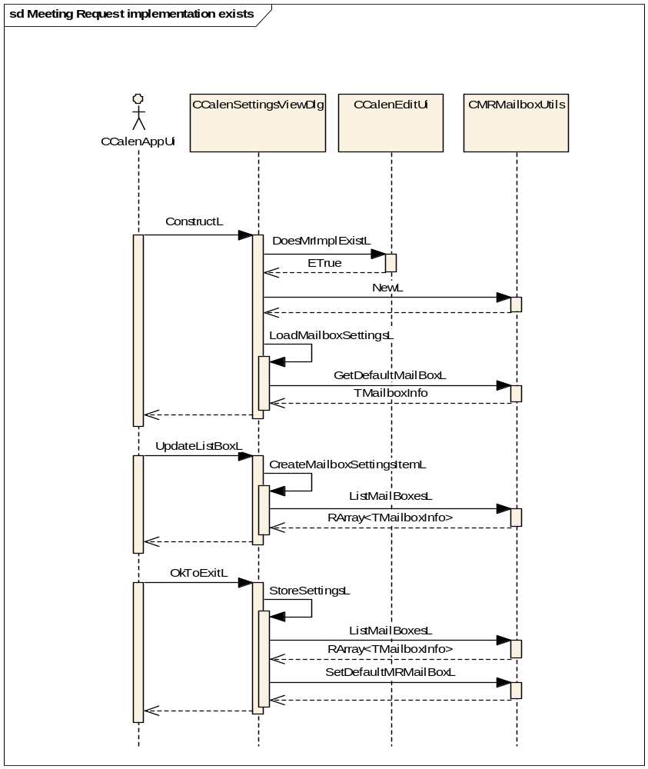
Figure 3.7 Default mailbox settings: meeting request functionality enabled
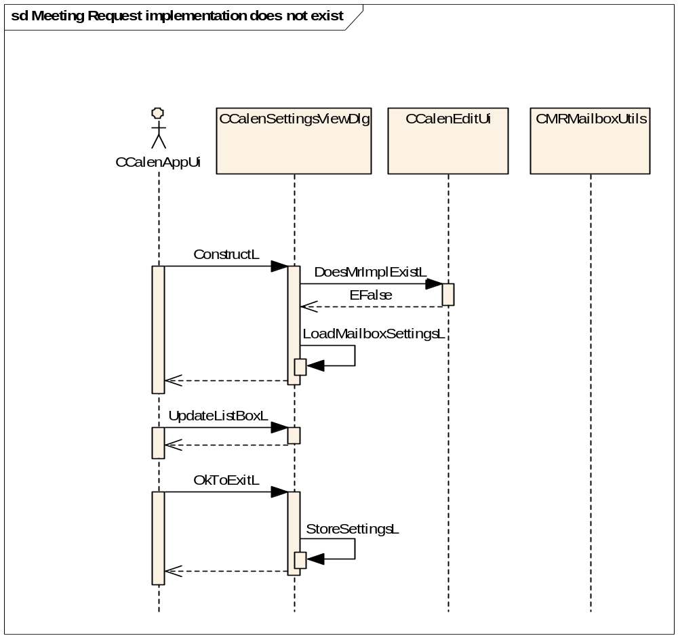
Figure 3.8 Default mailbox settings: meeting request functionality disabled

Default mailbox setting
This setting allows the user to select a mailbox (as defined in the Mail application) as the default mailbox to be used when sending or responding to meeting requests. The third party Meeting Request Viewer and utilities associated with the MTM of the mailbox in use are displayed to the user when viewing meeting requests directly from the Calendar Day view. This is shown in Figure 3.7 and Figure 3.8. If more than one viewer is associated with the selected mailbox, the first implementation returned by REComSession::ListImplementationsL is used.

CMRUtils::DeleteWithUiL
The meeting request utilities allow third parties to provide customized UI elements and extra functionality when deleting database entries. Example usage can include e.g. tombstone functionality or a prompt to notify invited attendees of the meeting deletion.

MR_ENABLERS Framework
Third party Meeting Request Viewers are loaded through ECom as required. If the meeting request functionality is not present on the device, the standard editor (CCalenDefaultEditors) is created through ECom and used by CCalenEditUi for all Calendar entries. If this is the case, none of the UI extensions described in Section 3.2 are visible. If the meeting request functionality is present, then an instance of CAgnEntryUi is created through ECom.
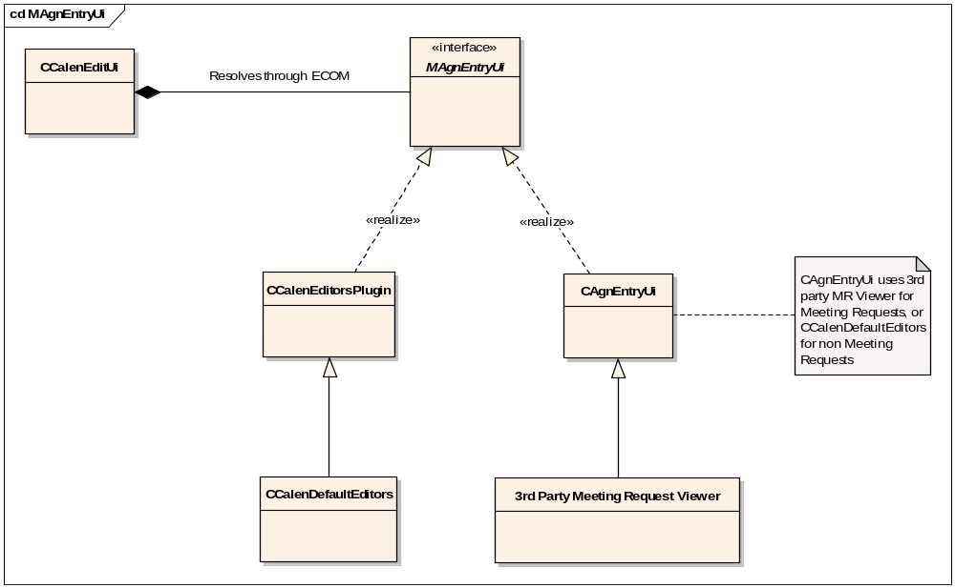
Figure 3.9 MR_ENABLERS plug-in architecture
If the entry to be edited is a meeting request, then an instance of a Meeting Request Viewer corresponding to the MTM of the default mailbox is created through ECom by CAgnEntryUi. If no matching implementation is found, then the default Meeting Request Viewer is created. If the entry to be edited is not a meeting request, then CAgnEntryUi creates the standard editor. CAgnEntryUi maintains two MAgnEntryUi pointers: one to store a CCalenEditorsPlugin object for non-meeting requests, and another to store a CAgnEntryUi object for meeting request. These objects are only initialized on first use. Figure 3.9 shows the Meeting Request Viewer architecture.

CCalenGlobalData
CCalenGlobalData is a singleton class used throughout Calendar to allow a single point of access to the following data members:
- CCalSession: Symbian Calendar session object.
- CCalEntryView: Symbian Agenda entry view.
- CCalInstanceView: Symbian Agenda instance view.
- CCalenInterimUtils2: Common utilities. See Section 3.5 for details.
- CCalenSend: A SendUI wrapper class.
- CMRMailBoxUtils: Mailbox utilities.
- CMRUtils: Meeting request utilities.

Note that Mailbox utilities and Meeting request utilities will only be available when the MR_ENABLERS runtime checks (see Section 3.1) return ETrue. CCalenGlobalData only initializes data members the first time they are requested.
CCalenGlobalData uses reference counting to keep track of how many objects are using its services. When no other classes are using CCalenGlobalData, it destroys itself. Clients should never call the destructor for this class, but instead call Release() when the object is no longer required. CCalenGlobalData is fully documented in reference document [6].

//Construction
CCalenGlobalData* aData = CCalenGlobalData::NewL();

//Destruction
aData->Release();

CCalenInterimUtils2
CCalenInterimUtils2 provides a number of utility methods related to the general usage of CalInterimAPI. The utility methods relevant to meeting requests are shown below. A more detailed discussion can be found in reference document [1].

TBool MRViewersEnabledL(TBool aForceCheck = EFalse);

The above function checks if Meeting Request Viewer functionality is enabled and available to use. After the first call, the result is buffered for the lifetime of the object. Calling this function with the parameter ETrue forces the check to be re-evaluated. This may be useful when a mailbox is added or deleted while Calendar is open.

TBool IsMeetingRequestL(CCalEntry& aEntry);

The above function checks if the given entry has properties consistent with a meeting request. The current logic is that a meeting request is CCalEntry with the type CCalEntry::EAppt and a valid Organizer field set.

Variation

MR_ENABLERS compile time flags
To enable extended meeting request functionality on a device, the flag __MEETING_REQUEST_ENABLER must be set at compile time. If this flag is set, the terminal is able to dynamically load third party Meeting Request Viewers and utilities at runtime. Each Meeting Request Viewer implementation must have a corresponding meeting request utility DLL to handle the Send and Delete functionality. Meeting Request Viewers and utilities are loaded through ECom with the MTM UID of the selected default mailbox used as the resolving parameter.

Enabling iCalendar support
To include Versit2 (iCalendar parser) and AgnVersit2 (iCalendar importer) in a build, the flag __I_CAL_SUPPORT must be set at compile time. The CalenImp component has been modified to include a runtime check for the Feature Manager flag KFeatureIdICalSupport. If this flag is not set, then both CCalenImporter::ImportICalendarL and CCalenExporter::ExportICalendarL leave with the standard error code KErrNotSupported. When iCalendars are imported using CCalenImporter::ImportICalendarL, the phone owner field of each entry is set to the email address for the default mailbox.

System resource usage
The system resource usage for Calendar is discussed in reference document [1].

Exception handling
Any exceptions when loading a third party MR Viewer implementation cause the existing Calendar note editor to be used. Exceptions are handled as described in reference document [1].

