S60 2.x
Calendar Server
Design Document

Team name | Author
Applications Helsinki / PIM | Teemu Kurppa

Change history:

Version | Date | Status | Comments
2.0 | 30.07.2007 | Approved | Editorial changes
1.0 | 25.07.2005 | Approved

Table of contents:

1. Document control 4
1.1 References 4
1.2 Documentation conventions 4
1.3 Abbreviations 4
1.4 Definitions 4
2. General 5
2.1 Introduction 5
2.2 Component environment 5
2.3 Use cases 6
2.3.1 Automatically re-queuing Calendar alarms 6
2.3.2 Preventing alarms from expiring when the system time changes 6
2.3.3 Creating an empty Calendar database 6
2.3.4 Notifying clients of Calendar database changes 7
2.3.5 Optimizing Agenda Model startup on client request 7
2.4 Services required 7
2.4.1 From the Symbian OS subsystems 7
2.4.2 From the Domestic OS subsystems 8
2.4.3 From HW 8
2.5 Services provided 8
2.5.1 UI 8
2.5.2 SW IF 8
3. UI control hierarchy 9
4. Design 10
4.1 Class diagrams 10
4.1.1 Framework 10
4.1.2 Server side implementation 11
4.1.3 Client side interface 12
4.1.4 Agenda observer 12
4.2 Class descriptions 12
4.2.1 State diagrams 14
4.2.1.1 CCalenSvrDBManager 14
4.2.1.2 CCalenSvrAlarmManager 15
4.3 Operations 15
4.3.1 Receiving Calendar database change notification 15
5. Variation 17
5.1 Agenda observer 17
6. System resource usage 18
6.1 Files 18
6.2 Databases 18
6.3 Memory consumption 18
6.4 Task allocation 18
6.5 Performance 18
6.6 Timers 18
7. Exception handling 19
8. Usage 20
8.1 Building 20

Document control

References

- S60 Calendar Application Design Document
- Symbian OS documentation
- S60 Calendar UI Specification

Documentation conventions
Code is shown with the Courier New font.
Following color coding is used in figures:
- S60 Calendar Server component: light yellow
- S60 Calendar subsystem component: light blue
- Symbian OS component: light gray

Abbreviations

API | Application Programming Interface
DLL | Dynamic Link Library

Definitions

Agenda Observer | Symbian Agenda Model offers special way for clients to listen for database changes. Client has to register observer DLL, which is automatically loaded, when database is opened. Observer DLL has to implement the Agenda Observer interface. For further description, see Symbian OS documentation (reference document [2]).

General

Introduction
Calendar Server is part of the S60 Calendar subsystem (see reference document [1]). It has a few different responsibilities. First, it ensures correct queuing of Calendar alarms in different situations. Second, it offers notification of Calendar database changes to components that do not want to keep Agenda Model session open all the time. Third, it creates an empty Calendar database file on first boot to ensure that other components can safely try to access the Calendar database. Fourth, it offers optimization possibility for clients to open Agenda Server and Agenda Model in the Calendar Server thread. This enables clients to ensure better responsiveness.

Component environment
Relationships of Calendar Server and other S60 Calendar subsystems or Symbian OS components are shown in Figure 2.1.
Calendar Server consists of three executable files. CalenSvrClient.DLL contains both client-side interface implementation and server-side internal implementation. CalenSvr.EXE is a very small wrapper executable, containing entry points (E32Main and E32Dll) for server and calling functionality in CalenSvrClient.DLL to start the server. CalenAgendaObserver.DLL is a polymorphic DLL that implements the Symbian OS Agenda Observer interface for observing changes in the Calendar database.
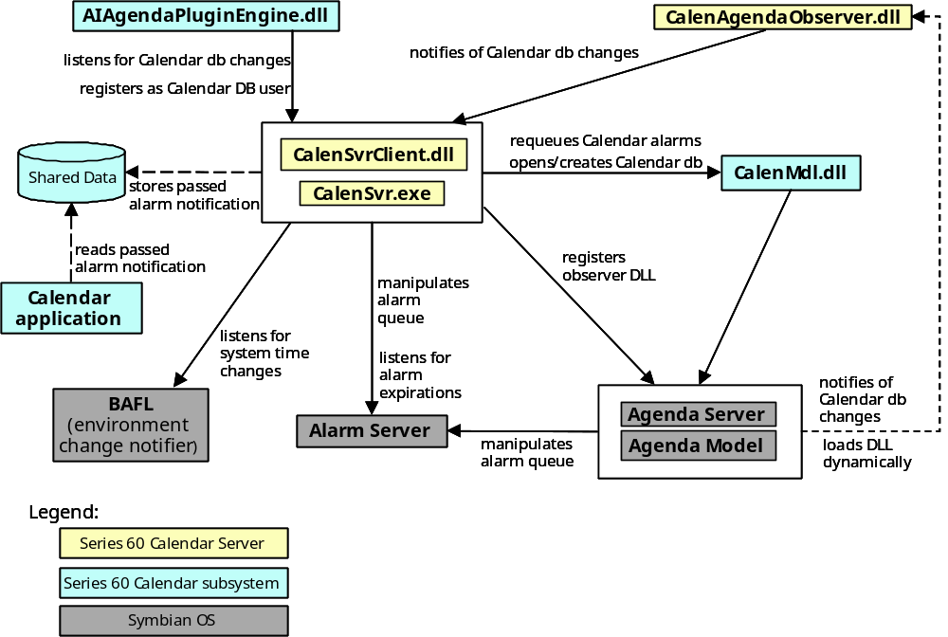
Figure 2.1 Calendar Server component environment

Use cases

Automatically re-queuing Calendar alarms

Summary | Calendar Server re-queues Calendar alarms on boot time and when the alarm expires.
Actor(s) | Calendar Server, Alarm Server.
Frequency | Low (once in every boot, for each expiring alarm).
Preconditions
Description | Symbian Agenda Server has a limitation; it queues only 10 next agenda alarms from the following 31 days when it closes. When Agenda Server is closed, agenda alarms are not updated. Automatic re-queuing Calendar alarms overcome this limitation. Re-queuing alarms on boot time ensure that alarm queue is up-to-date even if the device has been shut down for more than 31 days. Re-queuing alarms, when the alarm expires, ensures that after 10 alarms, 11th appears.
Exceptions
Postconditions | Calendar alarms in Symbian Alarm Server queue are up-to-date.

Preventing alarms from expiring when the system time changes

Summary | Calendar Application UI specification requires that passed Calendar alarms are not shown to the user when system time changes, but the user is informed about passed alarms the next time that Calendar Application is used.
Actor(s) | Calendar Server, Alarm Server, the Calendar application.
Frequency | Low. Once for every system time change.
Preconditions
Description | Symbian Alarm Server expires all passed alarms when the system time changes. On system time change notification, Calendar Server removes all passed alarms to prevent them from being visible to the user. If there were passed alarms, it also writes this information to Shared Data. This ensures the behavior specified in reference document [3].
Exceptions
Postconditions | If there were passed alarms, this information is stored in Shared Data file.

Creating an empty Calendar database

Summary | On boot time, Calendar Server creates an empty Calendar database, if one does not already exist.
Actor(s) | Calendar Server.
Frequency | Low. Ideally only in first boot of the device.
Preconditions | There is no Calendar database file in the device.
Description | Calendar Server creates an empty Calendar database, if one does not already exist. This ensures that other applications and components that try to access Calendar database does not fail.
Exceptions
Postconditions | Empty Calendar database exists in the device.

Notifying clients of Calendar database changes

Summary | Client can request notifications of Calendar database changes from Calendar Server. On change, Calendar Server notifies clients.
Actor(s) | Calendar Server, Calendar Agenda Observer, Calendar Server client.
Frequency | Low to High.
Preconditions
Description | Calendar Server registers Calendar Agenda Observer to Agenda Server. This component informs Calendar Server whenever Calendar database is changed.  Calendar Server then notifies each listening client of these changes.
Exceptions
Postconditions

Optimizing Agenda Model startup on client request

Summary | Client can be registered as a user of Calendar database. This instructs Calendar Server to perform some expensive launch operations, before the client itself connects to Agenda Server.
Actor(s) | Calendar Server, Agenda Server, Calendar Server client.
Frequency | Low.
Preconditions
Description | On client request, Calendar Server connects to Agenda Server, opens Calendar database, and instructs Agenda Server to build database indexes for Calendar database. After this it notifies the client that it is ready, and the client can perform these same operations quickly, because Agenda Server is already running and has built indexes.
Exceptions
Postconditions | Agenda Server is running and has built indexes for Calendar database.

Services required

From the Symbian OS subsystems

Required Service | Description
Symbian OS Agenda Model | Calendar Server creates a Calendar database, re-queues Calendar alarms and registers Agenda Observer.
Symbian OS Alarm Server | Calendar Server listens for alarm expirations and manipulates alarm queue on system time change events.
Symbian OS BAFL | Calendar Server listens for system time change events with environment notifier.
Series 60 Common Engine | Common Engine is used to access Shared Data.
Series 60 Calendar subsystem | Functionality in Calendar Model is required for opening and the creation of Calendar database and queuing of Calendar alarms.

From the Domestic OS subsystems
This component does not have any direct interfaces to the Domestic OS side subsystems.

From HW
This component has no direct HW interfaces.

Services provided

UI
This component does not provide any UI.

SW IF

Provided Service | Description
Calendar database change notifications | Clients can listen for Calendar database changes via Calendar Server API.
Optimized opening of Calendar database | Clients can request Calendar Server to start Agenda Server and build database indexes. These slow operations are performed in Calendar Server thread. After Calendar Server has performed these operations, the clients can connect to Agenda Server knowing that the connection is not a heavy operation and responsiveness is ensured.

UI control hierarchy
The component does not contain any UI or UI controls.

Design

Class diagrams

Framework
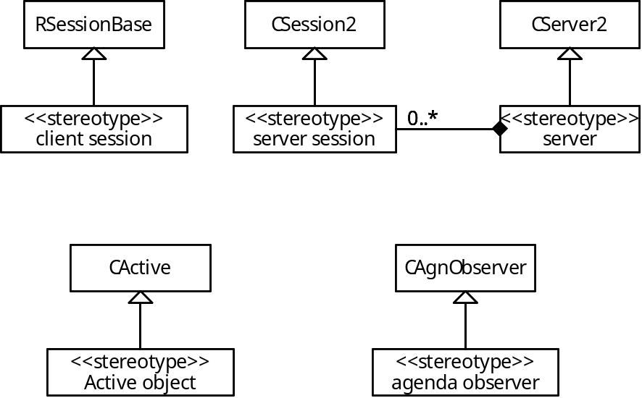
Figure 4.2 Metamodel definition

Server side implementation
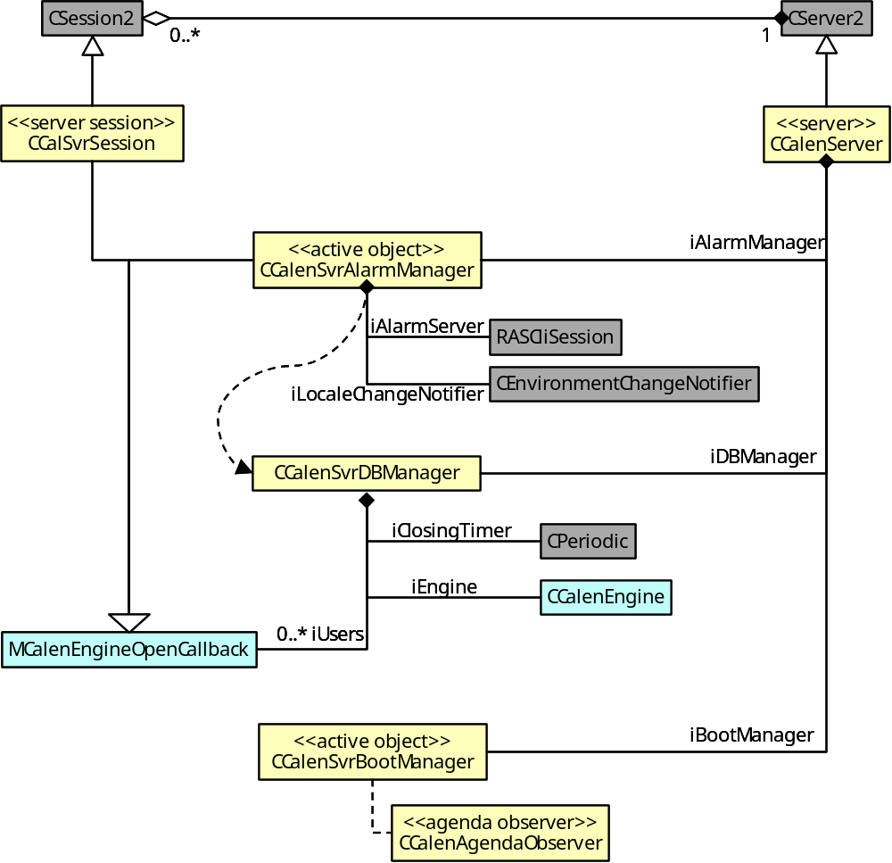
Figure 4.3 Class diagram for server side implementation of Calendar Server
Figure 4.3 shows class diagram for server side implementation of Calendar Server. CCalenServer and CCalSvrSession implement Symbian OS client-server framework’s server and server session objects, respectively. Especially the implementation of CCalSvrSession handles low-level Symbian Client Server Framework, such as completing client requests.
Server uses the flowing three manager objects to handle different responsibilities.
CCalenSvrBootManager is an active object that takes care of special boot time activities. It creates an empty Calendar database if needed, and registers CCalenAgendaObserver to it.
CCalenSvrDBManager uses CCalenEngine to connect to Agenda Server and to open Agenda Model. It keeps reference count of registered users of the Calendar database, and closes when the last user unregisters. For the state diagram of dynamic behavior of CCalenSvrDBManager, see Section 4.2.1.1.
CCalenSvrAlarmManager re-queues Calendar alarms in the following situations:
- Boot time
- When an alarm expires
- When the system time is changed

When CCalenSvrAlarmManager needs to re-queue alarms, it registers as a database user to CCalenSvrDBManager. When the database is opened it re-queues alarms, and finally unregisters itself from database users. For the state diagram of dynamic behavior of CCalenSvrAlarmManager, see Section 4.2.1.2.

Client side interface
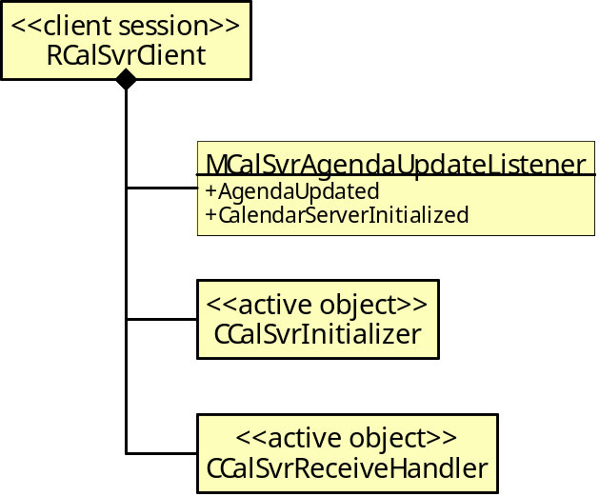
Figure 4.4 Class diagram for Calendar Server client side interface
Figure 4.4 shows a class diagram for client side interface of Calendar Server. RCalSvrClient implements client side session of Symbian OS client-server framework. Clients themselves implement the MCalSvrAgendaUpdateListener interface. Through this interface, completion of asynchronous requests is informed to clients. RCalSvrClient uses two active objects to handle the two asynchronous services it provides. For synchronous services these are not needed.

Agenda observer
Figure 4.5 Calendar Agenda observer class diagram

Class descriptions

Class | Description | Header file
RCalenSvrClient | Client side interface of Calendar Server. | CalSvrClient.H
MCalSvrAgendaUpdate  Listener | Callback interface for completion notifications of Calendar Server’s asynchronous services. | CalSvrClient.H
CCalenAgendaObserver | Class implementing the Symbian Agenda Model’s Agenda Observer interface for observing changes in Calendar database. | CalenAgendaObserver.H
CCalenServer | Server implementation for Symbian client-server framework. | CalenServer.H
CCalSvrSession | Server side session implementation for Symbian client-server framework. | CalSvrSession.H
CCalSvrScheduler | Active Scheduler for Calendar Server. Takes care of launching Calendar Server. | CalSvrScheduler.H
CCalenSvrBootManager | Manager class for boot time responsibilities of Calendar Server. | CalenSvrBootManager.H
CCalenSvrDBManager | Manager class managing open connection to Calendar database based on registered users. | CalenSvrDBManager.H
CCalenSvrAlarmManager | Manager class for alarm related responsibilities of Calendar Server. | CalenSvrAlarmManager.H

State diagrams

CCalenSvrDBManager
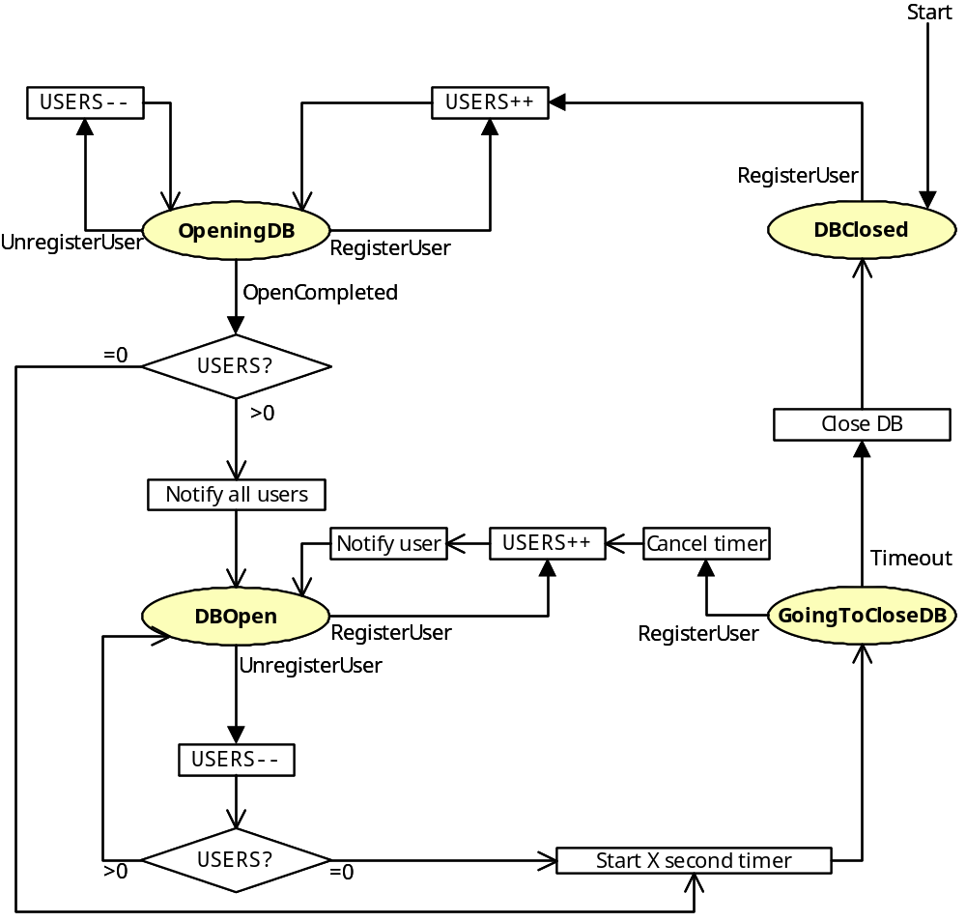
Figure 4.6 CCalenSvrDBManager state diagram

CCalenSvrAlarmManager
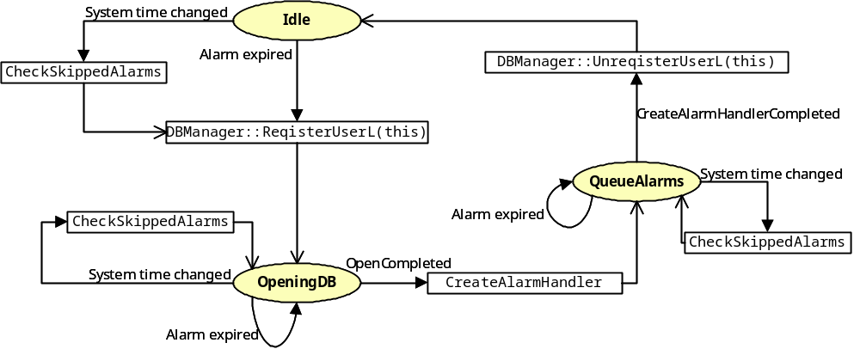
Figure 4.7 CCalenSvrAlarmManager state diagram

Operations

Receiving Calendar database change notification

Operation | Receiving Calendar database change notification.
Preconditions | Calendar Server is running and a client is registered as listener for change notifications.
Description | Symbian Agenda Server calls CCalenAgendaObserver. It starts Active Object CCalenNotifier, which notifies the client when the processor is idle. This prevents unnecessary notifications during long sequence of modifications, e.g. during synchronization. CCalenNotifier connects to Calendar Server and sends a notification. Calendar Server loops through clients and completes their asynchronous request, which eventually informs the client of change. Finally, client reissues asynchronous request to receive more notifications.
Inputs | Some program modifies Calendar database.
Modifies
Outputs | Notifies the client of change.
Postconditions
Related To
Related Event
Exceptions
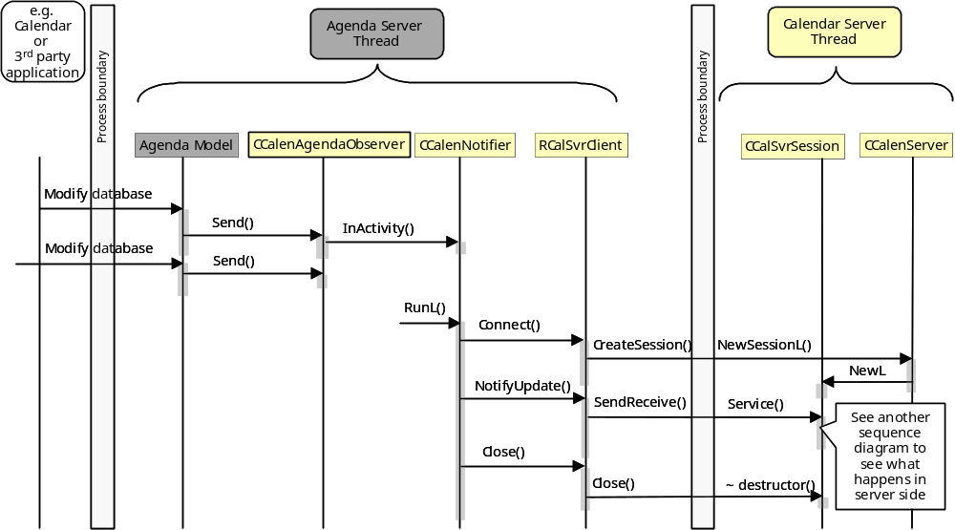
Figure 4.8 Sequence diagram of database change notification from Calendar Agenda Observer perspective. See Figure 4.9 for detailed description of sequence between Calendar Server and listening client.
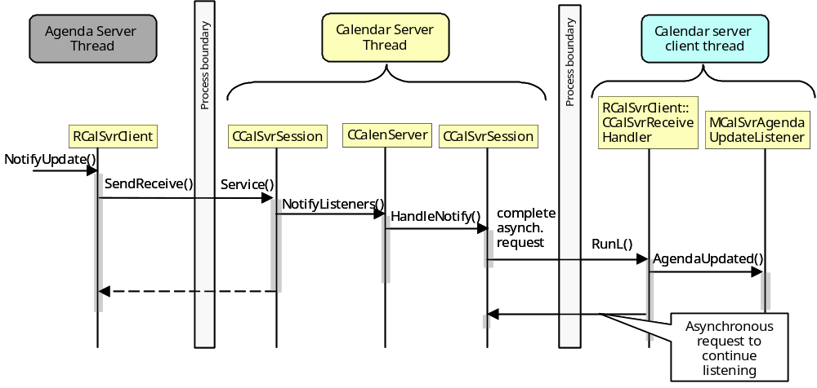
Figure 4.9 Receiving database change notification from Calendar Server’s perspective

Variation

Agenda observer
CalenAgendaObserver.DLL is included only in builds with Active Idle feature (controlled by the __ACTIVE_IDLE flag).
Used variation technique is ROM image creation time variation (i.e. in IBY file). Calendar Server uses Feature Manager to check if it should try loading and registering CalenAgendaObserver.

System resource usage

Files

File | Format | Size estimate | Description
1000599E.INI | Shared data file | <1Kb | Shared Data file of the AlmAlert component (for legacy reasons). It is used to communicate notification of passed alarms on system time changes to the Calendar application.

Databases
Calendar Server uses Symbian Agenda Database in file c:\system\data\Calendar.

Memory consumption

Memory/Build | Consumption
CalenObserver.DLL: ROM THUMB | 1,5 Kb
CalenSvrClient.DLL: ROM THUMB | 10 Kb
CalenSvr.EXE: ROM THUMB | 0,6 Kb

Task allocation
This component runs in the Calendar Server process. Thread is renamed as CalenSvrThread.

Performance
Symbian OS server responsiveness is defined by the longest-running CActive::RunL that it has. Because Calendar Server serves Active Idle plug-ins that run in system-critical Phone process, it is designed to be as responsive as possible on top of synchronous Agenda Model API.

Timers

Timer | Purpose | Interval | Lifetime
Database closing timer | To have a small delay before closing Agenda Model and Agenda Server so that they are not unnecessarily opened and closed during boot time. | 30 seconds. Runs just once for each creation. | Started when the last client unregisters as a Calendar database user. Destroyed when it expires.

Exception handling
The leave mechanism of Symbian OS environment is used to handle memory exhaustion.

Usage

Building
Normal Symbian build process.

