S60 3.0
Attendee View
Design Document

PIM/Digia | Jarkko Leminen

Change history:

Version | Date | Status | Comments
2.0 | 22.11.2007 | Approved | Editorial changes
1.0 | 13.04.2005 | Approved

Table of contents:

1. Document control 5
1.1 References 5
1.2 Documentation conventions 5
1.3 Abbreviations 5
1.4 Definitions 5
2. General 6
2.1 Introduction 6
2.2 Component environment 6
2.3 Use cases 7
2.3.1 Manipulating attendees 7
2.4 Services required 7
2.4.1 From the Symbian OS subsystems 7
2.4.2 From the Domestic OS subsystems 8
2.4.3 From HW 8
2.5 Services provided 8
2.5.1 UI 8
2.5.2 SW IF 8
3. UI control hierarchy 9
3.1 Framework 9
4. Design 10
4.1 Class diagrams 10
4.1.1 UI part of Attendee View 10
4.1.2 Engine part of Attendee View 11
4.2 Class descriptions 11
4.2.1 Structs, type definitions and enumerations 12
4.2.1.1 Enumerations 12
4.2.2 Flag definitions 12
4.2.3 State diagrams 12
4.3 Operations 13
4.3.1 Creating the Attendee View instance 13
4.3.2 Launching the Attendee View dialog 14
4.3.3 Closing Attendee View 15
4.4 Backup and Restore 16
5. Variation 17
5.1 AttendeeView/SYMBIAN_SECURE_ECOM 17
6. System resource usage 18
6.1 Files 18
6.2 Other data 18
6.2.1 Databases 18
6.2.2 Central Repository 18
6.2.3 Publish and Subscribe 18
6.3 Memory consumption 18
6.4 Task allocation 18
6.5 Performance 18
6.6 Timers 18
7. Security 19
7.1 Capabilities of this component 19
7.2 Input and output validation 19
7.3 Environmental assumptions 19
7.4 Additional enforcements 19
8. Exception handling 20
9. Usage 21
9.1 Building 21
9.2 User's guide 21

Document control

References

- S60 Calendar UI Specification

Documentation conventions
Code is written in the Courier New font.

Abbreviations

API | Application Programming Interface
DLL | Dynamic Link Library
ECom | Symbian OS infrastructure which supports dynamic selection and loading of DLLs
GUI | Graphical User Interface
UI | User Interface

Definitions

AppArc | Symbian OS Application Architecture.
AVKON | UIKON extended GUI.
CONE | Control Environment, graphical UI framework for Symbian OS.
UIKON | GUI library for Symbian OS.

General

Introduction
This document describes the design of S60 Attendee View. It explains the implementation of Attendee View. Attendee View is an ECom plug-in and it is used from Calendar or Messaging applications.
The user uses Attendee View to manage attendees of meeting request. The requirements for Attendee View are specified in reference document [1].

Component environment
The main component of the Attendee View ECom plug-in is AttendeeView.dll.
The dependencies between AttendeeView and the main Symbian OS components are shown in Figure 2.1. Some common Symbian OS components (such as EUSER, ESTOR, etc.) have been omitted from the figure for clarity. Attendee View is a standard ECom plug-in.
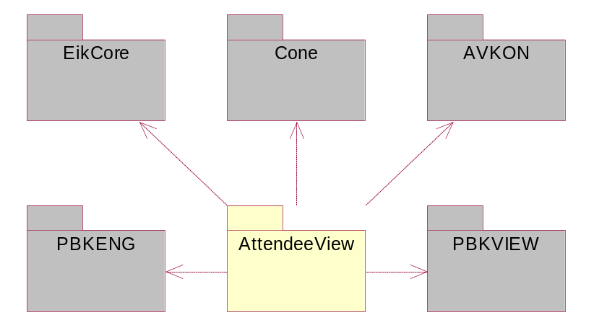
Figure 2.1 Physical diagram of the Attendee View ECom plug-in

Use cases
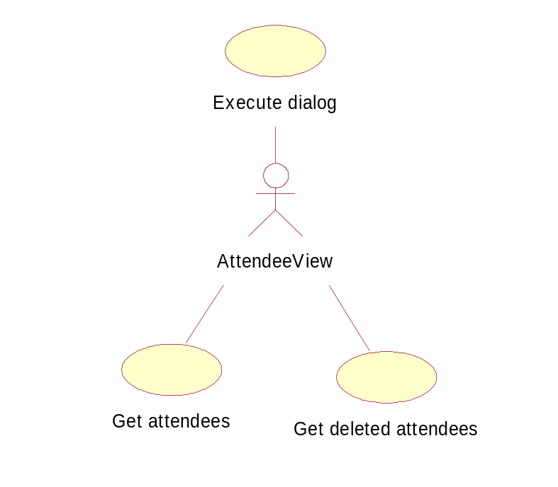
Figure 2.2 Attendee View use cases

Manipulating attendees

Summary | Attendee View is used to manipulate attendees.
Actor(s) | The user creates Attendee View and launches it.
Frequency | Low.
Preconditions | Attendee View is created with correct parameters.
Description | Attendee View is executed and when it returns, the user can get attendees in entry or deleted attendees that are not in entry anymore.
Exceptions
Postconditions
Illustrations | Figure 4.6, Figure 4.7, Figure 4.8.

Services required

From the Symbian OS subsystems
The following services are required from the Symbian OS subsystems:
- AVKON is used for UI components and dialogs.
- CONE is used for graphics.
- AgnModel is used to get and modify CAgnAttendee.

Detailed dependencies can be checked from AttendeeView.mmp.

API | Description
PbkEng | PbkEng is used to match email addresses to Phonebook contacts.
PbkView | PbkView is used to select email addresses from Phonebook.
ECom | ECom is used to enable plug-in functionality.
SendUI | SendUI is used to make possible enable sending functionality.
ServiceHandler | CallUI is used to make possible enable calling functionality.
FeatMgr | Feature Manager is used to check in run-time whether application Help content is available.
AknIcon | AknSkins API is used to load skinabled icons.
AknSkins | AknSkins API is used to load skinabled icons.

From the Domestic OS subsystems
Attendee View does not directly use any Domestic OS subsystems.

From HW
Attendee View does not have any direct HW interfaces.

Services provided

UI
The main UI of this module is specified in reference document [1].

SW IF
Attendee View provides for other applications to manage attendees of meeting request. The meeting request is created in the Calendar application. Attendee View has two different modes: Viewer and Editor.

UI control hierarchy

Framework
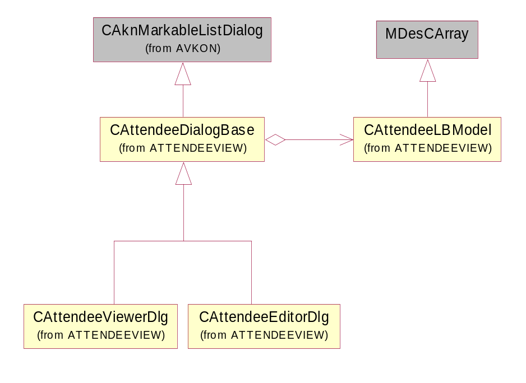
Figure 3.3 UI control

Design

Class diagrams

UI part of Attendee View
Attendee View is one DLL. However, in these figures Attendee View is split to two parts: UI and engine. Figure 4.4 shows the general structure of the Attendee View ECom plug-in and its simplified UI part. It does not describe the notification observer interface provided for engine. This simplification was done to make the diagram clearer. Green filled boxes describe the public interface.
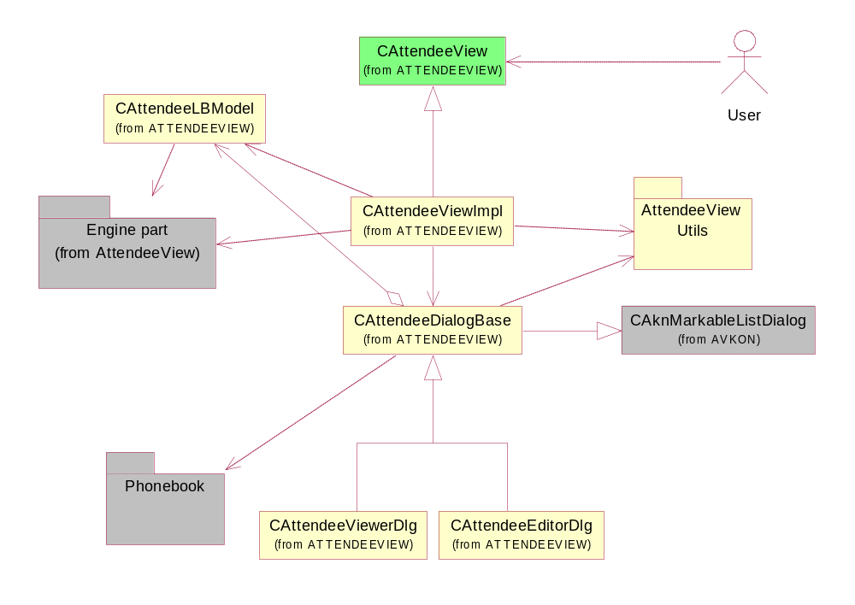
Figure 4.4 UI part of Attendee View

Engine part of Attendee View
Figure 4.5 shows the simplified structure of the engine part in Attendee View ECom plug-in. This simplification was done to make the diagram clearer. Green filled boxes describe the public interfaces.
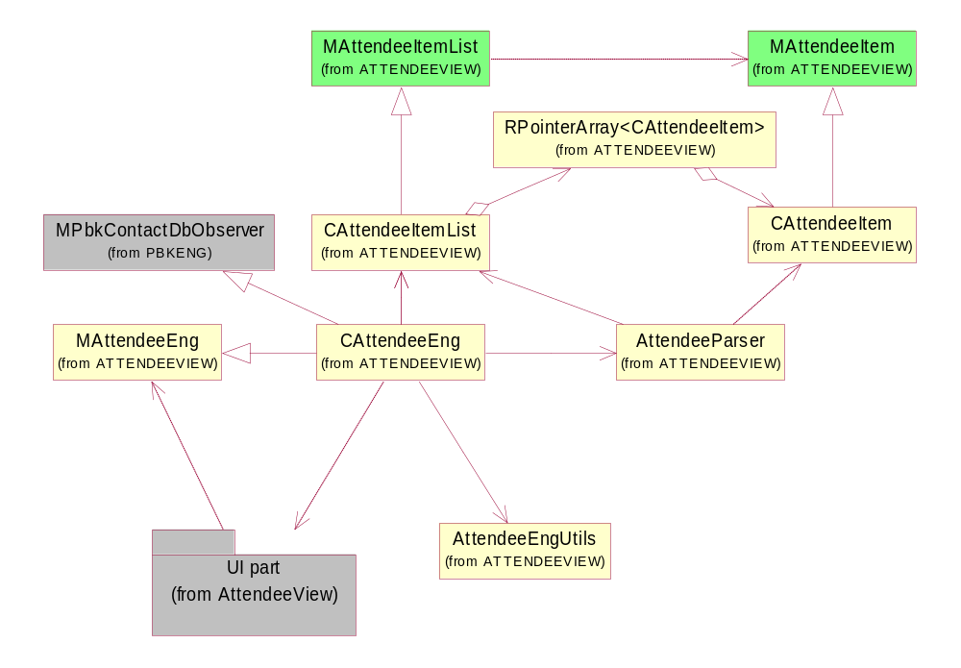
Figure 4.5 Engine part of Attendee View

Class descriptions

Class | Description | Header file
AttendeeEngUtils | Implements Attendee View's engine utilities. | AttendeeEngUtils.h
AttendeeNotes | Implements Attendee View’s information notes and query class. | AttendeeNotes.h
AttendeeParser | Implements Attendee View's parser. | AttendeeParser.h
CAttendeeCaller | Wraps the usage of CallUi into one simple class. | CAttendeeCaller.h
CAttendeeDetailsDlg | Implements Attendee View's details dialog. | CAttendeeDetailsDlg.h
CAttendeeDialogBase | Implements the CAttendeeDialogBase dialog. This is base class for viewer and editor dialogs. | CAttendeeDialogBase.h
CAttendeeEditorDlg | Implements Attendee View's Editor dialog. | CAttendeeEditorDlg.h
CAttendeeEng | Implements Attendee View's engine. | CAttendeeEng.h
CAttendeeItem | Implements an item in Attendee View. | CAttendeeItem.h
CAttendeeItemList | Implements Attendee View's item list. | CAttendeeItemList.h
CAttendeeLBModel | Implements list box model. | CAttendeeLBModel.h
CAttendeeSender | Wraps the usage of CSendAppUi into one simple class. | CAttendeeSender.h
CAttendeeUiUtils | CAttendeeUiUtils class:  - Stores and restores the Navi pane.  - Reads resource files. | CAttendeeUiUtils.h
CAttendeeView | Implements entry point class to Attendee View:  - Attendee View can be in Editor or Viewer mode.  - When Attendee View is constructed it starts to match e-mail addresses to Phonebook contacts and continues matching if it is not ready when view is executed. | CAttendeeView.h
CAttendeeViewerDlg | Implements Attendee View's viewer dialog. | CAttendeeViewerDlg.h
CAttendeeViewImpl | Implements the ECom interface of CAttendeeView. | CAttendeeViewImpl.h
MAttendeeEng | This API is only used by Attendee view. Defines interface of the AttendeeView engine. | MAttendeeEng.h
MAttendeeEngObserver | Engine provides this API only for Attendee View for observing engine events. | MAttendeeEngObserver.h
MAttendeeItem | Defines interface of attendee item. | MAttendeeItem.h
MAttendeeItemList | Defines interface of attendee item list. | MAttendeeItemList.h

Structs, type definitions and enumerations

Enumerations

Name of enumeration | Description
TPanicCode | Attendee View’s panic codes.
TAttendeeViewCommandIds | An enumeration for command IDs.
TAttendance | An enumeration for command attendances.

Flag definitions

Flag | Description
SYMBIAN_SECURE_ECOM | Variates security paths in MMP file.
RD_SECURE_BIN_RES | Variates security paths in icon file.

State diagrams
Attendee View can be launched in two different modes: Viewer and Editor. When Attendee View is initialized, it starts to match e-mail addresses to phonebook’s contacts. Attendee View’s dialog (Viewer or Editor) can be launched right away when initialization is ready. E-mail matching does not have to be completed when launching the dialog. When the user exits the dialog, it can be launched again if needed, or Attendee View can be destroyed.
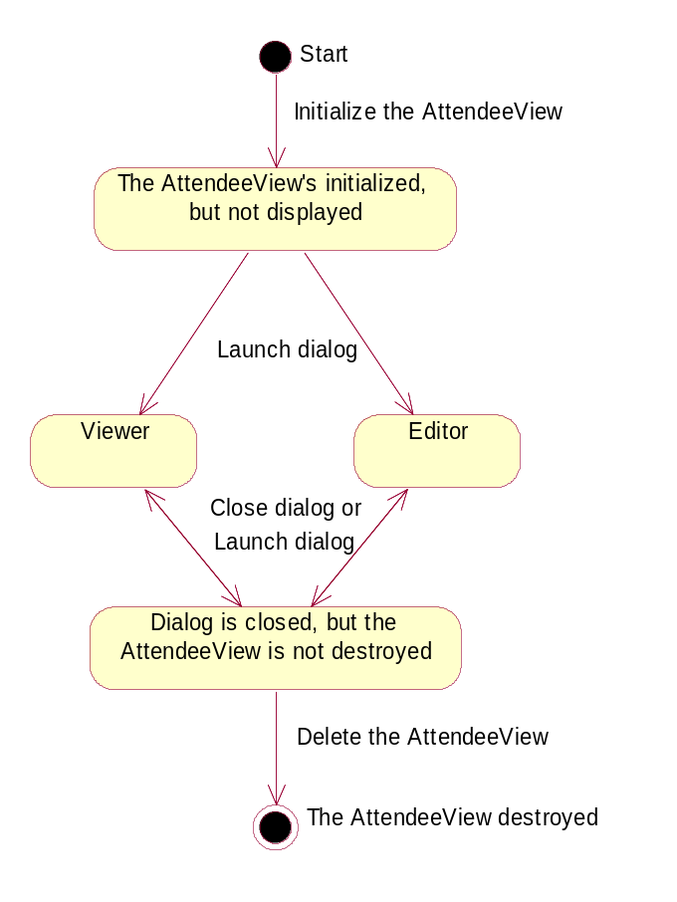
Figure 4.6 Attendee View’s state diagram

Operations

Creating the Attendee View instance

Operation | Creating the Attendee View instance.
Preconditions | The TAttendeeViewInit structure is created.
Description | The application that uses the Attendee View ECom plug-in creates the TAttendeeViewInit structure and then creates the Attendee View instance.
Inputs | TAttendeeViewInit
Modifies | CAgnAttendees items in CAgnEntry.
Outputs | CAttendeeView
Postconditions
Related to
Related event
Exceptions | OOM.

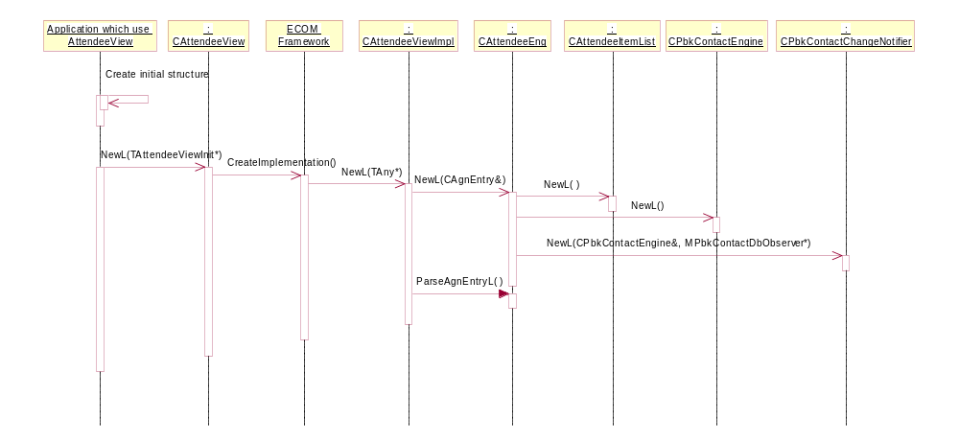
Figure 4.7 Creating the Attendee View instance

Launching the Attendee View dialog

Operation | Launching the Attendee View dialog.
Preconditions | The Attendee View instance is created.
Description | The application that uses the Attendee View ECom plug-in calls the ExecuteL-method.
Inputs
Modifies
Outputs
Postconditions | Attendee View is displayed in either Viewer or Editor mode.
Related to
Related event | The user presses the Back softkey or selects Exit from the Options menu.
Exceptions | OOM.

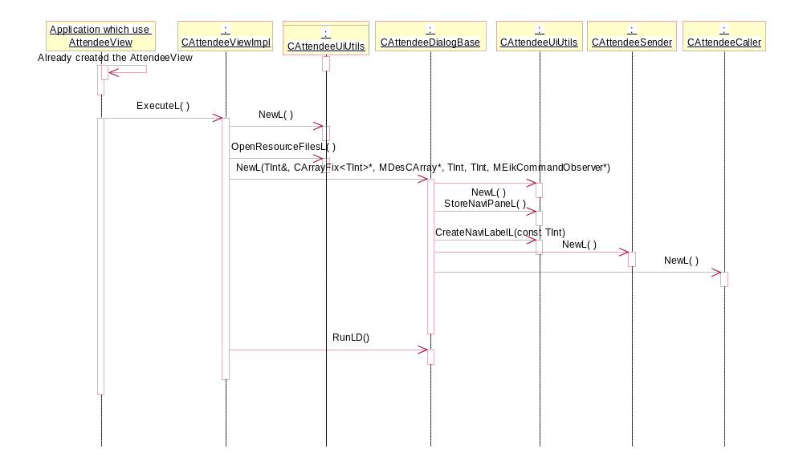
Figure 4.8 Launching the Attendee View dialog

Closing Attendee View

Operation | Closing Attendee View.
Preconditions | The Attendee View instance is created and launched.
Description | The Attendee View’s ExecuteL method returns.
Inputs
Modifies | CAgnAttendees items in CAgnEntry.
Outputs | Returns TInt variable, but it is not used anywhere.
Postconditions | When Attendee View has successfully returned and been deleted, the application that uses Attendee View needs to destroy CAgnEnry when it is not needed it anymore.
Related to
Related event
Exceptions

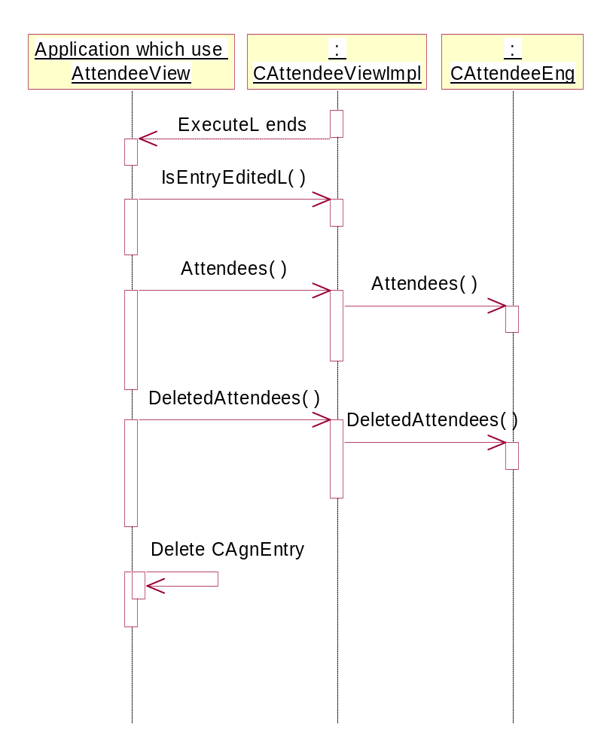
Figure 4.9 Closing Attendee View

Backup and Restore
Attendee View does not participate in Backup and Restore.

Variation
Feature Manager is used to check in runtime whether application help content is available.

AttendeeView/SYMBIAN_SECURE_ECOM
SYMBIAN_SECURE_ECOM flag is used to variate Platform Security.
RD_SECURE_BIN_RES flag is used to variate Platform Security in icon file.

System resource usage

Files
Attendee View does not use any files.

Other data

Databases
Attendee View does not use any databases directly.

Central Repository
Attendee View does not use Central Repository.

Publish and Subscribe
Attendee View does not use Publish and Subscribe.

Memory consumption
Attendee View has no exceptional stack consumption or ROM/user data area consumption and its demands for heap storage are low.

Task allocation
Attendee View runs in one thread, which is the thread of the ECom plug-in.

Performance
When Attendee View is matching attendees to contacts and the contacts database contains a large number of contacts, the process may take a while (i.e. 10 seconds): This may be a problem, depending on the acceptable processing time. In order to quicken this process, Attendee View starts matching attendees immediately when it is created, so in most cases matching is finished before launching the view.

Timers
Attendee View does not use any timers.

Security

Capabilities of this component

Capability | Justification
CAP_ECOM_PLUGIN | Attendee View is an ECom plug-in.

Input and output validation
Attendee View does not require or make any validation for data.

Environmental assumptions
Attendee View does not make any assumptions about its environment.

Additional enforcements
Attendee View does not have any additional security enforcements.

Exception handling
The leave mechanism of the Symbian OS environment is used to handle all runtime errors. Whenever possible, a leave results in a standard environment error message to the user and the operation started by the user is canceled.
Error TRAPs have been added to the code only when necessary for the correct program logic or when a non-standard error message is specified.
The panic mechanism is used only to stop the program when a programming error is detected in Attendee View.
All panics are triggered only from assertions (__ASSERT* macros). The panic messages are defined so that it is easy to find the code that triggered the panic. The panic messages consist of a class name and a panic number.

Usage

Building
- cd \s60\AttendeeView\group
- bldmake bldfiles
- abld build

User's guide
See reference document [1].

